Integrating the Healthcare Enterprise



IHE Patient Care Device
Technical Framework Supplement

Alarm Communication Management
(ACM)

Trial Implementation

Date: August 16, 2012
Author: IHE PCD Technical Committee
Email: pcd@ihe.net
Foreword
This is a supplement to the IHE Patient Care Device Technical Framework V2.0. Each supplement undergoes a process of public comment and trial implementation before being incorporated into the volumes of the Technical Frameworks.
This supplement is submitted for Trial Implementation as of August 16, 2012 and may be available for testing at subsequent IHE Connectathons. The supplement may be amended based on the results of testing. Following successful testing it will be incorporated into Patient Care Device Final Text Technical Framework. Comments are invited and may be submitted at http://www.ihe.net/pcd/pcdcomments.cfm.
This supplement describes changes to the existing technical framework documents and where indicated amends text by addition (bold underline) or removal (bold strikethrough), as well as addition of large new sections introduced by editor’s instructions to “add new text” or similar, which for readability are not bolded or underlined.
“Boxed” instructions like the sample below indicate to the Volume Editor how to integrate the relevant section(s) into the relevant Technical Framework volume:

Replace Section X.X by the following:

General information about IHE can be found at: www.ihe.net
Information about the IHE Patient Care Device domain can be found at: http://www.ihe.net/Domains/index.cfm
Information about the structure of IHE Technical Frameworks and Supplements can be found at: http://www.ihe.net/About/process.cfm and http://www.ihe.net/profiles/index.cfm
The current version of the IHE Technical Framework can be found at: http://www.ihe.net/Technical_Framework/index.cfm
CONTENTS

Introduction 6
Profile Abstract 6
Open Issues and Questions 6
Closed Issues 6
Volume 1 – Integration Profiles 8
1.7 History of Annual Changes 8
2.2.X ACM Integration Profile 9
X Alarm Communication Management (ACM) Integration Profile 9
X.1 Actors/ Transactions 10
X.2 ACM Integration Profile Options 11
X.3 ACM Use Cases and Interaction Diagrams 12
X.3.1 Case A1: Location Sourced 12
X.3.2 Case A2: Identified Patient Source 13
X.3.3 Case A3: Same as A1/A2 with Escalation with Cancel at Alarm Source 14
X.3.4 Case A4: Same as A1/A2 with Escalation with Cancel at Communication Endpoint 15
X.3.5 Case A5: Same as A1/A2 with Escalation with Cancel at AM 15
X.3.6 Case A6: Information with no destination other than logging by the Alarm Manager (AM) actor 15
X.3.7 Case A7: Equipment Sourced Alarm 15
X.4 ACM Security Considerations 15
<Appendix A> Actor Summary Definitions 15
GLOSSARY 21
Volume 2 - Transactions 22
3.Y PCD-04 Report Alarm 22
3.Y.1 Scope 22
3.Y.2 Use Case Roles 22
3.Y.3 Referenced Standards 22
3.Y.4 Interaction Diagrams 22
3.Y.4.1 AR reports to AM 22
3.Y.4.1.1 HL7 Conformance Statement 23
3.Y.4.1.2 PCD-04 Report Alarm (ORU^R40^ORU_R40) static definition 23
3.Y.4.1.3 Trigger Events 25
3.Y.4.1.4 Message Semantics 25
3.Y.4.1.5 Expected Actions 25
3.Y.4.1.6 Security Considerations 26
3.Y+1 PCD-05 Report Alarm Status 26
3.Y+1.1 Scope 26
3.Y+1.2 Use Case Roles 26
3.Y+1.3 Referenced Standard 26
3.Y+1.4 Interaction Diagrams 27
3.Y+1.4.1 AM status updates to AR 27
3.Y+1.4.1.1 Trigger Events 27
3.Y+1.4.1.2 Message Semantics 27
3.Y+1.4.1.3 HL7 Conformance Statement 28
3.Y+1.4.1.4 PCD-05 Report Alarm Status (ORA^R41^ORA_R41) static definition 28
3.Y+1.4.1.5 Expected Actions 29
3.Y+1.4.1.6 Security Considerations 29
3.Y+2 PCD-06 Disseminate Alarm 29
3.Y+2.1 Scope 29
3.Y+2.2 Use Case Roles 30
3.Y+2.3 Referenced Standard 30
3.Y+2.4 Interaction Diagrams 31
3.Y+2.4.1 AM disseminate alarm to AC 31
3.Y+2.4.1.1 HL7 Conformance Statement 31
3.Y+2.4.1.2 PCD-06 Disseminate Alarm static definition 31
3.Y+2.4.1.3 Trigger Events 32
3.Y+2.4.1.4 Message Semantics 32
3.Y+2.4.1.5 Expected Actions 33
3.Y+2.4.1.6 Security Considerations 33
3.Y+3 PCD-07 Report Dissemination Alarm Status 33
3.Y+3.1 Scope 33
3.Y+3.2 Use Case Roles 33
3.Y+3.3 Referenced Standard 34
3.Y+3.4 Interaction Diagrams 34
3.Y+3.4.1 AC status updates to AM 34
3.Y+3.4.1.1 Trigger Events 35
3.Y+3.4.1.2 Message Semantics 36
3.Y+3.4.1.3 HL7 Conformance Statement 36
3.Y+3.4.1.4 PCD-07 Report Dissemination Alarm Status static definition 36
3.Y+3.4.1.5 Expected Actions 36
3.Y+3.4.1.6 Security Considerations 37
3.Z Common Message Segments 37
3.Z.1 MSH Message Header Segment 37
3.Z.1.1 MSH-21 Message Profile Identifier (EI) 01598 37
3.Z.2 PID Patient Identification Segment 38
3.Z.2.1 PID-3 Patient Identifier List (CX) 00106 38
3.Z.2.2 PID-5 Patient Name (XPN) 00108 38
3.Z.2.3 PID-7 Date/Time of Birth (TSO) 00110 38
3.Z.2.4 PID-8 Administrative Sex (IS) 00111 38
3.Z.2.5 PID-31 Identity Unknown Indicator (ID) 01535 39
3.Z.3 PV1 Patient Visit Segment 39
3.Z.3.1 PV1-3 Assigned Patient Location (PL) 00133 39
3.Z.4 ORC Observation Control Segment 39
3.Z.5 OBR Observation Request Segment 40
3.Z.6 PRT Participation Information Segment 41
3.Z.6.1 PRT-1 Participation Instance ID (EI) 02379 42
3.Z.6.2 PRT-2 Action code (ID) 00816 42
3.Z.6.3 PRT-3 Action Reason (CWE) 02380 43
3.Z.6.4 PRT-4 Participation (CWE) 02381 44
3.Z.6.5 PRT-5 Participation Person (XCN) 02382 45
3.Z.6.6 PRT-6 Participation Person Provider Type (CWE) 02383 47
3.Z.6.7 PRT-7 Participation Organization Unit Type (CWE) 02384 48
3.Z.6.8 PRT-8 Participation Organization (XON) 02385 48
3.Z.6.9 PRT-9 Participation Location (PL) 02386 49
3.Z.6.10 PRT-10 Participation Device (EI) 02348 51
3.Z.6.11 PRT-11 Participation Begin Date/Time (DTM) 02387 52
3.Z.6.12 PRT-12 Participation End Date/Time (DTM) 02388 52
3.Z.6.13 PRT-13 Participation Qualitative Duration (CWE) 02389 52
3.Z.6.14 PRT-14 Participation Address (XAD) 02390 52
3.Z.6.15 PRT-15 Participation Telecommunication Address (XTN) 02391 54
3.Z.7 OBX Observation Result Segment 54
3.Z.7.1 Semantics 55
3.Z.7.2 OBX-2 Value Type (ID) 00570 56
3.Z.7.3 OBX-3 Observation Identifier (CE) 00571 56
3.Z.7.4 OBX-4 Observation Sub-ID (ST) 00572 56
3.Z.7.5 OBX-5 Observation Value (varies) 00573 57
3.Z.7.6 OBX-6 Units (CE) 00574 61
3.Z.7.7 OBX-7 References Range (ST) 00575 61
3.Z.7.8 OBX-8 Abnormal Flags (IS) 00576 61
3.Z.7.9 OBX-14 Observation Date/Time 63
3.Z.7.10 OBX-18 Equipment Instance Identifier (EI) 01479 63
3.Z.8 NTE Notes and Comment Segment 63
3.Z.8.1 NTE-3 Comment (FT) 00098 63
3.Z.9 Capture of WCTP 1.3 update 1 64
3.Z.9.1 Pre-Configuration 64
3.Z.9.2 Endpoint Device Addressing 64
3.Z.9.3 Polling Versus Push Responses 64
3.Z.9.4 Constraints 64
3.Z.9.5 Transactions 65
Appendix ’X’ Example Messages 66
Appendix ’X+1’ AM – AC Communication WCTP Protocol Transactions 69
2 IHE PCD Prerequisite Information 70
3 WCTP client–server messages and responses 74
3.1 Administrative - wctp-VersionQuery 74
3.2 Administrative - wctp-VersionResponse 74
3.3 Administrative - wctp-VersionResponse 75
3.4 IHE PCD-06 - wctp-SubmitRequest – no MCR 76
3.5 IHE PCD-06 - wctp-SubmitRequest – Unpaired MCR 76
3.6 IHE PCD-06 - wctp-SubmitRequest – Paired MCR 77
3.7 IHE PCD-06 wctp-SubmitRequest – WCM 79
3.8 IHE PCD-06 wctp-SubmitRequest – Call Back Phone Number 81
3.9 IHE PCD-07 - Synchronous response to wctp-SubmitRequest – Received by communications status update 82
3.10 For Pre-Connectathon/Virtual Connectathon testing - wctp-PollForMessages – general poll 83
3.11 For Pre-Connectathon/Virtual Connectathon testing - wctp-PollResponse – general poll 84
3.12 For Pre-Connectathon/Virtual Connectathon testing - wctp-PollResponse (message status update) 85
3.13 For Pre-Connectathon/Virtual Connectathon testing - wctp-PollResponse (message status update acknowledgement) 86
3.14 For Pre-Connectathon/Virtual Connectathon testing - wctp-PollResponse (message reply, not in response to an MCR based wctp-SubmitRequest) 87
3.15 IHE PCD-07 asynchronous status update (DELIVERED - delivery confirmation) 87
3.16 IHE PCD-07 asynchronous status update (READ - read receipt) 89
3.17 IHE PCD-07 asynchronous reply message with MCR 89

Introduction

Profile Abstract
This supplement extends the Device Enterprise Communication profile of the IHE Patient Care Devices domain to further specify the communication of alarm data describing states and events significant to patient care from patient care devices to alarm manager systems (systems which route alarms to end devices for notification of caregivers or for alarm logging purposes).
These alarms may be physiological, that is, representing the physiological state of the patient (such as a heart rate above or below a caregiver-specified safe range for the patient), or technical, reflecting conditions in the patient care devices themselves that may require action from caregivers (such as ECG leads off the patient).
The intent of this supplement is to give a uniform way of representing such common alarm conditions in HL7 messages to facilitate interoperability of systems from different vendors.

Open Issues and Questions
None.

Closed Issues
It was decided to treat alarm representation in HL7 as an extension of previous PCD work for observation reporting from patient care devices, with multiple OBX segments representing the aspects of an alarm that did went beyond what could readily be represented in the single OBX segment per parameter model previously used.
ISO/IEEE 11073 was selected as the preferred coding system for parameters and events to be used in the communication of alarms. If no applicable term is available in that nomenclature and a LOINC term is, the LOINC term may be used.
Aside from that which is directly affected by this profile, communication and functionality within alarm manager systems and the communication protocols, messaging, and presentation used between alarm manager systems and alarm dissemination and alarm endpoint client systems is not within the scope of this profile.
Systems covered by this document shall pass through rather than modify alarms created by patient care devices, and shall not create additional alarms based on interpreting alarms or based on correlating alarms from different alarm reporting systems.
There was consensus that snippets from ECG or other physiological waveforms associated with alarms were desirable to provide for in this document, but it was decided to define that in a separate format specification, Waveform Content Module (WCM). Inclusion of Waveform Content Module (WCM) components in ACM Report Alarm [PCD-04] messages is the direction going forward, once sufficient vendors have produced WCM conformant implementations for the ACM AR, AM, and AC actors.

Volume 1 – Integration Profiles
This section describes the changes required in Volume 1 of the Technical Framework that result from including this Integration Profile.

History of Annual Changes
The Alarm Communication Management integration profile defines the communication of alarms from alarm source systems to alarm manager systems and from alarm manager systems to alarm communicator systems.
Add the following bullet to the end of the bullet list in section 1.7
- Added the ACM Profile which defines the communication of alarms from alarm source systems to alarm manager systems and from alarm manager systems to alarm communicator systems.
- Integrated PCD domain approved Change Proposals (CP) from 2010-2011 cycle, including housekeeping updates and changes, changes in HL7 events and triggers in preparation for HL7 versions 2.7 and 2.8, addition of WCTP as a protocol choice between the AM and AC actors, integration of WCM content into PCD-04 and PCD-06 transactions, addition of optional PIN/Carrier recipient specification on PCD-04 transaction.
- Integrated PCD domain approved Change Proposals (CP) from the 2011-2012 cycle, including housekeeping updates and changes, removal of SMTP as an optional choice for the AM - AC communication protocol for the PCD-06 Disseminate Alarm and PCD-07 Report Dissemination Alarm Status transactions leaving WCTP as the only permissible AM – AC communication protocol, removal of the Alarm Archiver (AA) actor and its two related transactions PCD-08 Subscribe to Alarm and PCD-11 Report Alarm to Archiver to expedite migration of the ACM profile into the PCD Technical Framework in the next cycle. If Alarm Archiver-like functionality is required please examine the Asynchronous Data Query (ADQ) profile and specifically the Device Data Archiver (DDA).

Add the following section to Table 2-1 Integration Profiles Dependencies in section 2.1

Required Profiles  ITI Consistent Time (CT)  Related Profiles  Patient Identifier Cross Referencing (PIX) Profile  Patient Demographics Query (PDQ)  Waveform Content Module (WCM) | <?> | <?> | <->

Add the following section to section 2.2

2.2.X ACM Integration Profile
This is an alarm distribution solution providing the following:
- Communication of alarms from reporting devices to concentrating gateways
- Communication from the gateway to an alarm manager or distributor
- Communication to an alarm communicator for dissemination to people using both wired and wireless communication devices, typically clinicians, physicians, or other healthcare staff, for responding to patient needs or related workflows
- Communication of status updates and responses from people back to the alarm manager to the alarm reporter for delivery confirmation
The section shall be added to Volume 1

X Alarm Communication Management (ACM) Integration Profile
Alarm Communication Management defines the communication of alarms from alarm source systems to alarm manager systems and from alarm manager systems to alarm communicator systems.
This is an alarm distribution solution providing the following:
- Communication from the gateway to an alarm manager or distributor
- Communication to an alarm communicator for dissemination to people using both wired and wireless communication devices, typically clinicians, physicians, or other healthcare staff, for responding to patient needs or related workflows
- Communication of status updates and responses from people back to the alarm manager to the alarm reporter for delivery confirmation
The intended use of the IHE PCD Alarm Communications Management Profile is to serve in communication of alarm information from patient care devices to an alarm manager system communicating with additional means of notification to caregivers. Notification devices would include those capable of supporting this profile, in particular PCD-06 and PCD-07.
Alarm
Source
Alarm
Aggregator
Alarm
Receiver
Alarm
Coordinator
Alarm
Disseminator
Alarm
Communication
Alarm
Endpoint
Alarm
Communicator
(AC)
Alarm
Manager
(AM)
Alarm
Reporter
(AR)
Alarm Report Generator
Alarm
Cache
Communication detailed in this profile
Communication not detailed in this profile
.
.
.
.
.
.

Figure X-1: ACM Profile Actor Diagram

Out of Scope
Grouping or consolidation of alarms is out of scope for this profile.
The definition of escalation actions in response to a notification not being responded to are outside the scope of this profile.

X.1 Actors/ Transactions
Figure X-1 shows the actors directly involved in the ACM Integration Profile and the relevant transactions between them. Other actors that may be indirectly involved due to their participation in other related profiles, etc. are not necessarily shown.
Table X.1-1 lists the transactions for each actor directly involved in the ACM Profile. In order to claim support of this Integration Profile, an implementation must perform the required transactions (labeled “R”). Transactions labeled “O” are optional. A complete list of options defined by this Integration Profile and that implementations may choose to support is listed in Volume 1, Section X.2.

Table X.1-1: ACM Integration Profile – Actors and Transactions
Actors | Transactions | Direction | Optionality | Section in Vol. 2
Alarm Reporter (AR) | Report Alarm [PCD-04] | Outbound | R | 3.Y
Alarm Reporter (AR) | Waveform Content Module (WCM) data within [PCD-04] | Outbound | O | 3.Y
Alarm Reporter (AR) | Report Alarm Status [PCD-05] | Inbound | O | 3.Y+1
Alarm Manager (AM) | Report Alarm [PCD-04] | Inbound | R | 3.Y
Alarm Manager (AM) | Waveform Content Module (WCM) data within [PCD-04] | Inbound | O | 3.Y
Alarm Manager (AM) | Report Alarm Status [PCD-05] | Outbound | O | 3.Y+1
Alarm Manager (AM) | Disseminate Alarm [PCD-06] | Outbound | R | 3.Y+2
Alarm Manager (AM) | Waveform Content Module (WCM) data within [PCD-06] | Outbound | O | 3.Y+2
Alarm Manager (AM) | Report Dissemination Alarm Status [PCD-07] | Inbound | R | 3.Y+4
Alarm Communicator (AC) | Disseminate Alarm [PCD-06] | Inbound | R | 3.Y+2
Alarm Communicator (AC) | Waveform Content Module (WCM) data within [PCD-06] | Inbound | O | 3.Y+2
Alarm Communicator (AC) | Report Dissemination Alarm Status [PCD-07] | Outbound | R | 3.Y+4

X.2 ACM Integration Profile Options
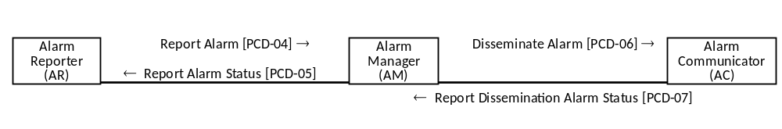
Options that may be selected for this Integration Profile are listed in the table X.2-1 along with the Actors to which they apply. Dependencies between options when applicable are specified in notes.

Table X.2-1: ACM – Actors and Options
Actor | Options | Vol. & Section
Alarm Reporter (AR) | Report Alarm Status option | 3.Y+1
Alarm Reporter (AR) | Identify Recipients option | 3.Y+1
Alarm Reporter (AR) | Waveform Content Module (WCM) option | 3.Y+1
Alarm Manager (AM) | Report Alarm Status option | 3.Y+1
Alarm Manager (AM) | Identify Recipients option | 3.Y+1
Alarm Manager (AM) | Waveform Content Module (WCM) in PCD-04 option | 3.Y+1
Alarm Manager (AM) | Waveform Content Module (WCM) in PCD-06 option | 3.Y+1
Alarm Communicator (AC) | Waveform Content Module (WCM) | 3.Y+1
The Report Alarm Status option indicates whether or not the particular actor supports the Report Alarm Status transaction (PCD-05).
The Identify Recipients option for the Alarm Reporter identifies whether or not the Report Alarm transaction (PCD-04) might include the identification of the notification recipient people or devices.
The Identify Recipients option for the Alarm Manager identifies whether or not the Alarm Manager sends to the Alarm Reporter notification recipient details as to people or devices notified and replies.

X.3 ACM Use Cases and Interaction Diagrams
Alarm Communication Management is meant to improve clinical efficiency by using technology to deliver the right alarms, with the right priority, to the right individuals via devices with the right content, and through configuration escalating communication of alarms to devices associated with other individuals.
The following are the use cases. The use cases are noticeably generic and not so much focused on the alarm clinical purpose as they are focused on the system interactions. The use cases may be directly applicable to other IHE domains, and may be supplemented with additional use cases to serve specific needs in other domains.

X.3.1 Case A1: Location Sourced
Use Case – Patient wants a pillow. Patient pulls nurse call. Nurse call system lights the room’s dome light and light at central station. Nurse call system, operating as an Alarm Reporter (AR) actor sends Report Alarm [PCD-04] to Alarm Manager (AM) indicating nurse call alarm. The Alarm Manager (AM) logs receipt of the alarm. The Alarm Manager (AM) identifies the appropriate nurse based upon configured nurse to patient assignments, identifies the appropriate Alarm Communicator (AC) actor and destination communication device based upon nurse to device configuration in Alarm Manager (AM), sends Disseminate Alarm [PCD-06] to nurse’s communication device. The Alarm Manager (AM) logs the dissemination to the Alarm Communicator (AC). The nurse receives the alarm on their assigned device. The information minimally includes the patient location (room number). The nurse replies to the alarm on the communication device, the Alarm Communicator (AC) sends a Report Dissemination Alarm Status [PCD-07] to the Alarm Manager (AM). The Alarm Manager sends a Report Alarm Status [PCD-05] to the Alarm Reporter (AR). The nurse goes to the room, determines the needs of the patient, and provides the patient with a pillow. The nurse then resets the nurse call pull. The nurse call system turns off the room’s dome light and the light at the central station. The nurse call system, operating as an Alarm Reporter (AR) actor sends Report Alarm [PCD-04] to Alarm Manager (AM) indicating reset of the nurse call alarm. The Alarm Manager (AM) receives the alarm turns off any configured alarm escalation and logs the alarm.

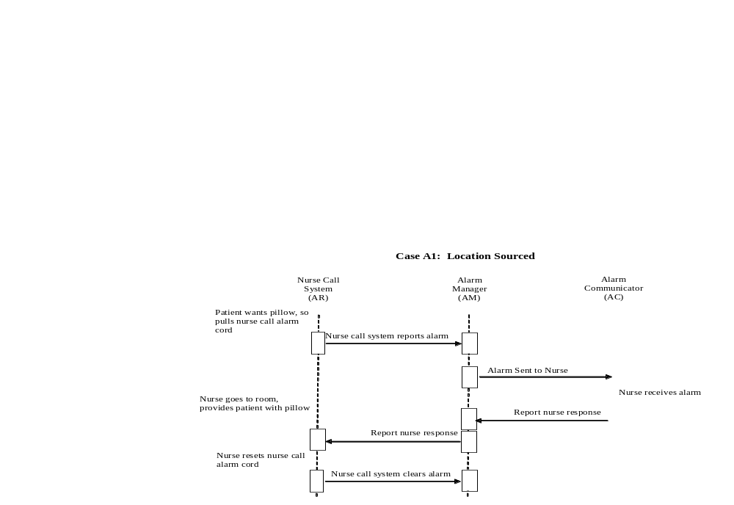X.3.2 Case A2: Identified Patient Source
Use Case – Alarm occurs on PCD assigned to patient. PCD or PCD gateway system, operating as an Alarm Reporter (AR) actor sends Report Alarm [PCD-04] to Alarm Manager (AM) indicating PCD alarm. The Alarm Manager (AM) logs receipt of the alarm. The Alarm Manager (AM) identifies the appropriate nurse based upon configured nurse to patient assignments, identifies the appropriate Alarm Communicator (AC) actor and destination communication device based upon nurse to device configuration in Alarm Manager (AM), sends Disseminate Alarm [PCD-06] to nurse’s communication device. The Alarm Manager (AM) logs the dissemination to the Alarm Communicator (AC). The nurse receives the alarm on their assigned device. The information minimally includes the patient identification. The nurse replies to the alarm on the communication device, the Alarm Communicator (AC) sends a Report Dissemination Alarm Status [PCD-07] to the Alarm Manager (AM). The Alarm Manager sends a Report Alarm Status [PCD-05] to the Alarm Reporter (AR). The nurse goes to the room, determines the needs of the patient, and responds to the PCD alarm. The nurse then clears the PCD alarm. The PCD or PCD gateway system, operating as an Alarm Reporter (AR) actor sends Report Alarm [PCD-04] to Alarm Manager (AM) indicating reset of the PCD alarm. The Alarm Manager (AM) receives the alarm turns off any configured alarm escalation and logs the alarm.

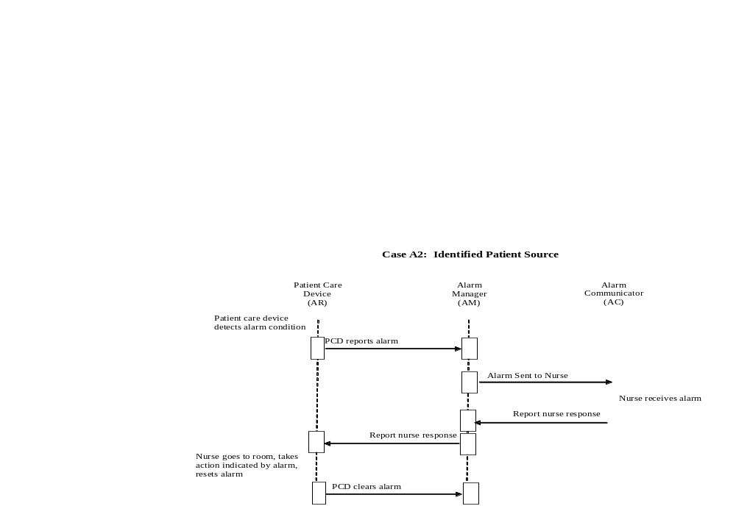X.3.3 Case A3: Same as A1/A2 with Escalation with Cancel at Alarm Source
Use Case 3: (same as use case 1 or 2 with escalation with cancel at source) if the communication destination is inaccessible or the target individual is indicated as unavailable, then the alarm is rerouted to one or more alternatives with escalation to higher levels of responsibility until the alarm is canceled at its source and the alarm system notified of the cancel.

X.3.4 Case A4: Same as A1/A2 with Escalation with Cancel at Communication Endpoint
Use Case 4: (same as use case 1 or 2 with escalation with cancel of any active Alarm Manager (AM) escalation actions at communication endpoint) if the communication destination is inaccessible or the target individual is indicated as unavailable then the alarm is rerouted to one or more alternatives with escalation to higher levels of responsibility until the alarm is canceled by a recipient at a communication endpoint.

X.3.5 Case A5: Same as A1/A2 with Escalation with Cancel at AM
Use Case 5: (same as use case 1 or 2 with escalation with cancel of any active Alarm Manager (AM) escalation actions at alarm mgmt. system) if the communication destination is inaccessible or the target individual is indicated as unavailable then the alarm is rerouted to one or more alternatives with escalation to higher levels of responsibility until the alarm is canceled by a user on the Alarm Manager (AM), however not automatically via algorithms in the Alarm Manager (AM).

X.3.6 Case A6: Information with no destination other than logging by the Alarm Manager (AM) actor
Use Case 6: The use case for this is to log information from the Alarm Reporter (AR) with the Alarm Manager (AM) and not to disseminate the information to the Alarm Communicator (AC). The information can be information meant to be used in concert with alarms received from the Alarm Reporter (AR), or for logs or information not meant for dissemination to users, but used in reporting alarm environment after the fact.

X.3.7 Case A7: Equipment Sourced Alarm
Use Case 7: The use case for this alarm is to communicate medical equipment management events from devices when those events are not patient focused, such as battery low or failure to charge or malfunctioning of alarms. Such events are device specific, patient independent, and potentially location independent.

X.4 ACM Security Considerations
This profile itself does not impose specific requirements for authentication, encryption, or auditing, leaving these matters to site-specific policy or agreement. The IHE PCD Technical Framework identifies security requirements across all PCD profiles.
<Appendix A> Actor Summary Definitions
Communication between the actors is covered in this profile. Communication between functional units within an actor is not covered in this profile.
Alarm Reporter – The Alarm Reporter (AR) actor sources the alarm to Alarm Manager (AM).
Alarm Manager – The Alarm Manager (AM) actor receives the alarm from the Alarm Reporter (AR), potentially analyzes the alarm, and dispatches the alarm to the Alarm Communicator (AC).
Alarm Communicator – The Alarm Communicator (AC) actor receives the alarm from the Alarm Manager (AM) and sends the alarm to the client application in the endpoint device.
The Alarm Communicator (AC) actor is not responsible for taking action in the event that the endpoint operator has received but not responded to the notification. Actions for non-response by the Alarm Communicator (AC) endpoint operator (clinical user) are within the scope of the Alarm Manager (AM) actor. These actions are commonly referred to as escalation whether it is repeatedly sending the same message to the same recipient or to alternate recipients. The definition of such actions has been identified as out-of-scope for the ACM profile.
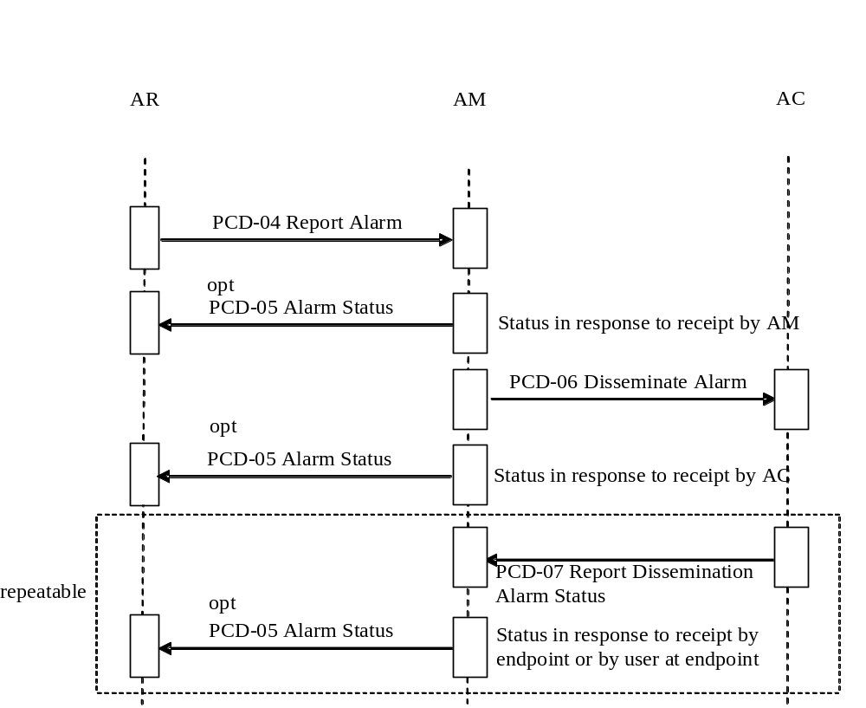
Figure X.2-1: Basic Process Flow in ACM Profile

Each actor is identified below. Actor identity is implicitly identified in the alarm (for example, through MSH-21 Message Profile, identifying the message as PCD-04 by OID, which is sent by an ACM AR actor, which is identified in MSH-3 Sending Application).
The functional units comprising an actor may be provided by one or more vendors in one or more systems. Reducing the total number of systems is preferred, but is not required.
Data flow of individual use model messaging communication indicates the command response sequences and directions.

Alarm Reporter (AR) Actor
This actor originates the alarm.
The semantics and data types used to represent alarm type, alarm priority, alarm inactivation state and escalation and de-escalation of priority in the messages of this actor are based on IEC 60601-1-8 definitions.
A single source can produce multiple, possibly concurrent, alarms.
A single Report Alarm transaction can contain at most a single alarm.
This profile specifies the required data and data types produced by this actor.
This profile specifies communication of the data produced by this actor.
This actor may optionally cancel an outstanding alarm condition.
This may optionally indicate cancellation of any related escalation.
An outstanding alarm condition may be optionally escalated via follow-on alarm.
This actor may aggregate and adapt alarms from multiple sources as needed to make them interoperable with the AM actor. It does not need to be the original source of the alarm data.
In large alarm source populations, an aggregation system may be useful for concentration and possible alarm coordination (smart alarming).
Alarm Manager (AM) Actor
This actor receives alarms from the AR, manages them, and dispatches them to the AC actor.
The semantics and data types used to represent alarm type, alarm priority, alarm inactivation state and escalation and de-escalation of priority in the messages of this actor are based on IEC 60601-1-8 definitions.
This profile specifies the required data and data types produced by this actor in communication with the AC and AR actors.
If the following is performed, it is likely performed within the AM.
Alarm formatting for dissemination
Alarm harmonization across multiple similar and dissimilar AR
Any additional alarm priority actions following any performed by the AR
Alarm mapping to AC actor endpoints,
Additional recipients are optionally indicated in the Report Alarm [PCD-04] transaction
Alarm dissemination escalation
Alarm dissemination sequencing to AC actor endpoints
Alarm dissemination escalation to AC actor endpoints
Location to staff assignments
Patient identification to staff assignments
Equipment to patient to staff assignments
Staff to AC actor endpoint assignments
Alarm reporting
Alarm caching
To accomplish assignments the AM may receive HL7 ADT or SCH message feeds from one or more sourcing systems for the following purposes:
Identify patients
Assign resources to patients (staff, equipment, rooms)
This profile specifies the required data and data types produced by this actor.
The protocol used in the communication of the data to/from the Alarm Manager (AM) actor and the Alarm Communicator (AC) actor is the Wireless Communication Transfer Protocol (WCTP).
Alarm Communicator (AC) Actor
The Alarm Communicator (AC) actor receives alarms from the Alarm Manager (AM) actor. Endpoint devices are connected either directly or indirectly to the Alarm Communicator (AC) actor. The Alarm Communicator (AC) may utilize a locally controlled or public infrastructure.
The protocol for communication between the Alarm Manager (AM) and the Alarm Communicator (AC) is WCTP.
This profile does not specify the protocol used in the communication of the data to the final destination as it is potentially not controllable by the Alarm Communicator (AC).
This profile does not specify the presentation of the data at the endpoint as that is beyond its control.
This profile does not specify the human interface at the endpoint as that is beyond its control.
This profile does make recommendations as to the significant data items to be included in alarm notifications with consideration for ePHI (electronic Patient Healthcare Information). The correlation of what data items are to be sent for specific alarms is defined in IHE PCD Device Profiles in conjunction with alarm inclusion in the IHE PCD Rosetta Terminology Mapping (RTM) activities.
It is recognized that in healthcare communication there are certain data items which should not be transported over unsecured and unencrypted communication connections. A number of controls come into play including HIPAA requirements and ePHI guidelines. It is the responsibility of the deploying parties to insure that capabilities are put into place and monitored to assure that information protection requirements are met.
WCTP was originally defined by the Personal Communications Industry Association (PCIA) consortium. The PCIA is not an SDO and is not at this time actively sustaining or enhancing WCTP. WCTP is in popular and stable use by a number of wide area communication service providers. The protocol provides the capabilities required by AM to AC communication, specifically Internet common practice recognized HTTP or HTTPS securable application to application communication, reliable TCP/IP transport, extensible XML data envelope, transactions for application to individual person communication, and communication status responses for closed loop confirmations for delivery to Alarm Communicator (AC), delivery to endpoint device, read by device operator, and operator responses. With permission from the PCIA, this IHE PCD ACM profile includes and adopts version 1.3 update 1 of the WCTP protocol as defined by PCIA at www.wctp.org for use in Alarm Manager (AC) to Alarm Communicator (AC) communication. Corrections and extensions to this capture of the protocol are the responsibility of the Alarm Communication Management (ACM) Working Group (WG) within the Patient Care Devices (PCD) domain of IHE. As the protocol has been in live operation with major communication carriers for some time the risk of changes required for corrective actions is perceived as low. The protocol includes defined areas for client-server agreed two-party extensions. The ACM profile will make use of that capability as needs arise.
Not all of the WCTP protocol possible request/response transactions are required for Alarm Manager (AM) to Alarm Communicator (AC) communication. Later sections of this document identify the specifics.
<Appendix B> Transaction Summary Definitions
No transactions are defined by this profile

GLOSSARY
ACM – Alarm Communication Management
Physiological alarm – an alarm reflecting the physiological state of the patient (such as a heart rate above or below a caregiver-specified safe range for the patient).
Technical alarm – an alarm reflecting the state of the patient care device itself that may require action from caregivers (such as ECG leads off the patient).

Volume 2 - Transactions
Add sections 3.Y
In anticipation of HL7 2.8 item 625, Add Alert Trigger Event, this profile is making forward looking use of the triggers and events from that item, specifically the use of ORU^R40 for [PCD-04], and ORA^R41 [PCD-05], and the Participation Information (PRT) segment which is in 2.7. The ORA event is Observational Report – Application Acknowledgement.

3.Y PCD-04 Report Alarm
This section corresponds to Transaction PCD-04 of the IHE Technical Framework. Transaction PCD-04 is used by the Alarm Reporter and the Alarm Manager (AM) actor.

3.Y.1 Scope
This transaction is used by the Alarm Reporter to report alarms to the Alarm Manager (AM). The Alarm Reporter (AR) sends alarms to the Alarm Manager (AM) actor in an unsolicited manner.

3.Y.2 Use Case Roles
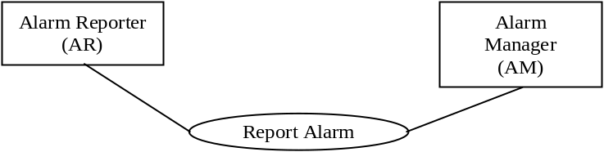

Actor: Alarm Reporter
Role: Sends Report Alarm to the Alarm Manager (AM)
Actor: Alarm Manager (AM)
Role: Receives Report Alarm from Alarm Reporter

3.Y.3 Referenced Standards
HL7 - Health Level 7 Version 2.6 Ch7 Observation Reporting
ISO/IEEE 11073-10201 Domain Information Model
ISO/IEEE 11073-10101 Nomenclature

3.Y.4 Interaction Diagrams

3.Y.4.1 AR reports to AM
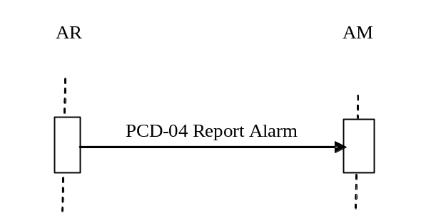
AR sends Report Alarm to AM as an HL7 ORU message.

3.Y.4.1.1 HL7 Conformance Statement
The conformance statement for this interaction described below is adapted from HL7 2.6.

Table 3.Y.4.1.1: PCD-04 Transaction Conformance
Publication ID: | R40
Type: | Unsolicited
Publication Name: | IHEPCD-04ReportAlarm
Trigger: | None
Mode: | Immediate
Response: | ORU^R40^ORU_R40
Characteristics: | Sends defined alarm data
Purpose: | Report Alarm from AR to AM
Based on Segment Pattern: | R40

3.Y.4.1.2 PCD-04 Report Alarm (ORU^R40^ORU_R40) static definition
The PCD-04 Report Alarm message is used to communicate ACM data
From an Alarm Reporter (AR) to Alarm Manager (AM)
Common HL7 segments are defined in Appendix B Common Message Segments.

Table 3.Y.4.1.2-1: ORU^R40^ORU_R40 HL7 Attribute table
ORU^R40^ORU_R40 | ORU Message | Usage | Card. | Section Ref
MSH | Message Header Segment | R | [1..1] | 2.15.9
PID | Patient Identification Segment | CE | [1..1] | 3.4.2
PV1 | Patient Visit Segment | CE | [1..1] | 3.4.3
[ORC] | Common Order Segment | O | [0..1] | 4.5.1
OBR | Observation Request Segment | R | [1..n] | 7.4.1
PRT | Participation Information Segment | O | [0..n] | HL7 2.7 7.4.4
OBX | Observation Result Segment | R | [1..n] | 7.4.2
[NTE] | Notes and Comments Segment | O | [0..1] | 2.5.10
While there can be multiple OBR segments per PCD-04 transaction (in support of inclusion of other material such as Waveform Content Module (WCM)) there is at most one alarm per PCD-04 transaction.

Table 3.Y.4.1.2-2: ORU^R40^ORU_R40 Static Definition
ORU^R40^ORU_R40 | Report Alarm Message
MSH | Message Header
[{SFT}] | Software Segment
{ | --- ALARM_begin
[ | --- PATIENT begin
PID | Patient Identification
[ | --- LOCATION begin
PV1 | Alarm Location
] | --- LOCATION end
] | --- PATIENT end
{ | --- ALARM_IDENTIFICATION begin
[ORC] | Alarm Common
{OBR} | Alarm Identification
[{PRT}] | Participation (for observation and direct specification of additional recipients)
[ { | --- ALARM_OBSERVATION begin
{OBX} | Alarm observation relative to OBR
{ [NTE] } | Notes and Comments
}] | --- ALARM OBSERVATION end
} | --- ALARM_IDENTIFICATION end
} | --- ALARM end

A single Report Alarm [PCD-04] transaction contains at most one alarm for a given patient and there must be an OBR preceding each group of OBX segments.
If waveform snippets are to be included in the Report Alarm [PCD-04] transaction, they must be encoded in the HL7 message in accordance with the Waveform Content Module (WCM).

3.Y.4.1.3 Trigger Events
The AR has arrived at the onset, continuation of, or conclusion an event which may be an alarm and sends it to the AM.

3.Y.4.1.4 Message Semantics
This message is meant to convey from the AR actor to the AM actor the fact that an alarm is occurring, is still occurring, or has ended along with the data related to the alarm to identify the patient and/or location, the alarming condition, and any observations associated with the alarm.

3.Y.4.1.5 Expected Actions
Whether or not the Alarm Manager sends a Report Alarm Status [PCD-05] to the Alarm Reporter is a configuration agreement between the Alarm Reporter and Alarm Manager implementations.
HL7 ACK from the Alarm Manager (AM) actor back to the Alarm Reporter (AR) actor is used to communicate that the Alarm Manager (AM) actor has received the Report Alarm [PCD-04] transaction from the Alarm Reporter (AR) actor. The Report Alarm [PCD-04] is asynchronous to Report Dissemination Alarm Status [PCD-07] transactions by an indeterminate amount of time. HL7 ACK is therefore not used to report dissemination status of the alarm as it would leave the Alarm Reporter (AR) actor awaiting HL7 ACK receipt for an indeterminate amount of time. Status updates as to the dissemination of the alarm are optional and are communicated using the Report Alarm Status [PCD-05] transaction from the Alarm Manager (AM) to the Alarm Reporter (AR).
While the AR to AM message [PCD-04] is one message it is likely to result in the potential for many messages from AM to AC and many messages from AC back to AM and from AM back to AR. Communication device operator response delays may result in delays of AC to AM and AM back to AR message delays.

3.Y.4.1.6 Security Considerations
This profile does not impose specific requirements for authentication, encryption, or auditing, leaving these matters to site-specific policy or agreement. The IHE PCD Technical Framework identifies security requirements across all PCD profiles.

3.Y+1 PCD-05 Report Alarm Status
This section corresponds to Transaction PCD-05 of the IHE Technical Framework. Transaction PCD-05 is used by the Alarm Manager (AM) actor to report alarm status updates to the Alarm Reporter (AR) actor.

3.Y+1.1 Scope
This transaction is used by the Alarm Manager (AM) to report dissemination status updates to the Alarm Reporter. The AM will send only one PCD-05 to the AR, which indicates the success or failure of the AM’s communication of the alarm to the AC and the AC’s communication of the alarm to the endpoint device.

3.Y+1.2 Use Case Roles
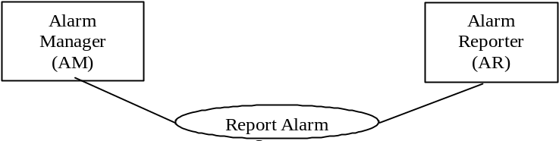

Actor: Alarm Manager (AM)
Role: Sends Report Alarm Status to Alarm Reporter (AR)
Actor: Alarm Reporter (AR)
Role: Receives Report Alarm Status from the Alarm Manager (AM)

3.Y+1.3 Referenced Standard
HL7 - Health Level 7 Version 2.6 Ch. 7 Observation Reporting
ISO/IEEE 11073-10201 Domain Information Model
ISO/IEEE 11073-10101 Nomenclature

3.Y+1.4 Interaction Diagrams

3.Y+1.4.1 AM status updates to AR
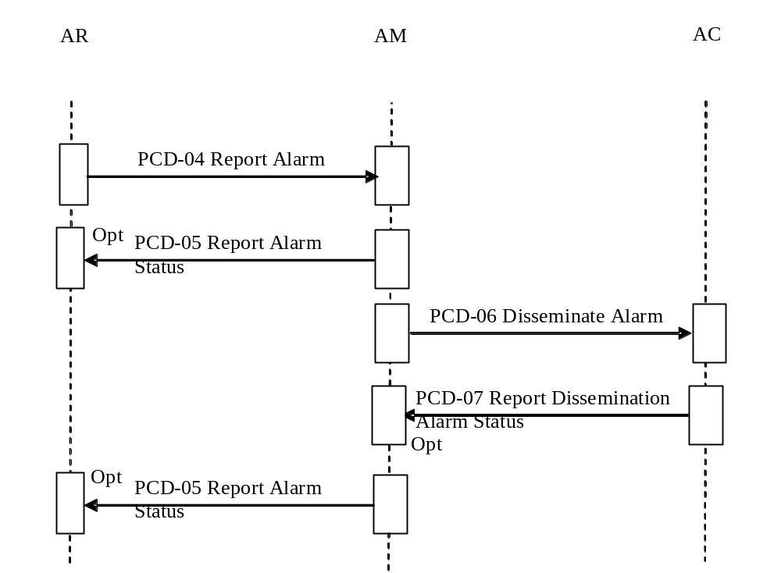
The AM sends Report Alarm Status to the AR actor as an HL7 ORA message.

3.Y+1.4.1.1 Trigger Events
The AM has determined either through configuration and contextual data driven decision rules or through receipt of Dissemination Status from the Alarm Communicator that an alarm status update needs to be sent to the AR.
AM internal trigger events include the following:
- Accept (not specified, correct)
- Reject (not specified, nuisance but correct, false positive)
- Deliverable, had a mapped destination
- Queued to communications
- Undeliverable (AC down or message not deliverable to AC endpoint device)

3.Y+1.4.1.2 Message Semantics
This message is meant to convey from the AM actor to the AR actor the success or failure of the AM and AC to communicate the alarm to the endpoint device.

3.Y+1.4.1.3 HL7 Conformance Statement
The conformance statement for the interaction described below is adapted from HL7 2.6.
While HL7 2.8 item 625 provides for the Alarm Manager (AM) to send either ORA^R41 or ORA^R42 as Report Alarm Status [PCD-05] to the Alarm Reporter (AR), ORA^R41 as defined in HL7 is not expected to be utilized by vendors as it presumes a guarantee of delivery that the Alarm Manager (AM) and the Alarm Communicator (AC) cannot assure. However, since the IPEC profile uses the R42 event which was originally intended for use by ACM, the ACM profile will use R41 to mean what R42 was originally meant to convey, that being the alarm communication status from the AM back to the AR
The AM and AC cannot provide any level of assurance of delivery of the alarm to the endpoint device. This lack of assurance of delivery is based upon the predominant use by healthcare of cost conscious one-way fire-and-forget pagers.
The PCD-04 message will presume a default filter for PCD-05 notifications so that only “delivered to one or more recipients” or “not successfully delivered to any recipients” will be the only notifications that the AR actor has to handle. This avoids the AM back to AR fire hose for all device specific notification activity details for all devices to which a notification is delivered. This also avoids the requirement for a filter segment in the PCD-04 message. In an R41 the Participation Information (PRT) segment PRT-4 field AAP (Alert Acknowledging Provider) is used to indicate the identity of the user to which the alert has been delivered and acknowledged.

Table 3.Y+1.4.1.3-1: Transaction Conformance
Publication ID: | R41
Type: | Unsolicited
Publication Name: | IHEPCD-05ReportAlarmStatus
Trigger: | None
Mode: | Immediate
Response: | ORA^R41^ORA_R41
Characteristics: | Sends alarm status data
Purpose: | Provide alarm status from AM to AR
Based on Segment Pattern: | R41

3.Y+1.4.1.4 PCD-05 Report Alarm Status (ORA^R41^ORA_R41) static definition
The PCD-05 Report Alarm Status message is used to communicate ACM messaging status from an Alarm Manager (AM) to Alarm Reporter (AR)
Common HL7 segments are defined in Appendix B Common Message Segments.
Device Technical Framework and Appendix C Common Data Types.

Table 3.Y+1.4.1.4.-1: ORA^R42^ORA_R42 static definition
ORA^R42^ORA_R42 | ORU Message | Usage | Card. | Section Ref
MSH | Message Header Segment | R | [1..1] | 2.15.9
PID | Patient Identification Segment | CE | [1..1] | 3.4.2
PV1 | Patient Visit Segment | CD | [1..1] | 3.4.3
[ORC] | Common Order Segment | O | [0..1] | 4.5.1
OBR | Observation Request Segment | R | [1..n] | 7.4.1
[PRT] | Participation Information Segment | O | [0..n] | HL7 2.7 7.4.4
OBX | Observation Result Segment | R | [1..n] | 7.4.1
[NTE] | Notes and Comments Segment | O | [0..1] | 2.5.10
While there can be multiple OBR segments per transaction there is at most one alarm on which status is reported per transaction.

3.Y+1.4.1.5 Expected Actions
AR takes appropriate action based upon alarm status update.

3.Y+1.4.1.6 Security Considerations
This profile does not impose specific requirements for authentication, encryption, or auditing, leaving these matters to site-specific policy or agreement. The IHE PCD Technical Framework identifies security requirements across all PCD profiles.

3.Y+2 PCD-06 Disseminate Alarm
This section corresponds to Transaction PCD-06 of the IHE Technical Framework. Transaction PCD-06 is used by the Alarm Manager (AM) actor to disseminate alarms to the Alarm Communicator (AC) actor.

3.Y+2.1 Scope
This transaction is used by Alarm Manager (AM) to disseminate the alarm to the Alarm Communicator (AC).

3.Y+2.2 Use Case Roles
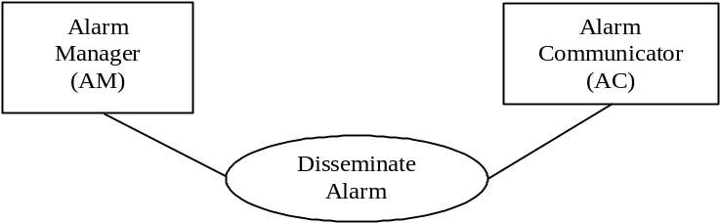

Actor: Alarm Manager (AM)
Role: Sends Disseminate Alarm to Alarm Communicator (AC)
Actor: Alarm Communicator (AC)
Role: Receives Disseminate Alarm from the Alarm Manager (AM)

3.Y+2.3 Referenced Standard
The communication protocol between the AM and AC actors is WCTP. The communicated data items are in scope for this profile. The correlation of what data items are to be sent for specific alarms is defined in IHE PCD Device Profiles in conjunction with alarm inclusion in the IHE PCD Rosetta Terminology Mapping (RTM) activities.
While alarm related data items available to the AM is specified in this profile the ability of individual communication devices to communicate, display, or respond to those data items are dependent upon the product capabilities and site specific configuration of the AC actor, the communication device, and the available communication infrastructure.
WCTP version 1.3 update 1 is as captured by this profile.
ISO/IEEE 11073-10201 Domain Information Model
ISO/IEEE 11073-10101 Nomenclature

3.Y+2.4 Interaction Diagrams

3.Y+2.4.1 AM disseminate alarm to AC
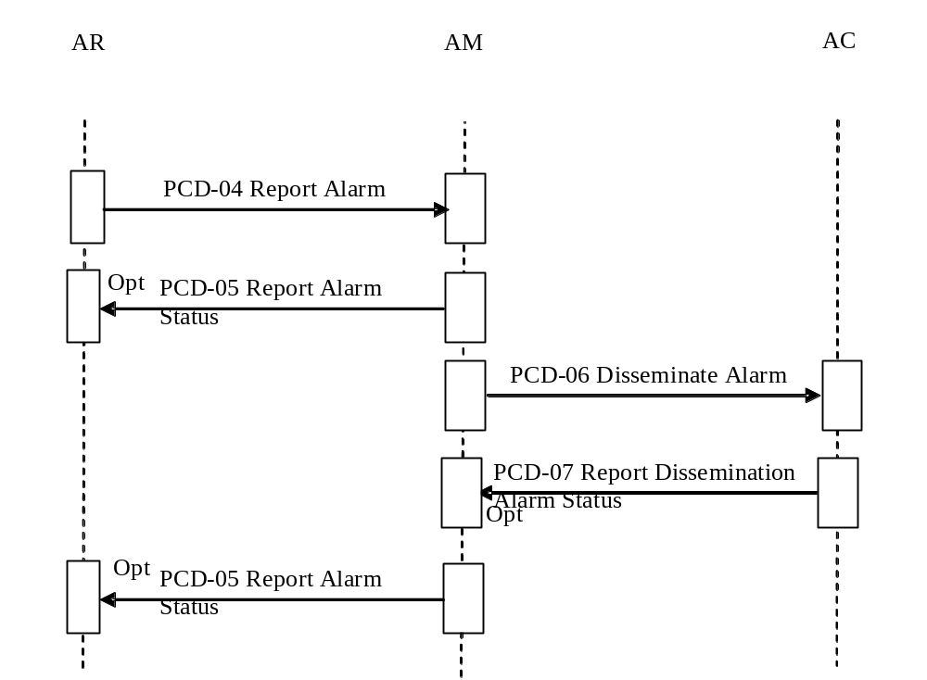
AM sends Disseminate Alarm to AC. The protocol between the AM and AC actors is WCTP.

3.Y+2.4.1.1 HL7 Conformance Statement
The communication protocol is WCTP. There is no specified HL7 conformance.

3.Y+2.4.1.2 PCD-06 Disseminate Alarm static definition
The PCD-06 Disseminate Alarm message is used to communicate ACM data from an Alarm Manager (AM) to the Alarm Communicator (AC).
The text message within the PCD-06 transaction is meant to be readily recognized and acted upon by people. Cryptic encodings are to be avoided. Lengthy messages containing excessive amounts of unnecessarily detailed information are also to be avoided. Most communication device displays are limited in size. Long messages requires scrolling to review the entire message before acting upon it to make sure that no pertinent information is missed.
Additionally the information, if sent to an endpoint communication device which lacks authentication and encryption should be examined to avoid sending electronic patient healthcare information over such a connection and thereby exposing patient information.
If the PCD-06 includes a human readable text description of the alarm indication that is the preferred description to be presented on the wireless endpoint communication device. In the absence of such information the Alarm Manager should produce the human readable text description from other information present in the transaction.
If waveform snippets in Waveform Content Module (WCM) format are included in the Report Alarm [PCD-04] transaction and the AM to AC protocol is WCTP then then the entire Report Alarm [PCD-04] message shall be included in a single extension XML element within the WCTP message body. This approach provides the maximum relevant data for the AC to process and display the evidentiary data.
If during communication negotiations between the AM and AC actors the AC actor indicates no readiness to produce graphics from the evidentiary data then that information is not to be sent to the AC and instead the AM, if a regulated medical device and if capable, should send a graphical snippet prepared from the evidentiary data received in the Report Alarm [PCD-04] transaction.

3.Y+2.4.1.3 Trigger Events
The AM has determined that an alarm needs to be disseminated and so sends it to the AC.

3.Y+2.4.1.4 Message Semantics
This message communicates alarms to communication endpoint devices.
The table below lists the data items and their optionality. All of these data items are within the WCTP message text.
Table 3.Y+2.4.1.4-1: PCD-06 static definition
PCD-06 | Fields | Usage | Card.
Alarm_Location | Alarm associated location based upon information from PV1-3 | CE | [1..1]
Alarm_Patient | Patient Identification | CE | [1..1]
Alarm_Text | Textual alarm identification | R | [1..1]
Alarm_Identifier | Alarm unique identifier | O | [0..1]
Alarm_Callback | Call back connection information | O | [0..1]
Alarm_Reference | URL or application link potentially containing alarm or patient contextual information | O | [0..1]
Alarm_Comment | Notes and Comments associated with alarm | O | [0..1]
Alarm_Evidentiary_Data | Evidentiary data associated with alarm, e.g., waveform data  See appendix for WCTP messaging information | O | [0..1]
Alarm_Evidentiary_Graphic | Evidentiary data transformed into a graphical image (SVG and/or PNG)  See appendix for WCTP messaging information. | O | [0..1]

3.Y+2.4.1.5 Expected Actions
AC sends alarm to endpoint. If the endpoint is a group then the AC is expected to send the alarm notification to all members of the group.

3.Y+2.4.1.6 Security Considerations
This profile while utilizing communication capabilities supportive of authentication, encryption, or auditing, does not impose specific requirements leaving these matters to site-specific policy or agreement. The IHE PCD Technical Framework identifies security requirements across all PCD profiles.

3.Y+3 PCD-07 Report Dissemination Alarm Status
This section corresponds to Transaction PCD-07 of the IHE Technical Framework. Transaction PCD-07 is used by the Alarm Communicator actor to signal dissemination status updates and replies to the Alarm Manager (AM).

3.Y+3.1 Scope
This transaction is used by Alarm Communicator to report one or more dissemination status updates and/or replies to the Alarm Manager (AM). A single PCD-06 transaction from the AM to the AC can result in numerous PCD-07 transactions from the AC back to the AM.

3.Y+3.2 Use Case Roles
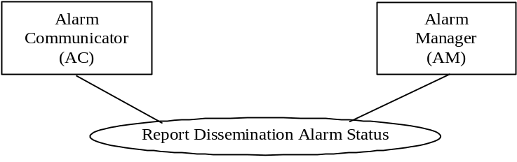

Actor: Alarm Communicator (AC)
Role: Sends Dissemination Status to the Alarm Manager (AM)
Actor: Alarm Manager (AM)
Role: Receives Dissemination Status from the Alarm Communicator (AC)

3.Y+3.3 Referenced Standard
The communication protocol is WCTP, the same as for the Disseminate Alarm [PCD-06] transaction. The communicated data items are in scope for this profile.
WCTP version 1.3 update 1 is as captured by this profile.
ISO/IEEE 11073-10201 Domain Information Model
ISO/IEEE 11073-10101 Nomenclature

3.Y+3.4 Interaction Diagrams

3.Y+3.4.1 AC status updates to AM
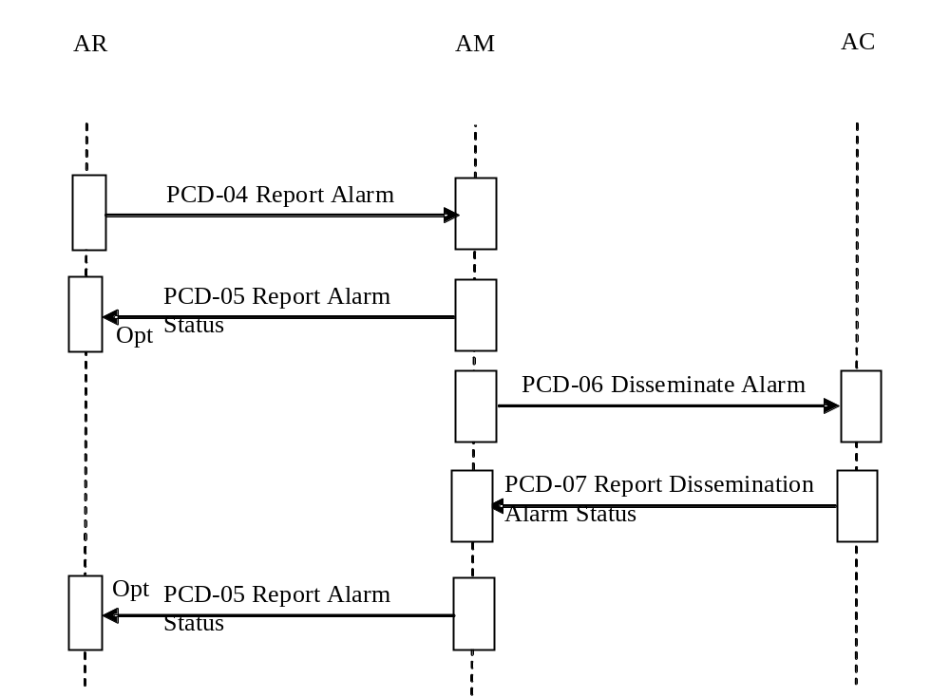
The AC sends Dissemination Status to the AM actor. The protocol utilized is WCTP.

3.Y+3.4.1.1 Trigger Events
The AC has determined a dissemination status update needs to be sent to the AM.
The following table lists the results of the dissemination from the AC back to the AM for optional relay back to the AR using the PCD-05 transaction. The required Communication Status Enumerations are indicated.
Table 3.Y+3.4.1.1-1: Status Enumerations
Usage | Communication Status Enumeration
R | Received by communications (accepted by WCTP gateway)
O | Undeliverable to endpoint  Optional in support of one-way devices, such as pagers.
O | Delivered to endpoint  Optional in support of one-way devices, such as pagers.
O | Read at endpoint  Optional in support of one-way devices, such as pagers.
O | Accepted by endpoint  Optional in support of one-way devices, such as pagers.
O | Accepted by endpoint as true positive
O | Accepted by endpoint as true positive however not clinically relevant
O | Accepted by endpoint as false positive
O | Rejected by endpoint  Optional in support of one-way devices, such as pagers.
O | Cancelled by endpoint
O | Cancelled by other than endpoint
O | Callback start at endpoint  See appendix for WCTP messaging details.  Optional as not supported by all notification devices.
O | Callback end at endpoint  See appendix for WCTP messaging details.  Optional as not supported by all notification devices.
O | Completed by endpoint operator  Optional in support of one-way devices, such as pagers.

A single PCD-04 to PCD-06 transaction may go through multiple communications status updates as the alarm is communicated to the endpoint user or application. Which of the status updates are possible is AC actor and endpoint implementation dependent. Some endpoint devices are output only and do not support two-way capabilities. Some devices and services offer transmission confirmation. More advanced communications endpoints offer two-way capabilities allowing the operator of the endpoint to accept or cancel the alarm.
Detailed reason for status can optionally be included to encompass the concept of presence (see WCTP interface specification) to allow for messages not making it to the endpoint or being rejected by the endpoint due to a presence state such as offline, busy, or do not disturb.

3.Y+3.4.1.2 Message Semantics
This message is used to communicate status updates on the communication of an alarm to endpoints. See appendix for WCTP messaging specifics.

3.Y+3.4.1.3 HL7 Conformance Statement
The communication protocol is WCTP. There is no specified HL7 conformance.

3.Y+3.4.1.4 PCD-07 Report Dissemination Alarm Status static definition
The PCD-07 Dissemination Status message is used to communicate ACM messaging status and replies from an Alarm Communicator (AC) to Alarm Manager (AM)
The Alarm Communicator (AC) actor is not responsible for indicating that the endpoint operator has received but not responded to the notification – as in received sending delivered to device status, automatically displayed which may or may not send back read indication, but no operator interaction. Actions for non-response by the Alarm Communicator (AC) endpoint operator (clinical user) (escalation or sending to alternate devices) is within the scope of the Alarm Manager (AM) actor. Such actions have been identified within the ACM Trial Implementation as out of scope for the ACM profile.

The endpoint device message communication protocol between the Alarm Communicator and the endpoint device is outside the scope of the profile. The data presentation by the endpoint device is outside the scope of the profile.
The table below lists the data items and their optionality.

Table 3.Y+3.4.1.4-1: PCD-07 static definition
PCD-07 | ORU Message | Usage | Card.
Alarm_Identifier | Alarm unique identifier  (see PCD-06) | R | [1..1]
Alarm_Status | Communication Status Enumeration item | R | [1..1]

3.Y+3.4.1.5 Expected Actions
The AM may send the Report Alarm Status [PCD-05] to the Alarm Reporter (AR) as a result of Alarm Manager (AM) receipt of this message.

3.Y+3.4.1.6 Security Considerations
This profile while utilizing communication capabilities supportive of authentication, encryption, or auditing, does not impose specific requirements leaving these matters to site-specific policy or agreement. The IHE PCD Technical Framework identifies security requirements across all PCD profiles.

3.Z Common Message Segments
The following descriptions rely on IHE PCD Technical Framework Appendix B Common Message Segments and A.1 Mapping ISO/IEEE 11073 Domain Information Model to HL7. All provisions of those referenced sections should be assumed to apply also to Alarm Communications Management. The additional information in this document supplements and comments on those referenced sections with specific reference to the communication of alarms.
These message segments are not appropriate to PCD-06 and PCD-07 communication between the ACM AM and ACM AC as that uses the WCTP protocol. It could be pertinent if the PCD-06 message includes support for WCM which would include the evidentiary data which is based upon HL7.

3.Z.1 MSH Message Header Segment

3.Z.1.1 MSH-21 Message Profile Identifier (EI) 01598
This field contains a message profile identification consistent with IHE PCD TF direction so as to uniquely identify IHE PCD ACM PCD-xx messages from IHE PCD DEC PCD-xx messages, and from messages associated with other IHE PCD profiles.

Table 3.Z.1-1: Message Profile Identifiers
Transactions | MSH-21.1  Entity  Identifier | MSH-21.2  Namespace  ID | MSH-21.3  Universal  ID (the OID) | MSH-21.4  Universal  ID Type
Report Alarm [PCD-04] | IHE_PCD_ACM_001 | IHE PCD | 1.3.6.1.4.1.19376.1.6.4.4 | ISO
Report Alarm Status [PCD-05] | IHE_PCD_ACM_002 | IHE PCD | 1.3.6.1.4.1.19376.1.6.4.5 | ISO
Disseminate Alarm [PCD-06] | IHE_PCD_ACM_003 | IHE PCD | 1.3.6.1.4.1.19376.1.6.4.6 | ISO
Report Alarm Dissemination Status [PCD-07] | IHE_PCD_ACM_004 | IHE PCD | 1.3.6.1.4.1.19376.1.6.4.7 | ISO
The sections below identify the data items used to identify the patient and/or the patient’s location to the AM actor and which may be included in displays on the endpoint device to allow the notification recipient to determine the patient to which the alarm applies.

3.Z.2 PID Patient Identification Segment
This segment is required to be present and is populated with data used to identify the patient associated with the alarm in the case where the identity is available from the Alarm Source system. If the patient identification is not available from the Alarm Source system, the alarm may be location source based per ACM use case A1 in which case the PV1 segment identifies the location associated with the alarm. Additional information may be present to more unambiguously identify the patient.

Table 3.Z.2-1: HL7 Attribute Table – PID – Patient Identification
SEQ | LEN | DT | OPT | RP/# | TBL# | ITEM# | ELEMENT NAME
3 | 250 | CX | O | Y |  | 00106 | Patient Identifier List
5 | 250 | XPN | O | Y |  | 00108 | Patient name
7 | 26 | TSO | O |  |  | 00110 | Date/Time of Birth
8 | 1 | IS | O |  |  | 00111 | Administrative Sex

3.Z.2.1 PID-3 Patient Identifier List (CX) 00106
This information may be used by the AM actor in the message sent to the AC actor to identify the patient associated with the alarm within site specific HIPAA and electronic patient healthcare information policies.

3.Z.2.2 PID-5 Patient Name (XPN) 00108
This information may be used by the AM actor in the message sent to the AC actor to identify the patient associated with the alarm within site specific HIPAA and electronic patient healthcare information policies. Refer to PID-31 Identity Unknown Indicator for the means to identify that while a PID segment is provided the identity of the patient is unknown.

3.Z.2.3 PID-7 Date/Time of Birth (TSO) 00110
This information may be used by the AM actor in the message sent to the AC actor to identify the patient associated with the alarm within site specific HIPAA and electronic patient healthcare information policies.

3.Z.2.4 PID-8 Administrative Sex (IS) 00111
This information may be used by the AM actor in the message sent to the AC actor to identify the patient associated with the alarm within site specific HIPAA and electronic patient healthcare information policies.

3.Z.2.5 PID-31 Identity Unknown Indicator (ID) 01535
Definition: This field indicates whether or not the patient's/person's identity is known. Refer to HL7 Table 0136 - Yes/No Indicator for valid values.
Y the patient's/person's identity is unknown
N the patient's/person's identity is known

3.Z.3 PV1 Patient Visit Segment
This segment is used to identify a patient location associated with the alarm. Real Time Location Services (RTLS) or GPS equipment or personnel location information is not passed in this segment. It is passed from the AR to the AM via an OBX segment.
If the Patient Identification (PID) segment is present in the alarm data and it contains an identified patient as in ACM use case A2 resolve patient location from a more contemporary information source than this segment.

Table 3.Z.3-1: HL7 Attribute Table – PV1 – Patient Visit
SEQ | LEN | DT | OPT | RP/# | TBL# | ITEM# | ELEMENT NAME
3 | 80 | PL | O |  |  | 00133 | Assigned Patient Location

3.Z.3.1 PV1-3 Assigned Patient Location (PL) 00133
This field contains the location associated with the alarm. This may not be the current location of the alarm related patient. It is typically a location established by an external system such as ADT, as in the patient assigned bed location as used in association with a patient station of a nurse call system.

3.Z.4 ORC Observation Control Segment
This segment is optionally used to convey order request information for alarms involving notification of order request or order result. In addition, this segment may allow the association of the completed observation results reported in OBX segments with a particular previous order request.
Table 3.Z.4-1: HL7 Attribute Table – ORC – Observation Control
SEQ | LEN | DT | OPT | RP/# | TBL# | ITEM# | ELEMENT NAME
2 | 22 | EI | O |  |  | 00216 | Placer Order Number
12 | 250 | XCN | O | Y |  | 00226 | Ordering Provider
14 | 250 | XTN | O | Y/2 |  | 00228 | Call Back Phone Number

ORC-2 Placer Order Number (EI) 00216
This field is the placer application's order number.
ORC-12 Ordering Provider (XCN) 00226
This field contains the identity of the person who is responsible for creating the request (i.e., ordering physician). ORC-12-ordering provider is the same as OBR-16-ordering provider. If the ordering provider is not present in the ORC, it may be present in the associated OBR. This is particularly important when results are transmitted in an ORU message. In this case, the ORC is not required and the identifying filler order number may be present in the OBR segment.
ORC-14 Call Back Phone Number (XTN) 00228
This field contains the telephone number to call for clarification of a request or other information regarding the order. ORC-14-call back phone number is the same as OBR-17-order callback phone number. If the structure of the telephony dial string is not known then the call back number should be in the Unformatted Telephone number (ST) component of the field.

3.Z.5 OBR Observation Request Segment
A Report Alarm [PCD-04] transaction contains at most one alarm indication.
The OBR segment is used to uniquely identify the alarm indication and the descendent alarm status update indications.

Table 3.Z.5-1: HL7 Attribute Table – OBR – Observation Result
SEQ | LEN | DT | OPT | RP/# | TBL# | ITEM# | ELEMENT NAME
2 | 22 | EI | O |  |  | 00216 | Placer Order Number
3 | 22 | EI | R |  |  | 00217 | Filler Order Number
4 | 250 | CE | R |  |  | 00238 | Universal Service Identifier
16 | 3220 | XCN | O | Y |  | 00226 | Ordering Provider
17 | 250 | XTN | O | Y/2 |  | 00250 | Order Callback Phone Number
28 | 3220 | XCN | O | Y |  | 00260 | Result Copies To

OBR-2 Placer Order Number (EI) 00216
This field identifies an individual order (e.g., OBR) and is the same as ORC-2.
OBR-3 Filler Order Number (EI) 00217
This field serves as the unique identifier for status updates to an alarm indication identified in OBR-29 Parent. This value is assigned by the Alarm Source and is used by system actors to associate updates to a particular alarm identified in OBR-29 Parent.

OBR-4 Universal Service Identifier (CE) 00238
This field contains the identifier code for the packaged message content type, such as ALARM, WAVEFORM, EVENT, PROCEDURE, TREND, etc.
OBR-17 Order Callback Phone Number (XTN) 00250
This field is the telephone number for reporting a status or a result using the standard format with extension and/or beeper number when applicable. This can be used to pass the nurse call system patient station telephony call back information to the caregiver. If the structure of the telephony dial string is not known then the call back number should be in the Unformatted Telephone number (ST) component of the field.
OBR-28 Result Copies To (XCN) 00260
This field should not be used in Report Alarm [PCD-04] transactions to indicate PIN/Carrier or other recipients for alarm dissemination. Instead use the Participant Information (PRT) segment.
OBR-29 Parent (EIP) 00261
This field serves as the unique identifier for the alarm indication. It is assigned by the Alarm Source and is used by system actors to associate all messages from all actors that pertain to a particular alarm throughout the history of the alarm. So the same value of OBR-29 will be sent by the Alarm Source in the messages concerning the start, end, continuation of the alarm, and will also be used in status messages from other actors concerning that alarm. It may consist of a unique identifier of the device such as an EUI-64 and a serial number or time stamp for the alarm, but other forms that are unique among alarms sourced by a particular Alarm Reporter are acceptable. An order number sourced by the filling application may be used in the case of an order (Pharmacy or Laboratory) and in this case must also serve to uniquely identify the related alarm events. For identification of status updates to an alarm indication see OBR-3 Filler order Number.

3.Z.6 PRT Participation Information Segment
The optional HL7 2.7 Participation Information Segment (PRT) is used to identify requested additional or the actual recipients of alarm disseminations and the status of those disseminations for the Report Alarm [PCD-04] and Report Alarm Status [PCD-05] transactions.
One instance of the PRT segment occurs for each specified dissemination destination or dissemination status update.
The Participation Information segment contains the data necessary to add, update, correct, and delete from the record persons, organizations, or locations (participants) participating in the activity being transmitted.
In general, the PRT segment is used to describe a participant playing a particular role within the context of the message. In this profile the role being played is that of an alarm dissemination requested or actual recipient.
The hierarchical positional location of the PRT segment within the HL7 message indicates the relationship. When the segment is used following the OBR segment, then the participations relate to the relevant participations in the observation.

Table 3.Z.6-1: HL7 Attribute Table - PRT – Participation Information
SEQ | LEN | DT | OPT | RP/# | TBL# | ITEM # | ELEMENT NAME
1 | 1..4 | EI | C | N |  | 02379 | Participation Instance ID
2 | 2..2 | ID | R |  | 0287 | 00816 | Action Code
3 |  | CWE | O |  |  | 02380 | Action Reason
4 |  | CWE | R |  | 0912 | 02381 | Participation
5 |  | XCN | C | Y |  | 02382 | Participation Person
6 |  | CWE | C |  |  | 02383 | Participation Person Provider Type
7 |  | CWE | C |  | 0406 | 02384 | Participant Organization Unit Type
8 |  | XON | C | Y |  | 02385 | Participation Organization
9 |  | PL | C | Y |  | 02386 | Participant Location
10 |  | EI | C | Y |  | 02348 | Participation Device
11 |  | DTM | O |  |  | 02387 | Participation Begin Date/Time (arrival time)
12 |  | DTM | O |  |  | 02388 | Participation End Date/Time (departure time)
13 |  | CWE | O |  |  | 02389 | Participation Qualitative Duration
14 |  | XAD | C | Y |  | 02390 | Participation Address
15 |  | XTN | O | Y |  | 02391 | Participant Telecommunication Address

3.Z.6.1 PRT-1 Participation Instance ID (EI) 02379
Components:<Entity Identifier (ST)> ^ <Namespace ID (IS)> ^ <Universal ID (ST)> ^ <Universal ID Type (ID)>
Definition: This field contains a unique identifier of the specific participation record.
In the case of waypoints tracked for a shipment, it identifies the waypoint.
Condition: The identifier is required for traceability
For the Report Alarm Status [PCD-05] transaction this is the unique ID of the disseminated message and all status updates on the dissemination should use the same ID value.

3.Z.6.2 PRT-2 Action code (ID) 00816
Definition: This field reveals the intent of the message. Refer to HL7 Table 0287 – Problem/goal action code for valid values.
For the Report Alarm [PCD-04] transaction the PRT-2 Action code is always AD indicating Add.
For the Report Alarm Status [PCD-05] transaction the PRT-2 Action Code is AD indicating Add for the first status update and UP indicating Update for all others.

3.Z.6.3 PRT-3 Action Reason (CWE) 02380
Components:<Identifier (ST)> ^ <Text (ST)> ^ <Name of Coding System (ID)> ^ <Alternate Identifier (ST)> ^ <Alternate Text (ST)> ^ <Name of Alternate Coding System (ID)> ^ <Coding System Version ID (ST)> ^ <Alternate Coding System Version ID (ST)> ^ <Original Text (ST)> ^ <Second Alternate Identifier (ST)> ^ <Second Alternate Text (ST)> ^ <Name of Second Alternate Coding System (ID)> ^ <Second Alternate Coding System Version ID (ST)> ^ <Coding System OID (ST)> ^ <Value Set OID (ST)> ^ <Value Set Version ID (DTM)> ^ <Alternate Coding System OID (ST)> ^ <Alternate Value Set OID (ST)> ^ <Alternate Value Set Version ID (DTM)> ^ <Second Alternate Coding System OID (ST)> ^ <Second Alternate Value Set OID (ST)> ^ <Second Alternate Value Set Version ID (DTM)>
Definition: This field indicates the reason why the person, organization, location, or device is assuming (or changing) the role (e.g., shift change, new primary nurse, etc.).
For the Report Alarm [PCD-04] transaction the PRT-3 Action Reason, Text, is not populated.
For the Report Alarm Status [PCD-05] transaction the PRT-3 Action Reason, Text, is the Report Dissemination Alarm Status [PCD-07] status text value, and the Coding System is IHE_PCD_ACM.
Alarm Communicator (AC) status values correlated from the Report Dissemination Alarm Status [PCD-07] status values to be returned to the Alarm Manager (AM) resulting from Disseminate Alarm [PCD-06] from Alarm Manager (AM) to Alarm Communicator (AC) and transcribed into PRT-3-2 Text.

Table 3.Z.6.3-1: Communication Status Enumeration from Report Dissemination Alarm Status [PCD-07]
Req. | Value for PRT-3-2 | Description
R | Received | Received by Alarm Communicator (AC)
R | Undeliverable | Undeliverable to endpoint
R | Delivered | Delivered to endpoint
R | Read | Read at endpoint
R | Accepted | Accepted by endpoint
O | AcceptedPositive | Accepted by endpoint as true positive
O | AcceptedNotRelevant | Accepted by endpoint as true positive however not clinically relevant
O | AcceptedFalse | Accepted by endpoint as false positive
R | Rejected | Rejected by endpoint
O | Cancelled | Cancelled by endpoint (does not cancel at alarm source)
O | CancelledOther | Cancelled by other than endpoint (does not cancel alarm at source)
O | CallbackStart | Callback start at endpoint (start of telephony call to alarm indicated destination)
O | CallbackEnd | Callback end at endpoint (end of telephony call to alarm indicated destination)

3.Z.6.4 PRT-4 Participation (CWE) 02381
Components:<Identifier (ST)> ^ <Text (ST)> ^ <Name of Coding System (ID)> ^ <Alternate Identifier (ST)> ^ <Alternate Text (ST)> ^ <Name of Alternate Coding System (ID)> ^ <Coding System Version ID (ST)> ^ <Alternate Coding System Version ID (ST)> ^ <Original Text (ST)> ^ <Second Alternate Identifier (ST)> ^ <Second Alternate Text (ST)> ^ <Name of Second Alternate Coding System (ID)> ^ <Second Alternate Coding System Version ID (ST)> ^ <Coding System OID (ST)> ^ <Value Set OID (ST)> ^ <Value Set Version ID (DTM)> ^ <Alternate Coding System OID (ST)> ^ <Alternate Value Set OID (ST)> ^ <Alternate Value Set Version ID (DTM)> ^ <Second Alternate Coding System OID (ST)> ^ <Second Alternate Value Set OID (ST)> ^ <Second Alternate Value Set Version ID (DTM)>
Definition: This field indicates the functional involvement with the activity being transmitted (e.g., Case Manager, Evaluator, Transcriber, Nurse Care Practitioner, Midwife, Physician Assistant, etc.). Refer to HL7 Table 0912 – Participation for valid values.
For the Report Alarm [PCD-04] transaction the presence of one or more PRT segments containing PRT-4 Participation Identifier, Text is RCT (indicating Result Copies To) indicates AR direct indication of additional recipients.
For the Report Alarm [PCD-04] transaction the PRT-4 Participation Identifier, Text is RO (indicating Responsible Observer).
For the Report Alarm Status [PCD-05] transaction the PRT-4 Participation Identifier, Text is RO (indicating Responsible Observer), and Alternative Identifier is AAP for Alert Acknowledging Provider.
Table 3.Z.6.4-1: HL7 Table 0912 - Participation
Value | Description | Used with
AD | Admitting Provider | PV1-17 Admitting doctor
AI | Assistant/Alternate Interpreter
AAP | Alert Acknowledging Provider | PCD ACM Report Alarm Status [PCD-05]
AP | Administering Provider | RXA-10 Administering Provider
ARI | Assistant Result Interpreter
AT | Attending Provider | PV1-7 Attending doctor
AUT | AUT Author/Event Initiator | ORC-19 Action By
CP | Consulting Provider
DP | Dispensing Provider | RXD-10 Dispensing Provider
EP | Entering Provider (probably not the same as transcriptionist?) | ORC-10 Entered By
EQUIP | Equipment
FHCP | Family Health Care Professional
MDIR | Medical Director | OBX-25 Performing Organization Medical Director
OP | Ordering Provider | ORC-12 Ordering Provider, OBR-16 Ordering Provider, RXO-14 Ordering Provider's DEA Number, RXE-13 Ordering Provider's DEA Number, ORC-24 Ordering Provider Address
PB | Packed by
PH | Pharmacist (not sure how to dissect Pharmacist/Treatment Supplier's Verifier ID) | RXE-14 Pharmacist/Treatment Supplier's Verifier ID
PI | Primary Interpreter
PO | Performing Organization
POMD | Performing Organization Medical Director
PP | Primary Care Provider
PRI | Principal Result Interpreter
RCT | Results Copies To
RO | Responsible Observer | OBX-16 Responsible Observer
RP | Referring Provider | PV1-8 Referring doctor
RT | Referred to Provider
SB | Send by
SC | Specimen Collector | OBR-10 Collector Identifier
TN | Technician
TR | Transcriptionist
VP | Verifying Provider | ORC-11 Verified By
VPS | Verifying Pharmaceutical Supplier (not sure how to dissect Pharmacist/Treatment Supplier's Verifier ID) | RXE-14 Pharmacist/Treatment Supplier's Verifier ID
VTS | Verifying Treatment Supplier (not sure how to dissect Pharmacist/Treatment Supplier's Verifier ID) | RXE-14 Pharmacist/Treatment Supplier's Verifier ID
WAY | Waypoint
WAYR | Waypoint Recipient

3.Z.6.5 PRT-5 Participation Person (XCN) 02382
Components:<Person Identifier (ST)> ^ <Family Name (FN)> ^ <Given Name (ST)> ^ <Second and Further Given Names or Initials Thereof (ST)> ^ <Suffix (e.g., JR or III) (ST)> ^ <Prefix (e.g., DR) (ST)> ^ <WITHDRAWN Constituent> ^ <DEPRECATED-Source Table (CWE)> ^ <Assigning Authority (HD)> ^ <Name Type Code (ID)> ^ <Identifier Check Digit (ST)> ^ <Check Digit Scheme (ID)> ^ <Identifier Type Code (ID)> ^ <Assigning Facility (HD)> ^ <Name Representation Code (ID)> ^ <Name Context (CWE)> ^ <WITHDRAWN Constituent> ^ <Name Assembly Order (ID)> ^ <Effective Date (DTM)> ^ <Expiration Date (DTM)> ^ <Professional Suffix (ST)> ^ <Assigning Jurisdiction (CWE)> ^ <Assigning Agency or Department (CWE)> ^ <Security Check (ST)> ^ <Security Check Scheme (ID)>
Subcomponents for Family Name (FN): <Surname (ST)> & <Own Surname Prefix (ST)> & <Own Surname (ST)> & <Surname Prefix from Partner/Spouse (ST)> & <Surname from Partner/Spouse (ST)>
Subcomponents for Source Table (CWE): <Identifier (ST)> & <Text (ST)> & <Name of Coding System (ID)> & <Alternate Identifier (ST)> & <Alternate Text (ST)> & <Name of Alternate Coding System (ID)> & <Coding System Version ID (ST)> & <Alternate Coding System Version ID (ST)> & <Original Text (ST)> & <Second Alternate Identifier (ST)> & <Second Alternate Text (ST)> & <Name of Second Alternate Coding System (ID)> & <Second Alternate Coding System Version ID (ST)> & <Coding System OID (ST)> & <Value Set OID (ST)> & <Value Set Version ID (DTM)> & <Alternate Coding System OID (ST)> & <Alternate Value Set OID (ST)> & <Alternate Value Set Version ID (DTM)> & <Second Alternate Coding System OID (ST)> & <Second Alternate Value Set OID (ST)> & <Second Alternate Value Set Version ID (DTM)>
Subcomponents for Assigning Authority (HD): <Namespace ID (CWE)> & <Universal ID (ST)> & <Universal ID Type (ID)>
Subcomponents for Namespace ID (CWE): <Identifier (ST)> & <Text (ST)> & <Name of Coding System (ID)> & <Alternate Identifier (ST)> & <Alternate Text (ST)> & <Name of Alternate Coding System (ID)> & <Coding System Version ID (ST)> & <Alternate Coding System Version ID (ST)> & <Original Text (ST)> & <Second Alternate Identifier (ST)> & <Second Alternate Text (ST)> & <Name of Second Alternate Coding System (ID)> & <Second Alternate Coding System Version ID (ST)> & <Coding System OID (ST)> & <Value Set OID (ST)> & <Value Set Version ID (DTM)> & <Alternate Coding System OID (ST)> & <Alternate Value Set OID (ST)> & <Alternate Value Set Version ID (DTM)> & <Second Alternate Coding System OID (ST)> & <Second Alternate Value Set OID (ST)> & <Second Alternate Value Set Version ID (DTM)>
Subcomponents for Assigning Facility (HD): <Namespace ID (CWE)> & <Universal ID (ST)> & <Universal ID Type (ID)>
Subcomponents for Namespace ID (CWE): <Identifier (ST)> & <Text (ST)> & <Name of Coding System (ID)> & <Alternate Identifier (ST)> & <Alternate Text (ST)> & <Name of Alternate Coding System (ID)> & <Coding System Version ID (ST)> & <Alternate Coding System Version ID (ST)> & <Original Text (ST)> & <Second Alternate Identifier (ST)> & <Second Alternate Text (ST)> & <Name of Second Alternate Coding System (ID)> & <Second Alternate Coding System Version ID (ST)> & <Coding System OID (ST)> & <Value Set OID (ST)> & <Value Set Version ID (DTM)> & <Alternate Coding System OID (ST)> & <Alternate Value Set OID (ST)> & <Alternate Value Set Version ID (DTM)> & <Second Alternate Coding System OID (ST)> & <Second Alternate Value Set OID (ST)> & <Second Alternate Value Set Version ID (DTM)>
Subcomponents for Name Context (CWE): <Identifier (ST)> & <Text (ST)> & <Name of Coding System (ID)> & <Alternate Identifier (ST)> & <Alternate Text (ST)> & <Name of Alternate Coding System (ID)> & <Coding System Version ID (ST)> & <Alternate Coding System Version ID (ST)> & <Original Text (ST)> & <Second Alternate Identifier (ST)> & <Second Alternate Text (ST)> & <Name of Second Alternate Coding System (ID)> & <Second Alternate Coding System Version ID (ST)> & <Coding System OID (ST)> & <Value Set OID (ST)> & <Value Set Version ID (DTM)> & <Alternate Coding System OID (ST)> & <Alternate Value Set OID (ST)> & <Alternate Value Set Version ID (DTM)> & <Second Alternate Coding System OID (ST)> & <Second Alternate Value Set OID (ST)> & <Second Alternate Value Set Version ID (DTM)>
Subcomponents for Assigning Jurisdiction (CWE): <Identifier (ST)> & <Text (ST)> & <Name of Coding System (ID)> & <Alternate Identifier (ST)> & <Alternate Text (ST)> & <Name of Alternate Coding System (ID)> & <Coding System Version ID (ST)> & <Alternate Coding System Version ID (ST)> & <Original Text (ST)> & <Second Alternate Identifier (ST)> & <Second Alternate Text (ST)> & <Name of Second Alternate Coding System (ID)> & <Second Alternate Coding System Version ID (ST)> & <Coding System OID (ST)> & <Value Set OID (ST)> & <Value Set Version ID (DTM)> & <Alternate Coding System OID (ST)> & <Alternate Value Set OID (ST)> & <Alternate Value Set Version ID (DTM)> & <Second Alternate Coding System OID (ST)> & <Second Alternate Value Set OID (ST)> & <Second Alternate Value Set Version ID (DTM)>
Subcomponents for Assigning Agency or Department (CWE): <Identifier (ST)> & <Text (ST)> & <Name of Coding System (ID)> & <Alternate Identifier (ST)> & <Alternate Text (ST)> & <Name of Alternate Coding System (ID)> & <Coding System Version ID (ST)> & <Alternate Coding System Version ID (ST)> & <Original Text (ST)> & <Second Alternate Identifier (ST)> & <Second Alternate Text (ST)> & <Name of Second Alternate Coding System (ID)> & <Second Alternate Coding System Version ID (ST)> & <Coding System OID (ST)> & <Value Set OID (ST)> & <Value Set Version ID (DTM)> & <Alternate Coding System OID (ST)> & <Alternate Value Set OID (ST)> & <Alternate Value Set Version ID (DTM)> & <Second Alternate Coding System OID (ST)> & <Second Alternate Value Set OID (ST)> & <Second Alternate Value Set Version ID (DTM)>
Definition: This field contains the identity of the person who is represented in the participation that is being transmitted.
If this attribute repeats, all instances must represent the same person.
Condition: At least one of the Participation Person, Participation Organization, Participation Location, or Participation Device fields must be valued.
For the Report Alarm [PCD-04] transaction the PRT-5 participation Person is the identification of an addition recipient of the dissemination of the alarm. The PRT-15 Participation Telecommunication Address may also be used if only a PIN/Carrier destination is known.
For the Report Alarm Status [PCD-05] transaction the PRT-5 Participation Person is the identification of the person that was the participating recipient of the message.

3.Z.6.6 PRT-6 Participation Person Provider Type (CWE) 02383
Components:<Identifier (ST)> ^ <Text (ST)> ^ <Name of Coding System (ID)> ^ <Alternate Identifier (ST)> ^ <Alternate Text (ST)> ^ <Name of Alternate Coding System (ID)> ^ <Coding System Version ID (ST)> ^ <Alternate Coding System Version ID (ST)> ^ <Original Text (ST)> ^ <Second Alternate Identifier (ST)> ^ <Second Alternate Text (ST)> ^ <Name of Second Alternate Coding System (ID)> ^ <Second Alternate Coding System Version ID (ST)> ^ <Coding System OID (ST)> ^ <Value Set OID (ST)> ^ <Value Set Version ID (DTM)> ^ <Alternate Coding System OID (ST)> ^ <Alternate Value Set OID (ST)> ^ <Alternate Value Set Version ID (DTM)> ^ <Second Alternate Coding System OID (ST)> ^ <Second Alternate Value Set OID (ST)> ^ <Second Alternate Value Set Version ID (DTM)>
Definition: This field contains a code identifying the provider type for the participating person. This attribute correlates to the following master file attribute: STF-4 Staff Type. Coded values from the correlated master file table are used; the user defined master file table is used as the coding system for this attribute. For example, if you are using values from STF-2 Staff Type, the coding system would be HL70182 which is the table number for the user defined Staff Type table. This field is included in this segment to support international requirements. When ROL is used in an encounter message, it is not intended as a master file update.
Condition: This field may only be valued if PRT-5 Participation Person is valued.
For the Report Alarm Status [PCD-05] transaction this field is not populated.

3.Z.6.7 PRT-7 Participation Organization Unit Type (CWE) 02384
Components:<Identifier (ST)> ^ <Text (ST)> ^ <Name of Coding System (ID)> ^ <Alternate Identifier (ST)> ^ <Alternate Text (ST)> ^ <Name of Alternate Coding System (ID)> ^ <Coding System Version ID (ST)> ^ <Alternate Coding System Version ID (ST)> ^ <Original Text (ST)> ^ <Second Alternate Identifier (ST)> ^ <Second Alternate Text (ST)> ^ <Name of Second Alternate Coding System (ID)> ^ <Second Alternate Coding System Version ID (ST)> ^ <Coding System OID (ST)> ^ <Value Set OID (ST)> ^ <Value Set Version ID (DTM)> ^ <Alternate Coding System OID (ST)> ^ <Alternate Value Set OID (ST)> ^ <Alternate Value Set Version ID (DTM)> ^ <Second Alternate Coding System OID (ST)> ^ <Second Alternate Value Set OID (ST)> ^ <Second Alternate Value Set Version ID (DTM)>
Definition: This field identifies the environment in which the participant acts in the role specified in PRT-3 Action Reason. In the case of a person, the environment is not the specialty for the provider. The specialty information for the provider is defined in the PRA segment.
This attribute is included in the PRT segment to allow communication of this data when the participant information may not have been communicated previously in a master file or to provide better context. Refer to User-defined table 0406 - Organization unit type. This field is included in this segment to support international requirements, and is not intended as a master file update.
Condition: This field may only be valued if PRT-5 Participation Person is valued.
For the Report Alarm Status [PCD-05] transaction this field is not populated.

3.Z.6.8 PRT-8 Participation Organization (XON) 02385
Components:<Organization Name (ST)> ^ <Organization Name Type Code (CWE)> ^ <WITHDRAWN Constituent> ^ <Identifier Check Digit (NM)> ^ <Check Digit Scheme (ID)> ^ <Assigning Authority (HD)> ^ <Identifier Type Code (ID)> ^ <Assigning Facility (HD)> ^ <Name Representation Code (ID)> ^ <Organization Identifier (ST)>
Subcomponents for Organization Name Type Code (CWE): <Identifier (ST)> & <Text (ST)> & <Name of Coding System (ID)> & <Alternate Identifier (ST)> & <Alternate Text (ST)> & <Name of Alternate Coding System (ID)> & <Coding System Version ID (ST)> & <Alternate Coding System Version ID (ST)> & <Original Text (ST)> & <Second Alternate Identifier (ST)> & <Second Alternate Text (ST)> & <Name of Second Alternate Coding System (ID)> & <Second Alternate Coding System Version ID (ST)> & <Coding System OID (ST)> & <Value Set OID (ST)> & <Value Set Version ID (DTM)> & <Alternate Coding System OID (ST)> & <Alternate Value Set OID (ST)> & <Alternate Value Set Version ID (DTM)> & <Second Alternate Coding System OID (ST)> & <Second Alternate Value Set OID (ST)> & <Second Alternate Value Set Version ID (DTM)>
Subcomponents for Assigning Authority (HD): <Namespace ID (CWE)> & <Universal ID (ST)> & <Universal ID Type (ID)>
Subcomponents for Namespace ID (CWE): <Identifier (ST)> & <Text (ST)> & <Name of Coding System (ID)> & <Alternate Identifier (ST)> & <Alternate Text (ST)> & <Name of Alternate Coding System (ID)> & <Coding System Version ID (ST)> & <Alternate Coding System Version ID (ST)> & <Original Text (ST)> & <Second Alternate Identifier (ST)> & <Second Alternate Text (ST)> & <Name of Second Alternate Coding System (ID)> & <Second Alternate Coding System Version ID (ST)> & <Coding System OID (ST)> & <Value Set OID (ST)> & <Value Set Version ID (DTM)> & <Alternate Coding System OID (ST)> & <Alternate Value Set OID (ST)> & <Alternate Value Set Version ID (DTM)> & <Second Alternate Coding System OID (ST)> & <Second Alternate Value Set OID (ST)> & <Second Alternate Value Set Version ID (DTM)>
Subcomponents for Assigning Facility (HD): <Namespace ID (CWE)> & <Universal ID (ST)> & <Universal ID Type (ID)>
Subcomponents for Namespace ID (CWE): <Identifier (ST)> & <Text (ST)> & <Name of Coding System (ID)> & <Alternate Identifier (ST)> & <Alternate Text (ST)> & <Name of Alternate Coding System (ID)> & <Coding System Version ID (ST)> & <Alternate Coding System Version ID (ST)> & <Original Text (ST)> & <Second Alternate Identifier (ST)> & <Second Alternate Text (ST)> & <Name of Second Alternate Coding System (ID)> & <Second Alternate Coding System Version ID (ST)> & <Coding System OID (ST)> & <Value Set OID (ST)> & <Value Set Version ID (DTM)> & <Alternate Coding System OID (ST)> & <Alternate Value Set OID (ST)> & <Alternate Value Set Version ID (DTM)> & <Second Alternate Coding System OID (ST)> & <Second Alternate Value Set OID (ST)> & <Second Alternate Value Set Version ID (DTM)>
Definition: The organization that is involved in the participation. If PRT-5 Participation Person is valued, it reflects the affiliation of the individual participating as identified in PRT-4 Participation. Otherwise the organization is directly participating as identified in PRT-4 Participation.
If this attribute repeats, all instances must represent the same organization.
Condition: At least one of the Participation Person, Participation Organization, Participation Location, or Participation Device fields must be valued.
For the Report Alarm Status [PCD-05] transaction this field is not populated.

3.Z.6.9 PRT-9 Participation Location (PL) 02386
Components:<Point of Care (HD)> ^ <Room (HD)> ^ <Bed (HD)> ^ <Facility (HD)> ^ <Location Status (IS)> ^ <Person Location Type (IS)> ^ <Building (HD)> ^ <Floor (HD)> ^ <Location Description (ST)> ^ <Comprehensive Location Identifier (EI)> ^ <Assigning Authority for Location (HD)>
Subcomponents for Point of Care (HD): <Namespace ID (CWE)> & <Universal ID (ST)> & <Universal ID Type (ID)>
Subcomponents for Namespace ID (CWE): <Identifier (ST)> & <Text (ST)> & <Name of Coding System (ID)> & <Alternate Identifier (ST)> & <Alternate Text (ST)> & <Name of Alternate Coding System (ID)> & <Coding System Version ID (ST)> & <Alternate Coding System Version ID (ST)> & <Original Text (ST)> & <Second Alternate Identifier (ST)> & <Second Alternate Text (ST)> & <Name of Second Alternate Coding System (ID)> & <Second Alternate Coding System Version ID (ST)> & <Coding System OID (ST)> & <Value Set OID (ST)> & <Value Set Version ID (DTM)> & <Alternate Coding System OID (ST)> & <Alternate Value Set OID (ST)> & <Alternate Value Set Version ID (DTM)> & <Second Alternate Coding System OID (ST)> & <Second Alternate Value Set OID (ST)> & <Second Alternate Value Set Version ID (DTM)>
Subcomponents for Room (HD): <Namespace ID (CWE)> & <Universal ID (ST)> & <Universal ID Type (ID)>
Subcomponents for Namespace ID (CWE): <Identifier (ST)> & <Text (ST)> & <Name of Coding System (ID)> & <Alternate Identifier (ST)> & <Alternate Text (ST)> & <Name of Alternate Coding System (ID)> & <Coding System Version ID (ST)> & <Alternate Coding System Version ID (ST)> & <Original Text (ST)> & <Second Alternate Identifier (ST)> & <Second Alternate Text (ST)> & <Name of Second Alternate Coding System (ID)> & <Second Alternate Coding System Version ID (ST)> & <Coding System OID (ST)> & <Value Set OID (ST)> & <Value Set Version ID (DTM)> & <Alternate Coding System OID (ST)> & <Alternate Value Set OID (ST)> & <Alternate Value Set Version ID (DTM)> & <Second Alternate Coding System OID (ST)> & <Second Alternate Value Set OID (ST)> & <Second Alternate Value Set Version ID (DTM)>
Subcomponents for Bed (HD): <Namespace ID (CWE)> & <Universal ID (ST)> & <Universal ID Type (ID)>
Subcomponents for Namespace ID (CWE): <Identifier (ST)> & <Text (ST)> & <Name of Coding System (ID)> & <Alternate Identifier (ST)> & <Alternate Text (ST)> & <Name of Alternate Coding System (ID)> & <Coding System Version ID (ST)> & <Alternate Coding System Version ID (ST)> & <Original Text (ST)> & <Second Alternate Identifier (ST)> & <Second Alternate Text (ST)> & <Name of Second Alternate Coding System (ID)> & <Second Alternate Coding System Version ID (ST)> & <Coding System OID (ST)> & <Value Set OID (ST)> & <Value Set Version ID (DTM)> & <Alternate Coding System OID (ST)> & <Alternate Value Set OID (ST)> & <Alternate Value Set Version ID (DTM)> & <Second Alternate Coding System OID (ST)> & <Second Alternate Value Set OID (ST)> & <Second Alternate Value Set Version ID (DTM)>
Subcomponents for Facility (HD): <Namespace ID (CWE)> & <Universal ID (ST)> & <Universal ID Type (ID)>
Subcomponents for Namespace ID (CWE): <Identifier (ST)> & <Text (ST)> & <Name of Coding System (ID)> & <Alternate Identifier (ST)> & <Alternate Text (ST)> & <Name of Alternate Coding System (ID)> & <Coding System Version ID (ST)> & <Alternate Coding System Version ID (ST)> & <Original Text (ST)> & <Second Alternate Identifier (ST)> & <Second Alternate Text (ST)> & <Name of Second Alternate Coding System (ID)> & <Second Alternate Coding System Version ID (ST)> & <Coding System OID (ST)> & <Value Set OID (ST)> & <Value Set Version ID (DTM)> & <Alternate Coding System OID (ST)> & <Alternate Value Set OID (ST)> & <Alternate Value Set Version ID (DTM)> & <Second Alternate Coding System OID (ST)> & <Second Alternate Value Set OID (ST)> & <Second Alternate Value Set Version ID (DTM)>
Subcomponents for Building (HD): <Namespace ID (CWE)> & <Universal ID (ST)> & <Universal ID Type (ID)>
Subcomponents for Namespace ID (CWE): <Identifier (ST)> & <Text (ST)> & <Name of Coding System (ID)> & <Alternate Identifier (ST)> & <Alternate Text (ST)> & <Name of Alternate Coding System (ID)> & <Coding System Version ID (ST)> & <Alternate Coding System Version ID (ST)> & <Original Text (ST)> & <Second Alternate Identifier (ST)> & <Second Alternate Text (ST)> & <Name of Second Alternate Coding System (ID)> & <Second Alternate Coding System Version ID (ST)> & <Coding System OID (ST)> & <Value Set OID (ST)> & <Value Set Version ID (DTM)> & <Alternate Coding System OID (ST)> & <Alternate Value Set OID (ST)> & <Alternate Value Set Version ID (DTM)> & <Second Alternate Coding System OID (ST)> & <Second Alternate Value Set OID (ST)> & <Second Alternate Value Set Version ID (DTM)>
Subcomponents for Floor (HD): <Namespace ID (CWE)> & <Universal ID (ST)> & <Universal ID Type (ID)>
Subcomponents for Namespace ID (CWE): <Identifier (ST)> & <Text (ST)> & <Name of Coding System (ID)> & <Alternate Identifier (ST)> & <Alternate Text (ST)> & <Name of Alternate Coding System (ID)> & <Coding System Version ID (ST)> & <Alternate Coding System Version ID (ST)> & <Original Text (ST)> & <Second Alternate Identifier (ST)> & <Second Alternate Text (ST)> & <Name of Second Alternate Coding System (ID)> & <Second Alternate Coding System Version ID (ST)> & <Coding System OID (ST)> & <Value Set OID (ST)> & <Value Set Version ID (DTM)> & <Alternate Coding System OID (ST)> & <Alternate Value Set OID (ST)> & <Alternate Value Set Version ID (DTM)> & <Second Alternate Coding System OID (ST)> & <Second Alternate Value Set OID (ST)> & <Second Alternate Value Set Version ID (DTM)>
Subcomponents for Comprehensive Location Identifier (EI): <Entity Identifier (ST)> & <Namespace ID (IS)> & <Universal ID (ST)> & <Universal ID Type (ID)>
Subcomponents for Assigning Authority for Location (HD): <Namespace ID (CWE)> & <Universal ID (ST)> & <Universal ID Type (ID)>
Subcomponents for Namespace ID (CWE): <Identifier (ST)> & <Text (ST)> & <Name of Coding System (ID)> & <Alternate Identifier (ST)> & <Alternate Text (ST)> & <Name of Alternate Coding System (ID)> & <Coding System Version ID (ST)> & <Alternate Coding System Version ID (ST)> & <Original Text (ST)> & <Second Alternate Identifier (ST)> & <Second Alternate Text (ST)> & <Name of Second Alternate Coding System (ID)> & <Second Alternate Coding System Version ID (ST)> & <Coding System OID (ST)> & <Value Set OID (ST)> & <Value Set Version ID (DTM)> & <Alternate Coding System OID (ST)> & <Alternate Value Set OID (ST)> & <Alternate Value Set Version ID (DTM)> & <Second Alternate Coding System OID (ST)> & <Second Alternate Value Set OID (ST)> & <Second Alternate Value Set Version ID (DTM)>
Definition: This field specifies the physical location (e.g., nurse station, ancillary service location, clinic, or floor) that is participating. If either PRT-5 Participation Person or PRT-8 Participation Organization is valued, it reflects the location of the individual or organization participating as identified in PRT-4 Participation. Otherwise the location is directly participating as identified in PRT-4 Participation.
If this attribute repeats, all instances must represent the same organization.
Condition: At least one of the Participation Person, Participation Organization, Participation Location, or Participation Device fields must be valued.
For the Report Alarm Status [PCD-05] transaction this field is optional.

3.Z.6.10 PRT-10 Participation Device (EI) 02348
Components:<Entity Identifier (ST)> ^ <Namespace ID (IS)> ^ <Universal ID (ST)> ^ <Universal ID Type (ID)>
Definition: Identifier for the device participating.
Example: The device used to register the shipment at the waypoint.
If this attribute repeats, all instances must represent the same device.
Condition: At least one of the Participation Person, Participation Organization, Participation Location, or Participation Device fields must be valued.
For the Report Alarm Status [PCD-05] transaction the Entity Identifier is the PIN/Carrier or device communication ID and namespace ID is the Alarm Communicator (AC) or Alarm Manager (AM) ID.

3.Z.6.11 PRT-11 Participation Begin Date/Time (DTM) 02387
Definition: This field contains the date/time when the participation began.
In the case of waypoints, this reflects the time a shipment arrives at the waypoint.
For the Report Alarm Status [PCD-05] transaction this field contains the time of the dissemination status or response update.

3.Z.6.12 PRT-12 Participation End Date/Time (DTM) 02388
Definition: This field contains the date/time when the participation ended.
In the case of waypoints, this reflects the time a shipment departs from the waypoint.
For the Report Alarm Status [PCD-05] transaction this field is not populated.

3.Z.6.13 PRT-13 Participation Qualitative Duration (CWE) 02389
Components:<Identifier (ST)> ^ <Text (ST)> ^ <Name of Coding System (ID)> ^ <Alternate Identifier (ST)> ^ <Alternate Text (ST)> ^ <Name of Alternate Coding System (ID)> ^ <Coding System Version ID (ST)> ^ <Alternate Coding System Version ID (ST)> ^ <Original Text (ST)> ^ <Second Alternate Identifier (ST)> ^ <Second Alternate Text (ST)> ^ <Name of Second Alternate Coding System (ID)> ^ <Second Alternate Coding System Version ID (ST)> ^ <Coding System OID (ST)> ^ <Value Set OID (ST)> ^ <Value Set Version ID (DTM)> ^ <Alternate Coding System OID (ST)> ^ <Alternate Value Set OID (ST)> ^ <Alternate Value Set Version ID (DTM)> ^ <Second Alternate Coding System OID (ST)> ^ <Second Alternate Value Set OID (ST)> ^ <Second Alternate Value Set Version ID (DTM)>
Definition: This field contains the qualitative length of time for participation (e.g., until the next assessment, four days, until discharge, etc.).
For the Report Alarm Status [PCD-05] transaction this field is not populated.

3.Z.6.14 PRT-14 Participation Address (XAD) 02390
Components:<Street Address (SAD)> ^ <Other Designation (ST)> ^ <City (ST)> ^ <State or Province (ST)> ^ <Zip or Postal Code (ST)> ^ <Country (ID)> ^ <Address Type (ID)> ^ <Other Geographic Designation (ST)> ^ <County/Parish Code (CWE)> ^ <Census Tract (CWE)> ^ <Address Representation Code (ID)> ^ <WITHDRAWN Constituent> ^ <Effective Date (DTM)> ^ <Expiration Date (DTM)> ^ <Expiration Reason (CWE)> ^ <Temporary Indicator (ID)> ^ <Bad Address Indicator (ID)> ^ <Address Usage (ID)> ^ <Addressee (ST)> ^ <Comment (ST)> ^ <Preference Order (NM)> ^ <Protection Code (CWE)> ^ <Address Identifier (EI)>
Subcomponents for Street Address (SAD): <Street or Mailing Address (ST)> & <Street Name (ST)> & <Dwelling Number (ST)>
Subcomponents for County/Parish Code (CWE): <Identifier (ST)> & <Text (ST)> & <Name of Coding System (ID)> & <Alternate Identifier (ST)> & <Alternate Text (ST)> & <Name of Alternate Coding System (ID)> & <Coding System Version ID (ST)> & <Alternate Coding System Version ID (ST)> & <Original Text (ST)> & <Second Alternate Identifier (ST)> & <Second Alternate Text (ST)> & <Name of Second Alternate Coding System (ID)> & <Second Alternate Coding System Version ID (ST)> & <Coding System OID (ST)> & <Value Set OID (ST)> & <Value Set Version ID (DTM)> & <Alternate Coding System OID (ST)> & <Alternate Value Set OID (ST)> & <Alternate Value Set Version ID (DTM)> & <Second Alternate Coding System OID (ST)> & <Second Alternate Value Set OID (ST)> & <Second Alternate Value Set Version ID (DTM)>
Subcomponents for Census Tract (CWE): <Identifier (ST)> & <Text (ST)> & <Name of Coding System (ID)> & <Alternate Identifier (ST)> & <Alternate Text (ST)> & <Name of Alternate Coding System (ID)> & <Coding System Version ID (ST)> & <Alternate Coding System Version ID (ST)> & <Original Text (ST)> & <Second Alternate Identifier (ST)> & <Second Alternate Text (ST)> & <Name of Second Alternate Coding System (ID)> & <Second Alternate Coding System Version ID (ST)> & <Coding System OID (ST)> & <Value Set OID (ST)> & <Value Set Version ID (DTM)> & <Alternate Coding System OID (ST)> & <Alternate Value Set OID (ST)> & <Alternate Value Set Version ID (DTM)> & <Second Alternate Coding System OID (ST)> & <Second Alternate Value Set OID (ST)> & <Second Alternate Value Set Version ID (DTM)>
Subcomponents for Expiration Reason (CWE): <Identifier (ST)> & <Text (ST)> & <Name of Coding System (ID)> & <Alternate Identifier (ST)> & <Alternate Text (ST)> & <Name of Alternate Coding System (ID)> & <Coding System Version ID (ST)> & <Alternate Coding System Version ID (ST)> & <Original Text (ST)> & <Second Alternate Identifier (ST)> & <Second Alternate Text (ST)> & <Name of Second Alternate Coding System (ID)> & <Second Alternate Coding System Version ID (ST)> & <Coding System OID (ST)> & <Value Set OID (ST)> & <Value Set Version ID (DTM)> & <Alternate Coding System OID (ST)> & <Alternate Value Set OID (ST)> & <Alternate Value Set Version ID (DTM)> & <Second Alternate Coding System OID (ST)> & <Second Alternate Value Set OID (ST)> & <Second Alternate Value Set Version ID (DTM)>
Subcomponents for Protection Code (CWE): <Identifier (ST)> & <Text (ST)> & <Name of Coding System (ID)> & <Alternate Identifier (ST)> & <Alternate Text (ST)> & <Name of Alternate Coding System (ID)> & <Coding System Version ID (ST)> & <Alternate Coding System Version ID (ST)> & <Original Text (ST)> & <Second Alternate Identifier (ST)> & <Second Alternate Text (ST)> & <Name of Second Alternate Coding System (ID)> & <Second Alternate Coding System Version ID (ST)> & <Coding System OID (ST)> & <Value Set OID (ST)> & <Value Set Version ID (DTM)> & <Alternate Coding System OID (ST)> & <Alternate Value Set OID (ST)> & <Alternate Value Set Version ID (DTM)> & <Second Alternate Coding System OID (ST)> & <Second Alternate Value Set OID (ST)> & <Second Alternate Value Set Version ID (DTM)>
Subcomponents for Address Identifier (EI): <Entity Identifier (ST)> & <Namespace ID (IS)> & <Universal ID (ST)> & <Universal ID Type (ID)>
Definition: This field contains addresses associated with the participation. The address can repeat to indicate alternate addresses or an alternate expression of the same address.
Condition: The address must be present if the Participation is Performing Organization Medical Director.
For the Report Alarm Status [PCD-05] transaction this field is not populated.

3.Z.6.15 PRT-15 Participation Telecommunication Address (XTN) 02391
Components:<WITHDRAWN Constituent> ^ <Telecommunication Use Code (ID)> ^ <Telecommunication Equipment Type (ID)> ^ <Communication Address (ST)> ^ <Country Code (SNM)> ^ <Area/City Code (SNM)> ^ <Local Number (SNM)> ^ <Extension (SNM)> ^ <Any Text (ST)> ^ <Extension Prefix (ST)> ^ <Speed Dial Code (ST)> ^ <Unformatted Telephone number (ST)> ^ <Effective Start Date (DTM)> ^ <Expiration Date (DTM)> ^ <Expiration Reason (CWE)> ^ <Protection Code (CWE)> ^ <Shared Telecommunication Identifier (EI)> ^ <Preference Order (NM)>
Subcomponents for Expiration Reason (CWE): <Identifier (ST)> & <Text (ST)> & <Name of Coding System (ID)> & <Alternate Identifier (ST)> & <Alternate Text (ST)> & <Name of Alternate Coding System (ID)> & <Coding System Version ID (ST)> & <Alternate Coding System Version ID (ST)> & <Original Text (ST)> & <Second Alternate Identifier (ST)> & <Second Alternate Text (ST)> & <Name of Second Alternate Coding System (ID)> & <Second Alternate Coding System Version ID (ST)> & <Coding System OID (ST)> & <Value Set OID (ST)> & <Value Set Version ID (DTM)> & <Alternate Coding System OID (ST)> & <Alternate Value Set OID (ST)> & <Alternate Value Set Version ID (DTM)> & <Second Alternate Coding System OID (ST)> & <Second Alternate Value Set OID (ST)> & <Second Alternate Value Set Version ID (DTM)>
Subcomponents for Protection Code (CWE): <Identifier (ST)> & <Text (ST)> & <Name of Coding System (ID)> & <Alternate Identifier (ST)> & <Alternate Text (ST)> & <Name of Alternate Coding System (ID)> & <Coding System Version ID (ST)> & <Alternate Coding System Version ID (ST)> & <Original Text (ST)> & <Second Alternate Identifier (ST)> & <Second Alternate Text (ST)> & <Name of Second Alternate Coding System (ID)> & <Second Alternate Coding System Version ID (ST)> & <Coding System OID (ST)> & <Value Set OID (ST)> & <Value Set Version ID (DTM)> & <Alternate Coding System OID (ST)> & <Alternate Value Set OID (ST)> & <Alternate Value Set Version ID (DTM)> & <Second Alternate Coding System OID (ST)> & <Second Alternate Value Set OID (ST)> & <Second Alternate Value Set Version ID (DTM)>
Subcomponents for Shared Telecommunication Identifier (EI): <Entity Identifier (ST)> & <Namespace ID (IS)> & <Universal ID (ST)> & <Universal ID Type (ID)>
Definition: The waypoint telecommunication address field carries telecommunications addresses for the waypoint. These telecommunications addresses are used to contact the waypoint for additional information regarding the receipt of the shipment. The address can repeat to indicate alternate addresses or an alternate expression of the same address.
For the Report Alarm [PCD-04] transaction this field may also be used if only a PIN/Carrier destination is known, in which case the PIN is in the first sub-component of the Communication Address component and the Carrier is in the second sub-component of the Communication Address component.
For the Report Alarm Status [PCD-05] transaction, if the PIN/Carrier of the recipient is known then this would contain that information just as it is passed in Report Alarm [PCD-04] so that the Alarm Reporter could use this information to contact the recipient.

3.Z.7 OBX Observation Result Segment
A Report Alarm [PCD-04] transaction contains at most one alarm indications. The alarm indication consists of multiple heterogeneous key attributes such as alarm source, alarm priority, and alarm phase which are called facets in this discussion, and which are encoded in multiple OBX segments hierarchically nested under one or more OBR segment (all OBX segments under the OBR must pertain to a single alarm). The different OBX segments pertaining to an alarm indication are distinguished by OBX-4 Observation Sub-ID, which uses a dotted notation to identify the specific source within an instrument, and for alarms, the facet represented by a particular OBX segment. This dotted notation is based on the DEC profile, which in turn is based on a suggestion in the HL7 version 2.6 specification (see section 7.4.2.4 "Observation Sub-ID").
Most alarm message characteristics are identified by combination of OBX-3 Observation Identifier and OBX-4 Observation Sub-ID and contain a value in OBX-5 Observation Value. Alarm Priority and Alarm Source are given in the OBX-8 Abnormal Flags field of the facet 1 OBX segment. They should not be repeated on subsequent OBX segments for other facets on the principle that data items should have one best placement and unneeded repetition invites inconsistency.
Since the information to be conveyed in this profile has much in common with clinical measurements already covered by the existing profile, only extensions and other necessary differences will be described here. For all other details, the IHE PCD technical Framework is to be followed.

3.Z.7.1 Semantics
The intention is to transmit transparently the key attributes of an event relevant to caregivers. These include:
- The identity of the alarm
- Whether its source is physiological or technical
- Its priority (severity)
- The state transition or persistent state that is being communicated by the current message
The representation relies on ISO/IEEE 11073 nomenclature and concepts for alarms, which in turn are consistent with IEC 60601-1-8 alarm nomenclature and concepts.

Table 3.Z.7.1-1: HL7 Attribute Table – OBX – Observation Result
SEQ | LEN | DT | OPT | RP/# | TBL# | ITEM# | ELEMENT NAME
2 | 2 | ID | C |  | 0125 | 00570 | Value Type
3 | 250 | CE | R |  |  | 00571 | Observation Identifier
4 | 20 | ST | C |  |  | 00572 | Observation Sub-ID
5 | 99999 | varies | C | Y/2 |  | 00573 | Observation Value
6 | 250 | CE | O |  |  | 00574 | Units
7 | 60 | ST | O |  |  | 00575 | References Range
8 | 5 | IS | O | Y | 0078 | 00576 | Abnormal Flags
14 | 26 | TS | CE |  |  |  | Observation Date/Time
18 | 22 | EI | O | Y |  | 01479 | Equipment Instance Identifier

3.Z.7.2 OBX-2 Value Type (ID) 00570
This field contains the format of the observation value in the OBX. For an alarm indication this is CWE. This is to permit OBX-5.9 Original Text to optionally contain the human readily recognizable description of the alarm indication so as to avoid displaying MDC or other encodings to notification dissemination recipients, often clinicians, assistants, or clinical engineers.

3.Z.7.3 OBX-3 Observation Identifier (CE) 00571
This field contains a unique identifier for the kind of measurement or device-dependent data that is given in OBX-5 Observation Value of the current segment. It shall preferably be drawn from the MDC nomenclature, or, failing that, LOINC. Terms not in the MDC nomenclature should be submitted to ISO/IEEE 11073 committee for possible standardization. Pending standardization, on a temporary basis by site agreement, agreed-on numeric codes and identifier strings in the range reserved in the standard for private codes may be used if necessary.

3.Z.7.4 OBX-4 Observation Sub-ID (ST) 00572
This field is used to distinguish between multiple OBX segments with the same observation ID organized under one OBR. The sub-identifier is also used to group related components. The scheme used for alarms is an extension of that used in the DEC profile transactions for measurements, which should be studied by those planning to use the Alarm Communication Management supplement. It uses a dotted notation, where the elements are numbers distinguishing the hierarchical containment levels of different measurements and different technical subsystems within the ISO/IEE 11073 Domain Information Model of the patient care device, that is, <MDS>.<VMD>.<CHANNEL>.<METRIC >.
In the Alarm Communications Management profile, a fifth element, <FACET>, is added to distinguish the additional facets of an alarm, such as Alarm State, Phase, Inactivation State, and Evidentiary Data, that must be conveyed in associated additional OBX segments beyond the first.

Table 3.Z.7.4-1: Observation Sub-ID Facets
<FACET> value | Facet name | Comments
1 | Event identification | This facet specifies the MDC event code for the alarm
2 | Source identification | Identifies the physiological measurement or technical source responsible for the alarm.
3 | Event phase | Whether the stimulus for the message is the beginning, end, or some other state or state transition of the alarm.
4 | Alarm state | Indicates the state of the underlying alarm condition at the patient care device:  inactive |  active |  latched (no longer active but persisted to allow caregivers to be notified of transient but significant events)
5 | Inactivation State | Optional. Indicates whether visual or aural indications at the patient care device are inactivated.
6 | Real-time location | Optional. Real time location data concerning the patient, if available.  Applicable where there are technical means to determine the current location of the patient, as distinct from the administratively assigned location that may be present in segment PV1. The Observation Value for this facet is based upon a combination of digital and site agreed named references with the digital information based upon the World Geodetic System (WGS) either 1984 or 2004. Additionally each digital data component should optionally include a metric distance based margin for error.
7 | Evidentiary data | Optional. Real time waveform evidentiary data or graphical snippet.

3.Z.7.5 OBX-5 Observation Value (varies) 00573
This field contains the value observed by the alarm reporter. Its meaning differs according to the facet identified in OBX-4 Sub-ID (see above). The following sections give the details for each facet.
In all cases, OBX-2-value type contains the data type for this field according to which observation value is formatted. It is not a required field because some systems will report only the abnormal flags for the observation (OBX-8). The length of the observation field is variable, depending upon OBX-3-value type. This field may repeat for multipart, single answer results with appropriate data types, e.g., CE, TX, and FT data types.
Facet 1. Event Identification
The identity of alarms is represented by event codes from ISO/IEEE 11073-10101 nomenclature for alerts (Block E).

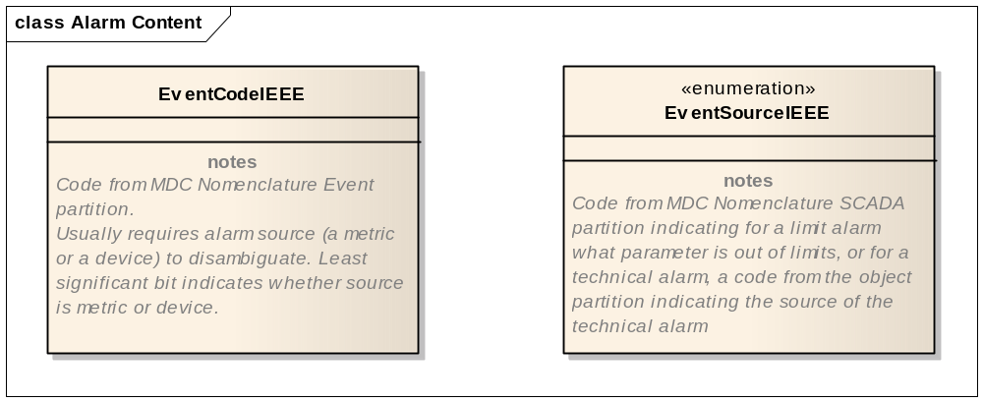
Figure 3.Z.7.5-1: Event Identification Facet

Facet 2. Source identification
For an event code corresponding with a metric alarm, this segment identifies the particular measurement that is the source of the alarm by its MDC nomenclature code in OBX-3 Observation Identifier. If it has a numeric value, it shall be in OBX-5 Observation Value, and if available the alarm range set in the device will be encoded in OBX-7 Reference Rang
For a technical alarm, this facet specifies the subsystem that is the source of the event by its MDC object code in OBX-5 Observation Value, and by its dotted sub-ID notation according to the DEC specification for OBX-4 Observation Sub-ID.
Facet 3. Event Phase
Each occurrence contains one of the following phase indications of the alarm from the EventCurrentPhase enumeration:
- tpoint
- start
- continue
- end
- update
- escalate
- de-escalate
- reset
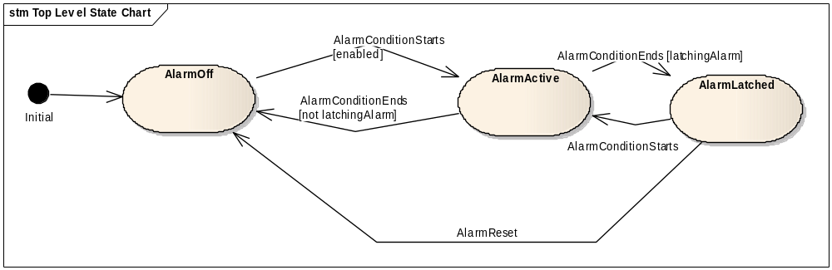

Figure 3.Z.7.5-2: Event Phase

The EventCurrentPhase identifies the state transition or state that the current alarm message is indicating: a tpoint event is a time point event with no duration, a continue event indicates that this message does not represent a state transition but rather reports the continuation of an event that started at some previous time. An update indicates a change other than a state transition in a previously reported alarm, such as a further change in an out-of-limit metric. The phases escalate and de-escalate represent changes in alarm priority as assessed by the patient care device.

State transitions
A message representing an alarm is sent aperiodically, when the alarm undergoes a state transition that may be significant for notification (alarm start, alarm end, escalation or de-escalation of priority as evaluated by the alarm source).
By site agreement, messages representing current state of alarms may optionally also be sent at other times, as for example on a periodic timed basis, or when systems are restarted and a list of currently active alarms is sent out by the Alarm Reporter to refresh the Alarm Manager.
Facet 4. Alarm current state
The value of the AlarmState facet reflects whether the alarm condition currently exists (inactive or active) or if the alarm condition formerly existed, does not now exist, but is “latched” or held by the alarm source so that caregivers may be notified of transient but significant conditions.
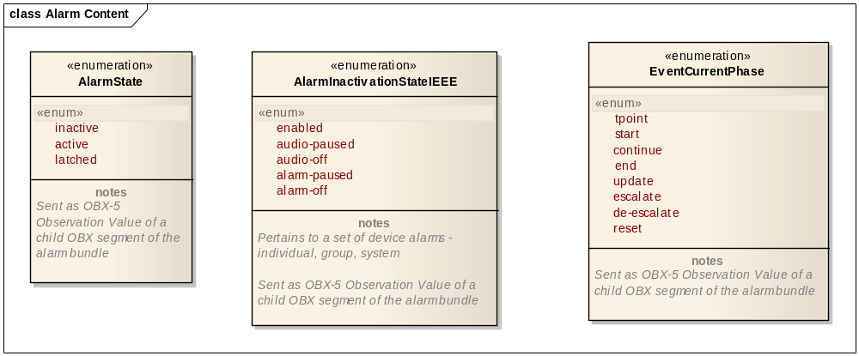
Figure 3.Z.7.5-3: Alarm Current State

Facet 5. Inactivation state
The AlarmInactivationState reflects the current state of the visual and aural alarm indications at the alarm source.
This may be empty. May contain the value 'enabled', meaning that both visual and aural alarm indications are enabled at the device. May be repeated, to indicate separately the state of visual indications at the device by including zero or one of the values:
- alarm-paused
- alarm-off
and zero or one of the values:
- audio-paused
- audio-off
If neither 'alarm-paused' nor 'alarm-off' is included, the visual alarm indication is assumed to be enabled regardless of whether 'enabled' is also present.
If neither 'audio-paused' nor 'audio-off' is included, the aural alarm indication is assumed to be enabled regardless of whether 'enabled' is also present.
Facet 6. Real-time location
Optional. Real time location data concerning the patient, if available.
Applicable where there are technical means to determine the current location of the patient, as distinct from the administratively assigned location that may be present in segment PV1. The Observation Value for this facet is based upon a combination of digital and site agreed named references with the digital information based upon the World Geodetic System (WGS) either 1984 or 2004. Additionally each digital data component should optionally include a metric distance based margin for error.
Facet 7. Evidentiary data
This facet encodes an array of real-time measurements typically representing a physiological waveform meant to be rendered by the Alarm Manager or Alarm Communicator at the endpoint device to assist the caregiver in assessing the condition of the patient that the alarm is for. The normative description of the data is found in the Waveform Content Message (WCM) message content document.

3.Z.7.6 OBX-6 Units (CE) 00574
This field specifies the units associated with the observed value.

3.Z.7.7 OBX-7 References Range (ST) 00575
The range of values for Observation Value. The Alarm Manager (AM) actor does not use this field to analyze or indicate whether an alarm is due to an abnormal or critical value in the Observation Value. Instead the Abnormal Flags field is used.

3.Z.7.8 OBX-8 Abnormal Flags (IS) 00576
This field may be repeated and can contain zero or more abbreviations indicating different facets of the abnormality of a result, including the type of abnormality (using predefined abbreviations from the table of values in the HL7 standard), and also values from the tables below alarm priority and whether the alarm is physiological or technical (AlarmType).

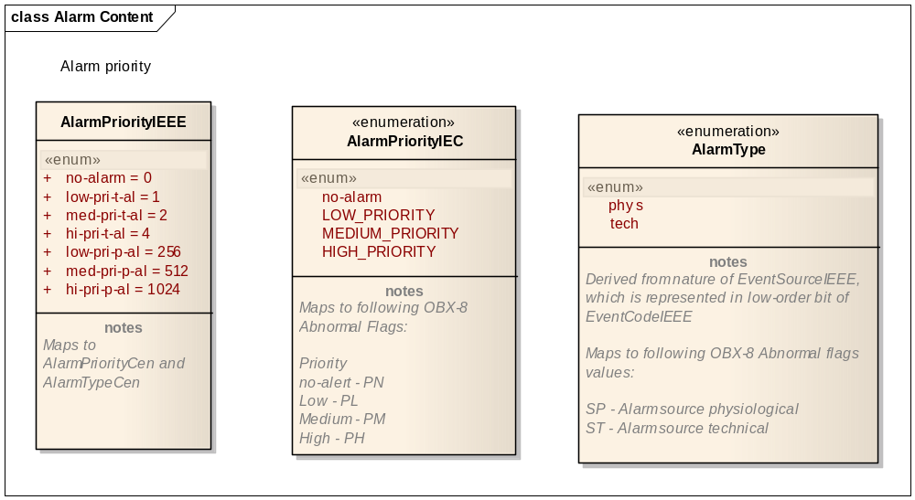
Figure 3.Z.7.8-1: Alarm Priority and Type

AlarmPriorityIEEE is displayed for reference, to show the correspondence between the combined encoding for priority and source used in ISO/IEEE-1073 and the separate encodings used in this Profile.
The following abbreviations in the OBX-8 Abnormality Flags field can be used to indicate the type of abnormality, its priority as indicated by the source patient care device, and whether it is a physiological alarm based on monitoring observations from the patient, or a technical alert indicating a condition of the patient care device and not the patient which nonetheless requires caregiver action.

Table 3.Z.7.8-2: Abnormal Flags, Abnormality Types
Abnormality Type | Abbreviation
Normal, not abnormal | N
Below low normal | L
Below lower panic limits | LL
Above high normal | H
Above higher panic limits | HH
Abnormal (for non-numeric results) | A

Table 3.Z.7.8-3: Abnormal Flags, Alarm Priority
Alarm Priority | Abbreviation
no-alarm | PN
low priority | PL
medium priority | PM
high priority | PH

Table 3.Z.7.8-4: Abnormal Flags, Alarm Source
Alarm Source | Abbreviation
physiological | SP
technical | ST
This is a repeatable field and values from the above table may be combined by entering them as repetitions of the field, for example, a field value of 'H~PH~SP' would signify a physiological measurement with an abnormally high value, constituting a high priority alarm condition.

3.Z.7.9 OBX-14 Observation Date/Time
The OBX segment of the Source Identification facet shall populate this field with the timestamp of the event transition this alarm represents (for example, the start time for an alarm start message, the end time for an alarm end message, and so forth). This is to be distinguished from the time the message was sent, which is carried in OBR-7.

3.Z.7.10 OBX-18 Equipment Instance Identifier (EI) 01479
This field uniquely identifies the Alarm Reporter source of the alarm, preferably an EUI-64 (see base document).

3.Z.8 NTE Notes and Comment Segment
For indicated issues not addressed in information normative locations under agreement between the AR and AM actors. Site or system specific indications are optionally passed in this manner to the AM for dispatch decision making or through the AM to the AC to communications endpoints.
Table 3.Z.8-1: HL7 Attribute Table – NTE – Notes and Comment
SEQ | LEN | DT | OPT | RP/# | TBL# | ITEM# | ELEMENT NAME
3 | 65536 | FT | O | Y |  | 00098 | Comment

3.Z.8.1 NTE-3 Comment (FT) 00098
This field contains the comment contained in the segment.

3.Z.9 Capture of WCTP 1.3 update 1
This section is a capture of the protocol definition, guidelines, and usage constraints of Wireless Communication Transfer Protocol (WCTP).

3.Z.9.1 Pre-Configuration
The HTTP source to destination is assumed to be resolved through pre-configuration.
Whether or not secure http (HTTPS) is used or not is resolved through pre-configuration
The WCTP PollerID and security password used to identify the message send requestor (not the request itself) are assumed to be resolved through pre-configuration.
The URI values for the WCTP senderID and sendResponseToID are assumed to be resolved through pre-configuration.

3.Z.9.2 Endpoint Device Addressing
Endpoint entity (wireless device) addressing can be per WCTP (often the phone number of the endpoint device), but in any event it is presumed to be pre-configured so that there is a match from Alarm Manager (AM) to Alarm Communicator (AC).

3.Z.9.3 Polling Versus Push Responses
The decision as to whether polling or push response is used for status updates is assumed to be resolved through pre-configuration. WCTP would be best used in its web push response form rather than polling for responses so as to maintain responsiveness of status updates and replies.
Some WCTP implementations have minimum tolerable poll intervals to reduce overall polling of the WCTP gateway server, the Alarm Communicator (AC).

3.Z.9.4 Constraints
The use of WCTP for ACM does not require Message Response Redirection.
Sub-second timing is not expected to be needed by ACM use of WCTP.
The WCTP messageID is used to track the status of a message that was sent from the AM to the AC.
The WCTP notifyWhen element should indicate notifyWhenDelivered (notify upon delivery to device) and notify upon read receipt.
If WCTP version query is not supported then a request for version query must not be ignored. It must be responded to with a Not Supported WCTP confirmation response.

3.Z.9.5 Transactions

Table 3.Z.9.5-1: WCTP requests and responses
Request | AC actor  (WCTP Server) | AM actor  (WCTP Client) | Needed
Request | Receives | Submits | Needed
wctp-ClientQuery | Yes | No | No (polling)
wctp-LookupSubscriber | Yes | No | No
wctp-LookupResponse | No | Yes | No
wctp-DeviceLocation | Yes | No | No
wctp-DeviceLocationResponse | No | Yes | No
wctp-MessageReply | Yes | Yes | Yes
wctp-PollForMessages | Yes | No | No
wctp-ReturnToSvc | Yes | No | Yes
wctp-SendMsgMulti | Yes | No | No
wctp-StatusInfo | Yes | Yes | No
wctp-SubmitClientMessage | Yes | No | Yes
wctp-SubmitRequest | Yes | Yes | No
wctp-VersionQuery | Yes | Yes | Yes
Appendix ’X’ Example Messages

Alarm Communications Management Sample messages

Numeric Alarm

Patient Monitoring Device, Low SPO2 Alarm Indication, Start

MSH|^~\&|MINDRAY_EGATEWAY^00A037EB2175780F^EUI-64|MINDRAY|AM_PHILIPS_IEM|PHILIPS|20120111150457-0600||ORU^R40^ORU_R40|1|P|2.6|||NE|AL||UNICODE UTF-8|||IHE_PCD_ACM_001^IHE PCD^1.3.6.1.4.1.19376.1.6.1.4.1^ISO
PID|||HO2009001^^^Hospital^PI||Hon^Albert^^^^^L||18991230|M\0DPV1||I|HO Surgery^OR^1\0DOBR|1|1^MINDRAY_EGATEWAY^00A037EB2175780F^EUI-64|1^MINDRAY_EGATEWAY^00A037EB2175780F^EUI-64|69952^MDC_DEV_MON_PT_PHYSIO_MULTI_PARAM^MDC|||20120111150457-0600
OBX|1|ST|196670^MDC_EVT_LO^MDC|1.3.1.150456.1|Low SpO2|||L~PM~SP|||R|||20120111150457-0600||||F1519EFX^SHENZHEN_DEVICE^mindray.com^DNS
OBX|2|NM|150456^MDC_PULS_OXIM_SAT_O2^MDC|1.3.1.150456.2|88|262688^MDC_DIM_PERCENT^MDC|90-96||||R|||20120111150457-0600
OBX|3|ST|EVENT_PHASE^EVENT_PHASE|1.3.1.150456.3|start||||||R
OBX|4|ST|ALARM_STATE^ALARM_STATE|1.3.1.150456.4|active||||||R

Qualitative Alarm

Infusion Pump, Fluid Line Occlusion, Alarm Indication Start

MSH|^~\&|PAT_DEVICE_BBRAUN^0012211839000001^EUI-64|BBRAUN|AM_Philips_IEM|Philips|20120109175417-0600||ORU^R40^ORU_R40|6346172845752460251|P|2.6|||NE|AL||ASCII|EN^English^ISO659||^^1.3.6.1.4.1.19376.1.6.1.4.1^ISO
PID|||HO2009003^^^AA1^PI||Hon^Amy^^^^^L|Coburn^^^^^^L|19610301000000-0600|F\0DPV1||I|HO 3 West ICU^10^1
OBR|1|634617284575713662^PAT_DEVICE_BBRAUN^0012211839000001^EUI-64|P6013_4^PAT_DEVICE_BBRAUN^0012211839000001^EUI-64|Heparin^Heparin|||20120109175417-0600
OBX|1||196940^MDC_EVT_FLUID_LINE_OCCL^MDC|1.0.0.0.1|||||||R|||||||P6013^^0012210000000000^EUI-64
OBX|2||69985^MDC_DEV_PUMP_INFUS_MDS^MDC|1.0.0.0.2|||||||X|||20120109175417-0600
OBX|3|ST|EVENT_PHASE^EVENT_PHASE|1.0.0.0.3|start||||||R
OBX|4|ST|ALARM_STATE^ALARM_STATE|1.0.0.0.4|active||||||R

Infusion Pump, Fluid Line Occlusion, Alarm Indication, End

MSH|^~\&|PAT_DEVICE_BBRAUN^0012211839000001^EUI-64|BBRAUN|AM_Philips_IEM|Philips|20120109175426-0600||ORU^R40^ORU_R40|6346172846620706282|P|2.6|||NE|AL||ASCII|EN^English^ISO659||^^1.3.6.1.4.1.19376.1.6.1.4.1^ISO
PID|||HO2009003^^^AA1^PI||Hon^Amy^^^^^L|Coburn^^^^^^L|19610301000000-0600|F\0DPV1||I|HO 3 West ICU^10^1
OBR|1|634617284662070628^PAT_DEVICE_BBRAUN^0012211839000001^EUI-64|P6013_4^PAT_DEVICE_BBRAUN^0012211839000001^EUI-64|Heparin^Heparin|||20120109175426-0600
OBX|1||196940^MDC_EVT_FLUID_LINE_OCCL^MDC|1.0.0.0.1|||||||R|||||||P6013^^0012210000000000^EUI-64
OBX|2||69985^MDC_DEV_PUMP_INFUS_MDS^MDC|1.0.0.0.2|||||||X|||20120109175426-0600
OBX|3|ST|EVENT_PHASE^EVENT_PHASE|1.0.0.0.3|end||||||R
OBX|4|ST|ALARM_STATE^ALARM_STATE|1.0.0.0.4|inactive||||||R
Appendix ’X+1’ AM – AC Communication WCTP Protocol Transactions
The following appendix covers the messages exchanged between an IHE PCD ACM AM actor and an AC actor using the WCTP protocol

Abbreviations and definitions
HTTP – HyperText Transport Protocol
WCTP – Wireless Communications Transfer Protocol – the protocol between the ACM AM and the ACM AC actors.
MCR (Multiple Choice Response) – the means to pass a message with selectable responses from the ACM AM to the ACM AC actor.
XML – eXtensible Markup Language

IHE PCD Prerequisite Information
- IHE PCD TF
- IHE PCD WCM profile TI

What is WCTP
WCTP is the protocol between the ACM AM and the ACM AC actors. It makes use of an optionally securable (authentication and encryption) HTTP transport layer to convey XML-based WCTP protocol exchanges between a WCTP client (the ACM AM) and the WCTP server (the ACM AC).

WCTP XML Element Common Data Items
Some message exchanges are administrative in nature, similar to TCP open, accept, and acknowledgement messages which are not documented as a part of HL7, while others have a direct and obvious place in the ACM profile as transactions, such as PCD-06 and PCD-07.
Please note, XML constant strings are presented in normal text. XML data to be filled in during implementation is presented in bold red text.

The format of WCTP conformant timestamps (timestamp) is: yyyy-mm-ddThh:mm:ss.ttt
All times are UTC. WCTP does not support the ability to indicate a time zone offset.
Hours (hh) in 24-hour format, and .ttt is the optional number of milliseconds
Example: 2011-01-19T20:33:52

A push response URI is the URI (URL minus the HTTP://) used to identify the HTTP POST destination for WCTP replies and status updates.

The notification text value is the actual text message to be presented to the wireless device operator.

The sender ID is the security identification of the IHE ACM actor to the WCTP receiver.

The security code is essentially the password to go with the security sender ID.

The message ID is the identification of the overall message to the ACM AC by the AM.

The transaction ID is the lower level transaction identification making up the message.

The recipient PIN is the identification of the destination device as per the ACM AC.

The e-mail address is the optional ACM AM contact information e-mail address.

The phone number is the optional ACM AM contact information voice telephony phone number.

The web site is the optional ACM AM contact information web site.

The info string is the optional ACM AM contact information comment.

The priority is any of HIGH, NORMAL, or LOW with a default of NORMAL.

The sequence number is a sequential value used for tracking polling requests and responses used during Virtual Pre-Connectathon testing.

The batch size is the numeric maximum count of responses a WCTP client (ACM AM) expects from a WCTP poll request to a WCTP server (ACM AC). A common value is 500.

The WCTP version indicates the expected version of WCTP XML message content supported.

Table 2-1: WCTP version values
Value | Indicating WCTP version | MCR support
wctp-dtd-v1r1 | 1.1 | None
wctp-dtd-v1r2 | 1.2 | Unpaired
wctp-dtd-v1r3 | 1.3 | Paired

The WCTP DTD identifies the URL of the DTD (Data Type Definition) for the indicated version of WCTP supported.
Table 2-2: WCTP DTD values
Value | Indicating WCTP version | MCR support
http://dtd.wctp.org/wctp-dtd-v1r1.dtd | 1.1 | None
http://dtd.wctp.org/wctp-dtd-v1r2.dtd | 1.2 | Unpaired
http://dtd.wctp.org/wctp-dtd-v1r3.dtd | 1.3 | Paired

The Next Poll Interval is the number of seconds the ACM AM (WCTP client) should wait before again polling the ACM AC (WCTP server). The ACM AC (WCTP server) dictates this value to reduce the aggregate polling load on the WCTP server by all WCTP polling clients. Given that there are typically not many ACM AM instances per ACM AC instance this interval can be kept to a small single digit number of seconds. In typical WCTP wide area communication deployment there are often hundreds if not maybe thousands of WCTP clients per WCTP server.

The graphics format indicates the format of the graphical image information, and the value can be any one of SVG, JPEG, PNG, or BMP as agreed between the ACM AM actor vendor and the ACM AC actor vendor.

The graphical image is a base-64 encoded string representing one of the WCM static graphical images represented by one of the sets of WCM evidentiary data from the ACM PCD-04 message sent from the ACM AR to the ACM AM.

The telephony dial string is an encoded telephony dial string, including any required prefixes, area codes, PBX switch hops, or pauses needed to permit the ACM AC endpoint communication device operator to make a telephone call from that device back to a patient’s room or to the observation producer/order filler.

The status update is the string indicating the type of status update that the ACM AC is reporting back to the ACM AM in wctp-Notification. Possible values are as QUEUED, DELIVERED, or READ. Additionally there are the optional IHE PCD ACM profile specific values for IHEPCDCALLBACKSTART and IHEPCDCALLBACKEND in support of Call Back Number phone dialing by the operator of the ACM AC endpoint communication device and the resulting telephony call start and call end, the status of which are useful as logged items in alarm response analysis.

The Send Choice n is the prompt component of an MCR request. This is the value used by the ACM AC to populate buttons, softkeys, or menu choices on the endpoint communication device for selection by the device operator. There can be multiple.

The Reply Choice n is the response value component of an MCR request. This value is correlated with its same ordinal occurrence Send Choice n value.

The response text is the string sent by the endpoint communication device of the ACM AC back to the ACM AM as the response to a notification message sent from the ACM AM to the ACM AC. In the case of an MCR response the text can be predefined. In the case of non-MCR responses the text can be an unexpected value.

WCTP client–server messages and responses
Sections are indicated as message classification – message type – usage indication

The message classification is either Administrative or the IHE PCD ACM message (PCD-06, PCD-07, etc.)

The messages type is the WCTP interface specification operation types.

The usage indication is used to distinctively indicate different uses for the same IHE PCD ACM message, like when MCR is not supported, supported but unpaired, or supported and paired, or to convey ACM profile proprietary extensions to WCTP like those needed to convey WCM information from the ACM AM to the ACM AC.

Administrative - wctp-VersionQuery
This message is used to determine whether or not the WCTP server, the ACM AC actor, supports Multiple Choice Response (MCR) pairs on SubmitRequest messages. See WCTP version above.

<?xml version="1.0"?>
<!DOCTYPE wctp-Operation SYSTEM “WCTP DTD” >
<wctp-Operation wctpVersion=“WCTP version”>
<wctp-VersionQuery inquirer="push response URI" listDTDs="yes"/>
</wctp-Operation>

Administrative - wctp-VersionResponse
This message is used when VersionQuery operation is not supported.

<?xml version="1.0"?>
<!DOCTYPE wctp-Operation SYSTEM “WCTP DTD”>
<wctp-Operation wctpVersion=“WCTP version” wctpToken="11AA">
<wctp-Confirmation>
<wctp-Failure errorCode="300" errorText="Operation not supported.">
</wctp-Failure>
</wctp-Confirmation>
</wctp-Operation>

The assumption to this response is that the ACM AM is to use only WCTP 1.1 XML messages and not later, e.g. is no support for MCR.

Administrative - wctp-VersionResponse
This message is used when Version Query operation is supported.

<?xml version="1.0" encoding="utf-8"?>
<!DOCTYPE wctp-Operation SYSTEM “WCTP DTD”>
<wctp-Operation wctpVersion=“WCTP version”>
<wctp-VersionResponse inquirer="push response URI" responder="responder name" dateTimeOfRsp="timestamp" dateTimeOfReq="timestamp" invalidAfter="timestamp">
<wctp-ContactInfo email="e-mail address" phone="phone number" www="web site" info="info string" />
<wctp-DTDSupport supportType="Supported" dtdName=“WCTP version” verToken="11AA" />
</wctp-VersionResponse>
</wctp-Operation>

A response dtdName of "wctp-dtd-v1r3" indicates support for ACM profile conformant WCTP version 1.3 which indicates support for Multiple Choice Response (MCR) pairs on WCTP SubmitRequest messages. MCR pairs are used to populate soft keys on wireless device operator interfaces and so that the reply value can be vendor specific and still be presented in a vendor agnostic manner. A response of dtdName of "wctp-dtd-v1r2" indicates support for WCTP 1.2 which supports non-paired MCR.

IHE PCD-06 - wctp-SubmitRequest – no MCR
This message is used to send a message from the ACM AM to the ACM AC when MCR is not to be indicated because this is either a test message or the ACM AC does not support MCR.

<?xml version="1.0"?>
<!DOCTYPE wctp-Operation SYSTEM “WCTP DTD”>
<wctp-Operation wctpVersion=“WCTP version”>
<wctp-SubmitRequest>
<wctp-SubmitHeader submitTimestamp="timestamp">
<wctp-Originator senderID="sender ID" securityCode="security code"/>
<wctp-MessageControl messageID="message ID" transactionID="transaction ID" allowResponse="true" deliveryPriority="priority" notifyWhenDelivered="true" preformatted="true"/>
<wctp-Recipient recipientID="recipient PIN"/>
</wctp-SubmitHeader>
<wctp-Payload>
<wctp-Alphanumeric>notification text</wctp-Alphanumeric>
</wctp-Payload>
</wctp-SubmitRequest>
</wctp-Operation>

IHE PCD-06 - wctp-SubmitRequest – Unpaired MCR
This message is used when the ACM AM wants to send a message to the ACM AC and while MCR is to be indicated the ACM AC does not support paired MCR so unpaired MCR is used.

<?xml version="1.0"?>
<!DOCTYPE wctp-Operation SYSTEM “WCTP DTD”>
<wctp-Operation wctpVersion=“WCTP version”>
<wctp-SubmitRequest>
<wctp-SubmitHeader submitTimestamp="timestamp">
<wctp-Originator senderID="sender ID" securityCode="security code"/>
<wctp-MessageControl messageID="message ID" transactionID="transaction ID" allowResponse="true" deliveryPriority="priority" notifyWhenDelivered="true" preformatted="true" notifyWhenRead="true"/>
<wctp-Recipient recipientID="recipient PIN"/>
</wctp-SubmitHeader>
<wctp-Payload>
<wctp-MCR>
<wctp-MessageText>notification text</wctp-MessageText>
<wctp-Choice>Accept</wctp-Choice>
<wctp-Choice>Reject</wctp-Choice>
</wctp-MCR>
</wctp-Payload>
</wctp-SubmitRequest>
</wctp-Operation>

When using unpaired MCR the wctp-Choice value selected by the endpoint device operator is the response data from the WCTP server (the ACM AC) back to the WCTP client (the ACM AM).

IHE PCD-06 - wctp-SubmitRequest – Paired MCR
This message is used to send a message from the ACM AM to the ACM AC when the ACM AC supports paired MCR.

<?xml version="1.0"?>
<!DOCTYPE wctp-Operation SYSTEM “WCTP DTD”>
<wctp-Operation wctpVersion=“WCTP version”>
<wctp-SubmitRequest>
<wctp-SubmitHeader submitTimestamp="timestamp">
<wctp-Originator senderID="sender ID" securityCode="security code"/>
<wctp-MessageControl messageID="message ID" transactionID="transaction ID" allowResponse="true" deliveryPriority="priority" notifyWhenDelivered="true" preformatted="true" notifyWhenRead="true"/>
<wctp-Recipient recipientID="recipient PIN"/>
</wctp-SubmitHeader>
<wctp-Payload>
<wctp-MCR>
<wctp-MessageText>notification text</wctp-MessageText>
<wctp-ChoicePair>
<wctp-SendChoice>Send Choice 1</wctp-SendChoice>
<wctp-ReplyChoice>Reply Choice 1</wctp-ReplyChoice>
</wctp-ChoicePair>
<wctp-ChoicePair>
<wctp-SendChoice> Send Choice 2</wctp-SendChoice>
<wctp-ReplyChoice Reply Choice 2</wctp-ReplyChoice>
</wctp-ChoicePair>
<wctp-ChoicePair>
<wctp-SendChoice> Send Choice 3</wctp-SendChoice>
<wctp-ReplyChoice> Reply Choice 3</wctp-ReplyChoice>
</wctp-ChoicePair>
</wctp-MCR>
</wctp-Payload>
</wctp-SubmitRequest>
</wctp-Operation>

When using a paired MCR the selectable values presented to the endpoint device operator are in the wctp-SendChoice elements. Once selected the correlated reply value sent to the WCTP client (the ACM AM) is in the wctp-ReplyChoice element.

IHE PCD-06 wctp-SubmitRequest – WCM
The following ACM profile proprietary extensions to the wctp-SubmitRequest are used to convey WCM content from the ACM AM to the ACM AC.

The WCTP 1.3r1 interface specification that is the basis for ACM AM – AC communication supports neither non-plain text messages (encoded attachments) in addition to plain text messages or transmissions of graphical images in addition to plan text messages. For this reason the ACM profile is required to extend the WCTP 1.3r1 interface specification in a backward transparent manner in order to convey the HL7 evidentiary data associated with WCM (for ECG waveform graphic generation by the ACM AC) or to convey a graphical image of the HL7 evidentiary data as produced by the ACM AM for delivery to a non-regulated medical device ACM AC.

In order for the WCTP server (the ACM AC actor) to signal its willingness to receive and potentially support these IHE ACM profile WCM specific extensions to WCTP 1.3r1, per the extensions mechanism defined in section 3.6 Protocol Version of the WCTP 1.3r1 interface specification, the DTD response value shall be “IHEPCD-PCD06-V1R1” to indicate support for reception of either or both of the PCD-04 (HL7 evidentiary data) or a graphical image representative of the evidentiary data. This version shall presume at a minimum WCTP version 1.3r1 capabilities, with primary emphasis on the ability of the WCTP server (ACM AC actor) to support paired MCR if sent in a wctp-SubmitRequest message from the WCTP client (the ACM AM actor) to the WCTP server (the ACM AC actor).

On wctp-SubmitRequest messages the WCTP 1.3r1 interface specification supports a choice of one of wctp-Alphanumeric (simple text with no MCR), wctp-TransparentData (binary encoded data), or wctp-MCR (simple text accompanied with either unpaired or paired MCR). Since only smarter devices, associated with the newest WCTP implementations, are expected to make use of the additional WCM information in the PCD-06 transaction and so as to offload simple non-MCR message WCTP implementations from having to ignore the extensions, the wctp-MCR element tree has been selected as the extension point for the WCM related additional XML elements.

<wctp-IHEPCD04 xmlns=”urn:ihe:pcd:acm:2012">
IHE PCD-04 HL7 message
</wctp-IHEPCD04>

<wctp-IHEPCDWCMImages>
<wctp-IHEWCMImage Format=”graphics format” Encoding=”base64”>
graphical image
</wctp-IHEWCMImage>
</wctp-IHEPCDWCMImages >

The IHE PCD-04 HL7 message may or may not contain WCM evidentiary data, but it is expected to contain ACM alarm indication data.

Since a single PCD-04 WCM extension can result in more than a single graphics image the wctp-IHEWCMImage can be repeated. Due to endpoint communication device display real estate limitations the ACM AC may not be able to display all of the images presented to it by the ACM AM, but shall present the images starting with the first for as many as the ACM AC supports for the given endpoint communication device.

Whether or not the ACM AM sends the rendered images to the ACM AC is ACM AM vendor specific.

The Format specification is required, indicates the format of the graphical image information, and the value can be any one of SVG, JPEG, PNG, or BMP as agreed between the ACM AM actor vendor and the ACM AC actor vendor.

If the ACM AC does not respond to the wctp-VersionQuery with the WCM supportive DTD response indicating value then the AM shall not send these extensions to the AC.

IHE PCD-06 wctp-SubmitRequest – Call Back Phone Number
The following ACM profile proprietary extensions to the wctp-SubmitRequest are used to convey the HL7 Call Back Phone Number from the ACM AM to the ACM AC.

The WCTP 1.3r1 interface specification that is the basis for ACM AM – AC communication does not support the ability to pass other than a client request contact phone number in association with a message submit request. For this reason the ACM profile is required to extend the WCTP 1.3r1 interface specification in a backward transparent manner in order to convey the HL7 Call Back Phone Number (OBR-17) from the ACM PCD-04 HL7 message received by the ACM AM from the ACM AR for sending to the ACM AC.

In order for the WCTP server (the ACM AC actor) to signal its willingness to receive and potentially support these IHE ACM profile WCM specific extensions to WCTP 1.3r1, per the extensions mechanism defined in section 3.6 Protocol Version of the WCTP 1.3r1 interface specification, the DTD response value shall be “IHEPCD-PCD06-V1R1” to indicate support for reception of the Call Back Phone Number extension to WCTP 1.3r1. This version shall presume at a minimum WCTP version 1.3r1 capabilities, with primary emphasis on the ability of the WCTP server (ACM AC actor) to support paired MCR if sent in a wctp-SubmitRequest message from the WCTP client (the ACM AM actor) to the WCTP server (the ACM AC actor).

On wctp-SubmitRequest messages the WCTP 1.3r1 interface specification supports a choice of one of wctp-Alphanumeric (simple text with no MCR), wctp-TransparentData (binary encoded data), or wctp-MCR (simple text accompanied with either unpaired or paired MCR). Since only smarter devices, associated with the newest WCTP implementations, are expected to make use of the additional WCM information in the PCD-06 transaction and so as to offload simple non-MCR message WCTP implementations from having to ignore the extensions, the wctp-MCR element tree has been selected as the extension point for the WCM related additional XML elements.

In order to pass the Call Back Phone Number used for the ACM nurse call use case for telephony call back to the patient in the room, or for the ACM laboratory results/observations use case for telephony call back to the results provider/order filler for any required results/observation read back, the following additional WCTP XML element is defined specifically to pass the telephony dial back string from the ACM AM to the ACM AC by means able to be more deterministically referenced than simply including the string in the message text sent to the endpoint communication device operator.

<wctp-IHEPCDDialback String=”telephony dial string” />

IHE PCD-07 - Synchronous response to wctp-SubmitRequest – Received by communications status update
This message is used by the ACM AC to convey immediate request status responses to the ACM AM while the submit request initiating TCP connection is still open. This is the means by which the PCD-07 status indication of Received by communications
(accepted by WCTP gateway) is conveyed from the ACM AC to the ACM AM.

The following is an indication of the successful queuing of a message from the ACM AM to the ACM AC.

<?xml version="1.0"?>
<!DOCTYPE wctp-Operation SYSTEM “WCTP DTD”>
<wctp-Operation wctpVersion=“WCTP version” wctpToken="11AA">
<wctp-Confirmation>
<wctp-Success successCode="200" successText="Accepted">comment</wctp-Success>
</wctp-Confirmation>
</wctp-Operation>

The following is an indication of the failed attempt to queue a message from the ACM AM to the ACM AC.

<?xml version="1.0"?>
<!DOCTYPE wctp-Operation SYSTEM “WCTP DTD”>
<wctp-Operation wctpVersion=“WCTP version” wctpToken="11AA">
<wctp-Confirmation>
<wctp-Failure errorCode="500" errorText="Timeout">comment</wctp-Failure>
</wctp-Confirmation>
</wctp-Operation>

Refer to the WCTP interface specification for all possible values for successCode and successText as well as errorCode and errorText.

For Pre-Connectathon/Virtual Connectathon testing - wctp-PollForMessages – general poll
In a Pre-Connectathon or Virtual Connectathon environment where firewalls may not permit the ACM AC to post asynchronous status updates and replies across the Internet there is a WCTP polling capability. As polling adds a potentially non-determinant delay in the ACM AM – AC interaction times the use of polling is not for use during IHE Connectathon testing nor should it be used in live deployments where the non-determinant delay could increase patient safety risk.

The following poll is a general poll and not a poll for status or replies for any specific messages.

<?xml version="1.0"?>
<!DOCTYPE wctp-Operation SYSTEM “WCTP DTD”>
<wctp-Operation wctpVersion=“WCTP version”>
<wctp-PollForMessages pollerID="poller ID" securityCode="security code" maxMessagesInBatch="batch size"/>
</wctp-Operation>

For Pre-Connectathon/Virtual Connectathon testing - wctp-PollResponse – general poll
This is the general poll response sent by the ACM AC to the ACM AM when the poll response is that no messages have status updates or replies.

<?xml version="1.0"?>
<!DOCTYPE wctp-Operation SYSTEM “WCTP DTD”>
<wctp-Operation wctpVersion="1.0">
<wctp-PollResponse minNextPollInterval=“Next Poll Interval”>
<wctp-NoMessages/>
</wctp-PollResponse>
</wctp-Operation>

For Pre-Connectathon/Virtual Connectathon testing - wctp-PollResponse (message status update)
This is the general poll response sent by the ACM AC to the ACM AM when the poll response is that a message has a status update. The value of status update can be any of “QUEUED”, “DELIVERED”, or “READ”.

<?xml version="1.0"?>
<!DOCTYPE wctp-Operation SYSTEM “WCTP DTD”>
<wctp-Operation wctpVersion="1.0">
<wctp-PollResponse minNextPollInterval=“Next Poll Interval”>
<wctp-Message sequenceNo="sequence number">
<wctp-StatusInfo>
<wctp-ResponseHeader responseToMessageID="message ID" responseTimestamp="timestamp">
</wctp-ResponseHeader>
<wctp-Notification type="status update" />
</wctp-StatusInfo>
</wctp-Message>
</wctp-PollResponse>
</wctp-Operation>

For Pre-Connectathon/Virtual Connectathon testing - wctp-PollResponse (message status update acknowledgement)
This is the poll response acknowledgement message sent from the ACM AM back to the ACM AC to let the AC know that the message status update has been successfully conveyed from the AC to the AM and that the AC can discard status updates for the messages.

<?xml version="1.0"?>
<!DOCTYPE wctp-Operation SYSTEM “WCTP DTD”>
<wctp-Operation wctpVersion=“WCTP version”>
<wctp-PollForMessages pollerID="poller ID" securityCode="security code" maxMessagesInBatch="batch size">
<wctp-MessageReceived sequenceNo="sequence number">
<wctp-Success successCode="200" successText="Message accepted">comment</wctp-Success>
</wctp-MessageReceived>
</wctp-PollForMessages>
</wctp-Operation>

For Pre-Connectathon/Virtual Connectathon testing - wctp-PollResponse (message reply, not in response to an MCR based wctp-SubmitRequest)
<?xml version="1.0"?>
<!DOCTYPE wctp-Operation SYSTEM “WCTP DTD”>
<wctp-Operation wctpVersion="1.0">
<wctp-PollResponse minNextPollInterval=“Next Poll Interval”>
<wctp-Message sequenceNo="sequence number">
<wctp-MessageReply>
<wctp-ResponseHeader responseToMessageID="message ID" responseTimestamp="timestamp">
</wctp-ResponseHeader>
<wctp-Payload>
<wctp-Alphanumeric>response text</wctp-Alphanumeric>
</wctp-Payload>
</wctp-MessageReply>
</wctp-Message>
</wctp-PollResponse>
</wctp-Operation>

IHE PCD-07 asynchronous status update (DELIVERED - delivery confirmation)
The value of status update would be “DELIVERED”.

<?xml version="1.0" encoding="utf-16"?>
<!DOCTYPE wctp-Operation SYSTEM “WCTP DTD”>
<wctp-Operation wctpVersion=“WCTP version”>
<wctp-StatusInfo>
<wctp-ResponseHeader responseTimestamp="timestamp" respondingToTimestamp="timestamp" onBehalfOfRecipientID="recipient PIN">
<wctp-Originator senderID="sender ID" />
<wctp-MessageControl messageID="message ID" transactionID="transaction ID" />
<wctp-Recipient authorizationCode="" />
</wctp-ResponseHeader>
<wctp-Notification type="status update" />
</wctp-StatusInfo>
</wctp-Operation>

IHE PCD-07 asynchronous status update (READ - read receipt)
The value of status update would be “READ”.

<?xml version="1.0" encoding="utf-16"?>
<!DOCTYPE wctp-Operation SYSTEM “WCTP DTD”>
<wctp-Operation wctpVersion=“WCTP version”>
<wctp-StatusInfo>
<wctp-ResponseHeader responseTimestamp="timestamp" respondingToTimestamp="timestamp" onBehalfOfRecipientID="recipient PIN">
<wctp-Originator senderID="sender ID" />
<wctp-MessageControl messageID="message ID" transactionID="transaction ID" />
<wctp-Recipient authorizationCode="" />
</wctp-ResponseHeader>
<wctp-Notification type="status update" />
</wctp-StatusInfo>
</wctp-Operation>

IHE PCD-07 asynchronous reply message with MCR
<?xml version="1.0" encoding="utf-16"?>
<!DOCTYPE wctp-Operation SYSTEM “WCTP DTD”>
<wctp-Operation wctpVersion=“WCTP version”>
<wctp-MessageReply MCRMessageReply="true">
<wctp-ResponseHeader responseToMessageID="message ID" responseTimestamp="timestamp" respondingToTimestamp="timestamp" onBehalfOfRecipientID="recipient PIN">
<wctp-Originator senderID="sender ID" miscInfo="" />
<wctp-MessageControl messageID="message ID" transactionID="transaction ID" />
<wctp-Recipient recipientID="recipient PIN" />
</wctp-ResponseHeader>
<wctp-Payload>
<wctp-Alphanumeric>response text</wctp-Alphanumeric>
</wctp-Payload>
</wctp-MessageReply>
</wctp-Operation>

