IHE Change Proposal

Tracking information:
IHE Domain | Patient Care Device (PCD)
Change Proposal ID: | CP-PCD-148
Change Proposal Status: | Submitted
Date of last update: | 2019-09-26
Person assigned: | Christophe FOURNIER

Change Proposal Summary information:
Adding information regarding alert fatigue
Submitter’s Name(s) and e-mail address(es): | Christophe FOURNIER  christophe.fournier@fresenius-kabi.com
Submission Date: | 2019-10-17
Integration Profile(s) affected: | Infusion Pump Event Communication (IPEC)
Actor(s) affected: | Device Observation Reporter (DOR) and Device Observation Cunsumer (DOC)
IHE Technical Framework or Supplement modified: | IPEC profile in Technical Framework Supplement, dated Oct 25, 2015
Volume(s) and Section(s) affected: | IHE PCD TF Vol 1,  IHE PCD TF Vol 2,  IHE PCD TF Vol 3 (Containment Tree)
Rationale for Change:
Channel Relay is not documented in the current IHE PCD Technical Framework.
Channel Relay allows a nurse to automate the relay of 2 syringe pumps, for the same prescription.
With the following additionnal information, it will be possible for the EMR to associate 2 pumps.

Volume 1
X.2 IPEC Options

Channel Relay is an Option

Appendix X Infusion Pump Events
X.1 Basic Infusion Events

Add one new term in other operational events:

• Channel Relay Programmed

Appendix X Infusion Pump Events
X.1.2 Infusion Pump Events

Add a new term in the Table X.1.2-1: Infusion Pump Events:

Event | MDC Code | Required by Profile
Channel Relay Programmed | MDC_EVT_PUMP_RELAY_PROG | Optional

Relay using 2 pumps / NO power off between Relay:

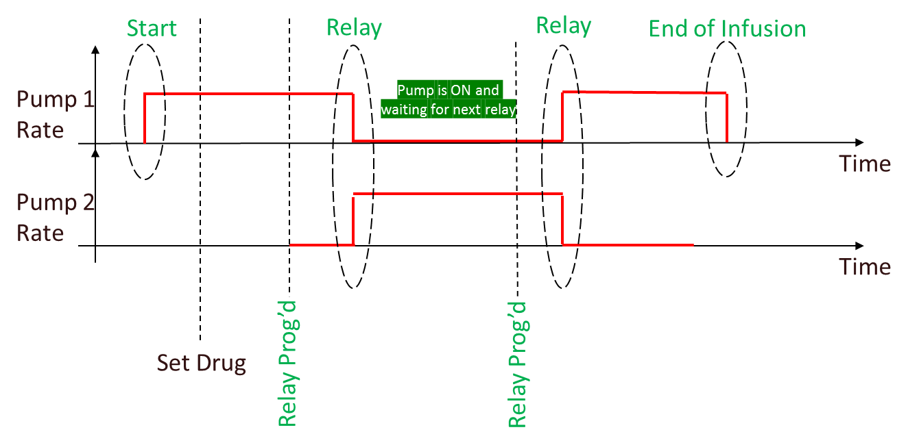

Relay using 2 pumps / power off between Relay:

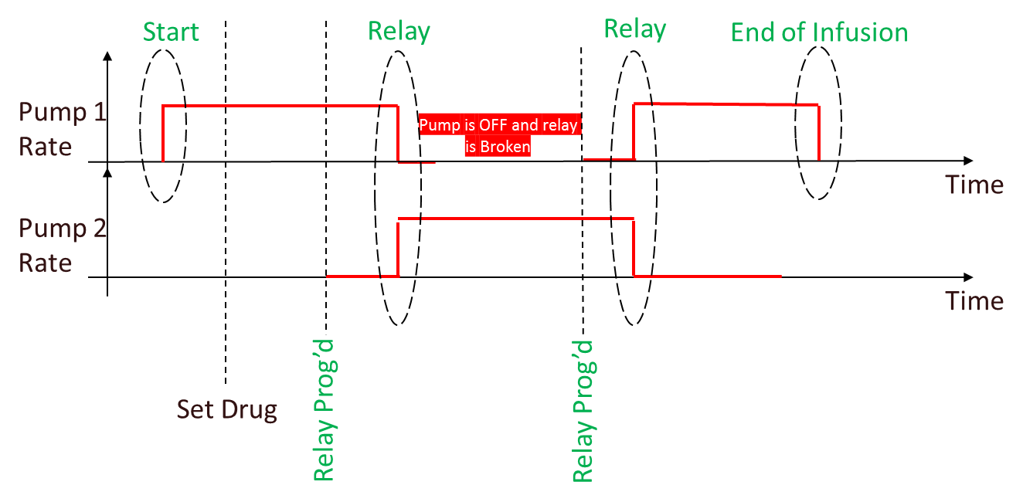

Relay using 3 pumps:

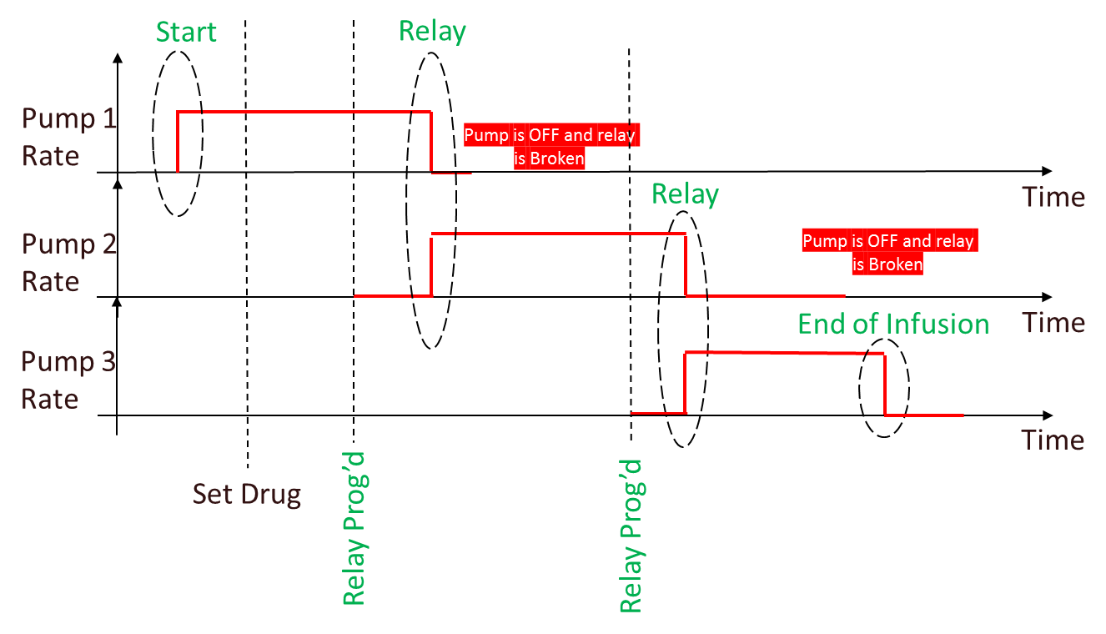

Appendix X Infusion Pump Events
X.1.2.1 Infusion Event Parameters

Add new terms in the Table X.1.2.1-1: Mapping of Infusion Pump Event Parameters to MDC Codes:

Parameter | MDC Code
Active Source Parameters:
Channel Relay State | MDC_PUMP_RELAY_STATE
Channel Relay GUID | MDC_PUMP_RELAY_GUID

Appendix X Infusion Pump Events
X.1.2.1 Infusion Event Parameters

Add new terms in the Table X.1.2.1-2: Infusion Pump Delivery Event Parameters:

Parameter | Note
Channel Relay State | Optional  See ENUM _ PUMP_RELAY_STATE below
Channel Relay GUID | Required if MDC_PUMP_RELAY_STATE is present and is different from pump-relay-none

Enum for Channel Relay State: ENUM _PUMP_RELAY_STATE
  - pump-relay-none: pump not participating in a relay
  - pump-relay-infusing: pump infusing in a relay
  - pump-relay-waiting: pump programmed for a relay and waiting to take that relay
  - pump-relay-complete: pump has just been relayed, and is waiting to be powered off or prepared for next relay

Nota: if state is pump-relay-none:
      - The OBX is optional if there is/was no relay
      - The OBX is required if there was a relay and it has been broken for any reason

Appendix X Infusion Pump Events
X.1.2.1 Infusion Event Parameters

add the scenario to the Table X.1.2.1-4: Clinical Scenarios

Clinical Scenario | PCD-10 Event | Parameters | Discussion
Channel Relay  An Infusion is already started.  The Channel Relay is Programmed  The Channel Relay Occurs  End of Channel Relay  Broken Relay | MDC_EVT_PUMP_PROG_RELAY | Pump Delivery Info Parameters:  Infusing Status=pump-status-infusing  Current Pump Fluid Flow=current rate  Pump Active Sources= pump-source-info-primary  Active Source Parameters:  Current Delivery Status=pump-delivery-status-delivering  Program Delivery Mode=pump-program-delivery-mode-continuous  Source Channel Label=vendor-specific  Rate=current rate  Dose Rate=current dose rate  Volume Programmed= initial volume in syringe  Current Segment Volume Delivered=volume delivered since last DELIV_START  Cumulative Volume Delivered=sum of “Current Segment Volume Delivered” values across all segments for the delivery, including the current one  Volume Remaining=current volume in syringe  Time Remaining=based upon Volume Remaining and Rate  Channel Relay State=pump-relay-infusing  Channel Relay GUID=guid | Infusing Pump
 | MDC_EVT_PUMP_PROG_RELAY | Pump Delivery Info Parameters:  Infusing Status=pump-status-not-infusing  Current Pump Fluid Flow=0  Pump Active Sources= pump-source-info-primary  Active Source Parameters:  Current Delivery Status=pump-delivery-status-not-delivering  Program Delivery Mode=pump-program-delivery-mode-continuous  Source Channel Label=vendor-specific  Rate=programmed rate  Dose Rate=programmed dose rate  Volume Programmed= initial volume in syringe  Current Segment Volume Delivered=0  Cumulative Volume Delivered=0  Volume Remaining=current volume in syringe  Time Remaining=based upon Volume Remaining and Rate  Channel Relay State=pump-relay-waiting  Channel Relay GUID=same guid as other pump | Waiting Pump
Channel Relay  An Infusion is already started.  The Channel Relay is Programmed  The Channel Relay Occurs  End of Channel Relay | MDC_EVT_PUMP_DELIV_ STOP | Pump Delivery Info Parameters:  Infusing Status=pump-status-not-infusing  Current Pump Fluid Flow=pump reported rate  Pump Active Sources=pump-source-info-primary  Active Source Parameters:  Current Delivery Status=pump-delivery-status-not-delivering  Program Delivery Mode= pump-program-delivery-mode-continuous  Source Channel Label=vendor-specific  Rate=old rate  Dose Rate=old dose rate  Volume Programmed= initial volume in syringe  Current Segment Volume Delivered=volume delivered since last DELIV_START  Cumulative Volume Delivered=sum of “Current Segment Volume Delivered” values across all segments for the delivery, including the one just completed  Volume Remaining= current volume in syringe  Channel Relay State=pump-relay-complete  Channel Relay GUID=same guid as previously | Pump that finished relay
 | MDC_EVT_PUMP_DELIV_ START | Pump Delivery Info Parameters:  Infusing Status=pump-status-infusing  Current Pump Fluid Flow=current rate  Pump Active Sources=pump-source-info-primary  Active Source Parameters:  Current Delivery Status=pump-delivery-status-delivering  Program Delivery Mode= pump-program-delivery-mode-continuous  Source Channel Label=vendor-specific  Rate=programmed rate  Dose Rate=programmed dose rate  Volume Programmed= initial volume in syringe  Current Segment Volume Delivered=0  Cumulative Volume Delivered=0  Volume Remaining= current volume in syringe  Time Remaining=based upon Volume Remaining and Rate  Channel Relay State=pump-relay-infusing  Channel Relay GUID=same guid as previously | Pump that started relay
Channel Relay  An Infusion is already started.  The Channel Relay is Programmed  The Channel Relay Occurs  End of Channel Relay  Broken Relay | MDC_EVT_PUMP_DELIV_ COMP | Pump Delivery Info Parameters:  Infusing Status= pump-status-not-infusing  Current Pump Fluid Flow=pump reported rate  Pump Active Sources= pump-source-info-primary  Active Source Parameters:  Current Delivery Status= pump-delivery-status-not-delivering  Program Delivery Mode=pump-program-delivery-mode-continuous  Source Channel Label=vendor-specific  Rate=last rate  Dose Rate=last dose rate  Volume Programmed= initial volume in syringe  Current Segment Volume Delivered= volume programmed  Cumulative Volume Delivered=volume programmed  Volume Remaining=0 | Last Relay pump.  No other pump has been programmed for Relay
Channel Relay  An Infusion is already started.  A Relay is already programmed  Broken Relay  Example: The Waiting pump is removed | MDC_EVT_PUMP_PROG_RELAY | Pump Delivery Info Parameters:  Infusing Status=pump-status-infusing  Current Pump Fluid Flow=current rate  Pump Active Sources= pump-source-info-primary  Active Source Parameters:  Current Delivery Status=pump-delivery-status-delivering  Program Delivery Mode=pump-program-delivery-mode-continuous  Source Channel Label=vendor-specific  Rate=current rate  Dose Rate=current dose rate  Volume Programmed= initial volume in syringe  Current Segment Volume Delivered=volume delivered since last DELIV_START  Cumulative Volume Delivered=sum of “Current Segment Volume Delivered” values across all segments for the delivery, including the current one  Volume Remaining=current volume in syringe  Time Remaining=based upon Volume Remaining and Rate  Channel Relay State=pump-relay-none | Infusing Pump
 | MDC_EVT_COMM_STATUS_CHANGE | Communication status=comm-status-offline  Channel Relay State=pump-relay-none | Waiting Pump

TF Volume 3
7.1.3 Channel: Delivery : add the following to Table 7.1.3-1: Infusor Delivery Channel Parameters

Infusor Delivery Channel Parameters
Name | Term Code | Data Type | Units | Values
Channel Relay State | MDC_PUMP_RELAY_STATE | Enumeration::TEXT | N/A | “pump-relay-none”+”  “pump-relay-infusing”+”  “pump-relay-waiting”+”  “pump-relay-complete”
Channel Relay GUID | MDC_PUMP_RELAY_GUID | Numeric::INT- Type | N/A

