**IHE Change Proposal**

**Tracking information:**

|  |  |
| --- | --- |
| IHE Domain | Patient Care Device (PCD) |
| Change Proposal ID: | CP-PCD-148 |
| Change Proposal Status: | Submitted |
| Date of last update: | 2019-09-26 |
| Person assigned: | Christophe FOURNIER |

**Change Proposal Summary information:**

|  |  |
| --- | --- |
| Adding information regarding Channel Relay Mode | |
| Submitter’s Name(s) and e-mail address(es): | Christophe FOURNIER  christophe.fournier@fresenius-kabi.com |
| Submission Date: | 2019-10-17 |
| Integration Profile(s) affected: | Infusion Pump Event Communication (IPEC) |
| Actor(s) affected: | Device Observation Reporter (DOR) and Device Observation Cunsumer (DOC) |
| IHE Technical Framework or Supplement modified: | IPEC profile in Technical Framework Supplement, dated Oct 25, 2015 |
| Volume(s) and Section(s) affected: | IHE PCD TF Vol 1,  IHE PCD TF Vol 2,  IHE PCD TF Vol 3 (Containment Tree) |
| Rationale for Change:  Channel Relay is not documented in the current IHE PCD Technical Framework.  Channel Relay allows a nurse to automate the relay of 2 syringe pumps, for the same prescription.  With the following additionnal information, it will be possible for the EMR to associate 2 pumps. | |

***Volume 1***

***X.2 IPEC Options***

Channel Relay is an Option

***Appendix X Infusion Pump Events***

***X.1 Basic Infusion Events***

Add one new term in other operational events:

• Channel Relay Programmed

***Appendix X Infusion Pump Events***

***X.1.2 Infusion Pump Events***

Add a new term in the **Table X.1.2-1: Infusion Pump Events**:

|  |  |  |
| --- | --- | --- |
| **Event** | **MDC Code** | **Required by Profile** |
| Channel Relay Programmed | MDC_EVT_PUMP_RELAY_PROG | Optional |

**Relay using 2 pumps / NO power off between Relay:**

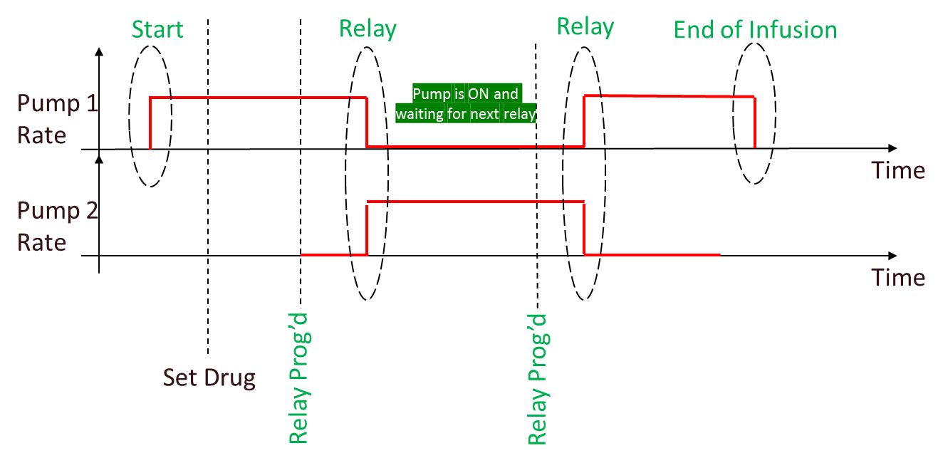

**Relay using 2 pumps / power off between Relay:**

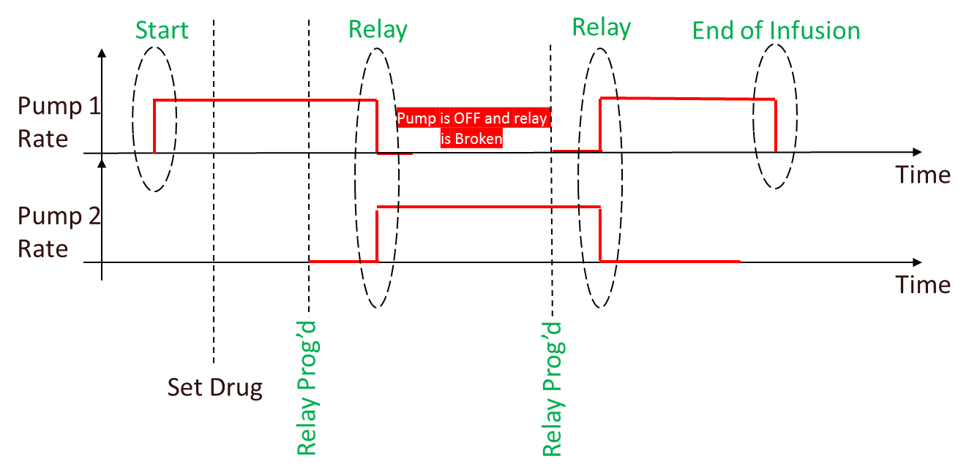

**Relay using 3 pumps:**

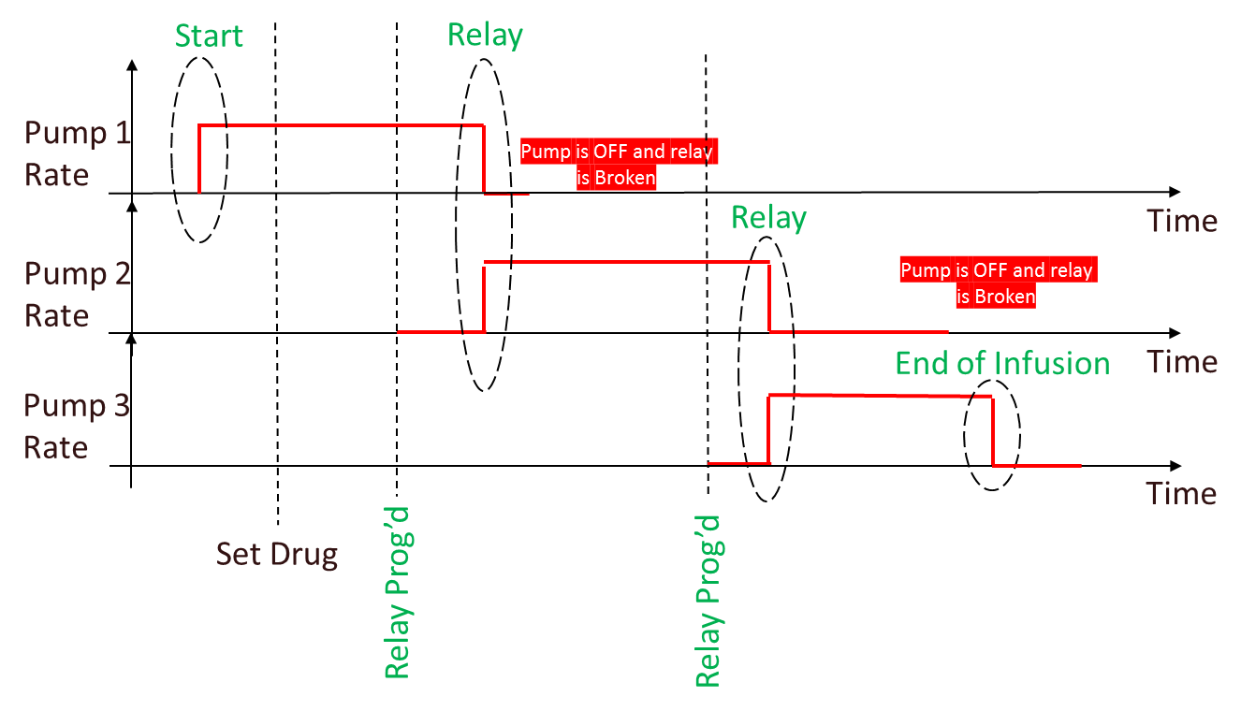

***Appendix X Infusion Pump Events***

***X.1.2.1 Infusion Event Parameters***

Add new terms in the **Table X.1.2.1-1: Mapping of Infusion Pump Event Parameters to MDC Codes**:

|  |  |
| --- | --- |
| **Parameter** | **MDC Code** |
| **Active Source Parameters:** | |
| Channel Relay State | **MDC_PUMP_RELAY_STATE** |
| Channel Relay GUID | **MDC_PUMP_RELAY_GUID** |

***Appendix X Infusion Pump Events***

***X.1.2.1 Infusion Event Parameters***

Add new terms in the **Table X.1.2.1-2: Infusion Pump Delivery Event Parameters**:

|  |  |
| --- | --- |
| **Parameter** | **Note** |
| Channel Relay State | Optional  See ENUM _ PUMP_RELAY_STATE below |
| Channel Relay GUID | Required if MDC_PUMP_RELAY_STATE is present and is different from pump-relay-none |

Enum for Channel Relay State: ENUM _PUMP_RELAY_STATE

* + **pump-relay-none**: pump not participating in a relay
  + **pump-relay-infusing**: pump infusing in a relay
  + **pump-relay-waiting**: pump programmed for a relay and waiting to take that relay
  + **pump-relay-complete**: pump has just been relayed, and is waiting to be powered off or prepared for next relay

Nota: if state is **pump-relay-none**:

* + - * The OBX is optional if there is/was no relay
      * The OBX is required if there was a relay and it has been broken for any reason

***Appendix X Infusion Pump Events***

***X.1.2.1 Infusion Event Parameters***

add the scenario to the **Table X.1.2.1-4: Clinical Scenarios**

|  |  |  |  |
| --- | --- | --- | --- |
| **Clinical Scenario** | **PCD-10 Event** | **Parameters** | **Discussion** |
| *Channel Relay*  An Infusion is already started.  **The Channel Relay is Programmed**  The Channel Relay Occurs  End of Channel Relay  Broken Relay | MDC_EVT_PUMP_PROG_RELAY | **Pump Delivery Info Parameters:**  Infusing Status=pump-status-infusing  Current Pump Fluid Flow=current rate  Pump Active Sources= pump-source-info-primary  **Active Source Parameters:**  Current Delivery Status=pump-delivery-status-delivering  Program Delivery Mode=pump-program-delivery-mode-continuous  Source Channel Label=vendor-specific  Rate=current rate  Dose Rate=current dose rate  Volume Programmed= initial volume in syringe  Current Segment Volume Delivered=volume delivered since last DELIV_START  Cumulative Volume Delivered=sum of “Current Segment Volume Delivered” values across all segments for the delivery, including the current one  Volume Remaining=current volume in syringe  Time Remaining=based upon Volume Remaining and Rate  Channel Relay State=pump-relay-infusing  Channel Relay GUID=guid | Infusing Pump |
| MDC_EVT_PUMP_PROG_RELAY | **Pump Delivery Info Parameters:**  Infusing Status=pump-status-not-infusing  Current Pump Fluid Flow=0  Pump Active Sources= pump-source-info-primary  **Active Source Parameters:**  Current Delivery Status=pump-delivery-status-not-delivering  Program Delivery Mode=pump-program-delivery-mode-continuous  Source Channel Label=vendor-specific  Rate=programmed rate  Dose Rate=programmed dose rate  Volume Programmed= initial volume in syringe  Current Segment Volume Delivered=0  Cumulative Volume Delivered=0  Volume Remaining=current volume in syringe  ~~Time Remaining=based upon Volume Remaining and Rate~~  Channel Relay State=pump-relay-waiting  Channel Relay GUID=same guid as other pump | Waiting Pump |
| *Channel Relay*  An Infusion is already started.  The Channel Relay is Programmed  **The Channel Relay Occurs**  End of Channel Relay | MDC_EVT_PUMP_DELIV_ STOP | **Pump Delivery Info Parameters:**  Infusing Status=pump-status-not-infusing  Current Pump Fluid Flow=pump reported rate  Pump Active Sources=pump-source-info-primary  **Active Source Parameters:**  Current Delivery Status=pump-delivery-status-not-delivering  Program Delivery Mode= pump-program-delivery-mode-continuous  Source Channel Label=vendor-specific  Rate=old rate  Dose Rate=old dose rate  Volume Programmed= initial volume in syringe  Current Segment Volume Delivered=volume delivered since last DELIV_START  Cumulative Volume Delivered=sum of “Current Segment Volume Delivered” values across all segments for the delivery, including the one just completed  Volume Remaining= current volume in syringe  Channel Relay State=pump-relay-complete  Channel Relay GUID=same guid as previously | Pump that finished relay |
| MDC_EVT_PUMP_DELIV_ START | **Pump Delivery Info Parameters:**  Infusing Status=pump-status-infusing  Current Pump Fluid Flow=current rate  Pump Active Sources=pump-source-info-primary  **Active Source Parameters:**  Current Delivery Status=pump-delivery-status-delivering  Program Delivery Mode= pump-program-delivery-mode-continuous  Source Channel Label=vendor-specific  Rate=programmed rate  Dose Rate=programmed dose rate  Volume Programmed= initial volume in syringe  Current Segment Volume Delivered=0  Cumulative Volume Delivered=0  Volume Remaining= current volume in syringe  Time Remaining=based upon Volume Remaining and Rate  Channel Relay State=pump-relay-infusing  Channel Relay GUID=same guid as previously | Pump that started relay |
| *Channel Relay*  An Infusion is already started.  The Channel Relay is Programmed  The Channel Relay Occurs  **End of Channel Relay**  Broken Relay | MDC_EVT_PUMP_DELIV_ COMP | **Pump Delivery Info Parameters:**  Infusing Status= pump-status-not-infusing  Current Pump Fluid Flow=pump reported rate  Pump Active Sources= pump-source-info-primary  **Active Source Parameters:**  Current Delivery Status= pump-delivery-status-not-delivering  Program Delivery Mode=pump-program-delivery-mode-continuous  Source Channel Label=vendor-specific  Rate=last rate  Dose Rate=last dose rate  Volume Programmed= initial volume in syringe  Current Segment Volume Delivered= volume programmed  Cumulative Volume Delivered=volume programmed  Volume Remaining=0 | Last Relay pump.  No other pump has been programmed for Relay |
| *Channel Relay*  An Infusion is already started.  A Relay is already programmed  **Broken Relay**  Example: The Waiting pump is removed | MDC_EVT_PUMP_PROG_RELAY | **Pump Delivery Info Parameters:**  Infusing Status=pump-status-infusing  Current Pump Fluid Flow=current rate  Pump Active Sources= pump-source-info-primary  **Active Source Parameters:**  Current Delivery Status=pump-delivery-status-delivering  Program Delivery Mode=pump-program-delivery-mode-continuous  Source Channel Label=vendor-specific  Rate=current rate  Dose Rate=current dose rate  Volume Programmed= initial volume in syringe  Current Segment Volume Delivered=volume delivered since last DELIV_START  Cumulative Volume Delivered=sum of “Current Segment Volume Delivered” values across all segments for the delivery, including the current one  Volume Remaining=current volume in syringe  Time Remaining=based upon Volume Remaining and Rate  Channel Relay State=pump-relay-none | Infusing Pump |
| MDC_EVT_COMM_STATUS_CHANGE | Communication status=comm-status-offline  Channel Relay State=pump-relay-none | Waiting Pump |

***TF Volume 3***

***7.1.3 Channel: Delivery :*** *add the following**to* ***Table 7.1.3-1: Infusor Delivery Channel Parameters***

|  |  |  |  |  |
| --- | --- | --- | --- | --- |
| **Infusor Delivery Channel Parameters** | | | | |
| **Name** | **Term Code** | **Data Type** | **Units** | **Values** |
| Channel Relay State | MDC_PUMP_RELAY_STATE | Enumeration::TEXT | N/A | “pump-relay-none”+”  “pump-relay-infusing”+”  “pump-relay-waiting”+”  “pump-relay-complete” |
| Channel Relay GUID | MDC_PUMP_RELAY_GUID | Numeric::INT- Type | N/A |  |