IHE Change Proposal

Tracking information:

|  |  |
| --- | --- |
| IHE Domain | Patient Care Device (PCD) |
| Change Proposal ID: | CP-PCD-156 |
| Change Proposal Status: | Submitted |
| Date of last update: | 2021-06-14 |
| Person assigned: | Kurt Elliason |

Change Proposal Summary information:

|  |  |
| --- | --- |
| Correcting information in section 3.3.4.4.10.2 Bolus from existing infusion. | |
| Submitter’s Name(s) and e-mail address(es): | Kurt Elliason  kurt.elliason@smiths-medical.com |
| Submission Date: | 2021-06-14 |
| Integration Profile(s) affected: | Point of Care Infusion Verification (PIV) |
| Actor(s) affected: | Infusion Order Programmer (IOP) and Infusion Order Consumer (IOC) |
| IHE Technical Framework or Supplement modified: | PIV profile in Technical Framework Framework, Revision 9.0, Dec 12, 2019 |
| Volume(s) and Section(s) affected: | IHE PCD TF Vol 2,  3.3.4.4.10.2 |
| Rationale for Change:  The table shown below is in section 3.3.4.4.10.2 of Volume 2 of the technical framework. The heading in columns 7 and 8 along with the descriptive text below the table are incorect. The table is also missing a use case for Dose or Volume only. | |

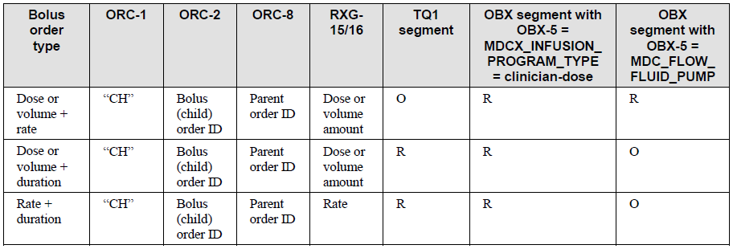

**Need to correct table in TF Vol 2 section 3.3.4.4.10.2**

The heading in Col 7 to be changed from:

*OBX segment with OBX-5 = MDCX_INFUSION_PROGRAM_TYPE = clinician-dose*

To:

*OBX segment with OBX-3 = MDCX_INFUSION_ ORDER_TYPE w/OBX-5 = clinician-dose*

The heading in Col 8 should be changed from:

*OBX segment with OBX-5 = MDC_FLOW_ FLUID_PUMP*

To:

*OBX segment with OBX-3 = MDC_FLOW_ FLUID_PUMP*

Insert a new 3rd row in the table above Rate + Duration as follows.

|  |  |  |  |  |  |  |  |
| --- | --- | --- | --- | --- | --- | --- | --- |
| Dose or volume | “CH” | Bolus (child) order ID | Parent order ID | Dose or volume amount | O | R | O |

The second bullet in the "OBX segment" section near line 1070 to be changed from :

*OBX-5 = MDCX_INFUSION_ORDER_TYPE. This term has enumerations “clinician-dose”, “loading-dose”, and “continuous”.*

To :

*OBX-3 = MDCX_INFUSION_ORDER_TYPE. This term has enumerations in OBX-5 of “clinician-dose”, “loading-dose”, or “continuous”.*

The third bullet in the "OBX segment" section near line 1070 to be changed from :

*When RXG-15 and RXG-16 specify a dose, include an OBX segment specifying the rate where OBX-5 = MDC_FLOW_FLUID_PUMP.*

To:

*When RXG-15 and RXG-16 specify a dose or a volume, any of the following three options are allowed:*

* *include an OBX segment specifying the rate where OBX-3 = MDC_FLOW_FLUID_PUMP and OBX-5 = the desired rate*
* *include a TQ1 segment*
* *neither rate or duration is explicitly specified resulting in pump using predefined rate or duration determined by pump or operator.*