IHE Change Proposal

Tracking information:
IHE Domain | Patient Care Device (PCD)
Change Proposal ID: | CP-PCD-155
Change Proposal Status: | Submitted
Date of last update: | 2021-05-012
Person assigned: | Tom Kowalczyk

Change Proposal Summary information:
Adding information regarding alert fatigue
Submitter’s Name(s) and e-mail address(es): | Tom KOWALCZYK  Tom.Kowalczyk@BBraunUSA.com
Submission Date: | 2021-05-03
Integration Profile(s) affected: | Infusion Pump Event Communication (IPEC) and  Device Enterprise Communication (DEC)
Actor(s) affected: | Device Observation Reporter (DOR) and  Device Observation Consumer (DOC)
IHE Technical Framework or Supplement modified: | IPEC & DEC profiles in Technical Framework Framework, Revision 9.0, Dec 9, 2019
Volume(s) and Section(s) affected: | IHE PCD TF Vol 2,  Containment Tree
Rationale for Change:
Some infusion pump models can be inserted into pump pillars consisting of one or more connected pump racks that stack either vertically or horizontally. In addition, these pump pillars can also be connected with a cable to other pillars in a daisy chain fashion.
When this is done, it is useful to know into which pillar (1..n) and slot (1..m), and possibly which rack, a specific pump has been inserted, where “n” is the number of pillars and “m” is the number of slots within the designated pillar. Each of the connected pillars need not have the same number of slots (eg. Pillar 1 can have 8 slots (2 racks of 4 pumps slots); Pillar 2: 12 slots (3 racks of 4); Pillar 3:4 slots (1 rack of 4) …)
When reporting pump infusion status for a pump in a pillar, its pillar, slot & possibly rack location will also be included in the PCD transaction along with all of the other information defined for PCD-01 and PCD-10 transactions.

Appendix M Definition of Pillar/Rack/Slot topology. A pump can be inserted into exactly one Slot within one Rack contained within one Pillar.

Definitions:

Rack: An enclosure which can house two or more pumps. Each rack can be directly connected to one or more racks to make up a “pillar”.
NOTE: In the examples shown below, each rack is able to hold four pumps.

Slot: One pump position in a rack within its containing pillar. Its index can be relative to a single rack or the entire pillar.

Pillar: A stack of one or more racks. Each pillar can be attached to a subsequent pillar in a daisy chain fashion. The examples below show two pillars. The connection between these are not shown in the diagrams.

Pillar Orientation: Racks that stack in an up/down direction is called a Vertical orientation.
Racks that stack in a left/right direction is called a Horizontal orientation

Pillar (Increasing) Direction: When counting pillars up from one, this is the direction where the count starts from and counts toward. For a Vertical pillar orientation, the Pillar Increasing Direction can be Left or Right; for a Horizontal pillar orientation, the Pillar Increasing Direction can be Up or Down.

Slot & Rack (Increasing) Direction: When counting pump slots (&racks) up from one, this is the direction where the count starts from and counts toward. For a Vertical pillar orientation, the Slot Increasing Direction can be Up or Down; for a Horizontal pillar orientation, the Slot Increasing Direction can be Left or Right.

MDC_ATTR_ PILLAR_ASSEMBLY –
(Number of Pillars, Number of Racks In Pillars, Number of Slots in Pillars, Pillar Orientation, Pillar Direction, Slot-Rack Direction)

Parameter | MDC Code
MDS Attribute:
Specification of the number, size, and orientation of pillars and their indexing directions | MDC_ATTR_PILLAR_ASSEMBLY

Parameter | Note
Number of Pillars | Optional - If a pump resides in a Pillar, this field may contain the number of Pillars present in the pillar system.
Number of Racks In Pillars | Optional – ARRAY of “Number of Pillars” entries  If a pump resides in a Pillar, this field may contain the number of Racks present in each Pillar in the system.
Number of Slots in Pillars | Optional – ARRAY of “Number of Pillars” entries  If a pump resides in a Pillar, this field may contain the number of Pump Slots present in each Pillar in the system.
Pillar Orientation | Optional – If a pump is contained within a pillar, this value may be populated with an ENUM value:  Vertical pillar-orientation-vertical  Horizontal pillar-orientation-horizontal
Pillar Direction | Optional – If a pump is contained within a pillar, this value may be populated with an ENUM value:  Up… pillar-direction-up  Down pillar-direction-down  Left pillar-direction-left  Right pillar-direction-right
Slot-Rack Direction | Optional – If a pump is contained within a pillar, this value may be populated with an ENUM value:  Up… slot-rack-direction-up  Down slot-rack-direction-down  Left slot-rack-direction-left  Right slot-rack-direction-right

Appendix M, Specifying a pump location within a Pillar (and Rack)

MDC_ATTR_PUMP_PILLAR_DETAILS –
(Pillar Index, Rack Index, Rack Slot Index, Pillar Slot Index)

Parameter | MDC Code
VMD Attribute:
Location of pump in a Pillar | MDC_ATTR_PUMP_PILLAR_DETAILS

Parameter | Note
Pillar Index | Optional  If a pump resides in a Pillar, this field must contain which pillar the pump is located in.
Rack Index | Optional – If a pump resides in a Pillar, it must also be contained within a Rack, since Pillars consist of one or more Racks. If this field is populated, “Rack Slot Index” must also be populated to specify a unique location within the entire Pillar topology. It indicates which Rack within the specified Pillar that the pump is located in. If rack position is not tracked, this field may be NA.  If this field is specified, “Pillar Slot Index” must be NA.  Only one of the two ways to indicate pump position within a Pillar can be populated with non-NA values:  Both “Rack Index” and “Rack Slot Index” or  “Pillar Slot Index”
Rack Slot Index | Optional – If a pump resides in a Pillar, it must also be contained within a Rack since Pillars consist of one or more Racks. If this field is populated, “Rack Index” must also be populated to specify a unique location within the entire Pillar topology. It indicates which position within the specified Rack and Pillar the pump is located in. . If “Rack Index” is NA, this field must also be NA.  If this field is specified, “Pillar Slot Index” must also be NA.  Only one of the two ways to indicate pump position within a Pillar can be populated with non-NA values:  Both “Rack Index” and “Rack Slot Index” or  “Pillar Slot Index”
Pillar Slot Index | Optional – If a pump is contained within a Pillar, this field indicates which position it is located in within that Pillar.  If this field is specified, “Rack Index” and “Rack Slot Index” must be NA.  Only one of the two ways to indicate pump position within a Pillar can be populated with non-NA values:  Both “Rack Index” and “Rack Slot Index” or  “Pillar Slot Index”

Enum: Pillar Orientation ENUM_PILLAR_ORIENTATION
• pillar-orientation-vertical: pillar consists of pumps/racks that are stacked vertically
• pillar-orientation-horizontal: pillar consists of pumps/racks that are stacked horizontally

Enum: Pillar Direction ENUM_PILLAR_DIRECTION
• pillar-direction-up: pillar indexing increments in the “up” direction
• pillar-direction-down: pillar indexing increments in the “down” direction
• pillar-direction-right: pillar indexing increments from left to right
• pillar-direction-left: pillar indexing increments from right to left

Enum: Slot-Rack Direction ENUM_SLOT_RACK_DIRECTION
• slot-rack-direction-up: pump slot/rack indexing increments in the “up” direction
• slot-rack-direction-down: pump slot/rack indexing increments in the “down” direction
• slot-rack-direction-right: pump slot/rack indexing increments from left to right
• slot-rack-direction-left: pump slot/rack indexing increments from right to left

For the following diagram, the following settings apply:

MDC_ATTR_PILLAR_ASSEMBLY (2, (3,2), (12,8), pillar-orientation-vertical, pillar-direction-right, slot-rack-direction-up)

Pillars – 2, Number Racks – (3,2), Number Slots – (12, 8)
2 connected pillars present Pillar 1 has 3 Racks; Pillar 1 has 12 Slots
Pillar 2 has 2 Racks Pillar 2 has 8 Slots
Pillar Orientation - VERTICAL, Pillar Direction – RIGHT, Slot-Rack Direction – UP

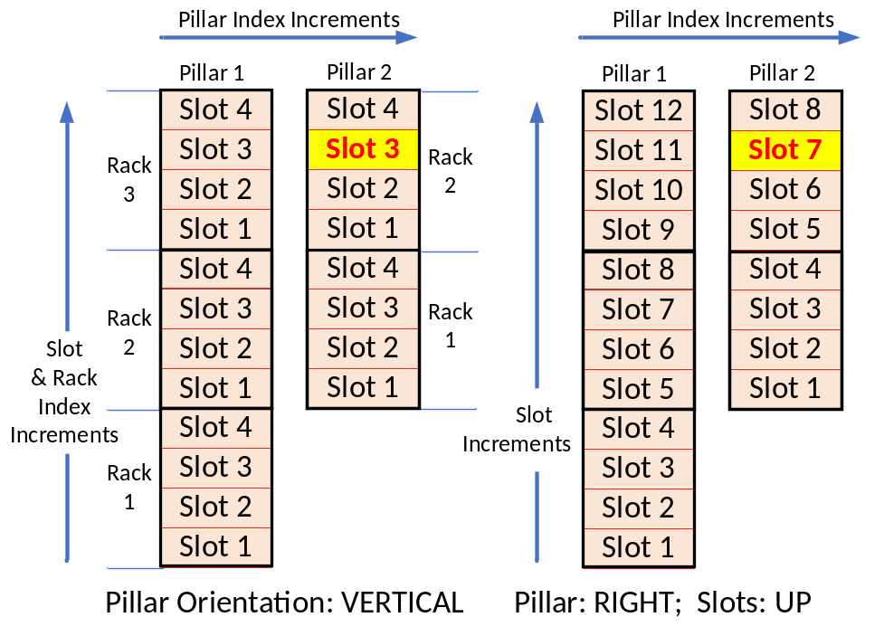
The slot highlighted above would have the following values…

MDC_ATTR_PUMP_PILLAR_DETAILS (2, 2, 3, NA)
Pillar 2, Rack 2, Rack Slot 3, Pillar Slot - NA

MDC_ATTR_PUMP_PILLAR_DETAILS (2, NA, NA, 7)
Pillar 2, Rack NA, Rack Slot NA, Pillar Slot – 7

For the following diagram, the following settings apply:

MDC_ATTR_PILLAR_ASSEMBLY (2, (3,2), (12,8), pillar-orientation-vertical, pillar-direction-right, slot-rack-direction-down)

Pillars – 2, Number Racks – (3,2), Number Slots – (12, 8)
2 connected pillars present Pillar 1 has 3 Racks; Pillar 1 has 12 Slots
Pillar 2 has 2 Racks Pillar 2 has 8 Slots
Pillar Orientation - VERTICAL, Pillar Direction – RIGHT, Slot-Rack Direction – DOWN

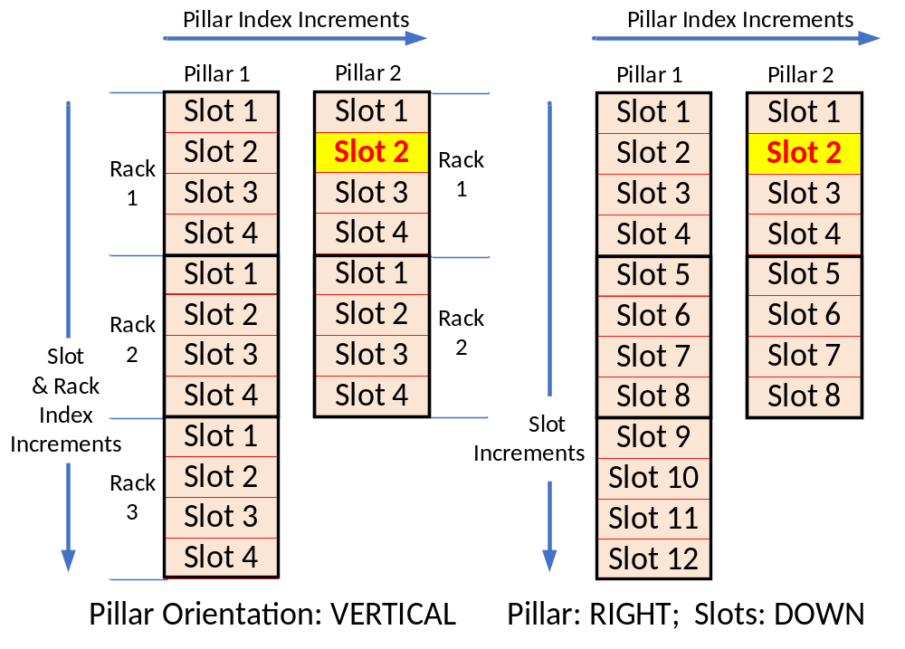

The slot highlighted above would have the following values…

MDC_ATTR_PUMP_PILLAR_DETAILS (2, 1, 2, NA)
Pillar 2, Rack 1, Rack Slot 2, Pillar Slot - NA

MDC_ATTR_PUMP_PILLAR_DETAILS (2, NA, NA, 2)
Pillar 2, Rack NA, Rack Slot NA, Pillar Slot - 2

For the following diagram, the following settings apply:

MDC_ATTR_PILLAR_ASSEMBLY (2, (3,2), (12,8), pillar-orientation-horizontal, pillar-direction-down,
slot-rack-direction-right)

Pillars – 2, Number Racks – (3,2), Number Slots – (12, 8)
2 connected pillars present Pillar 1 has 3 Racks; Pillar 1 has 12 Slots
Pillar 2 has 2 Racks Pillar 2 has 8 Slots
Pillar Orientation - HORZONTAL, Pillar Direction – DOWN, Slot-Rack Direction – RIGHT

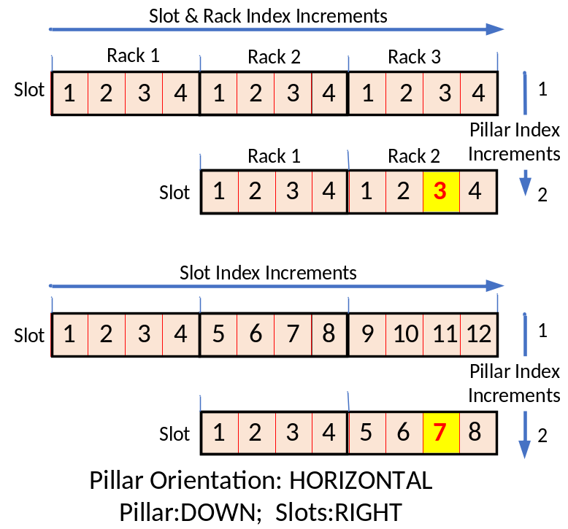

The slot highlighted above would have the following values…

MDC_ATTR_PUMP_PILLAR_DETAILS (2, 2, 3, NA)
Pillar 2, Rack 2, Rack Slot 3, Pillar Slot - NA

MDC_ATTR_PUMP_PILLAR_DETAILS (2, NA, NA, 7)
Pillar 2, Rack NA, Rack Slot NA, Pillar Slot - 7

For the following diagram, the following settings apply:

MDC_ATTR_PILLAR_ASSEMBLY (2, (3,2), (12,8), pillar-orientation-horizontal, pillar-direction-up, slot-rack-direction-left)

Pillars – 2, Number Racks – (3,2), Number Slots – (12, 8)
2 connected pillars present Pillar 1 has 3 Racks; Pillar 1 has 12 Slots
Pillar 2 has 2 Racks Pillar 2 has 8 Slots
Pillar Orientation - HORIZONTAL, Pillar Direction – UP, Slot-Rack Direction – LEFT

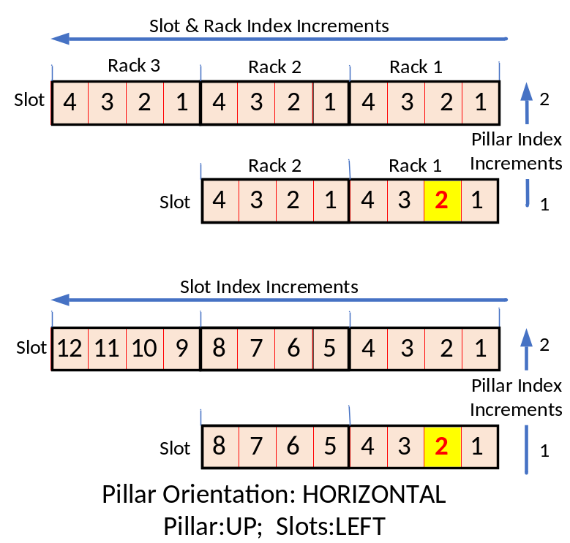

The slot highlighted above would have the following values…

MDC_ATTR_PUMP_PILLAR_DETAILS (1, 1, 2, NA)
Pillar 1, Rack 1, Rack Slot 2, Pillar Slot - NA

MDC_ATTR_PUMP_PILLAR_DETAILS (1, NA, NA, 2)
Pillar 1, Rack NA, Rack Slot NA, Pillar Slot - 2

