

The first general purpose crypto currency with Hybrid Consensus Algorithm, Dynamic Zerocoin Proof-of-Stake, Proof-of-Transaction and Masternode voting for period based reward burning

**WHITE PAPER V1.10**

Maik Broemme1, May 2019

**TABLE OF CONTENTS**

Executive Summary 3

Introduction 3

Galilel Coin 3

Problems and Solutions 4

Dynamic Zerocoin Proof-of-Stake (dzPoS) 4

Proof-of-Transaction (ghPoT) 6

Hybrid Proof-of-Stake (ghPoS) 7

Term Deposits (gTD) 9

Money Supply Control (gMSC) 10

Instant On Masternodes (gIOMN) 12

Features and Specifications 13

Competitive Analysis 16

Development Roadmap 18

Help 20

Important Links 21

Appendix 22

# EXECUTIVE SUMMARY

While fiat money has defined and proved economic standards for hundreds of years already, the situation with digital money is different. Digital money is a high-risk investment with unpredictable value and disappearing development teams leaving orphaned blockchains. Governments identified this problem and Initial Coin Offering (ICO) regulations will solve it in the next few years. Moreover, the digital currencies, which implement unique blockchain features, have a high probability to define the future standards of digital money. Galilel will be part of this process through implementing the unique features outlined in this paper.

# INTRODUCTION

Galilel Coin is a community driven crypto currency with full transparency and utilizing a public development method. The trust relationship between investors and the project team is the key to success. Therefore, we have created a GitHub organization named *Galilel-Project2*, which tracks all our development activities in public repositories including all our backend code and passed *Know Your Developer (KYD)3* public verification. The project uses mostly *MIT4*, *GPLv35* and *CC-BY-NC 4.06* open source and open content licenses. The translation and localization uses *Transifex7* platform.

# GALILEL COIN

Galilel Coin (GALI and zGALI) is an open-source public and private Proof-of-Stake digital crypto currency for fast (using SwiftX), private (*Zerocoin8* protocol) and secure micro transactions. Our main goal is to create a decentralized fully secure and anonymous network to run applications, which do not rely on any central body control. By having a distributed system, thousands of users will be responsible for maintaining the application and data so that there is no single point of failure.

# PROBLEMS AND SOLUTIONS

The blockchain technology hype generates huge interest, gaining popularity around the globe and is in use by many companies for different purposes beside digital money. However using it, as base for payment services require specific features to validate, store and verify thousands of transactions. While this is already solved using existing consensus algorithm to generate blocks in the chain, there exist several weak areas in current blockchain implementations to achieve mainstream adoption of digital money.

# DYNAMIC ZEROCOIN PROOF-OF-STAKE (dzPoS)

Zerocoin Proof-of-Stake (zPoS) was the most innovative blockchain feature introduced in 2018 by the PIVX development team. However, the technical implementation done in a specific way for their blockchain and does not allow easy adoption to others as their reward structure is statically included in the source code.

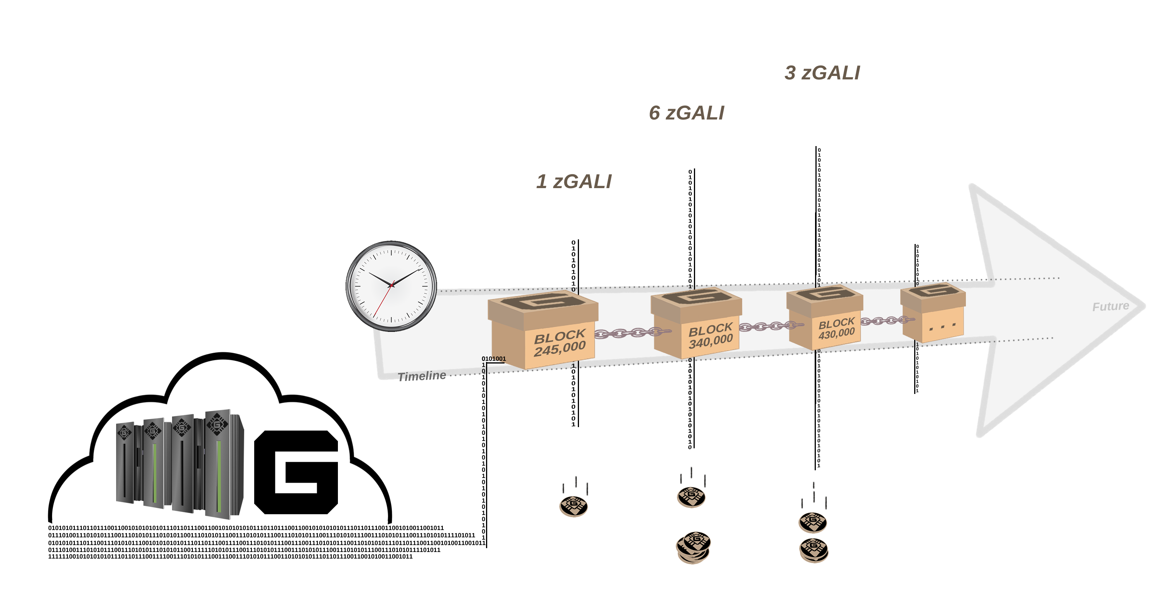

Figure 1. Dynamic Zerocoin Proof-of-Stake reward based on blockchain phase.

In Galilel, we implement a dynamic version of Zerocoin staking. Zerocoin staking generates rewards in denominations, which represent an integer value. The smallest possible denomination is **one [1]**. In the first version – warmup phase – we always use the smallest denomination value for testing purposes. The drawback of this approach is that Zerocoin staking is very CPU intensive and probability to generate an orphan block is higher as a public coin stake can solve the block later but distribute it to the chain earlier. In the second version – full phase – we auto determine the best denomination structure based on the block reward amount. This significantly reduces the probability to generate orphan blocks.

# PROOF-OF-TRANSACTION (ghPoT)

In traditional economics with money transfers between bank accounts, it is possible to specify a subject so that the recipient can assign the amount to a specific invoice. It is not possible in current wallet implementations. It allows specifying a comment or comment-to value, which is not part of the transaction and only stored locally. To assign an invoice to a particular payee it is necessary to create a wallet address with a one-to-one mapping between both stakeholders.

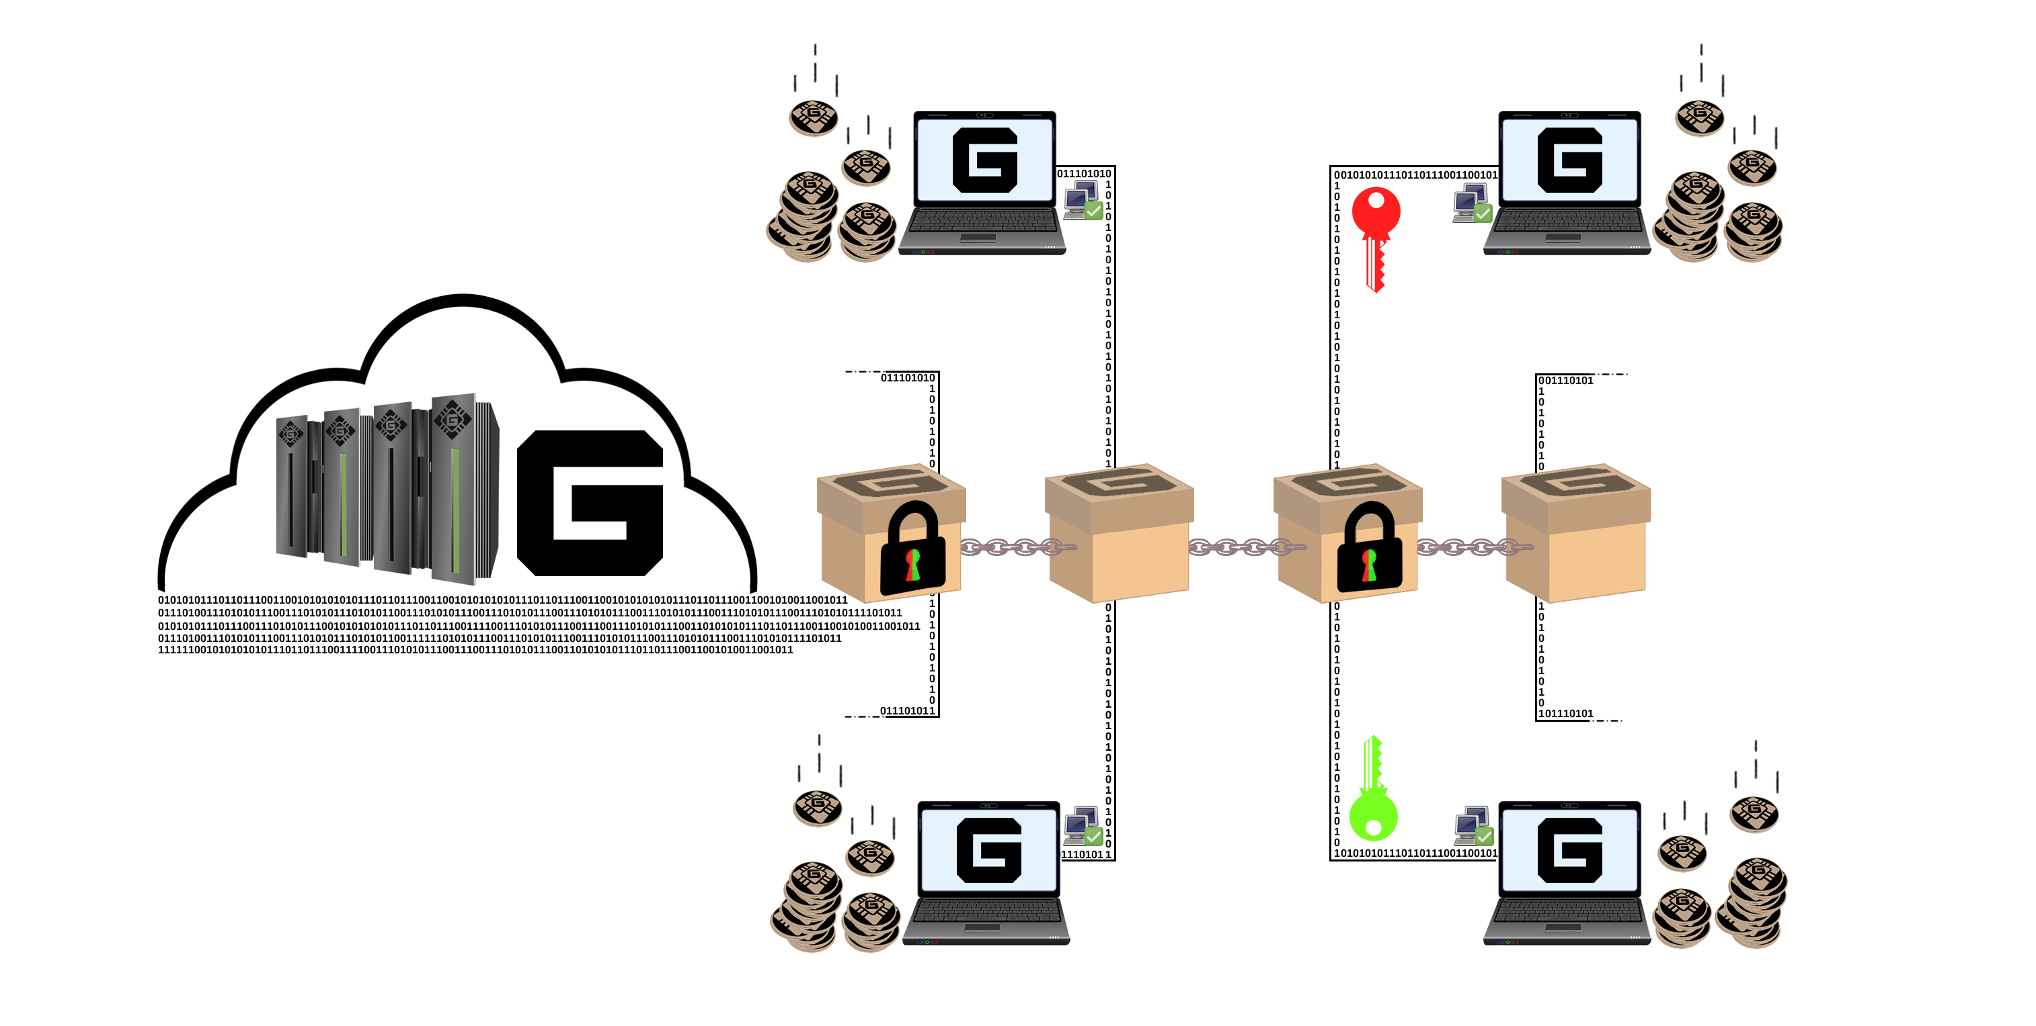

Figure 2. Proof-of-Transaction with encrypted subject.

In Galilel, we include an additional data field and attach it to the transaction, which is stored in the block. It is an encrypted field and decryption is only possible by the wallets, which negotiated the transaction. It solves the transaction assignment problem and allows payment-processing gateways to identify the payee of an invoice as it is with traditional fiat invoices.

# HYBRID PROOF-OF-STAKE (ghPoS)

While Proof-of-Stake (PoS) is an environmentally friendly consensus algorithm, it creates rewards only as long as the desktop wallet is running. One solution to this problem is to sign-up to any shared Proof-of-Stake pool and stake in the cloud. However, the disadvantage is that user need to trust the staking pool and transfer specific amount of coins to it. It can lead to situation that huge amount of coins are stored in a few wallets. This is a weak situation for a decentralized network approach and is a fundamental part to reach consensus. Private staking, so called Zerocoin Proof-of-Stake (zPoS), has the same problems and limitations.

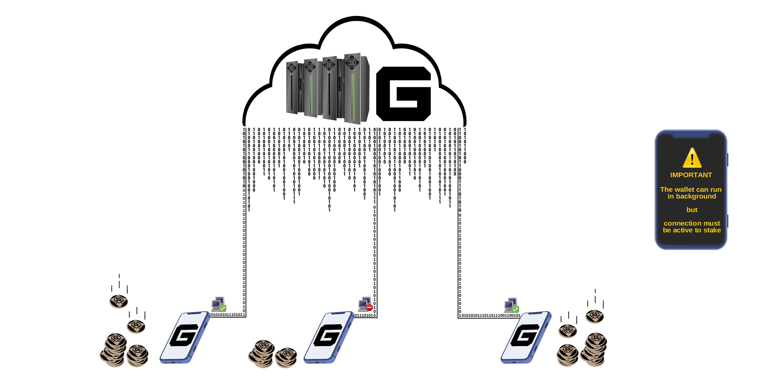

Figure 3. Possible ways to earn rewards from Galilel network.

In Galilel, the solution to this problem will be a complete hybrid consensus algorithm named Galilel Hybrid Proof-of-Stake (ghPoS). We will extend Proof-of-Stake with mobile staking capabilities for both public and private staking. Mobile staking is always on with **ten [10]** percent of the block reward paid out if mobile wallet finds a block. In this case **ninety [90]** percent paid out to masternode holder. The mobile wallets will work as a light node of the blockchain with minimum amount of blocks equal to the reorganization depth.

|  |  |  |
| --- | --- | --- |
| **HYBRID PROOF-OF-STAKE REWARD STRUCTURE** | | |
| STAKING TYPE1 | STAKING | MASTERNODE |
| Online (GALI) | 30% | 70% |
| Online (zGALI) | 60% | 40% |
| Mobile (GALI) | 10% | 90% |
| Mobile (zGALI) | 20% | 80% |

1 Calculation is based on 5 GALI reward > block 430,000

# TERM DEPOSITS (gTD)

While mobile staking is dependent from network difficulty and amount of staked coins, the *Term Deposit9* function allow to lock coins for a certain period and generate rewards.

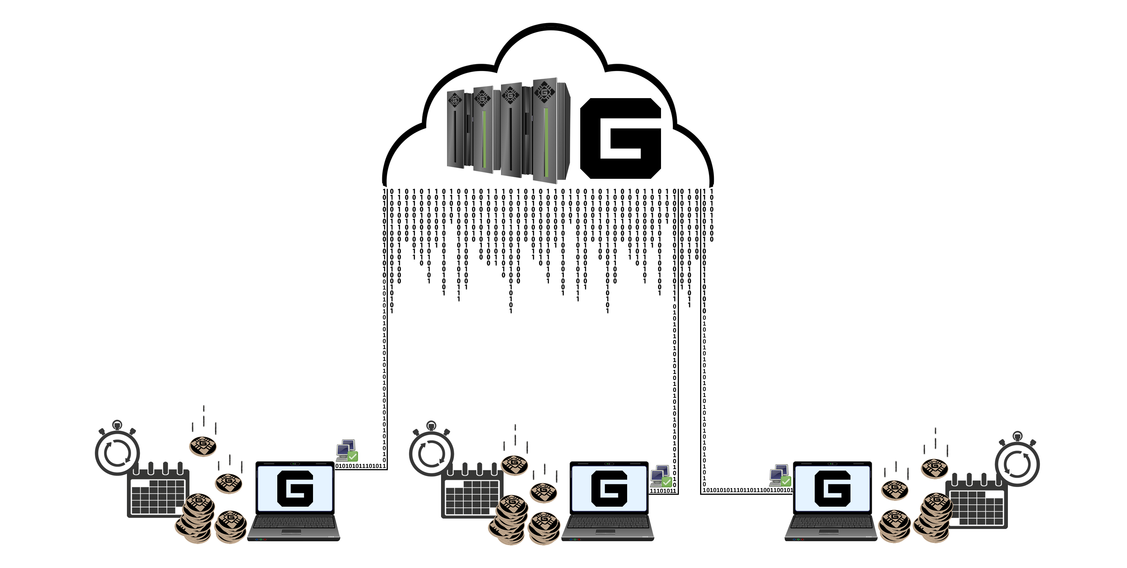

Figure 4. Calendar based term deposit in an offline wallet.

The minimum required amount of coins to use Galilel Term Deposit (gTD) is **five thousand [5,000]** GALI. The lock period is **one [1]** year. The block reward is **ten [10]** percent and locked coins of different wallets are weighted. With a new block in the network, wallets with locked coins get the amount according to their weight. Until Term Deposit period ends this reward is locked. Once locked, moving or spending coins for purchases is impossible, cancellation of term deposit before expiration time is impossible. This will effectively reduce the coin supply during the lock period.

# MONEY SUPPLY CONTROL (gMSC)

Inflation control is the most challenging part for digital money to be recognized and accepted as alternative to fiat money. Without any controlling mechanism, the value of any digital money is unpredictable. This leads to situation when investors’ starts betting on the value and this can seriously damage the market within hours and immediately eliminates the possibility to push digital money into market as accepted payment option. With inflation control, we believe that people outside the digital money sphere are attracted to use it, as there is no need to look every day at their portfolio. Unlike central banks in case of fiat money, there will be no central place for watching and maintaining money supply. In Galilel, we implement a decentralized approach to burn coins, so called *Proof-of-Burn10* mechanism for private and public staked coins. While this is one necessary step to control money circulation, masternode owners get the possibility to vote for reward reduction or complete burning for a specific period to reduce coin generation.

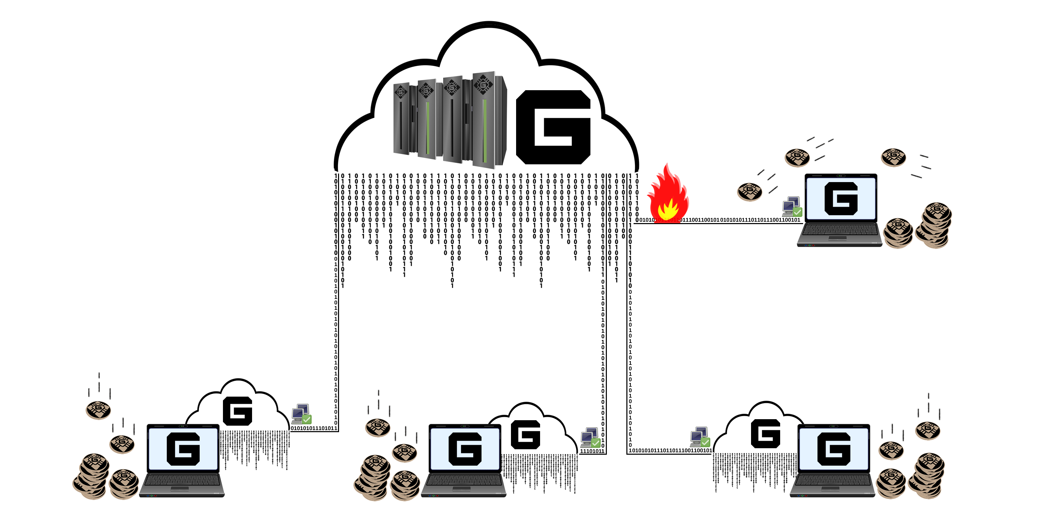

Figure 5. Masternode voting to reduce reward generation.

We name it Galilel Money Supply Control (gMSC), effectively Proof-of-Burn v2. This mechanism burns only rewards, never term deposits and development budget. The period for coin burning will be **one [1]** month, in steps described in reward burning structure table decreasing annual supply. Masternode owners are applicable to vote every month. The proposal can be made once a month, starting **one [1]** week before current reward burning period ends. The blockchain accepts any proposal starting from **thousand [1000]** GALI. Once proposal distributed in the blockchain, masternode owners can vote with spending additional **one [1]** or more GALI. The proposal with the highest amount of coins and with more than **fifty [50]** percent of masternode votes after proposal period ends, will win. If proposal period ends and is accepted, coins locked in proposals are burned and reward-burning period starts from next burn block. If minimum requirements for proposal acceptance not reached, locked coins will be unlocked.

|  |  |
| --- | --- |
| **REWARD BURNING STRUCTURE** | |
| BURN PERCENTAGE | BURN AMOUNT PER MONTH1 |
| 25% | 54,750 GALI |
| 50% | 109,500 GALI |
| 75% | 164,250 GALI |
| 100% | 219,000 GALI |

1 Calculation is based on 5 GALI reward > block 430,000

# INSTANT ON MASTERNODES (gIOMN)

Masternodes gained already a lot of attraction in digital money sphere. While many new digital crypto currencies try to create ridiculous high return of investment (ROI) coins and fail after coin inflation kicks in as well as having unbalanced reward distribution between masternodes and staking wallets, this is not the main purpose for running a masternode. In Galilel, the main use-case for masternodes is securing the network while having the opportunity to vote of future development aspects as well as maintaining coin circulation. However, the main weak point for available masternode implementations is the requirement to have the blockchain synced and indexed on each machine acting as a masternode.

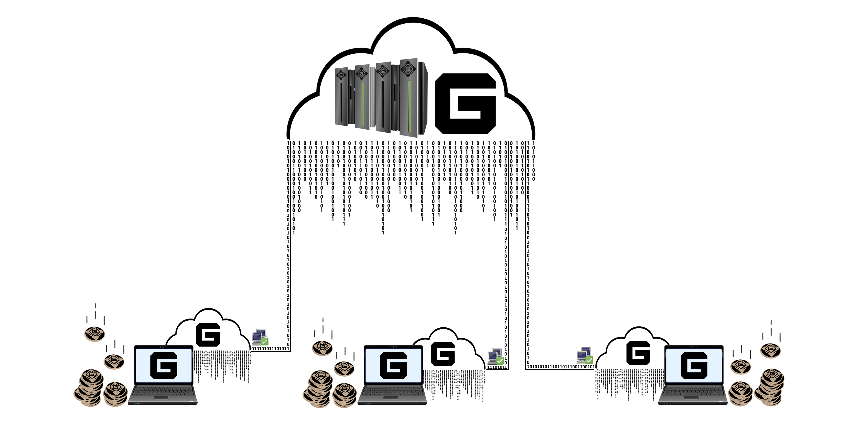

Figure 6. Multiple masternodes connected to single blockchain in the Cloud.

Galilel Instant On Masternode (gIOMN) solves this problem by implementing a shared blockchain to run *one-to-many11* wallet daemons in a client server model. It is comparable to “Instant On” model available in *Electrum12* client.

# FEATURES AND SPECIFICATIONS

|  |  |
| --- | --- |
| **COIN SPECIFICATIONS** | |
| Coin Name | Galilel |
| Coin Ticker | GALI |
| Hash Algorithm | Quark |
| Consensus Algorithm | PoS + zPoS Hybrid |
| Block Size | 2 MB |
| Block Time | 60 Seconds (Re-targeting every block) |
| RPC Port | 36002 |
| P2P Port | 36001 |
| Type | PoW / PoS / zPoS / MN |
| Minimum Staking Age | 2 Hours |
| Maturity | 120 confirmations |
| Send Eligibility | 6 confirmations |
| Rewards (till block 1,500) | MN 60%, PoW 40% |
| Rewards (till block 205,000) | MN 60%, PoS 40% |
| Rewards (from block 205,001) | MN 70%, PoS 30% |
| Last PoW Block | 1,500 |
| Masternode Collateral | 15,000 |
| Max Coin Supply (January 2020) | 19,035,999 GALI |
| Max Coin Supply (January 2030) | 45,315,999 GALI |
| Max Coin Supply (January 2040) | 71,595,999 GALI |
| Max Coin Supply (January 2050) | 97,875,999 GALI |
| Dynamic Coin Supply | Transaction fees & zGALI minting fees are burnt |
| Community Donation Address | [UUr5nDmykhun1HWM7mJAqLVeLzoGtx19dX](https://explorer.galilel.cloud/address/UUr5nDmykhun1HWM7mJAqLVeLzoGtx19dX) |
| Dev Budget (from block 250,001) | 10% in monthly superblock |

|  |  |
| --- | --- |
| **ZEROCOIN SPECIFICATIONS** | |
| Zerocoin v1 activation | block 245,000 |
| Zerocoin v2 activation | block 245,000 |
| zGALI Automint | 10% |
| zGALI Rewards (from block 245,001) | 1 zGALI |
| zGALI Rewards (from block 340,001) | MN 40%, zPoS 60% |
| zGALI Rewards (from block 430,001) | MN 40%, zPoS 60% |
| zGALI Denominators | 1, 5, 10, 50, 100, 500, 1000, 5000 |
| Accumulator Modulus | RSA-2048 |
| Maturity | 240 confirmations |
| Send Eligibility | 20 confirmations |
| Fees (mint) | 0.01 GALI per minted zGALI denomination |
| Fees (spend) | No fee |

|  |  |  |  |  |  |  |
| --- | --- | --- | --- | --- | --- | --- |
| **PROOF-OF-WORK REWARDS BREAKDOWN** | | | | | | |
| BLOCK HEIGHT | REWARD | MN | POW | SUPPLY | PERIOD | STAGE END |
| Block 1 | 220,000 | 60% | 40% | 220,000 | 0 days | 2018-05-25 |
| Block 2 – 1,500 | 1 | 60% | 40% | 221,499 | 1 day | 2018-05-26 |

|  |  |  |  |  |  |  |  |
| --- | --- | --- | --- | --- | --- | --- | --- |
| **PROOF-OF-STAKE REWARDS BREAKDOWN** | | | | | | | |
| STAGES | BLOCK HEIGHT | REWARD | MN | POS | SUPPLY | PERIOD | STAGE END |
| Stage 1 | 1,501-12,000 | 100 | 60% | 40% | 1,271,399 | 7 days | 2018-06-02 |
| Stage 2 | 12,001-22,000 | 90 | 60% | 40% | 2,171,309 | 7 days | 2018-06-09 |
| Stage 3 | 22,001-42,000 | 80 | 60% | 40% | 3,771,229 | 14 days | 2018-06-23 |
| Stage 4 | 42,001-100,000 | 70 | 60% | 40% | 7,831,159 | 40 days | 2018-08-02 |
| Stage 5 | 100,001-160,000 | 60 | 60% | 40% | 11,431,099 | 42 days | 2018-09-13 |
| Stage 6 | 160,001-205,000 | 50 | 60% | 40% | 13,681,049 | 31 days | 2018-10-14 |
| Stage 7 | 205,001-250,000 | 25 | 70% | 30% | 14,806,024 | 31 days | 2018-11-14 |
| Stage 8 | 250,001-340,000 | 13.5 | 70% | 30% | 16,156,009 | 62 days | 2019-01-15 |
| Stage 9 | 340,001-430,000 | 10 | 70% | 30% | 17,055,999 | 62 days | 2019-03-18 |
| Stage X | 430,001-ongoing | 5 | 70% | 30% | ongoing | ongoing | ongoing |

# COMPETITIVE ANALYSIS

Every day new digital crypto currency projects are born, mostly service currencies for a specific purpose. While it is a valid scenario, it limits the use case of the coin to a particular market and size. In the end, it limits the currency value. The market of crypto currencies sharing the same set of features with different amount of digital money and different block rewards is oversaturated. In the past, some projects with unique ideas and a bright future were born. Galilel will continue this trend and improve blockchain used for digital money while building an easy to use general-purpose crypto currency for mass adoption in the market.

|  |  |  |  |  |
| --- | --- | --- | --- | --- |
| **FEATURE** | **GALILEL** | **DASH** | **PIVX** | **ROI COIN** |
| Public Staking |  |  |  |  |
| Private Staking |  |  |  |  |
| Instant Send |  |  |  |  |
| Private Send |  |  |  |  |
| Masternodes |  |  |  |  |
| Decentralized Governance Voting |  |  |  |  |
| Variable Reward Distribution1 |  |  |  |  |
| Dynamic Zerocoin Proof-of-Stake |  |  |  |  |
| Proof-of-Transaction |  |  |  |  |
| Variable Reward Burning |  |  |  |  |
| Disconnected Blockchain |  |  |  |  |
| Mobile Proof-of-Stake |  |  |  |  |
| Term Deposits |  |  |  |  |

1 Possible to implement in Galilel using Seesaw algorithm

# DEVELOPMENT ROADMAP

The development of Galilel Coin is critical for the blockchain of the future. Some code has already been written and is in internal testing. The Galilel Instant On Masternode (gIOMN) feature is near completion while Galilel Hybrid Proof-of-Stake (ghPoS) require additional development and testing cycles after planned Zerocoin v2 activation at block 245,000. Our roadmap includes mainly development items only; we believe that it is necessary to define proper goals, expectations and deliverables rather than putting fine-tuned marketing items to it.

* 2018 – Fork PIVX codebase and launch MAINNET. Creating *Discord13* channel for community voting and pre-announcement in *BitcoinTalk14* forum.
* 2018 – Listing on first exchange and ranking sites. Implementing community vote results regarding reward distribution, reward structure modification and masternode collateral into **v2.0**. Design team creating Galilel brand and website with brand colors, logos and brand guide for application developers. Beside development and design, we will pass Know Your Developer (KYD) public verification.
* 2018 – Enable and release TESTNET, giving developers ability to test new blockchain code and users to test bleeding edge features. Refactor Galilel codebase to latest PIVX 3.1.1 source and release **v3.0** with Zerocoin v1 and v2 activation at block 245,000 and working Decentralized Autonomous Organization (DAO) for blockchain voting while keeping the blockchain and network backward compatible. Enable Zerocoin Proof-of-Stake (zPoS) for private staking and release **v3.1**. Creating and releasing whitepaper for Galilel Coin together with re-announcement in BitcoinTalk forum.
* 2019 – Finish implementation of Galilel Instant On Masternode (gIOMN) feature and proceed with General Availability (GA) of **v4.0**. This update will hard-fork the chain and is mandatory. Mobile wallet development starting in late Q1 after release of Galilel Core.
* 2019 – Finish implementation of Galilel Hybrid Proof-of-Stake (ghPoS) for public and private staking. We will publish the activation block once we get closer to the release date of **v5.0**. This update will hard-fork the chain and is mandatory. Mobile wallet release of **v1.0**. In late Q2, we start development of next generation mobile wallet and include Galilel Hybrid Proof-of-Stake (ghPoS).
* 2019 – Galilel Term Deposit (gTD) feature will become available to the public with wallet **v5.1**. This feature depends on Galilel Hybrid Proof-of-Stake (ghPoS) and developed afterwards. This update will hard-fork the chain and is mandatory. We will publish the activation block once we get closer to the release date.
* 2019 – Galilel Money Supply Control (gMSC) is ready for production and we proceed with General Availability (GA) of **v6.0**. This update will hard-fork the chain and is mandatory. We will publish the activation block once we get closer to the release date. In late Q4, we publish mobile wallet **v2.0** with Galilel Term Deposit (gTD) feature.
* 2020 – Full-fledged mobile wallet release of **v3.0** with Galilel Money Supply Control (gMSC).

While the roadmap above is sharp and put the focus on the blockchain, the team has several other ideas in mind for further technology improvements to simplify the wallet usage. One of these weak areas is the built-in Qt wallet. For better platform interoperability, it is necessary to replace it with a thin built-in webserver using a frontend framework giving the best user experience.

# HELP

Even if we are committed to our long-term development goals, anybody can assist or help with the project goals. While development is a very important part, anyone who can help with marketing, writing articles, explaining features to non-technical people is welcome.

# IMPORTANT LINKS

**Website**

<https://galilel.cloud/>

**Block Explorer (MAINNET)**

<https://explorer.galilel.cloud/>

**Block Explorer (TESTNET)**

<https://explorer.testnet.galilel.cloud/>

**Wallet**

<https://github.com/Galilel-Project/galilel/releases>

**Discord**

<https://discord.galilel.cloud>

**Twitter**

<https://twitter.com/GalilelEN>

**Facebook**

<https://facebook.com/GalilelEN>

**YouTube**

<https://youtube.com/channel/UC26rKBciicXp33dK8NkALmg>

**BitcoinTalk**

<https://bitcointalk.galilel.cloud>

# APPENDIX

1. <https://www.linkedin.com/in/mbroemme/>

<https://zuppy.pm/>

1. <https://github.com/Galilel-Project>
2. <https://review.kydcoin.io/galicoin/>
3. <https://opensource.org/licenses/MIT>
4. <https://www.gnu.org/licenses/gpl.txt>
5. <https://creativecommons.org/licenses/by-nc/4.0/legalcode.txt>
6. <https://www.transifex.com/galilel-project/galilel-project-translations/>
7. <http://zerocoin.org/media/pdf/ZerocoinOakland.pdf>
8. <https://en.wikipedia.org/wiki/Time_deposit>
9. <https://en.bitcoin.it/wiki/Proof_of_burn>
10. <https://en.wikipedia.org/wiki/One-to-many_(data_model)>
11. <https://electrum.org/>
12. <https://discord.com/>
13. <https://bitcointalk.org/>

galilel.cloud