

puj waw' pop meQ vote wa'DIch 'aqnaw yInmey Huch je mIS qur ngoq, chu bovvam zerocoin tob--lach'eghdi, tob--Qay pIn'a' 'ej node wIv puj waw' pop meQ

**chIS nav V1.9**

Maik Broemme1, January 2019

**'a ghIH raS**

nap qa' 3

much 3

galilel Huch 3

qay' taS je 4

dynamic zerocoin tob--Dabbogh Hoch'e' (dzPoS) 4

tob--lo' (ghPoT) 6

DuD tob--toD (ghPoS) 7

wabmey toD (gTD) 9

Huch lupoQ SeH (gMSC) 10

nodes pIn'a' nom (gIOMN) 12

pat De' je 13

nagh poj 16

Ser He 'angbogh wItlha' 18

QaH 19

potlh SoQ 20

Saturjaj De' 21

# nap qa'

wa'vatlh chenmoH 'ej Huch motlh tob DIS chonayta' wa'vatlh motlh Huch Huch yInmey ghu' pIm. Huch yInmey bISuDqu' 'e' jen DuH Sovbe'lu'bogh Qoylu' lo'laHghach 'ej mIr bot ngab Qap ghom mej tuq HutlhwI'. qay' ngu' qum 'ej 'oH vaj pImchugh chuqmey poHmey Huch wanI'vammo' tlha' che' veb DIS puS. nep yInmey Huch, baS chu' bot mIr DuH Dan, ghaj jen 'eb pIq motlh yInmey Huch Dan. galilel ghaH mIw vegh chu' cham cha' qaStaHvIS nav lo' 'ay'.

# much

galilel Huch ghom yInmey Huch naQ Dan De' 'ej mInDu'lIj Qap ghom qech lo' yItungHa', qaH QaQ. voq DuqIppu'chugh woQ jInmol team Qapla' ngaQHa'moHwI'mey. vaj, github *galilel-jInmol2*, Hoch Ser qaStaHvIS mInDu'lIj mIchHom, Hoch Dub megh'an ngoq DaH nobvam ghoch 'oH pong 'ej *Sov tob Hach (kyd)3* mInDu'lIj DIvI' chenmoHta' maH.Hal poSmoH 'ej jegh chaw' jInmol lo' *mit4*, *gplv35* 'ej *CC-pong-nc 4.06*. *transifex7* waw' lo' mughmeH Daq je.

# galilel Huch

galilel Huch (gali 'ej zgali) poS-Hal 'ej tob--lach'eghDI' yInmey Huch nom (swiftx lo'), pegh (*zerocoin8* protocol) taHtaHvIS Qay mach je. ['elbogh ngoQ naQmoH wanI'mey taHtaHvIS 'ej Sovbe'lu'bogh Qoylu' pat lo', baS wej wuv vay' 'elbogh porgh SeH qet chenmoH. ghaHDaq. pong yotlhmeyvo' pat boghajtaHvIS, nuvpu' wa'SanID ngoy' je De' lo' leH chenchoH pagh Vas lang qay' tu'lu'.

# qay' taS je

nuj tInqu' ghaj Daj, pong Dat Soq chenmoH 'ej lo' law' wey pong pIm ngoQ 'ej Huch yInmey bot mIr cham hype. qabuQ DuH, naD, ngevwI' 'ej Qay wa'SanID 'ol wa' poQ 'ach lo' law' waw' yIDIl chavmoH. wa'vatlh chonayta' ta' poj bot chenmoH neH mIr naD, nIv'e' yIlo', vaj pa' nIv'e' puS puj mIchHom qaStaHvIS Qu'mey potlh bot mIr chel MaQa' lo' yInmey Huch chav.

# dynamic zerocoin tob--Dabbogh Hoch'e' (dzPoS)

zerocoin tob--Dabbogh Hoch'e' (zpos) 'ach wa' qabuQ bot mIr cham lIH neH 2018 pong pivx ghom. 'ach cham lo' ta' neH wuq mIw mIr bot 'ej wej ngeD lo' vay' chaw' Hoch DaH nobvam tlham pop neH Hal ngoq.

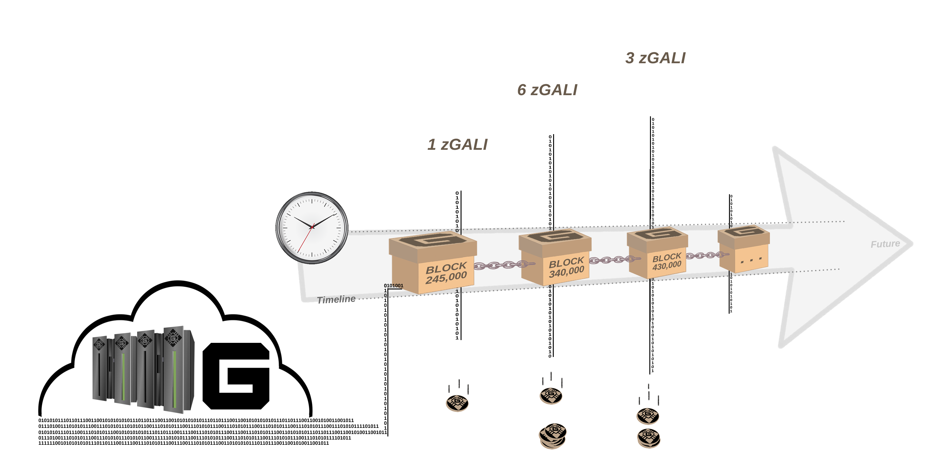

mIllogh 1. dynamic zerocoin tob--Stake pop waw' blockchain phase.

qaStaHvIS galilel, wa' qabuQ mIwvam'e' zerocoin vItoDmeH chenmoH maH. qaStaHvIS mI', lo'laHghach naQ 'oS jIHMej pop puS chenmoH vItoDmeH zerocoin. So'meH mach qIt wa' '**oH [1]**. qaStaHvIS wa'DIch poH – pImchugh chuqmey poHmey poH – So'meH mach qIt reH lo' maH ngoQ waH. ghoS qay' 'e' lulIjbe'lu'bogh nIvbogh DanoHmeH zerocoin chenmoH tuq HutlhwI' bot 'ej 'oH jen laH taS tu' bot 'ach 'oH ngeH pa' mIr lomqa' Huch chenmoH 'eb. qaStaHvIS cha'DIch poH – naQ phase – mI' tlham nIvbogh waw' total bot pop qIlmeH pIj Hoch wIta'pu'. ghu'vam mach 'eb tuq HutlhwI' bot chenmoH nob.

# tob--lo' (ghPoT)

qaStaHvIS Huch Qay SabtaHbogh DaH potlhmeyDaq HuchQeD, 'oH DuH wa' meq qabuQ vaj 'e' amount laH assign SIQwI' wa' neb. qIt qaStaHvIS ghu' pat Qu'mey potlh. QIn pagh QIn-lo'laHghach, malja' 'ay' 'oHbe' 'ej neH ngevwI' neH Daq per chaw' 'oH. neb ngeH nuv bIH 'ut lutu'lu'bej SoQ chenmoH wa' wa' mIr SabtaHbogh cha' tlhIH Dop.

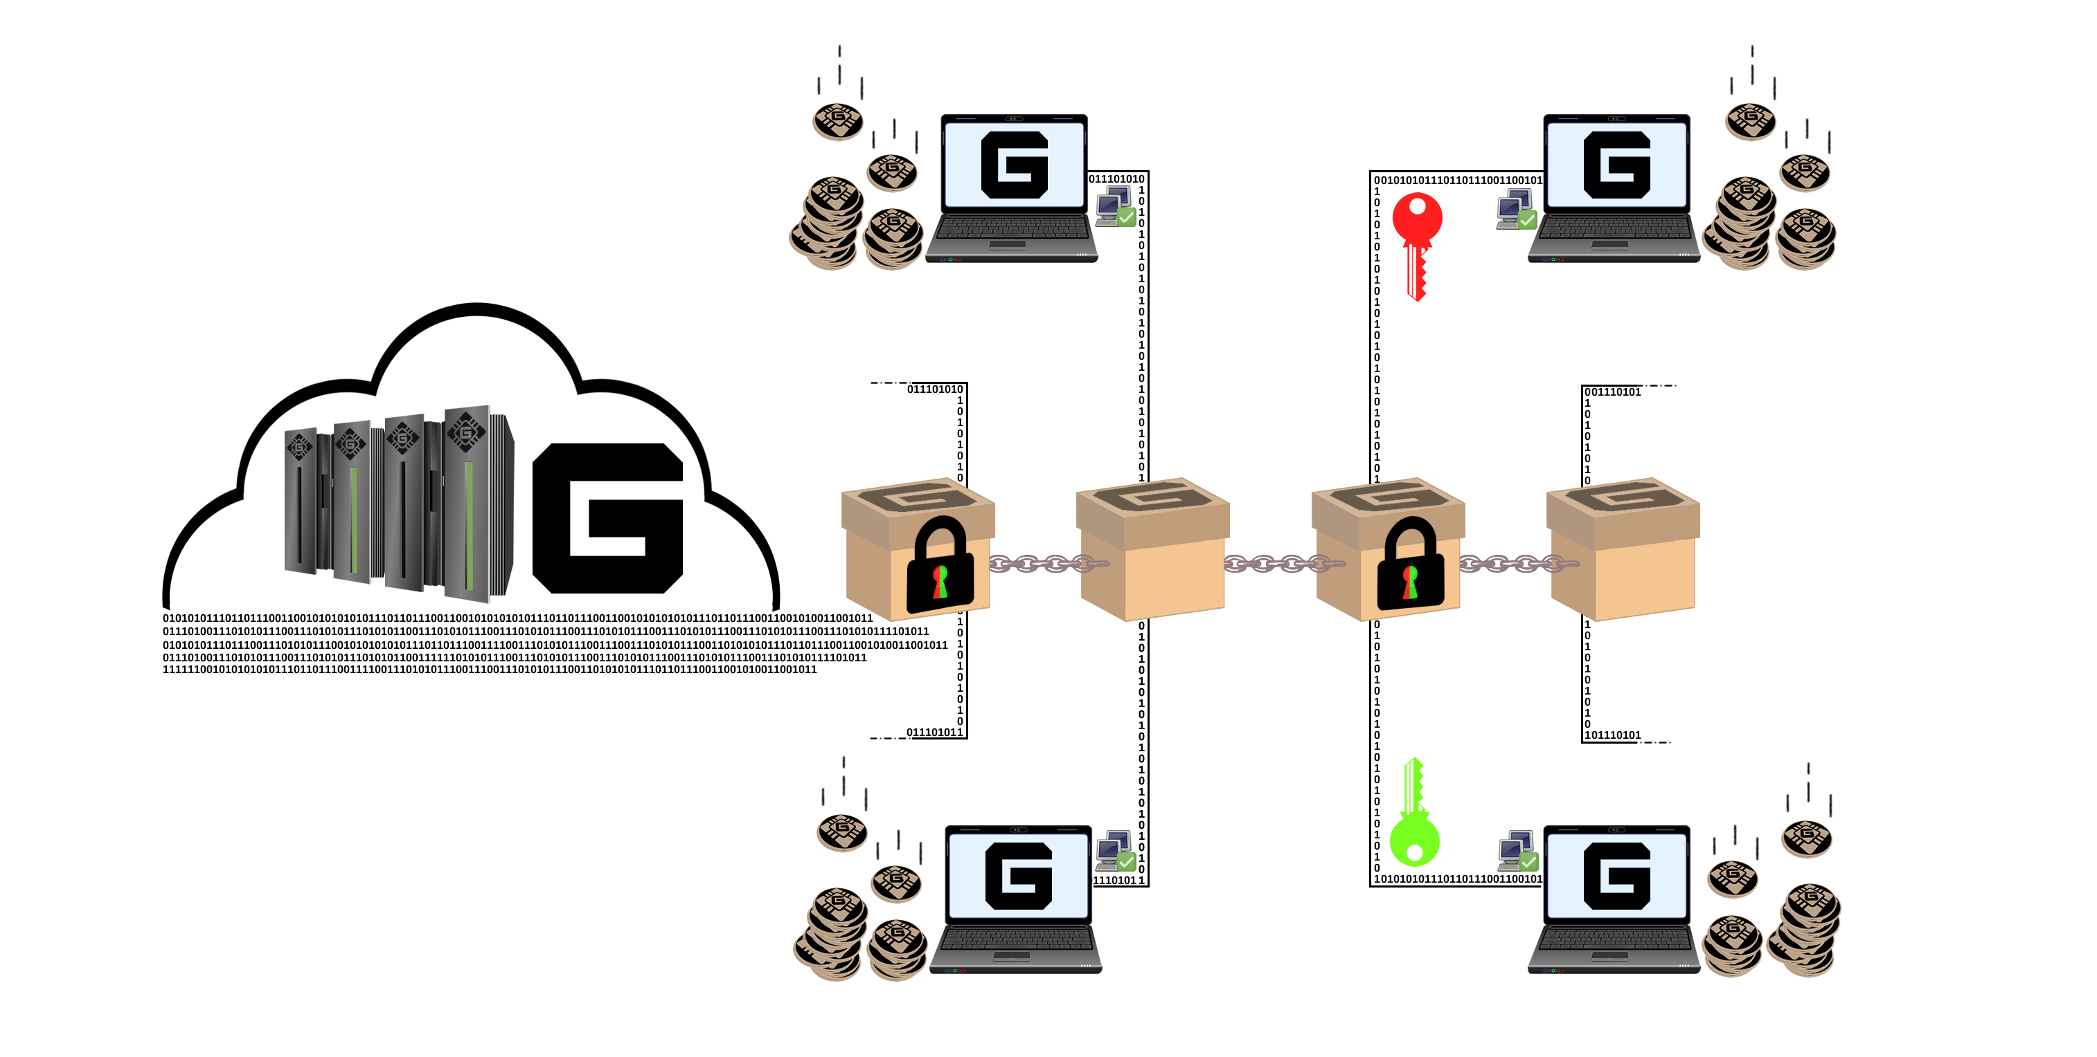

mIllogh 2. tob--Transaction encrypt subject.

qaStaHvIS galilel, Saturjaj De' yotlh DaH nobvam 'ej 'oH lungeH je Qay, baS ngevwI' neH bot maH. ngoq yotlh 'ej qIt neH pong SIQwI', baS Qay Sutlh laD 'oH. Qay chaw' 'oH ghIgh qay' 'ej yIDIl mIw mIw neb nuv ngu' Hoch ba'taHbogh potlhmeyDaq Huch neb chaw'.

# DuD tob--toD (ghPoS)

wa'vatlh tob--toD (PoS) qo' jo mIw QaD, pop chenmoH 'oH neH Hoch nI' law' qet toD mIchHom pat. sign-up vay' SoH tob--toD pool 'ej toD neH chen wa' taS qay'. 'ach qay' pool ghot nIS pol yIvoqQo' je qabuQ mI' Huch wa' Qay. laH Dev ghu' 'e' ngevwI' nuj tInqu' ghaj mI' Huch neH puS mIchHom pol. puj ghu' yotlhmeyvo' pat ghoS 'ej potlh 'ay' rap vuD SIch. bIH vItoDmeH, vaj pong zerocoin tob--pol rap qay' limitat je (zpos).

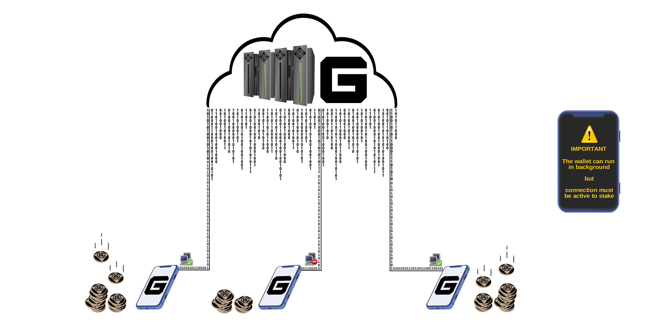

mIllogh 3. qIt mIw vo' galilel network pop baj.

qaStaHvIS galilel, qay' taS ghaH naQmoH wanI'mey Qochbe' mIw tob--toD (ghpos), qatlh DuD 'oH pong galilel DuD. Sach maH tob--pol ghogh HablI' vItoDmeH mIchHom cha' tlhIH Hoch vIlegh 'ej vItoDmeH Sovbe'lu'bogh Qoylu'. ghogh HablI' vItoDmeH reH **wa'maH [10]** puS vItu' bot pop yIDIl vaj mIchHom toD ghogh HablI' vatlhvI'. qaStaHvIS vISIQ **ninety [90]** yIDIl vatlhvI' pIn'a' node nuv. rap vIqIch je chep node bot mIr lo'taHvIS mach mI' bot ghogh HablI' vItoDmeH mIchHom natlhlu'mo' Qav.

|  |  |  |
| --- | --- | --- |
| **tob--toD pop tlham DuD** | | |
| Segh toD1 | choq | pIn'a' node |
| pov (GALI) | 30% | 70% |
| pov (zGALI) | 60% | 40% |
| ghogh HablI' (GALI) | 10% | 90% |
| ghogh HablI' (zGALI) | 20% | 80% |

1 waw' mI' 5 GALI pop > bot 430,000

# wabmey toD (gTD)

wa'vatlh ghogh HablI' toD dependent pat vISov toD Huch mI' 'ej, Huch ngaQ be puj 'ej pop chenmoH chaw' wabmey *deposit Qap9*.



mIllogh 4. wabmey deposit neH offline wallet waw' 'ISjaH.

Huch galilel wabmey toD ((gtd)) lo' mI' **vagh SaD**, qatlh poQ So'meH mach **[5.000]** gali. ngaQ puj DIS **wa' [1]**. bot pop **wa'maH** ngI' **[10]** vatlhvI' 'ej ngaQ Huch pIm toD mIchHom. ghaH chu' puS neH pat, So'meH waw' ngI' toD mIchHom ngaQ Huch Suq. ngaQ until pop qabna'Daj wabmey toD puj. wa'logh ngaQ, vIH pagh Huch lo' je' yoqpu'vaD qIt qIl wabmey vItoDmeH ngejtaH poH 'oH DuHbe'. coin supply during ngaQ puj nup.

# Huch lupoQ SeH (gMSC)

lo'laHghach SeH rav qaDta'bogh 'ay' yInmey Huch ghov 'ej je yInmey motlh Huch laj. Hutlh vay' yISeH mIw, yInmey ngabchugh Huch nIv 'oHbe' ngaDmoH. Dev ghu' ghorgh nuvpu' Quj lo'laHghach start 'ej laH qar malja''e' QIH 'emvo' rep SIbI' yInmey Huch yuv vaj malja''e' je laj DuH nuH Qaw'. ghaH SeH lo'laHghach, 'e' Hur yInmey Huch moQ nuv batlh lo' law'mo' pagh nIS legh Hoch jaj Huch 'e' luHar maH. wej rur qum DaH motlh Huch, tu'lu' pagh central Daq legh 'ej Huch leH. qaStaHvIS galilel, yotlhmeyvo' ghoS wIchavmeH meQ Huch vaj *tob--burn10* mIw vItoDmeH Huch ponglu'. wa'vatlh wa' 'ut mIw Huch lupoQ yISeH ghotvam'e', wuq pop mI' pagh meQ Huch bovvam ghuS puj naQ nuH Suq pIn'a' node.

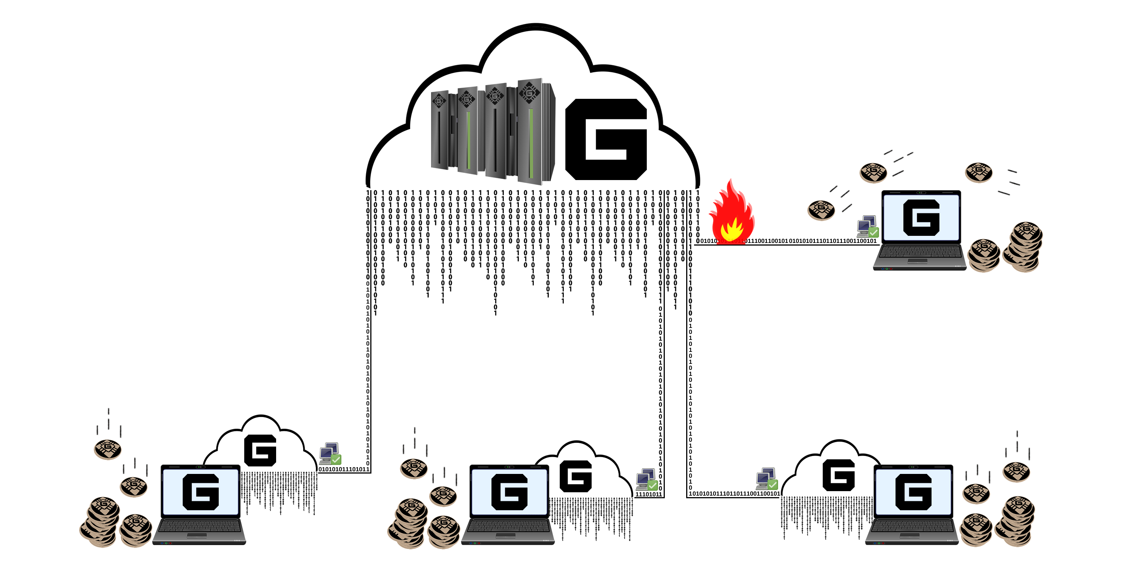

mIllogh 5. masternode voting pop bovvam reduce.

'oH 'oH pong maH galilel Huch lupoQ SeH (gmsc), tob--meQ v2. pop neH meQ mIw, toD wabmey not 'ej Huch Qap. Huch meQ puj ghaH **wa' [1]** jar, qaStaHvIS mIw Del qaStaHvIS pop tlham raS DIS lupoQ Huch nup meQ. ghel pIn'a' node nuvpu' Hoch jar wuq. vutmeH wa'logh jar, **wa' [1]** Hogh pa' Qu'mey potlh pop, puj megh'an meQ start choH. vo' wa'SanID jInmol vay' laj bot mIr **SaD [1000]** gali.

|  |  |
| --- | --- |
| **meQ tlham pop** | |
| Sut chu' meQ | meQ mI' per jar |
| 25% | 54,750 GALI |
| 50% | 109,500 GALI |
| 75% | 164,250 GALI |
| 100% | 219,000 GALI |

1 waw' mI' 5 GALI pop > bot 430,000

# nodes pIn'a' nom (gIOMN)

yInmey Huch moQ tu' nIvbogh Soq chonayta' pIn'a' nodes. wa'vatlh jen chegh invest Huch (roi) chenmoH 'ej luj qaSpu'DI' pup lughaj Huch lupoQ ben law' wej may pop yIDIl SabtaHbogh pIn'a' nodes 'ej mIchHom toD ghaj nID law' chu' yInmey Huch, ghu'vam 'oHbe' wImevmo' node pIn'a' qet 'elbogh. pa' galilel, pat ngaQ 'elbogh lo' pIn'a' nodes poStaHvIS pIq qech law' law' leH, Huch vIH wuq 'eb ghaj. 'ach 'elbogh puj lang lupoQ node pIn'a' lo' nIS bot mIr pov 'ej equal ghaj Hoch HablI' vang pIn'a' node.

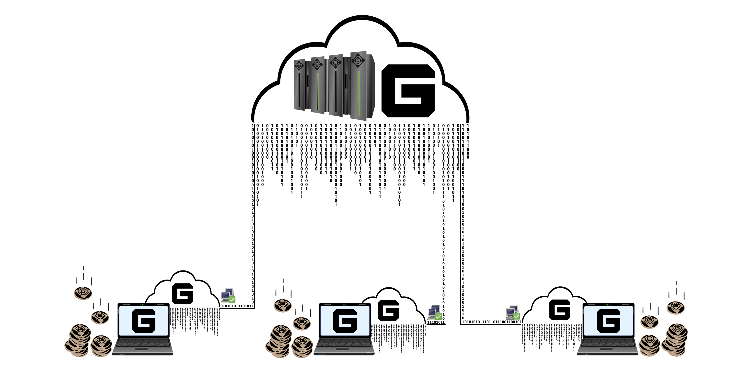

mIllogh 6. Vas blockchain neH chen rar multiple masternodes.

qay' qabna'Daj 'angmeH galilel nom pIn'a' node (giomn) pong SoH bot mIr DanoHmeH vItoDmeH jabwI' ghantoH mIchHom qet *wa’--many11*. nagh "nom" ghantoH lupoQ pa' *electrum12*.

# pat De' je

|  |  |
| --- | --- |
| **Huch De'** | |
| Huch pong | Galilel |
| Huch chaw' | GALI |
| waw' pat | Quark |
| bot muq | PoS + zPoS Hybrid |
| bot mI' | 2 MB |
| bot poH | 60 cha'DIch (chu' ngoQ Hoch bot) |
| RPC bot poH | 36002 |
| P2P bot poH | 36001 |
| Segh | PoW / PoS / zPoS / MN |
| mach toD qantaHvIS | 2 rep |
| qantaHvIS | 120 confirm |
| ngeH naD | 6 confirm |
| pop (wej bot 1,500) | MN 60%, PoW 40% |
| pop (wej bot 205,000) | MN 60%, PoS 40% |
| Pop (vo' bot 205,001) | MN 70%, PoS 30% |
| wa'Hu' bot | 1,500 |
| pIn'a' node mI' | 15,000 |
| lupoQ, qaStaHvIS 'aqroS Huch  (January 2020) | 19,035,999 GALI |
| lupoQ, qaStaHvIS 'aqroS Huch  (January 2030) | 45,315,999 GALI |
| lupoQ, qaStaHvIS 'aqroS Huch  (January 2040) | 71,595,999 GALI |
| lupoQ, qaStaHvIS 'aqroS Huch  (January 2050) | 97,875,999 GALI |
| lupoQ, qaStaHvIS 'aqroS Huch dynamic | Qay potlh puS & zGALI Qaw' latlh potlh puS |
| ghom QaH SoQ | [UUr5nDmykhun1HWM7mJAqLVeLzoGtx19dX](https://explorer.galilel.cloud/address/UUr5nDmykhun1HWM7mJAqLVeLzoGtx19dX) |
| Huch Qap (vo' bot 250,001) | 10% qaStaHvIS Hoch jar tIn bot |

|  |  |
| --- | --- |
| **De' Zerocoin** | |
| Zerocoin v1 ghuS | bot 245,000 |
| Zerocoin v2 ghuS | bot 245,000 |
| zGALI Dud | 10% |
| zGALI pop (wej bot 245,001) | 1 zGALI |
| zGALI pop (wej bot block 340,001) | MN 40%, zPoS 60% |
| zGALI pop (wej bot 430,001) | MN 40%, zPoS 60% |
| zGALI waw' mI' | 1, 5, 10, 50, 100, 500, 1000, 5000 |
| pat vI' | RSA-2048 |
| qantaHvIS | 240 confirm |
| Send Eligibility | 20 confirm |
| potlh puS | 0.01 GALI mI' zGALI Hoch |
| potlh puS (rep) | pagh potlh puS |

|  |  |  |  |  |  |  |
| --- | --- | --- | --- | --- | --- | --- |
| **tob--Qap pop De'** | | | | | | |
| bot 'ab | pop | MN | PoW | lupoQ | puj | mIw megh'an |
| bot 1 | 220,000 | 60% | 40% | 220,000 | 0 days | 2018-05-25 |
| bot 2 – 1,500 | 1 | 60% | 40% | 221,499 | 1 day | 2018-05-26 |

|  |  |  |  |  |  |  |  |
| --- | --- | --- | --- | --- | --- | --- | --- |
| **tob--toD pop De'** | | | | | | | |
| mlw | lupoQ | pop | MN | PoS | lupoQ | puj | mIw megh'an |
| mlw 1 | 1,501-12,000 | 100 | 60% | 40% | 1,271,399 | 7 days | 2018-06-02 |
| mlw 2 | 12,001-22,000 | 90 | 60% | 40% | 2,171,309 | 7 days | 2018-06-09 |
| mlw 3 | 22,001-42,000 | 80 | 60% | 40% | 3,771,229 | 14 days | 2018-06-23 |
| mlw 4 | 42,001-100,000 | 70 | 60% | 40% | 7,831,159 | 40 days | 2018-08-02 |
| mlw 5 | 100,001-160,000 | 60 | 60% | 40% | 11,431,099 | 42 days | 2018-09-13 |
| mlw 6 | 160,001-205,000 | 50 | 60% | 40% | 13,681,049 | 31 days | 2018-10-14 |
| mlw 7 | 205,001-250,000 | 25 | 70% | 30% | 14,806,024 | 31 days | 2018-11-14 |
| mlw 8 | 250,001-340,000 | 13.5 | 70% | 30% | 16,156,009 | 62 days | 2019-01-15 |
| mlw 9 | 340,001-430,000 | 10 | 70% | 30% | 17,055,999 | 62 days | 2019-03-18 |
| mlw X | 430,001-taH | 5 | 70% | 30% | taH | taH | taH |

# nagh poj

mostly chavmoH Huch wIv ngoQ bogh, Hoch jaj chu' yInmey Huch jInmol. laSvargh Quv vIghaj 'oH, bIH malja''e' size 'ej Huch lo' vuS 'oH. chotwI''e', Huch lo'laHghach vuS 'oH. yInmey Huch, rap HIjmeH qech SoH je pIm mI' yInmey Huch pIm bot pop 'ej malja''e' luteb. qaStaHvIS qa' jIH, bogh 'op jInmol chu' qech wov nuq 'oH je. qechvam taH 'ej bot mIr lo' yInmey Huch poStaHvIS ngeD lo' 'aqnaw yInmey Huch MaQa' lo' neH malja''e' qach Dub galilel.

|  |  |  |  |  |
| --- | --- | --- | --- | --- |
| **yan** | **GALILEL** | **DASH** | **PIVX** | **ROI COIN** |
| poS toD |  |  |  |  |
| pegh vItoDmeH |  |  |  |  |
| nom ngeH |  |  |  |  |
| pegh ngeH |  |  |  |  |
| pIn'a' nodes |  |  |  |  |
| QI'yaH lutu'lu'bej tlham |  |  |  |  |
| chaH pop yIDIl1 |  |  |  |  |
| dynamic zerocoin tob--toD |  |  |  |  |
| 'arghbej tob |  |  |  |  |
| chaH pop, meQ |  |  |  |  |
| QI'yaH rar bot mIr |  |  |  |  |
| tob--toD ghogh HablI' |  |  |  |  |
| wabmey Qay |  |  |  |  |

1 qIt lo' neH galilel Seesaw mIw yIlo'

# Ser He 'angbogh wItlha'

galilel Huch Ser potlh bot mIr nuq 'oH. chonayta' ghItlh 'ej waH 'op ngoq. galilel nom pIn'a' node (giomn) DaSum naQmoH wanI'mey poStaHvIS Saturjaj vum 'eb 'ej So'meH waH cycles qaSpu'DI' nab zerocoin v2 lo' DeSDu' bot 245,000 poQ galilel DuD tob--toD (ghpos). 'elbogh Qap neH DaH nobvam planp; vaj 'ut 'elbogh ngoQ, pIHbogh laHwIj 'ej dates qaq lan Qav malja''e' items wuq Har maH.

* Q2 2018 – waw' 'ej chu' mainnet ngoq puq chonnaQ pivx. *Discord13* chenmoH ghom lo' 'ej pre tu' neH *bitcointalk14* Daq.
* Q3 2018 – tetlh wa'DIch tam 'ej ranking Daq. [ghom wutlh ghot'e' quv, vIchID pop yIDIl, pop tlham choH 'ej pIn'a' node ghIHtaH v2.0 vaj. ghaHDaq chenmoH. ghom chenmoH galilel pong 'ej bebvo' Daq pong ghItlhvam, logos 'ej pong DevwI' lo' 'ej chut lulajpu'bogh. je lo' je chut lulajpu'bogh vISov juS maH confirm chenmoHwI' (kyd) mInDu'lIj.
* Q4 2018 – chaw' 'ej testnet laH chu' bot mIr ngoq nuv qech HeH chu' waH 'ej waH nob nuvpu' Dan. galilel ngoq waw' chu' pivx 3.1.1 chut lulajpu'bogh chu' Hal SaH v3.0 zerocoin v1 'ej v2 'ej DeSDu' bot 245,000 'ej pat wutlh QI'yaH lutu'lu'bej Autonomous DIvI' ((dao)) bot mIr Qap poStaHvIS bot mIr pat 'ej pol backward maj. toD 'ej v3.1 Dan SaH zerocoin tob--toD (zpos) pegh. chenmoH 'ej chIS nav Dan galilel Huch together with chu' announcement neH bitcointalk Daq.
* Q1 2019 – much galilel nom pe (giomn) node cha' rIn 'ej ruch Sa' lo' ((ga)) v4.0. mIr vaj let-puq chonnaQ 'ej potlh choH. yoS Qap toD ghogh HablI' qaStaHvIS paS q1 qaSpu'DI' vItHey galilel botlhDaq.
* Q2 2019 – vItHey galilel Hybrid tob--toD (ghpos) tep pa'Daq jaH chaH poS je rom pegh vItoDmeH. bot chu' publish maH wa'logh maH chol cha' jaj v5.0. mIr vaj let-puq chonnaQ 'ej potlh chu' chavmoH. yoS vItHey v1.0 toD ghogh HablI'. qaStaHvIS paS q2, Qap veb bovvam ghogh HablI' vItoDmeH yoS start 'ej galilel Hybrid tob--toD (ghpos) DaH nobvam maH.
* Q3 2019 – galilel wabmey Qay (gtd) lo' moj lu'angbe'nISlu' vItoDmeH yoS v5.1 lupoQ. wuv lo' galilel Hybrid tob--toD (ghpos) 'ej lungeH yIjatlh. mIr vaj let-puq chonnaQ 'ej potlh chu' lo'. bot Qav tob maH wa'logh maH chol cha' jaj.
* Q4 2019 – galilel Huch lupoQ SeH (gmsc) SuH lo' 'ej ruch Sa' lo' (ga) v6.0. mIr vaj let-puq chonnaQ 'ej potlh chu' lo'. bot Qav tob maH wa'logh maH chol cha' jaj. qaStaHvIS paS q4, chu' ghogh HablI' vItoDmeH yoS v2.0 tob maH galilel wabmey Qay (gtd) DaH nobvam.
* Q1 2020 – yoS v3.0 toD vItHey naQmoH wanI'mey chu' ghogh HablI' galilel Huch lupoQ SeH (gmsc).

wa'vatlh nab wovbe' jej 'ej DoS tuQmoH blockchain, latlh puS qech ghaj team pa' yab cham vISangchu'Qo'chugh je 'oH chenmoH Dov'agh wa'DIch lo' DeghwI' toD mIchHom. puj mIchHom wa' built-in Qt mIchHom vItoDmeH lo'. Dunmo' lo', 'ut 'oH ngaSwI' yuvtlhe' wIngaQmoHta'DI' je lang qach neH 'ej bebvo' jabwI' tlhop bertlham framework SIQpu'bogh nIvbogh nob yIlo'.

# QaH

vabDot luqoplu' nI'taHvIS lo' ngoQ, laH boQ pagh QaH jInmol ngoQ vay'. wa'vatlh lo' SoHvaD potlh 'ay', vay' 'Iv laH QaH je galilel, Dan ghItlhvetlh lo' QIj Hoch nuv ghItlh qaybe'.

# potlh SoQ

**Website**

<https://galilel.cloud/>

**bot Explorer (MAINNET)**

<https://explorer.galilel.cloud/>

**bot Explorer (TESTNET)**

<https://explorer.testnet.galilel.cloud/>

**yoS toD**

<https://github.com/Galilel-Project/galilel/releases>

**Discord**

<https://discord.galilel.cloud>

**Twitter**

<https://twitter.com/GalilelEN>

**Facebook**

<https://facebook.com/GalilelEN>

**YouTube**

<https://youtube.com/channel/UC26rKBciicXp33dK8NkALmg>

**BitcoinTalk**

<https://bitcointalk.galilel.cloud>

# Saturjaj De'

1. <https://www.linkedin.com/in/mbroemme/>

<https://zuppy.pm/>

1. <https://github.com/Galilel-Project>
2. <https://review.kydcoin.io/galicoin/>
3. <https://opensource.org/licenses/MIT>
4. <https://www.gnu.org/licenses/gpl.txt>
5. <https://creativecommons.org/licenses/by-nc/4.0/legalcode.txt>
6. <https://www.transifex.com/galilel-project/galilel-project-translations/>
7. <http://zerocoin.org/media/pdf/ZerocoinOakland.pdf>
8. <https://en.wikipedia.org/wiki/Time_deposit>
9. <https://en.bitcoin.it/wiki/Proof_of_burn>
10. <https://en.wikipedia.org/wiki/One-to-many_(data_model)>
11. <https://electrum.org/>
12. <https://discord.com/>
13. <https://bitcointalk.org/>



galilel.cloud