Name: Hiten Raj Singh

Sec: CSE C, Roll No.- 23

Reg. No.- 230905152

Q1.
#include <stdio.h>
#include <stdlib.h>
int main(){
FILE *fptr1;
char filename[100], c;
printf("Enter the filename to open for reading: \n");
scanf("%s", filename);
fptr1 = fopen(filename, "r");
if (fptr1 == NULL){
printf("Cannot open file %s \n", filename);
exit(0);
}
int ct_lines=0;
int ct_chars=0;
c = fgetc(fptr1); // Read contents from file
while (c != EOF){
if(c=='\n') ++ct_lines;
else ++ct_chars;
c = fgetc(fptr1);
}
printf("\n File %s has %d lines and %d characters.\n", filename,ct_lines,ct_chars);
fclose(fptr1);
return 0;
}
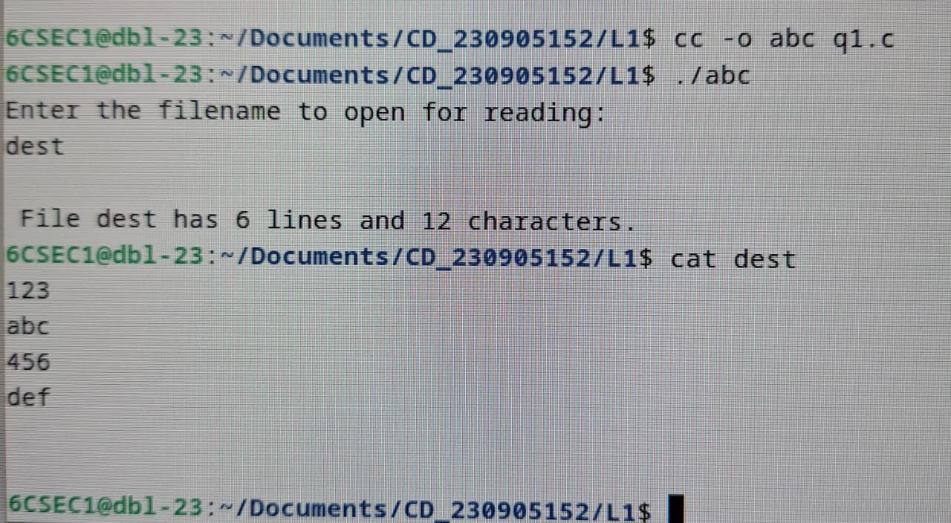

Q2.
#include <stdio.h>
#include <stdlib.h>
int main() {
FILE *fp1, *fp2; long size; char filename[100],ch;
printf("Enter the filename to open for reading: \n");
scanf("%s", filename);
fp1 = fopen(filename, "r");
printf("Enter the filename to open for writing: \n");
scanf("%s", filename);
fp2 = fopen(filename, "w+");
fseek(fp1, 0, SEEK_END);
size = ftell(fp1);
printf("Size of the file: %ld bytes\n", size);
for (long i = 1; i <= size; i++) {
fseek(fp1, -i, SEEK_END);
ch = fgetc(fp1);
fputc(ch, fp2);
}
fclose(fp1);
fclose(fp2);
printf("File contents reversed successfully.\n");
return 0;
}

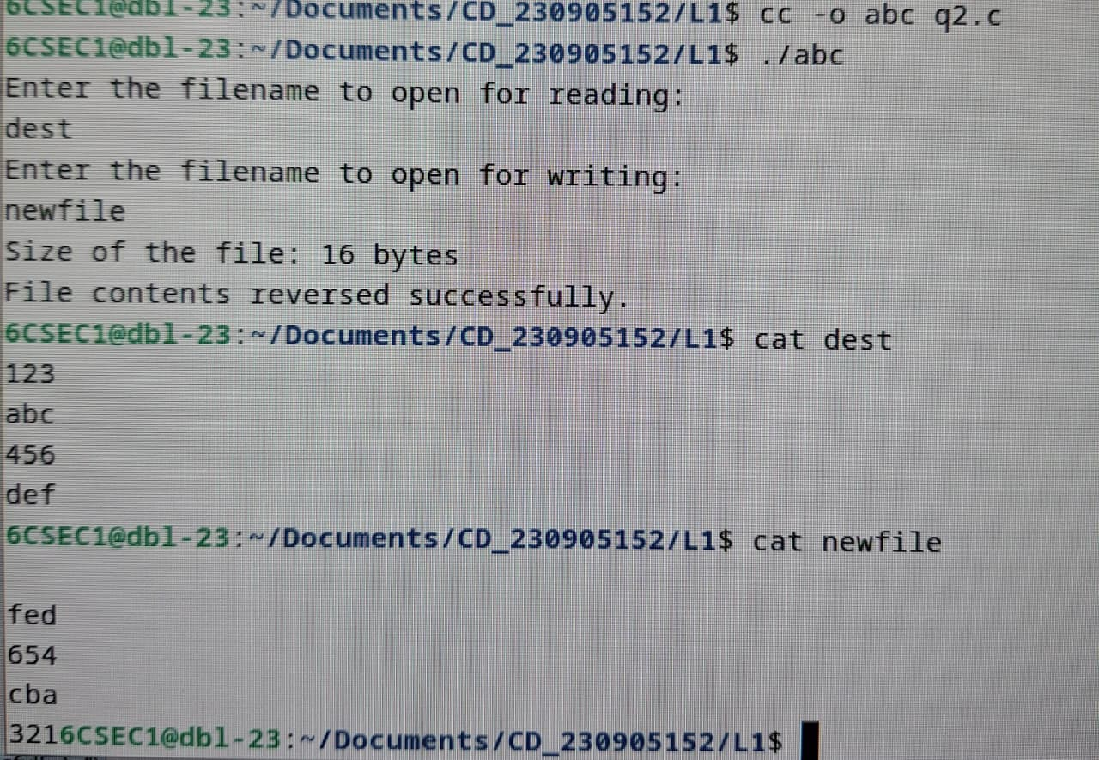

Q3.
#include <stdio.h>
#include <stdlib.h>
int main(){
FILE *fptr1, *fptr2, *fptr3;
char filename[100], c;
printf("Enter the filename to open for reading: \n");
scanf("%s", filename);
fptr1 = fopen(filename, "r");
if (fptr1 == NULL){
printf("Cannot open file %s \n", filename);
exit(0);
}
scanf("%s", filename);
fptr2 = fopen(filename, "r");
if (fptr2 == NULL){
printf("Cannot open file %s \n", filename);
exit(0);
}
printf("Enter the filename to open for writing: \n");
scanf("%s", filename);
fptr3 = fopen(filename, "w+");
int f1_done = 0, f2_done = 0;
while (!f1_done || !f2_done) {
if (!f1_done) {
while (1) {
c = fgetc(fptr1);
if (c == EOF) {
f1_done = 1;
break;
}
fputc(c, fptr3);
if (c == '\n') break;
}
}
if (!f2_done) {
while (1) {
c = fgetc(fptr2);
if (c == EOF) {
f2_done = 1;
break;
}
fputc(c, fptr3);
if (c == '\n') break;
}
}
}
printf("\nContents merged to %s \n", filename);
fclose(fptr1);
fclose(fptr2);
fclose(fptr3);
return 0;
}
