Feasibility Model Design

F2019 – Edit this document into a deliverable.

|  |  |  |  |
| --- | --- | --- | --- |
| Lab Section: | 6 | Group: | 17 |

# System-Level Design

Our ECE 298 projects start with a conceptual architecture, like the block diagram in Figure 1a). Specific example in Figure 1b). **Replace this figure with a high-level block diagram of your system.**



Figure a: ECE 298 Project Conceptual Starting Point

## Project Design Requirements

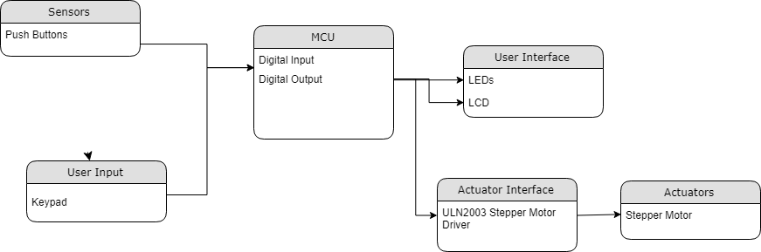

In PD 21 you learned about engineering requirements. they fall into three major categories, as follows:

1. **Functional requirements** are quantities that specify the performance of a design. They are related to the functions of the design, identified as answers to the question, "What does it do?" For example, a functional requirement for a coffee maker may specify the time required to brew a pot of coffee, a DC power supply may specify its maximum voltage, and a vehicle alarm system may specify how much noise it makes when it is set off
2. **Non-functional requirements** specify characteristics of the design that are not performance based. Theses are typically features or qualities that are desirable to the client. For example, ease of use, ease of manufacturing, and use of recycled materials.
3. **Constraint requirements** place limits on the design space, and often reflect budget or other project limitations. For example, cost, weight, and noise.

The basic form of most of these requirements is the same: a short description, followed by a relationship (equals, less than, or greater than) and a value.

**State three to five major Functional Requirements that your project must meet to successfully solve your problem statement.**

1. The project must intake a number of (preferably five) pairs of single-digit numeric inputs through a keypad.
2. The project must move two stepper motors, representative of an X and Y axis of a plotter to coordinates.
3. The project must use mechanical endstops to halt the movement of the plotter head and light up leds when the maximum limits of the plotter have been reached.

## Project Sensors and User Inputs

* List the types of sensors and user inputs you may require (light, sound, temperature, magnetic field).
  + 3x4 membrane keypad
  + 4 push buttons, representative of mechanical endstops.
  + The LCD display
* For each sensor and user input, list how you will connect it to the MCU, including additional interface components, if needed.
  + 3x4 membrane keypad is attached through 7 GPIO pins, and input data is decoded on the MCU.
  + Push buttons are attached through GPIO pins, and input data is interpreted on the MCU.
  + Already connected to the MCU, will just write to registers.

## Project Actuators and Indicators

* List the types of actuators and indicators you may require (e.g. light, sound, mechanical motion)
  + 2 Stepper motors, representative of the x and y axis of a plotter.
  + 4 LEDs, representative of when a mechanical endstop (pushbutton) has been hit.
* For each actuator and indicator, list how you will connect it to the MCU, including additional interface components, if needed.
  + Each stepper motor will be connected to a ULN2003 stepper motor driver that is also supplied with 5V (USB/DC power supply for prototype, 5V jack and supply or USB for final daughter board). The ULN2003 stepper motor driver board will connect to the MCU through 4 GPIO pins.
  + The LEDs will be connected to the MCU through GPIO pins, as the 3.3V digital signal is enough to safely power a 3mm LED.

## Project MCU Peripherals

* List the resources inside the MCU that could be used to implement your project (e.g. ADC, timers, interrupts, GPIO functions).
  + Typical GPIO functions can be used to turn on the output and input of GPIO pins for various actuators and sensors. A short list has been compiled below.
    - GPIO_setOutputHighOnPin(),GPIO_setOutputLowOnPin(), GPIO_toggleOutputOnPin(),GPIO_clearInterrupt(),GPIO_enableInterrupt()
  + Interrupts will be used for the mechanical endstops to halt stepper movement
* List parameters that the software running on the MCU might require.

## Project Testing Methodology

* For each sensor, user input, actuator, indicator, and MCU peripheral listed above, state how you will verify that each one is functioning as expected (a table may be helpful)

|  |  |  |  |  |  |  |
| --- | --- | --- | --- | --- | --- | --- |
| Keypad | Push buttons | LCD Display | Stepper Motors | LEDs | GPIO functions | Interrupts |
| Intake a number and write to LCD | Use push buttons to cause interrupts to toggle LEDs | Write characters from keypad and axis system. | Spin forwards and backwards using prebuilt ULN2003 driver boards. | Use push buttons to cause interrupts to toggle LEDs | Used in literally every other test. | Use push buttons to cause interrupts to toggle LEDs |

* State how you will validate that each Project Design Requirement has been met

# Feasibility Model Diagram and Software Flowchart (High-Level)

A simplified example is shown in Figure 2 and Figure 3. **Replace these figures with high-level block diagrams of your system.**

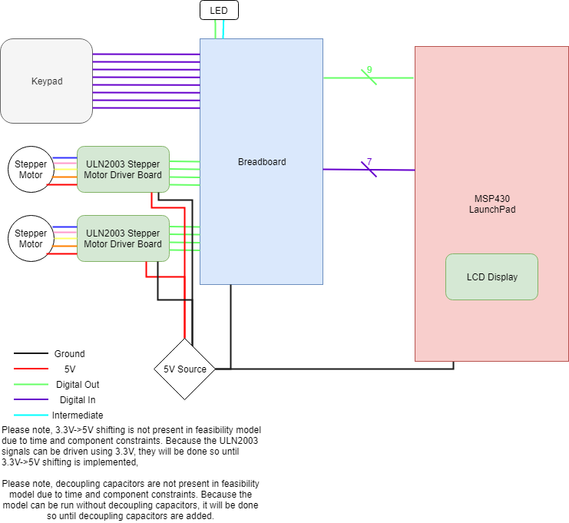

Figure : Feasibility Model Design

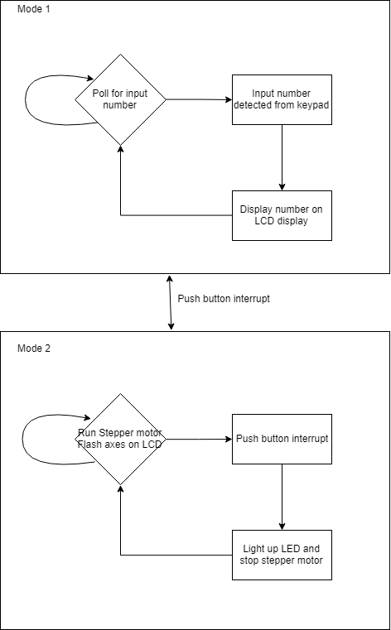

Figure : Software feasibility model

## Initial Bill of Materials

* List what modules and components (including quantities) are needed from the ECE 298 Parts spreadsheet for your Feasibility Model Design

|  |  |  |  |  |  |
| --- | --- | --- | --- | --- | --- |
| Module Name | Part Reference | DipTrace ID | Part # | Price | Quantity |
| MODULE - Stepper Motor Driver | Amazon Distributed Longmire ULN2003 Stepper Driver Board |  | 4916796 | $2.30 | 2 |
| MODULE - Keypad 4x4 | Sparkfun COM-14662 |  | 4915977 | $6.00 | 1 |
| MODULE - Stepper Motor 5V | Amazon Distributed Stepper Motor |  | 4916741 | $2.30 | 2 |
| COMPONENT - Male Connector 1x5 (Stepper Motor I/F) | Digikey 455-2270-ND | HPART1x5 | 4916223 | $0.30 | 2 |
| COMPONENT - Break-away Module Header Pins (Male/Male) 1x40 | Male to Male Module Header Connector for soldering to SMD Adapters and Modules |  | 4916278 | $0.15 | 1 |
| COMPONENT - RED LED - Diffused (3mm) | Digikey 1497-1030-ND | QPARTR3D1 | 4916303 | $0.40 | 2 |