User manual

TodoMVC

Visitor
webapp-docs-kit example
October 2026

About this manual
This manual explains how to use TodoMVC to keep a simple to-do list. It is written for the Visitor role and covers adding tasks, completing them and filtering the list.
It is an example generated with webapp-docs-kit against the public Playwright demo. Screenshots are illustrative; in a real manual any personal data is blurred.

Contents
About this manual 2
1. Introduction 4
1.1 Purpose 4
1.2 What the Visitor can do 4
2. Getting started 4
2.1 Opening the app 4
3. Managing tasks 5
3.1 Adding a task 5
3.2 Completing a task 5
3.3 Filtering the list 6
4. Tips and support 7

1. Introduction

1.1 Purpose
TodoMVC keeps a list of tasks in your browser so you can track what is still pending and what is already done.

1.2 What the Visitor can do
- Add tasks to the list.
- Mark tasks as completed.
- Filter the list to see all, active or completed tasks.

2. Getting started

2.1 Opening the app
Open the app address in a modern browser (Chrome, Edge, Firefox or Safari). No sign-in is needed: the list is stored in your browser.
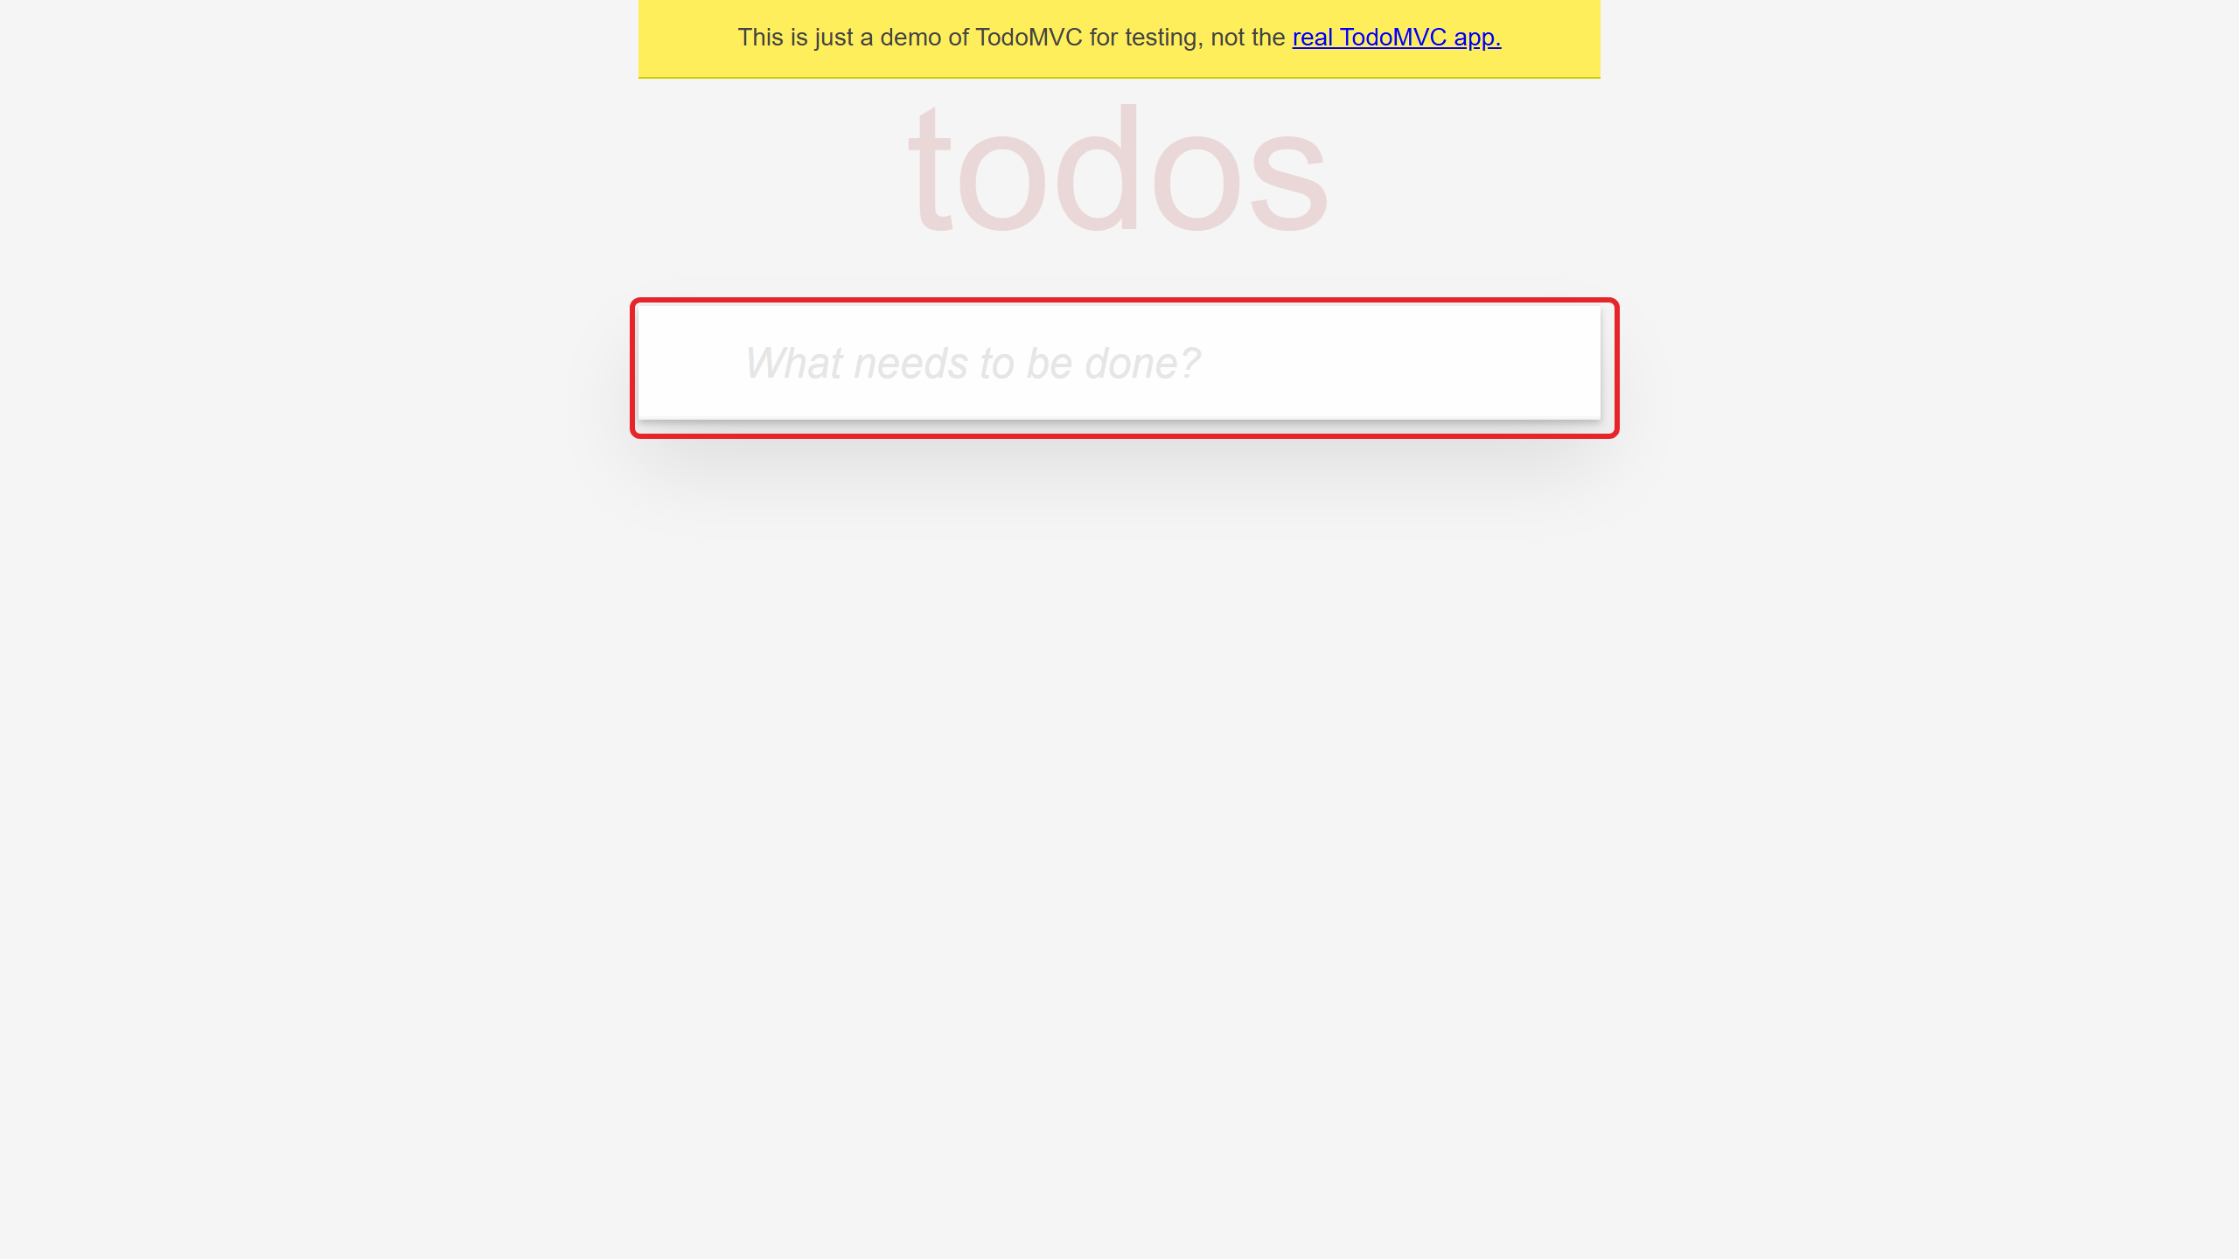
Figure 1. The TodoMVC home page.
Important: the list is saved only in this browser. Opening the app in another browser or device shows a different list.

3. Managing tasks

3.1 Adding a task
- Click the What needs to be done? box.
- Type the task.
- Press Enter.

The task appears at the top of the list.
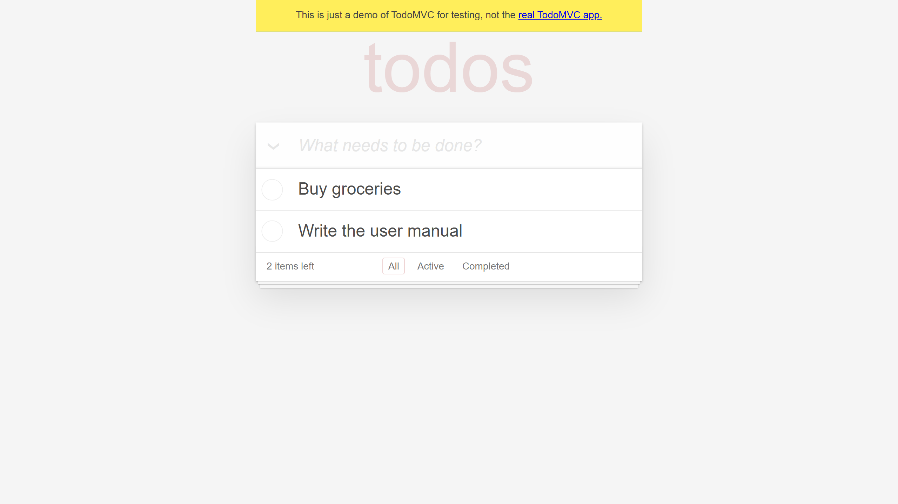
Figure 2. The list with two tasks.

3.2 Completing a task
Click the circle to the left of a task. The task is crossed out and the items left counter goes down.
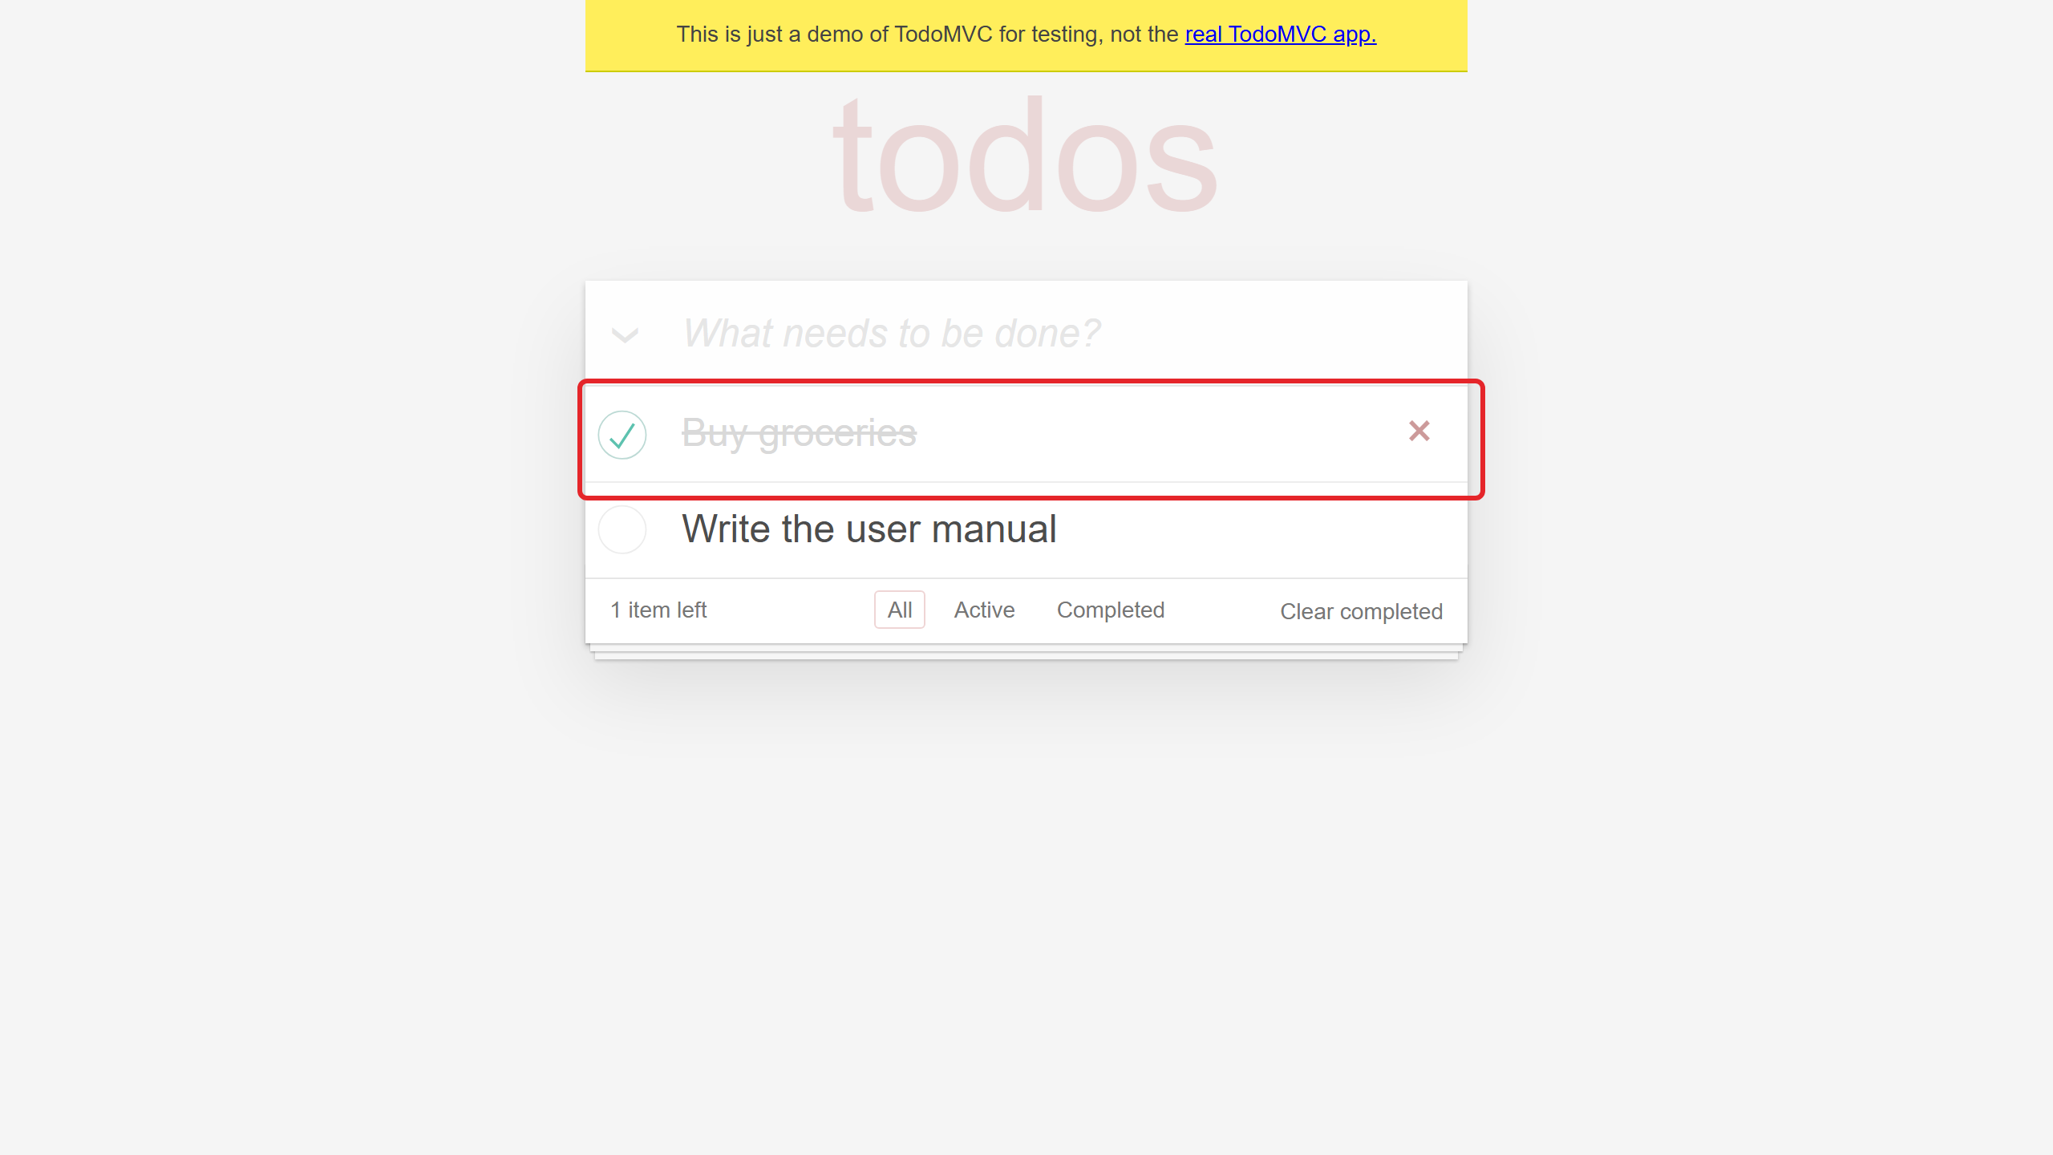
Figure 3. A completed task.
Element | Description
Circle | Marks the task as completed. Click it again to reopen the task.
Cross (Delete) | Appears when you point at a task. Removes the task from the list.

3.3 Filtering the list
Use the filters at the bottom of the list.
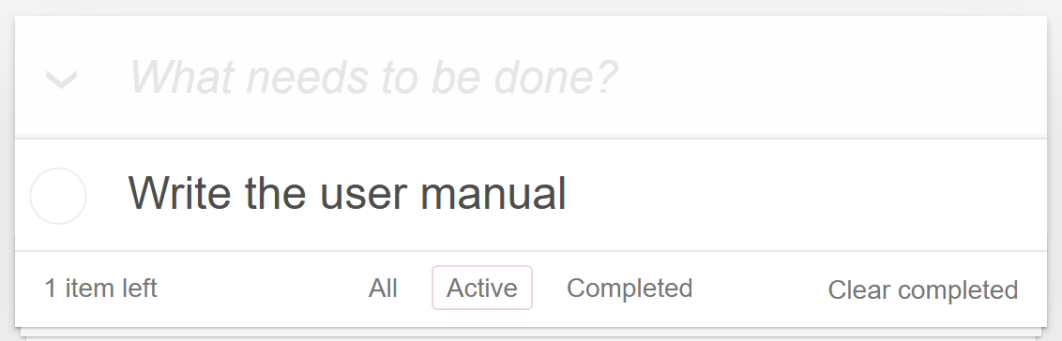
Figure 4. The list filtered to active tasks.
Filter | Shows
All | Every task.
Active | Only pending tasks.
Completed | Only completed tasks.
Clear completed | Removes every completed task from the list.

4. Tips and support
- Keep each task short and specific.
- Clear completed tasks from time to time to keep the list readable.

For questions, contact your help desk.

