NutritionPlanner
Product Feature Set
Table of Contents
Introduction 2
Vision 2
Product Vision 2
Business Vision 2
Design Vision 3
Material 3
Motion 3
Product 4
Information Architecture 4
Technical Architecture 6
Software and frameworks 6
Hosting 7
Source control and pipeline 7
Features 8
Product Roadmap 9
Phase 1 – MVP 9
Phase 2 – UI/UX improvements 9
Phase 3 – Shopping List and Information Center 10
Phase 4 – User Accounts and Sharing 10
Phase 5 – Calendar and Rating System 10
Phase 6 – Going Public, Marketing (optional) 10
Phase 7 – Additional Platform Specific Apps 10

Introduction
With NutritionPlanner, users can learn about nutrition fundamentals and plan their diets to meet their needs. At the core of the software sits a collection of ingredients with their nutritional values, which users can look up, expand, and assemble into recipes and shopping lists.
With these basic functions users should have all the tools they need to plan a healthy, balanced diet, which is the foundation for a healthy lifestyle. NutritionPlanner helps them on their journey by providing answers to the questions of which food to buy, which meals to prepare and ultimately what to eat each day.
While there are many tools and resources available which provide similar functionality, there seems to be no software that includes a core set of tools from planning to meal prep to shopping, which is free to use, available on a multitude of platforms, and which can be expanded and customized by the user. NutritionPlanner aims to fill this void.

Vision

Product Vision
We want to help people to learn about their own bodies, the fundamentals of nutrition and about healthy and balanced diets because we believe that health is one of the vital cornerstones of living a good life. We want to awaken a desire in people to tackle the challenge of taking care of their own body and we aim to empower them with information and tools to master that challenge. This topic is universal to every human and we believe that professional, flexible and practical tools aiming to support people on this journey should be freely available to everyone.
As developers we enjoy working in a team of professionals who believe in the importance of developing automated workflows and good coding practices. We see this project as an opportunity to learn from each other and enjoy the process of creating something useful for a wide range of people, not least of all for ourselves.

Business Vision
This product is a hobby project and is not meant to return any profits. The intention is to make the product available to as many people as possible. With that goal in mind, publishing the product with an open source license makes sense (GPL, MIT). Since the product core is a web platform, server costs will incur. To cover those costs, a donation system could be set up.

Design Vision
To be determined
https://code.tutsplus.com/articles/what-you-can-learn-from-googles-material-design--cms-22516

Material
Color
Typography
Layout

Motion
Easing
Responsive interaction (user feedback on clicks and hovers, transitions between interfaces)

Product

Information Architecture
- User entrance
  - Registration
  - Log in
  - Reset password
- Accounts
  - View your profile
  - Edit your profile
  - Search and find other users
- Information center
  - Basic information about nutrition (based on scientific citations)
  - Tools to calculate various fitness and health related factors (BMI, BMR, IBW)
  - Take notes
- Ingredient database
  - Search for ingredients
  - Add new / delete ingredients
  - Create and manage ingredient lists
- Recipes
  - Create recipes
  - Add ingredients to recipes
  - Add steps to recipes
  - Add images to recipes
  - Search recipes
- Shopping list
  - Create shopping lists
  - Add ingredients and recipes to shopping lists
  - Move items between lists
  - Check off bought items
- Sharing system
  - Share recipes with other users
  - Share shopping lists with other users
  - Share calendars with other users
- Calendar
  - Assign recipes to dates
  - Assign shopping lists to dates
  - Track health data (weight)
- Sync
  - Sync account data between all platforms
  - Allow offline use
  - Allow sync after offline use
- Rating system
  - Rate ingredients
  - Rate recipes
- Data management
  - Allow user to choose data model (offline use with local database, sync through official server, use self-hosted server and database)

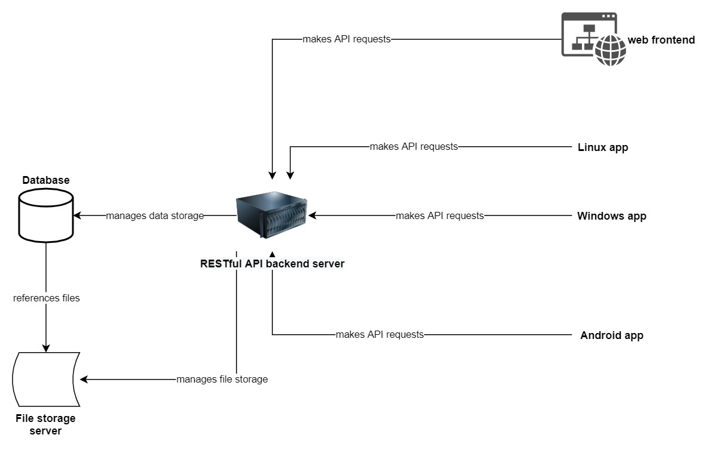
Technical Architecture
The system consists of four parts. A RESTful API back end server, a database, a file storage server and a collection of front end applications.
The central database stores all the data about accounts, ingredients, recipes, etc.
The file storage server stores all files like recipe images and user avatars.
The API server is the integral unit that communicates with the database and file storage server. No front end application interacts directly with the database or storage server but traffic rather goes through the API server.
There are four planned front end apps. The most important one is a web front end that allows users to access the services from any platform and device. Additional platform specific applications will be provided for Linux, Windows and Android to offer the user additional flexibility. In the final stages of the product, these apps will provide the option to run local databases and work offline. Syncing between the offline database and the official server should be possible.

Software and frameworks
Specific software and frameworks are yet to be determined by the core developers.
Web front ends are usually written in JavaScript these days. Since the back end mostly just handles data and file storage and doesn’t do any complex, concurrent logic, using NodeJS for the back end is the logical choice. With Electron the same code base can be used to deploy Windows and Linux applications. The AndroidJS library allows deployment to android. This setup allows for a single code base that covers all intended target platforms.
Alternatively, one could consider Java as the core language for the system. Java is often used for back end servers. A front end written in Java can be used on Windows and Linux with the JRE or packaged into self-contained applications. Java is also the standard language for Android app development. In this scenario, it still makes sense to write the web front end in JavaScript, although certain frameworks for Java exist for the same job.
Mixing languages and developing a front end in each platform’s native language also has merit. A web front end in JavaScript makes sense, an android app in Java, a. .Net application for windows. The downside is that the code needs to get rewritten multiple times, but this offers an opportunity for the developers to learn new languages and frameworks. Ultimately, the applications can better be tailored to each platform’s specific details.

Hosting
Developers will host the database, the file storage, the API server and the front end locally in their development environment.
There will be an official back end server, database and file storage server. All three could be hosted on AWS, which takes care of a lot of the network setup, security concerns and scalability. For new accounts an entire year of hosting small server instances and databases is free on AWS. That should be enough for the development of the product. Later on, donations can easily cover the costs.
Since All-inkl.com is used by the core developers, that could be a second option. Web front end and MySQL database can certainly be hosted on the platform, while it is somewhat unclear if the API server can run on their system.
Hosting the service on a developer machine could be a feasible option for development as well.

Source control and pipeline
Hosting the project source is no real concern, a myriad of free options are available. The defining factor for choosing a source control hosting service is the integration of a continuous integration and delivery pipeline.
GitHub is the de facto standard platform for hosting open source projects. It is unclear if the free plan also offers CI and CD capabilities (GitHub Actions?).
Bitbucket is a widely used platform in the commercial world. The free plan allows for up to 10 developers to collaborate and includes plenty of computing hours in their cloud for CI and CD. Making the project available to the wider public could be done at a later stage of development. Moving the code and pipeline incurs additional time and effort costs though.
A Jenkins instance could also be hosted on AWS. This option seems plausible when the rest of the system is hosted on AWS as well.

Features
Specific feature requirements are still to be determined

Product Roadmap

Phase 1 – MVP
- Pipeline setup
  - Source control
  - CI
  - CD
- Architecture setup
  - API Server
  - Database
  - Web front end
- Features
  - Ingredients
    - Nutritional values
    - Create, get, delete
  - Recipes
    - Create, get, delete
    - Manage ingredients, amount, unit
    - Manage steps
    - Manage images
  - Accounts
    - Create user (only back end)
    - Login, logout

Phase 2 – UI/UX improvements
- Design UI, document guidelines
- Implement UI for MVP features
- Improve UX, usability
- (Re)define product name and logo

Phase 3 – Shopping List and Information Center
- Information center core
- Information center content
- Tools and calculators
- Shopping lists

Phase 4 – User Accounts and Sharing
- Registration
- Sharing
- Setting up staging and production environments
- Alpha/beta testing

Phase 5 – Calendar and Rating System
- Calendar
- Rating system
- Improvements for existing features

Phase 6 – Going Public, Marketing (optional)
- Update, adjust and finalize hosting
- Determine license
- Write EULA
- Plan marketing strategy and campaign
- Set up donation service
- Release

Phase 7 – Additional Platform Specific Apps
- Windows
- Linux
- Android
- Syncing
- Data management

