VECTORBAT
Mobile App Design & Raw Demo Data Document
Project: AI Cricket Bat Shot Tracking & Performance Analytics Device
Hardware: ESP32 + BNO085 IMU + ADXL375 high-g accelerometer
Purpose: Build a professional React Native app first using realistic raw demo data, then replace demo values with live ESP32 sensor values.

1. App Goal
The first app version should look like a real commercial sports analytics product. It can use demo data generated from the expected sensor pipeline. The user flow follows the VectorBat product story: start a batting session, capture bat movement, process sensor data, display metrics, and generate AI insights. This flow is aligned with the current VectorBat website concept.

2. Core App Flow
- 01 Start Session: Launch a batting session from the dashboard.
- 02 Player Performs Shot: The batsman plays naturally while the device records movement.
- 03 Sensors Capture Data: BNO085 tracks motion/orientation; ADXL375 detects high impact acceleration.
- 04 ESP32 Filters & Sends: ESP32 filters sensor stream and sends packets via WiFi/BLE.
- 05 Dashboard Displays Metrics: Live bat speed, impact intensity, bat lift angle and swing analysis appear.
- 06 AI Predicts Insight: AI estimates shot type, quality score, timing index and safe-shot probability.

3. Screens to Build First
Screen | Purpose | Main Values | Data Type
Dashboard | Quick view of current session | Shots, hits, misses, sweet spot, timing, bat speed, impact speed, bat lift angle | Demo + sensor-derived
Start Session | Create new practice session | Player, venue, bat, session type, duration | App input
Live Tracking | Show real-time swing values | Raw acceleration, gyro, orientation, live speed, impact spike | Raw demo stream
Session Report | Summarize one full session | Avg speed, max speed, shot count, shot quality, timing index | Processed data
Shot Analysis | Show each shot detail | Shot #, type, speed, impact g, bat angle, quality score | Processed data
3D View | Replay bat movement | Bat path, pitch, roll, yaw timeline | Sensor orientation
AI Insights | Coaching suggestions | Strengths, weakness, improvement tips | AI/rule-based
Profile / Compare | Compare progress | Sessions, trends, best performance | Database history

4. Realistic Metrics With ESP32 + BNO085 + ADXL375
Metric | Can We Show It? | Source | Notes for Demo App
Total Shots | Yes | App counts detected swings | Use swing detection threshold.
Hits | Estimated / demo | ADXL375 impact spike | Count as hit when impact-g crosses threshold; not true ball tracking.
Misses | Estimated / demo | Swing without impact spike | Exact misses require ball/camera detection.
Bat Speed | Yes | Gyro + acceleration + bat length estimate | Show km/h as processed value.
Impact Speed | Estimated | Impact acceleration + swing velocity | Use as calculated score, not direct sensor value.
Bat Lift Angle | Yes | BNO085 pitch/quaternion | Show backlift angle in degrees.
Sweet Spot % | Estimated | Impact vibration pattern | Lower vibration + clean impact = higher score.
Timing Index | Custom score | Speed + impact + smoothness | Create formula for demo.
Shot Type | AI/rule-based | Orientation + gyro pattern | Classify Drive, Pull, Cut, Flick, Sweep.
Zone Analysis | Estimated | Yaw/swing direction | Real ball direction requires camera.
Boundary Probability | AI estimate | Shot power + angle + timing | Demo probability/model output.
Catch Chance | AI estimate | Loft angle + impact + direction | Demo only unless trajectory is captured.

5. Raw Sensor Demo Data Format
The app can start with JSON packets that look like live ESP32 messages. Each packet represents one sensor reading at a specific time.
{
"sessionId": "VB-S-001",
"shotId": 153,
"timestamp": 12345,
"bno085": {
"ax": 1.25, "ay": -0.82, "az": 9.45,
"gx": 320.5, "gy": 650.3, "gz": 42.7,
"roll": 12.5, "pitch": 45.2, "yaw": 8.1,
"qw": 0.92, "qx": 0.12, "qy": 0.31, "qz": 0.08
},
"adxl375": {
"impactX_g": 7.8,
"impactY_g": 18.4,
"impactZ_g": 42.6,
"peakImpact_g": 47.1
}
}

6. Processed Shot Data Format
{
"shotId": 153,
"shotType": "Cover Drive",
"result": "Hit",
"batSpeedKmh": 73,
"impactSpeedKmh": 65,
"batLiftAngleDeg": 63,
"impactIntensityG": 47.1,
"sweetSpotScore": 81,
"timingIndex": 97,
"swingSmoothness": 88,
"zone": "Off Side",
"boundaryProbability": 64,
"catchChance": 18,
"aiFeedback": "Good timing and controlled bat lift. Improve sweet spot consistency."
}

7. Demo Formulas for First App Version
- Shot detected when gyroscope magnitude crosses a swing threshold for a short duration.
- Hit detected when ADXL375 peakImpact_g is greater than an impact threshold, for example 12g or above.
- Miss detected when a swing is detected but no impact spike occurs inside the expected impact window.
- Bat speed can be estimated from angular velocity and distance from sensor to bat tip: speed = angular velocity x radius.
- Sweet spot score can be estimated from impact vibration stability: cleaner lower vibration after impact means higher sweet spot score.
- Timing index can be a weighted score from bat speed, impact quality, swing smoothness and impact angle.
- Shot type can be rule-based first, then replaced by ML once real training data is collected.

8. UI Design Direction
Use a dark premium sports-tech theme like the provided screenshots: black background, red glow cards, bold white typography, rounded KPI cards and icon-based navigation.
- Primary background: #050505 or #090909
- Card background: #111111 with subtle gradient
- Primary red: #EF233C or #DC2626
- Text: white for headings, #CFCFCF for body
- Use large numeric KPI cards for speed, angle, timing and impact.
- Bottom navigation: Dashboard, Sessions, Practice, Compare, Profile.

9. Reference Screen Style
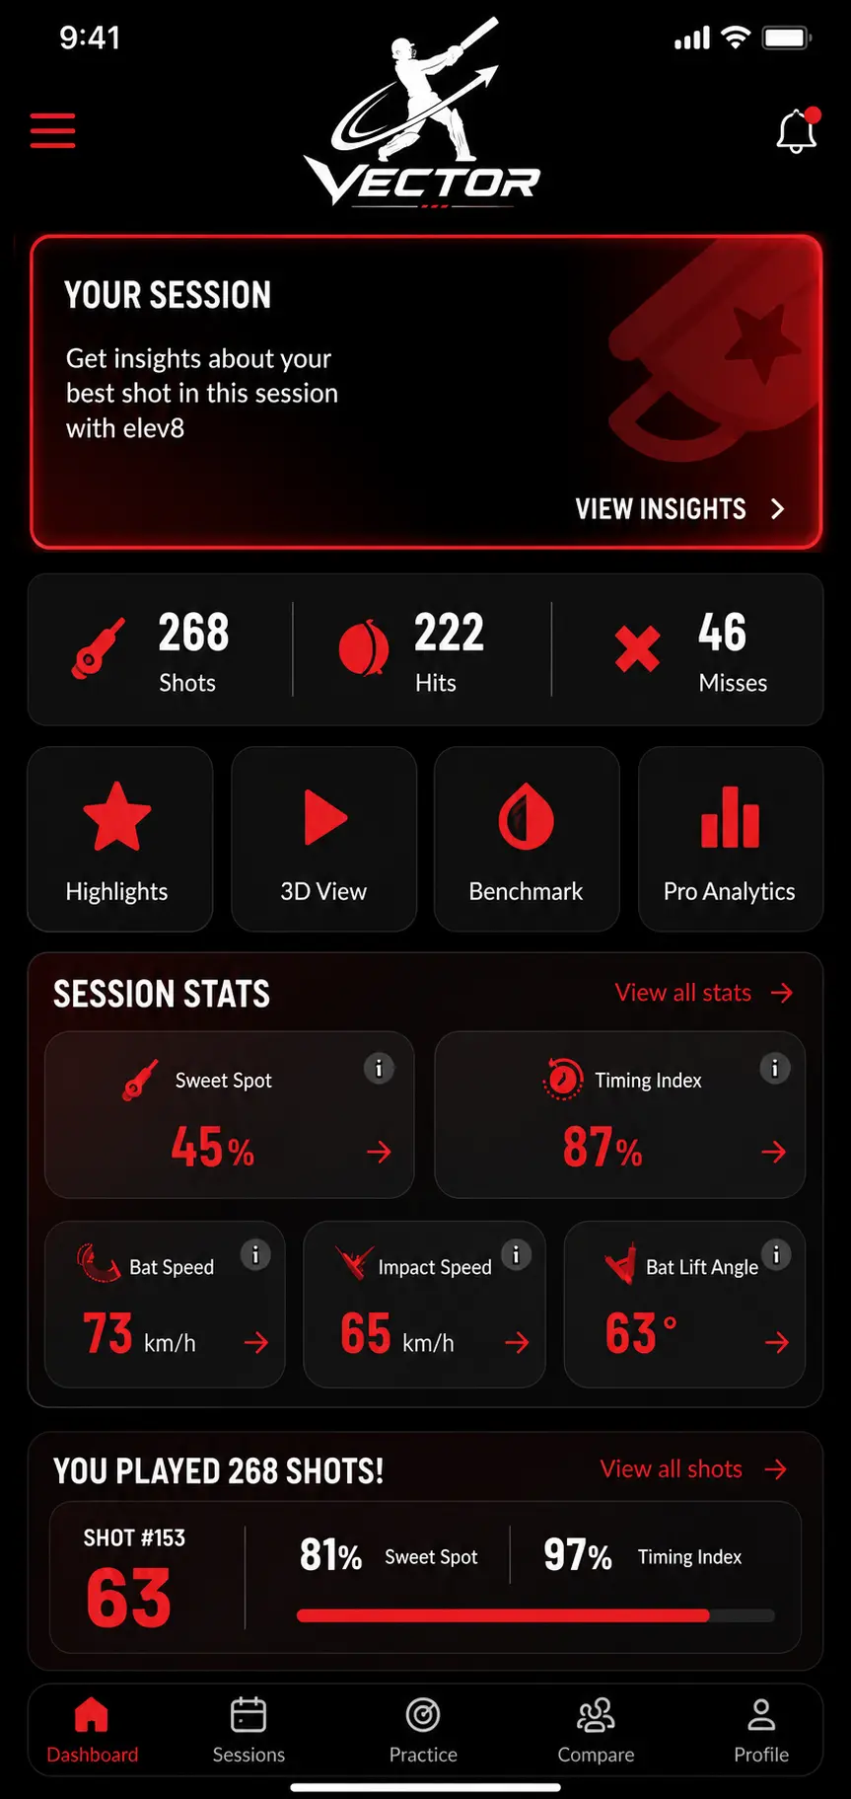 | 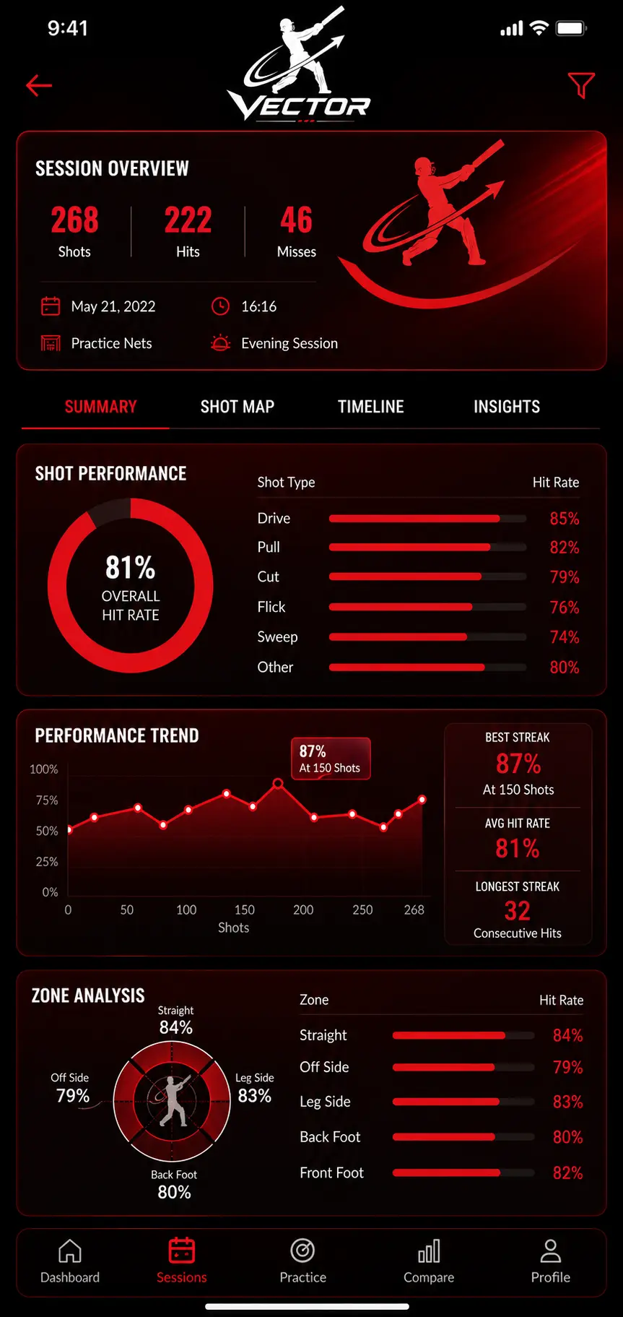 | 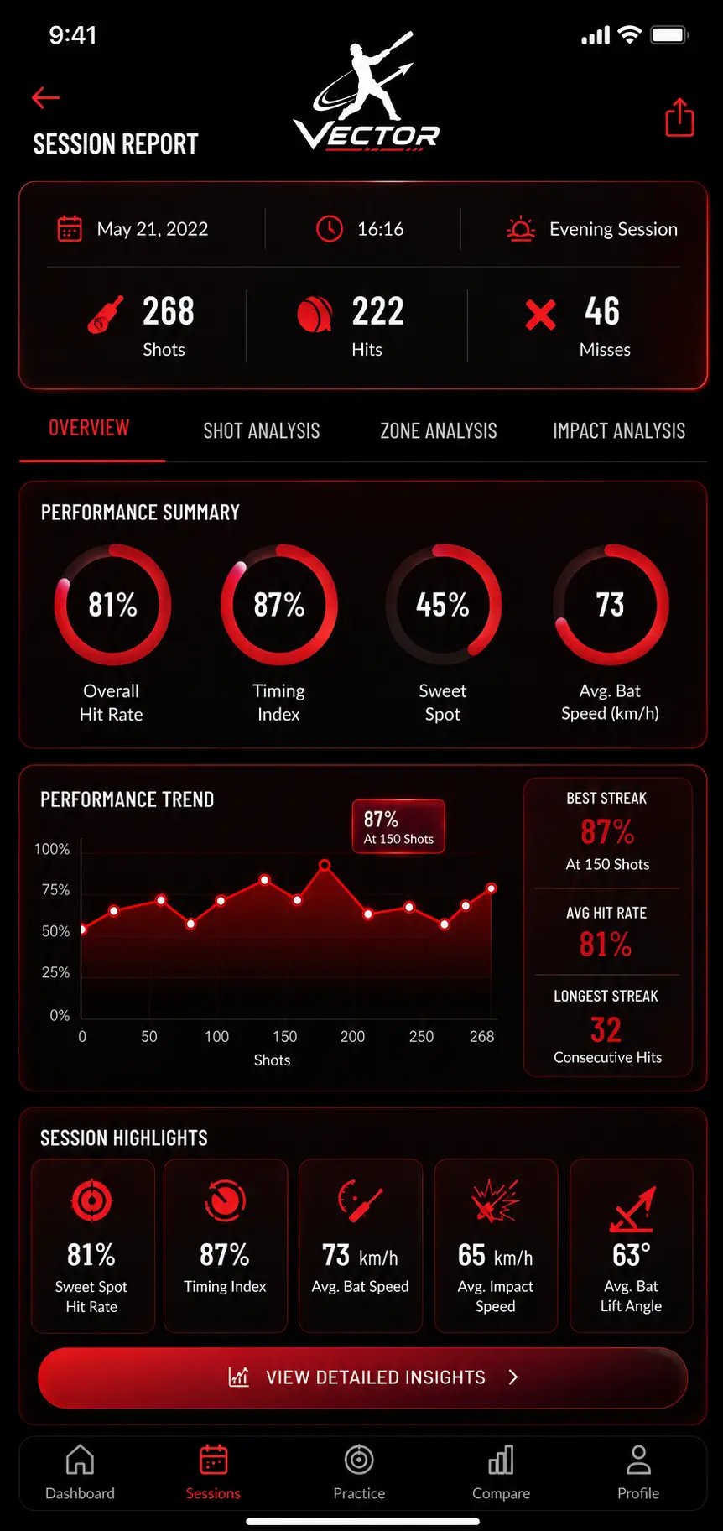

10. Recommended Navigation Structure
- Dashboard: Current session summary, quick start button, top stats and highlights.
- Sessions: All sessions list, filter by date/player, open detailed report.
- Practice: Start live tracking, countdown, sensor connection status and live cards.
- Compare: Compare two sessions by speed, timing, sweet spot and shot types.
- Profile: Player details, bat/device settings, calibration and report export.

11. MVP Recommendation
For the first FYP app, build a polished demo with realistic dummy data. Do not claim exact hit/miss or ball trajectory unless a camera/ball detection module is added. Present those values as estimated analytics based on impact detection and AI scoring.
- Phase 1: UI + raw demo data + charts + session reports.
- Phase 2: Connect ESP32 and stream BNO085/ADXL375 data.
- Phase 3: Collect labeled shots and train shot classification model.
- Phase 4: Add optional mobile camera for real hit/miss, shot map and ball direction.

