**SSW810 Special Topics in Systems Centric Software Engineering Fall 2022**

**Assignment #3**

**Due October 6, 6:30 pm**

**Hu, I-Hsuan 20010728**

There are four linear programming problems in this assignment focusing on transportation, transshipment, and assignment problems. Please submit (i) a single document demonstrating the mathematical formulation for each problem and (ii) **four Python files** for solving the models using Gurobi optimizer.

# Problem 1

A manufacturing company has two warehouses from which it distributes its product to five retailers. At the start of every week, each retailer sends an order to the company’s head office, which is then dispatched from the appropriate warehouse to the retailer. The company would like to have an interactive computer program which they can run week by week to tell them which warehouse should supply which retailer so as to minimize the costs of the whole operation. For example, suppose that at the start of a given week the company has 2000 products at warehouse A, and 3000 products at warehouse B, and that the retailers require 500, 800, 1800, 300, and 700 products respectively.

Transportation Cost of each path is given in the following Table.

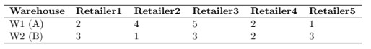

1. What data structure can be used to store number of retailers, warehouses capacity, costs information, and retailers’ demand?

Ans: Use Hashmap, which is called Dictionary in Python, to store items with identifiers.

1. Create the appropriate data structures in Python (**Note:** It is not required to solve the model for this question)

Ans: retailer = [‘1’,’2’,’3’,’4’,’5’] , supply = [‘A’, ‘B’]

demandV = {‘1’:500, ‘2’:800, ‘3’:1800, ‘4’:300, ‘5’:700}, supplyV ={‘A’: 2000, ‘B’: 3000}

cost = {(‘1’,’A’):2, (‘1’,’B’):3, (‘2’,’A’):4, (‘2’,’B’):1, (‘3’,’A’):5, (‘3’,’B’):3, (‘4’,’A’):2, (‘4’,’B’):2,

(5,’A’):1, (5,’B’):3}

1. Formulate the linear programming model for this problem

Minimum Z = 2XA1 + 3XB1 + 4XA2 + XB2 + 5XA3 + 3XB3 + 2XA4 + 2XB4 + XA5 + XB5

Demand Constraints: XA1 + XB1 = 500, XA2 + XB2 = 800, XA3 + XB3 = 1800,

XA4 + XB4 = 300, XA5 + XB5 = 700

Supply constraints: XA1 + XA2 + XA3 + XA4 + XA5 = 2000

XB1 + XB2 + XB3 + XB4 +XB4 + XB5 = 3000

Nonnegativity constraints Xij >= 0

# Problem 2

Oranges are grown, picked, and then stored in warehouses in Tampa, Miami, and Fresno. These warehouses supply oranges to markets in New York, Philadelphia, Chicago, and Boston. The following table shows the shipping costs per truckload (in hundreds of dollars), supply, and demand.

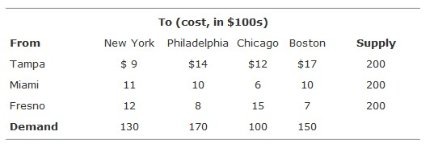

Because of an agreement between distributors, shipments are prohibited from Miami to Chicago.

1. Formulate this problem as a linear programming model

Minimum Z = 9XTN + 11XMN + 12XFN + 14XTP + 10XMP­ + 8XFP + 12XTC + 15XFC + 17XTB + 10XMB + 7XFB

Supply constraints XTN + XTP + XTC + XTB <= 200, XMN + XMP­ + XMB  <=200, XFN + XFP + XFC + XFB <= 200

Demand constraints XTN + XMN + XFN = 130, XTP + XMP­ + XFP = 170, XTC + XFC = 100, XTB + XMB + XFB = 150

Nonnegativity constraints Xij >= 0

1. Find the optimal solution by using Python and Gurobi optimizer

The minimum cost of transportation is $190,000

Oranges from Tampa to New York are 50

Oranges from Tampa to Chicago are 100

Oranges from Miami to New York are 80

Oranges from Miami to Philadelphia are 120

Oranges from Fresno to Philadelphia are 50

Oranges from Fresno to Boston are 150

# Problem 3

Walsh's Fruit Company contracts with growers in Ohio, Pennsylvania, and New York to purchase grapes. The grapes are processed into juice at the farms and stored in refrigerated vats. Then the juice is shipped to two plants, where it is processed into bottled grape juice and frozen concentrate. The capacity at each plant were 140,000 tons. The juice and concentrate are then transported to three food warehouses/distribution centers.

The transportation costs per ton from the farms to the plants and from the plants to the distributors, and the supply at the farms and demand at the distribution centers are summarized in the following tables:

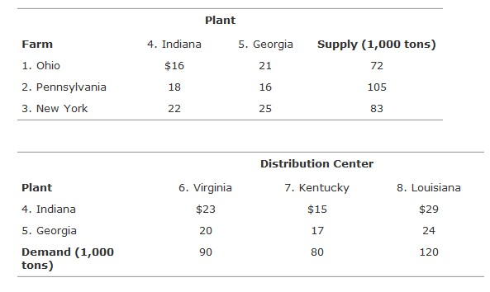

1. Formulate this problem as a linear programming model

Minimum Z = (16XOI + 18XPI + 22XNI + 21XOG + 16XPG + 25XNG) + (23XIV + 20XGV + 15XIK +17XGK + 29XIL + 24XGL)

Supply constraints XOI + XPI + XNI = XIV + XIK + XIL <= 140, XOG + XPG + XNG = XGV +XGK + XGL <= 140

Demand constraints XIV + XGV = 90, XIK +XGK = 80, XIL + XGL = 120

Nonnegativity constraints Xij >= 0

1. Determine the optimal shipments from farms to plants to distribution centers to minimize total transportation costs by using Python and Gurobi optimizer

The minimum cost of transportation is $10043

Grapes from Ohio to Indiana are 72,000 tons

Grapes from Pennsylvania to Georgia are 105,000 tons

Grapes from New York to Indiana are 68,000 tons

Grapes from New York to Georgia are 15,000 tons

Juice from Indiana to Virginia is 60,000 tons

Juice from Indiana to Kentucky is 80,000 tons

Juice from Georgia to Virginia is 30,000 tons

Juice from Georgia to Louisiana is 90,000 tons

# Problem 4

State University has planned six special catered events for the Saturday of its homecoming football game. The events include an alumni brunch, a parents' brunch, a booster club luncheon, a postgame party for season ticket holders, a lettermen's dinner, and a fund-raising dinner for major contributors.

The bids (in thousands of dollars) based on menu guidelines for the events prepared by the university are shown in the following table:

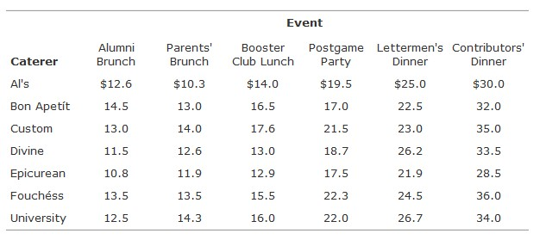

The Bon Apetít, Custom, and University caterers can handle two events, whereas each of the other four caterers can handle only one. The university is confident that all the caterers will do a high-quality job, so it wants to select the caterers for the events that will result in the lowest total cost.

1. Formulate this problem as a linear programming model

Minimum Z = 12.6XAA + 14.5XAB + 13.0XAC + 11.5XAD + 10.8XAE + 13.5XAF +12.5XAU +

10.3XPA + 13.0XPB + 14.0XPC + 12.6XPD + 11.9XPE + 13.5XPF +14.3XPU +

14.0XBA + 16.5XBB + 17.6XBC + 13.0XBD + 12.9XBE + 15.5XBF +16.0XBU +

19.5XPA + 17.0XPB + 21.5XPC + 18.7XPD + 17.5XPE + 22.3XPF +22.0XPU +

25.0XLA + 22.5XLB + 23.0XLC + 26.2XLD + 21.9XLE + 24.5XLF +26.7XLU +

30.0XCA + 32.0XCB + 35.0XCC + 33.5XCD + 28.5XCE + 36.0XCF +34.0XCU

Demand constraint XAA + XAB + XAC + XAD + XAE + XAF +XAU = 1, XPA + XPB + XPC + XPD + XPE + XPF + XPU = 1, XBA + XBB + XBC + XBD + XBE + XBF + XBU = 1, XPA + XPB + XPC + XPD + XPE + XPF + XPU = 1, XLA + XLB + XLC + XLD + XLE + XLF + XLU = 1, XCA + XCB + XCC + XCD + XCE + XCF + XCU = 1

Supply constraint XAA + XPA + XBA + XPA + LA + XCA = 1, XAB + XPB + XBB + XPB + XLB + XCB <= 2, XAC +XPC +XBC +XPC +XLC +XCC <= 2, XAD + XPD + XBD + XPD + XLD + XCD = 1, XAE + XPE + XBE + XPE + XLE + XCE = 1, XAF + XPF + XBF + XPF + XLF + XCF = 1, XAU + XPU + XBU + XPU + XLU + XCU <= 2

Nonnegativity constraints Xij >= 0

1. Determine the optimal selection of caterers to minimize total cost by using Python and Gurobi optimizer

The lowest total cost is $ 103.8

Alumni Brunch will be held in University

Parents' Brunch will be held in AI's

Booster Club Lunch will be held in Divine

Postgame Party will be held in Bon Apetit

Lettermen's Dinner will be held in Bon Apetit

Contributors Dinner will be held in Epicurean