 Republic of the Philippines  
 **DEPARTMENT OF AGRICULTURE RFO 1  
 Regional Project Coordination Office 1** San Fernando City, La Union

**Name: CHRISTIAN JAVE V. TEJANO  
Division: AO II (GGU)**

**TRAVEL ACCOMPLISHMENT REPORT**

|  |  |  |
| --- | --- | --- |
| **Date** | **Particulars/Place** | **Accomplishments/Highlight of the Activity** |
| **September 11, 2024** | **San Fabian, Pangasinan** | Provided assistance for the preparation of the venue which will be used for the conduction of Inauguration for the SP Construction of Aramal-Tocok Consolidation and Storage Facility |
| **September 12, 2024** | **Bauang, La Union** | Performed a site visit for the subproject Rehabilitation and Road Opening of Cabayangan-Sta. Monica FMR, while observing on how joint inspections are conducted. Taught on what documents or reports are required throughout the process of the project. |

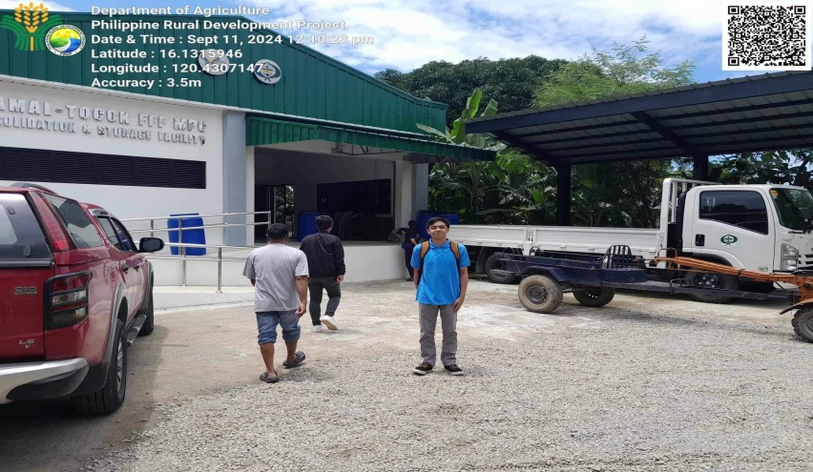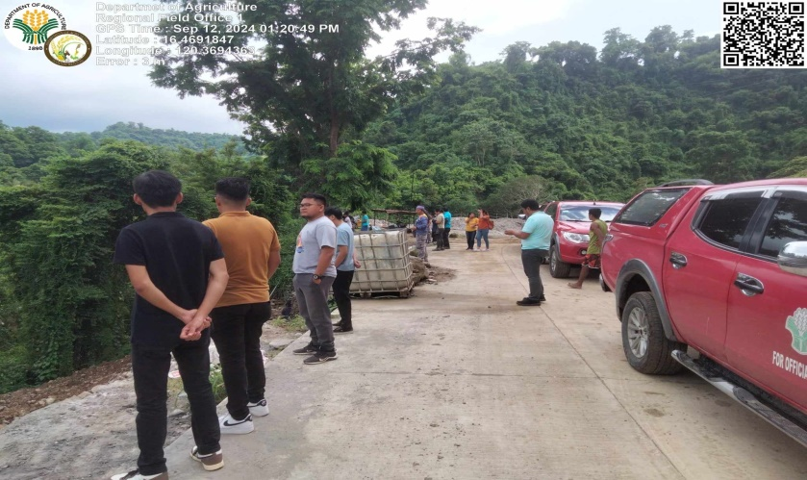

Prepared by: Noted:

CHRISTIAN JAVE V. TEJANO DEO G. RIVERA  
 AO II GGU HEAD