Ivan Dadakov & Martin Kafedzhiev
Tonttutrack
Real-Time GPS Tracker
Content

Project description 2
Hardware 3
Diagrams 4
Software 5
Diagrams 6
Timeline 7
Next steps in development 7

Project description
№ | Description
1 | A general idea about the project  The Tonttutrack project is an innovative system for tracking a person's location and speed in real time using a combination of hardware and software components. The main goal is to provide reliable and accurate tracking through a web application that visualizes the data on an interactive map. The project was developed between February and July and involved various stages of planning, development, testing and integration.
2 | How to access the project  Our repository:  githttps://github.com/codingburgas/arduino-projects-11a-IIDadakov20.git
3 | Team  Ivan Dadakov  Martin Kafedzhiev
4 | Used technologies for our project development  For the hardware we use Arduino IDE. The firmware is written in C++ and we use esp-now library for communication between the devices.  For the software we used Visual Studio 2022 as our IDE. The web app is written in C# using ASP.NET for the backend and HTML, CSS and JavaScript for the frontend. For our database we used MSSQL.

Hardware
№ | Components
1 | ESP32-S3 (Transmitter device)  The ESP32-S3 is a microcontroller used to collect data from the GPS module and display it on the OLED display. It supports communication with ESP32-WROOM-32 (Receiver device) via MAC address using the esp-now library.  Features:  - Wi-Fi and Bluetooth support  - Low power consumption  - Built-in encryption
2 | ESP32-WROOM-32 (Receiver device)  The ESP32-WROOM-32 serves as an intermediate controller connected to the user's device, receiving data from the ESP32-S3 and sending it to the web application.  Features:  - Wi-Fi and Bluetooth support  - Low power consumption
3 | L80R GPS module  The L80R GPS module provides precise coordinates, speed, altitude, date and time. It is connected to ESP32-S3 via serial communication.  Features:  - High location accuracy  - AGPS support
4 | I2C OLED display  The I2C OLED display shows basic information collected by the GPS module.  Features:  - High resolution  - Low power consumption

Diagrams
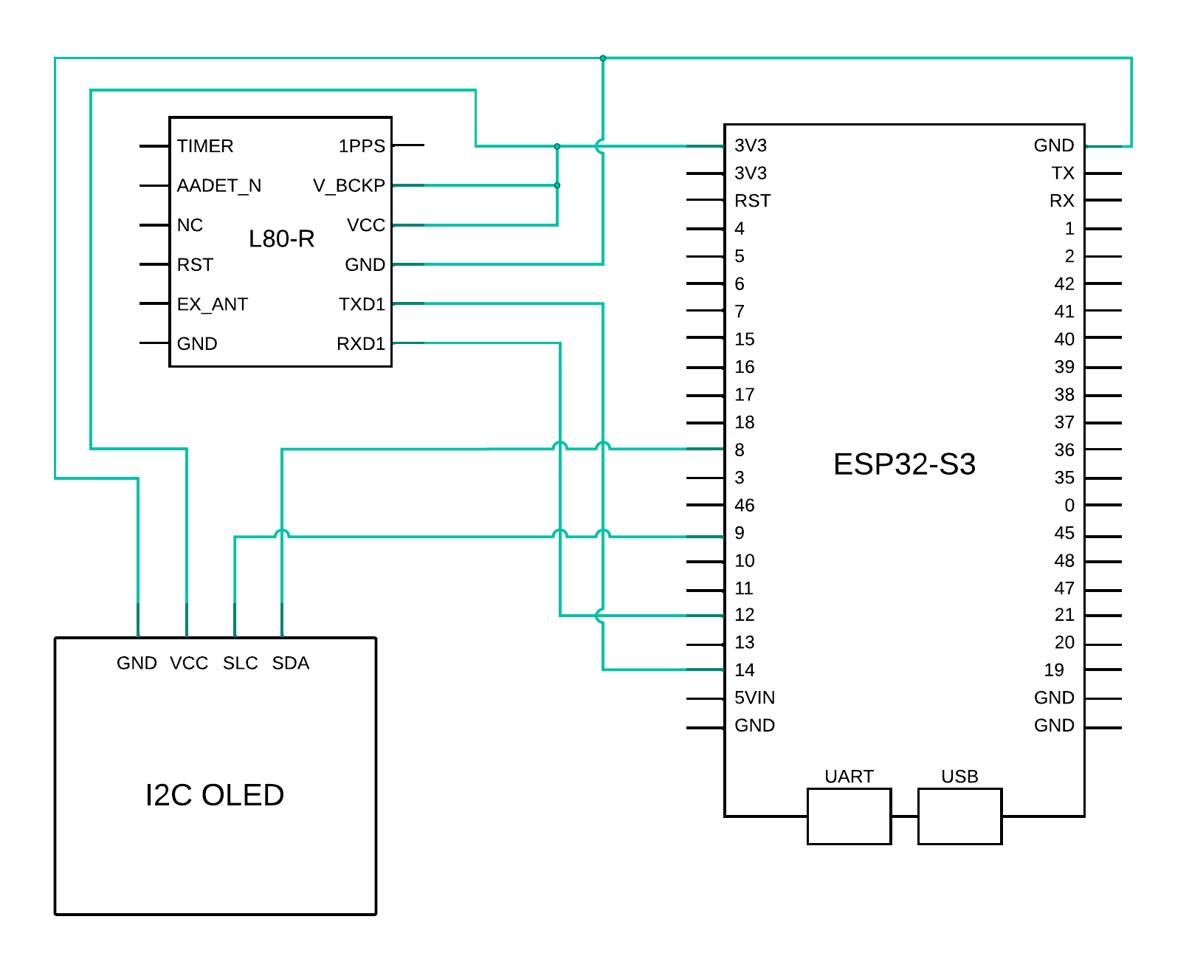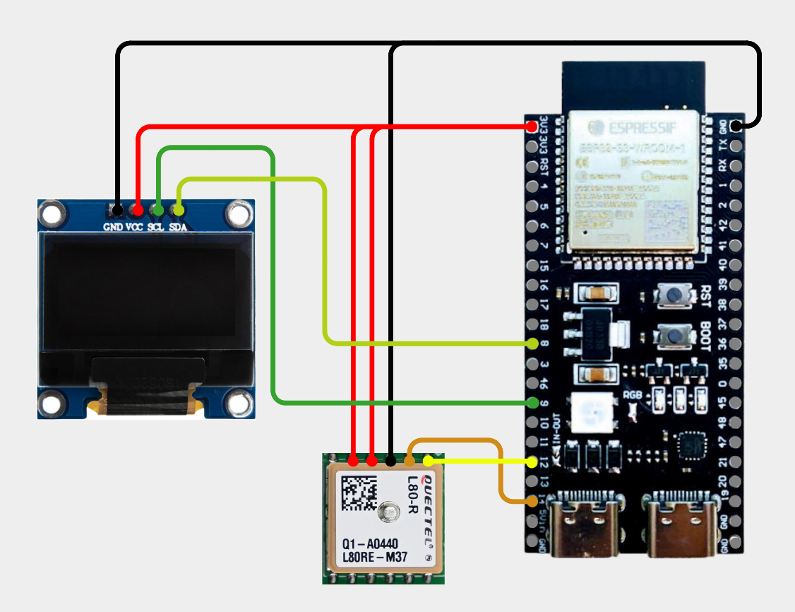

Software
№ | Components
1 | Firmware for ESP32-S3  The firmware for the ESP32-S3 collects data from the GPS module and updates the information every second. The data is sent to the ESP32-WROOM-32 (Receiver device) via the esp-now library, which uses a MAC address.  Features:  - GPS data collection  - Update OLED display  - Data transmission to ESP32-WROOM-32 (Receiver device)
2 | Firmware for ESP32-WROOM-32  The ESP32 firmware receives data from the ESP32-S3 every 5 seconds and sends it to the web application for processing.  Features:  - Receiving data from ESP32-S3  - Communication with ueb application
3 | C# WebApp  The web application is developed in C# using ASP.NET, a three-layer architecture and MSSQL database. It contains the following pages:  - Login and registration  - Users can register and log in. Login details are stored in a database and cookies are used to keep the session active for 10 days.  - Home page  - The Home page provides general information and navigation to other features of the web application.  - Map-tracker page  - Device connection form. When a device is present, the map displays the current location and speed of the device. The data is updated every 5 seconds and displayed on the map.

Diagrams
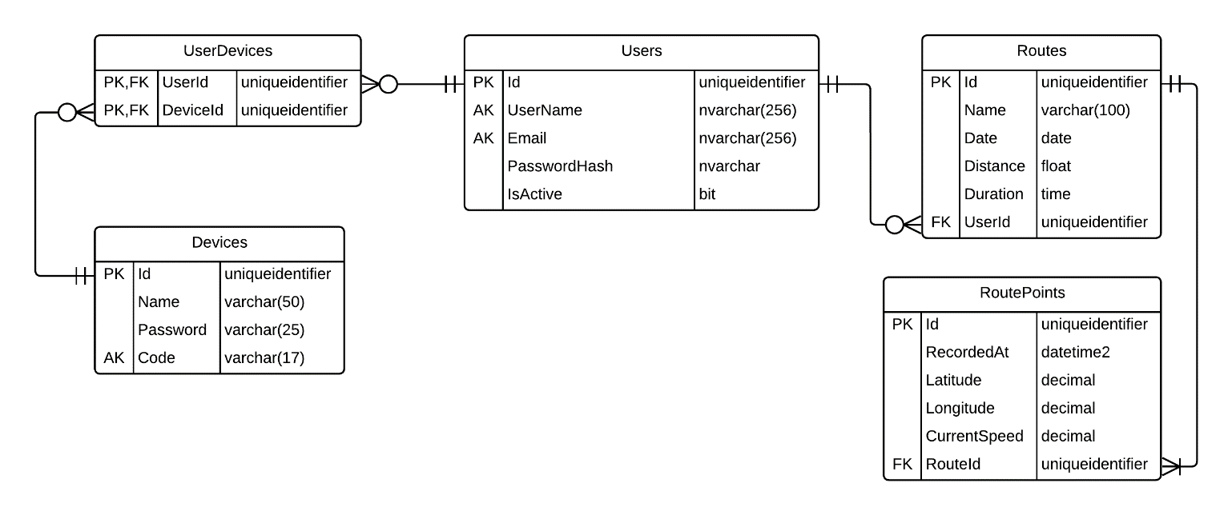
Entity-relationship diagram
Use case diagram
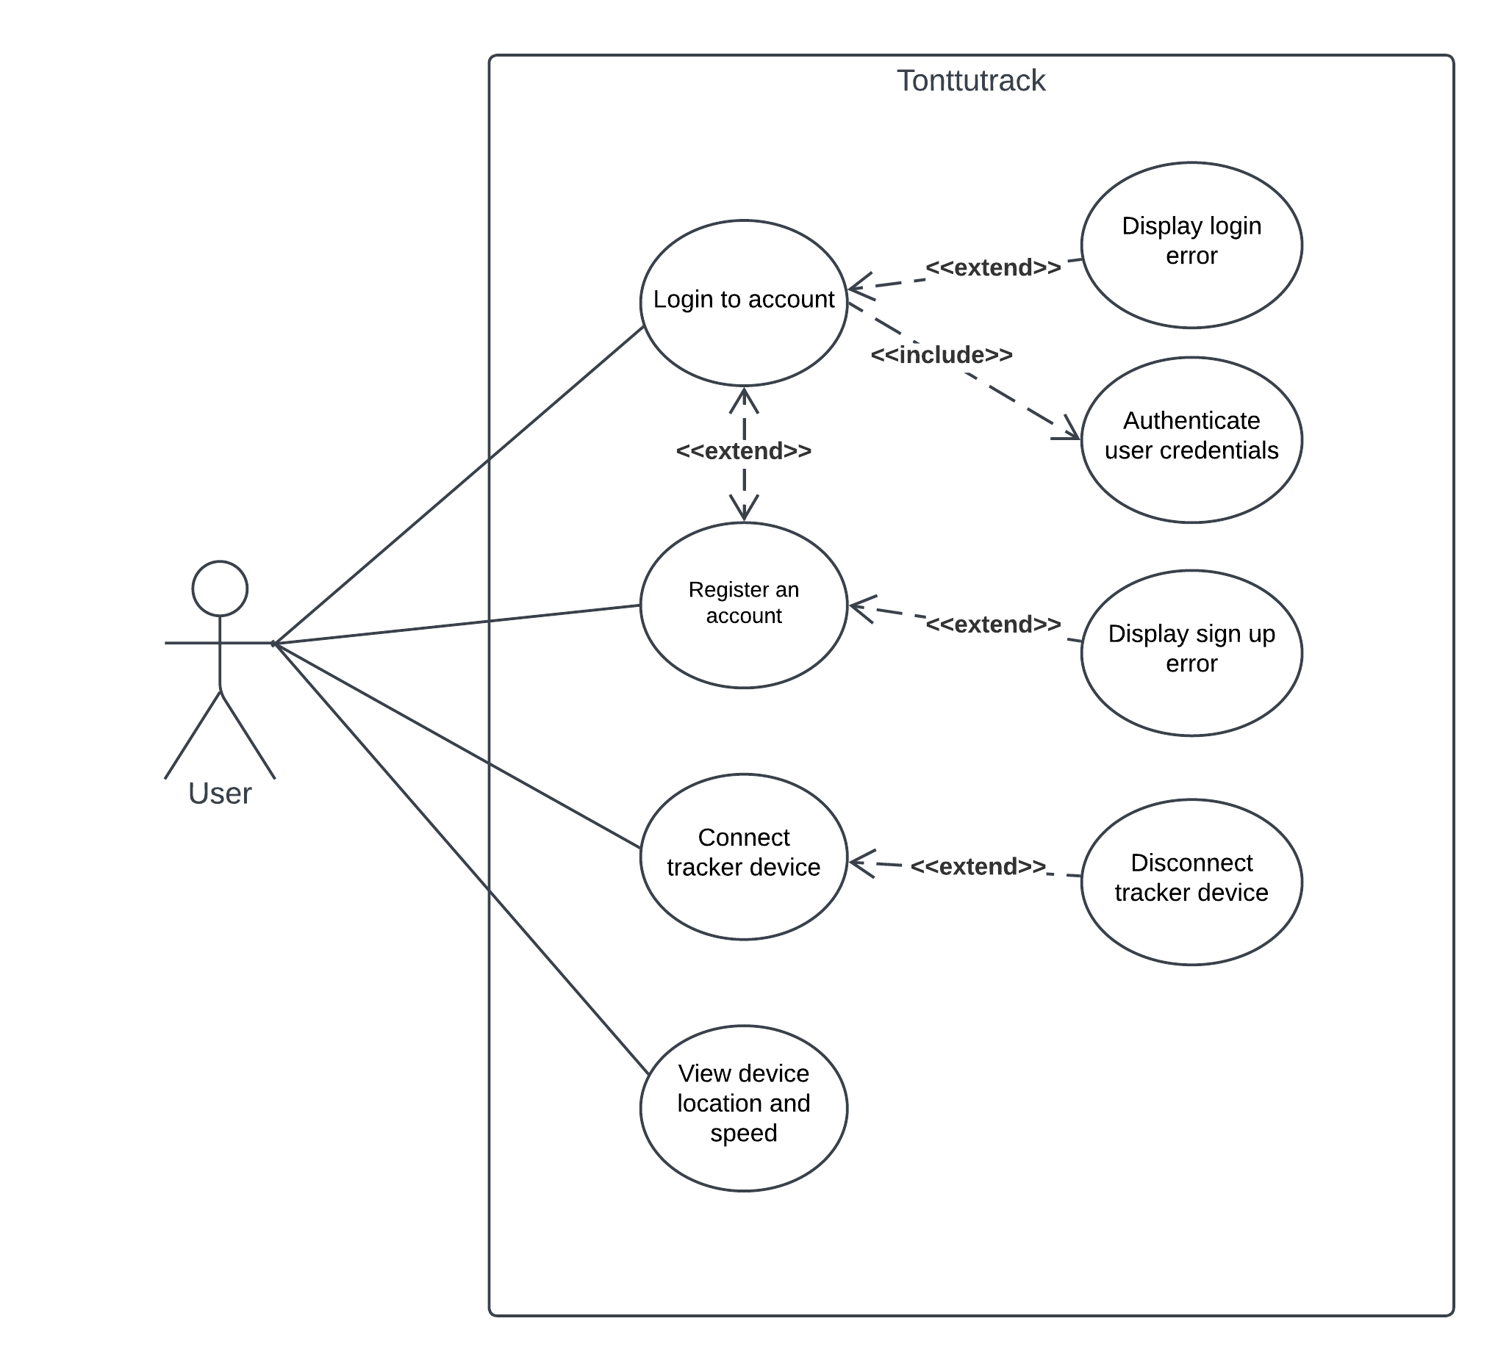
Sequence diagram
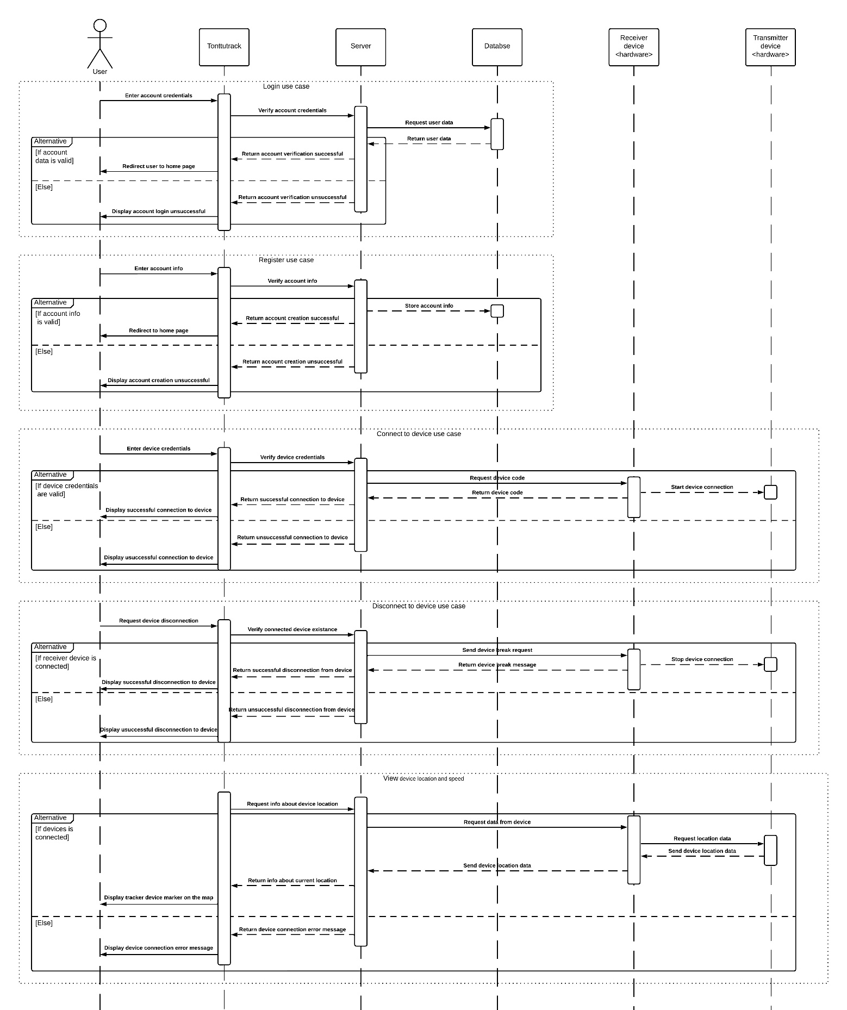

Timeline
- February: project start, planning.
- March: hardware development and initial testing.
- April: Firmware development and integration with hardware.
- May&June: Web application development.
- July: Project completion and final adjustments.

Next steps in development
- Saving routes and displaying statistics about them
- Admin panel
- My Profile page with settings and user information

