
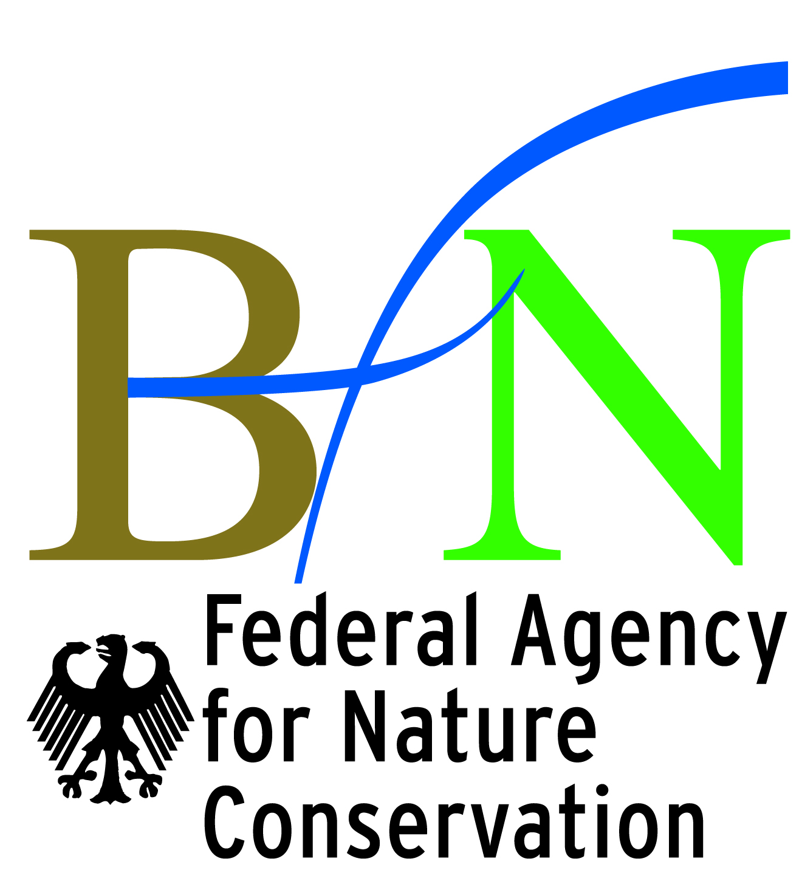

International Workshop

Biodiversity Conservation, Ecosystem Services
and Poverty Reduction

Shaping a New Agenda

September 17th to 21st 2009
International Academy for Nature Conservation, Isle of Vilm, Germany

The global economic crisis shocked the world earlier this year. Many governments have responded with enormous, unprecedented economic stimulus and support programs to avoid increasing unemployment and poverty. It is well known today that poverty impacts on the environment and increasing ecosystem degradation aggravates poverty. The loss of biodiversity is a central element in this vicious circle.

On the basis of recent discussions and experiences on linking biodiversity and ecosystems services with development and poverty reduction, the workshop primarily aims to develop inputs for the Strategic Plan of the Convention on Biological Diversity (CBD). The plan, which will be negotiated at the 10th Conference of the Parties in October 2010 in Nagoya, Japan, will influence environmental policies of 191 member states for the period 2011 to 2022. Among other issues, the plan will specify the importance of biodiversity for poverty reduction and the achievements of the Millennium Development Goals.

More specifically, the workshop focuses on three aspects: (1) a conceptual framework (2) targets and indicators and (3) policy instruments (e.g. PES and TEEB) for the integration of biodiversity and ecosystem services into sustainable development and poverty reduction strategies. Expected outputs of the workshop include recommendations for the new Strategic Plan of the CBD and a road map for further engagement into the process of policy implementation.

In 2010 the world will celebrate the UN International Year of Biodiversity and the theme of next year’s International Day on Biodiversity is "biodiversity for development and poverty alleviation". In the run-up to these events, the workshop provides a forum to discuss key issues and to develop inputs for a new agenda related to biodiversity conservation and poverty reduction. Through case studies we hope not to loose track and to incorporate practical experience. Ample space for discussions and working groups is considered.

Draft Programme

Thursday, 17 September 2009

Afternoon/evening: Individual arrival of participants

18:30 Dinner

20:00 Welcome to the Isle of Vilm and introduction to the International Academy for Nature Conservation
Gisela Stolpe, German Federal Agency for Nature Conservation (BfN)

Welcome of participants and introduction to the workshop
Bettina Hedden-Dunkhorst, BfN

Comprehensive introductory round
All participants

Introduction to the Strategic Plan of the CBD and the ongoing review process
N.N.

Friday, 18 September 2009

As of 7:30 Breakfast

09:00 Setting the Stage: Key Statements on Conservation and Poverty Reduction

Why do we need a conceptual framework?
Alfred Oteng-Yeboah, Council for Science and Technology

What targets and indicators are necessary to support the process?
Lea Scherl, IUNC CEESP, Taskforce on Protected Areas, Equity and Livelihoods

What are the requirements for successful policy implementation?
Carlos Manuel Rodriguez, Conservation International

Discussion

10:30 Coffee break

11:00 Conceptual Framework

An umbrella framework to link the CBD implementation with development and poverty reduction processes: Gap-analysis of the thematical CBD Programmes of Work and other inputs to the CBD planning cycle
Alberto Vega, Secretariat of the Convention on Biological Diversity

An up-date on the current discussions around Post-2010 frameworks that link biodiversity and human well being
Abisha Mapendembe, UNEP-WCMC

Discussion

12:30 Lunch

13:30 Excursion on the Isle of Vilm
N.N.,, BfN, Vilm

15:00 Coffee Break

15:30 Targets and Indicators

The post-2010 target and indicators: Overview, lessons and recommendations
David Thomas, BirdLife International

Experiences developing ecosystem indicators that link to wellbeing
Monica Hernandez- Morcillo, UNEP-WCMC

Social assessment of protected areas: Indicators, models and approaches
Lea Scherl

Discussion

17:00 Specification of Working Group Sessions

18:30 Dinner

20:00 Opportunities for further short ad-hoc presentation of activities and social gathering

Saturday, 19 September 2009

09:00 Policies and Policy Instruments

Payments for ecosystem services in Costa Rica: A successful policy instrument for linking conservation and sustainable development
Carlos Manuel Rodriguez, Conservation International

Challenges and potentials resulting from TEEB (The Economics of Ecosystems and Biodiversity)
N.N.

Discussion

10:30 Coffee break

11:00 Working Group Session I

12:30 Lunch

13:30 Exchange on Working Groups

14:00 Working Group Session II

17:00 Visit to Putbus / Rügen

20:30 Dinner

21:30 Opportunities for further short ad-hoc presentation of activities and social gathering

Sunday, 20 September 2009

09:00 Conservation, poverty, and policy in the field: Perspectives from the
Banggai Islands, Indonesia
Mochamad Indrawan

Title
IUCN Representative

10:00 Coffee Break

10:30 Working Group Session III

12:30 Lunch

13:30 Working Group Session IV

15:00 Coffee break

15:30 Working Group Presentations and Write up of Recommendations

17:30 Way Forward Discussion and Wrap Up

18:30 Dinner and Visit to the Vilm Photo Gallery and Social Gathering

Monday, 21 September 2009

As of 7:30 Breakfast

Individual departure of participants

07:25 First Departure option by ferry for train connections from Lauterbach-Mole at 08:05, breakfast packets will be provided

09:20 Second Departure option by ferry for train connections from Lauterbach-Mole at 10:05, lunch packets will be provided

Payments for Environmental Services
The Economics of Ecosystems and Biodiversity

