**CLDV6211 Part 1 of the POE**

**ST10435318**

**Byron Grove**

**URL GitHub Repository: https://github.com/IIEMSA/part-1-poe-GroveByron.git**

**URL Web App: https://eventeasevenuebookingapp-b8dydwfxh5cjcggy.southafricanorth-01.azurewebsites.net**

**Admin Login:**

**Username-Byron**

**Password EventEase1**

**Table of Contents**

A. Database Design 2

ERD Diagram 2

Database script 2

B. Develop the web application 3

C. Deploy your web app and Database to Microsoft Azure 4

Azure Web App service 4

Screenshot of service created 4

Screenshot of successful deployment message in VS 5

Azure SQL database 6

Screenshot of service created 7

Screen shot of migrated data and tables existing inside query editor 8

Web app URL in correct format 8

D. Cloud Computing basics 12

Difference between cloud hosting models 12

Difference between on-premises and cloud deployments 12

References 15

# A. Database Design

## ERD Diagram

Found within the submission folder.

# 

## Database script

Found within the submission folder.



# B. Develop the web application

All relevant data to this section is found within the submission folder. It includes the following:

1. Models, View, Controller for each Class, the following are Venue, Event, Booking.
2. CRUD functionality for each Class has been implemented the following are Venue, Event, Booking.
3. Image placeholder for URL is viewable in the application.
4. ASP.NET Project is provided in the submission folder.

# C. Deploy your web app and Database to Microsoft Azure

## Azure Web App service

#### Screenshot of service created



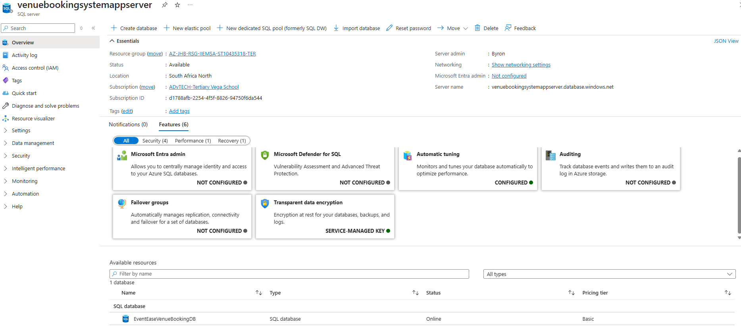

#### Screenshot of successful deployment message in VS

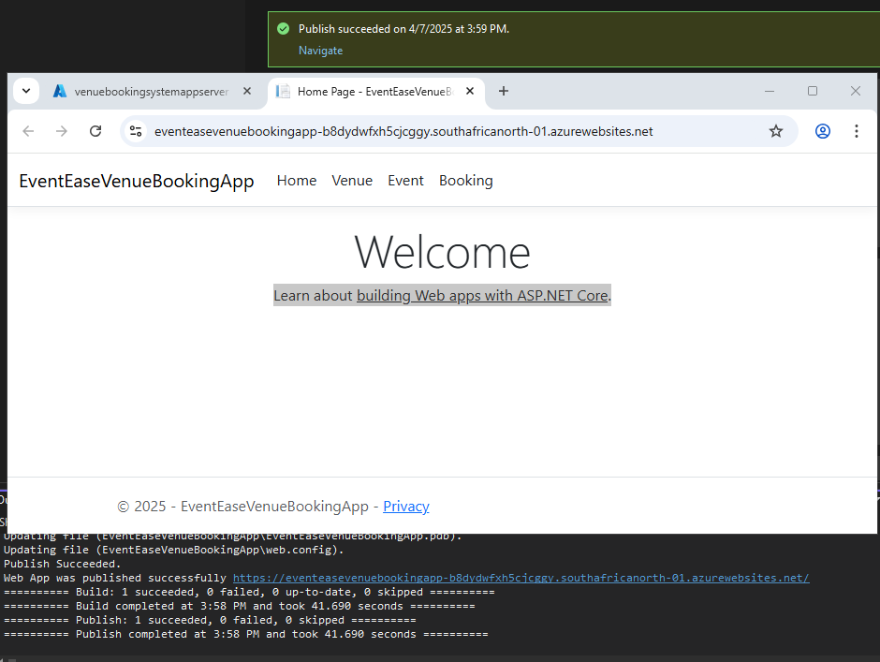

## Azure SQL database

#### Screenshot of service created



#### Screen shot of migrated data and tables existing inside query editor

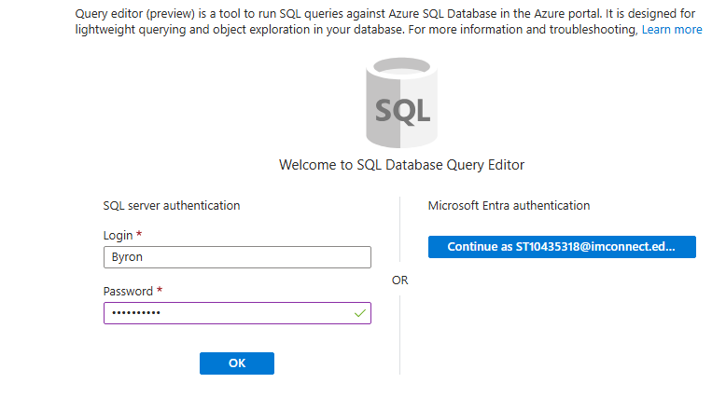

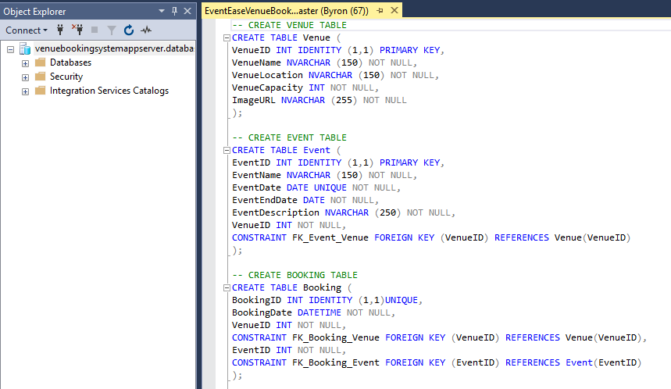

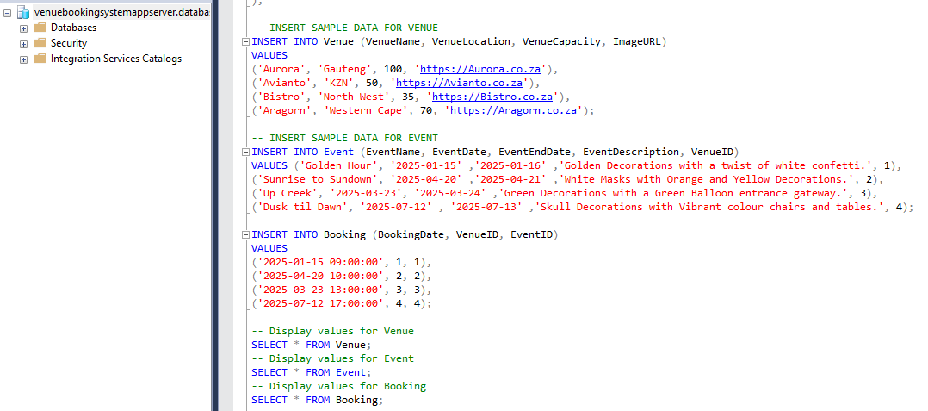

#### Web app URL in correct format

<https://eventeasevenuebookingapp-b8dydwfxh5cjcggy.southafricanorth-01.azurewebsites.net>

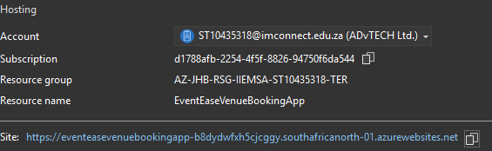

# D. Cloud Computing basics

#### Difference between cloud hosting models

1. There’s a various types of cloud models that are used in our everyday life such as Public cloud, Private cloud, Hybrid cloud, Community cloud, Multi-cloud each has their own unique way of meeting peoples and companies needs and wants.

#### Difference between on-premises and cloud deployments

Usually when deploying a cloud service remotely and not making use of an on-site premises it comes with a lot of benefits but also has its issue. Here below is how a Cloud Application is different to an On-site premises one.

* Creating and deploying an application for the cloud allows a user or company to improve security risks as its now left to be guarded by companies that are hired to ensure security is their priority. With an example if the University decided to choose a Cloud application they would trust their security to be run by a professional company that is regarded for protecting their cloud applications. This is a service that a Cloud application offers to relief some pressure that the University no longer needs to cover.
* The deployment speed that the cloud runs and operates allowing for fast expansion and grow within the cloud network. This improves scalability and grow of the user or company. With an example with the growing amount of students and users of the University there is always demand for growth, Having a deployment speed that improves the stability and run time of the cloud application as many users will be on from time to time allowing it to be dynamic to increase and decrease depending on the demand at the moment.
* Regarding resource management its a lot better to make use of a cloud application as it provides services such as Pay as you go, Quality Monitoring and allows users to manage their services. With an example the University activity and business is always changing, having a cloud application allows for dynamic change meaning the University can pay more or less depending on the activity on the cloud, this is useful as it ensure cost effectiveness and that the University doesn’t have to worry or struggle with the changes that happen on a daily base.

Here below is how an On-Site premises is different to a Cloud application one.

* When it comes to security for a On-site premises application the location and the organization or administration takes full responsibility for looking after it, maintaining it and ensuring updates are made regularly. There is a lot of work when it comes to on-site but however your in control of your own security so you understand that protocols and measures you take to ensure safety, this helps reduce threats from outside factors. With an example the University can manage their own security for the cloud application ensuring only the organization knows how the network works and that if an attack was to happen they know it was within the organization and not from outside as It would be less likely.
* The deployment speed would be affected a lot since everything is done manually and on-site this creates a slower start and running of the application. This creates a lot of difficulty when managing and trying to improve it. With an example the University is trying to deploy the application quickly however errors and problems evolve as the application now became complex with all the users that make use of the application have slowed down the operation and creating back logs that can crash the application.
* When it comes to resource management it is uncontrollable and unpredictable, there is always changes and its impossible for the on-site administrators to keep up with the changes leading to a lot of resources being used to sort the problem out. With an example of the University when the IT team are battling to improve the application as there are now more users making use of the application which is now increasing cost and that its unpredictable if it will decrease in activity so cost are being wasted as its not effective and unable to manage the activity of users.

2. The difference between the 3 Cloud service models is that each one has its own features which meets users needs and wants and satisfy company interest and goals.

* IaaS mainly focuses on aspects such as Hardware and Infrastructure, this means it allows a user to manage and create their own application and operating system. You as a user can manage your own application and data but the provider will be in charge of managing the hardware and network of your IaaS.
* PaaS mainly focuses or improvements such as providing tools and services that help manage and deploy applications which creates an easy user experience. You as a user can only make use of building the application where the provider manages the storage, the network and operating system of your PaaS.
* Saas provides a functional software base application meaning its ready to be accessed without any additional needs. You as a user are only able to make use of the software when the provider manages everything in your SaaS to ensure it runs smoothly.

The reason why I think EventEase would benefit from a PaaS model as it only needs a application and the PaaS model helps provide the tools for building and deploying as we’ve done in this part 1. The other aspects are being managed by the provider which is Azure Microsoft these aspects would be the operating system, the storage and servers as well as the networking, this provides an easy use of creating and deploying the application and not having to deal with other properties. As we created a Database and a Web app which is deployed and allowing for user input and we don’t need to manage it as its done already by the provider. This is why I think PaaS meets and satisfy the requirements for EventEase over the other two models.

## References

**Google Cloud. “PaaS vs IaaS vs SaaS: What’s the Difference?” *Google Cloud*, Google, 2024, cloud.google.com/learn/paas-vs-iaas-vs-saas.**

**Hughes, Adam. “Blog: On Premise vs. Cloud: Key Differences, Benefits and Risks | Cleo.” *Cleo*, 2018, www.cleo.com/blog/knowledge-base-on-premise-vs-cloud.**

**mgoertz-msft. “Use Models in Your Development Process - Visual Studio (Windows).” *Microsoft.com*, 10 Mar. 2023, learn.microsoft.com/en-us/visualstudio/modeling/use-models-in-your-development-process?view=vs-2022. Accessed 7 Apr. 2025.**

**Rick-Anderson. “Provide CRUD (Create, Read, Update, Delete) Data Form Entry Support.” *Learn.microsoft.com*, learn.microsoft.com/en-us/aspnet/mvc/overview/older-versions-1/nerddinner/provide-crud-create-read-update-delete-data-form-entry-support.**

**---. “Updating, Deleting, and Creating Data with Model Binding and Web Forms.” *Microsoft.com*, 21 July 2022, learn.microsoft.com/en-us/aspnet/web-forms/overview/presenting-and-managing-data/model-binding/updating-deleting-and-creating-data. Accessed 7 Apr. 2025.**

**S, Hanna. “Types of Cloud Computing: PaaS, SaaS, IaaS, FaaS, and CaaS.” *Cloudpanel.io*, 2021, www.cloudpanel.io/blog/types-of-cloud-computing/. Accessed 7 Apr. 2025.**

**StephenWalther. “Creating a Controller (C#).” *Microsoft.com*, 11 July 2022, learn.microsoft.com/en-us/aspnet/mvc/overview/older-versions-1/controllers-and-routing/creating-a-controller-cs. Accessed 7 Apr. 2025.**

**tdykstra. “Views in ASP.NET Core MVC.” *Microsoft.com*, 17 June 2024, learn.microsoft.com/en-us/aspnet/core/mvc/views/overview?view=aspnetcore-9.0.**

**“Visual Studio Code.” *Visualstudio.com*, 14 Apr. 2016, code.visualstudio.com/Docs/languages/html.**