Oarabile Marwane

ST10436124

part 2

CLDV6211 POE

Table of Contents

**No table of contents entries found.**

Table of Figures

**No table of figures entries found.**

# URLs:

GitHub: <https://github.com/IIEMSA/part-1-poe-MarwaneOarabile.git>

Deployed Web App: <https://st10436124.azurewebsites.net/>

Unlisted Youtube video:

A: Integrate Azure Storage

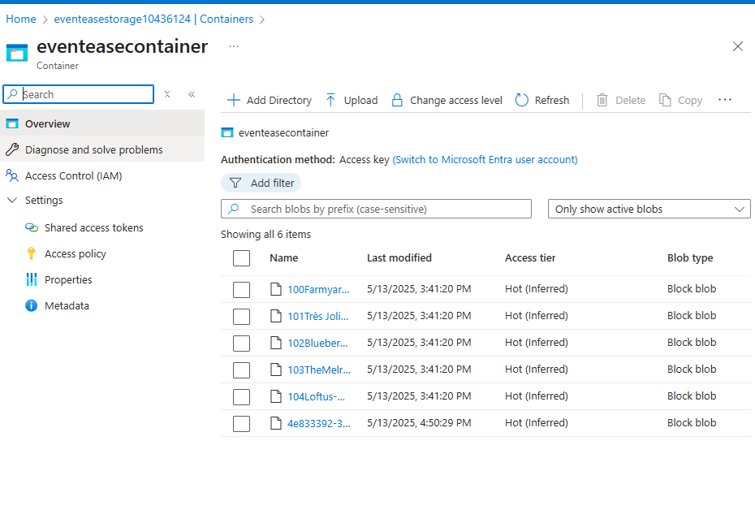

Proof of Images on blob storage

B

C Enhanced display and seacrch

Database script:

// creates New Booking View created displaying relevant information from event, venue, and booking

CREATE VIEW BookingOverviewView AS

SELECT

b.BookingID,

b.BookingDate,

e.EventID,

e.EventName,

e.EventDate,

e.Description AS EventDescription,

v.VenueID,

v.VenueName,

v.Location AS VenueLocation,

v.Capacity,

v.ImageUrl

FROM

Booking b

JOIN

[Event] e ON b.EventID = e.EventID

JOIN

Venue v ON b.VenueID = v.VenueID;

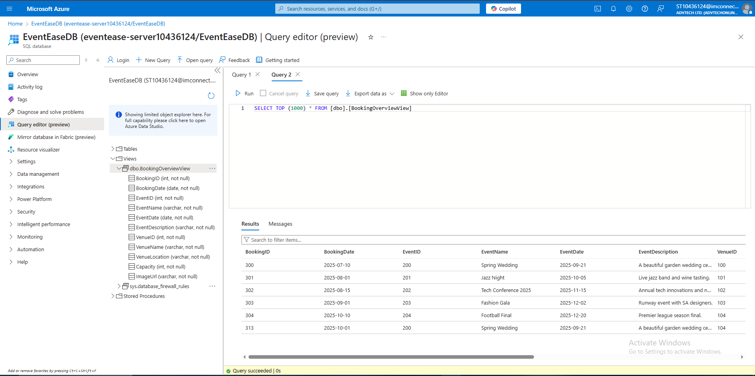

# E. Database Design, Cognitive Search:

1.

Azure’s cognitive search differences:

* Traditional search engines rely on keyword matching algorithms while AI powered search engines relay results on more complex algorithms bringing on more relevant and accurate search results.
* AI powered search engines support natural language processing and conversational search, making it easier for the search engines to relay accurate results to the user while traditional search engines have limited context understanding.
* ⁠Azures cognitive search uses AI and Machine Learning to enhance searching capabilities, ensuring more accuracy.
* ⁠They can utilise multiple search techniques, allowing for a wider range of search results.

Potential use cases where Cognitive Search would offer a clear advantage include:

* Content recommendation on content platforms such as; blogs, websites, and news etc Cognitive search engines utilise data collected such as user behaviour, preferences and interests to provide personalised content recommendations.
* It provides more relevant recommendations by analysing user queries, content aims semantics
* Its multi-format support for multiple content formats such as videos and audio helps making it all the more relevant and accurate.
* Information discovery and exploration on platforms such as; e-learning platforms and in research and development.
* ⁠Cognitive search engines are able to uncover hidden insights and patterns in large datasets.
* It allows users to make use of facets such as tags, categories and/or attributes to narrow down search results.

- Performance issues

* search results can be slowed down by complex queries and/or large indexes.
* Mitigation - improve query design by using efficient query techniques like filtering.

- Scalability

* Too little storage capacity can slow down queries or drop requests.
* Mitigation ⁠- Storage capacity can be increased by upgrading to a higher tier or adding resources.

- Query complexity

* Some queries can be computationally expensive.
* Mitigation - Queries can be broken down into simpler parts.

2.

* Data Consistency: By removing redundant and inconsistent data, data consistency is guaranteed.
* Data Integrity: By minimizing oddities and inconsistencies, data integrity is made possible.
* Scalability: Normalized databases are very scalable since they eliminate data duplication and increase the effectiveness of data retrieval.
* Enhanced speed: Normalization can enhance query speed by lowering the volume of data that must be processed.
* - Cost Optimization: In cloud environments, normalized databases can assist lower storage expenses.

Normalized Structures

Benefits:

* Data Consistency: Normalized structures minimize redundancy and provide data consistency.
* Enhanced Data Integrity: By lowering data anomalies, normalization contributes to the preservation of data integrity.
* Scalability: By minimizing data duplication, normalized architectures can increase scalability.

Challenges:

* Complex Queries: The performance of queries may be impacted by the complex joins that normalized structures frequently call for.
* An increase in latency may result from complex searches.

Denormalized Structures

Benefits

* + Improved Query Performance: By eliminating the need for intricate joins, denormalized structures can enhance query performance.
  + Reduced Latency: By storing previously calculated results, denormalized structures can lower latency.

Challenges

* Data Inconsistency: If denormalized structures are not appropriately maintained, they may result in inconsistent data.
* More storing: Denormalized structures may need more room for storing.

# Reference list

Adisa, A. (2025). ‘partOne.mp4’, <https://advtechonline-my.sharepoint.com/:v:/g/personal/aadisa_iie_ac_za/EW_qTy9HRmRGtDdiwKO1DCYBvbV_2iIB_PCBkMUc6RZNwg?nav=eyJyZWZlcnJhbEluZm8iOnsicmVmZXJyYWxBcHAiOiJTdHJlYW1XZWJBcHAiLCJyZWZlcnJhbFZpZXciOiJTaGFyZURpYWxvZy1MaW5rIiwicmVmZXJyYWxBcHBQbGF0Zm9ybSI6IldlYiIsInJlZmVycmFsTW9kZSI6InZpZXcifX0%3D&e=sWuViN>, accessed 22 March 2025.

—— (n.d.). ‘SQL Database Setup & Configuration -Part 1’.

—— (n.d.). ‘Creating SQL Tables in Azure & Connecting to SSMS Part 2’.

—— (n.d.). ‘MVC, Entity FrameWork Part 4’.

—— (n.d.). ‘MVC, Entity FrameWork Part 5’.

—— (n.d.). ‘MVC, Entity FrameWork Part 6’.

Chen, Y., & Toh, B. L. (2018). *Cloud Data Management: Key Techniques and Tools for Building Cloud Database Systems*. Springer.

Elmasri, R., & Navathe, S. B. (2015). *Fundamentals of Database Systems* (7th ed.). Addison-Wesley.

Harrington, J. L. (2016). *Relational Database Design and Implementation* (4th ed.). Morgan Kaufmann.

Hughes, A. (2018). *Blog: On Premise vs. Cloud: Key Differences, Benefits and Risks | Cleo*, Cleo, <https://www.cleo.com/blog/knowledge-base-on-premise-vs-cloud>, accessed 7 April 2025.

IBM. (2021). *IaaS, PaaS and SaaS*, IBM.com, <https://www.ibm.com/think/topics/iaas-paas-saas>.

Kamil Mrzygłód. (2018). *Hands-On Azure for Developers*, Packt Publishing Ltd.

Kimball, R., & Ross, M. (2013). *The Data Warehouse Toolkit: The Definitive Guide to Dimensional Modeling* (3rd ed.). Wiley.

Microsoft. (2020). *Azure Cosmos DB Documentation*. Retrieved from <https://docs.microsoft.com/en-us/azure/cosmos-db/>

Microsoft. (2021). *Azure SQL Database Documentation*. Retrieved from <https://docs.microsoft.com/en-us/azure/sql-database/>

w3schools. (2025). *W3Schools online HTML editor*, W3schools.com, <https://www.w3schools.com/w3css/tryit.asp?filename=tryw3css_templates_interior_design&stacked=h>, accessed 7 April 2025.