Web application link: <https://eventeaseapp25-b4asf6c3dtf5ddb5.canadacentral-01.azurewebsites.net/>

Theoretical questions:

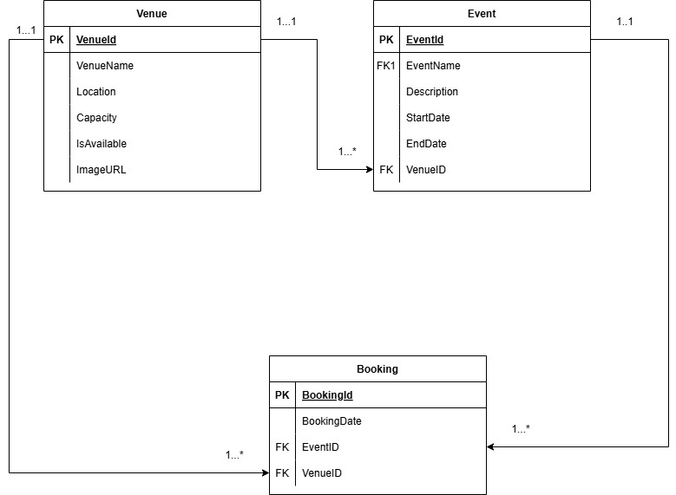

1.

Differences between deploying in cloud and deploying on premises:

Deployment of an application on the cloud is systematically known as PaaS (Platform-As-A-Service) whereby often a third party provider is able to give provision of resources such as their virtual servers within this scenario context to allow the application to be hosted in a sophisticated environment. Deploying on premises would equate to being responsible for the provision resources that such a deployment would require. This would mean locally hosting the servers and their upkeep and supervision opposed to hosting it on cloud whereby the third party (Google, Azure etc.) would still bear responsibility for the supervision and maintenance of their allocated resources.

In cloud deployment security is maintained at an extremely high standard especially with regards to third party major cloud providers you are likely to have the latest protection systems in place to safeguard your application/deployment such as Google Cloud armor which can protect you from application attacks and more such as SQL injections, DDoS(Distributed-Denial-of-Service). When deploying on premises you are responsible for security, and it is limited to your extent of knowledge of prevention systems and attacks etc. you also may be responsible for the physical security aspects and maintaining it. Scaling and accounting for growth for the application is easier with cloud deployment as cloud providers are able to account for growing traffic by having larger scale operations and flexible operating models whereas deploying locally/on-premises means accounting for scaled growth by increasing costs to fluctuate with the traffic growth and recession which can be costly and result in additional hardware costs. Depending on the cloud provide pay model you are likely to utilize or encounter more reasonable costs or a pay as you go model which alleviates the total cost price and is more efficient as often you are charged for resources used or per use when you deploy on the cloud. When deploying locally the costs are likely to be higher to account for all the additional equipment and hardware necessary to deploy the application as you are not provided with them.

When deploying to the cloud the upkeep of systems is the responsibility of the cloud provider which is often able to quickly respond to threats, bugs and provide updates to system to ensure they run concurrently with everything else without error or minimal room thereof. When deploying locally responsibility for maintenance is your own responsibility and can increase cost as you may require experts to attain a standard of maintenance for complex hardware that may not be always possible for one individual. Deploying on cloud is faster than deploying locally because cloud providers have readily made systems designated for the deployment of applications that are suited for many scenarios because it is their specialization and business model whereas deploying an application yourself would require you to be attempting to attain a set of specifications for deployment of your particular application on your own which can be a timely procedure.

Deploying to the cloud also means that the accessibility of your application is widespread because it is available on the internet whereas deploying locally would mean it is often not and would require extensive procedures to make it accessible to larger groups of people.

In this scenario Azure was used to deploy the EventEase application this is useful because many people are able to access the application, and many customers may likely one day want to access such an application from different areas of the world as it is a booking service.

2.

In IaaS (Infrastructure as a Service) the cloud provider gives the user access to virtual environments and more such as virtual machines, storage and networking while allowing the user to supervision and monitor the application and operating system. The cloud designates the responsibility of maintaining the operating system to the user while they bear the responsibility of maintaining hardware. An example of infrastructure as a service would be Azure Virtual Machines.

In PaaS (Platform as a Service) the cloud provider gives you access to infrastructure and runtime the user would only need to deploy applications. In this business model the cloud provider is responsible for the hardware, operating system and middleware whereas the user is designated the responsibility over their application. An example of platform as a service would be Azure Web Application Service .

In SaaS (Software as a Service) all necessary and additional resources are provided by the cloud provider the cloud provides is also responsible for the supervision of all resources in entirety. The presence of the user is considered as business so utilizing the software from such a third party is often enough to generate them revenue .An example of software as a service would be Outlook.

The EventEase scenario requires that an application is created utilizing Azure SQL and ASP. Net Core Web Application this means that the central focus of the scenario is developing and deploying the application successfully which makes the scenario suited for PaaS (Platform as a Service). With the PaaS model the application is able to account for its further development and growth easily and the software familiar environments allow for communication of different systems from the same provider seamlessly. The PaaS model also accounts for additional complex configuration procedures that may be needed in deploying the application as Azure is likely to account for a variety of possible types of applications and their possible needs. The use of PaaS here has provided an ecosystem of systems that can easily allow us to provide efficient fixes and updates to our application with minimal interference.

REFERENCES:

IBM. (n.d.) *IaaS vs. PaaS vs. SaaS*. [online] Available at: <https://www.ibm.com/think/topics/iaas-paas-saas> [Accessed 5 Apr. 2025].

Google Cloud. (n.d.) *PaaS vs. IaaS vs. SaaS: What’s the difference?* [online] Available at: <https://cloud.google.com/learn/paas-vs-iaas-vs-saas> [Accessed 7 Apr. 2025].

Nguyen, S. (2024) *Self-hosted, on-premises, or cloud: Which deployment model is best?* [online] DreamFactory Blog, 2 December. Available at: <https://blog.dreamfactory.com/self-hosted-on-premises-or-cloud-which-deployment-model-is-best> [Accessed 7 Apr. 2025].

Mrzyglod, K. 2022. **Azure for Developers: Implement rich Azure PaaS ecosystems using containers, serverless services, and storage solutions.** ISBN: 9781803240091

Bagha, A. & Madisetti, V. 2019. Cloud Computing Solutions Architect: **A Hands-On Approach: A Competency-based Textbook for Universities and a Guide for AWS Cloud Certification and Beyond**. VPT. ISBN: 9781949978018. (Open Access Textbook – register and download copy from <https://site.bookcenterapp.com/0996025596>)

Microsoft. 2022. **The Developer’s Guide to Azure.** Microsoft Press. (Open Access Textbook – download free copy here: <https://azure.microsoft.com/en-us/resources/research/developer-guide-to-azure/>)

Additional reference to videos provided by lecturer Juliana Adeola Adisa