

CLDV6211POE Part1

St10450570_Chuma_Makhathini



Table of Contents

ERD 2

WebApp Deployment 3

SQL Database Migration 5

References 7

# ERD

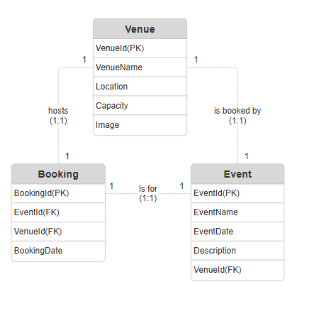  
This ERD models a strict one-to-one relationship between **Venue**, **Event**, and **Booking**, ensuring that each event occurs at a single venue and has only one booking. It prevents overbooking and double-booking by enforcing unique links between entities. Each relationship is clearly defined with 1:1 cardinality and labeled accordingly.

WebApp Deployment

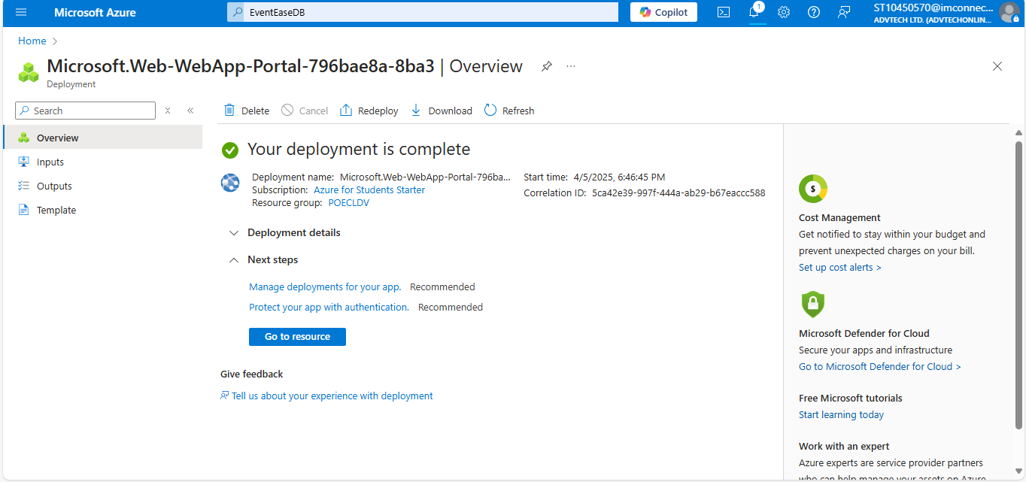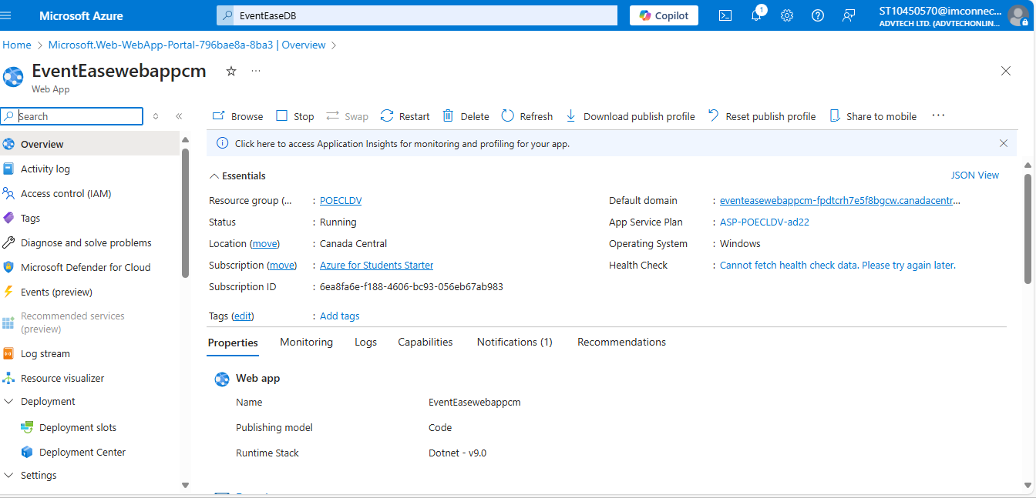My azure web application was created and deployed

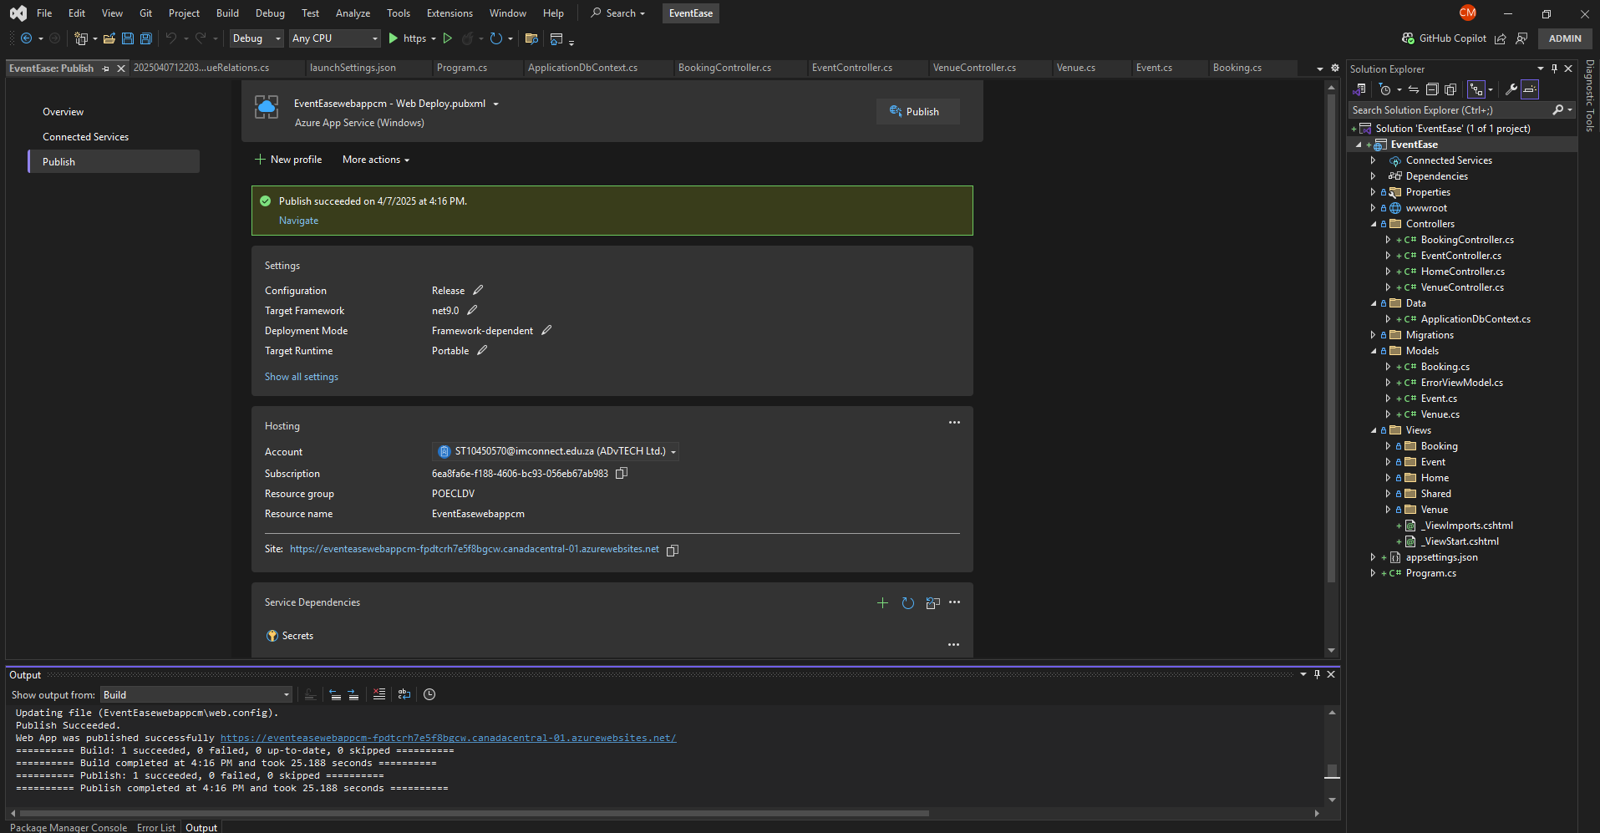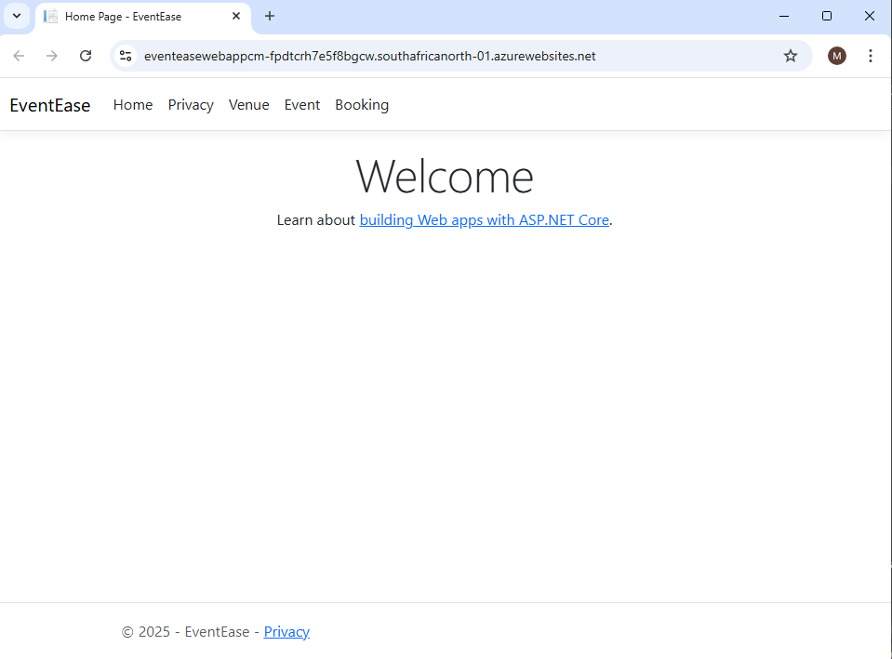Microsoft ASP.Net core Web app successfully deployed and published to azure Web applications as shown in the link

# SQL Database Migration

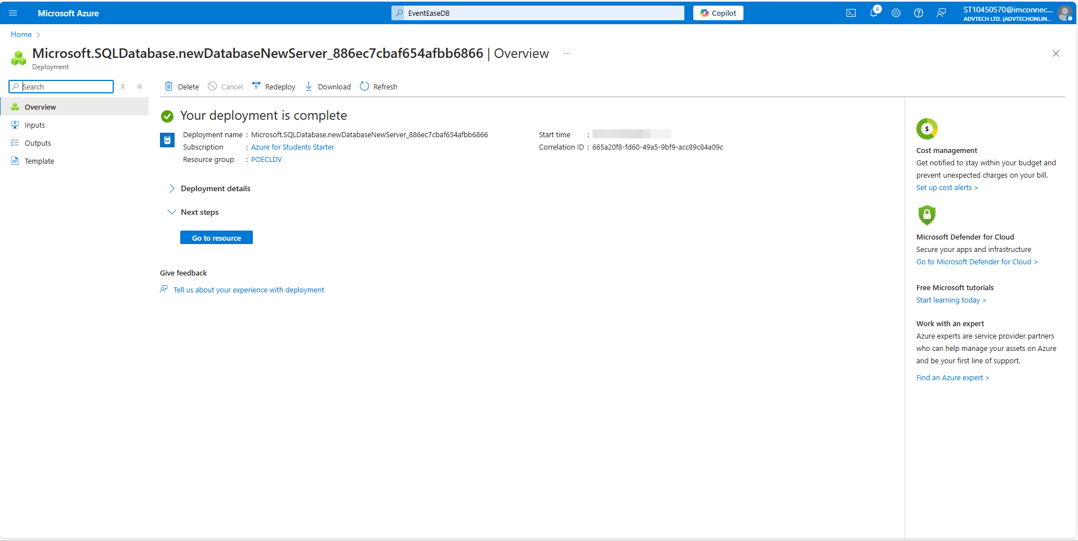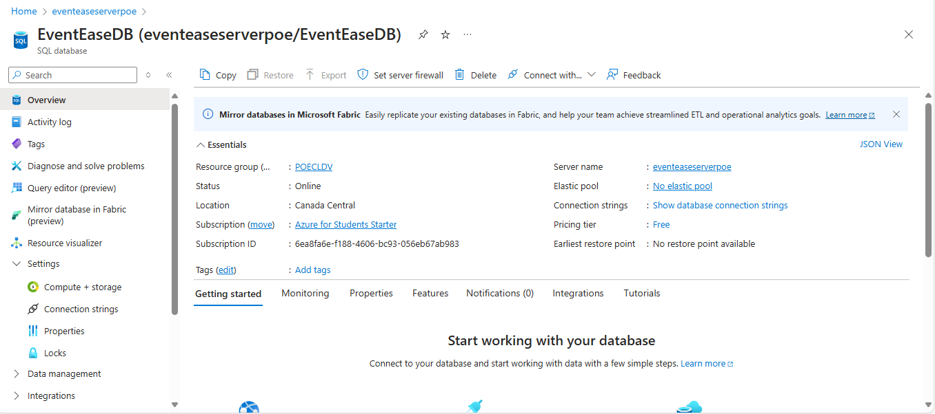Screenshots showing and confirming that my Azure SQL database has been created

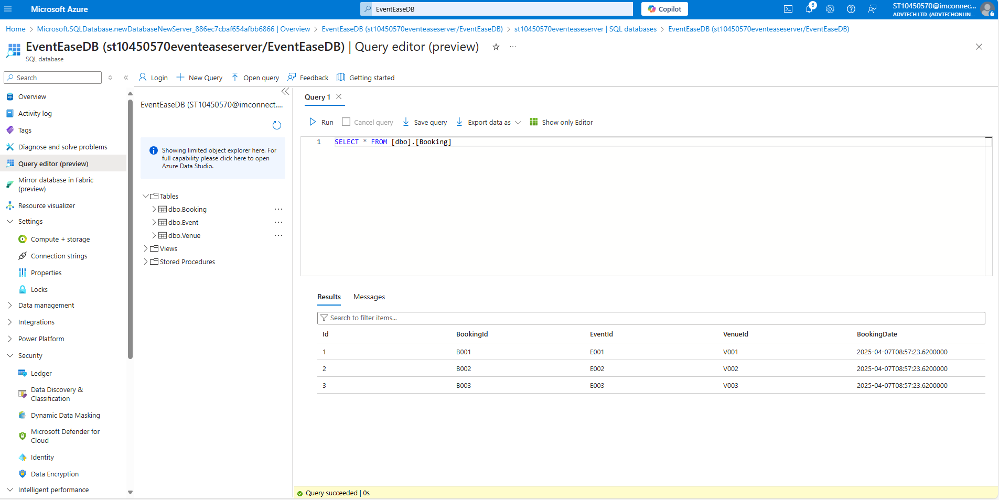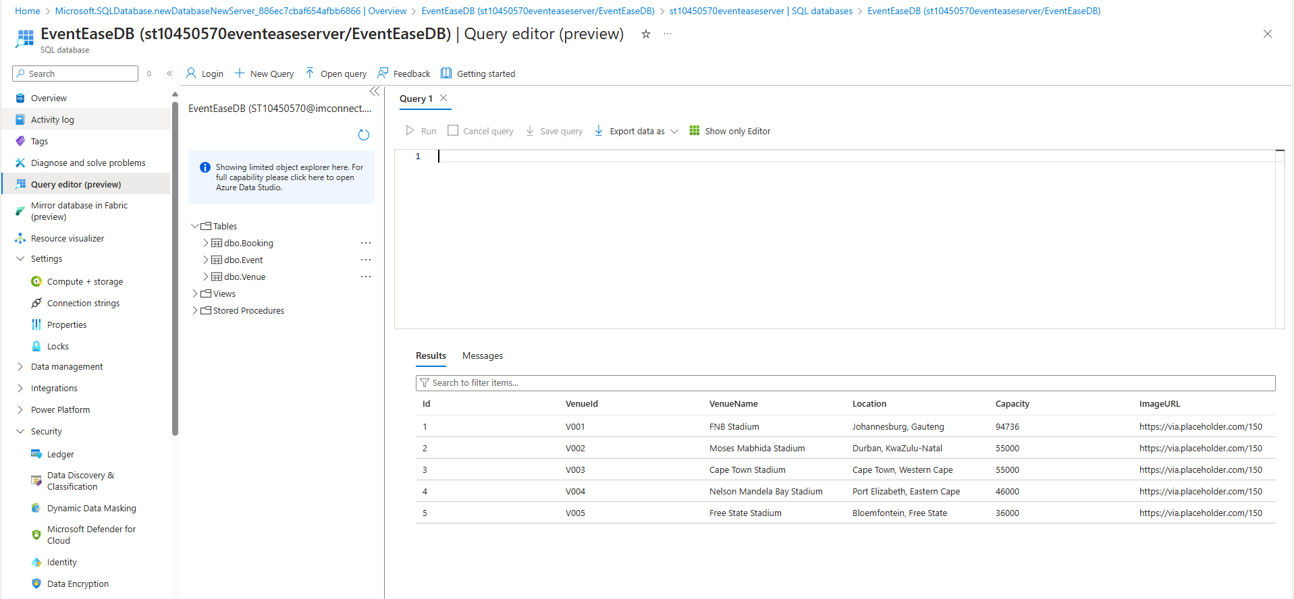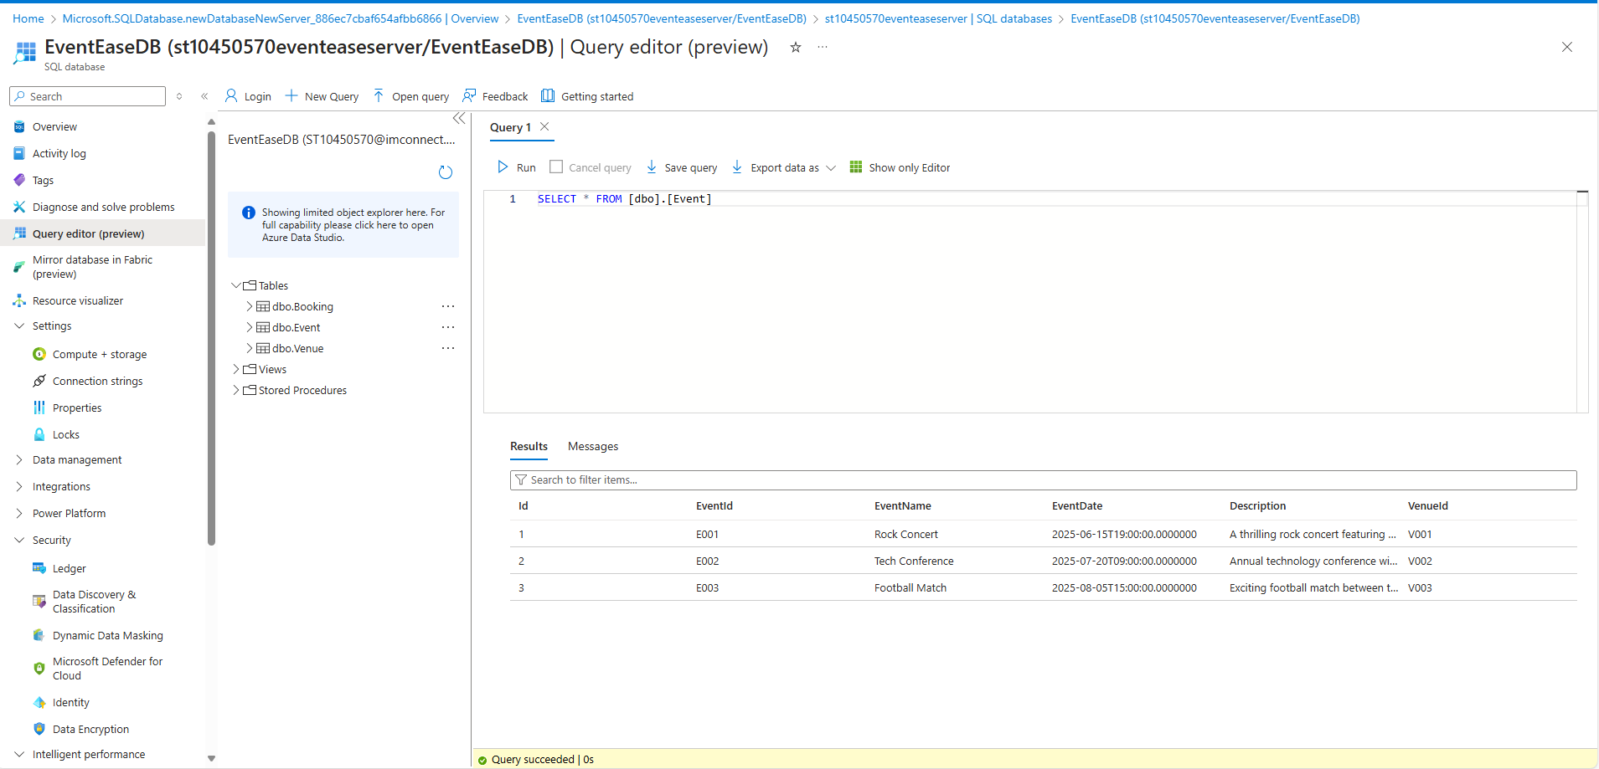Screenshots showing that my data has been migrated, and tables exist   
  
URLs

<https://github.com/IIEMSA/part-1-poe-ST10450570>

eventeasewebappcm-fpdtcrh7e5f8bgcw.canadacentral-01.azurewebsites.net [Home Page - EventEase](https://eventeasewebappcm-fpdtcrh7e5f8bgcw.canadacentral-01.azurewebsites.net/)

# References

Mrzygłod, K., 2022. *Azure for Developers: Implement rich Azure PaaS ecosystems using containers, serverless services, and storage solutions*. Packt Publishing. ISBN: 9781803240091.

Bagha, A. & Madisetti, V., 2019. *Cloud Computing Solutions Architect: A Hands-On Approach: A Competency-based Textbook for Universities and a Guide for AWS Cloud Certification and Beyond*. VPT. ISBN: 9781949978018

Huawei, 2022. *Cloud Computing Technology*. Springer. ISBN: 978-981-19-3025-6. Available at: <https://link.springer.com/book/10.1007/978-981-19-3026-3> [Accessed 7 Apr. 2025].

Microsoft, 2022. *The Developer’s Guide to Azure*. Microsoft Press. Available at: <https://azure.microsoft.com/en-us/resources/research/developer-guide-to-azure> [Accessed 7 Apr. 2025].