Field Visit Audit of Two Intersections

Audit Report

* Shibpur TD Intersection
* Intersection of Chowringhee Road and Elgin Road

*Report submitted by*

1. Shubhajit Saha Exam Roll: 110704060
2. Sisir Samadder Exam Roll: 110704026
3. Sariful Alam Exam Roll: 110704071

# Shibpur Tram Depot Intersection

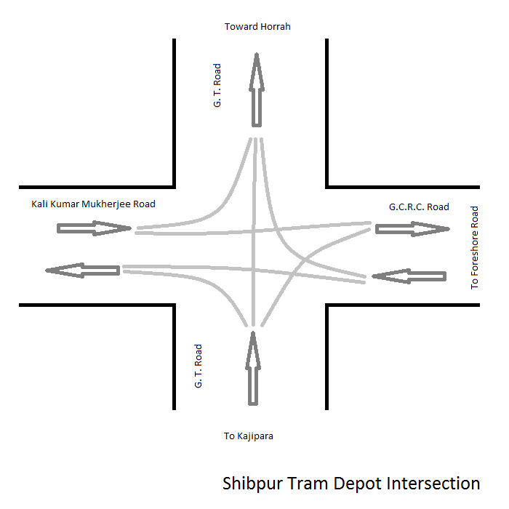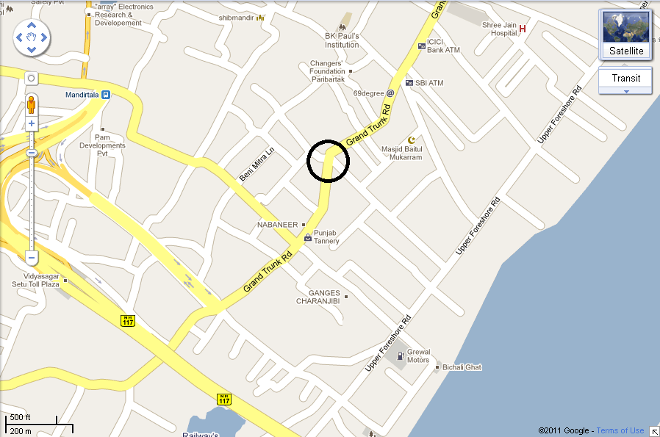

## ROAD SAFETY AUDIT

|  |  |  |
| --- | --- | --- |
| **Serial No.** | **Characteristics** | **Conditions** |
| 1 | Road Marking | There is no road marking, which driver can follow. No zebra crossing was present. |
| 2 | Traffic Signal | Single Traffic signals were present. |
| 3 | Pedestrian Signal Phase | Pedestrian signal phase is missing |
| 4 | Railing on Roads | Railing is not present, that’s why people cross the roads from anywhere. |
| 5 | Pedestrian | Flow of pedestrians is high. |
| 6 | Foot paths | Foot paths are not properly mention and maintained. People walk through beside the road. |
| 7 | Turning | Traffic load is high that why drivers prefer to overtake in the turnings, causing chaos in the road. |
| 8 | Traffic Signs | High traffic load & no proper traffic signs. No traffic police is controlling the traffic flow. The traffic does not follow the traffic signs. |
| 9 | Advertisement Boards | Many advertisement boards are present. |
| 10 | Accident Prone | Traffic flow is high at the junction and lacking of good traffic controlling system, the junction becomes high accidents prone zone. |
| 11 | Manhole/ Other construction | No speed breaker is present to control the traffic speed. |
| 12 | Bus stops | No proper bus stop is there. |
| 13 | Parking Lots | There is a parking lot of Bus (Route no. 55A) in G.C.R.C. Road. |
| 14 | Street light | Condition of street light is poor due to lack of proper maintenance. Some street lights are not working. Trees beside the roads, causing obstruction to the street light. |
| 15 | Traffic Police | No traffic police is controlling the traffic system. |
| 16 | Road Condition | Condition of the road is fair due to improper maintenance. |

# Intersection of Chowringhee Road and Elgin Road

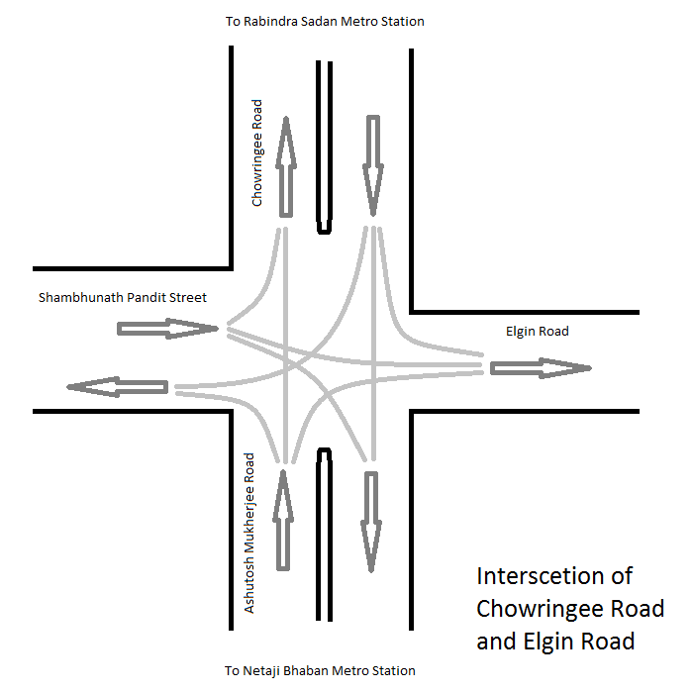

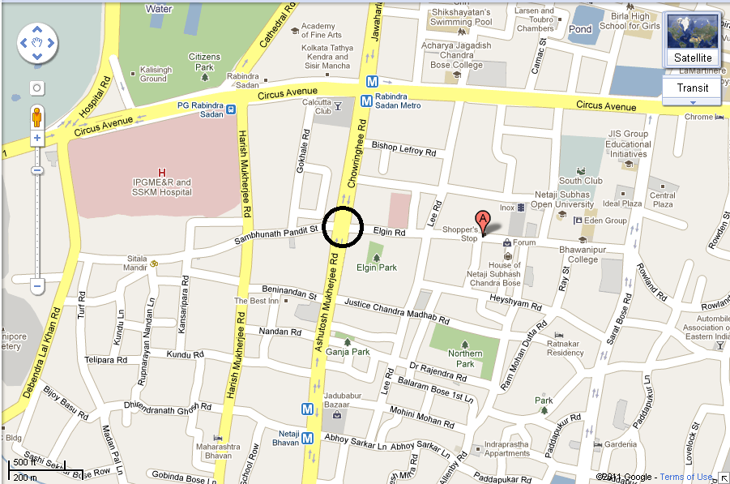

## ROAD SAFETY AUDIT

|  |  |  |
| --- | --- | --- |
| **Serial No.** | **Characteristics** | **Conditions** |
| 1 | Road Marking | There is no road marking, which driver can follow. Zebra crossing was present. |
| 2 | Traffic Signal | Single Traffic signals were present. |
| 3 | Pedestrian Signal Phase | Pedestrian signal phase is missing |
| 4 | Railing on Roads | Railing is partially present. |
| 5 | Pedestrian | Flow of pedestrians is medium. |
| 6 | Foot paths | Foot paths are properly mentioned and maintained. |
| 7 | Turning | Traffic load is high that why drivers prefer to overtake in the turnings, causing chaos in the road. |
| 8 | Traffic Signs | Less traffic signs were present. |
| 9 | Advertisement Boards | Too many signs/advertisements displayed within intersection area and conspicuity of signals is lost. |
| 10 | Accident Prone | The traffic controlling system was good, making it a less accident pone zone. |
| 11 | Manhole/ Other construction | No speed breaker is present to control the traffic speed. |
| 12 | Bus stops | No proper bus stop is there. |
| 13 | Parking Lots | There is no parking lot present. |
| 14 | Street light | Condition of street light is good. Trees beside the roads, causing obstruction to the street light. |
| 15 | Traffic Police | Two traffic police is controlling the traffic system. |
| 16 | Road Condition | Condition of the road is good. |