Application of GIS in Rural Road and Habitation Mapping

By,

SHAMSHER ALAM (I.D. 110407062)

SHUBHAJIT SAHA (I.D. 110407060)

Under guidance of

Prof. SUJATA BISWAS



A project

*Submitted in partial fulfillment of the requirement for the degree of*

Bachelor of Engineering in Civil engineering

At The

Department of Civil Engineering

Bengal Engineering and Science University, Shibpur

Howrah – 711103, West Bengal, India

Session 2010 – 2011

**Bengal Engineering and Science University, Shibpur**

**Howrah – 711103, West Bengal, India**



*FORWARD*

I hereby forward this Seminar Paper on Project titled “Application of GIS in Rural Road and Habitation Mapping”, submitted by Shubhajit Saha and Shamsher Alam under my guidance and supervision in partial fulfillment of the requirements for the award of the degree of Bachelor of Engineering in Civil Engineering from Bengal Engineering and Science University, Shibpur, Howrah – 711103.

…………………………………………………....

Prof. Sujata Biswas

Department of Civil Engineering

Bengal Engineering and Science University, Shibpur.

Countersigned by

…………………………………………………....

Dr. Kalyan Kumar Chattopadhyay

Professor and Head

Department of Civil Engineering,

Bengal Engineering and Science University, Shibpur

**Bengal Engineering and Science University, Shibpur**

**Howrah – 711103, West Bengal, India**



*CERTIFICATE OF APPROVAL*

The foregoing Seminar Paper on Project titled “Application of GIS in Rural Road and Habitation Mapping”, was carried out and presented satisfactorily to warrant its acceptance as a pre-requisite to the Degree of Bachelor of Engineering (Civil Engineering) of this University. It is understood that by this approval the undersigned do not necessarily approve of any statement expressed and any conclusion drawn but approve this seminar paper on thesis only for the purpose for which it is submitted.

Board of examiners

1 …………………………………………………....

2 …………………………………………………....

3 …………………………………………………....

*ACKNOWLEDGEMENT*

We express our sincere gratitude and indebtedness to Prof. Sujata Biswas, Department of Civil Engineering, Bengal Engineering & Science University and allowing us to carry on the present topic “Application of GIS in Rural Road and Habitation Mapping” and later on for their inspiring guidance, constructive criticism and valuable suggestions throughout this project work. We are very much thankful to them for their able guidance and pain taking effort in improving my understanding of this project.

An assemblage of this nature could never have been attempted without reference to and inspiration from the works of others whose details are mentioned in reference section. We acknowledge my indebtedness to all of them.

At the last, our sincere thanks to all our friends who have patiently extended all sorts of help for accomplishing this assignment.

…………………………………………………....

SHAMSHER ALAM

…………………………………………………....

SHUBHAJIT SAHA

Date: 30th May, 2010

Bengal Engineering and Science University, Shibpur

Department of Civil Engineering

Howrah – 711103, West Bengal, India

Contents

1 Introduction 1

1.1 General 1

1.2 Condition of road network of India 1

1.3 Road Transport in West Bengal 3

1.4 Pradhan Mantri Gram Sadak Yojana (PMGSY) 4

1.4.1 Objective 4

1.4.2 Guiding principles 4

2 Geographic Information Systems (GIS) 6

2.1 Brief 6

2.2 Raster data 6

2.3 Vector data 6

2.3.1 Different kinds of Vector data 7

2.4 GIS in the field of transportation 8

3 Objective 9

3.1 Scope of the work 9

4 Present Study 10

4.1 Study Area 10

4.2 Data collection 10

4.2.1 Village Data 11

4.2.2 Rural road Data 12

4.2.3 Map Data 13

5 Procedure of work 14

5.1 Geo Referencing using ERDAS Imagine 14

5.2 Application of Arc View GIS 14

5.3 Creating Point, Line or Polygon Themes 14

5.3.1 Creating Point Themes 14

5.3.2 Creating Line Themes 15

5.3.3 Creating Polygon Themes 15

5.4 Calculating Length, Area of different theme layers 16

6 Results 17

6.1 Habitation Data 17

6.2 Through route Data 20

6.3 Link route Data 22

7 Analysis 25

7.1 General 25

7.2 Identification of unconnected habitation 25

7.2.1 Procedure 25

7.3 Identification of Growth Center 26

7.3.1 Procedure 26

7.3.2 Sample calculation of HINDEX for Pal para habitation 29

# Introduction

## General

The development of any country depends on the infrastructural facilities available therein. Good road network facilities plays major role here. The developed countries have good road infrastructure not because of the fact that they are wealthy; instead they become developed because of good road infrastructure. Over the last few decades, lack of transportation infrastructure has affected the economic growth and development of India. Rural India does not have all-weather road connectivity for marketing agricultural products and existing highway network in the country is inadequate and insufficient. Moreover the main roads in India are under huge pressure and in great need of modernization in order to handle the increased requirements of the Indian economy. In addition to maintenance, the expansion of the network and widening of existing roads is becoming increasingly important. This would then enable the roads to handle increased traffic, and also allow for a corresponding increase in the average movement speed on India's roads.

Realizing this fact an ambitious and biggest ever infrastructure development project in India (expected cost of $26 billion) named as Pradhan Mantri Gram Sadak Yojana (PMGSY) under ministry of Rural Development was conceptualized and launched on 25th December, 2000 to provide connectivity to unconnected rural habitations as part of a poverty eradication measure.

## Condition of road network of India

Almost 80% of passenger traffic and about 65% of freight movement is handled by this vast network.

In general, roads in India are primarily bitumen-based macadamized roads. However, a few of the National Highways have concrete roads too. In some locations, such as in Kanpur, British-built concrete roads are still in use. Concrete roads were less popular prior to 1990s because of low availability of cement then. However, with large supplies of cement in the country and the virtues of concrete roads, they are once again gaining popularity. Concrete roads are weather-proof and require lower maintenance compared to bituminous roads. Because bitumen is obtained mostly from imported crude oil, and due to other factors, concrete-based roads will prove to be more cost-effective in future. Apart from these, one also comes across unpaved dirt roads in the countryside, which is fast getting converted to paved roads.

Table Indian road network

|  |  |
| --- | --- |
| **Class** | **Length (km)** |
| Access Controlled Expressways | 200 km (120 mi) |
| 4-6 lane Divided Highways (with service rd in crowded areas) | 10,000 km (6,200 mi) |
| National Highways | 66,590 km (41,380 mi) |
| State Highways | 131,899 km (81,958 mi) |
| Major district roads | 467,763 km (290,654 mi) |
| Rural & other roads | 2,650,000 km (1,650,000 mi) |
| Total (approx) | 3,300,000 km (2,050,000 mi) |

Table State-wise Road Network

|  |  |  |  |  |  |  |
| --- | --- | --- | --- | --- | --- | --- |
| **State/UT** | **National Highways (km)** | **State Highways (km)** | **Major District Roads (km)** | **Other District & Link Roads (km)** | **Total surfaced length (km) as on March 31, 2002** | **Total length (km) as on March 31, 2002** |
| Andaman & Nicobar | 300 |  |  |  | 1,180 | 1,180 |
| Andhra Pradesh | 4,472 |  |  |  | 1,19,857 | 1,96,172 |
| Arunachal Pradesh | 392 |  |  |  | 5,689 | 18,365 |
| Assam | 2,836 |  |  |  | 12,882 | 89,486 |
| Bihar | 3,642 |  |  |  | 32,858 | 76,065 |
| Chandigarh | 24 |  |  |  | 2,045 | 2,045 |
| Chhattisgarh | 2,184 |  |  |  | 24,476 | 35,372 |
| Dadra & Nagar Haveli | | |  |  | 580 | 580 |
| Daman & Diu | |  |  |  | 324 | 414 |
| Delhi | 72 |  |  |  | 23,274 | 28,508 |
| Goa | 269 |  |  |  | 6,830 | 9,672 |
| Gujarat | 3,245 |  |  |  | 1,24,295 | 1,37,617 |
| Haryana | 1,512 |  |  |  | 26,311 | 28,203 |
| Himachal Pradesh | 1,208 | 2,160 | 2,240 |  | 16,754 | 29,617 |
| Jammu & Kashmir | 1,245 |  |  |  | 9,943 | 23,429 |
| Jharkhand | 1,805 |  |  |  | 2,840 | 11,486 |
| Karnataka | 3,843 |  |  |  | 1,04,241 | 1,52,599 |
| Kerala | 1,457 | 4,006 | 23,702 |  | 50,164 | 1,50,851 |
| Lakshadweep | |  |  |  | 150 | 150 |
| Madhya Pradesh | 4,670 |  |  |  | 78,191 | 1,60,968 |
| Maharashtra | 4,176 | 33,705 |  |  | 2,09,559 | 2,67,452 |
| Manipur | 959 |  |  |  | 3,863 | 11,434 |
| Meghalaya | 810 |  |  |  | 6,560 | 9,565 |
| Mizoram | 927 |  |  |  | 2,877 | 5,075 |
| Nagaland | 494 |  |  |  | 6,451 | 21,021 |
| Orissa | 3,704 |  |  |  | 52,245 | 2,37,034 |
| Puducherry | 53 |  |  |  | 2,115 | 2,571 |
| Punjab | 1,557 | 2,166 | 1,799 | 34,997 | 52,747 | 61,530 |
| Rajasthan | 5,585 |  |  |  | 82,456 | 1,32,482 |
| Sikkim | 62 |  |  |  | 1,546 | 2,019 |
| Tamil Nadu | 4,462 | 7,163 | 7,362 | 40,963 | 1,54,958 | 1,91,947 |
| Tripura | 400 |  |  |  | 4,393 | 16,296 |
| Uttarakhand | 1,991 |  |  |  | 10,730 | 33,547 |
| Uttar Pradesh | 5,874 |  |  |  | 1,66,659 | 2,48,481 |
| West Bengal | 2,524 |  |  |  | 49,517 | 92,023 |
| Total | 66,754 |  |  |  |  |  |

By acting as the link between the rural and urban areas, the State Highways and Major District Roads contribute significantly to the development of the rural economy and industrial growth of the country. It is estimated that the secondary system carries about 40 per cent of the total road traffic and comprises about 20% of the total road length.

## Road Transport in West Bengal

The total length of surface road in West Bengal is over 92,023 km; national highways comprise 2,377 km and state highways 2,393 km. The road density of the state is 103.69 km per 100 km²; higher than the national average of 74.7 km per 100 km². Average speed on state highways varies between 40–50 km/h; in villages and towns, speeds are as low as 20–25 km/h due to the substandard quality of road constructions and low maintenance.

Table List of National Highways in West Bengal

|  |  |  |  |
| --- | --- | --- | --- |
| **Srl No.** | **NH No.** | **Route** | **Length (km.)** |
| 1 | 2 | From Jharkhand border-Barakar-Asansol-Raniganj-Durgapur-Panagarh-Palsit-Dankuni near Culcutta/Kolkata | 235 km (146 mi) |
| 2 | 6 | From Jharkhand Border-Kharagpur-Debra-Panskura-Kolaghat-Bagnan-Dankuni near Kolkata | 161 km (100 mi) |
| 3 | 31 | Dalkhola-Kanki-Panjipara-Islampur-Bagdogra-Sevok-Mainaguri-Gairkata-Falakata-Cooch Behar-Tufanganj up to Assam Border | 366 km (227 mi) |
| 4 | 31A | Sevok-Namthang up to Sikkim Border | 30 km (19 mi) |
| 5 | 31C | Galgalia-Naxalbari-Bagdogra-Chalsa-Nagrakata- Gairkata- Alipurdura up to Assam Border. | 142 km (88 mi) |
| 6 | 32 | From Jharkhand Border-Goorinathdham -Puruliya- Kantadih-Urma- Balarampur up to Jharkhand Border | 72 km (45 mi) |
| 7 | 34 | Dalkhola-Karandighi-Raiganj-Pandua-Ingraj Bazar-Morgram-Baharampur-Palashi-Krishnanagar-Barasat-Kolkata | 443 km (275 mi) |
| 8 | 35 | Barasat-Gaighata-Bangaon-Petrapole on India-Bangladesh border. | 61 km (38 mi) |
| 9 | 41 | Junction with NH-6 near Panskura-Tamluk-Mahishadal-Haldia Port. | 51 km (32 mi) |
| 10 | 55 | Siliguri-Kurseong-Darjeeling | 77 km (48 mi) |
| 11 | 60 | From Orissa Border-Dantan-Belda-Kharagpur-Midnapore-Bankura-Mejia-Raniganj and terminating at its junction with NH 2 | 389 km (242 mi) |
| 12 | 60A | Bankura-Chhatna-Hura-Landhurka-Puruliya | 100 km (62 mi) |
| 13 | 80 | Farrakka up to Bihar Border | 10 km (6.2 mi) |
| 14 | 81 | From Bihar Border-Harishchandrapur-Kumangarj-Malda | 55 km (34 mi) |
| 15 | 117 | Setu-Kolkata-Diamond Harbour-Kulpi-Namkhana-Bakkhali | 138 km (86 mi) |

## 

## Pradhan Mantri Gram Sadak Yojana (PMGSY)

### Objective

1. The primary objective of the PMGSY is to provide Connectivity, by way of an all-weather Road (with necessary culverts and cross-drainage structures, which is operable throughout the year), to the eligible unconnected Habitations in the rural areas, in such a way that all Unconnected Habitations with a population of 1000 persons and above are covered in three years (2000-2003) and all Unconnected Habitations with a population of 500 persons and above by the end of the Tenth Plan Period (2007). In respect of the Hill States (North-East, Sikkim, Himachal Pradesh, Jammu & Kashmir, Uttaranchal) and the Desert Areas (as identified in the Desert Development Programme) as well as the Tribal (Schedule V) areas, the objective would be to connect Habitations with a population of 250 persons and above.
2. The PMGSY will permit the Upgradation (to prescribed standards) of the existing roads in those Districts where all the eligible Habitations of the designated population size have been provided all-weather road connectivity. However, it must be noted that Upgradation is not central to the Programme and cannot exceed 20% of the State’s allocation as long as eligible Unconnected Habitations in the State still exist. In Upgradation works, priority should be given to Through Routes of the Rural Core Network, which carry more traffic

### Guiding principles

1. The spirit and the objective of the Pradhan Mantri Gram Sadak Yojana (PMGSY) is to provide good all-weather road connectivity to unconnected Habitations. A habitation which was earlier provided all-weather connectivity would not be eligible even if the present condition of the road is bad.
2. The unit for this Programme is a Habitation and not a Revenue village or a Panchayat. A Habitation is a cluster of population, living in an area, the location of which does not change over time. Desam, Dhanis, Tolas, Majras, Hamlets etc. are commonly used terminology to describe the Habitations.
3. An Unconnected Habitation is one with a population of designated size located at a distance of at least 500 metres or more (1.5 km of path distance in case of Hills) from an All-weather road or a connected Habitation.
4. The population, as recorded in the Census 2001, shall be the basis for determining the population size of the Habitation. The population of all Habitations within a radius of 500 meters (1.5 km. of path distance in case of Hills) may be clubbed together for the purpose of determining the population size. This cluster approach would enable provision of connectivity to a larger number of Habitations, particularly in the Hill / mountainous areas.
5. The eligible Unconnected Habitations are to be connected to nearby Habitations already connected by an All-weather road or to another existing All-weather road so that services (educational, health, marketing facilities etc.), which are not available in the unconnected Habitation, become available to the residents.
6. A Core Network is that minimal Network of roads (routes) that is essential to provide Basic access to essential social and economic services to all eligible habitations in the selected areas through at least a single all-weather road connectivity.
7. A Core Network comprises of Through Routes and Link Routes. Through routes are the ones which collect traffic from several link roads or a long chain of Habitations and lead it to Marketing centers either directly or through the higher category roads i.e., the District Roads or the State or National Highway. Link Routes are the roads connecting a single Habitation or a group of Habitations to Through Routes or District Roads leading to Market Centers. Link routes generally have dead ends terminating on a Habitation, while Through Routes arise from the confluence of two or more Link Routes and emerge on to a major Road or to a Market Centre.
8. It should be ensured that each road work that is taken up under the PMGSY is part of the Core Network. While keeping the objective of Connectivity in view, preference should be given to those roads which also incidentally serve other Habitations. In other words, without compromising the basic objective (covering 1000+ Habitations first and 500+ Habitations next and 250+ Habitations where eligible, last), preference should be given to those roads which serve a larger population. For this purpose, while Habitations within a distance of 500 meters from the road is considered as connected in case of plain areas, this distance should be 1.5 km (of path length) in respect of Hills.
9. The PMGSY shall cover only the rural areas. Urban roads are excluded from the purview of this Programme. Even in the rural areas, PMGSY covers only the Rural Roads i.e., Roads that were formerly classified as ‘Other District Roads’ (ODR) and ‘Village Roads’ (VR). Other District Roads (ODR) are roads serving rural areas of production and providing them with outlet to market centres, taluka (tehsil) headquarters, Block headquarters or other main roads. Village Roads (VR) are roads connecting villages / Habitation or groups of Habitation with each other and to the nearest road of a higher category. Major District Roads, State Highways and National Highways cannot be covered under the PMGSY, even if they happen to be in rural areas. This applies to New Connectivity roads as well as Upgradation works.
10. The PMGSY envisages only single road Connectivity to be provided. If a Habitation is already connected by way of an All-weather road, then no new work can be taken up under the PMGSY for that habitation.

# Geographic Information Systems (GIS)

## Brief

Geographic information systems (GIS) or geospatial information systems is a set of tools that captures, stores, analyzes, manages, and presents data that are linked to location(s). In the simplest terms, GIS is the merging of cartography, statistical analysis, and database technology. GIS may be used in archaeology, geography, cartography, remote sensing, land surveying, public utility management, natural resource management, precision agriculture, photogrammetry, urban planning, emergency management, navigation, aerial video, and localized search engines.

Raster and vector are the two basic data structures for storing and manipulating images and graphics data on a computer. All of the major GIS (Geographic Information Systems) software packages available today are primarily based on one of the two structures, either raster based or vector based, while they have some extended functions to support other data structures.

## Raster data

In computer graphics, a raster graphics image or bitmap is a data structure representing a generally rectangular grid of pixels, or points of color, viewable via a monitor, paper, or other display medium. Raster images are stored in image files with varying formats (see Comparison of graphics file formats).

A bitmap corresponds bit-for-bit with an image displayed on a screen, generally in the same format used for storage in the display's video memory, or maybe as a device-independent bitmap. A bitmap is technically characterized by the width and height of the image in pixels and by the number of bits per pixel (a color depth, which determines the number of colors it can represent).

The printing and prepress industries know raster graphics as contones (from "continuous tones") and refer to vector graphics as "line work".

## Vector data

Vector graphics is the use of geometrical primitives such as points, lines, curves, and shapes or polygon(s), which are all based on mathematical equations, to represent images in computer graphics.

Vector graphics formats are complementary to raster graphics, which is the representation of images as an array of pixels, as it is typically used for the representation of photographic images.[1] There are instances when working with vector tools and formats is the best practice, and instances when working with raster tools and formats is the best practice. There are times when both formats come together. An understanding of the advantages and limitations of each technology and the relationship between them is most likely to result in efficient and effective use of tools.

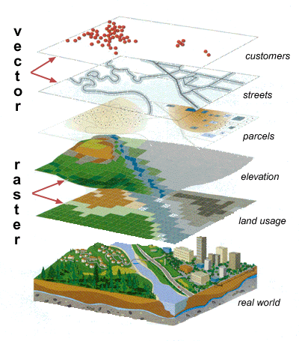

Figure Raster and Vector data

### Different kinds of Vector data

#### Points

Points are used to display individual locations, or data sampled at specific points, such as temperature, pH, and conductivity.



Figure Point example

#### Lines

Lines represent linear features, such as roads, trails, streams, and contour lines.



Figure Line example

#### Polygons

Polygons are closed figures and represent areas of the Earth’s surface. These may be lakes, cities, shopping malls, national parks, or any feature that can be described by area. The figure above shows lakes (blue) and part of the land area (green) of Ireland as polygon data.



Figure Polygon example

## GIS in the field of transportation

Using GIS in the field of transportation opens up a wide range of possible applications, as diverse as the field of transportation itself. Whether these are cars and trucks along a road, trains along a track, ships across the sea or airplanes in the sky, all applications have one thing in common: They are objects that move along a path in space. A GIS can provide a valuable tool for managing these objects in a spatially referenced context, viewing the paths as a transportation network.

# Objective

* To develop habitation database and rural road network database in block level.
* To identify the unconnected habitation in the block
* To identify the growth centre in block level based on socio-economic parameters.

## Scope of the work

The database development is very much useful for problem identification of rural road network planning, allocation of resources and also for future maintenance of the road system. It directly helps the villagers to upgrade living quality in terms of livelihood, medical, educational facilities as well as other socio-economical parameters.

# Present Study

## Study Area

**Geography**: Arambagh is located at 22.88°N 87.78°E. It has an average elevation of 15 meters (118 feet). It is located on the bank of the Dwarakeswar River.

This sub-division is actually the westernmost part of the District of Hooghly. The river Damodar forms the eastern boundary of the Arambagh Sub-Division. Arambagh Sub-Division is one of the four Sub-Divisions of Hooghly District – the remaining three being Sadar (Chinsurah), Serampore and Chandannagore. Arambagh is located on the western front of Hooghly District and is being bordered by four districts viz Burdwan, West Midnapore, Bankura and Howrah.

Geographical area of Arambagh being: 322.53 km2

Perimeter = 133.99 km

Demographics: As of 2011 India census, Arambag had a population of 3,47,225. Males constitute 62% of the population and females 38%. Arambag has an average literacy rate of 82%, higher than the national average of 59.5%; with 79% male literacy and 58% of female literacy. 17% of the population is under 6 years of age.

**Climate**: The maximum temperature during summer rises up to 38 °C while minimum temperature during winter comes down to 8°C. Average annual rainfall is 1600 millimeters.

**Economics**: This is a rice and potato agricultural area with several cold storages.

**Civic Administration**: Arambagh municipality is divided into 18 wards.

**In the present study, an attempt is being made to develop an information system for road network planning using GIS for a particular block in rural area under PMGSY program.**

## Data collection

Various data items required for the development of the comprehensive rural road planning and development can be broadly categorized under three categories

1. Village Data
2. Rural Road Data
3. Map Data

Flowchart for Rural Road Inventory

Rural Road Inventory

PMGSY Map

Habitation Level

Road Reference

Road Geometric Details

Road pavement condition

Terrain & soil type & traffic

CD

* Serial no.
* Name of the road
* Road code
* Length
* Carriage Width
* Surface type
* CBR
* Total traffic per day
* Commercial vehicle per day
* Total length
* Width

### Village Data

Database developed above has been applied to the Arambagh block in Hoogly District of West Bengal. The block has 242 villages with a total population of 233094. The block has 11 Gram Panchayat headquarters.

A habitation can be defined as a cluster of population, living in an area, the location of which change over time.

Table Habitation Intensity

|  |  |  |  |  |  |  |  |
| --- | --- | --- | --- | --- | --- | --- | --- |
| **Srl No.** | **Name of Block** | **Total No of Habitations** | **Category** | | | | |
| **1000+** | **500 - 999** | **250 - 249** | **< 250** | **Total** |
| 1 | Arambagh | 242 | 139 | 55 | 31 | 17 | 242 |

Table Habitation Facilities

|  |  |
| --- | --- |
| **Facilities** | **Number** |
| School and education centre | 115 |
| Health centre | 103 |
| Market centre | 17 |
| Gram Panchayat Headquater | 11 |
| District Headquater | 0 |
| Block Headquater | 1 |

### Rural road Data

The road inventory data is essential for planning, management of the road system and planning of rural connectivity. 14 Through route (T1 to T14) and 48 link routes (L021 to L068) are well connected to state highway and other district roads the proposed roads prove to be beneficial to the village. The total existing road length is 282.15 Km.

Total length of Through Routes = 50.5 km

Total length of Link Routes = 131.65 km

T - Through Routes - Through routes are the ones which collect traffic from several link roads or a long chain of habitation and lead it to marketing centers either directly or through the higher category of road i.e. the district roads or state or national highway.

L - Link Routes - Link routes are the routes connecting a single habitation to Through Routes or District Roads leading to a market centers. Link route is the newly constructed road. Link route generally have dead ends terminating on a habitation while Through Routes arise from the confluence of two or more Link Routes and emerges on to a major Roads or to a Growth Centers.

### Map Data

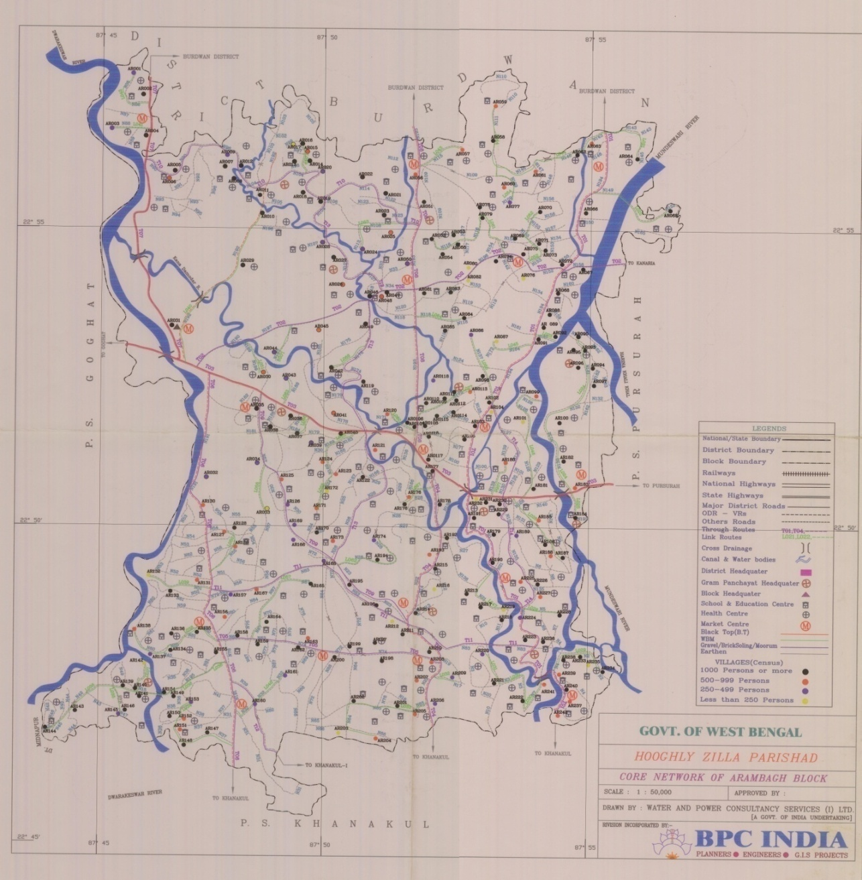

Figure Map of Arambagh Block (Scale 1:50,000)

# Procedure of work

## Geo Referencing using ERDAS Imagine

The scanned map of Arambagh was Geo Referenced using ERDAS Imagine.

## Application of Arc View GIS

Arc View is a useful software or desktop GIS and mapping. It is a product of Environmental System Research Institute (ESRI). Arc view GIS is a powerful software that provides for visualizing, querying, exploring, and analyzing data geographically. Arc view is a powerful GIS tool that can display information (which resides locally or over a distributed network), read spatial and tabular information from a variety of data formats, access external databases, produced thematic maps (use colors and symbols to represent features based upon their attributes), perform spatial queries, connect spatial information to data attributes, provides several analytical tools and allows for a high degree of customization using Avenue. Using Arc View, we can understand the geographical context of our data, allowing us to see relationship and identify patterns in new ways.

## Creating Point, Line or Polygon Themes

Creating new data such as point, line, or polygon themes, the shapefile created will be stored in the same projected units as the existing data sources. That means further, the data created will merely be displayed correctly with themes based on data sources that are also stored in the same projecting units (here: UTM meters); and additionally it means, there is no necessity to adjust the projection of any new theme if the new theme is added to an already existing data.

### Creating Point Themes

Creating point themes is necessary if we want to add e.g. important buildings (health centre, schools etc.) to a map for a better orientation. Peaks of mountains can also be displayed as point themes. When creating a map of a certain catchment area, where erosion control activities takes place, also a single checkdam or microbasins can be displayed as point themes. To create a point theme click ‘*View’* ‘*New theme’*, choose the feature type we want (here: point) and confirm choice by clicking ‘*OK’*. Store the theme under *GIS projects\Enabered\MyData* and name it ‘*Health Centre’*. Then, choose at the tool bar the very right symbol for digitizing point themes and click where we want to have displayed any kind of building, no matter if schools, churches or other buildings. After having finalized digitizing buildings we want to have displayed on our own map click *Theme\Stop editing* and confirm that the changes in the shapefile are stored.

### Creating Line Themes

To add a new line theme do the same steps as described before, instead of choosing create point theme choose line theme. Click the tool bar and choose ‘*Draw line’*. Now a line shaped feature such as roads or rivers can be drawn. But before start drawing a line feature in the map, adjust the ‘*snapping’* feature. It is important that all line features belonging to the same feature class, such as rivers resp. gullies, share the same endpoint, and for there to be overshoots or undershoots. The most comfortable snapping tool is the ‘interactive’ snapping environment. To activate that, first make the new line theme active and click under *Theme\Properties\Editing* the field ‘*interactive’*.

Have set the interactive snap enjoinment as described above, then while adding line hold down the right mouse button to display the popup menu, and choose one of the following snapping options to control how the next vertex shall snap to the existing line:

* Snap to Vertex: Snaps the next vertex to the nearest vertex in an existing line,
* Snap to Boundary: Snaps the next vertex to the nearest line segment in an existing line,

The other options are of negligible importance, since they are covered by the option ‘*snap to vertex’*.

After having activated the entire necessary fields the lines can be drawn with clicking with the left mouse button at the starting point and set other vertices along the line where it is needed to draw the line. To end the line feature double click at the endpoint. When different lines have a shared endpoint click, before reaching the endpoint respectively the end line or boundary to set the last vertex, the right mouse button an choose ‘*Snap to Vertex’*, then click as near as possible to the vertex at the endpoint to end the line.

### Creating Polygon Themes

When creating polygon themes the snapping tool should be used to guarantee correctness as well as to prevent gaps and overlaps. Follow the steps as described in the chapter before and define general snapping or the interactive snapping environment. Especially when creating polygons, snapping is essential if one wants to utilize maps for further analyses, otherwise calculations will not be correct.

Note that snapping is possible merely if work within one theme. Snapping within and between two different themes is not possible. Thus, generalize in the beginning of creating maps as much as possible. E.g. to create a map which shows the existing land use types of one area better digitize the different land use types of one area in one theme and divide them later on by marking them with the single marking tool (tool bar) and convert them into shapefiles (*Theme\Convert to Shapefile*) instead of creating single land use type themes from beginning on.

Table Different Themes used in the block

|  |  |
| --- | --- |
| **Theme type** | **Category** |
| Point | Habitation  Health centre  School  Market place  Gram panchyat  Block head quarter |
| Line | Through route  Link route |
| Polygon | Block boundary |

## Calculating Length, Area of different theme layers

Calculations can be performed in the Attribute Table surface. Activate the Theme to analyse and click to the Attribute Table. Start editing under menu Table and add a new field under menu Edit. Define that have a number field and determine the field width. Then activate the new field (it appears dark grey instead of light grey), here: Area, and click the calculator. Enter the formula [*Shape*].ReturnArea and confirm with *OK*. Precondition for any calculation is that the map is adjusted in correct map units. Adjust under *View\Properties* and define maps units, which should be *meters*.

# Results

## Habitation Data

The road inventory as well as village level data has been developed through ArcView GIS software as shown in figure and mapping as done as per population.

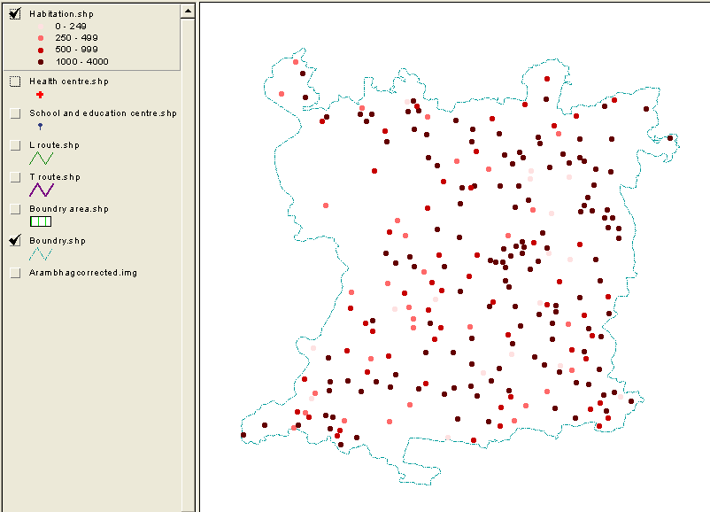

Figure Habitation mapping as per population

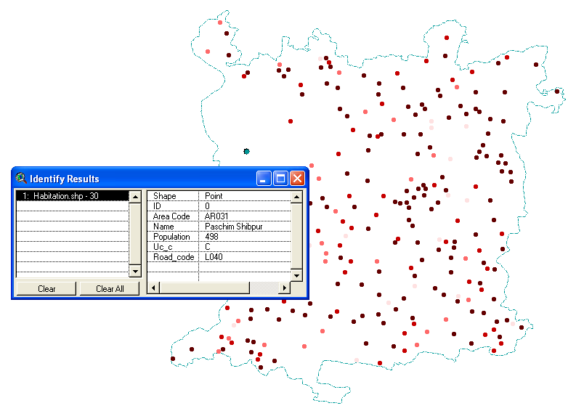

Figure Habitation Data of a selected point (shown in Green)

Table Sample Attribute Table of Habitation

|  |  |  |  |  |
| --- | --- | --- | --- | --- |
| **AREA_CODE** | **NAME** | **POPULATION** | **UC_C** | **ROAD_CODE** |
| AR001 | Bhabapur | 253 | UC | L042 |
| AR002 | Maminpur | 2037 | C | T07 |
| AR003 | Paradra | 329 | UC | L041 |
| AR004 | Krithchandrapur | 1154 | C | T07 |
| AR005 | Manodra | 1062 | UC | T10 |
| AR006 | Dadanpur | 639 | UC | T10 |
| AR007 | Ghosh para | 1051 | UC | T10 |
| AR008 | Bagpara | 1010 | UC | T10 |
| AR009 | Daspara | 390 | UC | T10 |
| AR010 | Chandibati | 1550 | C | L040 |
| AR011 | Donga bathan | 622 | UC | T10 |
| AR012 | Yadpur | 1049 | UC | T10 |

**UC_C** = **UC** unconnected / **C** connected

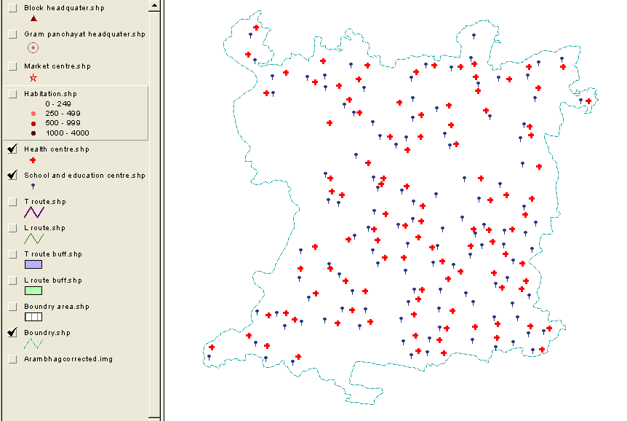

Figure Schools and Health Centre

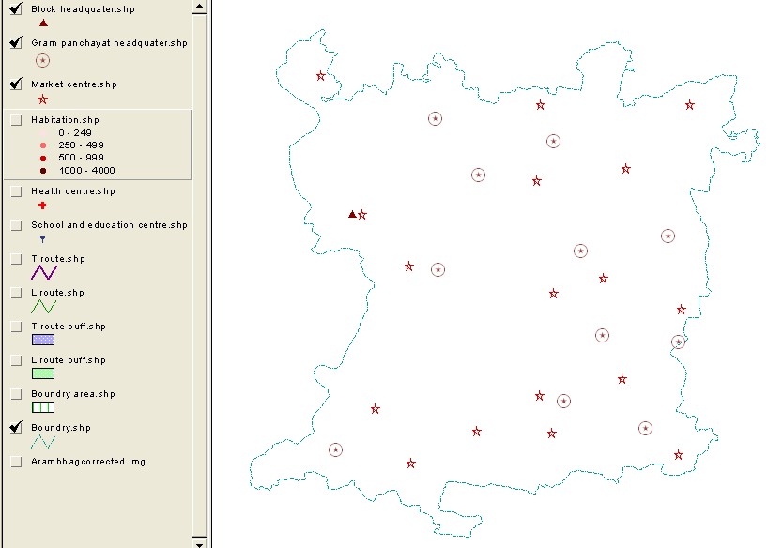

Figure Block Head Quarter, Gram Panchayat and Market Centre

## Through route Data

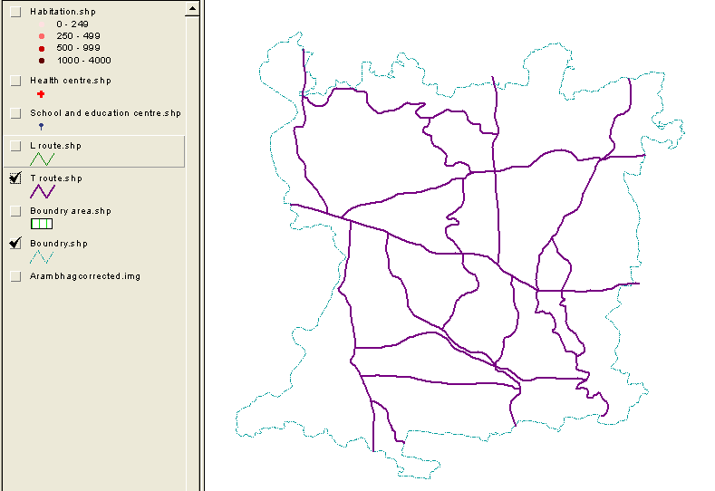

Figure Through routes in the block

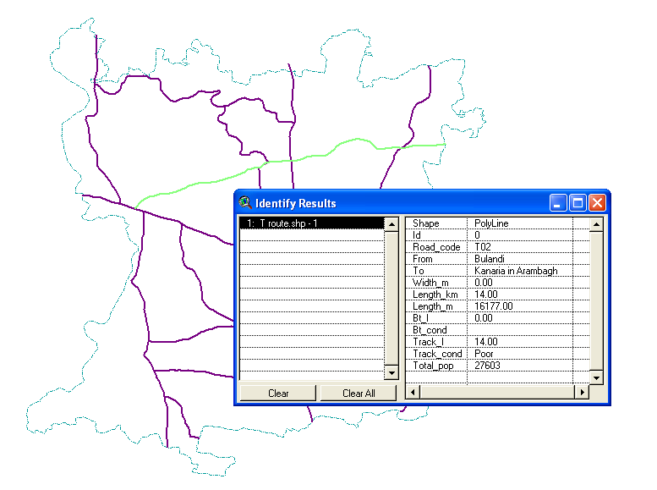

Figure Road data of selected through route (shown in Green)

Table Road data of Through routes

|  |  |  |  |  |  |  |  |  |  |
| --- | --- | --- | --- | --- | --- | --- | --- | --- | --- |
| **ROAD_CODE** | **FROM** | **TO** | **LENGTH_KM** | **CAL_LENGTH_M** | **BT_L** | **BT_COND** | **TRACK_L** | **TRACK_COND** | **TOTAL_POP** |
| T01 | Fatepur | Tilakchak | 20.00 | 23876.00 | 20.00 | Poor | 0.00 |  | 37783 |
| T02 | Bulandi | Kanaria in Arambagh | 14.00 | 16177.00 | 0.00 |  | 14.00 | Poor | 27603 |
| T03 | Pallishree (Arambag) | Amgram (Continuation of Goghat) | 8.50 | 18369.00 | 8.50 | Good | 0.00 |  | 39417 |
| T04 | Mayapur | Bhanderhati (to Garerghat) | 9.00 | 9396.30 | 9.00 | Poor | 0.00 |  | 18609 |
| T05 | Kapshit | Samta | 7.50 | 7942.00 | 0.00 |  | 7.50 | Poor | 12038 |
| T06 | Gourhati More (Arambag) | Ghourhati (to Bandar) | 13.00 | 12870.00 | 13.00 | Good | 0.00 |  | 26411 |
| T07 | Pallishree (Arambag) | Maminpur (to Burdwan) | 8.00 | 9632.00 | 8.00 | Good | 0.00 |  | 3773 |
| T08 | Satispur (From Burdwan) | Muthadanga | 10.00 | 10075.00 | 10.00 | Poor | 0.00 |  | 20106 |
| T09 | Bikrampur Kalitala | Pandugram Bus Stand | 9.50 | 9931.10 | 0.00 |  | 9.50 | Poor | 6922 |
| T10 | Baise Mile | Batanaal Via Seali | 10.00 | 13480.00 | 0.00 |  | 10.00 | Poor | 17828 |
| T11 | Char Mile | Dakshin Narayanpur | 12.00 | 12449.00 | 0.00 |  | 12.00 | Poor | 7850 |
| T12 | Gourhati Market | Radhaballavpur | 5.00 | 3084.80 | 0.00 |  | 5.00 | Poor | 977 |
| T13 | Gholpukur Kuraui Bora | Ranhat Battala | 15.50 | 16329.00 | 0.00 |  | 15.50 | Poor | 11293 |
| T14 | Haraditya | Sahabagh to Madhurpur | 8.50 | 7579.90 | 0.00 |  | 8.50 | Poor | 15559 |

**LENGTH_KM** = length of the road in KM

**CAL_LENGTH_KM** = calculated length of the road in KM

**BT_L** = Black Top length

**BT_COND** = Black Top Condition

**TRACK_L** = Track length

**TRACK_COND** = Track condition

**TOTAL_POP** = Population served

## Link route Data

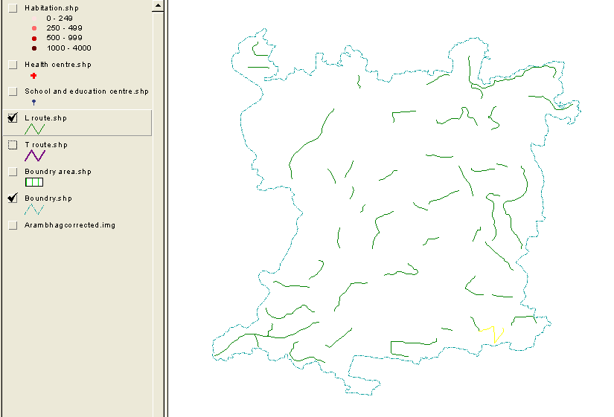

Figure Link routes in the block

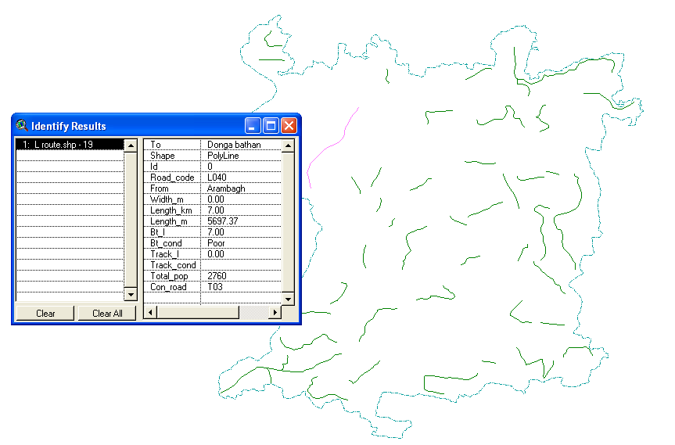

Figure Road data of selected link route (shown in Pink)

Table Road data of Link routes

|  |  |  |  |  |  |  |  |  |  |  |
| --- | --- | --- | --- | --- | --- | --- | --- | --- | --- | --- |
| **ROAD_CODE** | **FROM** | **TO** | **LENGTH_KM** | **CAL_LENGTH_M** | **BT_L** | **BT_COND** | **TRACK_L** | **TRACK_COND** | **TOTAL_POP** | **CON_ROAD** |
| L021 | Fatepur | Purba Haripur | 1.50 | 1943.69 | 0.00 |  | 1.50 | Poor | 1481 | T01 |
| L022 | Balia Road | Bank of Mundeswari rivers (upto Ghargohal) | 3.00 | 3168.22 | 0.00 |  | 3.00 | Poor | 1769 | T01 |
| L023 | Kesabpur Bush Road | Moyrapara | 1.00 | 720.22 | 0.00 |  | 1.00 | Poor | 2373 | T01 |
| L024 | Harinkhola | Purba Kesabchawk | 8.00 | 6082.56 | 0.00 |  | 8.00 | Poor | 11126 | T03 |
| L025 | SH Road | Amgram | 1.00 | 698.02 | 0.00 |  | 1.00 | Poor | 1343 | T03 |
| L026 | Chandra | Tajpur | 5.00 | 2550.27 | 0.00 |  | 5.00 | Poor | 3788 | T03 |
| L027 | Malaypur suripara | Malikpukur | 3.00 | 2064.72 | 0.00 |  | 3.00 | Poor | 7063 | T14 |
| L028 | Gholpura | Purbaragpur | 2.00 | 1272.71 | 0.00 |  | 2.00 | Poor | 1033 | T01 |
| L029 | Hiyatpur | Chandraban | 1.50 | 2164.26 | 0.00 |  | 1.50 | Poor | 3474 | T01 |
| L030 | Kismat Khedail | Satmasa | 3.00 | 3153.47 | 0.00 |  | 3.00 | Poor | 3298 | T01 |
| L031 | Satmasa | Arakul | 1.00 | 1111.95 | 0.00 |  | 1.00 | Poor | 1605 | L030 |
| L032 | Balaichak | Tantisal | 0.75 | 740.98 | 0.00 |  | 0.75 | Poor | 419 | T04 |
| L033 | Bhanderhati | Ragpur | 5.00 | 4795.32 | 0.00 |  | 5.00 | Poor | 4199 | T04 |
| L034 | Daharkundu | Faterchak | 2.50 | 3517.86 | 0.00 |  | 2.50 | Poor | 6402 |  |
| L035 | Atpur School | Mahisghat | 2.00 | 914.10 | 0.00 |  | 2.00 | Poor | 1539 | L036 |
| L036 | Borodongol | Srimantapur | 8.50 | 7148.24 | 0.00 |  | 8.50 | Poor | 7483 | T06 |
| L037 | Borodanghal | Dakshin Sekhpur | 1.00 | 1102.48 | 0.00 |  | 1.00 | Poor | 156 | L036 |
| L038 | Ratanpur | Paschimpur | 2.90 | 3807.51 | 0.00 |  | 2.90 | Poor | 4815 | T06 |
| L039 | Salepur | Salepur 5 Mile Bus Stop | 3.50 | 2275.48 | 0.00 |  | 3.50 | Poor | 2189 | T06 |
| L040 | Arambagh | Donga bathan | 7.00 | 5697.37 | 7.00 | Poor | 0.00 |  | 2760 | T03 |
| L041 | Kirtichandrapur | Paradra | 1.25 | 1310.51 | 0.00 |  | 1.25 | Poor | 329 | T07 |
| L042 | Mominpur | Bhabapur | 1.00 | 1813.66 | 0.00 |  | 1.00 | Poor | 253 | T07 |
| L043 | Satispur | Chakfazil | 1.50 | 1596.63 | 0.00 |  | 1.50 | Poor | 866 | T08 |
| L044 | Fatepur | Sekhpur | 7.50 | 6331.34 | 0.00 |  | 7.50 | Poor | 7331 | T14 |
| L045 | Chakanar | Kablemalaypur Road | 1.50 | 1557.42 | 0.00 |  | 1.50 | Poor | 105 | T01 |
| L046 | Shayamgram | Majafarpur | 4.50 | 4205.84 | 0.00 |  | 4.50 | Poor | 2887 | T03 |
| L047 | Katabani | Pratapnagar | 4.00 | 2327.40 | 0.00 |  | 4.00 | Poor | 3544 | T01 |
| L048 | Subhaypur | Gourhati | 1.50 | 2220.72 | 0.00 |  | 1.50 | Poor | 498 | T12 |
| L049 | Duleypara | Dharapara | 2.50 | 915.61 | 0.00 |  | 2.50 | Poor | 2100 | T10 |
| L050 | Ramnagar | Ramnagar Road | 3.00 | 1806.15 | 0.00 |  | 3.00 | Poor | 2571 | T06 |
| L051 | Raghunathpur | BulandhiKanaria Road | 1.00 | 1103.37 | 0.00 |  | 1.00 | Poor | 863 | T02 |
| L052 | Malaypur | Chak Besia | 4.00 | 2387.53 | 0.00 |  | 4.00 | Poor | 5683 | T02 |
| L053 | Chack Madan | Batanal | 5.50 | 2096.30 | 0.00 |  | 5.50 | Poor | 2807 | T10 |
| L054 | Malaypur | Chackhazi | 1.50 | 1447.19 | 0.00 |  | 1.50 | Poor | 1278 | L044 |
| L055 | Asanpur | Jasapur | 4.00 | 2158.91 | 0.00 |  | 4.00 | Poor | 2585 | T01 |
| L056 | SH 7 Road | Tirol | 1.50 | 1179.57 | 0.00 |  | 1.50 | Poor | 801 | T03 |
| L057 | Kapsit | Beurgram | 2.25 | 3125.33 | 0.00 |  | 2.25 | Poor | 2172 | T05 |
| L058 | Chandsit | Paharchak | 1.50 | 1396.60 | 0.00 |  | 1.50 | Poor | 396 | T09 |
| L059 | Bulandikanaria Road | Raghunathpur | 1.00 | 1223.02 | 0.00 |  | 1.00 | Poor | 444 | T02 |
| L060 | Muthadanga | Mohanpur | 1.25 | 1088.76 | 0.00 |  | 1.25 | Poor | 893 | T02 |
| L061 | Malaypur | Chack Behala | 3.50 | 4210.65 | 0.00 |  | 3.50 | Poor | 5331 | T02 |
| L062 | Basulichak | Joteram | 2.00 | 3128.69 | 0.00 |  | 2.00 | Poor | 1289 | T09 |
| L063 | Dihibayra | Hatbasantapur | 3.75 | 874.42 | 0.00 |  | 3.75 | Poor | 496 | T03 |
| L064 | Narainpur | Bevkul | 1.00 | 1659.71 | 0.00 |  | 1.00 | Poor | 2549 | T08 |
| L065 | Joyrampur | Madhabpur | 3.00 | 3305.63 | 0.00 |  | 3.00 | Poor | 2972 | T03 |
| L066 | SH7 Road | Bamsaamrel | 0.75 | 624.51 | 0.00 |  | 0.75 | Poor | 2242 | T03 |
| L067 | Sahapur | Hamirbati | 1.75 | 1191.28 | 0.00 |  | 1.75 | Poor | 2504 | T04 |
| L068 | Bulundi Gokardhar | Keledona | 1.00 | 1359.36 | 0.00 |  | 1.00 | Poor | 1343 | T03 |

**LENGTH_KM** = length of the road in KM

**CAL_LENGTH_KM** = calculated length of the road in KM

**BT_L** = Black Top length

**BT_COND** = Black Top Condition

**TRACK_L** = Track length

**TRACK_COND** = Track condition

**TOTAL_POP** = Population served

# Analysis

## General

Under the scheme of Pradhan Mantri Gram Sadak Yojana (PMGSY) a massive program has been taken up to provide all-weather road connectivity to all the unconnected villages in the country. Before selecting the optimum new connecting route, one needs to identify all unconnected habitations and growth centre in the block. A habitation located beyond 500 m from existing road is considered as unconnected habitation. Growth centers are areas of concentrated activity such as office, public facilities, a range of residential development, cultural and recreational activities linked with a variety of transportation choices such as vehicular, bicycle and pedestrian. In this study, the main criteria are that to provide a all-weather connectivity from centre to single or group of unconnected habitations. In this way, the population of unconnected habitations shall have to travel to nearby growth centre to fulfill their locally unsatisfied needs.

## Identification of unconnected habitation

A village or habitation located within a distance of 500 m from an all-weather road or any existing road may be considered to be already connected. The permissible maximum distance has been kept at 500m for the plain areas. With the help of GIS tool, unconnected habitation can be identified by buffering technique.

Buffering involves the creation of a zone of a specified width around a point, line, or polygon area. The resulting puffer is a new polygon, which can be used in queries to determine which entities occur either within or outside the defined buffer zone. Using these operations, the characteristics of an area surrounding in a specified location are evaluated.

### Procedure

The link routes and the through routes are buffered to 500m range. All the habitations that lie between the buffered routes are considered as connected. So, the unconnected habitation can be found referring to figure below.

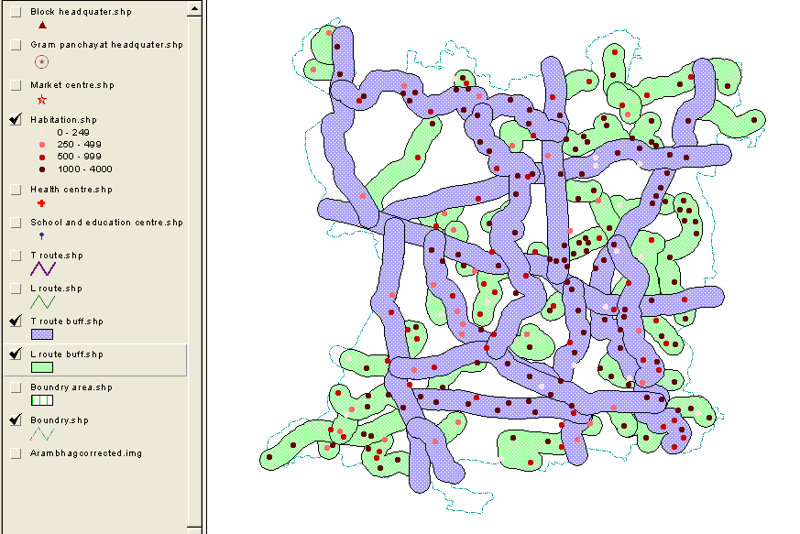

Figure Buffering of all existing routes to a specified width of 500m

**In above analysis it is seen that no habitation lies outside the buffered area. So, no habitation can be considered as unconnected**.

## Identification of Growth Center

Growth Centers are areas of concentrated activity such as office, public facilities, a range of residential development, cultural and recreational activities linked with a variety of transportation choices such as vehicular, bicycle and pedestrian.

Before, selecting the new network, one needs to identify all the Growth Centers in the Block. This is because an analysis of the transport patterns in the rural areas reveals that most of the travel is to the growth centers.

### Procedure

* 1km buffering of health centre is being done and the habitation that falls under the buffered area is being noted (see Fig. 15)
* 1km buffering of school is being done and the habitation that falls under the buffered area is being noted (see Fig. 16)
* 2km buffering of market centre is being done and the habitation that falls under the buffered area is being noted (see Fig. 17)

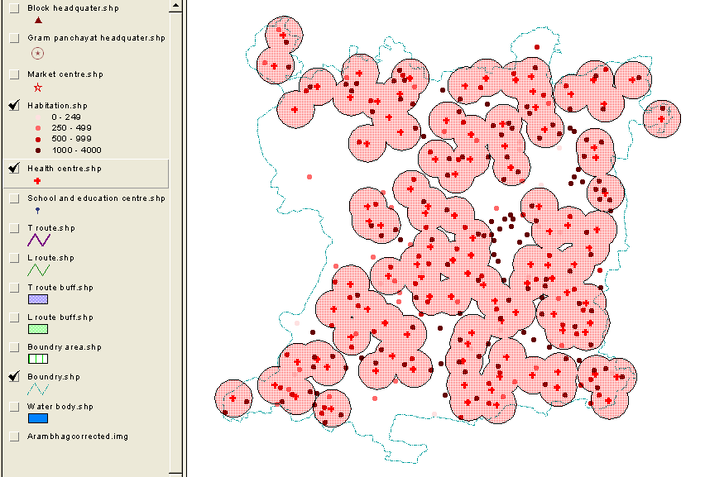

Figure Health center buffered 1 km

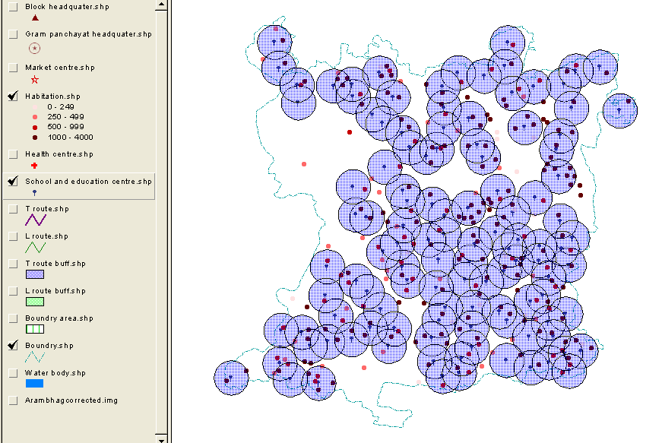

Figure School buffered 1 km

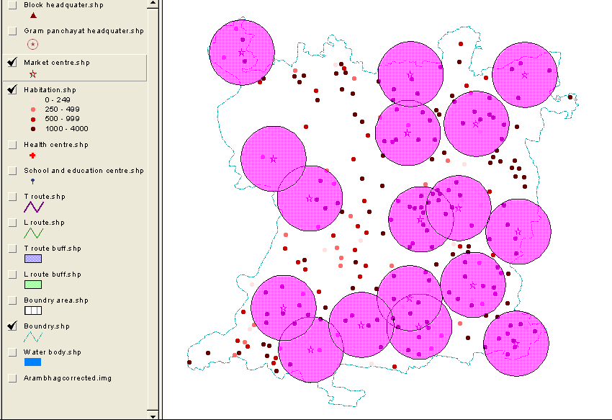

Figure Market centre buffered 2 km

The Utility value for the habitation should consider a set of demographic, socio-economic. Infrastructure and level of development data. This composite measure of development may be called as HINDEX (Habitation Index) of the habitation. Selection of the variables for computation the HINDEX value may be made from the habitation level data. The chosen set of variables may be different in different part of the country based on local development aspiration. Each variable can be given a weightage based on its present level and importance in the integrated development philosophy. Table: 10 show the choices for weights and HINDEX has been calculated for all habitations. The computed HINDEX may be used for the prioritization of the habitations.

The HINDEX for habitation *i* may be computed as shown in the equation:

*HINDEXi* = Habitation index for habitation *i*

*Fxyi* = Number of facility of *xth* type with *yth* intensity in habitation *i*

*Wxyi* = Weight for *xth* facility of *yth* intensity

For example if we consider a particular habitation and facility of two schools exist in that habitation, weightage value considered is 4. The HINDEX value of calculated for that particular facility is 2 × 4 = 8.

### Sample calculation of HINDEX for Pal para habitation

Habitation Pal para (AR201) having population 1015. The habitation has one health centre, two schools and one market place. Then from table 10 we get their weightage value.

HINDEX = 6 + 6 + (2 x 4) + 0 = 20

Table Weightage table

|  |  |  |  |  |  |  |  |
| --- | --- | --- | --- | --- | --- | --- | --- |
| **Sl No** | **Facility Variables of the Habitation** | **Weightage of Variables** | | | | | |
| **0** | **2** | **4** | **6** | **8** | **Max Weightage** |
| 1 | Habitation | Below 250 | 251 -500 | 501 -1000 | 1001 -2000 | Above 2000 | 8 |
| 2 | School | No | 1 | >1 |  |  | 4 |
| 3 | Health Centre | No |  |  | Yes |  | 6 |
| 4 | Market place | 1 | >1 |  |  |  | 2 |

Table Percentage Habitation in HINDEX range

|  |  |  |
| --- | --- | --- |
| **HINDEX range** | **No. of Habitation** | **% of Habitation** |
| 2 - 6 | 18 | 7.44 |
| 7 - 10 | 55 | 22.73 |
| 11 - 16 | 109 | 45.04 |
| 17 - 22 | 60 | 24.79 |
|  | Total = 242 | Total = 100 |

**Maximum habitation of 45.04 % falls in the HINDEX range of 11 – 16**.

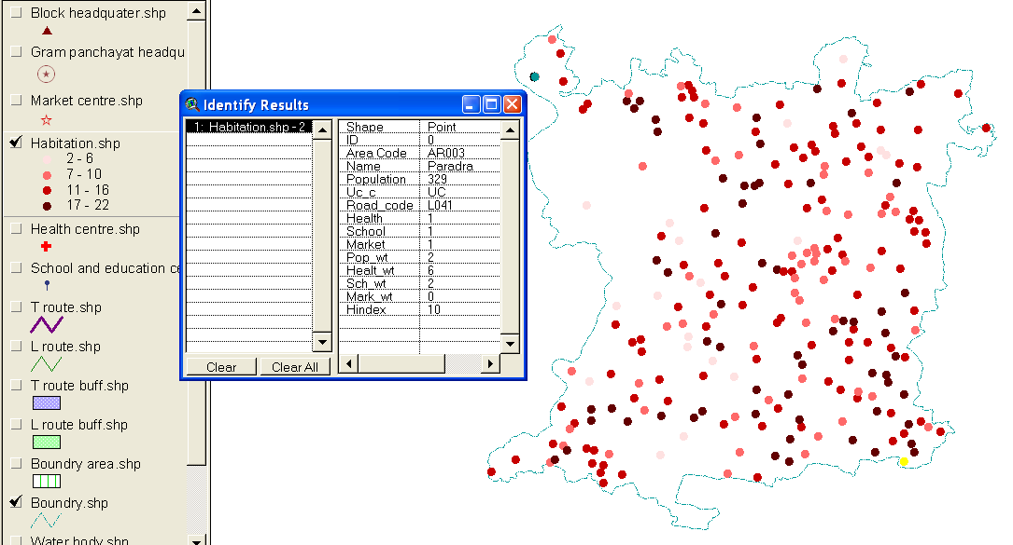

Figure Habitation mapping according to HINDEX value

Table Attribute table of Habitation along with HINDEX

|  |  |  |  |  |  |  |  |  |  |  |  |  |
| --- | --- | --- | --- | --- | --- | --- | --- | --- | --- | --- | --- | --- |
| **AREA_CODE** | **NAME** | **POPULATION** | **UC_C** | **ROAD_CODE** | **HEALTH** | **SCHOOL** | **MARKET** | **POP_WT** | **HEALT_WT** | **SCH_WT** | **MARK_WT** | **HINDEX** |
| AR001 | Bhabapur | 253 | C | L042 | 1 | 1 | 1 | 2 | 6 | 2 | 0 | 10 |
| AR002 | Maminpur | 2037 | C | T07 | 1 | 1 | 1 | 8 | 6 | 2 | 0 | 16 |
| AR003 | Paradra | 329 | C | L041 | 1 | 1 | 1 | 2 | 6 | 2 | 0 | 10 |
| AR004 | Krithchandrapur | 1154 | C | T07 | 1 | 1 | 1 | 6 | 6 | 2 | 0 | 14 |
| AR005 | Manodra | 1062 | C | T10 | 1 | 1 | 0 | 6 | 6 | 2 | 0 | 14 |
| AR006 | Dadanpur | 639 | C | T10 | 1 | 1 | 0 | 4 | 6 | 2 | 0 | 12 |
| AR007 | Ghosh para | 1051 | C | T10 | 1 | 2 | 0 | 6 | 6 | 4 | 0 | 20 |
| AR008 | Bagpara | 1010 | C | T10 | 1 | 2 | 0 | 6 | 6 | 4 | 0 | 20 |
| AR009 | Daspara | 390 | C | T10 | 1 | 1 | 0 | 2 | 6 | 2 | 0 | 10 |
| AR010 | Chandibati | 1550 | C | L040 | 1 | 2 | 0 | 6 | 6 | 4 | 0 | 20 |
| AR011 | Donga bathan | 622 | C | T10 | 1 | 2 | 0 | 4 | 6 | 4 | 0 | 18 |
| AR012 | Yadpur | 1049 | C | T10 | 1 | 2 | 0 | 6 | 6 | 4 | 0 | 20 |
| AR013 | Kapalic para | 1045 | C | T10 | 1 | 1 | 0 | 6 | 6 | 2 | 0 | 14 |
| AR014 | Duley para | 1046 | C | T10 | 1 | 1 | 0 | 6 | 6 | 2 | 0 | 14 |
| AR015 | Karmakarpara | 989 | C | L049 | 1 | 1 | 0 | 4 | 6 | 2 | 0 | 12 |
| AR016 | Bramhanpara | 1011 | C | L049 | 1 | 1 | 0 | 6 | 6 | 2 | 0 | 14 |
| AR017 | Dhara para | 100 | C | L049 | 1 | 1 | 0 | 0 | 6 | 2 | 0 | 8 |
| AR018 | Mandalpara | 1064 | C | T10 | 1 | 1 | 0 | 6 | 6 | 2 | 0 | 14 |
| AR019 | Chaudhurypara | 1395 | C | T10 | 1 | 1 | 0 | 6 | 6 | 2 | 0 | 14 |
| AR020 | Mollapara | 305 | C | T10 | 1 | 1 | 0 | 2 | 6 | 2 | 0 | 10 |
| AR021 | Benga Uttarpara | 1043 | C | T10 | 1 | 2 | 1 | 6 | 6 | 4 | 0 | 20 |
| AR022 | Benga Dhaksinpara | 1200 | C | T10 | 0 | 1 | 1 | 6 | 0 | 2 | 0 | 8 |
| AR023 | Chakjalal | 1681 | C | L053 | 1 | 1 | 1 | 6 | 6 | 2 | 0 | 14 |
| AR024 | Chakmadan | 497 | C | L053 | 1 | 1 | 1 | 2 | 6 | 2 | 0 | 10 |
| AR025 | Rohitchak | 629 | C | L053 | 1 | 2 | 1 | 4 | 6 | 4 | 0 | 18 |
| AR026 | Bora | 727 | C | T13 | 1 | 2 | 0 | 4 | 6 | 4 | 0 | 18 |
| AR027 | Kurui | 1867 | C | T13 | 0 | 1 | 0 | 6 | 0 | 2 | 0 | 8 |
| AR028 | Golta | 1205 | C | T13 | 1 | 1 | 0 | 6 | 6 | 2 | 0 | 14 |
| AR029 | Chak chamrul | 712 | C | L040 | 1 | 0 | 0 | 4 | 6 | 0 | 0 | 10 |
| AR030 | Teghari | 863 | C | L051 | 1 | 1 | 1 | 4 | 6 | 2 | 0 | 12 |
| AR031 | Paschim Shibpur | 498 | C | L040 | 0 | 0 | 1 | 2 | 0 | 0 | 0 | 2 |
| AR032 | Parbatichak | 289 | C | T06 | 0 | 0 | 1 | 2 | 0 | 0 | 0 | 2 |
| AR033 | Paharchak | 144 | C | L058 | 1 | 1 | 1 | 0 | 6 | 2 | 0 | 8 |
| AR034 | Chandsit | 252 | C | L058 | 0 | 0 | 1 | 2 | 0 | 0 | 0 | 2 |
| AR035 | Mahespur | 1106 | C | T09 | 1 | 2 | 1 | 6 | 6 | 4 | 0 | 20 |
| AR036 | Bhargakhetri para | 1067 | C | L066 | 1 | 1 | 1 | 6 | 6 | 2 | 0 | 14 |
| AR037 | Uttar Pan para | 1175 | C | L066 | 0 | 1 | 0 | 6 | 0 | 2 | 0 | 8 |
| AR038 | Ghosh para | 1025 | C | T09 | 1 | 2 | 1 | 6 | 6 | 4 | 0 | 20 |
| AR039 | Bamsa Amrel | 324 | C | L065 | 0 | 1 | 0 | 2 | 0 | 2 | 0 | 4 |
| AR040 | Jayrampur | 1148 | C | T03 | 1 | 1 | 0 | 6 | 6 | 2 | 0 | 14 |
| AR041 | Gopinathpur | 665 | C | T03 | 1 | 1 | 0 | 4 | 6 | 2 | 0 | 12 |
| AR042 | Keledona | 1343 | C | L068 | 1 | 2 | 0 | 6 | 6 | 4 | 0 | 20 |
| AR043 | Kulbeyra | 496 | C | L063 | 0 | 0 | 1 | 2 | 0 | 0 | 0 | 2 |
| AR044 | Raghunathpur | 444 | C | L059 | 0 | 1 | 1 | 2 | 0 | 2 | 0 | 4 |
| AR045 | Kasthadahi | 897 | C | T02 | 1 | 1 | 0 | 4 | 6 | 2 | 0 | 12 |
| AR046 | BhargakhetriPara | 1002 | C | T02 | 1 | 2 | 1 | 6 | 6 | 4 | 0 | 20 |
| AR047 | Muslim para | 1321 | C | T02 | 1 | 2 | 1 | 6 | 6 | 4 | 0 | 20 |
| AR048 | Tellipara | 579 | C | T02 | 1 | 2 | 1 | 4 | 6 | 4 | 0 | 18 |
| AR049 | Uttarnarayanpur | 2007 | C | T13 | 1 | 2 | 0 | 8 | 6 | 4 | 0 | 22 |
| AR050 | Behala | 443 | C | T08 | 1 | 2 | 1 | 2 | 6 | 4 | 0 | 16 |
| AR051 | Sarkar para | 1020 | C | T08 | 0 | 0 | 1 | 6 | 0 | 0 | 0 | 6 |
| AR052 | Esan Para | 1010 | C | L061 | 1 | 1 | 1 | 6 | 6 | 2 | 0 | 14 |
| AR053 | Karmakar Para | 1013 | C | L061 | 1 | 0 | 0 | 6 | 6 | 0 | 0 | 12 |
| AR054 | Tettulia | 1014 | C | L061 | 1 | 1 | 1 | 6 | 6 | 2 | 0 | 14 |
| AR055 | Khachari para | 1006 | C | T08 | 1 | 0 | 0 | 6 | 6 | 0 | 0 | 12 |
| AR056 | Sastipur | 529 | C | T08 | 1 | 1 | 1 | 4 | 6 | 2 | 0 | 12 |
| AR057 | Chakfazil Uttar | 866 | C | L043 | 1 | 2 | 1 | 4 | 6 | 4 | 0 | 18 |
| AR058 | Rasulpur uttar | 1830 | C | L044 | 1 | 1 | 0 | 6 | 6 | 2 | 0 | 14 |
| AR059 | Sekhpur | 852 | C | L044 | 0 | 1 | 0 | 4 | 0 | 2 | 0 | 6 |
| AR060 | Chak Ahmed | 835 | C | L054 | 1 | 2 | 0 | 4 | 6 | 4 | 0 | 18 |
| AR061 | Tala | 997 | C | L044 | 1 | 1 | 0 | 4 | 6 | 2 | 0 | 12 |
| AR062 | Bachhanari | 1850 | C | L044 | 1 | 2 | 1 | 6 | 6 | 4 | 0 | 20 |
| AR063 | Fatepur | 524 | C | L044 | 1 | 1 | 1 | 4 | 6 | 2 | 0 | 12 |
| AR064 | Purbaharipur | 1481 | C | L021 | 1 | 1 | 1 | 6 | 6 | 2 | 0 | 14 |
| AR065 | Ghargohal | 1769 | C | L022 | 1 | 1 | 0 | 6 | 6 | 2 | 0 | 14 |
| AR066 | Balia | 1804 | C | T01 | 1 | 1 | 1 | 6 | 6 | 2 | 0 | 14 |
| AR067 | Chakbensia | 1139 | C | T02 | 1 | 1 | 0 | 6 | 6 | 2 | 0 | 14 |
| AR068 | Banamalipur | 1187 | C | T01 | 1 | 2 | 1 | 6 | 6 | 4 | 0 | 20 |
| AR069 | Dhasksin para | 1094 | C | L052 | 1 | 1 | 1 | 6 | 6 | 2 | 0 | 14 |
| AR070 | Konear para | 1105 | C | L052 | 1 | 0 | 1 | 6 | 6 | 0 | 0 | 12 |
| AR071 | Uttarpara | 1055 | C | L052 | 0 | 0 | 1 | 6 | 0 | 0 | 0 | 6 |
| AR072 | Fakirdanga | 1050 | C | T02 | 1 | 1 | 1 | 6 | 6 | 2 | 0 | 14 |
| AR073 | Chandpara | 1179 | C | L052 | 0 | 0 | 1 | 6 | 0 | 0 | 0 | 6 |
| AR074 | Kailaschak | 1021 | C | T02 | 1 | 1 | 1 | 6 | 6 | 2 | 0 | 14 |
| AR075 | Uttarpara | 1250 | C | L052 | 1 | 1 | 1 | 6 | 6 | 2 | 0 | 14 |
| AR076 | Samanta para | 150 | C | T02 | 1 | 1 | 1 | 0 | 6 | 2 | 0 | 8 |
| AR077 | Chak Behala | 443 | C | L054 | 1 | 2 | 1 | 2 | 6 | 4 | 0 | 16 |
| AR078 | Uttarpara | 1193 | C | L061 | 1 | 1 | 0 | 6 | 6 | 2 | 0 | 14 |
| AR079 | Dhaksinpara | 1101 | C | L061 | 1 | 1 | 1 | 6 | 6 | 2 | 0 | 14 |
| AR080 | Kasigare | 132 | C | T02 | 1 | 1 | 1 | 0 | 6 | 2 | 0 | 8 |
| AR081 | Barui para | 1040 | C | T02 | 1 | 1 | 1 | 6 | 6 | 2 | 0 | 14 |
| AR082 | Goalapara | 100 | C | T02 | 1 | 1 | 1 | 0 | 6 | 2 | 0 | 8 |
| AR083 | Musalman para | 1045 | C | T02 | 1 | 2 | 1 | 6 | 6 | 4 | 0 | 20 |
| AR084 | Purbapara | 1049 | C | L064 | 1 | 1 | 0 | 6 | 6 | 2 | 0 | 14 |
| AR085 | Paschimpara | 1500 | C | L064 | 1 | 1 | 0 | 6 | 6 | 2 | 0 | 14 |
| AR086 | Jasapur | 331 | C | L055 | 1 | 0 | 0 | 2 | 6 | 0 | 0 | 8 |
| AR087 | Chakanar | 105 | C | L045 | 1 | 1 | 1 | 0 | 6 | 2 | 0 | 8 |
| AR088 | Gharai para | 1009 | C | T01 | 0 | 1 | 0 | 6 | 0 | 2 | 0 | 8 |
| AR089 | Hari para | 1198 | C | L023 | 0 | 2 | 0 | 6 | 0 | 4 | 0 | 14 |
| AR090 | Malpara | 1002 | C | L024 | 1 | 1 | 0 | 6 | 6 | 2 | 0 | 14 |
| AR091 | Saha para | 1025 | C | T01 | 0 | 1 | 0 | 6 | 0 | 2 | 0 | 8 |
| AR092 | Moyra para | 1175 | C | L023 | 0 | 1 | 0 | 6 | 0 | 2 | 0 | 8 |
| AR093 | Bene para | 1205 | C | L024 | 1 | 1 | 0 | 6 | 6 | 2 | 0 | 14 |
| AR094 | Kaji para | 1005 | C | L024 | 1 | 0 | 0 | 6 | 6 | 0 | 0 | 12 |
| AR095 | Malik para | 1250 | C | L024 | 1 | 1 | 0 | 6 | 6 | 2 | 0 | 14 |
| AR096 | Brahaman para | 1054 | C | L024 | 1 | 1 | 0 | 6 | 6 | 2 | 0 | 14 |
| AR097 | Sayer para | 1200 | C | L024 | 1 | 0 | 0 | 6 | 6 | 0 | 0 | 12 |
| AR098 | Asanpur | 2254 | C | L055 | 1 | 1 | 1 | 8 | 6 | 2 | 0 | 16 |
| AR099 | Mazaffarpur | 762 | C | L046 | 1 | 1 | 0 | 4 | 6 | 2 | 0 | 12 |
| AR100 | Purba Krishanapur | 3058 | C | L024 | 1 | 1 | 1 | 8 | 6 | 2 | 0 | 16 |
| AR101 | Purba Shibpur | 100 | C | T14 | 1 | 1 | 1 | 0 | 6 | 2 | 0 | 8 |
| AR102 | Koley Para | 1156 | C | T14 | 1 | 1 | 1 | 6 | 6 | 2 | 0 | 14 |
| AR103 | Bargakhetria para | 1244 | C | T01 | 0 | 2 | 1 | 6 | 0 | 4 | 0 | 14 |
| AR104 | Sen para | 86 | C | T14 | 1 | 1 | 1 | 0 | 6 | 2 | 0 | 8 |
| AR105 | Sarali | 1117 | C | T01 | 0 | 1 | 2 | 6 | 0 | 2 | 2 | 10 |
| AR106 | Surir para | 1053 | C | T08 | 1 | 2 | 1 | 6 | 6 | 4 | 0 | 20 |
| AR107 | Muthadanga | 1020 | C | T08 | 1 | 1 | 1 | 6 | 6 | 2 | 0 | 14 |
| AR108 | Brahaman para | 1030 | C | T08 | 1 | 1 | 1 | 6 | 6 | 2 | 0 | 14 |
| AR109 | Duley para | 1005 | C | L027 | 0 | 1 | 2 | 6 | 0 | 2 | 2 | 10 |
| AR110 | Simultalla | 1015 | C | L027 | 0 | 1 | 1 | 6 | 0 | 2 | 0 | 8 |
| AR111 | Khumbhakar para | 1010 | C | L027 | 0 | 1 | 1 | 6 | 0 | 2 | 0 | 8 |
| AR112 | Duttabati | 1020 | C | L027 | 0 | 1 | 2 | 6 | 0 | 2 | 2 | 10 |
| AR113 | Patiatambandh | 989 | C | L027 | 1 | 1 | 1 | 4 | 6 | 2 | 0 | 12 |
| AR114 | Kanadighi | 1011 | C | L027 | 0 | 1 | 2 | 6 | 0 | 2 | 2 | 10 |
| AR115 | Muslim para | 1013 | C | L027 | 0 | 1 | 2 | 6 | 0 | 2 | 2 | 10 |
| AR116 | Malik pukur | 1039 | C | T08 | 0 | 1 | 1 | 6 | 0 | 2 | 0 | 8 |
| AR117 | Kumarpara | 1165 | C | T08 | 0 | 1 | 1 | 6 | 0 | 2 | 0 | 8 |
| AR118 | Susni Para | 430 | C | T08 | 0 | 1 | 0 | 2 | 0 | 2 | 0 | 4 |
| AR119 | Hat Basantapur | 2652 | C | T13 | 1 | 1 | 0 | 8 | 6 | 2 | 0 | 16 |
| AR120 | Mohanpur | 893 | C | L060 | 1 | 2 | 1 | 4 | 6 | 4 | 0 | 18 |
| AR121 | Rajhati | 567 | C | T13 | 1 | 1 | 1 | 4 | 6 | 2 | 0 | 12 |
| AR122 | Balarampur | 1271 | C | T13 | 1 | 1 | 0 | 6 | 6 | 2 | 0 | 14 |
| AR123 | Satpur | 859 | C | L065 | 1 | 2 | 0 | 4 | 6 | 4 | 0 | 18 |
| AR124 | Krishanabati | 689 | C | L065 | 1 | 1 | 0 | 4 | 6 | 2 | 0 | 12 |
| AR125 | Ajoypur | 776 | C | T09 | 1 | 1 | 0 | 4 | 6 | 2 | 0 | 12 |
| AR126 | Chandchak | 409 | C | T09 | 1 | 1 | 0 | 2 | 6 | 2 | 0 | 10 |
| AR127 | Bauripara | 500 | C | L050 | 1 | 2 | 0 | 2 | 6 | 4 | 0 | 16 |
| AR128 | Koley pukur | 1271 | C | L050 | 1 | 1 | 0 | 6 | 6 | 2 | 0 | 14 |
| AR129 | Malik para | 800 | C | L050 | 1 | 1 | 0 | 4 | 6 | 2 | 0 | 12 |
| AR130 | Mubarakpur | 999 | C | T06 | 1 | 1 | 0 | 4 | 6 | 2 | 0 | 12 |
| AR131 | Hazra bagan | 995 | C | L039 | 1 | 1 | 1 | 4 | 6 | 2 | 0 | 12 |
| AR132 | Dumdumpati | 89 | C | L039 | 1 | 1 | 0 | 0 | 6 | 2 | 0 | 8 |
| AR133 | Salepur | 1105 | C | L039 | 0 | 0 | 1 | 6 | 0 | 0 | 0 | 6 |
| AR134 | Manikpara Uttar | 1017 | C | L038 | 1 | 2 | 1 | 6 | 6 | 4 | 0 | 20 |
| AR135 | Manikpara Purba | 1235 | C | L038 | 1 | 2 | 1 | 6 | 6 | 4 | 0 | 20 |
| AR136 | Manikpara Dakshin | 1265 | C | L038 | 1 | 2 | 1 | 6 | 6 | 4 | 0 | 20 |
| AR137 | Partar para | 307 | C | L038 | 1 | 2 | 1 | 2 | 6 | 4 | 0 | 16 |
| AR138 | Paschim pur | 991 | C | L038 | 1 | 1 | 0 | 4 | 6 | 2 | 0 | 12 |
| AR139 | Hazra para | 975 | C | L036 | 1 | 1 | 0 | 4 | 6 | 2 | 0 | 12 |
| AR140 | Dey para | 467 | C | L036 | 1 | 1 | 0 | 2 | 6 | 2 | 0 | 10 |
| AR141 | Baradangal | 925 | C | L036 | 1 | 2 | 0 | 4 | 6 | 4 | 0 | 18 |
| AR142 | Dakshin Sekhpur | 156 | C | L037 | 1 | 1 | 1 | 0 | 6 | 2 | 0 | 8 |
| AR143 | Uttarpara | 1022 | C | L036 | 1 | 1 | 0 | 6 | 6 | 2 | 0 | 14 |
| AR144 | Dhaksinpara | 1030 | C | L036 | 1 | 1 | 1 | 6 | 6 | 2 | 0 | 14 |
| AR145 | Atpur | 421 | C | L035 | 0 | 2 | 0 | 2 | 0 | 4 | 0 | 10 |
| AR146 | Berabere | 1118 | C | L035 | 1 | 2 | 0 | 6 | 6 | 4 | 0 | 20 |
| AR147 | Dharkundu Uttar | 1325 | C | L034 | 1 | 1 | 1 | 6 | 6 | 2 | 0 | 14 |
| AR148 | Dhaksin | 1175 | C | L034 | 1 | 1 | 0 | 6 | 6 | 2 | 0 | 14 |
| AR149 | Purba | 1002 | C | L034 | 1 | 1 | 0 | 6 | 6 | 2 | 0 | 14 |
| AR150 | Beraber | 1298 | C | L034 | 1 | 1 | 0 | 6 | 6 | 2 | 0 | 14 |
| AR151 | Mondalpara | 600 | C | L034 | 1 | 1 | 0 | 4 | 6 | 2 | 0 | 12 |
| AR152 | Jana para | 550 | C | L034 | 1 | 1 | 0 | 4 | 6 | 2 | 0 | 12 |
| AR153 | Faterchak | 452 | C | L034 | 1 | 1 | 1 | 2 | 6 | 2 | 0 | 10 |
| AR154 | Dongal | 1369 | C | L036 | 1 | 1 | 0 | 6 | 6 | 2 | 0 | 14 |
| AR155 | Ratanpur | 1042 | C | T06 | 1 | 2 | 2 | 6 | 6 | 4 | 2 | 22 |
| AR156 | Tatarchak | 621 | C | T06 | 1 | 1 | 1 | 4 | 6 | 2 | 0 | 12 |
| AR157 | Helarchak | 496 | C | T11 | 1 | 1 | 1 | 2 | 6 | 2 | 0 | 10 |
| AR158 | Hari para | 1002 | C | T05 | 0 | 1 | 1 | 6 | 0 | 2 | 0 | 8 |
| AR159 | Bargakhatripara | 1031 | C | T05 | 1 | 2 | 1 | 6 | 6 | 4 | 0 | 20 |
| AR160 | Gaurhati | 479 | C | T12 | 0 | 0 | 1 | 2 | 0 | 0 | 0 | 2 |
| AR161 | Subhaypur | 498 | C | L048 | 0 | 1 | 2 | 2 | 0 | 2 | 2 | 6 |
| AR162 | Kharal | 1153 | C | T05 | 1 | 2 | 1 | 6 | 6 | 4 | 0 | 20 |
| AR163 | Paisara | 666 | C | T05 | 1 | 2 | 1 | 4 | 6 | 4 | 0 | 18 |
| AR164 | Gouri | 1044 | C | L057 | 1 | 1 | 0 | 6 | 6 | 2 | 0 | 14 |
| AR165 | Beurgram | 1128 | C | L057 | 1 | 0 | 0 | 6 | 6 | 0 | 0 | 12 |
| AR166 | Khorbalarurchak | 428 | C | T09 | 0 | 0 | 0 | 2 | 0 | 0 | 0 | 2 |
| AR167 | Mahishgot | 876 | C | T11 | 1 | 1 | 0 | 4 | 6 | 2 | 0 | 12 |
| AR168 | Basulichak | 948 | C | T11 | 0 | 1 | 0 | 4 | 0 | 2 | 0 | 6 |
| AR169 | Sonagachhi | 354 | C | T09 | 0 | 1 | 0 | 2 | 0 | 2 | 0 | 4 |
| AR170 | Dhaksin para | 1283 | C | T09 | 1 | 2 | 0 | 6 | 6 | 4 | 0 | 20 |
| AR171 | Golpukur | 985 | C | L065 | 1 | 1 | 0 | 4 | 6 | 2 | 0 | 12 |
| AR172 | Purbapara | 115 | C | L065 | 1 | 1 | 1 | 0 | 6 | 2 | 0 | 8 |
| AR173 | Ranhat | 997 | C | T13 | 1 | 2 | 0 | 4 | 6 | 4 | 0 | 18 |
| AR174 | Joteram | 251 | C | L062 | 1 | 1 | 0 | 2 | 6 | 2 | 0 | 10 |
| AR175 | Hamirbati | 1553 | C | L067 | 1 | 1 | 1 | 6 | 6 | 2 | 0 | 14 |
| AR176 | Krishna Ballabhpur | 951 | C | L067 | 1 | 1 | 1 | 4 | 6 | 2 | 0 | 12 |
| AR177 | Panpit | 2192 | C | T04 | 0 | 1 | 1 | 8 | 0 | 2 | 0 | 10 |
| AR178 | Sahapur | 1265 | C | T04 | 0 | 1 | 1 | 6 | 0 | 2 | 0 | 8 |
| AR179 | Dakshin Rasulpur | 2599 | C | T01 | 0 | 2 | 1 | 8 | 0 | 4 | 0 | 16 |
| AR180 | Tirol | 801 | C | L056 | 1 | 1 | 1 | 4 | 6 | 2 | 0 | 12 |
| AR181 | Shyamgram | 2125 | C | L046 | 1 | 2 | 1 | 8 | 6 | 4 | 0 | 22 |
| AR182 | Arunbera | 1352 | C | L024 | 1 | 2 | 1 | 6 | 6 | 4 | 0 | 20 |
| AR183 | Golamichak | 846 | C | T03 | 0 | 2 | 1 | 4 | 0 | 4 | 0 | 12 |
| AR184 | Amgram | 1343 | C | L025 | 0 | 1 | 1 | 6 | 0 | 2 | 0 | 8 |
| AR185 | Chandra | 789 | C | L026 | 1 | 2 | 0 | 4 | 6 | 4 | 0 | 18 |
| AR186 | Chakraborty para | 1009 | C | L026 | 1 | 1 | 1 | 6 | 6 | 2 | 0 | 14 |
| AR187 | Bargakhatripara | 1090 | C | L026 | 1 | 1 | 0 | 6 | 6 | 2 | 0 | 14 |
| AR188 | Debnathpur | 900 | C | L026 | 1 | 2 | 1 | 4 | 6 | 4 | 0 | 18 |
| AR189 | Birati | 268 | C | T14 | 1 | 2 | 1 | 2 | 6 | 4 | 0 | 16 |
| AR190 | Katabani | 1435 | C | T01 | 1 | 1 | 1 | 6 | 6 | 2 | 0 | 14 |
| AR191 | Pirijpur | 1192 | C | T01 | 1 | 2 | 0 | 6 | 6 | 4 | 0 | 20 |
| AR192 | Selalpur | 1018 | C | T04 | 1 | 1 | 0 | 6 | 6 | 2 | 0 | 14 |
| AR193 | Elma | 703 | C | T04 | 1 | 2 | 1 | 4 | 6 | 4 | 0 | 18 |
| AR194 | Madhabpur | 1038 | C | L062 | 1 | 1 | 1 | 6 | 6 | 2 | 0 | 14 |
| AR195 | Pandugram | 1906 | C | T11 | 0 | 0 | 0 | 6 | 0 | 0 | 0 | 6 |
| AR196 | Jaisinhachak | 1733 | C | T11 | 1 | 2 | 1 | 6 | 6 | 4 | 0 | 20 |
| AR197 | Dehibagnan Purba | 1250 | C | T05 | 1 | 2 | 2 | 6 | 6 | 4 | 2 | 22 |
| AR198 | Dihibagan Paschim | 1300 | C | T05 | 1 | 1 | 2 | 6 | 6 | 2 | 2 | 16 |
| AR199 | Dehibagnan Uttar | 1450 | C | T05 | 0 | 1 | 1 | 6 | 0 | 2 | 0 | 8 |
| AR200 | Dehibagnan Dhaksin | 1086 | C | T05 | 1 | 1 | 1 | 6 | 6 | 2 | 0 | 14 |
| AR201 | Pal para | 1015 | C | L033 | 1 | 2 | 1 | 6 | 6 | 4 | 0 | 20 |
| AR202 | Para Bagan | 1785 | C | L033 | 0 | 1 | 1 | 6 | 0 | 2 | 0 | 8 |
| AR203 | Madhya Para | 52 | C | L033 | 1 | 1 | 1 | 0 | 6 | 2 | 0 | 8 |
| AR204 | Bhabanipur | 653 | C | L033 | 1 | 1 | 0 | 4 | 6 | 2 | 0 | 12 |
| AR205 | Chunait | 694 | C | L033 | 1 | 2 | 1 | 4 | 6 | 4 | 0 | 18 |
| AR206 | Bhandarhati | 303 | C | T04 | 1 | 0 | 1 | 2 | 6 | 0 | 0 | 8 |
| AR207 | Balaichak | 607 | C | T04 | 1 | 2 | 1 | 4 | 6 | 4 | 0 | 18 |
| AR208 | Samta | 928 | C | T05 | 1 | 1 | 1 | 4 | 6 | 2 | 0 | 12 |
| AR209 | Tantisal | 419 | C | L032 | 1 | 1 | 1 | 2 | 6 | 2 | 0 | 10 |
| AR210 | Purba Sitalpur | 1330 | C | T04 | 1 | 2 | 2 | 6 | 6 | 4 | 2 | 22 |
| AR211 | Paschim Sitalpur | 1301 | C | T04 | 1 | 1 | 2 | 6 | 6 | 2 | 2 | 16 |
| AR212 | Kajimahal | 107 | C | T11 | 1 | 1 | 1 | 0 | 6 | 2 | 0 | 8 |
| AR213 | Mandaran | 1171 | C | L047 | 0 | 2 | 1 | 6 | 0 | 4 | 0 | 14 |
| AR214 | Sadgop para | 1068 | C | T04 | 1 | 2 | 2 | 6 | 6 | 4 | 2 | 22 |
| AR215 | Banerjee para | 1598 | C | T04 | 1 | 2 | 1 | 6 | 6 | 4 | 0 | 20 |
| AR216 | Bargakhetria para | 102 | C | T04 | 1 | 1 | 1 | 0 | 6 | 2 | 0 | 8 |
| AR217 | Dorjipota | 1073 | C | L047 | 0 | 2 | 1 | 6 | 0 | 4 | 0 | 14 |
| AR218 | Dorjipota | 1220 | C | L047 | 0 | 2 | 1 | 6 | 0 | 4 | 0 | 14 |
| AR219 | Goala para | 80 | C | L047 | 1 | 1 | 1 | 0 | 6 | 2 | 0 | 8 |
| AR220 | Arakul | 420 | C | L031 | 1 | 1 | 0 | 2 | 6 | 2 | 0 | 10 |
| AR221 | Satmasa | 1185 | C | L031 | 1 | 2 | 0 | 6 | 6 | 4 | 0 | 20 |
| AR222 | Bahukhedail | 1148 | C | L030 | 1 | 2 | 1 | 6 | 6 | 4 | 0 | 20 |
| AR223 | Pura | 1784 | C | T11 | 1 | 2 | 0 | 6 | 6 | 4 | 0 | 20 |
| AR224 | Gholpura | 332 | C | T01 | 1 | 1 | 1 | 2 | 6 | 2 | 0 | 10 |
| AR225 | Siara | 964 | C | T14 | 1 | 2 | 1 | 4 | 6 | 4 | 0 | 18 |
| AR226 | Ragpur | 1018 | C | T14 | 1 | 2 | 1 | 6 | 6 | 4 | 0 | 20 |
| AR227 | Gobra | 673 | C | T14 | 1 | 2 | 1 | 4 | 6 | 4 | 0 | 18 |
| AR228 | Purba Ragpur | 1033 | C | L028 | 1 | 2 | 0 | 6 | 6 | 4 | 0 | 20 |
| AR229 | Madhurpur | 1040 | C | T14 | 1 | 1 | 1 | 6 | 6 | 2 | 0 | 14 |
| AR230 | Sen para | 1356 | C | T03 | 1 | 2 | 0 | 6 | 6 | 4 | 0 | 20 |
| AR231 | Dey para | 949 | C | T03 | 1 | 2 | 0 | 4 | 6 | 4 | 0 | 18 |
| AR232 | Bakherchak | 205 | C | T03 | 1 | 1 | 1 | 0 | 6 | 2 | 0 | 8 |
| AR233 | Kotal para | 1050 | C | L029 | 1 | 1 | 1 | 6 | 6 | 2 | 0 | 14 |
| AR234 | Gopal Danga | 1302 | C | L029 | 1 | 1 | 1 | 6 | 6 | 2 | 0 | 14 |
| AR235 | Lalurchak | 101 | C | L029 | 1 | 1 | 1 | 0 | 6 | 2 | 0 | 8 |
| AR236 | Dakshin Narayanpur | 1747 | C | T01 | 0 | 2 | 1 | 6 | 0 | 4 | 0 | 14 |
| AR237 | Muslim para | 945 | C | T01 | 1 | 2 | 1 | 4 | 6 | 4 | 0 | 18 |
| AR238 | Sarkar para | 1021 | C | L029 | 1 | 2 | 1 | 6 | 6 | 4 | 0 | 20 |
| AR239 | Roy para | 655 | C | T01 | 1 | 1 | 1 | 4 | 6 | 2 | 0 | 12 |
| AR240 | Guchhaitpara | 1105 | C | T01 | 1 | 2 | 1 | 6 | 6 | 4 | 0 | 20 |
| AR241 | Kismat Khedail | 545 | C | L030 | 0 | 2 | 1 | 4 | 0 | 4 | 0 | 12 |
| AR242 | Tilakchak | 725 | C | T01 | 0 | 2 | 1 | 4 | 0 | 4 | 0 | 12 |

**UC_C = UC** unconnected **/ C** connected

**HEALTH** = number of Health centre

**SCHOOL** = number of Schools and education centers

**MARKET** = number of Market centers

**POP_WT** = Population weightage

**HEALT_WT** = Health centre’s weightage

**SCH_WT** = School and education centre’s weightage

**MARK_WT** = Market centre’s weightage

**HINDEX** = Habitation Index

REFERENCES

1. Jens Steuernagel, GIS & mapping with ArcView® GIS 3.x, Training module July 2007.
2. Dr. Walid H. Shayya, An Introduction to ArcView® GIS, <http://people.morrisville.edu/~shayyaw/ArcView/IntroArcView.htm>
3. Operations Manual of PMGSY
4. Pradhan Mantri Gram Sadak Yojana under the Ministry of Rural Development, Government of India, PMGSY, <http://pmgsy.nic.in/>
5. West Bengal Panchayats and Rural Development, WBPRD, <http://wbprd.gov.in/>
6. Daya Krishnankutty (1997), “Rural Road Network Planning for Kasargod District”, M.Tech thesis submitted to Calicut University.
7. Khanna.S.K and Justo C.E.G, “A text book on Highway Engineering”, Nem Chand and Bros,Roorkee
8. Kumar.A and Tillotson (1989), “A comprehensive Planning Methodology for Rural Roads in India”, IRC Journal, Vol 9-2, pp 290-332.
9. Lakshmana Rao.K.M and Jayasree.K (2005), “Road Network-Design Methods and Evaluation Patterns”, Indian Highways, April 2005, pp 33-53.
10. Mahendru A.K, Sikdar P.K and Khanna.S.K (1982), “Nodal Points in Rural Road Network Planning”, Indian Highways Vol 10 -4, pp 5-10.
11. Mineetha.C (1992), “Generation and testing of Alternatives for Rural Road Network Development”, M.Tech thesis submitted to Calicut University
12. Minimal.K (1992), “Development of Land use Transportation Models for Rural Road Network Planning in Thrissur district”, M.Tech thesis submitted to Calicut University.
13. Prasad Rao, Kangadurai.B, Jain.P.K and Neelam Jain (2003), “Information System for Rural Road Network Planning-A case study”, Map India Conference 2003. www.gisdevelopment.net/proceedings/mapindia-2003
14. Praveen Kumar, Manoj Arora and Marem Sudhakar (2004), “Facility Based Network Planning of Rural Roads Using GIS”, Indian Highways, July 2004, pp 5-22
15. Ken Waters, Scientific Services Division (SSD), Southern Region, National Weather Service, Using ArcView 3.1 with AWIPS. <http://www.weather.gov/geodata/tutorial/avtutor.htm#Line%20Editing>