**Application of GIS in Road Network Inventory**

**BY,**

**SHAMSHER ALAM (I.D.110407062)**

**SHUBHAJIT SAHA (I.D. 110407060)**

**Under guidance of Prof. Sujata Biswas**



***A midterm project Submitted in partial fulfillment of the requirement***

**FOR THE DEGREE OF BACHELOR OF ENGINEERING (CIVIL ENGINEERING) AT THE DEPARTMENT OF CIVIL ENGINEERING BENGAL ENGINEERING AND SCIENCE UNIVERSITY, SHIBPUR, HOWRAH-711103**

**SESSION 2010 - 2011**

**ACKNOWLEDGEMENT**

I express my sincere gratitude and indebtedness to Prof. Sujata Biswas, Department of Civil Engineering, Bengal Engineering & Science University and allowing me to carry on the present topic “**Application of GIS in Road Network Inventory**” and later on for their inspiring guidance, constructive criticism and valuable suggestions throughout this project work. I am very much thankful to them for their able guidance and pain taking effort in improving my understanding of this project.

An assemblage of this nature could never have been attempted without reference to and inspiration from the works of others whose details are mentioned in reference section. I acknowledge my indebtedness to all of them.

At the last, my sincere thanks to all my friends who have patiently extended all sorts of help for accomplishing this assignment.

SHAMSHER ALAM &

SHUBHAJIT SAHA

DEPT.OF CIVIL ENGINEERING

DATE: 20-12-2010

PLACE: BESU, SHIBPUR.

**Bengal Engineering and Science University,Shibpur**

**Department of Civil Engineering**

**Howrah – 711103(West Bengal)**



*CERTIFICATE OF APPROVAL*

The foregoing Seminar Paper on Project titled “**Application of GIS in Road Network Inventory”**, was carried out and presented satisfactorily to warrant its acceptance as a pre-requisite to the Degree of Bachelor of Engineering (Civil Engineering) of this University. It is understood that by this approval the undersigned do not necessarily approve of any statement expressed and any conclusion drawn but approve this seminar paper on thesis only for the purpose for which it is submitted.

***Board of examiners***

Date : 1) …………………………...

2) …………………………...

3) …………………………...

**Bengal Engineering and Science University,Shibpur**

**Department of Civil Engineering**

**Howrah – 711103(West Bengal)**



***FORWARD***

I hereby forward this Seminar Paper on Project titled “**Application of GIS in Road Network Inventory**”, submitted by

* **SHUBHAJIT SAHA**
* **SHAMSHER ALAM**

under my guidance and supervision in partial fulfillment of the requirements for the award of the degree of Bachelor of Engineering in Civil Engineering from Bengal Engineering and Science University, Shibpur, Howrah – 711103.

Date : ………………………

***Prof. Sujata Biswas***

***Department of Civil Engineering***

***Bengal Engineering and Science University, Shibpur.***

**Countersigned by :-**

……………………………….

***Dr. Kalyan Kumar Chattopadhyay***

***Professor and Head***

***Department of Civil Engineering,***

***Bengal Engineering and Science University, Shibpur***

Contents

1. INTRODUCTION 6

1.1 General 6

1.2 Condition of road network of India 6

1.3 Pradhan Mantri Gram Sadak Yojana (PMGSY) 8

Objective 8

Guiding princicles 9

2. LITERATURE REVIEW 10

2.1 General 10

2.2 Review of Literature 11

3. GEOGRAPHIC INFORMATION SYSTEMS (GIS) 11

3.1 Brief 11

3.2 Raster graphics 12

3.3 Vector graphics 12

4. OBJECTIVE 13

5. PRESENT STUDY 13

5.1 Study Area 13

5.2 Data Collection 14

5.2.1 Flowchart for Road Information System 14

5.2.2 Collected Data 15

5.2.3 Map Data 16

5.3 Application of Arc View in GIS 16

6. RESULTS 17

REFERENCES 18

# 1. INTRODUCTION

## 1.1 General

The development of any country depends on the infrastructural facilities available therein. Good road network facilities plays major role here. The developed countries have good road infrastructure not because of the fact that they are wealthy; instead they become developed because of good road infrastructure. Over the last few decades, lack of transportation infrastructure has affected the economic growth and development of India. Rural India does not have all-weather road connectivity for marketing agricultural products and existing highway network in the country is inadequate and insufficient. Moreover the main roads in India are under huge pressure and in great need of modernization in order to handle the increased requirements of the Indian economy. In addition to maintenance, the expansion of the network and widening of existing roads is becoming increasingly important. This would then enable the roads to handle increased traffic, and also allow for a corresponding increase in the average movement speed on India's roads.

Realizing this fact an ambitious and biggest ever infrastructure development project in India (expected cost of $26 billion) named as Pradhan Mantri Gram Sadak Yojna (PMGSY) under ministry of Rural Development was conceptualized and launched on 25th December, 2000. to provide connectivity to unconnected rural habitations as part of a poverty eradication measure.

**In the present study, an attempt is being made to develop an information system for road network planning using GIS for a particular block in rural area under PMGSY program.**

## 1.2 Condition of road network of India

Almost 80% of passenger traffic and about 65% of freight movement is handled by this vast network.

In general, roads in India are primarily bitumen-based macadamized roads. However, a few of the National Highways have concrete roads too. In some locations, such as in Kanpur, British-built concrete roads are still in use. Concrete roads were less popular prior to 1990s because of low availability of cement then. However, with large supplies of cement in the country and the virtues of concrete roads, they are once again gaining popularity. Concrete roads are weather-proof and require lower maintenance compared to bituminous roads. Because bitumen is obtained mostly from imported crude oil, and due to other factors, concrete-based roads will prove to be more cost-effective in future. Apart from these, one also comes across unpaved dirt roads in the countryside, which is fast getting converted to paved roads.

**Indian Road Network**

**Class Length (km)**

Major district roads 470,000

National Highways/Expressways 66,754

Rural & other roads 2,650,000

State Highways 128,000

**Total (approx)** **3,314,754**

By acting as the link between the rural and urban areas, the State Highways and Major District Roads contribute significantly to the development of the rural economy and industrial growth of the country. It is estimated that the secondary system carries about 40 per cent of the total road traffic and comprises about 20% of the total road length.

|  |  |  |  |  |  |  |
| --- | --- | --- | --- | --- | --- | --- |
| State-wise Road Network | | | | | | |
| State/UT | **National Highways (km)** | **State Highways (km)** | **Major District Roads (km)** | **Other District & Link Roads (km)** | **Total surfaced length (km) as on March 31, 2002** | **Total length (km) as on March 31, 2002** |
| Andaman & Nicobar | 300 |  |  |  | 1,180 | **1,180** |
| Andhra Pradesh | 4,472 |  |  |  | 1,19,857 | **1,96,172** |
| Arunachal Pradesh | 392 |  |  |  | 5,689 | **18,365** |
| Assam | 2,836 |  |  |  | 12,882 | **89,486** |
| Bihar | 3,642 |  |  |  | 32,858 | **76,065** |
| Chandigarh | 24 |  |  |  | 2,045 | **2,045** |
| Chhattisgarh | 2,184 |  |  |  | 24,476 | **35,372** |
| Dadra & Nagar Haveli |  |  |  |  | 580 | **580** |
| Daman & Diu |  |  |  |  | 324 | **414** |
| Delhi | 72 |  |  |  | 23,274 | **28,508** |
| Goa | 269 |  |  |  | 6,830 | **9,672** |
| Gujarat | 3,245 |  |  |  | 1,24,295 | **1,37,617** |
| Haryana | 1,512 |  |  |  | 26,311 | **28,203** |
| Himachal Pradesh | 1,208 | 2,160 | 2,240 |  | 16,754 | **29,617** |
| Jammu & Kashmir | 1,245 |  |  |  | 9,943 | **23,429** |
| Jharkhand | 1,805 |  |  |  | 2,840 | **11,486** |
| Karnataka | 3,843 |  |  |  | 1,04,241 | **1,52,599** |
| Kerala | 1,457 | 4,006 | 23,702 |  | 50,164 | **1,50,851** |
| Lakshadweep |  |  |  |  | 150 | **150** |
| Madhya Pradesh | 4,670 |  |  |  | 78,191 | **1,60,968** |
| Maharashtra | 4,176 | 33,705 |  |  | 2,09,559 | **2,67,452** |
| Manipur | 959 |  |  |  | 3,863 | **11,434** |
| Meghalaya | 810 |  |  |  | 6,560 | **9,565** |
| Mizoram | 927 |  |  |  | 2,877 | **5,075** |
| Nagaland | 494 |  |  |  | 6,451 | **21,021** |
| Orissa | 3,704 |  |  |  | 52,245 | **2,37,034** |
| Puducherry | 53 |  |  |  | 2,115 | **2,571** |
| Punjab | 1,557 | 2,166 | 1,799 | 34,997 | 52,747 | **61,530** |
| Rajasthan | 5,585 |  |  |  | 82,456 | **1,32,482** |
| Sikkim | 62 |  |  |  | 1,546 | **2,019** |
| Tamil Nadu | 4,462 | 7,163 | 7,362 | 40,963 | 1,54,958 | **1,91,947** |
| Tripura | 400 |  |  |  | 4,393 | **16,296** |
| Uttarakhand | 1,991 |  |  |  | 10,730 | **33,547** |
| Uttar Pradesh | 5,874 |  |  |  | 1,66,659 | **2,48,481** |
| West Bengal | 2,524 |  |  |  | 49,517 | **92,023** |
| Total | **66,754** |  |  |  |  |  |

## 1.3 Pradhan Mantri Gram Sadak Yojana (PMGSY)

### Objective

1 ) The primary objective of the PMGSY is to provide Connectivity, by way of an All-weather Road (with necessary culverts and cross-drainage structures, which is operable throughout the year), to the eligible unconnected Habitations in the rural areas, in such a way that all Unconnected Habitations with a population of 1000 persons and above are covered in three years (2000-2003) and all Unconnected Habitations with a population of 500 persons and above by the end of the Tenth Plan Period (2007). In respect of the Hill States (North-East, Sikkim, Himachal Pradesh, Jammu & Kashmir, Uttaranchal) and the Desert Areas (as identified in the Desert Development Programme) as well as the Tribal (Schedule V) areas, the objective would be to connect Habitations with a population of 250 persons and above.

2 ) The PMGSY will permit the Upgradation (to prescribed standards) of the existing roads in those Districts where all the eligible Habitations of the designated population size (refer Para 2.1 above) have been provided all-weather road connectivity. However, it must be noted that Upgradation is not central to the Programme and cannot exceed 20% of the State’s allocation as long as eligible Unconnected Habitations in the State still exist. In Upgradation works, priority should be given to Through Routes of the Rural Core Network, which carry more traffic

### Guiding princicles

1. The spirit and the objective of the Pradhan Mantri Gram Sadak Yojana (PMGSY) is to provide good all-weather road connectivity to unconnected Habitations. A habitation which was earlier provided all-weather connectivity would not be eligible even if the present condition of the road is bad.
2. The unit for this Programme is a Habitation and not a Revenue village or a Panchayat. A **Habitation** is a cluster of population, living in an area, the location of which does not change over time. Desam, Dhanis, Tolas, Majras, Hamlets etc. are commonly used terminology to describe the Habitations.
3. An **Unconnected Habitation** is one with a population of designated size (refer to Para 2.1 above) located at a distance of at least 500 metres or more (1.5 km of path distance in case of Hills) from an All-weather road or a connected Habitation.
4. Para 2.1 above refers to Population size of Habitations. The population, as recorded in the Census 2001, shall be the basis for determining the population size of the Habitation. The population of all Habitations within a radius of 500 metres (1.5 km. of path distance in case of Hills) may be clubbed together for the purpose of determining the population size. This **cluster approach** would enable provision of connectivity to a larger number of Habitations, particularly in the Hill / mountainous areas.
5. The eligible Unconnected Habitations are to be connected to nearby Habitations already connected by an All-weather road or to another existing All-weather road so that services (educational, health, marketing facilities etc.), which are not available in the unconnected Habitation, become available to the residents.
6. A **Core Network** is that minimal Network of roads (routes)that is essential to provide Basic access to essential social and economic services to all eligible habitations in the selected areas through at least a single all-weather road connectivity.
7. A Core Network comprises of **Through Routes** and **Link Routes**. Through routes are the ones which collect traffic from several link roads or a long chain of Habitations and lead it to Marketing centres either directly or through the higher category roads i.e., the District Roads or the State or National Highway. **Link Routes** are the roads connecting a single Habitation or a group of Habitations to Through Routes or District Roads leading to Market Centres. Link routes generally have dead ends terminating on a Habitation, while Through Routes arise from the confluence of two or more Link Routes and emerge on to a major Road or to a Market Centre.
8. It should be ensured that each road work that is taken up under the PMGSY is part of the Core Network. While keeping the objective of Connectivity in view, preference should be given to those roads which also incidentally serve other Habitations. In other words, without compromising the basic objective (covering 1000+ Habitations first and 500+ Habitations next and 250+ Habitations where eligible, last), preference should be given to those roads which serve a larger population. For this purpose, while Habitations within a distance of 500 metres from the road is considered as connected in case of plain areas, this distance should be 1.5 km (of path length) in respect of Hills.
9. The PMGSY shall cover only the rural areas. Urban roads are excluded from the purview of this Programme. Even in the rural areas, PMGSY covers only the **Rural Roads** i.e., Roads that were formerly classified as ‘Other District Roads’ (ODR) and ‘Village Roads’ (VR). **Other District Roads** (ODR) are roads serving rural areas of production and providing them with outlet to market centres, taluka (tehsil) headquarters, Block headquarters or other main roads. **Village Roads** (VR) are roads connecting villages / Habitation or groups of Habitation with each other and to the nearest road of a higher category. Major District Roads, State Highways and National Highways cannot be covered under the PMGSY, even if they happen to be in rural areas. This applies to New Connectivity roads as well as Upgradation works.
10. The PMGSY envisages only single road Connectivity to be provided. If a Habitation is already connected by way of an All-weather road, then no new work can be taken up under the PMGSY for that habitation.

**\*Attempt made to study the road network of Arambagh block using GIS**

# 2. LITERATURE REVIEW

## 2.1 General

The use of geographic information system (GIS) is an important part of Traffic engineering. Many scientists have applied GIS in the transportation sector such as route planning and analysis, Automatic Vehicle location, etc.

## 2.2 Review of Literature

**M.L.Agarwal et.al (2007):** Carried out an experimental preprogram to study the noise impact assessment for high way project by the use of GIS framework. The use of GIS enhances the capability of the exiting model by providing area wise distribution of noise impact.

**Praveen Kumar & Atul Agarwal (2007):** Used GIS in Delhi metro. This study provide both pre-trip and & en- route information to the users. In this study a GIS based ATIS (Advanced Traveler Information System) was developed.

**Prof. V. Guruswany et.al (2006):** Carried out an experimental program to study the optimal route analysis using GIS. GIS can be used to address the objectives of finding the optimal route between the given origin and destination.

# 3. GEOGRAPHIC INFORMATION SYSTEMS (GIS)

## 3.1 Brief

Geographic information systems (GIS) or geospatial information systems is a set of tools that captures, stores, analyzes, manages, and presents data that are linked to location(s). In the simplest terms, GIS is the merging of cartography, statistical analysis, and database technology. GIS may be used in archaeology, geography, cartography, remote sensing, land surveying, public utility management, natural resource management, precision agriculture, photogrammetry, urban planning, emergency management, navigation, aerial video, and localized search engines.

As GIS can be thought of as a system, it digitally creates and "manipulates" spatial areas that may be jurisdictional, purpose or application oriented for which a specific GIS is developed. Hence, a GIS developed for an application, jurisdiction, enterprise, or purpose may not be necessarily interoperable or compatible with a GIS that has been developed for some other application, jurisdiction, enterprise, or purpose. What goes beyond a GIS is a spatial data infrastructure (SDI), a concept that has no such restrictive boundaries.

Therefore, in a general sense, the term describes any information system that integrates, stores, edits, analyzes, shares, and displays geographic information for informing decision making. GIS applications are tools that allow users to create interactive queries (user-created searches), analyze spatial information, edit data, maps, and present the results of all these operations.[1] Geographic information science is the science underlying the geographic concepts, applications and systems.[2] GIS can be studied in degree and certificate programs at many universities.

Raster and vector are the two basic data structures for storing and manipulating images and graphics data on a computer. All of the major GIS (Geographic Information Systems) and CAD (Computer Aided Design) software packages available today are primarily based on one of the two structures, either raster based or vector based, while they have some extended functions to support other data structures.

## 3.2 Raster graphics

In computer graphics, a raster graphics image or bitmap is a data structure representing a generally rectangular grid of pixels, or points of color, viewable via a monitor, paper, or other display medium. Raster images are stored in image files with varying formats (see Comparison of graphics file formats).

A bitmap corresponds bit-for-bit with an image displayed on a screen, generally in the same format used for storage in the display's video memory, or maybe as a device-independent bitmap. A bitmap is technically characterized by the width and height of the image in pixels and by the number of bits per pixel (a color depth, which determines the number of colors it can represent).

The printing and prepress industries know raster graphics as contones (from "continuous tones") and refer to vector graphics as "line work".

## 3.3 Vector graphics

Vector graphics is the use of geometrical primitives such as points, lines, curves, and shapes or polygon(s), which are all based on mathematical equations, to represent images in computer graphics.

Vector graphics formats are complementary to raster graphics, which is the representation of images as an array of pixels, as it is typically used for the representation of photographic images.[1] There are instances when working with vector tools and formats is the best practice, and instances when working with raster tools and formats is the best practice. There are times when both formats come together. An understanding of the advantages and limitations of each technology and the relationship between them is most likely to result in efficient and effective use of tools.

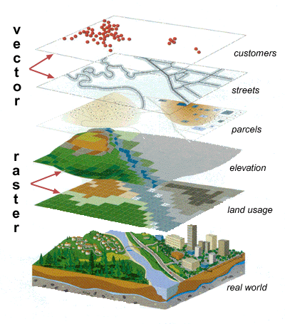

# 4. OBJECTIVE

1. To study the existing core network from the district rural plan (DRRP) map preprared by the authority.
2. To develop rural road network inventory in block level.

# 5. PRESENT STUDY

## 5.1 Study Area

The study area taken is Arambagh block in Hooghly district in the state of West Bengal. Arambagh lies between latitude 22’53’00” N and longitude 87’47’00” E.

As of 2001 India census, Arambag had a population of 56,129. Males constitute 51% of the population and females 49%. Arambag has an average literacy rate of 66%, higher than the national average of 59.5%; with 73% male literacy and 58% of female literacy. 12% of the population is under 6 years of age

It has an average elevation of 15 metres (118 feet). It is located on the bank of the Dwarakeswar River

## 5.2 Data Collection

### 5.2.1 Flowchart for Road Information System

Rural Road Inventory

PMGSY Map

Road Reference

Road Geometric Details

Road pavement condition

Terrain & soil type & traffic

CD

* Serial no.
* Name of the road
* Road code
* Length
* Carriage Width
* Surface type
* CBR
* Total traffic per day
* Commercial vechicle perday
* Total length
* Width

### 5.2.2 Collected Data

|  |  |  |  |  |  |  |  |  |  |  |
| --- | --- | --- | --- | --- | --- | --- | --- | --- | --- | --- |
| **Sr.No.** | [Name of District](https://www.online.omms.nic.in/government/ims/online/datasheet/SanctionedRoad4STA.asp?district=8&state=WB&year=0&packageId=0&stream=0&roadStatus=0&Batch=0&OrderBy=Desc&sortby=4) | **Name of Block** | **Road Name** | **Pavement** | **Design** | | | | **Traffic Intensity** | **CBR Value** |
| **Length (in Kms)** | **Carriage Way Width** | **Proposed Surface** | **Curve Type** | **Related Road in Core Network** |
| **1** | **2** | **3** | **6** | **11** | **31** | **32** | **33** | **34** | **36** | **37** |
| 3 | Hooghly | Arambag | Duttapur - Monirampur upto Acharjapara | 5.55 | 3.75 | Sealed Surface | B | T05 | 2008,93,24 | 4,5,3.61 |
| 4 | Hooghly | Arambag | Bais Mile - Batanal | 10.18 | 3.75 | Unsealed | B | T01 | 2004,105,49 | 4.5,9.5,3.12 |
| 5 | Hooghly | Arambag | Harinkhola - Purba Keshabpur | 5.73 | 3.75 | Unsealed | B | T01 | ##### | 3.5,5.7,3.53 |
| 6 | Hooghly | Arambag | Charmile - Dakshinnarayanpur | 12.64 | 3.75 | Sealed Surface | B | T11 | 2007,305,18 | 11.349,12.258,3.21 |
| 7 | Hooghly | Arambag | GoghatMetalRoad - Bijalkona | 17.92 | 3.75 | Sealed Surface | B | T14 | 2007,233,15 | 16.395,17.915,3.98 |

### 5.2.3 Map Data

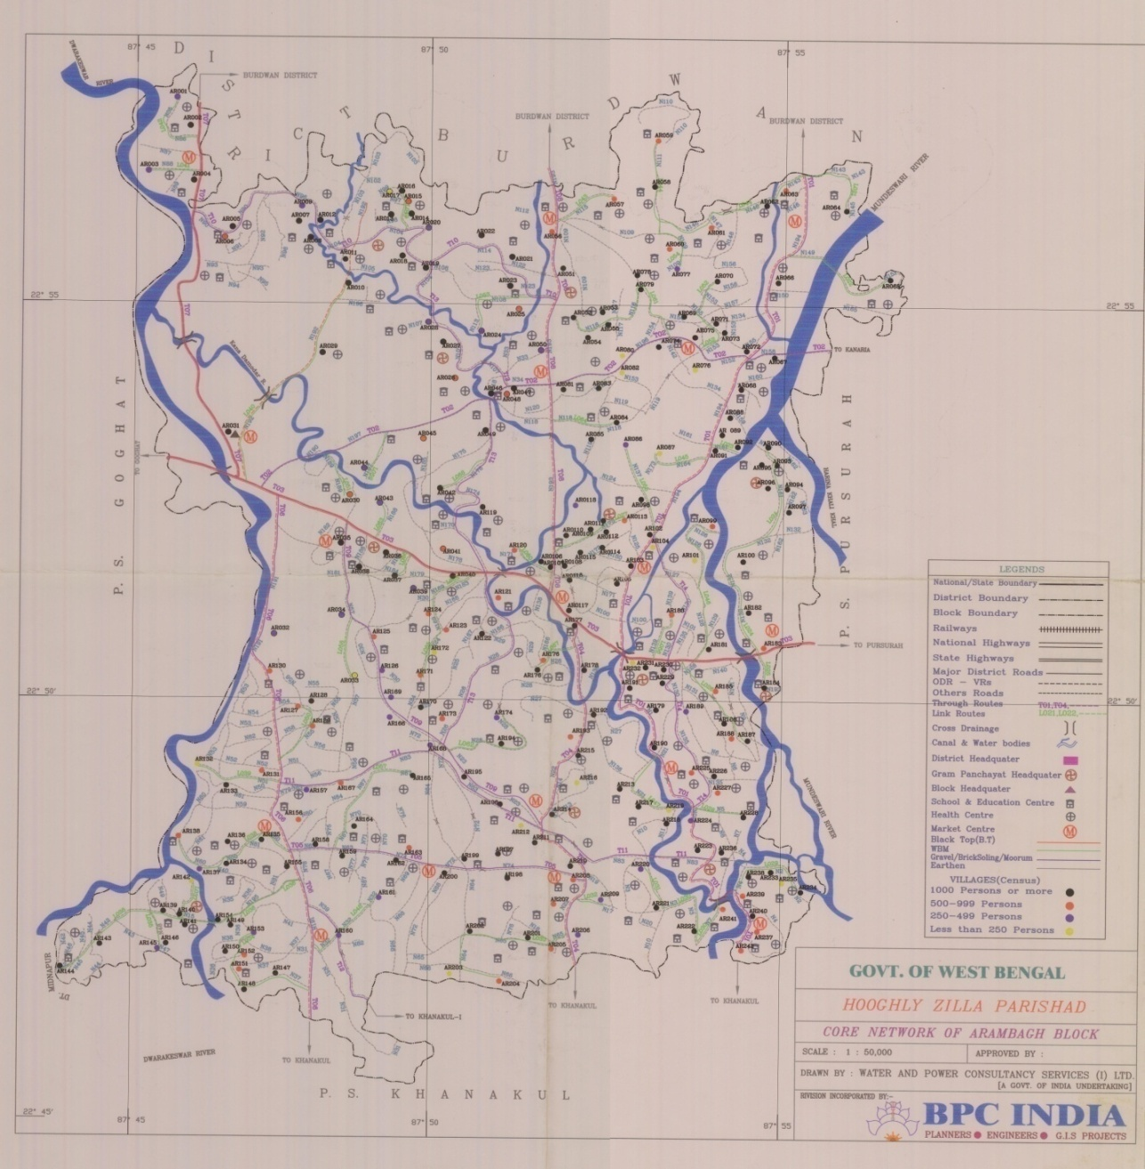

**Map of Arambagh Block (Scale 1:50,000)**

## 5.3 Application of Arc View in GIS

.Arc View is a useful software or desktop GIS and mapping. It is a product of Environmental System Research Institute (ESRI). Arc view GIS is a powerful software that provides for visualizing, querying, exploring, and analyzing data geographically. Arc view is a powerful GIS tool that can display information (which resides locally or over a distributed network), read spatial and tabular information from a variety of data formats, access external databases, produced thematic maps (use colors and symbols to represent features based upon their attributes), perform spatial queries, connect spatial information to data attributes, provides several analytical tools and allows for a high degree of customization using Avenue. Using Arc View, we can understand the geographical context of our data, allowing us to see relationship and identify patterns in new ways.

# 6. RESULTS

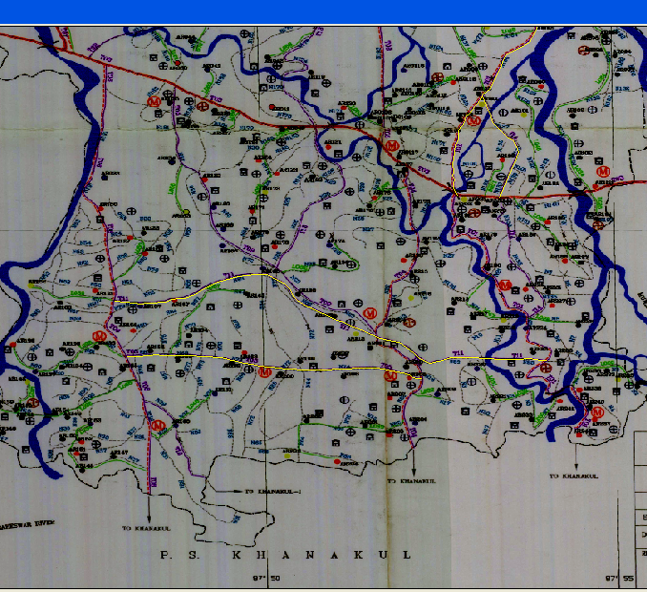

Roads in the Block

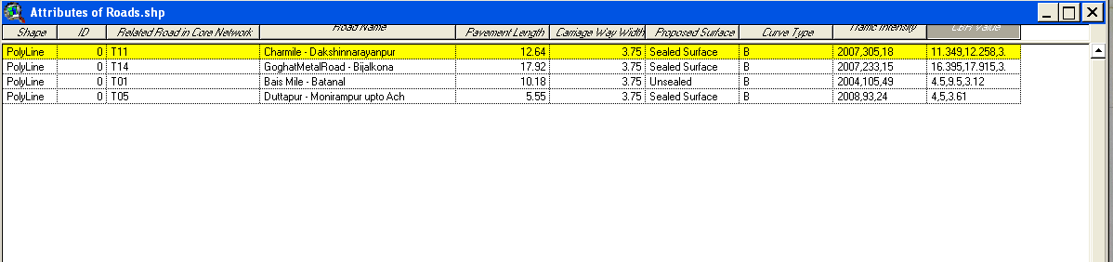

Attribute table

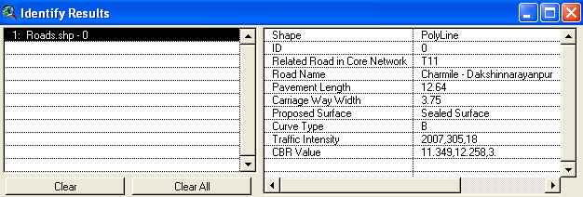

Inventory Data of road T11

# REFERENCES

Operations Manual ofPMGSY

Daya Krishnankutty (1997), “Rural Road Network Planning for Kasargod District”, M.Tech thesis submitted to Calicut University.

Khanna.S.K and Justo C.E.G, “A text book on Highway Engineering”, Nem Chand and Bros,Roorkee

Kumar.A and Tillotson (1989), “A comprehensive Planning Methodology for Rural Roads in India”, IRC Journal, Vol 9-2, pp 290-332.

Lakshmana Rao.K.M and Jayasree.K (2005), “Road Network-Design Methods and Evaluation Patterns”, Indian Highways, April 2005, pp 33-53.

Mahendru A.K, Sikdar P.K and Khanna.S.K (1982), “Nodal Points in Rural Road Network Planning”, Indian Highways Vol 10 -4, pp 5-10.

Mineetha.C (1992), “Generation and testing of Alternatives for Rural Road Network Development”, M.Tech thesis submitted to Calicut University

Minimal.K (1992), “Development of Land use Transportation Models for Rural Road Network Planning in Thrissur district”, M.Tech thesis submitted to Calicut University.

Prasad Rao, Kangadurai.B, Jain.P.K and Neelam Jain (2003), “Information System for Rural Road Network Planning-A case study”, Map India Conference 2003. www.gisdevelopment.net/proceedings/mapindia-2003

Praveen Kumar, Manoj Arora and Marem Sudhakar (2004), “Facility Based Network Planning of Rural Roads Using GIS”, Indian Highways, July 2004, pp 5-22