[Date]

lerayongoetjana@gmail.com

[company name]

Princess Ngoetjana st10092184 cloud development part1 18 March 2025

Part 1

1. ERD diagram

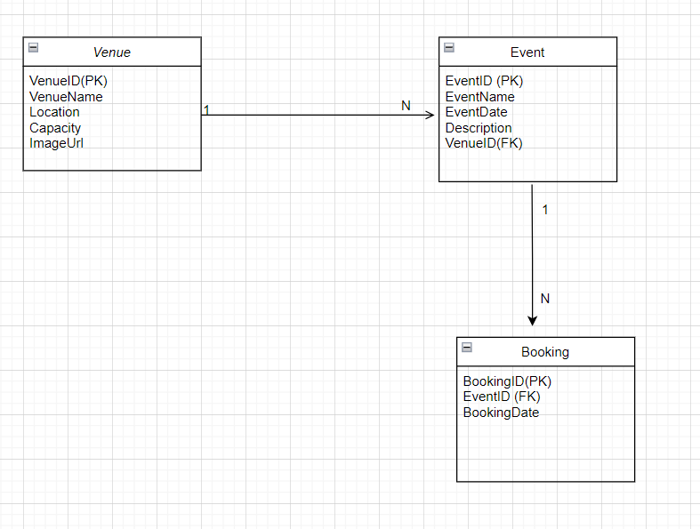

Database script:

Github link <https://github.com/IIEWFL/cldv6211-part-1-PrincessNgoetjana.git>

1. Locally developed web app link :

[Home Page - EventEase](https://localhost:7191/)

**C.1. In what ways does deploying an application in the cloud differ from deploying it on-premises, particularly regarding security, deployment speed, and resource management? Use examples to illustrate your points.**

Deploying an application in the cloud has various advantages over on-premises deployment, especially in terms of security, deployment speed, and resource management. This is how they differ:  
  
Security:  
Cloud: Security is a joint responsibility of the cloud provider and the customer. Encryption, network protection, identity management, and automatic security upgrades are common security features included by providers. For example, Azure and AWS provide enhanced threat detection, automated patch management, and GDPR and HIPAA compliance.  
On-Premises: Security is solely the responsibility of the organization. This includes manually configuring firewalls and intrusion detection systems, as well as routinely patching servers. The business is also responsible for guaranteeing the physical security of its gear.

For example, if EventEase's venue booking system experiences an unexpected increase in traffic (e.g., a special event resulting in more bookings), cloud resources can be scaled instantaneously without the need for extra physical hardware. On-premises, they may struggle to satisfy demand until new servers are acquired and configured.

Deployment Speed:  
Cloud: Cloud solutions provide speedier deployment because resources (such as servers, databases, and storage) are readily available and do not require physical setup. For example, using cloud infrastructure, EventEase can swiftly provision and scale the servers required to meet rising demand.  
On-Premises: On-premises deployment is slower since physical hardware needs to be purchased, deployed, and configured. Scaling also necessitates purchasing and configuring additional hardware, which takes time.

For example, in cloud computing, EventEase may deploy its application across many regions with a few clicks. This would be far more time-consuming and complicated if done on-premises.

Resource Management:  
The cloud allows for flexible and scalable resource management. Cloud providers provide pay-as-you-go pricing, allowing businesses to scale up or down according to demand. If EventEase has an increase in reservations, it can instantly add more computational resources without requiring any physical infrastructure adjustments.  
On-premises infrastructure necessitates that enterprises plan for capacity ahead of time. If demand exceeds estimates, scaling may require the purchase of extra gear, which can be expensive and time-consuming.

For example, if EventEase's venue booking system experiences an unexpected increase in traffic (e.g., a special event resulting in more bookings), cloud resources can be scaled instantaneously without the need for extra physical hardware. On-premises, they may struggle to satisfy demand until new servers are acquired and configured.

**2. Key Differences Between IaaS, PaaS, and SaaS**

IaaS (Infrastructure as a Service) offers virtualized computer resources such as servers, storage, and networking. The customer is responsible for managing the operating system and application software, while the cloud provider is in charge of the physical infrastructure.  
  
For example, Amazon EC2 offers IaaS. You can rent virtual computers and customize them as needed.  
  
Platform as a Service (PaaS): Provides a platform and environment for developing, managing, and running applications. The cloud provider handles the infrastructure, which includes the operating system, middleware, and runtime, while customers concentrate on app development.  
  
Examples include Microsoft Azure App Service and Heroku. These platforms let developers to launch web apps without having to worry about server maintenance or operating system setups. (Microsoft.com, 2025)  
  
SaaS (Software as a Service) offers fully functional programs via the internet. The cloud provider hosts, maintains, and manages the software, which users can access using a web browser. There is no requirement for installation or local management.  (Microsoft Azure, 2023)  
  
For example, Google Workspace and Microsoft Office 365 let end users to use fully developed programs such as email, calendars, and document editors without having to manage anything on the backend. (Harris, 2022)

**EventEase would gain the most from embracing PaaS for the reasons listed below:**  
  
PaaS simplifies management by eliminating the need to manage underlying infrastructure (servers, storage, and networks). This enables the development team to concentrate on the program itself rather than server maintenance or software updating.  
  
Faster Deployment: Using PaaS, EventEase can quickly deploy its Venue Booking System without having to deal with low-level configurations like operating systems or middleware. The platform would handle these, allowing for a faster time to market.  
  
Scalability: Because EventEase's booking system may need to accommodate changing traffic (for example, higher demand around holidays or events), a PaaS solution can grow automatically based on demand, eliminating the burden of manual scaling.

Cost Effectiveness: PaaS can be less expensive since it abstracts many of the costs involved with infrastructure administration. EventEase just pays for the resources it uses, avoiding the initial costs of purchasing hardware and software. (Ford, 2023)

Reference

Microsoft.com. (2025). *What is IaaS? Infrastructure as a Service | Microsoft Azure*. [online] Available at: https://azure.microsoft.com/en-us/resources/cloud-computing-dictionary/what-is-iaas/?msockid=21a03508377b61462d0521d83607602c. [Accessed 18 Mar. 2025].

Microsoft Azure (2023). *What is SaaS? Software as a Service | Microsoft Azure*. [online] azure.microsoft.com. Available at: <https://azure.microsoft.com/en-us/resources/cloud-computing-dictionary/what-is-saas/>.

Harris, C. (2022). *Microsoft 365 Vs. Google Workspace: a Complete Comparison*. [online] Expert Insights. Available at: <https://expertinsights.com/insights/microsoft-365-vs-google-workspace-a-complete-comparison/>.

Ford, Liam. “Implementing PaaS Management in Cloud Computing.” *PaaS Lane*, 2 Nov. 2023, [www.paaslane.com/implementing-paas-management/](http://www.paaslane.com/implementing-paas-management/) . Accessed 18 Mar. 2025.

‌