lerayongoetjana@gmail.com

[Company name]  [Company address]

ST10092184 Princess Ngoetjana cloud development6211 Poe part 1 07/04/2025

**Introduction**  
KhumaloCraft Emporium, founded by entrepreneur James Khumalo, promises a thriving worldwide platform that links craftsmen with clients from all over the world. This platform is designed to promote and sell one-of-a-kind, handcrafted products, providing artisans with a voice and a marketplace outside of their local communities.  
  
To meet this lofty ambition, KhumaloCraft must implement a modern web-based solution that is globally accessible, simple to use, scalable, and secure. Cloud computing provides the appropriate basis for realizing this objective by offering the required infrastructure, services, and tools to allow rapid development and a consistent user experience.

**Comparison of the current workflow and the proposed solution**  
KhumaloCraft currently lacks a consolidated digital platform. Artisans might market their products through local events, word of mouth, or informal social media sales. Customers have limited access to these products, and monitoring orders, inventory, and artisan profiles is done manually or via disconnected systems.  
  
whereas the suggested cloud-based web application will function as a centralized, professional platform. Artisans will be able to build profiles and post information about their craftwork. Customers will be able to browse products, place orders, and interact with craftsmen from around the world. Orders and inventories will be handled automatically by the system. (Susnjara and Smalley, 2024)

**Advantages of Using Cloud Computing**  
Cloud computing enables KhumaloCraft to conduct its whole company without the need to purchase and maintain physical servers. Microsoft Azure, a renowned cloud platform, provides variable pricing methods, allowing the organization to pay only for the resources it utilizes. It also allows quick deployment, allowing the development team to easily deliver updates and new features.  
  
Security is another significant advantage. Azure has built-in capabilities for identity control, data protection, and monitoring, ensuring that both artisan and customer data are secure. Furthermore, cloud services include built-in backup and disaster recovery solutions, giving users piece of mind in the event of technological troubles. (GeeksforGeeks, 2022)

**Scalability**  
Scalability is one of the most significant advantages of using the cloud. As more craftsmen join the platform and more clients use it, the system will automatically scale up to match the additional demand. Whether there is a sudden increase in traffic due to a global incident or seasonal shopping peaks, the platform will remain responsive and efficient.  
  
Azure provides both vertical and horizontal scaling, which means that the system's computing power and data capacity may be increased as needed—with no downtime or manual intervention. This adaptability enables KhumaloCraft to expand spontaneously without regard for technological limitations. (GeeksforGeeks, 2024)

**Accessibility**  
Accessibility is key to KhumaloCraft's aim. The cloud enables this by making the website and its services accessible from anywhere, at any time, and on any device. Microsoft Azure features data centres across the world, allowing clients to connect to the platform swiftly and reliably from any location.  
  
Furthermore, a responsive design makes the platform accessible on mobile phones, tablets, and desktop computers. With cloud-hosted global infrastructure, users have a fast, consistent experience regardless of location. (Blog, 2020)

**Services based on the cloud**Microsoft Azure provides a variety of services that are ideal for developing and expanding the KhumaloCraft platform. Azure App Service will host the web application, making it always available and simple to manage. The Azure SQL Database will be utilized to securely store artisan data, customer profiles, items, and orders.  
  
To improve functionality, Azure Cognitive Search can be incorporated, allowing users to effortlessly and intuitively search for products and artists. Azure Functions can be used to carry out background operations such as emailing order confirmations, processing payments, and updating stock. These services work together to provide a modern, sophisticated, and automated platform that benefits both craftsmen and clients. (TheKnowledgeAcademy, 2023)

**Conclusion**  
KhumaloCraft Emporium has a daring mission: to connect the world's craftsmen with worldwide buyers via a strong, user-friendly e-commerce platform. The easiest approach to realize this ambition is to implement a cloud-based solution like Microsoft Azure.  
  
Cloud computing gives KhumaloCraft the freedom to expand, the tools to engage users, and the infrastructure to maintain a secure and dependable online presence. By leveraging Azure, KhumaloCraft will be able to easily scale, engage a worldwide audience, and provide a meaningful digital place for artists to thrive.  
  
Now is the moment to make the move. With the appropriate technology and strategy, KhumaloCraft can establish a global presence and empower craftspeople like never before.

B. Web page screenshot

Webpage link:

[Home - KhumaloCraftEmporium_](https://localhost:7222/)

Process of deploying web applications on app service

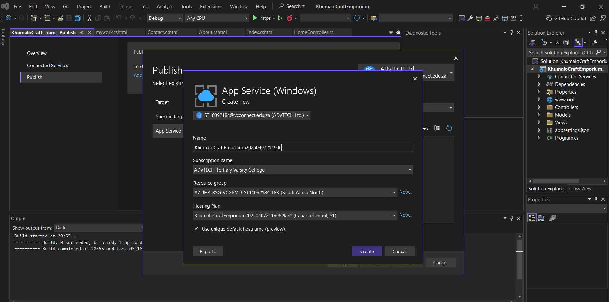

C.

Process of deploying web applications on app service

Github link :

<https://github.com/IIEWFL/cldv6211-part-1-PrincessNgoetjana.git>

**Reference**

GeeksforGeeks (2022). *Advantages of Cloud Computing*. [online] GeeksforGeeks. Available at: <https://www.geeksforgeeks.org/advantages-of-cloud-computing/>.

GeeksforGeeks. (2024). *What is Cloud Scalability?* [online] Available at: <https://www.geeksforgeeks.org/cloud-scalability/>.

Blog, M.A. (2020). *Building a cloud that is accessible to all*. [online] Microsoft Accessibility Blog. Available at: <https://blogs.microsoft.com/accessibility/buildfor2030/>.

TheKnowledgeAcademy (2023). *List of Top Azure Services: Detailed Explanation*. [online] Theknowledgeacademy.com. Available at: <https://www.theknowledgeacademy.com/blog/microsoft-azure-services/>.

Susnjara, S. and Smalley, I. (2024). *Cloud Computing*. [online] Ibm.com. Available at: <https://www.ibm.com/think/topics/cloud-computing>.

‌

‌

**‌**

**‌**

**‌**