CLDV6211

Mr. Leshaba,Isaac

PART 1

ST10259834

Aaryan Makan

Contents

GitHub Repo Link: 3

Web App Link: 3

Screenshots: 4

Theory/ Cloud Computing Basics: 5

References: 8

# GitHub Repo Link:

https://github.com/IIEWFL/cldv6211-part-1-ST10259834-Aaryan-Makan

# Web App Link:

st10259834.azurewebsites.net

# Screenshots:

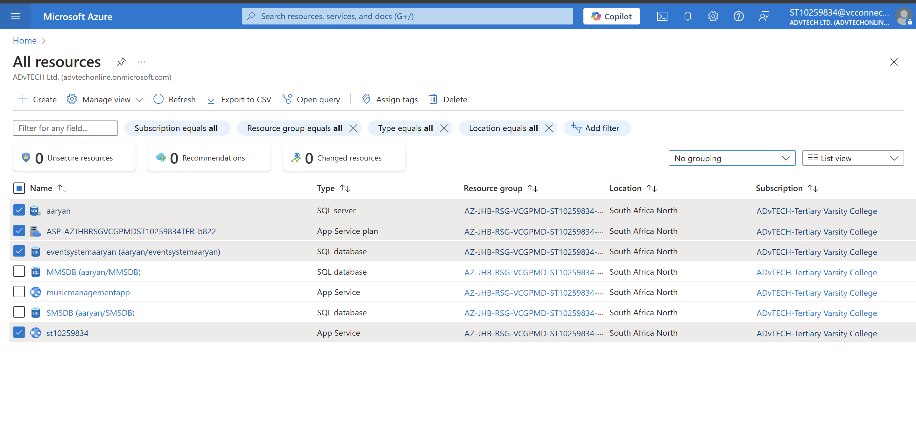

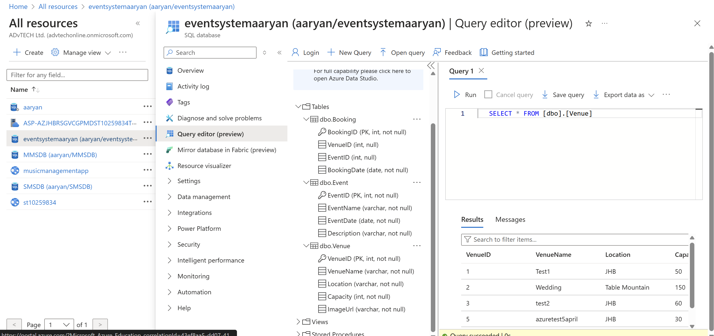

# Theory/ Cloud Computing Basics:

**1. In what ways does deploying an application in the cloud differ from deploying it on-premises, particularly regarding security, deployment speed, and resource management?**

**Use examples to illustrate your points.**

When it comes to **security**, hosting your applications on-premises means your company has full control over everything. You can set up your own security rules and tailor them exactly to meet your needs and industry requirements. The trade-off, though, is that your internal team is responsible for everything—from keeping systems updated to handling threats—which can take up a lot of time and resources. On the flip side, with **cloud-based security**, things are a bit more balanced. The cloud provider handles the physical security and the core infrastructure, while your team focuses on securing your data and applications. It’s a shared responsibility model, and while it can offer powerful built-in security features, it still requires proper configuration on your part to avoid any gaps.

Looking at **deployment speed**, on-premises setups can be pretty slow to get going. You usually have to buy hardware, set it up, configure everything, and then install your software. It could take weeks—or even months—especially if you need to wait on new equipment. Cloud deployments, on the other hand, are way faster. You can launch servers and services in a matter of minutes. This makes it much easier to test, build, and roll out updates quickly, which is great if you need to move fast or react to changes in the market.

Then there’s **resource management**. With on-premises infrastructure, you have to plan carefully to make sure you have enough capacity for your needs now and in the future. Scaling up can get expensive since it usually means buying new equipment—and if demand drops, you’re stuck with underused hardware. In the cloud, you get way more flexibility. You can scale resources up or down based on what you actually need, which helps keep costs under control. You only pay for what you use, and you’re not tied to physical hardware.

A good example of this is a retail company preparing for the holiday rush. If they use on-premises infrastructure, they’d need to invest heavily in extra servers to handle the surge in traffic—which takes time and money. And once the season’s over, those extra servers might not be needed, meaning wasted resources. But if they’re using the cloud, they can simply scale up for the busy period and scale down when things quiet down, keeping things efficient and cost-effective.

**2. What are the key differences between Infrastructure as a Service (IaaS), Platform as a Service (PaaS), and Software as a Service (SaaS), and why might EventEase benefit from the use of PaaS over the other two when building a new application? Use examples to support your answer.**

When it comes to cloud computing, there are three main service models that businesses can choose from—Infrastructure as a Service (IaaS), Platform as a Service (PaaS), and Software as a Service (SaaS). **IaaS** is essentially the most flexible option, where businesses rent virtualized computing resources like servers, storage, and networking on a pay-as-you-go basis. With this model, the cloud provider takes care of the physical infrastructure, but it’s up to the organization to install and manage the operating systems, apps, and data. A great example of IaaS is Amazon Web Services (AWS) EC2, which offers scalable virtual servers so companies can run their applications without having to buy or maintain physical hardware.

**PaaS**, on the other hand, is a bit more hands-off when it comes to infrastructure management. It gives developers a ready-made environment with tools and services like databases, frameworks, and hosting capabilities, so they can focus solely on building and running applications. The cloud provider handles everything behind the scenes—servers, OS, and middleware—making it easier and faster for development teams to get their apps up and running. A good example of this is Google App Engine, which allows developers to deploy apps using pre-built services and APIs without worrying about what’s happening under the hood.

Finally, **SaaS** is the most user-friendly model. It delivers fully functional software applications over the internet, usually on a subscription basis. There’s no need for users to install anything—just log in through a browser and start working. Everything, from infrastructure to data, is managed by the service provider. Think of Microsoft Office 365, which lets people access apps like Word and Excel from any device, anywhere, as long as there’s an internet connection.

**Why PaaS Might Benefit EventEase:**

For a company like EventEase that’s planning to build a new application, using Platform as a Service (PaaS) could be a smart move. One of the biggest advantages is development efficiency—PaaS offers a wide range of development tools, frameworks, and pre-built components that help speed up the process. This means the developers at EventEase can spend less time worrying about infrastructure and more time focusing on building the actual features users will interact with. PaaS is also highly scalable, automatically adjusting resources to handle changes in user demand, which is especially useful if the app gains popularity quickly. On top of that, it can be more cost-effective, since there's less infrastructure to manage and maintain, reducing operational overhead and helping the company bring their app to market faster. Plus, if the EventEase team is spread across different locations, PaaS platforms often come with built-in collaboration tools that make it easier for everyone to stay on the same page and work together efficiently.

# 

# References:

Cho, J. (2023). *Cloud Computing: Comparing IaaS, PaaS, and SaaS - Jun Cho - Medium*. [online] Medium. Available at: https://zoveloper.medium.com/cloud-computing-comparing-iaas-paas-and-saas-ca05a0b06e14 [Accessed 6 Apr. 2025].

PayPro Global. (2025). *What is a Cloud Service Model? Exploring SaaS, PaaS & IaaS*. [online] Available at: https://payproglobal.com/answers/what-is-cloud-service-model/ [Accessed 6 Apr. 2025].

Miller, T. (2024). *SaaS, PaaS, and IaaS: Differences and Use Cases Explained*. [online] Emergent Software. Available at: https://www.emergentsoftware.net/blog/saas-paas-and-iaas-differences-and-use-cases-explained [Accessed 6 Apr. 2025].

Davis, N. (2024). *Cloud Deployment Models explained by Neal Davis | Medium*. [online] Medium. Available at: https://neal-davis.medium.com/cloud-deployment-models-explained-public-private-hybrid-and-multicloud-67a3e938df99.

Intel (n.d.). *An Overview of Cloud Deployment Models*. [online] Intel. Available at: https://www.intel.com/content/www/us/en/cloud-computing/deployment-models.html.