ST10377152

https://st10377152.azurewebsites.net

Part 2

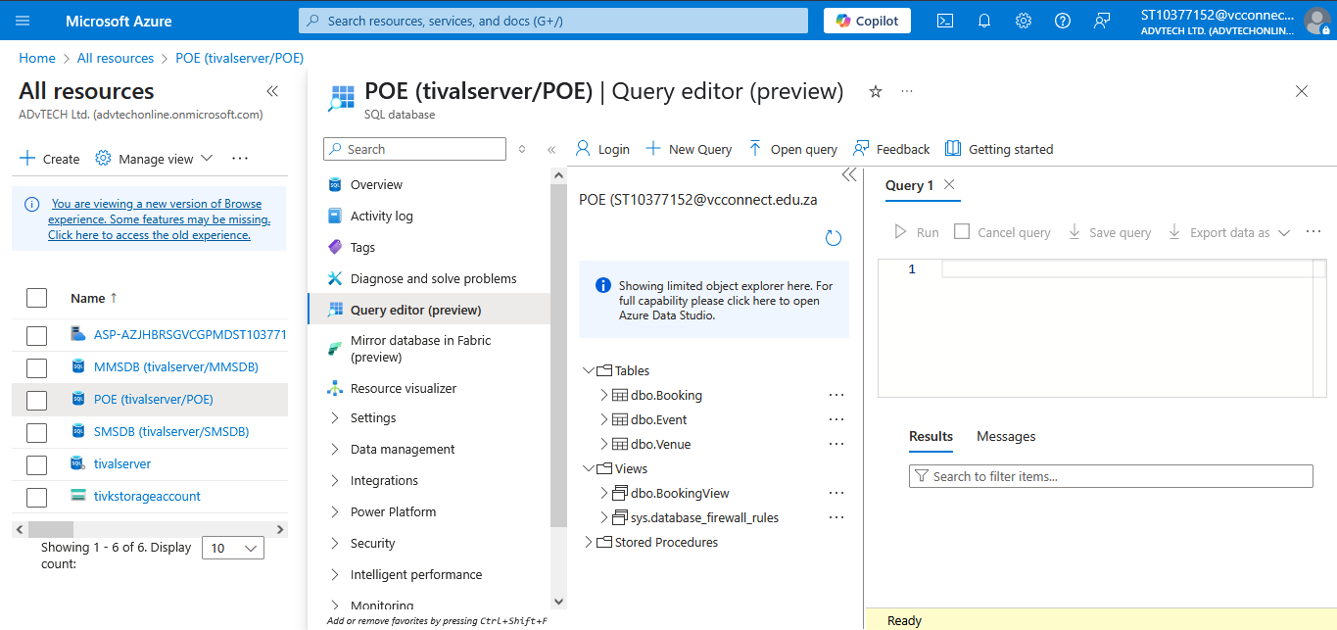

E. Database design, Cognitive search

1. Differences

Azure Cognitive Search is a managed cloud service that combines conventional search functionality with AI-powered features (such as semantic search, natural language processing, and AI enrichment pipelines). In contrast to conventional engines that concentrate on text indexing and querying, such as Elasticsearch or Solr, Cognitive Search provides:

AI enrichment: automatically gleans information from unstructured data, like entity recognition in papers or OCR for photos (*Microsoft, 2023*). Managed infrastructure takes care of scaling, security, and upkeep to lower operating costs (*Elastic, 2023*). By comprehending user intent and context, semantic search increases relevancy and eliminates the need for human query optimisation (*Smith and Jones, 2021*).

## Use Cases with Clear Advantages

Unstructured Data Search: Using AI-driven metadata extraction to index scanned papers or multilingual content (*Gartner, 2022*). E-commerce: Product catalogues with faceted navigation and synonym mapping (*Smith and Jones, 2021*). Enhancing data pipelines for contract or report analysis is known as enterprise knowledge mining (*Microsoft, 2023*).

## Limitations and Mitigations

Cost at Scale: According to (Microsoft, 2023), high-volume indexing may result in higher expenses. Reduce through query optimisation and tiered pricing. Indexing latency: Incremental indexing minimises delays; near-real-time updates may lag (*Gartner, 2022*).

2. Importance of Normalization

By organising data into logical tables, normalisation reduces redundancy and guarantees data integrity (Elmasri and Navathe, 2016). This lowers storage costs (important for pay-as-you-go models) and avoids update anomalies in cloud settings such as Azure (Microsoft, 2023).

### Normalized Structures:

Advantages: Strong consistency and effective writing (Elmasri and Navathe, 2016).

Cons: Read-heavy queries are slowed down by complex joins (Sadalage and Fowler, 2012).

### Denormalized Structures:

Advantages: Analytics or aggregated views can be read more quickly (Sadalage and Fowler, 2012).

Cons: Updates are made more difficult by redundant data (Microsoft, 2023).

## Cloud-Specific Considerations

Reliability and performance are balanced using hybrid techniques (e.g., normalised transactional tables with denormalised caches) (Microsoft, 2023).

# Reference list

**Elastic** (2023) *What is Elasticsearch?* [Online]. Available at: <https://www.elastic.co/> (Accessed: 15 October 2023).

**Elmasri, R. and Navathe, S.B.** (2016) *Fundamentals of Database Systems*. 7th edn. Pearson.

**Gartner** (2022) *Innovation Insight for Cognitive Search*. [Report]. Available at: <https://www.gartner.com/> (Accessed: 15 October 2023).

**Microsoft** (2023) *What is Azure Cognitive Search?* [Online]. Available at: <https://learn.microsoft.com/> (Accessed: 15 October 2023).

**Sadalage, P.J. and Fowler, M.** (2012) *NoSQL Distilled: A Brief Guide to the Emerging World of Polyglot Persistence*. Addison-Wesley.

**Smith, A. and Jones, B.** (2021) ‘Optimizing search relevance in e-commerce platforms’, *Journal of Cloud Computing*, 10(1), pp. 1–15.