CDVL6211

PoE Part 2

Nikki Gordhan

ST10108243

Query 5

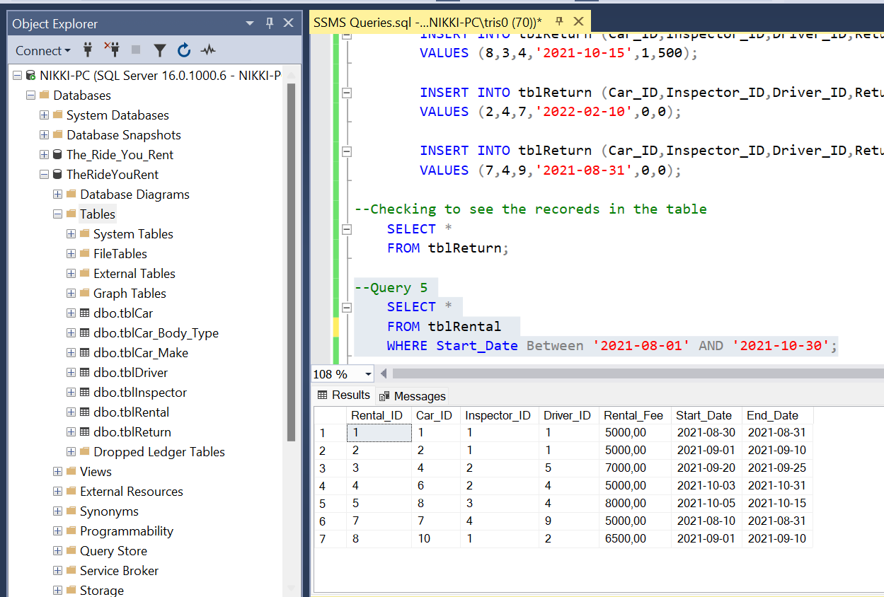

Query 6

Query 7

Query 8

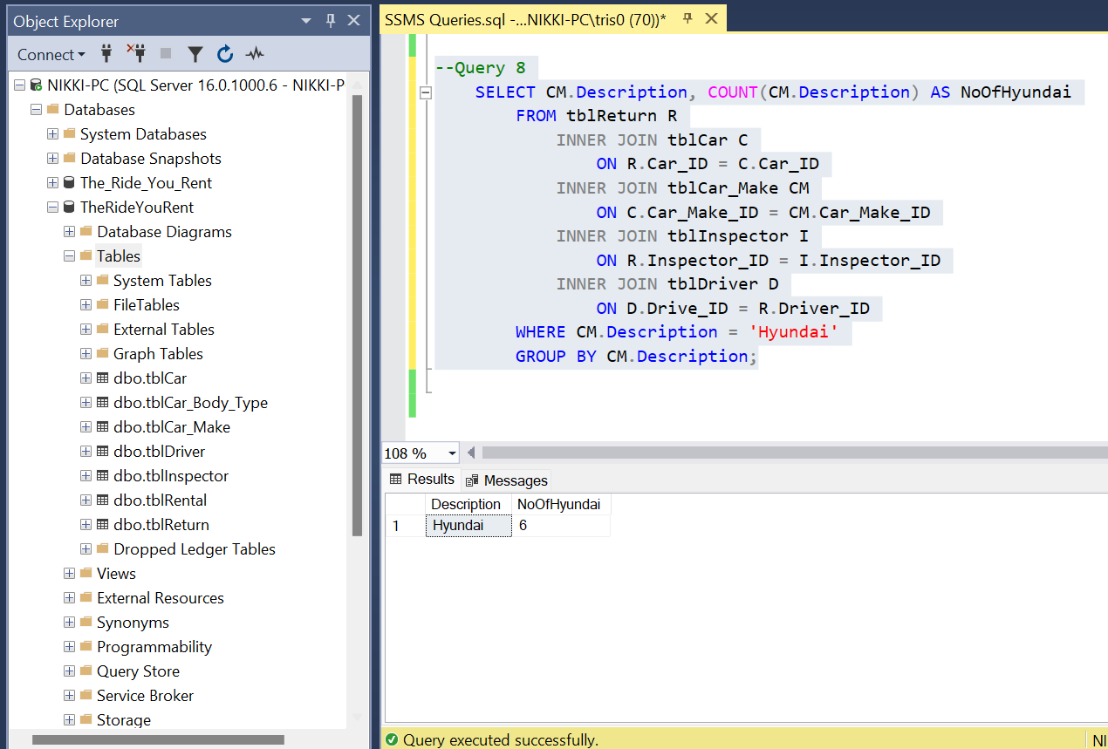

Query 9

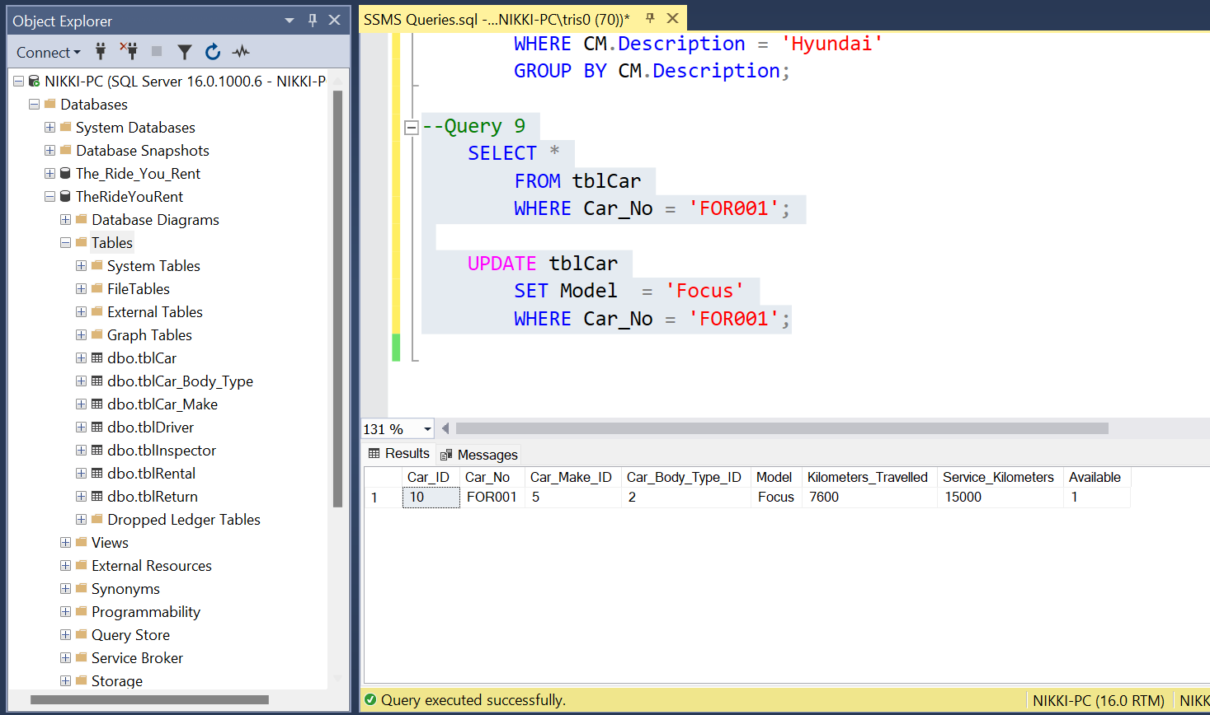

Query 10

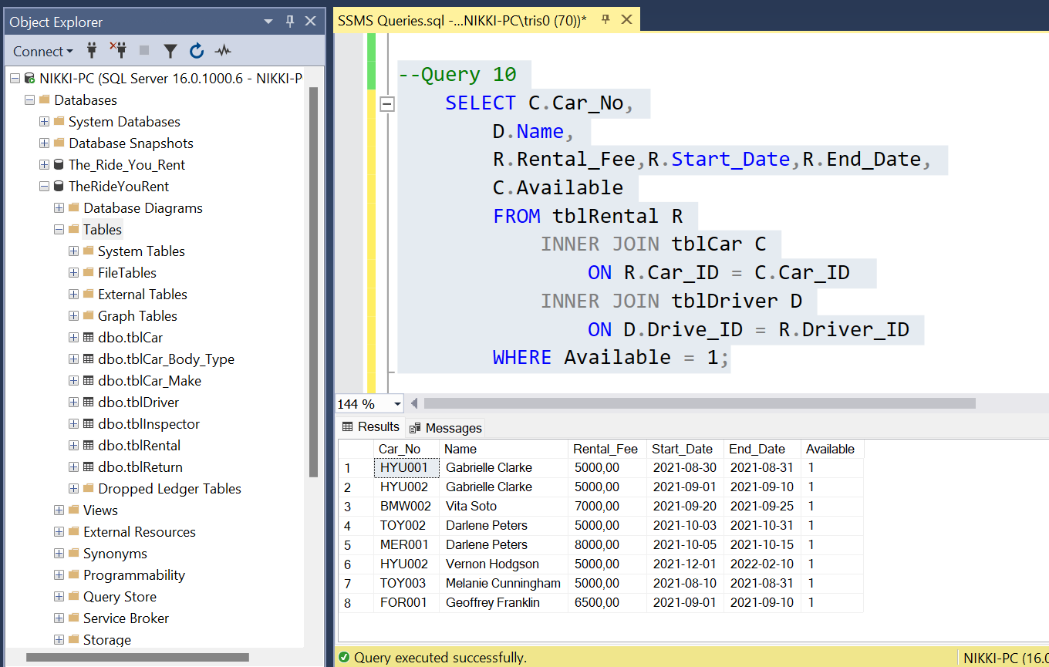

Query 11

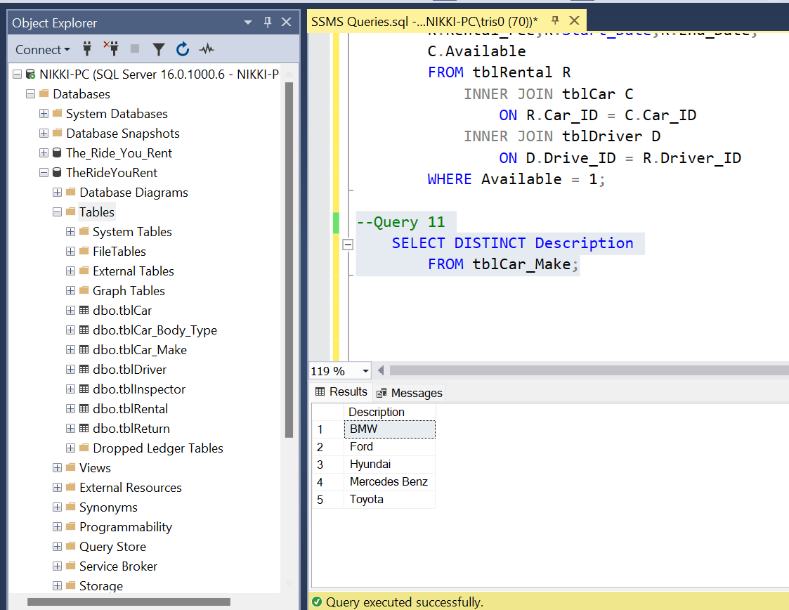

Query 12

Query 13

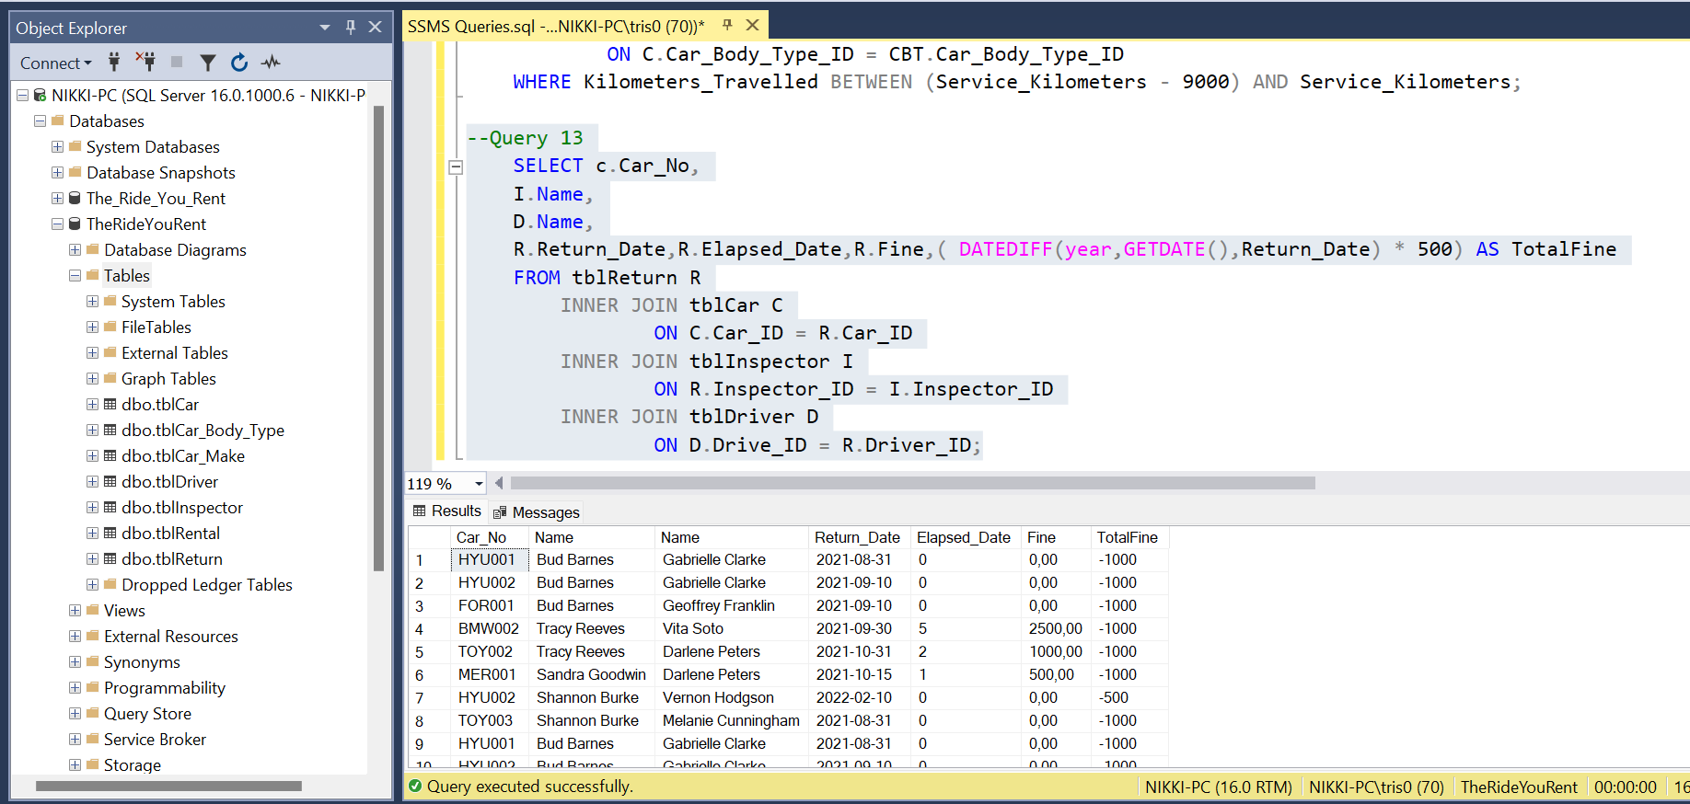

A screenshot of the connection to my Azure SQL Server Database in my Azure portal.

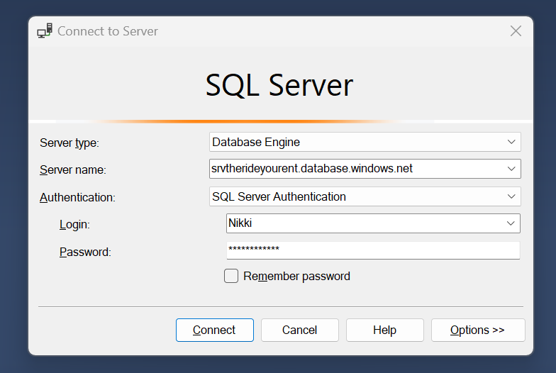

At least one table result called back as a query.

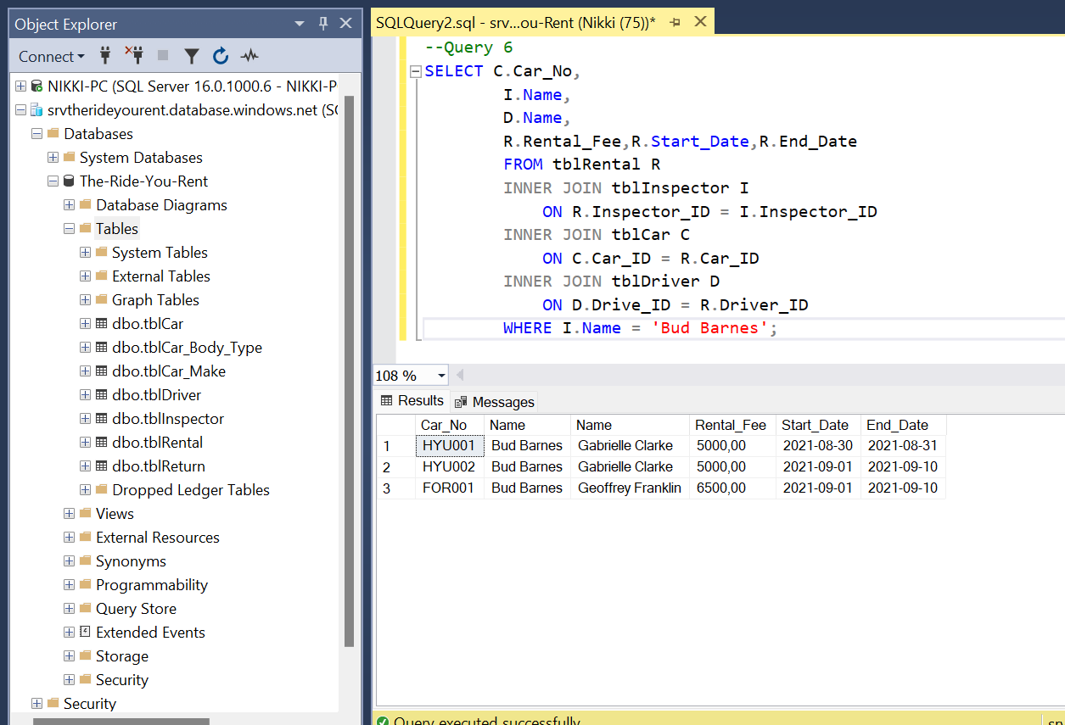

A screenshot from the Azure Query Editor to demonstrate that data shows up in the query editor on Microsoft Azure with a query being run.

