**Name: Noluthando Mohoni**

**Student Number: ST10246312**

**PATHWAY: CLDV6211**

**Lecture: Isaac Leshaba**

**Date: 04 May 2023**

**POE: PART 2**

Table of Contents

QUERY SCREENSHOT RESULTS 3

Q5: 3

Q6: 4

Q7: 4

Q8: 5

Q9: 5

Q10: 6

Q11: 6

Q12: 7

Q13: 8

Connection to MS Azure from ssms with call back query 8

Result for kilometres travelled is 9000 kilometres shown in query editor 9

# QUERY SCREENSHOT RESULTS

## Q5:

Write a query that will return all the rentals placed between the following dates “2021-08- 01” AND “2021-10-30”.

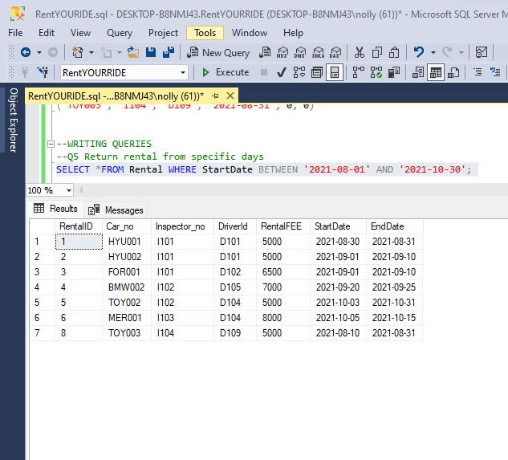

## Q6:

Write a query that selects all the rentals placed by Bud Barnes.

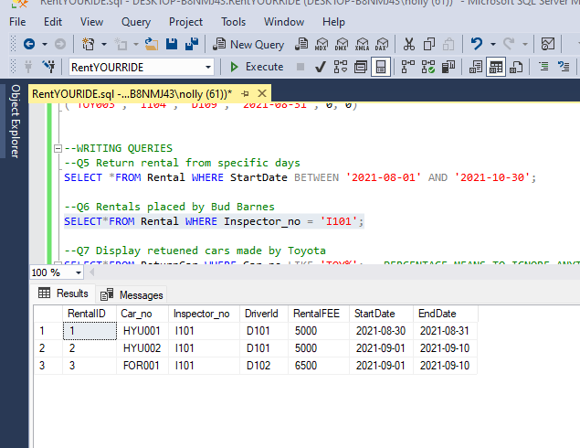

## Q7:

Write a query that displays all the returns for the car make Toyota.

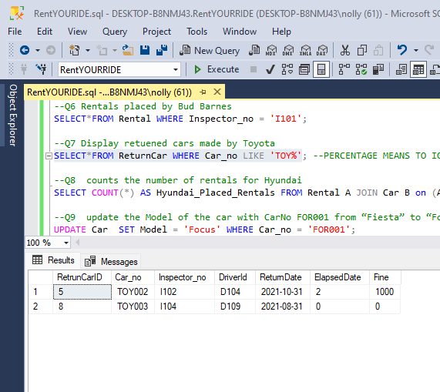

## Q8:

Write a query that counts the number of rentals that were placed for the car make Hyundai.

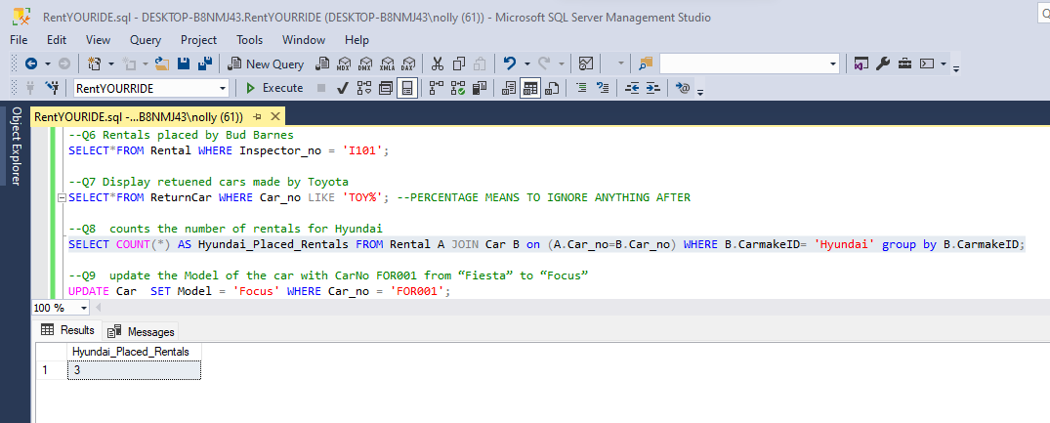

## Q9:

Write a query to update the Model of the car with the CarNo FOR001 from “Fiesta” to “Focus”.

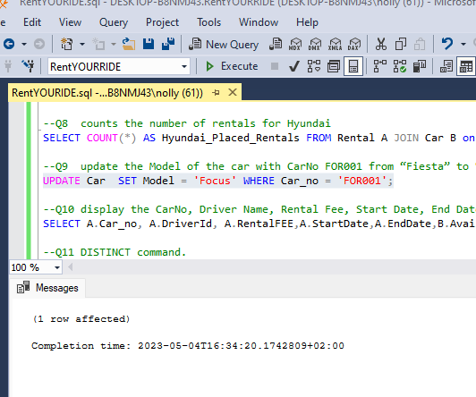

## Q10:

Write a query that will display the CarNo, Driver Name, Rental Fee, Start Date, End Date and Availability of all available rentals.

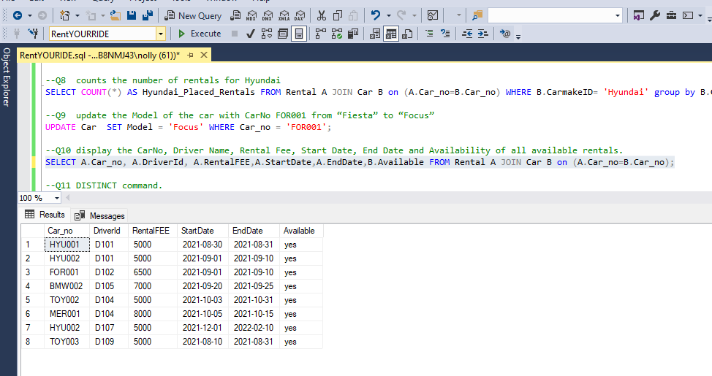

## Q11:

Write a query that will show a list of the available car makes in the database use the DISTINCT command.



## Q12:

Write a query that will determine the cars which will need service soon. If a car’s kilometres travelled is 9000 kilometres away from the service kilometres that would indicate that the car would need to get a service soon.

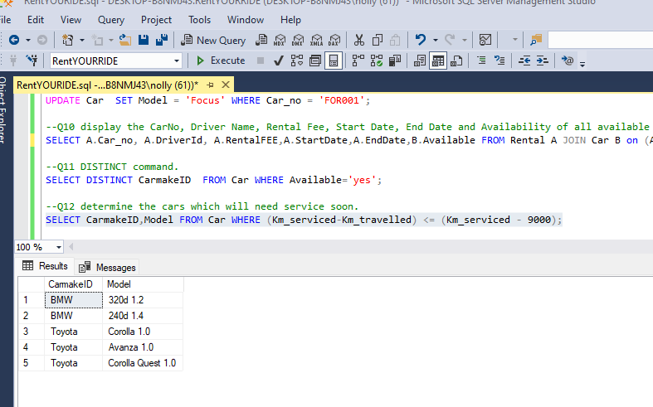

## Q13:

Write a query that will calculate the late fee for a return (a R500 a day fine is placed on rentals returned passed the elapsed return date. The query should use the return date and the current/Today’s date to calculate the elapsed number of days and multiply those days by the R500 fine to get the total fine).

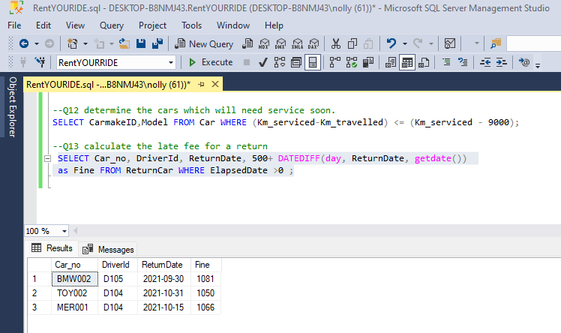

## Connection to MS Azure from ssms with call back query

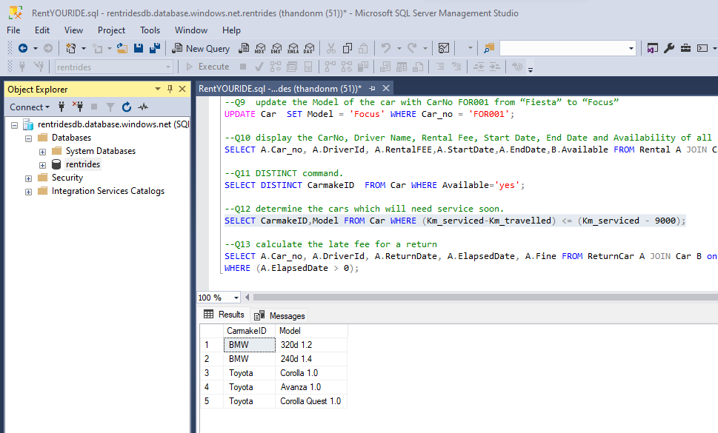

## Result for kilometres travelled is 9000 kilometres shown in query editor

