Cloud Development A

POE Part 3

ST10379182  
  
A. How-To-Guide for implementing a cognitive search engine (Azure AI Search)   
  
  
Table of Contents

1. Introduction   
  
2. Requirements

3. Configuring Cognitive Search in Azure

4. Bringing in Data Sources and Using Full-Text Search

5. Improving Search Using Cognitive Capabilities

6. Connecting Your Web Application with Azure Cognitive Search

7. Conclusion

8. References

* 1. Introduction:  
       
     Developers can include Azure Cognitive Search into their web applications in a step-by-step manner by following this guidance. Using cognitive skills to improve search capability, creating full-text search for particular items, and importing an existing data source are all covered in this document.

2. Requirements:  
  
An active Azure subscription

Access to Azure Portal

Basic knowledge of Azure services and web development

Existing web application developed in Part 2 of the project

3. Configuring Cognitive Search in Azure:

3.1 Creating an Azure Cognitive Search Service:

1. Open the Azure Portal and log in.

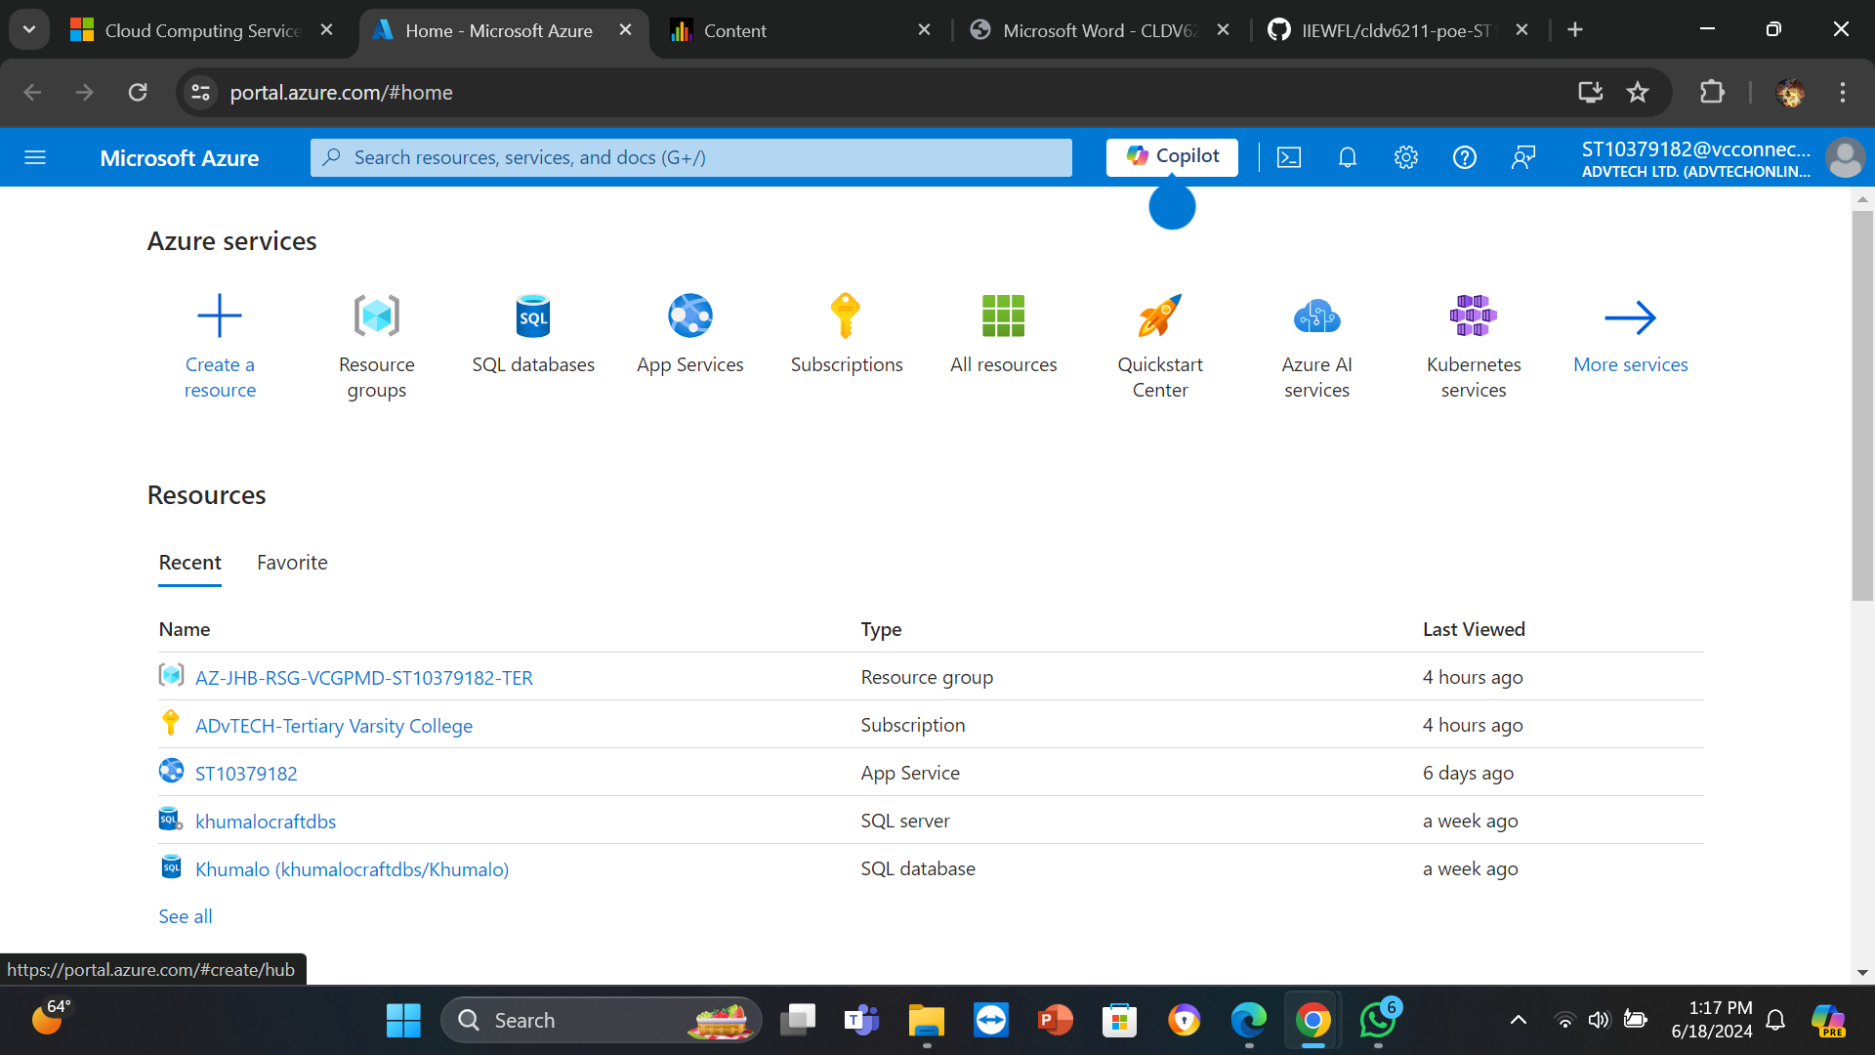

2. From the menu on the left, choose "Create a resource."

3. Type Azure Cognitive Search into the Search the Marketplace box, then click to pick it.

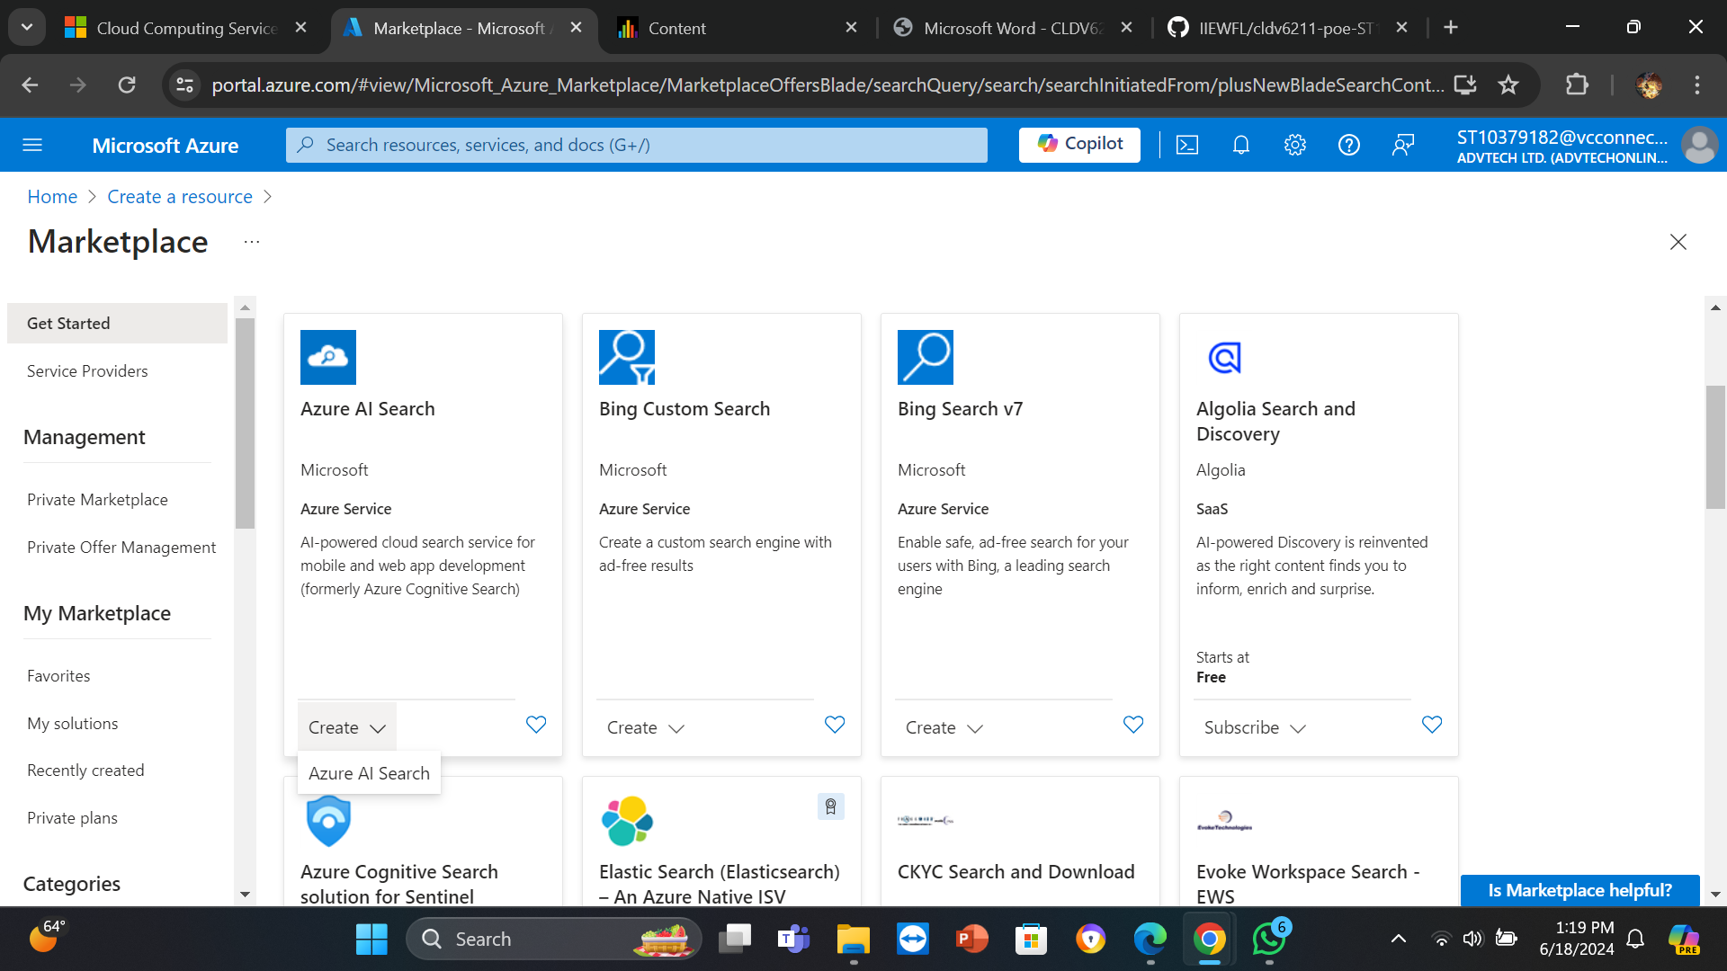

4. Click the "Create" button.

5. Complete the required fields:

a. Resource Name: Give your search engine a distinctive moniker.

b. Resource Group: Either form a new resource group or choose an already-existing one.

c. Location: Pick an area that is close to the source of your data.

d. Price Tier: Choose a price tier in accordance with your needs.

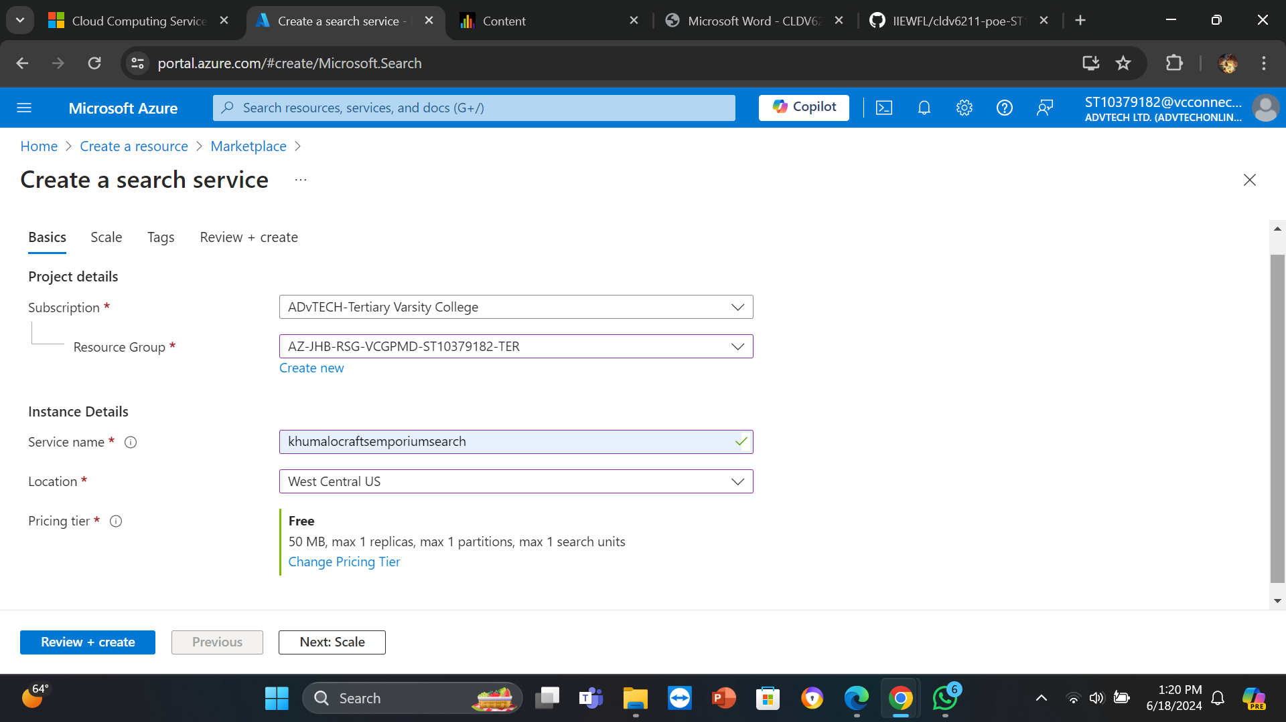

6. Select Review + Create, followed by Create.  
  
  
3.2 Importing Data Source:  
  
1. Go to the Cognitive Search service you just built.

2. Then choose Import data from the option on the left.

3. Select the source of your data. Data can be imported from a number of sources, including Azure Blob Storage, Azure Cosmos DB, and Azure SQL Database.

4. Set up your data source connection parameters:

a. Name of the data source: Give your data source a name.

b. Type of data source: Decide which kind of data source to use.

c. Connection string: Input the data source's connection string here.

5. Select Next: Include mental abilities.

4. Bringing in Data Sources and Using Full-Text Search:

4.1 Creating Indexes:  
  
1. Navigate to the Add cognitive skills section in the Import data wizard.

2. For now, ignore this and select Next: Make an index.

3. Give your index a name and some fields (such ProductID, ProductName, and Description) to define it.

4. Enter the Key field, which serves as your papers' unique identifier.

5. Select Next: Make an indexer.

4.2 Querying the Index:  
  
1. Go to Indexes in your search service and choose the index you made.

2. You can query your index via the REST API endpoint, which is shown on the Index page.

3. Utilize your web application's SDKs (such as.NET, Python, or JavaScript) or the Search REST API to query the index.

5. Improving Search Using Cognitive Capabilities:  
  
5.1 Adding Cognitive Skills:  
  
1. Select Skillsets from your Cognitive Search service.

2. To add a skillset, click +.

3. Include pre-established cognitive capabilities or develop your own:

a. OCR: Text extraction from pictures.

b. Text entity identification is known as entity recognition.

c. Text sentiment is examined via sentiment analysis.

5.2 Configuring Skillsets:  
  
1. Define the input and output fields for each skill.

2. Save the skillset and attach it to your indexer.

6. Connecting Your Web Application with Azure Cognitive Search:  
  
1. To integrate your web application with the Cognitive Search service, use the REST API or Azure Search SDK.

2. Incorporate search capabilities into your application by presenting results and running queries on the index.

3. By incorporating cognitive skills, you may improve the search experience by offering rich search options like faceted navigation, autocomplete, and suggestions.

7. Conclusion:  
  
Through the use of this tutorial, developers can successfully include cognitive skills and advanced search capabilities into their online apps, hence improving user experience. Using the thorough methods in this tutorial, you can ensure that your application offers strong search functionality and an improved user experience by implementing Azure Cognitive Search.  
  
  
8. References:  
  
1. Learn.microsoft.com, Import data wizard in Azure AI Search [Online] (16 November 2023)

Available at: [Import data into a search index using Azure portal - Azure AI Search | Microsoft Learn](https://learn.microsoft.com/en-us/azure/search/search-import-data-portal)

[Accessed on 18 June 2024]

2. docs.informatica.com, Reference 360, n.d. [Online]

Available at: [Using REST APIs to import and export (informatica.com)](https://docs.informatica.com/master-data-management-cloud/reference-360/current-version/reference-360/reference-360-rest-api/using-rest-apis-to-import-and-export.html)

[Accessed on 18 June 2024]

3. boltic.io, Importing REST API into SQL Server: A Comprehensive Guide, n.d. [Online]

Available at: [Importing REST API into SQL Server: A Comprehensi (boltic.io)](https://www.boltic.io/blog/importing-rest-api-into-sql-server)

[Accessed on 18 June 2024]

4. learn.microsoft.com, JavaScript resource management modules for Azure Search, 11 June 2024 [Online]

Available at: <https://learn.microsoft.com/en-us/javascript/api/overview/azure/search?view=azure-node-latest>

[Accessed on 18 June 2024]

5. learn.microsoft.com, REST Tutorial: Use skillsets to generate searchable content in Azure AI Search, 8 March 2024 [Online]

Available at: <https://learn.microsoft.com/en-us/azure/search/cognitive-search-tutorial-blob>

[Accessed on 18 June 2024]

6. learn.microsoft.com, What’s Azure AI Search? 21 May 2024 [Online]

Available at: <https://learn.microsoft.com/en-us/azure/search/search-what-is-azure-search>

[Accessed on 18 June 2024]

7. learn.microsoft.com, Create an Azure AI Search service in the portal, 24 May 2024 [Online]

Available at: <https://learn.microsoft.com/en-us/azure/search/search-create-service-portal>

[Accessed on 18 June 2024]