

Table of Contents

1. **Introduction…………………………………………………………………………………………………3**
2. **Prerequisites……………………………………………………………………………………………….3**
3. **How to import existing data to integrate to your search engine…………………………...3**
   1. Creating the Azure Cognitive Search resource in Azure………………………………………3
   2. Adding the data source………………………………………………………………………………….4
   3. Creating the index………………………………………………………………………………………..4
   4. Creating the indexer……………………………………………………………………………………..5
4. **How to implement full-text search to search for specific products……………………..5**
5. **How to ensure that your Azure Cognitive Search makes use of cognitive skills……..6**
   1. Create a skillset……………………………………………………………………………………………6
   2. Link skillset to the indexer……………………………………………………………………………..6
   3. Enrich specific index fields…………………………………………………………………………….6
6. **Conclusion………………………………………………………………………………………………….8**
7. **Bibliography…………………………………………………………………………………………………9**
8. **Screenshots……………………………………………………………………………………………….10**
9. **Function app link………………………………………………………………………………………..14**
10. **GitHub link…………………………………………………………………………………………………14**

**A How-To-Guide on how to implement a Cognitive Search Engine (Azure AI Search)**

**Introduction**

In this how-to-guide, you will be shown how to integrate Azure Cognitive Search into your web application. We will go over all the prerequisites required to integrate Azure Cognitive Search, how to import your existing data source to integrate into your search engine, how to implement a full-text search to search for a specific product, and how to ensure that your Azure Cognitive Search makes use of Cognitive skills to enhance your search functionality.

**Prerequisites**

Before we begin, ensure that you have:

* An Azure account with a valid subscription.
* A pre-existing data source populated with data.
* Microsoft visual studio.

**How to import existing data to integrate into your search engine**

Creating the Azure Cognitive Search resource in Azure. (Arinti, 2021)

* Log in to the [Azure portal](https://portal.azure.com/).
* Click “Create a resource” and search for “Azure Cognitive Search”
* Click “Create” and select your:
* Azure subscription
* Resource group
* Service name
* Location
* Pricing plan
* Click “Review + create” and confirm your settings
* Click “Create”

**Adding a data source**

(Arinti, 2021)

* In the overview section, select “Import Data”
* Select your data source from the list of available data sources
* Name your data source
* Add your connection string
* Select “Choose an existing connection” and locate the data source which you will be implementing. (This should already be created)
* Select your identity authentication under “Managed identity authentication”
* Enter your user id and password to your data source to which the connection string belongs to
* Click “Test Connection” to ensure that the system can connect to your data source
* Once the Connection has been validated, you will be able to view all your data within the data source
* Click “Customize target index” to configure the index

**Creating the Index (Arinti, 2021)**

* By default, the Index name should be auto generated so you can leave it as that or rename it to better suit your project
* Ensure that your index has a key
* In the fields table, you will see all the data being pulled from your selected data source, here you will be able to select which fields can be searched for and retrieved by the user.
* Select which fields you would like to be retrievable, filterable, sortable, facetable, or searchable.
* Click “Create an Indexer” to configure the Indexer

**Creating the Indexer**

* Name your Indexer under “Name”
* Select your schedule, you can choose from either Once, Hourly, Daily, or Custom
* Once you’ve configured everything, you can click “Submit” to create your data source, index, and indexer

**How to implement full-text search to search for specific products**

Here, you will be shown how to implement a full-text search to search for specific products within your web application.(BevLoh, nd), (Heidisteen, 2024)

* In your Azure Cognitive Search resource, click “Overview”
* Click on “Search explorer”
* Ensure that you have the correct index loaded under “Index”
* Under view, select “JSON” in the drop-down menu
* By default, you should be seeing this: 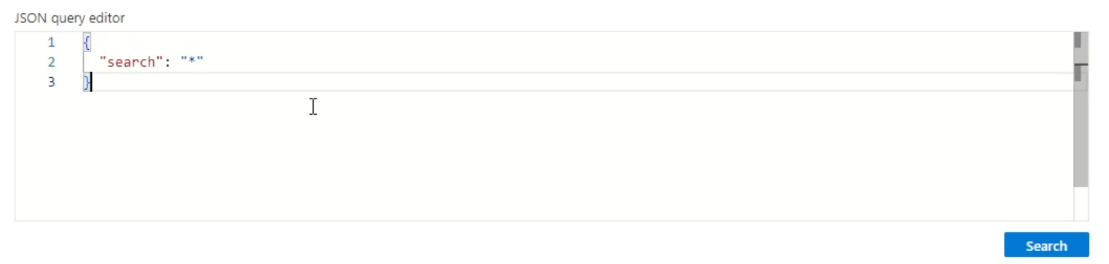

This indicates that the search will return all the data in the data source, we only want to return specific products. To do this, we need to edit the code.

* In the query editor, type the following code to search for a specific product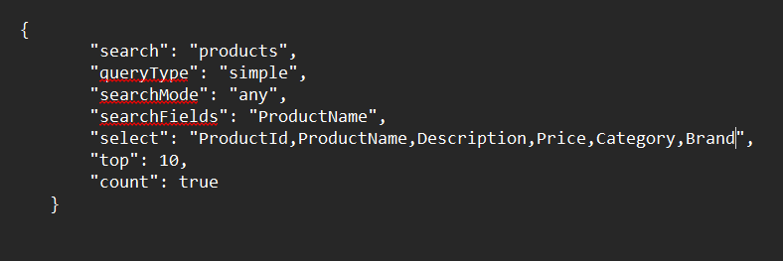

(Code adapted from example code ‘Full-text query how-to - azure ai search’, Heidisteen, 2024)

In this code:

“search” will search for the term “products”

“queryType” makes use of a simple query for the search function

“searchMode” “any” will return any item that matches the search

“searchFields” specifies what field index to be searched

“select” will select the fields that will be returned

“top” will only display the top 10 results

“count” will include the total number of matches found

* By following these steps, you will be able to search for a specific product in the web application

**How to ensure that your Azure cognitive search makes use of cognitive skills**

(HeidiSteen, 2024), (Swaminathan, 2019)

**Create a Skillset**

* On the left-hand menu, click on “Skillsets”
* Click “Add Skillset”
* Name your skillset and define the skills you require
* Click on “OK” to create the skillset

**Link the skillset to the indexer**

* Click on “Indexers” on the left-hand side menu and select the indexer you created earlier
* Edit the indexer and add your skill newly created skillset under “Skillset”
* Save changes and run the indexer to update it

**Enrich required fields to improve functionality**

* Ensure that all your fields are enriched within your index by clicking the checkbox
* Define the specific skill you want your cognitive search to have. Example: This example is a code snippet which defines the language detection skill to detect the language of the user input. You can copy this code into your JSON editor.

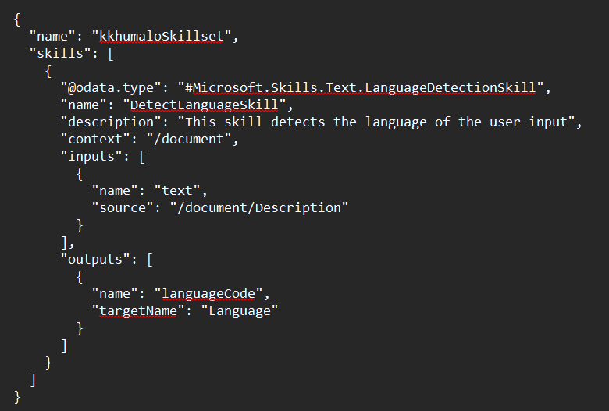

(Code adapted from example code ‘azure ai search skillsets concepts’, Heidisteen, 2024)

In this code, we have:

“name” which is the name of the skillset

“skills” which is the array containing the skills

“odata.type” is the import for detecting languages

“name” is the name of the skill

“description” is a summary of what the skill does

“context” is where the skill will operate

“input” is the inputs for the skill

“output” is the output for the skill

“targetName” is the index field where output is stored

* By following these steps, you will be able to add cognitive skills to your cognitive search

**Conclusion**

By following these steps, you will be able to successfully create your Azure cognitive search resource, implement full-text search to search for specific products, and make use of cognitive skills in your cognitive search. This will provide users with a more user-friendly search experience on your web application

**Bibliography**

Arinti (2021) *How to - push data into an azure cognitive search index without an indexer*, *YouTube*. Available at: <https://www.youtube.com/watch?v=1R4oEiJ60dw> (Accessed: 24 June 2024).

BevLoh (no date) *Search documents - azure ai search*, *Search Documents - Azure AI Search | Microsoft Learn*. Available at: <https://learn.microsoft.com/en-us/rest/api/searchservice/search-documents> (Accessed: 24 June 2024).

HeidiSteen (2024a) *Full-text query how-to - azure ai search*, *Full-text query how-to - Azure AI Search | Microsoft Learn*. Available at: <https://learn.microsoft.com/en-us/azure/search/search-query-create?tabs=portal-text-query> (Accessed: 24 June 2024).

HeidiSteen (2024b) *Introduction to azure ai search - azure ai search*, *Introduction to Azure AI Search - Azure AI Search | Microsoft Learn*. Available at: <https://learn.microsoft.com/en-us/azure/search/search-what-is-azure-search> (Accessed: 24 June 2024).

HeidiSteen (2024c) *Quickstart: Create A search index in the Azure Portal - Azure Ai Search*, *Azure AI Search | Microsoft Learn*. Available at: <https://learn.microsoft.com/en-us/azure/search/search-get-started-portal> (Accessed: 24 June 2024).

HeidiSteen (2024d) *Skillset concepts - azure ai search*, *Skillset concepts - Azure AI Search | Microsoft Learn*. Available at: <https://learn.microsoft.com/en-us/azure/search/cognitive-search-working-with-skillsets> (Accessed: 24 June 2024).

Rajalakshmi SwaminathanRajalakshmi Swaminathan                      1144 bronze badges and Arvind - MSFTArvind - MSFT                      55922 silver badges66 bronze badges (2019) *Using a skillset when adding documents to Azure search index*, *Stack Overflow*. Available at: <https://stackoverflow.com/questions/54529101/using-a-skillset-when-adding-documents-to-azure-search-index> (Accessed: 24 June 2024).

Yahnoosh (2023) *Create a skillset - azure ai search*, *Create a skillset - Azure AI Search | Microsoft Learn*. Available at: <https://learn.microsoft.com/en-us/azure/search/cognitive-search-defining-skillset> (Accessed: 24 June 2024).

Screenshots

publishing functional apps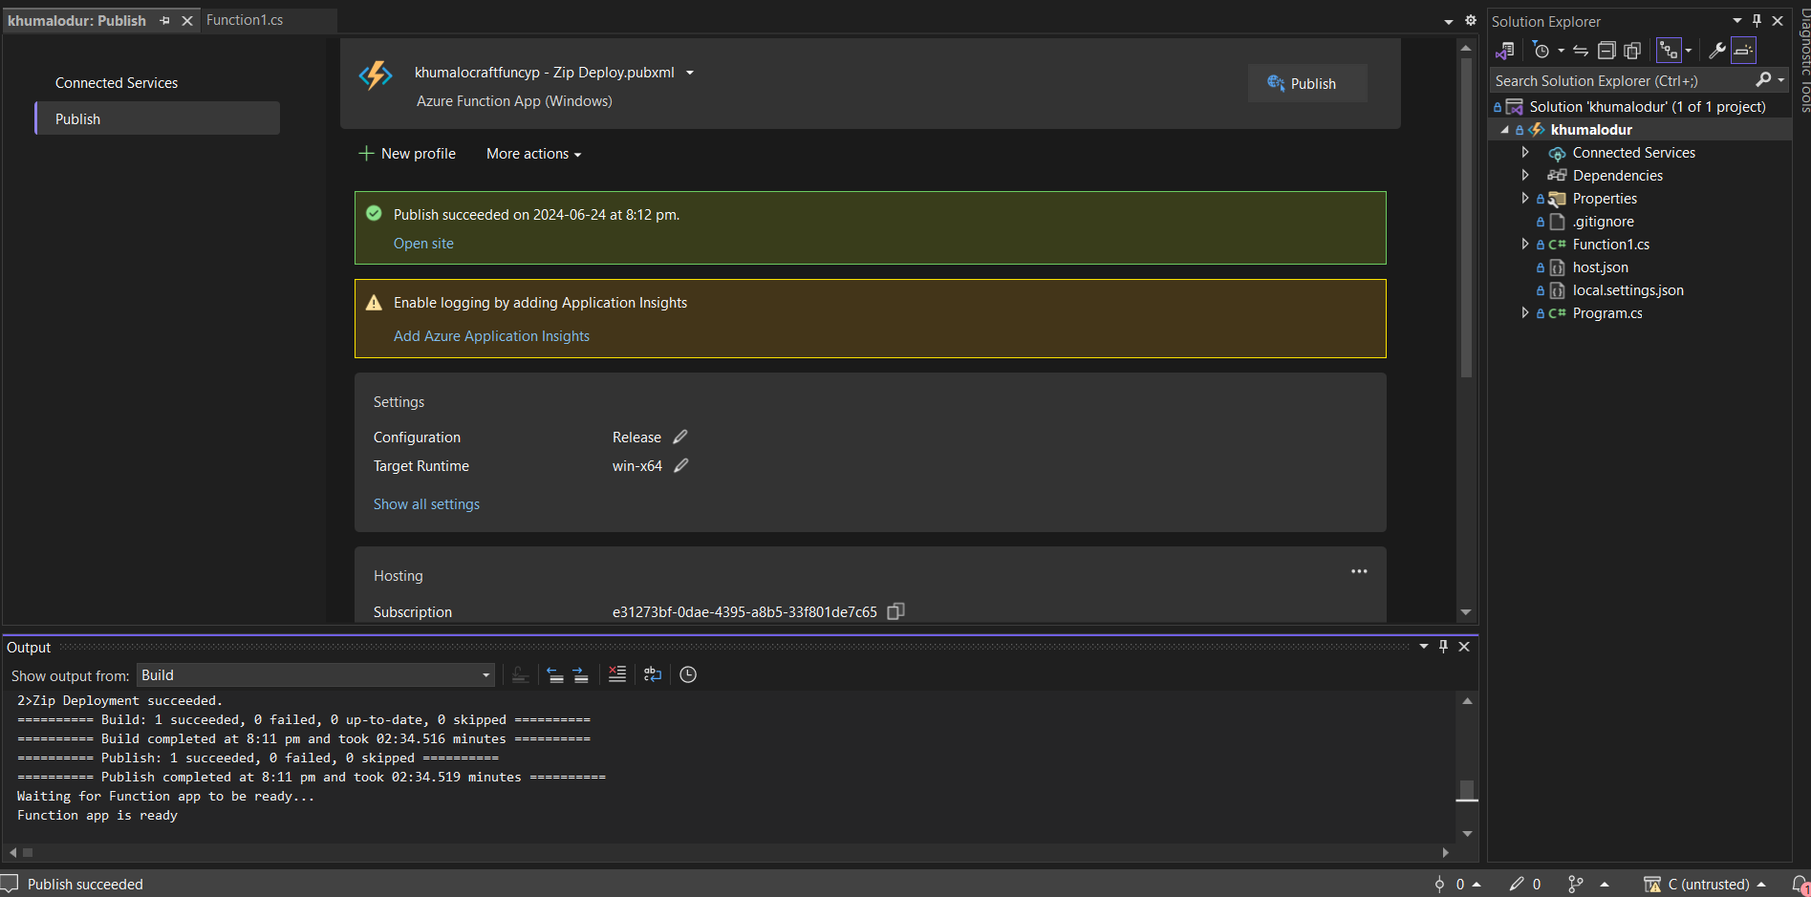publish succeeded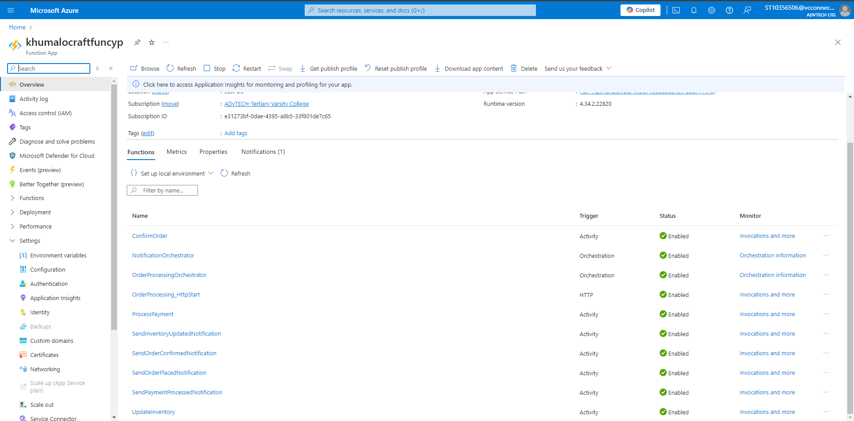functional apps on azure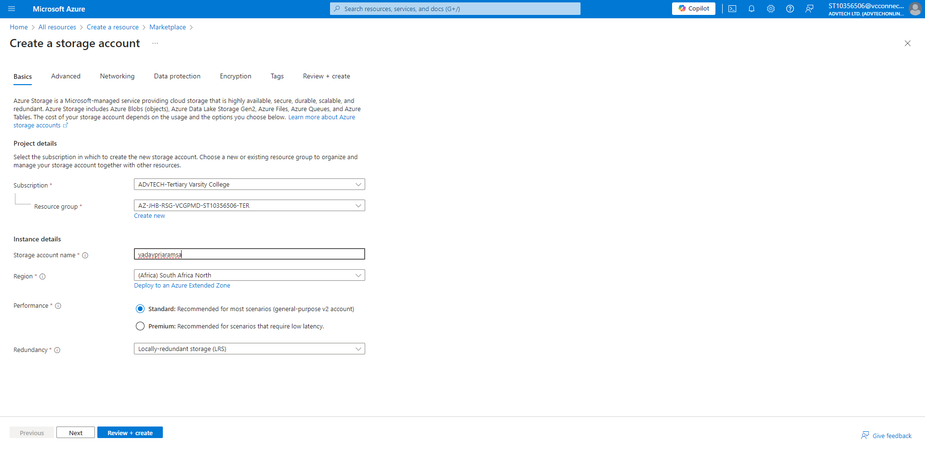deployed storage account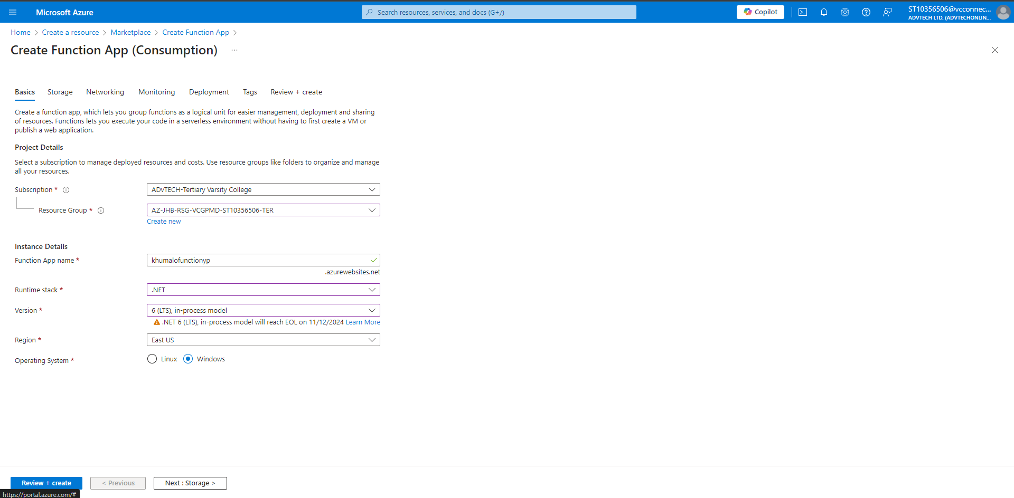create functional app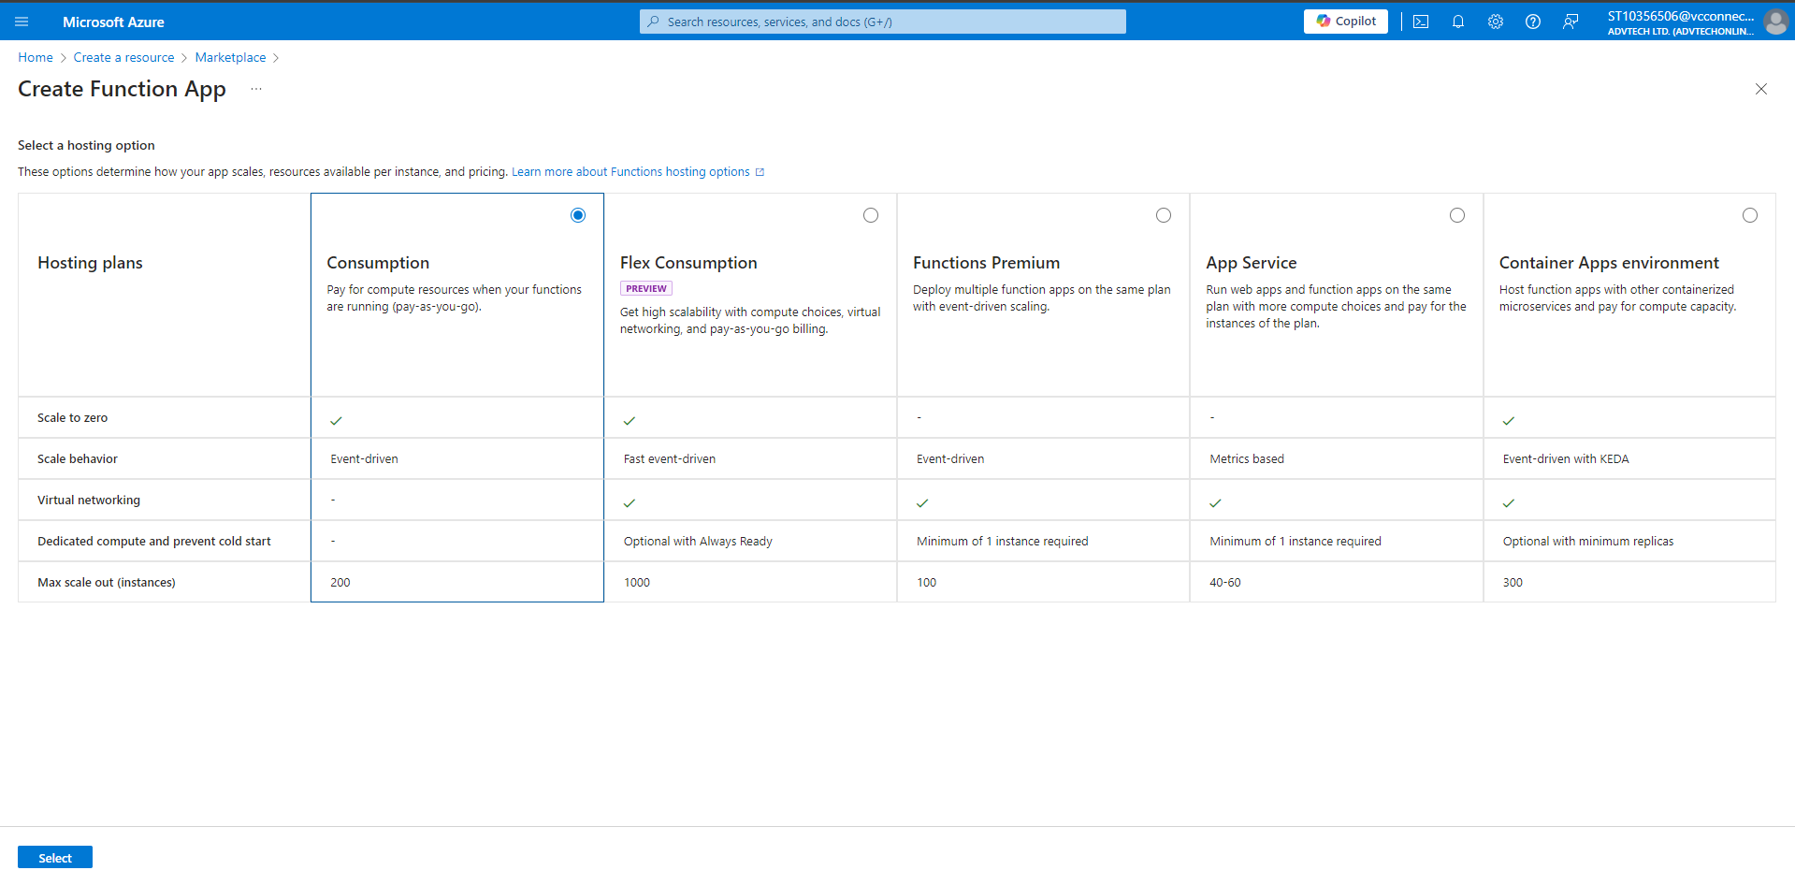

Function app link: <https://khumalocraftfuncyp.azurewebsites.net/>

GitHub link: <https://github.com/IIEWFL/cldv6211-poe-st10356506>