cldv6212-part-1-ST10259834-Aaryan-Makan

**Web App Link:**

https://st10259834abcretail.azurewebsites.net

**GitHub Repo:**

**Proof of publish:**

**Table Storage Screenshots:**

**Blob Storage Screenshots:**

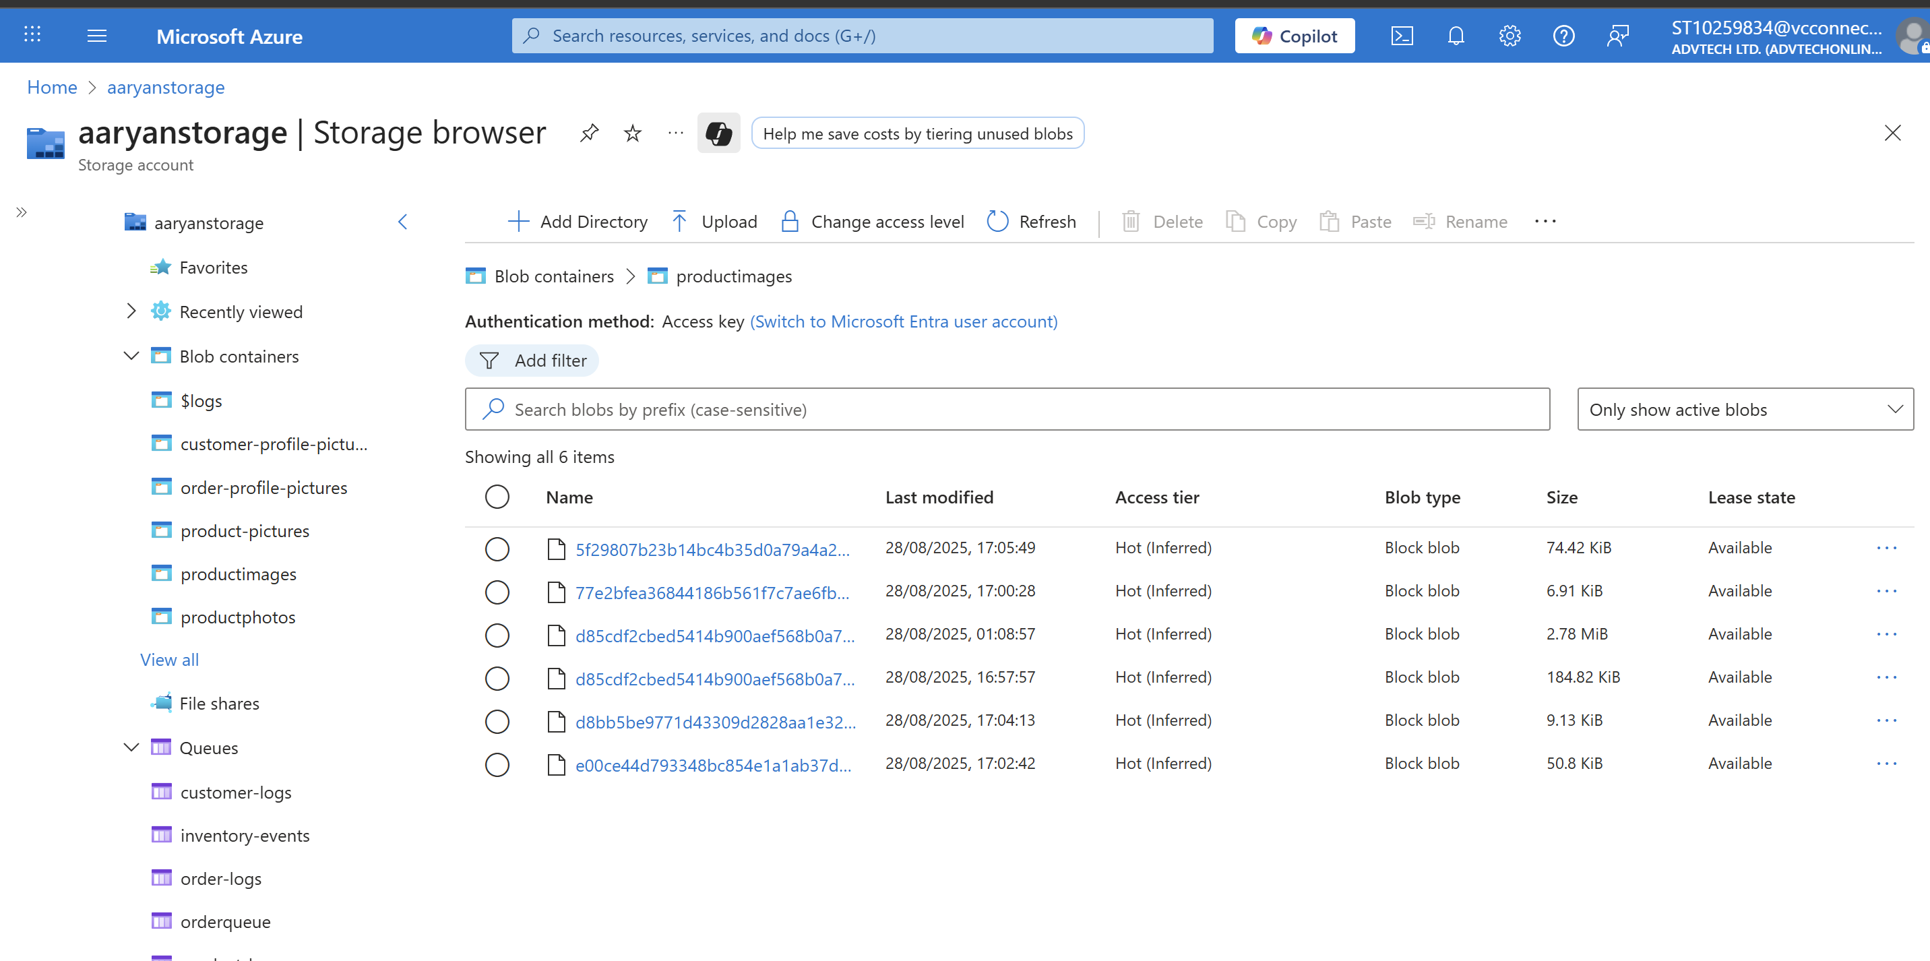

**Queues screenshots:**

**File Upload/File Service screenshots:**

**References**

* Microsoft. (2025) *Azure Tables client library for .NET*. Available at: <https://learn.microsoft.com/en-us/dotnet/api/overview/azure/data.tables-readme?view=azure-dotnet> (Accessed: 28 August 2025).
* Microsoft. (2025) *Get started with Azure Blob Storage and .NET*. Available at: <https://learn.microsoft.com/en-us/azure/storage/blobs/storage-blob-dotnet-get-started> (Accessed: 28 August 2025).
* Microsoft. (2024) *Tutorial: Work with Azure Queue Storage queues in .NET*. Available at: <https://learn.microsoft.com/en-us/azure/storage/queues/storage-tutorial-queues> (Accessed: 28 August 2025).
* Microsoft. (2025) *Develop for Azure Files with .NET*. Available at: <https://learn.microsoft.com/en-us/azure/storage/files/storage-dotnet-how-to-use-files> (Accessed: 28 August 2025).
* Microsoft. (2025) *Deploy ASP.NET Core apps to Azure App Service*. Available at: <https://learn.microsoft.com/en-us/aspnet/core/host-and-deploy/azure-apps/?view=aspnetcore-9.0> (Accessed: 28 August 2025).
* W3Schools. (n.d.) *C# Tutorial*. Available at: <https://www.w3schools.com/cs/index.php> (Accessed: 28 August 2025).
* W3Schools. (n.d.) *ASP.NET Razor C# Syntax*. Available at: <https://www.w3schools.com/asp/razor_syntax.asp> (Accessed: 28 August 2025).