**Function Code**

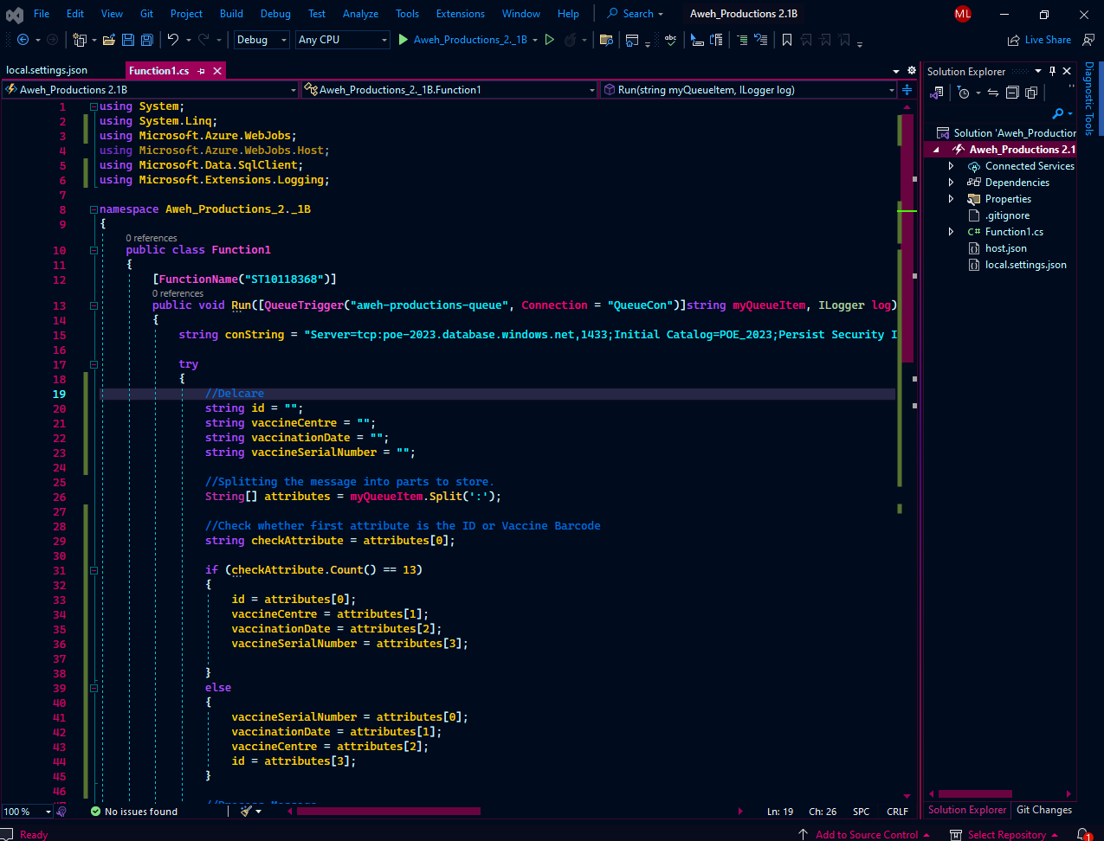

**Console Code**

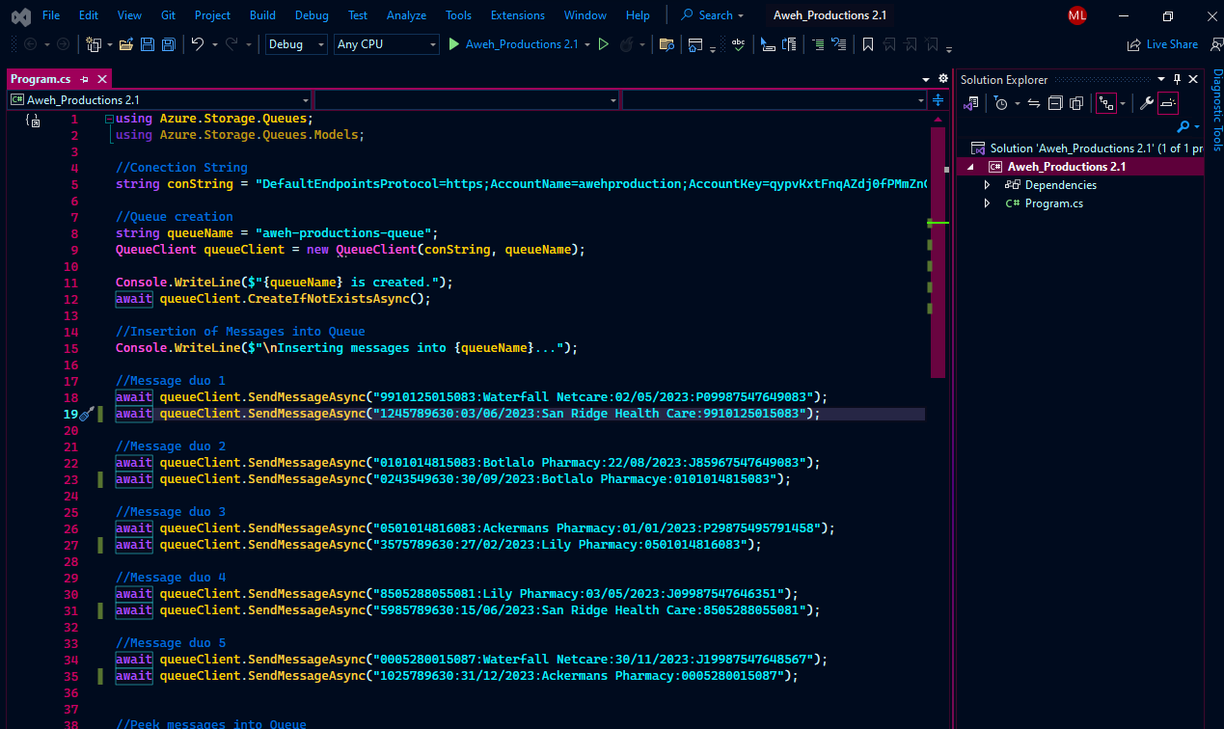

**Azure Queue Messages**

**Azure Database**

