What I changed:

In my calorie calculation, I used a delegate this time, in my part 2 I didn’t use a delegate. In my read me file, I didn’t use titles in my part 2, in my past 3 I used titles in my read me file, my recipes display in the list in alphabetical order, the total calories are calculated and displayed, the text turns red when the calories are over 300 , an unlimited amount of recipes can be added and scaled, the ingredients and the calories are scaled according to the user input and when quantities are reset, the calories are reset too.

how to use the application

application home page, here you will find all the features you can use

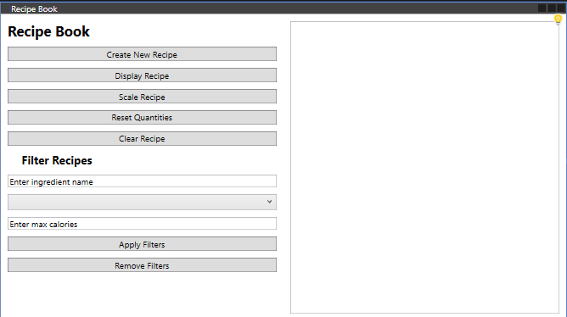

create recipe:

display recipe:

to display a recipe, select the recipe from the list and press display recipe. This will open a new window to display the recipe

scale recipe:

select a recipe to scale from the list and press scale, you will be taken to a scale window and choose the scaling factor. The ingredients and calories will be scaled

reset quantities

select the recipe from the list and press reset quantities, the ingredients and calories will be reset

clear recipes

select the recipe from the list and press clear recipes button, the selected recipe will be reset.

Filtering

To filter recipes:

1. Enter the desired filters:
   * **Ingredient Name**: Enter an ingredient name to filter recipes containing that ingredient.
   * **Food Group**: Select a food group from the drop-down menu.
   * **Maximum Calories**: Enter the maximum number of calories.
2. Click the **Apply Filters** button, the recipes that meet the criteria will be displayed.

Removing filter

To remove filters and display all recipes:

1. Click the **Remove Filters** button.

This will clear all filters and show the complete list of recipes.