SAND6221

Take Home Exam

Nikki Gordhan

ST10108243

**Contents:**

**Question 1:** 2

**Question 2:** 3

**Question 3:** 5

**Question 4:** 6

**Question 5:** 8

**References:** 10

# **Question 1:**

Consider the following short scenario, then answer the questions that follow:

You are an IT intern working for a small accountancy firm. During the COVID hard lockdown period, the firm realised that it has to be more adaptable if it is to survive and as such have decided to develop an application that will allow clients to make use of the firm’s services via an online platform. The IT department of the accountancy firm will be developing this new online platform.

**Q.1.1.** **List six things that you, as a developer, will be able to accomplish as a result of properly engaging in the process of Systems Analysis and Design. [6]**

* Outline the current environment to understand the processes,
* Design the application and software,
* Create the user interfaces,
* Create the system interfaces,
* Create and design the database and
* Design the system control and security. (Cerritos Collage, unknown)

**Q.1.2.** **Describe the activities you will perform as part of the first core process of the Systems Development Life Cycle (SDLC).** **[6]**

A business analyst and project manager will collect information that is used to help them create the product that is expected. A business analyst and project manager have meeting with the customer to discuss the requirements of the software. Requirements such as who will use the software and the main purpose of the software. When all the requirements are captured, a test is done to check the practicality of the product, if there is still any confusion then another meeting is set to clear up the confusion. An SRS (Software Requirement Specification) document will be created, this document can be used a s a reference for what the software needs. (Software Testing Help, 2023).

**Q.1.3 Which two documents will be created when planning the project? [2]**

* System Vision Document
* A project business case. (indeed, 2022)

**Q.1.4 Which diagram will you create to represent what the clients of the accounting firm’s application will need to do with the new online platform being developed? [1]**

Use Case Diagram.

# **Question 2:**

When a user enters their details on the home page of the application, the client management subsystem will confirm whether they are a registered user or not. If they are a registered user, their identity will be verified, and they will be able to select a service action such as a statement request or a tax filing request from the services subsystem. If they are not a registered user, the system will register a profile for them based on the information they provided, verify their identity and allow them to select a service action. As yearly tax submissions are time sensitive, the platform should be available 24 hours a day, 365 days a year.

**Q.2.1 From the background information provided at the beginning of this question, identify one functional requirement and one non‐functional requirement. [4]**

Functional Requirement: if the user is not part of the system, it must redirect them to the sign-up page automatically.

Non-Functional Requirement: tax submissions are yarely which means they need to be available 24 hours a day 365 days a year. (Reqtest, 2012)

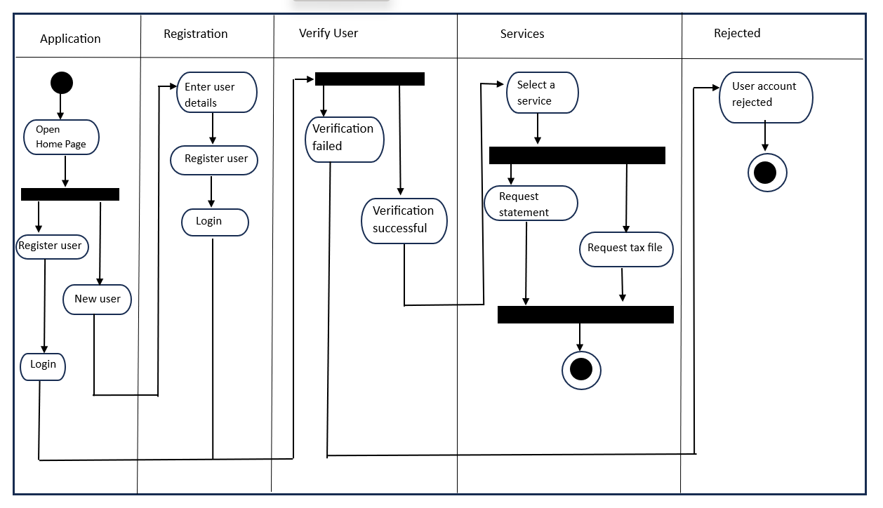**Q.2.2 Draw an activity diagram that will illustrate the workflow described at the beginning of the question. [12]**

**Q.2.3 In a step‐by‐step manner, show how you will use the Event Decomposition Technique to identify use cases for the accounting firm’s application. Relate your answer to the information presented at the beginning of this question. [14]**

Step 1 – Determine the external events in the system environment that is needed to make the system respond by creating a list.

Example from the accounting firm: opening up the home page.

Step 2 – For each event name and identify the use case.

Example from the accounting firm: sign into the system and register to use the system.

Step 3 – Review the temporal events that need response from the system by creating a list.

Example from the accounting firm:

* internal outputs needed (management reports (summaries) and internal statements and documents (detailed transactions))
* external outputs needed (statements, status reports and bills)

Step 4 - For each temporal event name and identify the use case and then determine the time that will trigger the use case.

Example from the accounting firm: verifying the users identify.

Step 5 – determine the state events that the system responds to, especially if it is a real-time system.

Example from the accounting firm: needs to be available 24 hours a day, 365 days a year as submissions of taxes are sensitive.

Step 6 - For each state event name and identify the use case and then define that state change.

Example from the accounting firm: register before login when it’s a new user.

Step 7 – when all events and use cases are defined check to see if they are part of the analysis.

Example from the accounting firm: user will be allowed to successfully get statements and successfully fill in tax forms.

**Q.2.4 Create a fully developed use case description for a use case identified during the completion of Q.2.3. [15]**

|  |  |
| --- | --- |
| **Accountancy** **Firm** | |
| **Use case** | **Users/Actors** |
| Create a user account | Customer |
| Login to the system | Customer |
| Request Statements | Customer, finance department |
| Request a tax file | Customer, finance department |

# **Question 3:**

All systems analysis activities have been concluded for the application to be developed for the accounting firm. It was decided that the application will run through a web browser to ensure greater portability of the application. It will only interact with the company’s internal databases for the time being. All data inside the database will be encrypted.

**Q.3.1 Identify the five activities that will form part of the Design phase and provide a brief overview of the tasks you will be performing during each activity. [10]**

1. Step 1(Research User needs): you first need to understand the problem before finding a solution to solve the problem. By understanding the user needs you are understanding the problem.
2. Step 2(Communicate the users’ needs and problems): here you will arrange the information you found in step 1. You will discuss these issues with your team and come up with the problem statement that is easy for all parties to understand.
3. Step 3(Create ideas): this step is where you and your team come up with ideas to solve the problem, by using the information gathered in step 1 and 2.
4. Step 4(Prototype): this step is where a prototype is created. This prototype might be the possible answer to solve the problem statement. These prototype are sent for testing and based on the users feedback they will either be accepted or rejected.
5. Step 5(Test): once one prototype is accepted a final product will be created from the prototype and the final product will go for testing to see if there are any bugs and if the end user is happy with the overall product. (Dam, 2022)

# **Question 4:**

**Q.4.1 Write a report in which you recommend and motivate the following for the development of the application: [13]**

* **Methodology to be used,**
* **Tools to be used,**
* **Techniques to be used.**

Methodology: used to plan, design, develop and test systems. Many software engineers use the SDLC when developing and maintain software.(Sherman, 2015)**.**

Examples: The System Development Life Cycle.

Tools used for the development of the application:

* Project managing tools – helps to keep track of the applications progress.
* Graphics tool – will help with the development of the user interfaces.
* IDEs (Integrated Development Environment) – programmers will use this tool when coding the application. (John Satzinger, unknown)

Techniquesused:

* Software testing:
  + Manual testing: when the programmer manually enters data to test the system.
  + Functional testing: when part of the systems functions is tested as each function is created.
  + Performance testing: tests the scalability, speed and stability of the system.
* User-interviewing – by asking the user what they would prefer in the system as well as meeting the requirements of the system. (GeekForGeeks, unknown)
* OOP (Object Oriented Programming) – are techniques that a programmer will use when coding the system. These techniques help them code in a more efficient way.

**Q.4.2 A project manager will be appointed to manage the development of the application for the accounting firm. The PMBOK is organized into 10 knowledge areas. Identify and describe four knowledge areas that the project manager to be appointed will need to have mastered to successfully manage the application development project. Show how the knowledge area relates to the development of the application. [12]**

Project Scope Management: describe the functions that are needed by the system as well as a plan on what work needs to be done by the team. This knowledge area is needed as the team would need someone who knows what is required of the system to guide them when they develop the system.

Project Time Management: create a schedule of all the tasks that need to be done and by when they need to be done. This knowledge area is important in the development of the system as the team need milestones, they need to achieve by a certain time otherwise the system will take a very long to be developed.

Project Human Resource Management: the project manager needs to find people to hire that are qualified to do the job. This will make sure that the system requirements are met as the team developing the system know what they are doing.

Project Quality Management: the project manager needs to make sure that the system that was developed is of good quality before handing it to the client. This is an important part of the development cycle of the system as the system needs to be good quality.

# **Question 5:**

When a client registers a profile using the application, they provide their name, surname, address, ID number, tax number.

**Q.5.1 Create the front and back of a CRC card for a class called Client. Indicate at least five responsibilities and attributes for the class. [10]**

**Front of card:**

|  |  |
| --- | --- |
| **Client** | |
| Update name and surname  Update address  Update ID number  Update tax number request history | Registration |

**Back of card:**

|  |
| --- |
| **clientName**  **clientSurname**  **clientAddress**  **clientIdNumber**  **taxNo** |

**Q.5.2 Explain how you will convert class Client to a table that will form part of a relational database. [6]**

**Client class**

|  |
| --- |
| **Name**  **Surname**  **Id Number**  **Address**  **TaxNo** |

Above is the class diagram of Client.

Shown below is the Client class changed into a table:

|  |
| --- |
| **ClientID (PK) int**  **Name string**  **Surname string**  **Id Number int**  **Address string**  **TaxNo int** |

* The table needs a field to make each record unique therefore a primary key is added (**ClientID).**
* each of the attributes in the class become fields in the table.
* In a table you need data types so depending on the type of data captured by each field will determine the data type.

**Q.5.3 Explain the purpose of transaction logging and its potential role in the accounting firm’s application. [7]**

Transaction logging: tracks each record ever made, updated or deleted that is in the database. If there is a failure you can use a log to get the database back to its consistent state (Microsoft, 2023)and preserve the integrity of the database. By putting the logs in a file system allows the logs to be placed on their own disks which is separate from the database table.(IBM, 2023)**.** Transaction logging also allows you to track the changes done to the data and who did the changes, which means the security of the database is good.

**Q.5.4 Identify two types of tests that will be performed in order to assist with the quality control of the application developed for the accounting firm. [2]**

* Performance testing
* Component testing (Synoptek, 2023)

# **References:**

Cerritos Collage, unknown. *Chapter 6 - Foundations for Systems Design.* [Online]   
Available at: https://www.cerritos.edu/dwhitney/SitePages/CIS201/Lectures/IM-7ed-Chapter06.pdf  
[Accessed 07 July 2023].

Dam, R. F., 2022. *The 5 Stages in the Design Thinking Process.* [Online]   
Available at: https://www.interaction-design.org/literature/article/5-stages-in-the-design-thinking-process  
[Accessed 07 July 2023].

GeekForGeeks, unknown. *Software Testing Techniques.* [Online]   
Available at: https://www.geeksforgeeks.org/software-testing-techniques/  
[Accessed 07 July 2023].

IBM, 2023. *Transaction log files for the database.* [Online]   
Available at: https://ibm.com/docs/it/imdm/11.6?topic=configurations-transaction-log-files-database  
[Accessed 07 July 2023].

indeed, 2022. *11 Essential Documents To Use as a Project Manager.* [Online]   
Available at: https://www.indeed.com/career-advice/career-development/essential-project-management-documents  
[Accessed 07 July 2023].

John Satzinger, R. J. B., unknown. *Systems Analysis and Design.* 7 ed. unknown: Cengage Learning.

Microsoft, 2023. *The Transaction Log (SQL Server).* [Online]   
Available at: https://learn.microsoft.com/en-us/sql/relational-databases/logs/the-transaction-log-sql-server?view=sql-server-ver16  
[Accessed 07 July 2023].

Reqtest, 2012. *Why is the difference between functional and Non-functional requirements important?.* [Online]   
Available at: https://reqtest.com/en/knowledgebase/functional-vs-non-functional-requirements/#:~:text=Let's%20take%20an%20example%20of,fast%20the%20webpage%20must%20load.  
[Accessed 07 July 2023].

Sherman, R., 2015. *Project Management.* [Online]   
Available at: https://www.sciencedirect.com/topics/computer-science/project-methodology#:~:text=Project%20Methodologies,test%2C%20and%20deploy%20software%20applications.  
[Accessed 07 July 2023].

Software Testing Help, 2023. *SDLC (Software Development Life Cycle) Phases, Process, Models.* [Online]   
Available at: https://www.softwaretestinghelp.com/software-development-life-cycle-sdlc/  
[Accessed 07 July 2023].

Synoptek, 2023. *Types of QA Testing: Everything You Need to Know.* [Online]   
Available at: https://synoptek.com/insights/it-blogs/types-of-qa-testing-everything-you-need-to-know/  
[Accessed 07 July 2023].