

ST10057559

TAFADZWA KASHIRI



[Date]

HP

[Company address]

NAME: TAFADZWA KASHIRI

STUDENT NUMBER: ST10057559

MODULE CODE: SAND6221

TAKE HOME TEST

Question 1

Q.1.1 Planning

In this stage, the issue must be evaluated considering the goals and policies of the organization. Identify and interact with stakeholders, such as the administration of the campus canteen, students, and potential application users. According to ProjectManager (2022) in order to know about their needs, preferences, and expectations for the application interviews, surveys, and meetings must be done. (ProjectManager, 2022)

Analysis

In this phase, teams will work on the core of their issue or modification that is required during this phase. If an issue needs to be solved, potential solutions are proposed and evaluated to determine which one’s best fits in the project’s main goals. Teams here think about the needs for the solution’s functionality. (Bydrec, n.d.)

Design

In this stage, all specifications, processes, and features essential to ensure that that the proposed system’s functional requirements are met are defined. There, end users can talk about and pinpoint the precise business information demands they have for the program. Users will think about key elements, network capabilities, and processes to achieve the project’s goals at this phase. (Bydrec, n.d.)

Building

The real code is created in this stage. Depending on the size of the project, a single developer, a larger team, or even many teams may do this. If multiple teams work together, developers will have to keep track of changes made to the code and be able to discuss with one another. It is crucial to make a record of the changes, whether formally or informally. (ProjectManager, 2022)

Testing

Create and run test cases to ensure the application’s performance, usability, and usefulness. The individual application modules and components are verified using unit testing. Test the integration of every system component to guarantee an easy communication between the system components. Conduct system testing to verify the procedures for delivery scheduling, placing orders, and processing payments. (ProjectManager, 2022)

Deployment

The software is released when all faults have been fixed. This is when the item is manufactured and made available in a commercial setting. (ProjectManager, 2022)y

Maintenance

Monitor the program performance, work to resolve any issues, and apply any necessary upgrades and bug fixes. The software is maintained throughout the maintenance phase to keep it functional and current. The original software can be improved such that it keeps being a workable and bug-free solution. Continuously respond to the questions of the user and problems regarding the use and operation of the program. (ProjectManager, 2022)

Question 2

Q.2.1. Order Placement

Students should be able to browse the menu and choose what they wish to order using the app. Students should be allowed to specify the quantity of each item and view an order summary before confirming their order. (EASTERN PEAK, 2021)

Delivery scheduling

Students should be able to plan delivery of their orders to a specific location on campus using the program. They should be able to choose the preferred delivery time and location from a list of alternatives, such as various buildings or pickup locations on campus. (EASTERN PEAK, 2021)

Credit card payments.

Students should be able to use their credit cards to pay for their orders via the program. Sensitive data should be encrypted, the transaction process should be handled securely, and a proof of the payment’s success should be provided. (EASTERN PEAK, 2021)

Q.2.2 stakeholders

Parents

Students

Canteen managers. (SidmartinBio, 2020)

Q.2.3 Domain class diagram

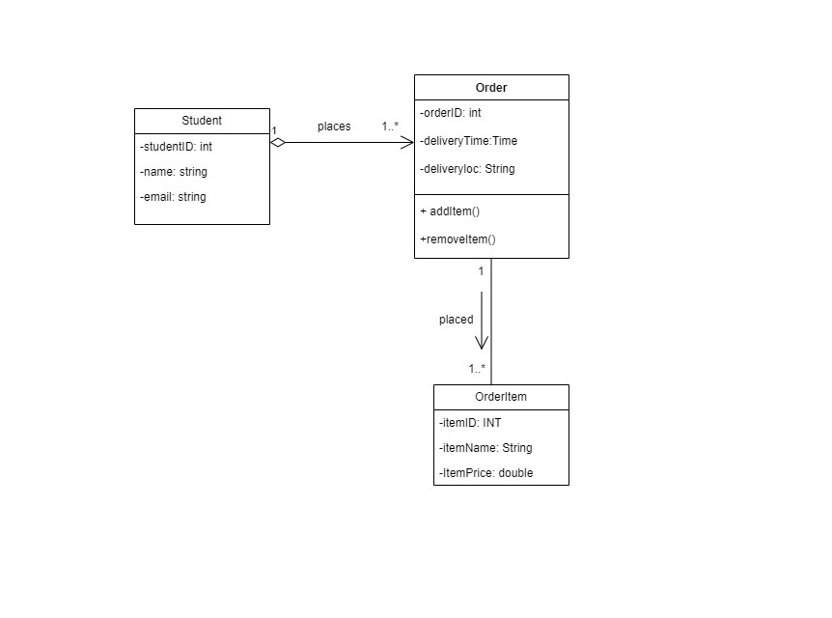

Q.2.4. Functional requirement chosen: Order placement.

Use case name: Place an order.

Brief description: This use case describes the process of a student browsing the canteen’s menu, selecting items, and placing an order for food or drinks.

Actor: Student.

Flow of activities

-Students should be able to look through the menu and select what they want to order using the app.

-Students should be able to schedule delivery of their orders to a specific location on campus using the app.

-Students should be able to pay for their orders through the software using credit cards. (SCRIBD, n.d.)

QUESTION 3

Q.3.1 Encryption.

Sensitive information, including credit card numbers and personal data, should be encrypted both in transit and at rest to prevent unauthorized access. (GetApp, 2023)

Authentication and Authorization.

To make sure that only users who have been granted permission may access the program, effective authentication measures like multi-factor authentication should be used. In order to guarantee that users can only access the features and information to which they have been given access to, role-based access control should be used. (up.pt, n.d.)

Input Validation,

Application input validation is important to guard against typical attacks like SQL injection and cross-site scripting. (ScienceDirect, 2020)

Q.3.2 User-centered design

The user should be considered when developing the application. This comprises doing user research to comprehend the needs and preferences of the target market and incorporating their suggestions into the application’s design. The user interface should have simple navigation, clear prompts and must be easy to use. (careerfoundry.com, 2021)

Usability testing

To find any issues or potential areas to improve, the application should regularly go through usability testing. This could be asking consumers for feedback, observe how users interact with the app, or tracking user activity with analytics software. Iterative adjustments to the application should be made based on the outcomes of the usability testing. (Optimizely, n.d.)

# Bibliography

Bydrec, n.d. *A Detailed List of the System Developement Life Cycle Phases.* [Online]   
Available at: https://blog.bydrec.com/a-detailed-list-of-the-system-development-life-cycle-phases  
[Accessed 19 May 2023].

careerfoundry.com, 2021. *What is User-Centered Design?.* [Online]   
Available at: https://careerfoundry.com/en/blog/ux-design/user-centered-design/#:~:text=User%2Dcentered%20design%20(UCD),knowledge%20into%20their%20design%20process.  
[Accessed 19 May 2023].

EASTERN PEAK, 2021. *RESTAURANT APPS FROM A TO Z.* [Online]   
Available at: https://easternpeak.com/blog/restaurant-apps-from-a-to-z-core-features-and-development-tips/  
[Accessed 19 May 2023].

GetApp, 2023. *What Is Encryption? Why Is It Important for Your Small Business?.* [Online]   
Available at: https://www.getapp.com/resources/why-encryption-is-important/  
[Accessed 19 May 2023].

Optimizely, n.d. *Usability Testing.* [Online]   
Available at: https://www.optimizely.com/optimization-glossary/usability-testing/#:~:text=Why%20is%20usability%20testing%20important,changes%20based%20on%20the%20results.  
[Accessed 19 May 2023].

ProjectManager, 2022. *SDLC – The Software Development Life Cycle.* [Online]   
Available at: https://www.projectmanager.com/blog/sdlc-the-software-development-life-cycle  
[Accessed 19 May 2023].

ScienceDirect, 2020. *Input Validation.* [Online]   
Available at: https://www.sciencedirect.com/topics/computer-science/input-validation  
[Accessed 19 May 2023].

SCRIBD, n.d. *Use Case of Placing Order.* [Online]   
Available at: https://www.scribd.com/document/342257587/Use-Case-of-Placing-Order  
[Accessed 19 May 2023].

SidmartinBio, 2020. *Who are the stakeholders in retaurant?.* [Online]   
Available at: https://biosidmartin.com/who-are-the-stakeholders-in-restaurant/  
[Accessed 19 May 2023].

up.pt, n.d. *Technologies and Tools for Security and Control.* [Online]   
Available at: https://paginas.fe.up.pt/~als/mis10e/ch8/chpt8-4bullettext.htm#:~:text=Various%20tools%20and%20technologies%20used,and%20antivirus%20and%20encryption%20software.  
[Accessed 19 May 2023].