

SAND6211 Take Home Test

ST10091324



May 19, 2023

BCA2 Group 2

VC WFL

Table of Contents

QUESTION 1 2

Question 2 3

2.1 3

2.2 3

2.3 4

2.4 4

Question 3 6

3.1 6

3.2 6

REFERENCES 7

# QUESTION 1

The System Development Lifecyle (SDLC) refers to a necessary structure that pinpoints every component needed to successful research, build, deploy and maintain a project (Satzinger, Jackson & Burd, 2015).

* The first step is to determine what your project will be trying to achieve and then get permission to carry out the project (Satzinger et al., 2015). The team will need to brainstorm what the purpose of campus canteen application is. The answer to that question could be to reduce long ques in the canteen, having such an application can also increase the canteen’s sales significantly (Satzinger et al., 2015).
* Secondly, the team should brainstorm some more and design a cohesive and detailed blueprint of the project (Satzinger et al., 2015). This could be by interviewing the canteen owner and asking them what they would like the app to have/do (Business rules). After that the team can design a rough diagram based on the business rules established.
* Thirdly, the team should create the required system components for the project (Satzinger et al., 2015). Such as a button that redirects the user to a payment gateway page, a login screen that can validate users and a cart that will hold all the customer’s order (Satzinger et al., 2015).
* Fourthly, the team should start integrating all components they build and test whether it integrates without issue (Satzinger et al., 2015). This can be done by implementing various unit tests for sections of the application’s code and by pushing their code to repositories such as the ones on GitHub.
* The penultimate step would be to release the application to the public (Satzinger et al., 2015). The team can achieve this by making use of a cloud provider such as Microsoft or Google or they can use their own servers to host the application. I would recommend that they make use of a cloud service such as Microsoft Azure. They will handle most of the nuances of deploying applications and will allow the team to focus mainly on developing new features for the application.
* Lastly, the team must maintain the project (Satzinger et al., 2015). They can do this by using version control platforms such as GitHub, every time a new feature is implemented or a bug is fixed, the members that were tasked with that responsibility would have to upload their version of the application to a test branch and then merge their work into a stable branch if all tests have been successful.

# Question 2

2.1 Functional requirements:

* Nuclino ([s.a.]) argues that the system must allow the placement of orders.
* Nuclino ([s.a.]) argues that the system must allow delivery of those orders to specific campus venues.
* Nuclino ([s.a.]) argues that the system must allow payments to be made via credit cards.

2.2 Landau (2022) argues that there are two types of stakeholders, internal stakeholders, and external stakeholders. Landau (2022) argues that internal Stakeholders work directly on the project and benefit from the success of the project, this includes myself and the development team. Landau (2022) argues that external stakeholders benefit from the success of our project but do not contribute/work directly on the project, this includes campus students and all campus canteen employees.

## 2.3

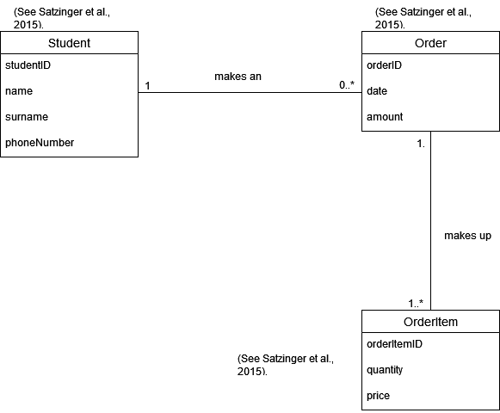

2.4

|  |  |
| --- | --- |
| Use case name: | Payment |
| Brief description: | A student will be asked to provide their credit card information so that the order can be made (Satzinger et al., 2015). |
| Actors: | Students and Bank (Satzinger et al., 2015). |
| Flow of activities: | Actions | System |
|  | * 1. Select payment as credit card to enter payment information (Satzinger et al., 2015). | * 1. Process request.   2. Open payment gateway page. |
|  | * 1. Enter credit card information (Satzinger et al., 2015).   2. Click buy button to buy order/s (Satzinger et al., 2015).   3.1 Click on try again, loop back and start at 2.1 (Satzinger et al., 2015). | * 1. Validate credit card information (Satzinger et al., 2015).   2. Send payment information to student’s bank and wait for transaction approval (Satzinger et al., 2015).   3. If approved. Send order confirmation message to student phone number or email (Satzinger et al., 2015).   4. If approved. Send order confirmation message to canteen logistics (Satzinger et al., 2015).   3.1 If denied. Display error message to user and provide user with choice of trying again or cancelling order (Satzinger et al., 2015).  3.2 If approved. Loop back and start at 2.3 (Satzinger et al., 2015). |

# Question 3

3.1 We can also implement output control measures, which are security methods used to ensure that data in transmit is secured, untampered and arrives at its correct destination (Satzinger et al., 2015). To prevent digital access and tampering will we have to encrypt all data in transit and provide checksums to recipient so that they can verify whether or not the data they received was tampered with (Satzinger et al., 2015). To prevent fraud, we will need to implement detailed records and audit trails of all cancelled, incomplete, and complete transactions (Satzinger et al., 2015). We will also have to limit physical access to our payment processing servers by placing them in a secure location away from students and other unauthorized threat actors (Satzinger et al., 2015).

3.2 Usability in this scenario will refer to how easy it is for students and canteen employees to interact with our ordering system (Satzinger et al., 2015). We can make our application more usable by design a simple user interface that requires minimal clicks to successful make an order (Satzinger et al., 2015). We can also add cohesive error messages so that users know what went wrong and how to quickly fix it if possible (Satzinger et al., 2015).

# REFERENCES

Satzinger, J., Jackson, R. and Burd, S. 2015. System Analysis and Design in a Changing World. 7th ed. Boston: Cengage.

Nuclino. [s.a.]. A Guide to Functional Requirements (with Examples), Nuclino, s.a. [Blog]. Available at: https://www.nuclino.com/articles/functional-requirements#what-are-functional-requirements [Accessed 16 May 2023].

Landau, P. 2022. What Is a Stakeholder? Definitions, Types & Examples, ProjectManager Blog, 22 March 2022. [Blog]. Available at: https://www.projectmanager.com/blog/what-is-a-stakeholder [Accessed 19 May 2023].