Take Home Test

SAND6221

Nikki Gordhan

ST10108243

**Contents:**

**Question 1:** 2

**Question 2:** 3

**Question 3:** 5

**References:** 6

# **Question 1:**

**Your team of software developers have decided that it is time to develop an application for the campus canteen that will allow a student to place an order and schedule delivery of that order to a specified venue on campus. The application will also accept payments via credit card.**

**Q1.1. In relation to the campus canteen application, outline what tasks will be performed for each of the core processes of the System Development Life Cycle. [15]**

**Core process 1 (planning):** Where everyone who is going to contribute to the project, come together to write the business goals, the requirements, specifications and the risks for the project. (Coursera, 2022). This plan is sometimes called a ‘Feasibility stage’, it allows the team to point out the resources to build the project. The projects goals are discussed here. (Preston, 2023).

**Core process 2 (system analysis):** This is the part where the users/customers need and requirements are discussed and finalized. Functional assessments are done. (Preston, 2023). This phase needs lots of research and planning so that the software that will be developed meets its expectations. (Coursera, 2022).

**Core process 3 (systems design):** A detailed plan is created in this phase of the SDLC. It is where the infrastructure is crested for the project. High-quality work is needed for the foundation of the project. (Preston, 2023) Here everyone is told what part they will be contributing to. (Coursera, 2022).

**Core process 4 (development):** the code for the program is written during this stage according to the design document. All the planning done in stage 1 will make the coding very easy. Tools that the developer will use are debuggers, compilers and interpreters. (Preston, unknown)

**Core process 5 (testing):** during this stage the application is tested for any bugs ang any logical errors. It is important that the application meets the requirements of the SRS. (Preston, unknown)

**Core process 6 (implementation):** this stage is only reached once there are no bugs in the application which means it is ready to go on the market and ready for users to use. (Preston, unknown)

**Core process 7 (maintenance):** this is when end-user report bugs that need to be fixed or any bugs that couldn’t be fixed before the application was released. (Preston, unknown)

# **Question 2:**

**Q.2.1 Identify three functional requirements for the canteen application. [6]**

1. The application allows the user to place an order, it also allows the student to select when and where the order should be delivered to.
2. A confirmation message must be sent to the user showing that the canteen has received the order as well as the order details.
3. The user should be able to choose a payment method. (altexsoft, 2021).

**Q.2.2 Identify three stakeholders that will benefit from the development of the canteen application.[3]**

* Students
* Staff members (like the cleaning staff or security guards)
* Lectures (TechTarget, unknown)

**Q.2.3 Create a domain model class diagram to show the relationship between a class called ‘Student’, ‘Order’ and ‘OrderItem’.**

**Indicate at least three attributes for each class. Also indicate relationships between the classes.[16]**

What is a domain model class diagram? (IBM, 2021)

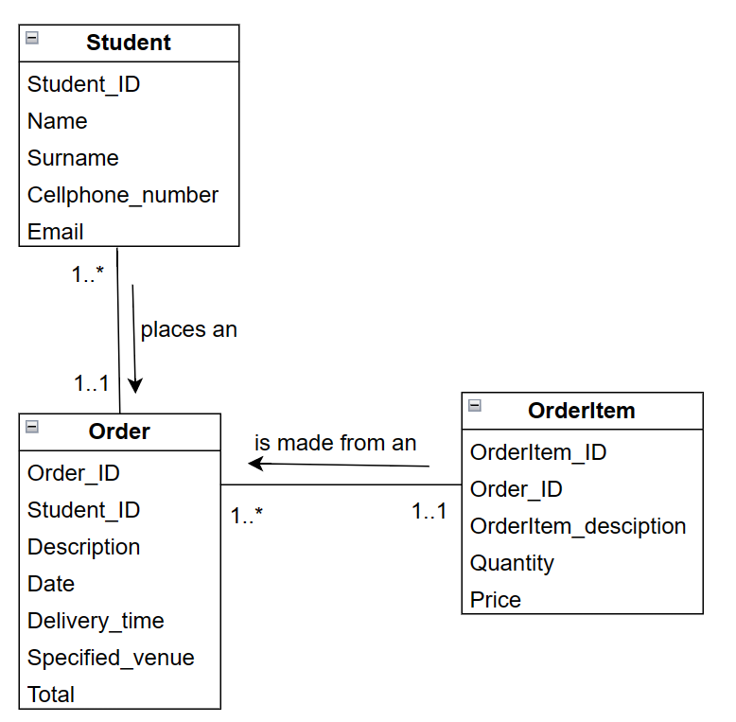

What I used to create a domain model. (diagrams.net, unknown)

**Q.2.4 A fully developed use case description contains several items to be addressed. Choose one of the functional requirements identified in Q.2.1. Then, complete the following sections of a fully developed use case description for the identified functional requirement: [10]**

* **Use case name**
* **Brief description**
* **Actor(s)**
* **Flow of activities**

|  |  |
| --- | --- |
| Use case name | User places an order |
| Actors | Student, lectures |
| Primary actor | Students |
| Description | A student will open the application. The student will then sign in using their username and password. The student will then place their order, they will also indicate when and where it must be delivered to. The student will then select a payment method and pay for their order. They will then click save. |
| Goals | A student is able to place an order successfully. |
| Alternative flow | If the order was unable to save, then the student will have to try again. |

(usability.gov, unknown)

# **Question 3:**

**As cyber security is becoming a big concern, and because the application that you will be developing for the canteen accepts and processes payments, you will need to make provision for the security of the data that you will be processing. All the controls implemented to secure applications, should however not impede on the usability of an application.**

**Q.3.1 Describe any three security controls that you will implement in the application. [6]**

* Each user needs a username and password in order to protect themselves as well as multifactor authentication this ensures that the user is using the application and not someone imposing as them.
* Since the application captures the users credit card details this data needs to be stored in a database but must be encrypted as it is sensitive information.
* When the user creates their profile, they should be able to capture a picture of themselves as this will help the person delivering the order know who it’s for, the application will also show a picture of the delivery person to the user. (Willis, 2022)

**Q.3.2 Describe any two ways in which you will ensure the usability of the application. [4]**

* **Screen layout:** the screen should adjust to the screen of the mobile device that the user is using.
* **Interactive menu:** the application should have drop down boxes and checkboxes that prevents the users from typing too much.(POTTS, unknown)

# **References:**

altexsoft, 2021. *Functional and Nonfunctional Requirements: Specification and Types.* [Online]   
Available at: https://www.altexsoft.com/blog/business/functional-and-non-functional-requirements-specification-and-types/#:~:text=Functional%20requirements%20are%20product%20features,system%20behavior%20under%20specific%20conditions.  
[Accessed 19 May 2023].

Coursera, 2022. *What Is the Software Development Life Cycle? SDLC Explained.* [Online]   
Available at: https://www.coursera.org/articles/software-development-life-cycle  
[Accessed 19 May 2023].

diagrams.net, unknown. *diagrams.net.* [Online]   
Available at: https://app.diagrams.net/?src=about  
[Accessed 19 May 2023].

IBM, 2021. *Domain modeling class diagrams.* [Online]   
Available at: https://www.ibm.com/docs/en/radfws/9.6.1?topic=diagrams-domain-modeling-class  
[Accessed 19 May 2023].

POTTS, R., unknown. *10 simple ways to improve software’s usability.* [Online]   
Available at: https://3di-info.com/10-simple-ways-to-improve-softwares-usability/  
[Accessed 19 May 2023].

Preston, R., 2023. *7 Phases of the System Development Life Cycle (With Tips).* [Online]   
Available at: https://www.indeed.com/career-advice/career-development/system-development-life-cycle  
[Accessed 19 May 2023].

TechTarget, unknown. *stakeholder.* [Online]   
Available at: https://www.techtarget.com/searchcio/definition/stakeholder#:~:text=A%20stakeholder%20is%20a%20person,can%20have%20no%20official%20affiliation.  
[Accessed 19 May 2023].

usability.gov, unknown. *Use Cases.* [Online]   
Available at: https://www.usability.gov/how-to-and-tools/methods/use-cases.html  
[Accessed 19 May 2023].

Willis, B., 2022. *Three Categories of Security Controls.* [Online]   
Available at: https://www.lbmc.com/blog/three-categories-of-security-controls/#:~:text=Operational%20Security%20is%20the%20effectiveness,networks%2C%20systems%2C%20and%20applications.  
[Accessed 19 May 2023].