XY G-Code Pen Plotter
User & Technical Manual
An Arduino-based, image-to-drawing two-axis CNC plotter
with desktop conversion and streaming software

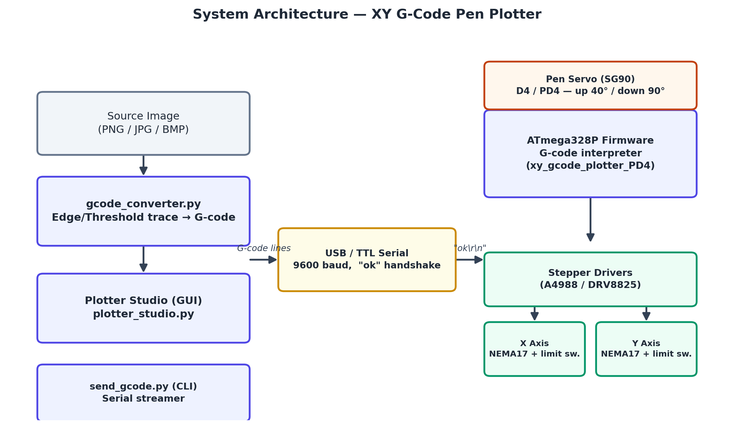

Document version | 1.0
Date | August 10, 2026
Firmware baseline | xy_gcode_plotter_PD4 (build: plotterf2.hex)

Table of Contents
1. Introduction
2. System Architecture
3. Hardware Requirements (Bill of Materials)
4. Wiring and Pin Assignments
5. Firmware: Setup, Flashing and Configuration
6. G-code and M-code Command Reference
7. Installing the Host (PC) Software
8. Using Plotter Studio (Graphical Interface)
9. Using the Command-Line Tools
10. Quick-Start: First Drawing, Start to Finish
11. Troubleshooting Guide
12. Maintenance and Safety
Appendix A — Firmware Variant Comparison
Appendix B — Configuration Constants Quick Reference
Appendix C — Sample G-code Listing
Revision History

1. Introduction

1.1 Purpose of This Manual
This manual documents the design, assembly, firmware, and host software of the XY G-code Pen Plotter — a two-axis, stepper-motor-driven drawing machine controlled by an ATmega328P microcontroller (Arduino Uno/Nano class) and operated from a Windows PC. It is intended for the builder/operator who needs to wire the electronics, flash the firmware, install the desktop software, and run day-to-day drawing jobs, as well as for anyone maintaining or extending the system in the future.

1.2 System Overview
The plotter converts a digital image or a hand-written G-code file into physical pen strokes on a flat bed measuring 275 mm × 190 mm. A desktop application ("Plotter Studio") traces the outlines of a source image using computer-vision edge/contour detection, converts the traced paths into G-code, and streams that G-code to the machine over a USB/TTL serial link at 9600 baud. Firmware running on the microcontroller interprets each line of G-code, drives the two stepper motors in a coordinated (Bresenham-style) straight-line motion, and raises or lowers a pen using a hobby servo between strokes.

1.3 Key Features
- Image-to-drawing pipeline: PNG/JPG/BMP/GIF/TIFF images are auto-traced into pen strokes (edge or threshold mode).
- Standard G-code/M-code support: G0, G1, G20, G21, G28, G90, G91, M2, M3, M4, M5, M30, plus Z-driven pen control.
- Automatic homing against mechanical limit switches with a slow, repeatable two-stage approach.
- Flow-controlled serial streaming ("ok" handshake per line) — safe for the Uno's small 64-byte UART buffer.
- Graphical desktop app (Plotter Studio) with live preview, image-processing controls, orientation correction (flip X/Y, rotate 90°), and one-click send-to-plotter with progress logging.
- Command-line alternative (send_gcode.py) for scripted or headless operation.
- Validated on real hardware: a 1,310-line G-code job streamed over COM7 completed with zero timeouts or dropped responses in approximately 18.7 minutes.

2. System Architecture
The system is split into a PC-side software layer and a microcontroller-side firmware layer, connected by a single USB/TTL serial link. The diagram below shows the complete signal path from a source image to physical pen motion.
Figure 2.1 — End-to-end system architecture

2.1 Hardware Layer
- ATmega328P microcontroller (16 MHz), Arduino Uno/Nano compatible.
- Two NEMA17 stepper motors (X and Y), each driven by an A4988- or DRV8825-style step/direction driver configured for 1/16 microstepping (MS1–MS3 all HIGH), giving 80 steps/mm on a 20-tooth GT2 pulley.
- Two normally-open mechanical limit switches, one per axis, used for homing.
- One SG90-class hobby servo that lifts and lowers the pen.
- USB-to-serial link to the host PC (9600 baud).

2.2 Software Layer
- gcode_converter.py — pure conversion library; turns a raster image into G-code sized for this bed.
- plotter_studio.py — the Tkinter desktop GUI ("Plotter Studio") that wraps the converter and the serial streamer behind a graphical workflow.
- send_gcode.py — a command-line utility that streams an existing .gcode file to the plotter.
- Firmware (xy_gcode_plotter_PD4, compiled to plotterf2.hex) — the G-code interpreter and motion controller running on the microcontroller.

2.3 Data Flow
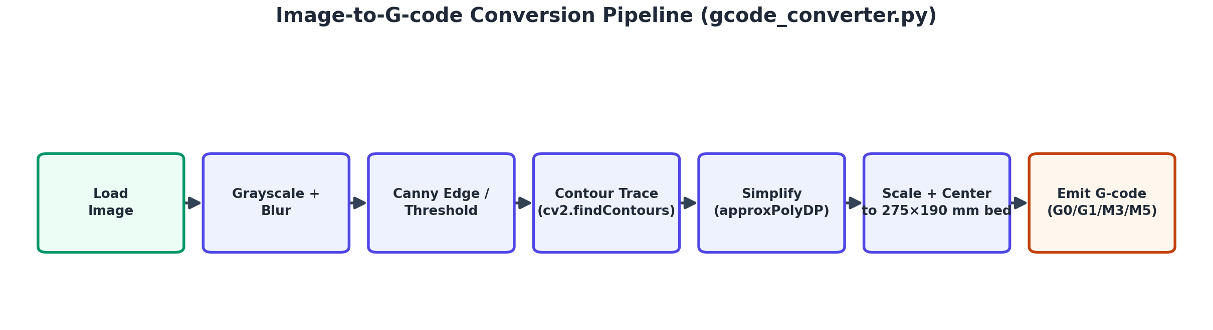
Figure 2.2 — Image-to-G-code conversion pipeline
An image is converted to grayscale, optionally blurred, then either Canny edge-detected or thresholded into a binary mask. OpenCV traces the resulting shapes into contours, which are simplified into polylines, scaled and centered to fit the 275 × 190 mm bed with a configurable margin, and finally written out as G-code: a rapid travel move (G0) to the start of each stroke, a pen-down command (M3), a series of draw moves (G1), and a pen-up command (M5).

3. Hardware Requirements (Bill of Materials)
Item | Specification / Notes
Microcontroller board | ATmega328P, Arduino Uno or Nano compatible, 16 MHz
Stepper motors | 2 × NEMA17, 200 steps/rev
Stepper drivers | 2 × A4988 or DRV8825, microstepping set to 1/16 (MS1–MS3 = HIGH)
Motion hardware | 20-tooth GT2 pulleys + GT2 belt (gives 80 steps/mm at 1/16 microstepping)
Limit switches | 2 × normally-open microswitch, wired COM → signal pin with INPUT_PULLUP, other leg to GND
Pen actuator | 1 × SG90-class hobby servo
Drawing bed | Flat surface, usable travel 275 mm (X) × 190 mm (Y)
Power supply | Suitable DC supply for the stepper drivers/motors (per driver/motor rating)
Host computer | Windows PC with a free USB port and Python 3.x installed
Cabling | USB cable (PC ↔ board)

4. Wiring and Pin Assignments
The pin map below matches the recommended firmware build, xy_gcode_plotter_PD4 (compiled as plotterf2.hex), which places the pen-servo signal on D4 (PD4) instead of D11 (PB3). D11 doubles as the AVR's hardware SPI MISO line, so keeping the servo off it leaves in-circuit ISP programming and any future SPI peripherals undisturbed while the servo remains connected.
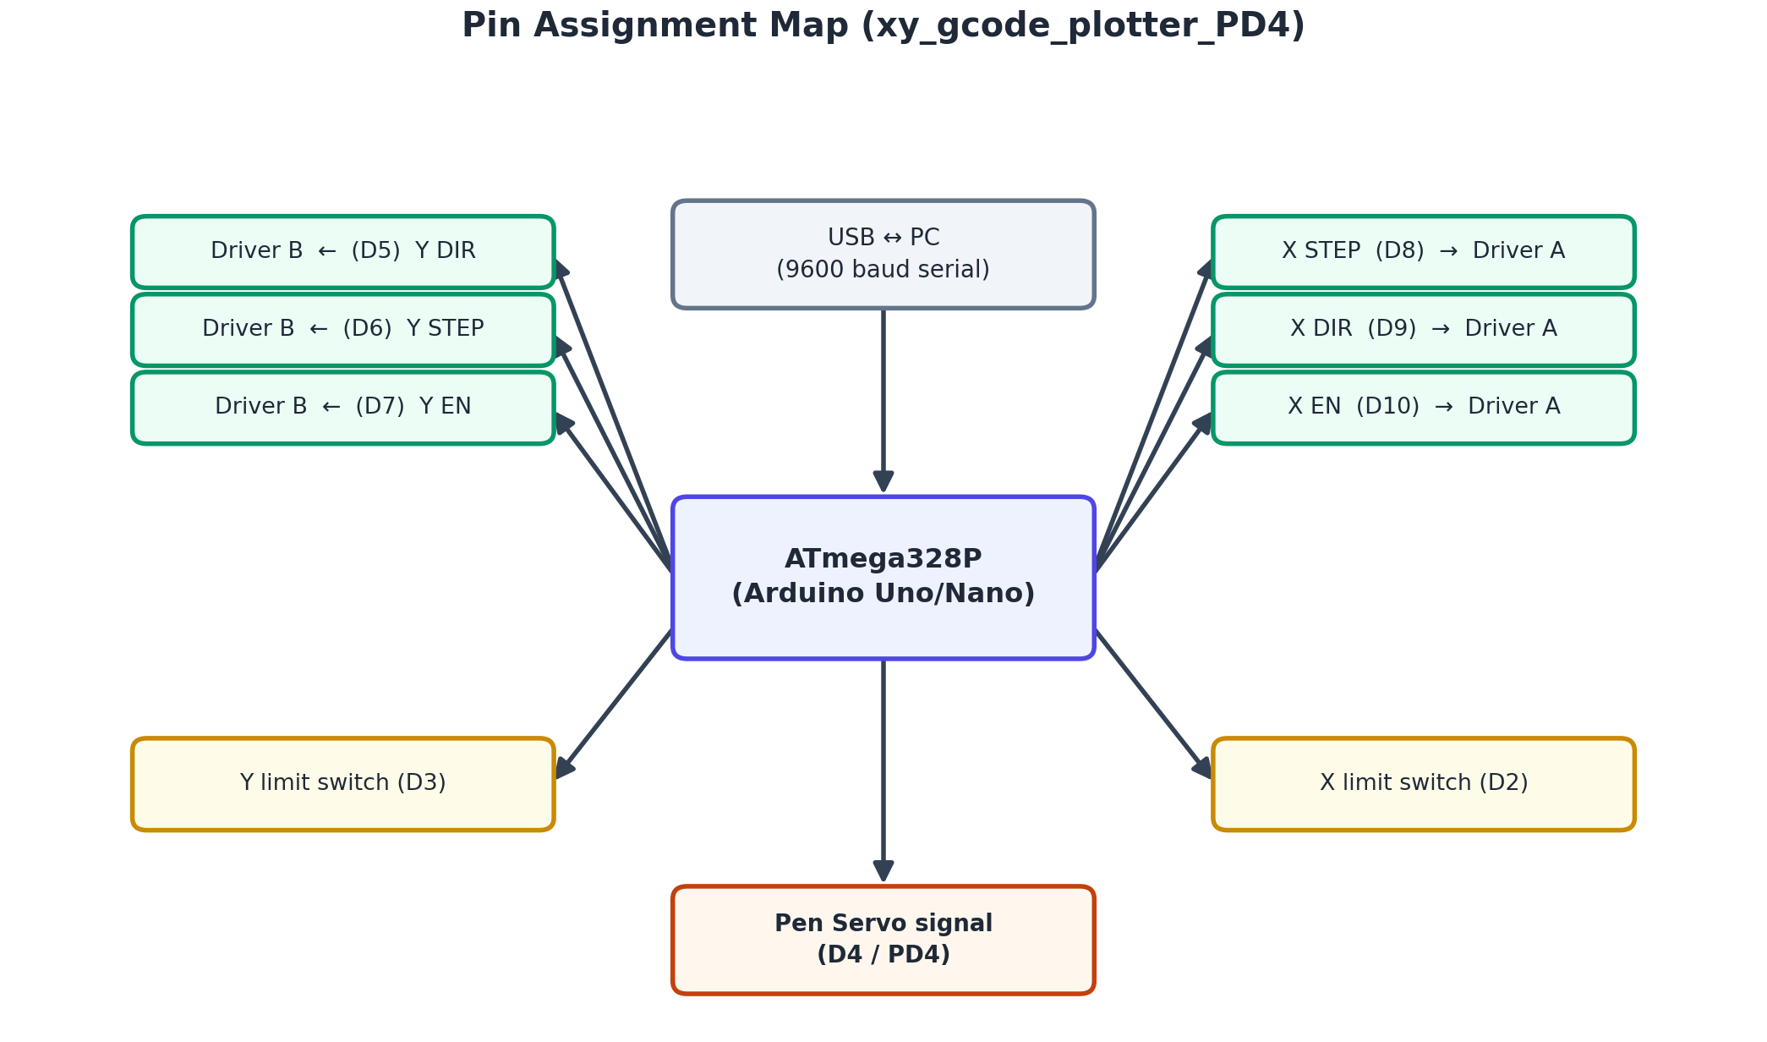
Figure 4.1 — Pin assignment map
Function | Arduino Pin | AVR Port.Bit
X axis — STEP | D8 | PB0
X axis — DIR | D9 | PB1
X axis — EN (active-low) | D10 | PB2
X axis — limit switch | D2 | PD2
Y axis — DIR | D5 | PD5
Y axis — STEP | D6 | PD6
Y axis — EN (active-low) | D7 | PD7
Y axis — limit switch | D3 | PD3
Pen servo signal (recommended build) | D4 | PD4
Pen servo signal (original build) | D11 | PB3 — shares SPI MISO, avoid if possible

Note: The Y-axis pin order is DIR, STEP, EN (D5/D6/D7) while the X-axis order is STEP, DIR, EN (D8/D9/D10). This asymmetry is intentional and consistent across every firmware build in this project — double-check it carefully when wiring so the X and Y driver signals are not swapped.
Enable (EN) lines on both drivers are active-low: drive them LOW to enable the driver.
Limit switches are wired normally-open, using the microcontroller's internal pull-up resistor; the input reads LOW when the switch is pressed (triggered).

5. Firmware: Setup, Flashing and Configuration

5.1 Recommended Build
Use xy_gcode_plotter_PD4.c (pre-compiled as plotterf2.hex) as the production firmware. It is a bare-metal AVR-C implementation — direct register I/O, no Arduino core — that includes full G-code parsing, homing, coordinated X/Y stepping, and software-PWM servo control on D4/PD4.

5.2 Flashing the Pre-compiled Firmware
Using avrdude against an Uno/Nano's bootloader over the same USB serial port:
avrdude -c arduino -p atmega328p -P COM7 -b 115200 -U flash:w:plotterf2.hex:i
Replace COM7 with the port your board enumerates as (visible in Windows Device Manager). If flashing over a dedicated ISP programmer instead of the bootloader, use the programmer's -c value (e.g. -c usbasp) and drop the -P/-b arguments as appropriate for that programmer.
Tip: Building from source (xy_gcode_plotter_PD4.c, or the original xy_gcode_plotter.ino for the D11/Arduino-IDE variant) is covered in Appendix A for anyone modifying the firmware. Most users only need the pre-compiled .hex files already included in the project folder.

5.3 First Boot and Verification
After flashing (or on every power-up/reset), the firmware automatically homes both axes. Open a serial terminal at 9600 baud to observe:
Homing...
Ready
"Ready" confirms both axes are homed to (0, 0) and the machine is waiting for G-code. Every subsequent line sent to the board is answered with "ok" once processed — this is the flow-control signal the host software waits for before sending the next line.

5.4 Key Configuration Constants
These constants are compiled into the firmware. They must match the values hardcoded in gcode_converter.py (steps/mm and bed size) if you change them — see Appendix B for the full list.
Constant | Value | Meaning
STEPS_PER_MM_X / Y | 80.0 | Steps per millimetre of travel on each axis
MAX_MM_X | 275.0 | Soft limit — X travel in millimetres
MAX_MM_Y | 190.0 | Soft limit — Y travel in millimetres
PEN_UP_ANGLE | 40° | Servo angle for pen raised — tune to your pen linkage
PEN_DOWN_ANGLE | 90° | Servo angle for pen lowered — tune to your pen linkage
PEN_Z_THRESHOLD | 0.0 | Z values ≤ this trigger pen-down; above it, pen-up
DRAW_DELAY_US | 500 µs | Per-step delay for G1 draw moves
TRAVEL_DELAY_US | 400 µs | Per-step delay for G0 rapid moves
MIN_DELAY_US | 350 µs | Fastest allowed step delay (feed-rate clamp ceiling)
HOMING_DELAY_US | 500 µs | Per-step delay while homing
BACKOFF_STEPS | 100 | Steps backed off after first limit-switch contact before the slow re-approach

6. G-code and M-code Command Reference
The firmware's line interpreter supports the following commands:
Code | Description
G0 Xnn Ynn [Znn] [Fnn] | Rapid travel move (uses TRAVEL_DELAY_US unless F overrides the feed rate)
G1 Xnn Ynn [Znn] [Fnn] | Linear draw move (uses DRAW_DELAY_US unless F overrides the feed rate)
G20 | Switch to inches (unit scale × 25.4)
G21 | Switch to millimetres (default, unit scale × 1.0)
G28 | Home both axes against their limit switches; resets current position to (0, 0)
G90 | Absolute positioning mode (default)
G91 | Relative positioning mode
M3 / M4 | Pen down
M5 | Pen up
M2 / M30 | Program end (parsed and acknowledged, otherwise a no-op)
Znn (on a move line) | Also drives the pen: Z × unit-scale ≤ 0.0 → pen down, otherwise pen up
; or ( ... ) | Comment — everything from ; to end of line, or from ( onward, is stripped

Every processed line — including blank or comment-only lines — is answered with "ok\r\n". This handshake is mandatory flow control: the microcontroller's UART receive buffer is only 64 bytes, and a single draw move can take several seconds to execute, so the host must always wait for "ok" before transmitting the next line.

7. Installing the Host (PC) Software

7.1 Requirements
Install Python 3.x, then install the required packages:
pip install opencv-python-headless numpy pillow pyserial
Tkinter, used for the Plotter Studio GUI, ships with the standard Windows Python installer.

7.2 Project Files
File | Role
gcode_converter.py | Image → G-code conversion engine (importable library, no GUI)
plotter_studio.py | Desktop GUI application — run this for day-to-day use
send_gcode.py | Command-line G-code streamer

8. Using Plotter Studio (Graphical Interface)
Launch the application from the project folder:
python plotter_studio.py

8.1 Layout
The window is split into a left preview pane — showing the traced pen path over an outline of the 275 × 190 mm bed — and a right-hand control panel.

8.2 Loading Source Material
- Load Image... — opens a PNG/JPG/BMP/GIF/TIFF file to trace into strokes.
- Load .gcode file... — opens an existing G-code file directly, bypassing image conversion.

8.3 Image-Processing Controls
Control | Purpose | Default
Mode: Edges / Threshold | Choose Canny edge detection or binary threshold as the tracing method | Edges
Canny low / high | Edge-detection sensitivity thresholds | 60 / 150
Threshold value | Binarization cutoff (Threshold mode only) | 128
Blur kernel | Pre-processing blur size, reduces noise before tracing | 3
Simplify epsilon | Polyline simplification tolerance (larger = smoother/fewer points) | 1.5 px
Min stroke length | Discards traced fragments shorter than this | 6.0 px
Invert | Inverts the mask before tracing | Off
Margin | Blank border kept around the traced artwork on the bed | 10.0 mm

8.4 Orientation Controls
Flip X, Flip Y, and Rotate 90° correct mirrored or upside-down output. Flip Y is enabled by default because image row 0 is the top of the picture while the plotter's Y axis increases upward — leaving Flip Y on is usually correct for a typical photo. If a test run shows the artwork mirrored or upside-down on the bed, toggle these checkboxes and regenerate the preview before drawing again.

8.5 Speed
Draw feed (mm/min) sets the feed rate written into G1 draw moves (default 900 mm/min).

8.6 Preview, Save, and Send
- Generate Preview — runs the conversion in the background and draws the resulting path in the left pane.
- Save G-code As... — writes the generated program to a .gcode file.
- Port — select the plotter's COM port (refreshable from the dropdown).
- Baud — 9600 (default, matches the firmware) or 115200.
- Max wait/line (s) — timeout per line before the send is aborted (default 60 s).
- Send to Plotter — asks for confirmation, then streams the G-code with a live progress bar and log.
- Stop — aborts an in-progress send.
Tip: A full hardware validation run streamed a 1,310-line photo-derived G-code file over COM7 with zero timeouts or dropped responses, completing in roughly 18.7 minutes — confirming the Load → Preview → Save → Send workflow end to end.

9. Using the Command-Line Tools

9.1 send_gcode.py
Syntax:
python send_gcode.py <file.gcode> <port> [baud] [max_wait_seconds]
Examples:
python send_gcode.py circle.gcode COM3
python send_gcode.py circle.gcode COM3 9600
python send_gcode.py circle.gcode COM3 9600 60
Defaults: baud = 9600, max_wait = 60 seconds per line.
On start, the script opens the port, waits ~4 seconds for the board to reset and finish homing, then streams the file one line at a time, waiting for an "ok" response (with a repeating heartbeat message) before sending the next line. The wait clock resets whenever any response is received, so a single long move will not falsely time out.

9.2 gcode_converter.py as a Library
The conversion engine can be scripted directly without the GUI:
from gcode_converter import convert_image, ConversionParams
result = convert_image("photo.png", ConversionParams(mode="edges", flip_y=True))
with open("output.gcode", "w") as f:
f.write("\n".join(result.gcode_lines))
result.contours_mm holds the traced paths in millimetres, and result.stats holds summary statistics (including an estimated draw time).

10. Quick-Start: First Drawing, Start to Finish
1. Wire the machine per Section 4, double-checking the X/Y pin order and driver EN polarity.
2. Flash plotterf2.hex per Section 5.2.
3. Power on the machine. Confirm "Homing..." then "Ready" on a 9600-baud serial terminal.
4. Install the Python packages listed in Section 7.1.
5. Run: python plotter_studio.py
6. Click Load Image... and choose a source picture.
7. Click Generate Preview and check the traced path in the left pane.
8. If the artwork looks mirrored or upside-down, adjust Flip X / Flip Y / Rotate 90° and regenerate.
9. Select the correct Port and confirm Baud is 9600.
10. Click Send to Plotter and confirm. Monitor the progress bar and log.
11. When the log shows completion, the pen will have returned to the origin (0, 0) automatically.

11. Troubleshooting Guide
Symptom | Likely Cause | Suggested Fix
Drawing appears mirrored or upside-down | Image row order vs. plotter Y direction mismatch | Toggle Flip X / Flip Y / Rotate 90° in Plotter Studio and regenerate
Send to Plotter times out mid-job | Wrong COM port/baud, loose USB cable, or firmware not replying "ok" | Verify port and baud (9600), reseat the cable, confirm firmware boots to "Ready"
An axis moves the wrong direction | DIR wiring reversed relative to firmware expectations | Swap the axis's DIR wiring, or invert the axis's direction constant in firmware and reflash
Homing never completes / axis crashes into the frame | Limit switch not wired to the internal pull-up correctly, or wiring open/broken | Check switch wiring (COM → signal pin, other leg → GND) and continuity
Pen does not lift/lower correctly | Servo angles not matched to the physical linkage | Adjust PEN_UP_ANGLE / PEN_DOWN_ANGLE in firmware to suit the linkage, reflash
Lines come out at the wrong scale or run off the bed | gcode_converter.py bed/steps constants do not match the firmware | Confirm BED_MAX_X_MM/BED_MAX_Y_MM/STEPS_PER_MM in gcode_converter.py match the firmware's MAX_MM_X/Y and STEPS_PER_MM_X/Y
No response at all on the serial terminal | Wrong board reset timing, wrong port, or firmware not flashed | Reconnect after the ~2 second Arduino auto-reset delay; re-flash plotterf2.hex; verify COM port in Device Manager

12. Maintenance and Safety
- Power off the machine before rewiring, re-seating connectors, or adjusting the servo linkage.
- Periodically check GT2 belt tension — a loose belt causes skipped steps and distorted drawings.
- Keep the pen-lift linkage free of binding; re-tune PEN_UP_ANGLE/PEN_DOWN_ANGLE if the linkage is adjusted.
- Do not exceed the stepper driver's rated current; verify current-limiting potentiometers on A4988/DRV8825 boards match the motor's rated current before first use.
- Keep fingers and loose cabling clear of the gantry during homing and drawing moves.
- Re-run homing (G28, or a power cycle) any time the machine has been manually moved while powered off.

Appendix A — Firmware Variant Comparison
The project folder includes several firmware builds and bring-up test sketches produced during development. The recommended production firmware is xy_gcode_plotter_PD4.c (plotterf2.hex); the rest are retained for reference, testing, or as a fallback if a bare-metal AVR-C toolchain is unavailable.
File | Type | Servo | Notes
xy_gcode_plotter_PD4.c → plotterf2.hex | Bare-metal AVR-C | D4 / PD4 | Recommended. Frees the SPI MISO pin (D11) for ISP programming / future SPI peripherals.
xy_gcode_plotter.c → plotterf.hex | Bare-metal AVR-C | D11 / PB3 | Original full build; functionally identical apart from servo pin.
xy_gcode_plotter/xy_gcode_plotter.ino | Arduino sketch (Servo.h) | D11 / PB3 | Arduino-IDE-friendly equivalent of the above; easiest to modify without an AVR-C toolchain.
xy_gcode_plotter_no_servo.c / .ino → plotter.hex | Bare-metal AVR-C / Arduino sketch | None (no-op) | Pen up/down commands are logged but not physically actuated; used for the initial full-length hardware/communication test.
servo.c → servo_test.elf/.hex | Bare-metal AVR-C test | PB3, ~61 Hz Timer2 PWM | Isolated servo sweep test (0°→90°→180°), independent of the plotter firmware.
rawcircle.c / raw_circle_draw.ino → rawcircle.hex | Bare-metal AVR-C / Arduino sketch | None | Hard-coded 60 mm-radius circle motion test; verifies mechanics before mounting the pen.
single_axis_home_and_max.ino | Arduino sketch | — | X-axis-only homing/travel bring-up test.
y_axis_home_and_max.ino | Arduino sketch | — | Y-axis-only homing/travel bring-up test.
xy_home_and_max.ino | Arduino sketch | — | Combined X+Y homing/travel bring-up test.

Note: xy_gcode_plotter_no_servo.ino uses noticeably faster step timings (350/180/150 µs) than every other build (500/400/350 µs), including its own bare-metal .c port. If reusing that Arduino sketch, be aware the motion speed will differ from the recommended production firmware.

Appendix B — Configuration Constants Quick Reference
Constant | Firmware Value | Also Appears In
Bed size (X × Y) | 275.0 mm × 190.0 mm | gcode_converter.py: BED_MAX_X_MM / BED_MAX_Y_MM
Steps per mm (X and Y) | 80.0 | gcode_converter.py: STEPS_PER_MM
Serial baud rate | 9600 | send_gcode.py / plotter_studio.py default baud
Pen up / down angle | 40° / 90° | Tune in firmware to match the physical pen linkage
Pen Z threshold | 0.0 | Z ≤ 0.0 → pen down; Z > 0.0 → pen up
Servo settle time | 180 ms | Delay after each pen up/down command before the next move
Servo pulse range | 544–2400 µs @ 50 Hz | Matches Arduino Servo.write() angle mapping
Draw / travel / min step delay | 500 / 400 / 350 µs | Feed-rate clamp range: [MIN_DELAY_US, 4000 µs]
Homing delay / backoff | 500 µs / 100 steps | Slow re-approach after backoff runs at 2× homing delay
Default draw feed rate | 900 mm/min | gcode_converter.py: draw_feed_mm_min

Note: If any of the bed size or steps/mm constants are changed in the firmware, the matching constants in gcode_converter.py (BED_MAX_X_MM, BED_MAX_Y_MM, STEPS_PER_MM) must be updated to the same values, or generated drawings will be mis-scaled relative to the physical bed.

Appendix C — Sample G-code Listing
Excerpt from circle.gcode (a 60 mm-radius circle centered at 137.5, 95):
; Circle: center (137.5, 95), radius 60mm
G21
G90
G28
G0 X197.500 Y95.000
M3
G1 X197.180 Y97.617
G1 X196.223 Y100.101
... (144 segments total)
M5
G0 X0.000 Y0.000
M2
This structure — G21/G90/G28 header, a rapid travel to the stroke start, M3, a run of G1 moves, M5, then a return-to-origin G0 and a final M2 — is exactly the pattern gcode_converter.py emits for every traced contour, so any file generated by Plotter Studio can be read and understood the same way.

Revision History
Version | Date | Description
1.0 | August 10, 2026 | Initial release of the User & Technical Manual.

