E-Commerce Automation

Table of Contents

Key Activities to implement. 2

Helper activities to implement. 3

Locator to implement. 3

PROBLEM STATEMENT

Develop a Java-based Selenium automation script that navigates to a given e-commerce website, selects a product from the list, and adds it to the shopping cart. The goal of this exercise is to demonstrate proficiency in web automation using Selenium WebDriver, handling web elements, and executing basic navigation tasks.

BUSINESS REQUIREMENTS:

## Key Activities to implement.

1. Navigate to: http://practice.automationtesting.in/
2. Click “Shop” menu and validate if navigated to shop page.
   1. Check if “Shop” Menu Option is available.
   2. Click on “Shop” Menu Option.
   3. Check if the control is successfully navigated to “Shop” page.
3. Click “Home” menu and validate if navigated to shop page.
   1. Check if “Home” Menu Option is available.
   2. Click on “Home” Menu Option.
   3. Check if the control is successfully navigated to “Home” page.
4. Check if “Home” page has 3 new arrivals.
   1. Check if “Home” page has a section of new arrivals.
   2. Check of “Arrivals” section has some products enlisted.
   3. Check of “Arrivals” section has exactly 3 products enlisted.
5. Click on any product image and confirm if it navigates to product details page.
   1. Check if we are a product image is clickable.
   2. Click on Product Image.
   3. Check if the control is successfully navigated to Product Details page.
6. Click on “ADD TO BASKET” button on product description page to add it to cart.
   1. Check if product details page has an option “ADD TO BASKET”.
   2. Check how many items are there in the cart before adding new item into cart.
   3. Click on “ADD TO BASKET” option.
   4. Check how many items are there in the cart after adding new item.
   5. Check if count of items in cart has increased by 1 after adding.
7. Check if product added message is shown when product is added to basket.

For all the above activities to accomplish, there are template methods in Activites Class. These methods need to take use of helper methods available in SubActivites class. Those are also templated.

# Helper activities to implement.

Helper methods (in SubActivities class) to be implemented are as follows:

* + 1. Check a page has been loaded completely.
    2. Find an element using xpath.
    3. Wait for an element if it is not present.
    4. Wait for an element if it is present.
    5. Wait for an element if it is not visible.
    6. Wait for an element if it is visible.
    7. Close the ads.
    8. Close the banners.
    9. Implement do_javascript_click functionality.

# Locator to implement.

Add appropriate locators in locator class and use them in SubActivities class.

Expectations:

1. Learners should write automation script using Java and selenium to automate all the steps in the above question. In other words, automation script should perform all mentioned steps.
2. Learners should not use any tools to create the xpath. They should develop the xpath/cssselector on their own.

IMPLEMENTATION/FUNCTIONAL REQUIREMENT

* 1. **CODE QUALITY/OPTIMIZATIONS**
     1. Associates should have written clean code that is readable.
     2. Associates need to follow SOLID programming principles.

EXECUTION STEPS TO FOLLOW

1. **You are mandatory required to run test cases for applications before final submission. Without which project evaluation will not happen.**
2. **You can run the Junit test cases using Eclipse menu options.**
3. **Before final submission, you are also required to push your code to GIT. Following are the steps to follow:**



Right click in folder and open Git Bash

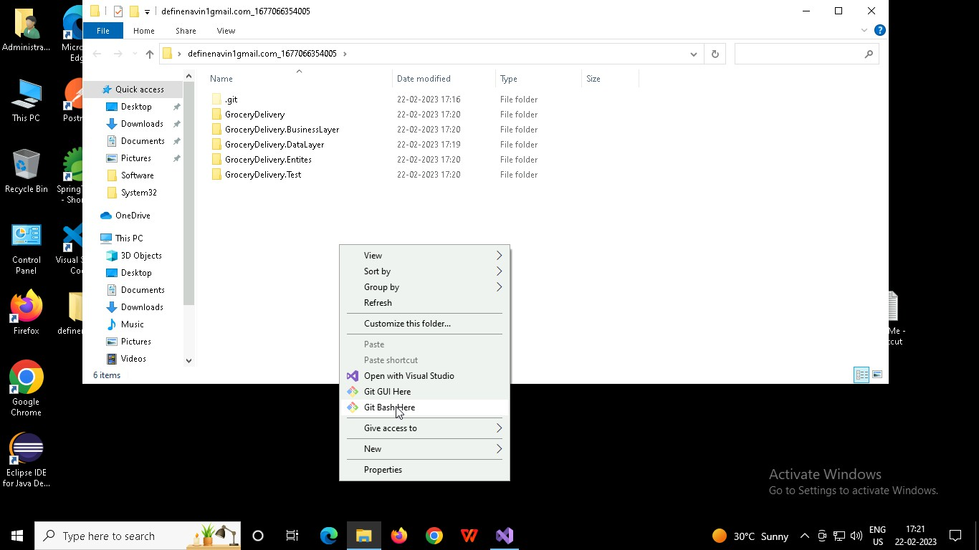

In Git bash terminal, run following commands

* 1. git status
  2. git add .
  3. git commit -m “First commit”

(You can provide any message every time you commit)

* 1. git push

