FaceBook Automation

PROBLEM STATEMENT

Need to automate the following activities using Selenium + Java.

Key Activities to implement:

|  |  |
| --- | --- |
| **SN** | **Test Steps** |
| 1 | Navigate to the URL and Validate the facebook LogIn Page Title |
| 2 | Verify Presence Of All Fields in The Login Page |
| 3 | Validate the error message, when user does not provide any credentials |
| 4 | Enter Email or Phone No in Email or Phone No Text field and click on Login and validate Error Message |
| 5 | Enter Password in password Text field and click on Login and validate Error Message |
| 6 | Go Back To LogIn Page And Validate CreateNewAccount button Is Present or not |
| 7 | Click on Create Account Button and Verify navigate to the signUp page. |
| 8 | Verify first name,surname,Mobile Number or email address,New password field are present in the signup page or not |
| 9 | Enter data(Read the data from Json File) in the first name field |
| 10 | Enter data (Read the data from Json File)in the surname,Mobile Number email address,New password field. |
| 11 | Select any date from date dropdown field and and verify the date dropdown is present or not |
| 12 | Select any Month from month dropdown field and and verify the Month dropdown is present or not |
| 13 | Select any Year from the Year dropdown field and and verify the Year dropdown is present or not |
| 14 | Select "Custom" radio button and validate "Custom" radio button is present or not |
| 15 | Select any option from the "Select your pronoun" dropdown and verify "Select your pronoun" dropdown" is present or not |
| 16 | Enter Value in "Gender Optional" Textfield and verify "Gender Optional" Textfield is present or not |
| 17 | Select "Female" radio button and validate "Female" radio button is present or not |
| 18 | Select "Male" radio button and validate "Male" radio button is present or not |
| 19 | Close the "signup" page and verify the All Fields prsense in The Login Page or not |
| 20 | Enter valid email or phone no in email or phone no text field and enter password in password textfield and validate "login" button is present or not |
| 21 | Login the facebook by given valid credential and validate any element is present or not |
| 22 | After Logged In, Validate the title of Facebook Home Page |
| 23 | Click On Profile and Validate the Profile Name |
| 24 | Upload a profile Picture |
| 25 | Click On Edit Profile And fill The Detail In Bio Section |
| 26 | Click On Posts and Go to Intro Section and Add Details In Add Bio |
| 27 | Hide The People You May Know Section by clicking on the upper arrow button |
| 28 | Click On About and Go Into overview and Education and add university |
| 29 | Click on add a workplace and add company name |
| 30 | Click on Add home town and add home town. |
| 31 | Click on add a current city and add current city. |
| 32 | Click on Add secondary school and add school |
| 33 | Click on add relationship status and add relationship status as single |
| 34 | Go to the previous page and click on Account at the right top corner |
| 35 | After that click on logout button. |

Pre-requisite:

As soon as you import project in eclipse, update the project using maven update option as below. This is to resolve issue if any maven dependency not downloaded properly:

1. Right click on project : Go to “Maven” : Select “Update Project”

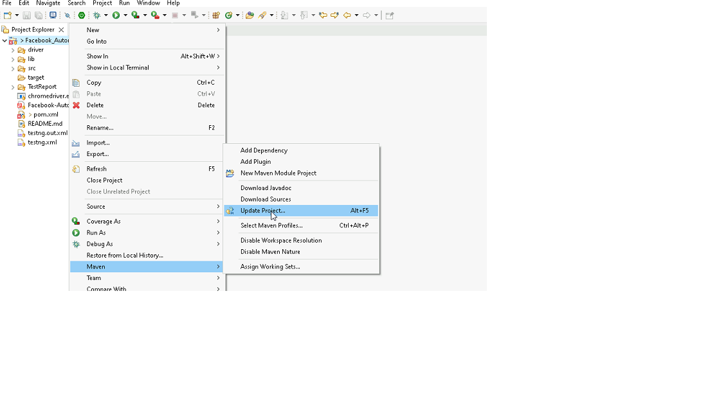

1. In Update Maven Project Box Select “Force Update of Snapshots/Releases” and click OK

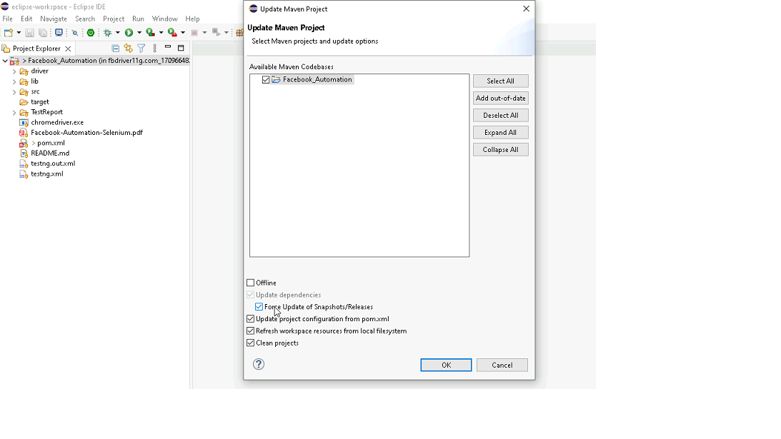

Template Code Structure: Packages and files you will be required to work upon. Other Files and packages you can ignore.

|  |  |  |
| --- | --- | --- |
| Package | Class/File | Description |
| pages | FaceBookPage.java  Facebook_L2_Pages.java | 1. All core activities (mentioned in list above) to be performed here. 2. The comments associated with each templated method here describe the expectation. 3. You can define locators and xpath here. 4. Declare any variable/object you need to share data/status between different methods. 5. Do not modify the signature of methods declared here. 6. You can create additional supportive common methods in CommonEvents class. |
| resources | Config.json | URL to navigate to. Already URL is defined here |
|  | expected_data.json | Contains data to fill in form |
| coreUtilities.utils | CommonEvents.java | 1. Contains all common activities. 2. Certain templated common method declared here. 3. You implement them as per your need. 4. You can add any additional method for common activity here |
|  | FileOperations.java | 1. Contains methods to read from json file. 2. Method is in templated form. 3. **You will be required to implement these methods as very first activity, because even URL to navigate to, is read using these methods.** |
|  |  |  |

Expectations:

1. Learners should write automation script using Java and selenium to automate all the steps in the above question. In other words, automation script should perform all mentioned steps.
2. Learners should not use any tools to create the xpath. They should develop the xpath/cssselector on their own.

IMPLEMENTATION/FUNCTIONAL REQUIREMENT

* 1. **CODE QUALITY/OPTIMIZATIONS**
     1. Associates should have written clean code that is readable.
     2. Associates need to follow SOLID programming principles.

EXECUTION STEPS TO FOLLOW

1. **You are mandatory required to run test cases for applications before final submission. Without which project evaluation will not happen.**
2. **You can launch test cases any time as follows: Right click on testng.xml and run TestNGSuite**

1. **Before final submission, you are also required to push your code to GIT. Following are the steps to follow:**



Right click in folder and open Git Bash

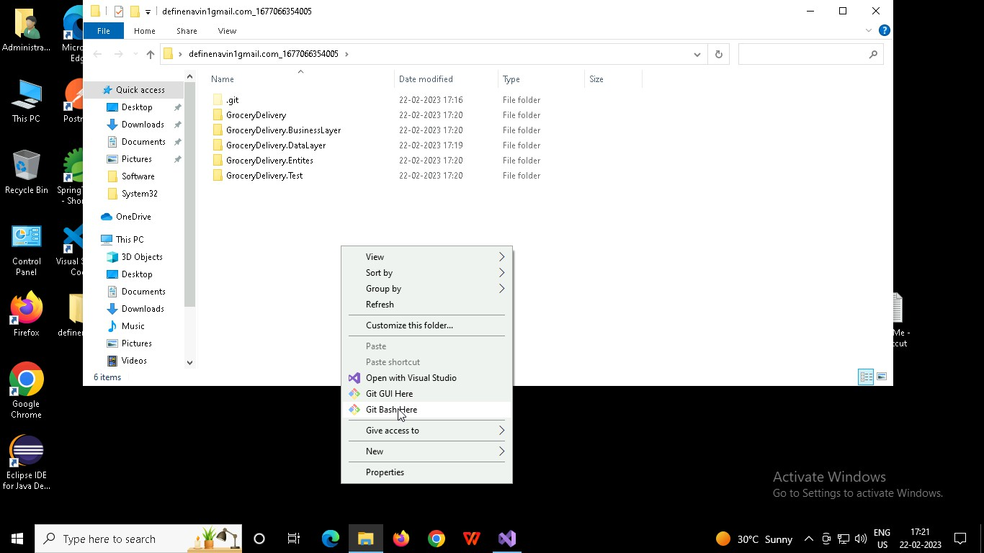

In Git bash terminal, run following commands

* 1. git status
  2. git add .
  3. git commit -m “First commit”

(You can provide any message every time you commit)

* 1. git push

