FaceBook Automation

PROBLEM STATEMENT

Need to automate the following activities using Selenium + Java.

Key Activities to implement:

1. Navigate to https://www.facebook.com/
2. Validate the login Page
3. Validate other fields login Page
4. Validate incorrect username
5. Validate incorrect password
6. Provide valid username and password. Get details of same from json file (expected_data.json)
7. Validate that the login button is present and clickable
8. verify Forgot Password? link redirects to the password recovery page
9. Verify that clicking on the Create New Account button
10. Verify that user navigates to the signup page
11. Enter values in the First name and Surname
12. Enter values in the Mobile number field
13. Select different dates from the Date Of Birth fields
14. Validate that date,year and months are selectable
15. Verify selected DOB values should be captured accurately
16. Select each radio button option for gender
17. Validate that only one radio button option should be selectable at a time
18. Verify that clicking on the Terms link redirects to the Facebook Terms of Service page
19. Ensure that clicking on the Data Policy link redirects to the Facebook Data Policy page
20. Click on the sign up button,leave the new password as empty
21. Verify that error messages for incomplete field displayed as appropriate

Pre-requisite:

As soon as you import project in eclipse, update the project using maven update option as below. This is to resolve issue if any maven dependency not downloaded properly:

1. Right click on project : Go to “Maven” : Select “Update Project”

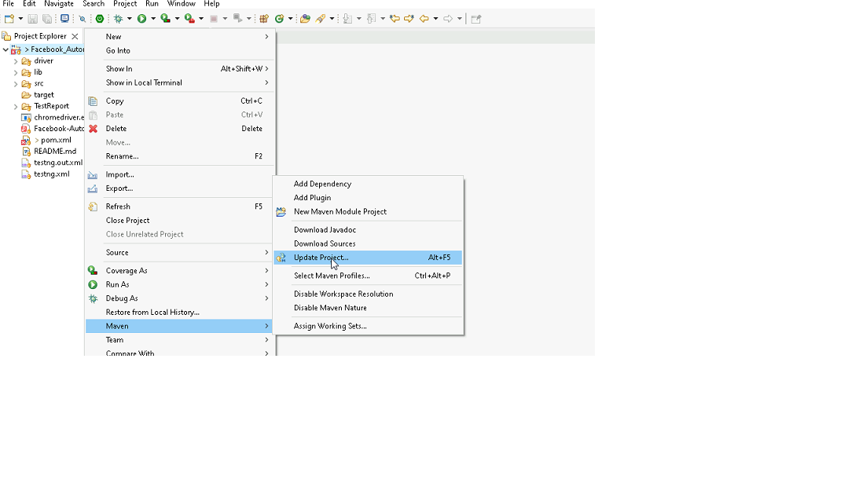

1. In Update Maven Project Box Select “Force Update of Snapshots/Releases” and click OK

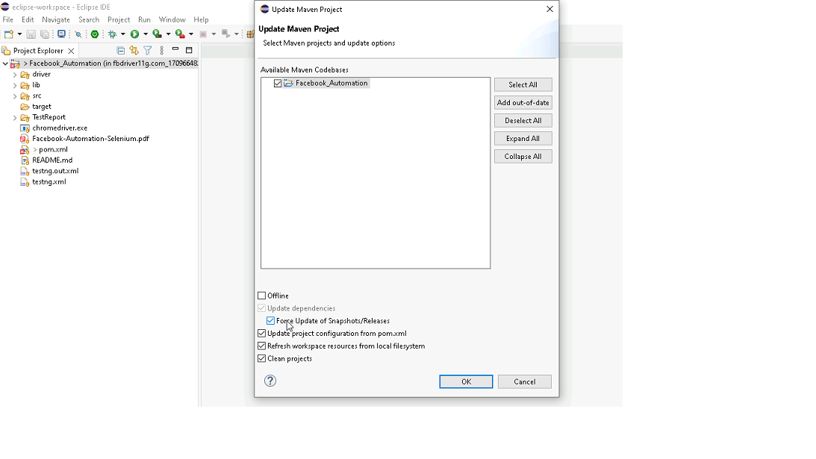

Template Code Structure: Packages and files you will be required to work upon. Other Files and packages you can ignore.

|  |  |  |
| --- | --- | --- |
| Package | Class/File | Description |
| pages | FaceBookPage.java | 1. All core activities (mentioned in list above) to be performed here. 2. The comments associated with each templated method here describe the expectation. 3. You can define locators and xpath here. 4. Declare any variable/object you need to share data/status between different methods. 5. Do not modify the signature of methods declared here. 6. You can create additional supportive common methods in CommonEvents class. |
| resources | Config.json | URL to navigate to. Already URL is defined here |
|  | expected_data.json | Contains data to fill in form |
| coreUtilities.utils | CommonEvents.java | 1. Contains all common activities. 2. Certain templated common method declared here. 3. You implement them as per your need. 4. You can add any additional method for common activity here |
|  | FileOperations.java | 1. Contains methods to read from json file. 2. Method is in templated form. 3. **You will be required to implement these methods as very first activity, because even URL to navigate to, is read using these methods.** |
|  |  |  |

Expectations:

1. Learners should write automation script using Java and selenium to automate all the steps in the above question. In other words, automation script should perform all mentioned steps.
2. Learners should not use any tools to create the xpath. They should develop the xpath/cssselector on their own.

IMPLEMENTATION/FUNCTIONAL REQUIREMENT

* 1. **CODE QUALITY/OPTIMIZATIONS**
     1. Associates should have written clean code that is readable.
     2. Associates need to follow SOLID programming principles.

EXECUTION STEPS TO FOLLOW

1. **You are mandatory required to run test cases for applications before final submission. Without which project evaluation will not happen.**
2. **You can launch test cases any time as follows: Right click on testng.xml and run TestNGSuite**

1. **Before final submission, you are also required to push your code to GIT. Following are the steps to follow:**

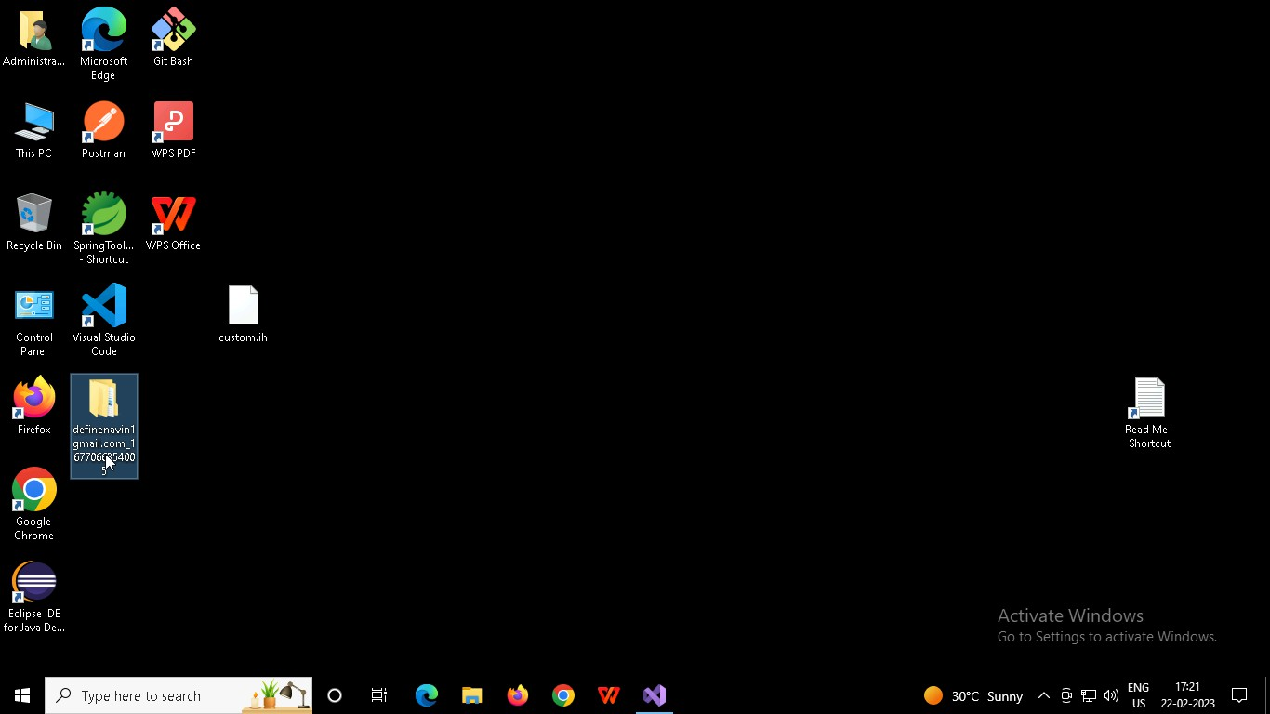

Right click in folder and open Git Bash

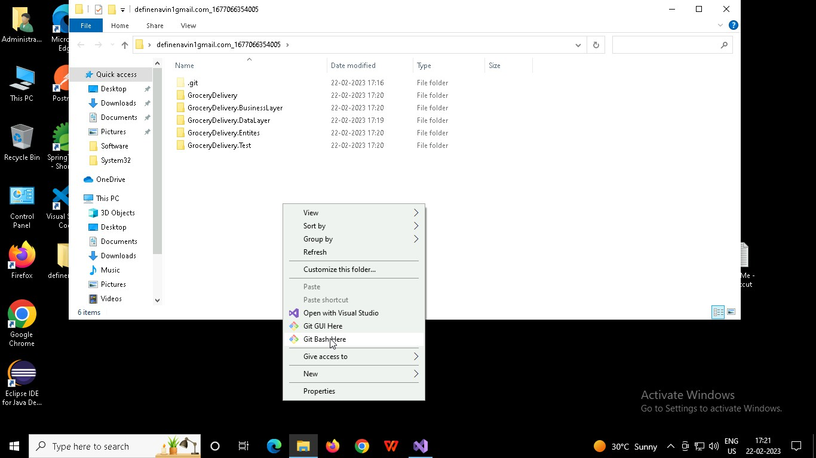

In Git bash terminal, run following commands

* 1. git status
  2. git add .
  3. git commit -m “First commit”

(You can provide any message every time you commit)

* 1. git push

