Form Automation

PROBLEM STATEMENT

Need to automate the following activities using Selenium + Java.

Key Activities to implement:

1.       Navigate to https://demo.automationtesting.in/Register.html.

2.       Retrieve the title of the page. The title of the page should be "Register".

3.       Click SwitchTo à Alert Link.

4.       Validate if control is navigated to new page

5.       Click on button to display the alert box

6.       Validate if alert popup is shown.

7.       Close the popup.

8.       Click on Register menu option to navigate to Register page.

9.       Fill the form with data provided in json file (expected_data.json).

10.   Click on the country dropdown.(Second One)

11.   Select each country option one by one.

12.   Validate if each country option is selectable from the dropdown.

13.   Check and uncheck each hobby checkbox.

14.   Validate that the checkboxes are responding correctly to user interaction, allowing selection and deselection.

15.   Select each radio button option for gender.

16.   Validate that only one radio button option should be selectable at a time.

17.   Enter passwords in the "Password" and "Confirm Password" fields according to different scenarios (matching, non-matching, pattern validation).

18.   Select different dates from the Date Of Birth fields.

19.   Validate that dates are selectable, and the selected values should be captured accurately.

20.   Click on the image upload button.

21.   Choose an image file from the file system.

22.   Validate that the selected image should be displayed on the page after upload.

23.   Leave the phone number empty.

24.   Attempt to submit the form.

25. Verify that error messages for incomplete field displayed as appropriate.

26. Click on “SwitchTo” Tab, Click on Window and then Click on Tab.

27. Check of a new Tab is opened.

28. Click on “SwitchTo” Tab, Click on Window and then Click on Open New Separate Window

29. Check if a new Window is opened

30. Click on “SwitchTo” Tab, Click on Window and then Click on Open Separate Multiple Window.

31. Check if multiple windows are open.

32. Click on “SwitchTo” Tab, Click on Frame and then click on Single Frame and Pass the Value In Textbox

33. Click on “SwitchTo” Tab, Click on Frame and then click on Frame within Frame and Pass the Value In Textbox

34. Click on “Widgets” Tab, Click on Accordion, Select Any Groups And Fetch Data

35. Click on “Widgets” Tab, Click on Auto Complete and Pass Value

36. Click on “Widgets” Tab, Click on Slider and Perform Maximize Minimize activity

37. Click on “Interactions” Tab, Click on DragAndDrop, Click on Static and Perform Drag And Drop Action

38. Click on “Interactions” Tab, Click on DragAndDrop, Click on Dynamic and Perform Drag And Drop Action

Pre-requisite:

As soon as you import project in eclipse, update the project using maven update option as below. This is to resolve issue if any maven dependency not downloaded properly:

1. Right click on project : Go to “Maven” : Select “Update Project”

1. In Update Maven Project Box Select “Force Update of Snapshots/Releases” and click OK

Template Code Structure: Packages and files you will be required to work upon. You can avoid other files and packages

|  |  |  |
| --- | --- | --- |
| Package | Class/File | Description |
| pages | DemoRegisterPages.java | 1. All core activities (mentioned in list above) to be performed here. 2. The comments associated with each templated method here describe the expectation. 3. You can define locators and xpath here. 4. Declare any variable/object you need to share data/status between different methods. 5. Do not modify the signature of methods declared here. 6. You can create additional supportive common methods in CommonEvents class. |
| resources | Config.json | URL to navigate to. Already URL is defined here |
|  | expected_data.json | Contains data to fill in form |
| coreUtilities.utils | CommonEvents.java | 1. Contains all common activities. 2. Certain templated common method declared here. 3. You implement them as per your need. 4. You can add any additional method for common activity here |
|  | FileOperations.java | 1. Contains methods to read from json file. 2. Method is in templated form. 3. **You will be required to implement these methods as very first activity, because even URL to navigate to, is read using these methods.** |
|  |  |  |

Expectations:

1. Learners should write automation script using Java and selenium to automate all the steps in the above question. In other words, automation script should perform all mentioned steps.
2. Learners should not use any tools to create the xpath. They should develop the xpath/cssselector on their own.

IMPLEMENTATION/FUNCTIONAL REQUIREMENT

* 1. **CODE QUALITY/OPTIMIZATIONS**
     1. Associates should have written clean code that is readable.
     2. Associates need to follow SOLID programming principles.

EXECUTION STEPS TO FOLLOW

1. **You are mandatory required to run test cases for applications before final submission. Without which project evaluation will not happen.**
2. **You can launch test cases any time as follows: Right click on testng.xml and run TestNGSuite**

1. **Before final submission, you are also required to push your code to GIT. Following are the steps to follow:**

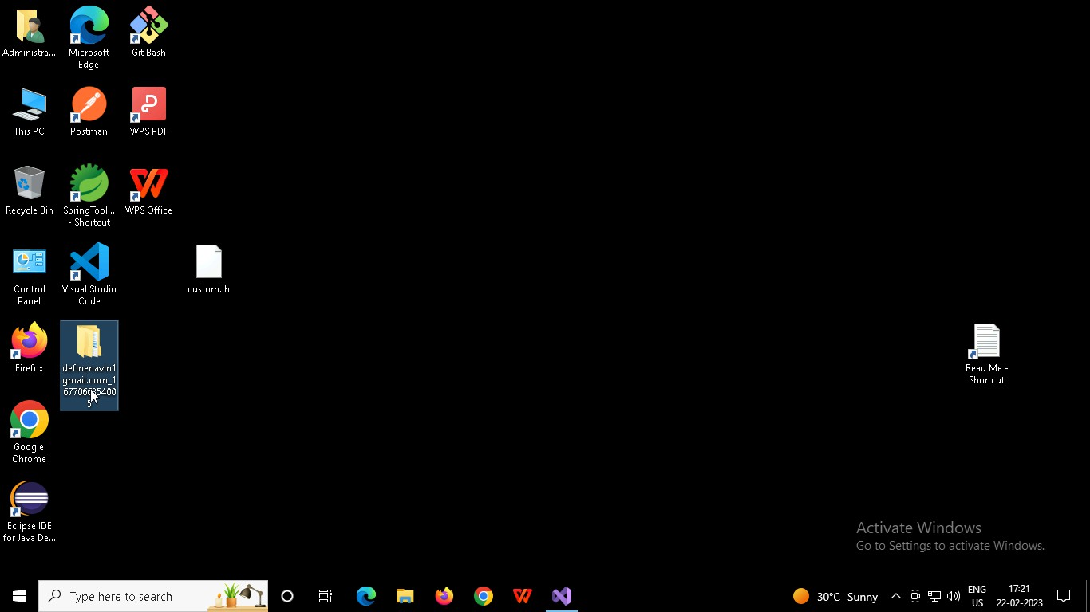

Right click in folder and open Git Bash

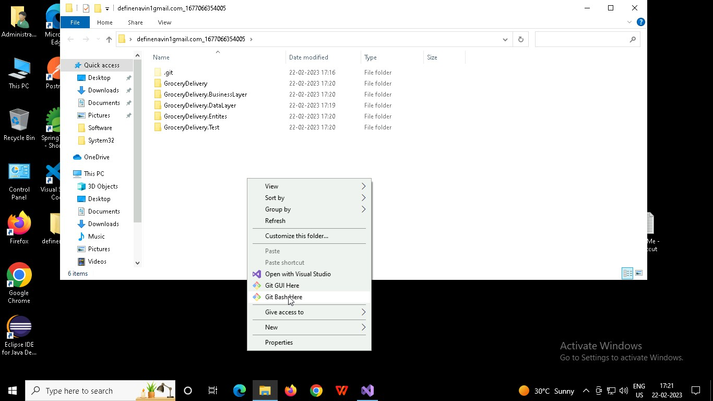

In Git bash terminal, run following commands

* 1. git status
  2. git add .
  3. git commit -m “First commit”

(You can provide any message every time you commit)

* 1. git push

