Shopping Cart Automation

Table of Contents

Key Activities to implement. 2

Helper activities to implement. 3

Locator to implement. 3

PROBLEM STATEMENT

Need to automate the following activities using Selenium + Java.

Key Activities to implement:

|  |  |
| --- | --- |
| **SN** | **Test Steps** |
| **1** | Navigate to: http://practice.automationtesting.in/ |
| **2** | Verify navigate to the home page |
| **3** | Check “Shop” Menu Option is present or not |
| **4** | Click on “Shop” Menu Option |
| **5** | Validate if successfully navigated to the shop page or not |
| **5** | Click on the Automation Testing logo. |
| **6** | Verify if navigate to the home page by clicking on the Logo |
| **7** | Check if Home page has a section of new arrivals. |
| **8** | Check of “Arrivals” section has exactly 3 products enlisted. |
| **9** | Click on Selenium Ruby Product. |
| **10** | Check if the control is successfully navigated to Selenium Ruby Product Details page |
| **11** | Check if product details page has an option ADD TO BASKET. |
| **12** | Click on ADD TO BASKET |
| **13** | Verify that view button is present after click on add to basket and click on View basket |
| **14** | Verify that user is navigate to the Cart or Basket page |
| **15** | Verify after clicking on View basket the Selenium Ruby product is present or not. |
| **16** | Verify Coupon code field and Apply Coupon button is present |
| **17** | Check if we have price defined after product name |
| **18** | Check if we have quantity defined after product price. |
| **19** | Check if we have total defined is present after quantity. |

Pre-requisite:

As soon as you import project in eclipse, update the project using maven update option as below. This is to resolve issue if any maven dependency not downloaded properly:

1. Right click on project : Go to “Maven” : Select “Update Project”

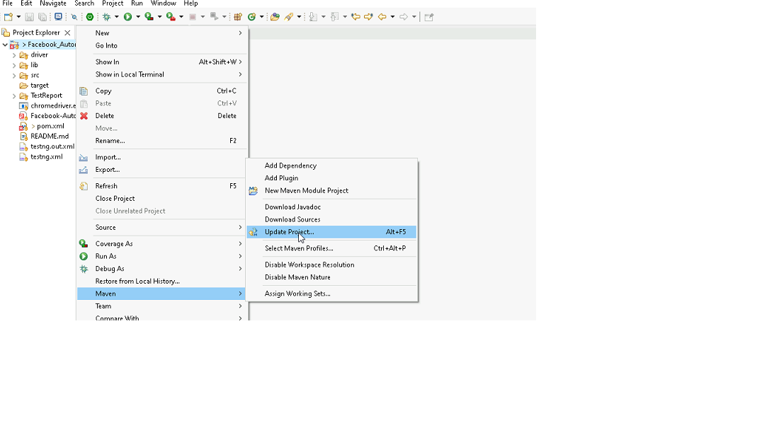

1. In Update Maven Project Box Select “Force Update of Snapshots/Releases” and click OK

Template Code Structure: Packages and files you will be required to work upon. Other Files and packages you can ignore

|  |  |  |
| --- | --- | --- |
| Package | Class/File | Description |
| pages | Practice_Automation_L1_Pages.java | 1. All core activities (mentioned in list above) to be performed here. 2. The comments associated with each templated method here describe the expectation. 3. You can define locators and xpath here. 4. Declare any variable/object you need to share data/status between different methods. 5. Do not modify the signature of methods declared here. 6. You can create additional supportive common methods in CommonEvents class. |
| resources | Config.json | URL to navigate to. Already URL is defined here |
| coreUtilities.utils | CommonEvents.java | 1. Contains all common activities. 2. Certain templated common method declared here. 3. You implement them as per your need. 4. You can add any additional method for common activity here |
|  | FileOperations.java | 1. Contains methods to read from json file. 2. Method is in templated form. 3. **You will be required to implement these methods as very first activity, because even URL to navigate to, is read using these methods.** |
|  |  |  |

Expectations:

1. Learners should write automation script using Java and selenium to automate all the steps in the above question. In other words, automation script should perform all mentioned steps.
2. Learners should not use any tools to create the xpath. They should develop the xpath/cssselector on their own.

IMPLEMENTATION/FUNCTIONAL REQUIREMENT

* 1. **CODE QUALITY/OPTIMIZATIONS**
     1. Associates should have written clean code that is readable.
     2. Associates need to follow SOLID programming principles.

EXECUTION STEPS TO FOLLOW

1. **You are mandatory required to run test cases for applications before final submission. Without which project evaluation will not happen.**
2. **You can launch test cases any time as follows: Right click on testng.xml and run TestNGSuite**

1. **Before final submission, you are also required to push your code to GIT. Following are the steps to follow:**

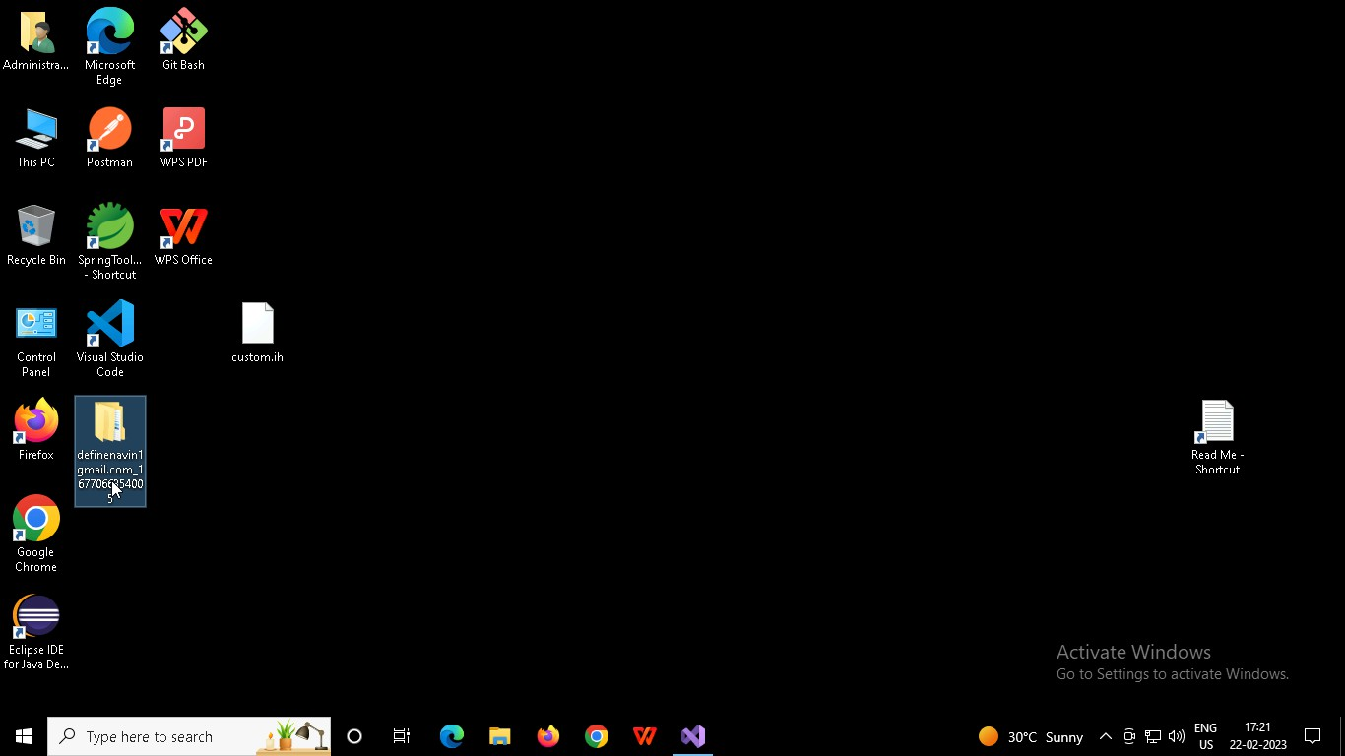

Right click in folder and open Git Bash

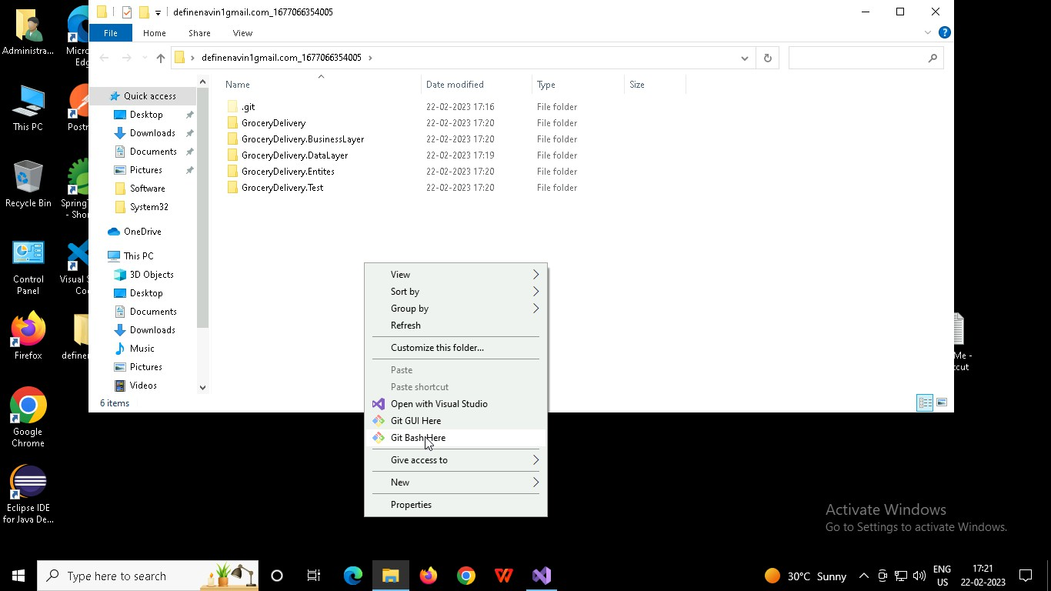

In Git bash terminal, run following commands

* 1. git status
  2. git add .
  3. git commit -m “First commit”

(You can provide any message every time you commit)

* 1. git push

