Shopping Cart Automation

Table of Contents

Key Activities to implement. 2

Helper activities to implement. 3

Locator to implement. 3

PROBLEM STATEMENT

Need to automate the following activities using Selenium + Java.

Key Activities to implement:

|  |  |
| --- | --- |
| **SN** | **Test Steps** |
| **1** | Navigate to: http://practice.automationtesting.in/ |
| **2** | Verify navigate to the home page |
| **3** | Check “Shop” Menu Option is present or not |
| **4** | Click on “Shop” Menu Option |
| **5** | Validate if successfully navigated to the shop page or not |
| **5** | Click on the Automation Testing logo. |
| **6** | Verify if navigate to the home page by clicking on the Logo |
| **7** | Check if Home page has a section of new arrivals. |
| **8** | Check of “Arrivals” section has exactly 3 products enlisted. |
| **9** | Click on Selenium Ruby Product. |
| **10** | Check if the control is successfully navigated to Selenium Ruby Product Details page |
| **11** | Check if product details page has an option ADD TO BASKET. |
| **12** | Click on ADD TO BASKET |
| **13** | Verify that view button is present after click on add to basket and click on View basket |
| **14** | Verify that user is navigate to the Cart or Basket page |
| **15** | Verify after clicking on View basket the Selenium Ruby product is present or not. |
| **16** | Verify Coupon code field and Apply Coupon button is present and Check if we have price defined, quantity defined, total defined fields are present. |
| **17** | Validate if we have an option to remove an added product or not and remove the product, validate if we get a message after removing an item with its name or not. |
| **18** | Go to the Home Icon and click on selenium ruby then click on add to basket and verify the item no is increased to +1 |
| **19** | Click on "My Account" and verify all the fields are present or not |
| **20** | Click on "Test Cases ", it should navigate to the "Test Cases " pages . |
| **21** | Verify the url of the "Test Cases " pages |
| **22** | Click on "AT SITE" and verify the "Selenium" and "appium" fields is present or not |
| **23** | Click on "Shop" and verify the "Refine By, Home and filter by price" fields are present or not |

NOTE: "Please do not delete any file in the src folder.  But you are free to add any other file".

Pre-requisite:

As soon as you import project in eclipse, update the project using maven update option as below. This is to resolve issue if any maven dependency not downloaded properly:

1. Right click on project : Go to “Maven” : Select “Update Project”

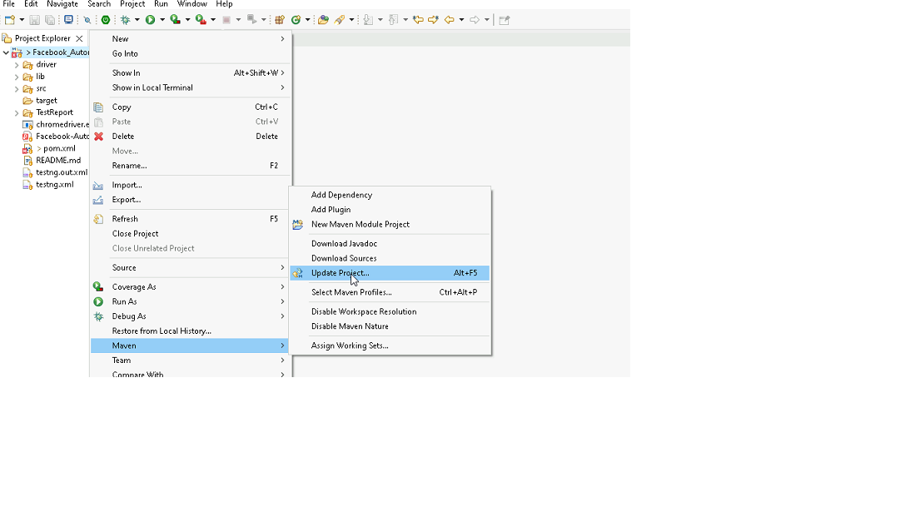

1. In Update Maven Project Box Select “Force Update of Snapshots/Releases” and click OK

Template Code Structure:

1. Below are the packages and files you will be required to work upon.
2. Other Files and packages you can ignore.
3. In other Files and packages do not do any changes. It would affect your evaluation.
4. You are not required to work in “Test” Folder. Files there are non-editable. Editing those files and trying to save them will throw error and would affect your evaluation.

|  |  |  |
| --- | --- | --- |
| Package | Class/File | Description |
|  | FileOperations.java | 1. Contains methods to read from json file. 2. Method is in templated form. 3. **You will be required to implement these methods as very first activity, because even URL to navigate to, is read using these methods.** |
| pages | ShoppingCartAutomationPages.java | 1. All core activities (mentioned in list above) to be performed here. 2. The comments associated with each templated method here describe the expectation. 3. You can define locators and xpath here. 4. Declare any variable/object you need to share data/status between different methods. 5. Do not modify the signature of methods declared here. 6. You can create additional supportive common methods in CommonEvents class. |
| resources | Config.json | URL to navigate to. Already URL is defined here |
| coreUtilities.utils | CommonEvents.java | 1. Contains all common activities. 2. Certain templated common method declared here. 3. You implement them as per your need. 4. You can add any additional method for common activity here |
|  |  |  |

Expectations:

1. Learners should write automation script using Java and selenium to automate all the steps in the above question. In other words, automation script should perform all mentioned steps.
2. Learners should not use any tools to create the xpath. They should develop the xpath/cssselector on their own.

IMPLEMENTATION/FUNCTIONAL REQUIREMENT

* 1. **CODE QUALITY/OPTIMIZATIONS**
     1. Associates should have written clean code that is readable.
     2. Associates need to follow SOLID programming principles.

EXECUTION STEPS TO FOLLOW

1. **You are mandatory required to run test cases for applications before final submission. Without which project evaluation will not happen.**
2. **You can launch test cases any time as follows: Right click on testng.xml and run TestNGSuite**

1. **Before final submission, you are also required to push your code to GIT. Following are the steps to follow:**

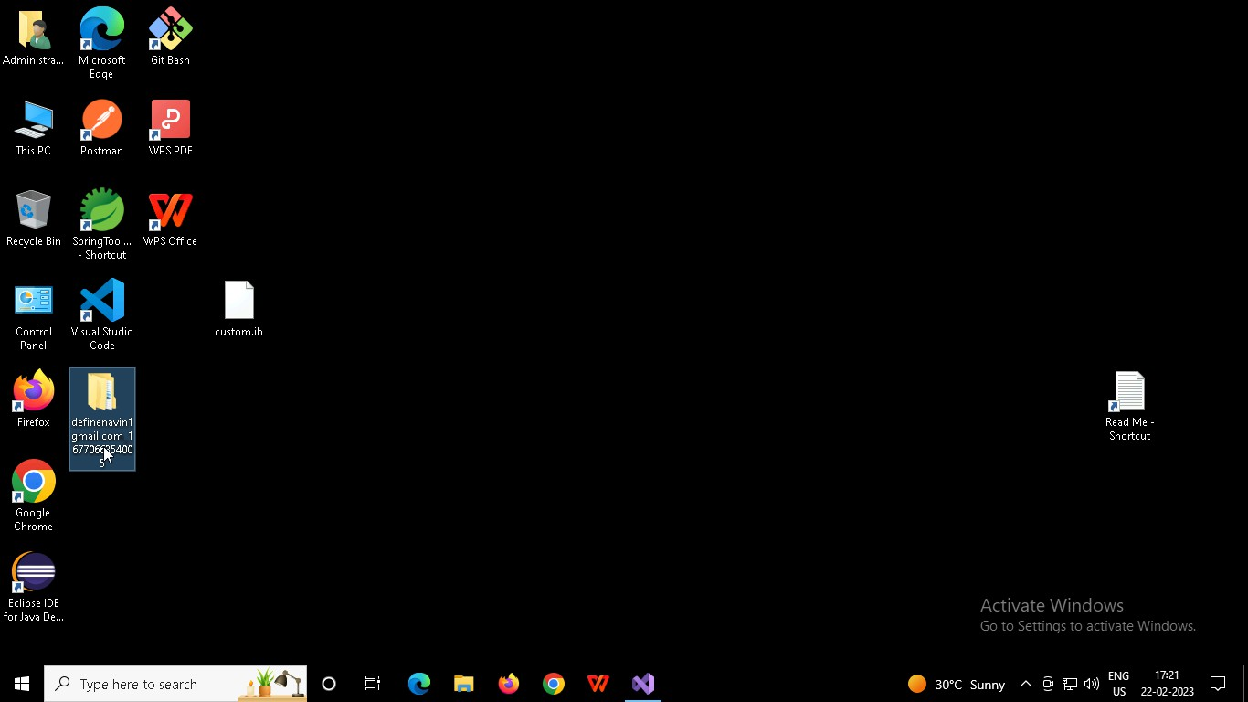

Right click in folder and open Git Bash

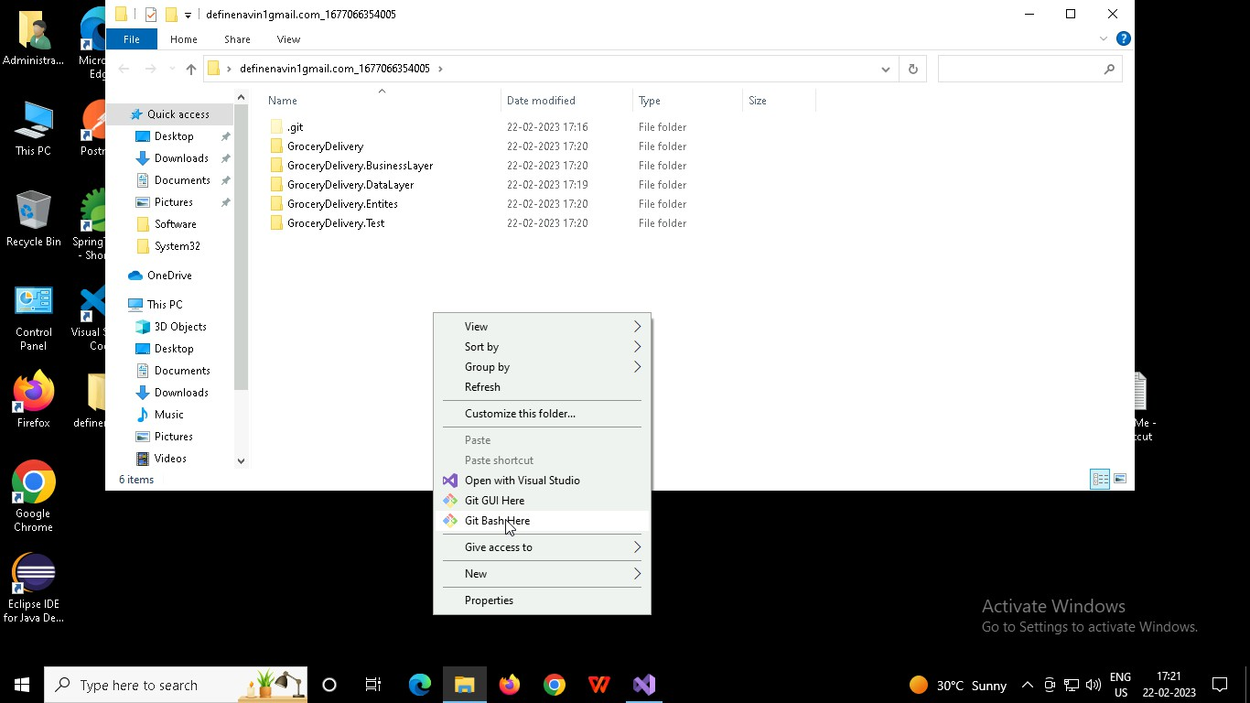

In Git bash terminal, run following commands

* 1. git status
  2. git add .
  3. git commit -m “First commit”

(You can provide any message every time you commit)

* 1. git push

