YAKSHA HEALTH APP WITH JAVASCRIPT AND CYPRESS

**Usecase summary**

**Project Name:**opensource-demo.orangehrmlive.com app – HR management system**.**

**Use Case Summary:** opensource-demo.orangehrmlive.com is designed to manage Employee record.

Records (HRMS). It allows users to view, search, and manage employee records. It features functionality such as adding/editing employee details, filtering data by department and role, and exporting records. The primary use case is to automate the process of employee data management, ensuring efficient and reliable operations for human resources teams in organizations

**Technology Stack:**

* **Automation Tool: Cypress (for testing)**

**Key Features:**

* **Patient Record Management:** Add, edit, and delete Employee records**.**
* **Filtering and Search**: Search Employee records by date range, name, department, and more.
* **Export Functionality:** Export records for offline access.

**Expected Outcomes:**

* Automate key HR operations like employee record handling, filtering, and validation.
* Ensure the accurate retrieval and modification of employee records, enhancing operational efficiency.

**Overview of the application**

**Pages/Features that are to be focused for the application**

Please use the Application URL [**https:/opensource-demo.orangehrmlive.com**](https://healthapp.yaksha.com/)

PROBLEM STATEMENT

Need to automate the following activities using cypress+javascript

You will be given few Json files in fixtures folder like doctor.json, login.json, maternity.json, medicalRecord.json, patientName.json, pharmacy.json, radiology.json, settings.json and subStore.json.

|  |  |  |
| --- | --- | --- |
| **Path** | **File** | **Description** |
| \fixtures | USerDetailForm.Json  ImgaeGreaterThan1Mb.jpeg  LoginData.json  skyImage.jpg | 1. Contains data to read   from json file. |

|  |  |  |
| --- | --- | --- |
| PageObjects\Pages | * AdminPage * BuzzPage * HomePage * LeavePage * LoginProfile * ProfilePage * MyInfoPage * PimPage | 1. All core activities to be performed here. 2. The comments associated with each templated method here describe the expectation. 3. Declare any variable/object you need to share data/status between different methods.   Do not modify the signature of methods declared here. |

Here’s a detailed table format for the test cases to be tested

|  |  |  |  |  |  |
| --- | --- | --- | --- | --- | --- |
| **Test Case**  **No.** | **Test Case Name** | **Test Steps to be performed** | **Path & Method Used** | | **Expected Result** |
| 1 | Verify "Delete Post"  Functionality | 1. Login using valid   credentials  2. Click on "Buzz" tab in   sidebar  3. Click on Delete buƩon on   any post in the List  4. Click on "Yes delete"   button in popup.  **Images must exist in Cypress /fixtures User must be logged in.** | **Located in** PageObjects/Pages/BuzzPage.js  **Methods:** deletePostCheck(),  verifyBuzzPostDelete() | | Post should get Deleted |
| 2 | Verify "Get" help button is functional | 1. Login using valid credentials 2. click on "Ques on mark icon"   button.  **Images must exist in Cypress /fixtures User must be logged in.** | | **Located in** PageObjects/Pages/HomePage.js,  **Methods:** tooltipFunctional(),  verifyHelpButtonOpensNewTab() | Verify "Get" help button is functional | |

|  |  |  |  |  |
| --- | --- | --- | --- | --- |
| **Test Case**  **No.** | **Test Case Name** | **Test Steps to be performed** | **Path & Method Used** | **Expected Result** |
| 3 | |  | | --- | | Verify List of Reports |  |  | | --- | |  | | 1. Login using valid credentials 2. Click on "PIM" in the sidebar 3. Click on the Employee List tab 4. check for presence of a list   **User must be logged in with Admin access.** | **Reference path**  PageObjects/Pages/  PimPage.js:  **Methods**  employeeListCheck(),  verifyEmpListPresense() | |  | | --- | |  |  |  | | --- | | A list of employees  should appear. | |
| 4 | Verify Employee List Search functionality | 1. Login using valid credentials 2. Click on "PIM" in the sidebar 3. Click on the Employee List tab 4. Enter the Username to search 5. Click the "Search" button   **User must be logged in and on the home page** | **Reference path**  PageObjects/Pages/PimPage.js  **Methods**  searchEmployeeById()  verifyEmpListSearch() | Admin record is saved successfully with toast confirmation |
| 5 | |  | | --- | | Verify  Primary  Colour of  corporate  branding  could be  changed |  |  | | --- | |  | | |  | | --- | | 1. Login using valid credentials 2. Click on "admin" in the side   bar   1. Click on the "Corporate branding" tab 2. Click the colour circle after   primary colour label   1. Enter the hexacode of the   colour   1. Click on Publish button   **User must be logged in with**  **Admin privileges.** |  |  | | --- | |  | | **Reference path**  PageObjects/Pages/AdminPage.j  **Methods**  changePrimaryColour verifyColourChanged() | Primary colour should set to desired one |

|  |  |  |  |  |
| --- | --- | --- | --- | --- |
| **Test Case**  **No.** | **Test Case Name** | **Test Steps to be performed** | **Path & Method Used** | **Expected Result** |
| 6 | Verify Client Logo could not be uploaded above 1 mb | 1. Login using valid credentials 2. Click on "admin" in the sidebar 3. Click on the "Corporate branding" tab 4. Click the Client Logo Browse button 5. Select the desired file from device and click open button   **Images must exist in cypress/fixtures User must be logged in** | **Located in** PageObjects/Pages/AdminPage.js:  **Methods :**  uploadImageGt1Mb('ImageGreaterThan1Mb.jpg'),  verifyIncorrecrDimError(); | Incorrect Dimension  Error should Display |
| 7 | |  |  | | --- | --- | | Verify  Language  change  Functionality |  |  |  | | --- | |  | | |  | | --- | |  | | 1. Login using valid credentials 2. Click on "admin" in the sidebar 3. Click on the "Configuration" tab. 4. Click the Localization button 5. Select the desired Language from the dropdown (Chinese) 6. Click on Save button | |   **At least one user should exist in the user list User must be logged in with Admin privileges.** | **Reference path**  PageObjects/Pages/AdminPage.js:  **Methods:**  languageChangeFunctionality()  verifyLanguageChangeFunctionality(); | Successfully Updated alert should be displayed |
| 8 | |  | | --- | | Verify Required Field Error in Leaves Tab displays when required field is empty |  |  | | --- | |  | | 1. Login using valid credentials 2. Click on "leave" in the sidebar 3. Click on the "assign Leave"   button   1. Click on "Assign" button without filing any details in any field   **User must be logged in with Admin access At least two records with different usernames must exist** | **Reference path**  PageObjects/Pages/  LeavePage.js:  **Methods**  leaveAssignEmptyValueError()  varifyAssignEmptyFieldError() | |  | | --- | | "Required" error should  be displayed | |
| 9 | Verify My info Download  Functionality | 1. Login using valid credentials 2. Click on "My info" in the sidebar 3. Scroll to the bottom 4. Click on "Download icon"   buton  **User must be logged in and on the Home page** | **Reference path**  PageObjects/Pages/MyInfoPage.js  **Methods**  myInfoPageDownloadFunctionality()  verifyMyInfoPageDownloadFunctionality() | File should get  Downloaded |
| **10** | Verify User details could be  Updated | 1. Login using valid credentials 2. Click on "My info" in the sidebar 3. Enter the user name ,middle name, last name in the form 4. Click the save button>Refresh   **User must be logged in and on the Home page** | **Reference path**  PageObjects/Pages/ProfilePage.js  **Methods**  userProfileUpdateFunction()  verifyUserProfileDetail() | User name should  get Updated successfully |

Learners will gain experience in building strongly-typed applications using React.js and managing data flow with **JavaScript**. They'll learn how to define interfaces, use types for error prevention, and improve code maintainability.

With **Cypress**, learners will learn to write and execute automated tests for the [**https:/opensource-demo.orangehrmlive.com**](https://healthapp.yaksha.com/) app.

Key skills include:

* **Browser Automation**: Interacting with web elements and testing multiple browsers.
* **Assertions & Validations**: Ensuring app behaviour meets expected results.
* **End-to-End Testing**: Automating real user interactions and validating overall app functionality.

# IMPLEMENTATION/FUNCTIONAL REQUIREMENT

* 1. **Code Quality/Optimizations**

# Associates should have written clean code that is readable.

* + 1. Associates need to follow SOLID programming principles.

Execution Steps:

Steps for Execution:

1. **Please open the folder created on desktop with the email name you used to login.**

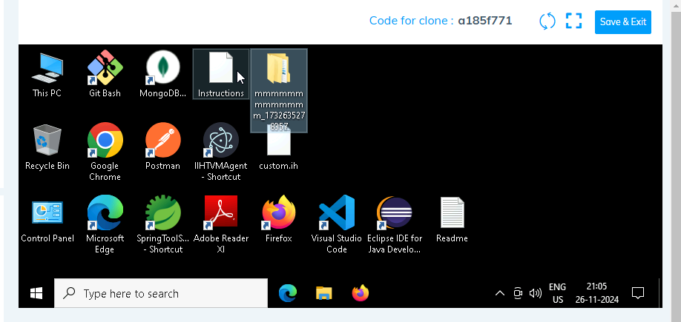

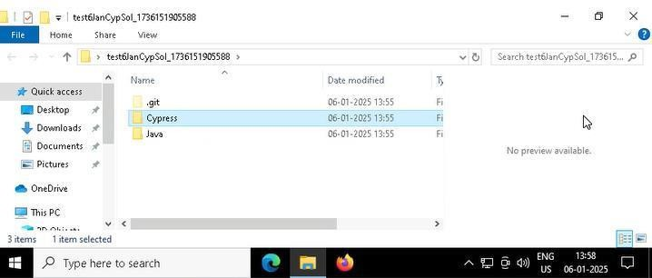

1. **Go into the Cypress folder and execute this “runner” file. This will keep pushing the code at regular**

intervals.

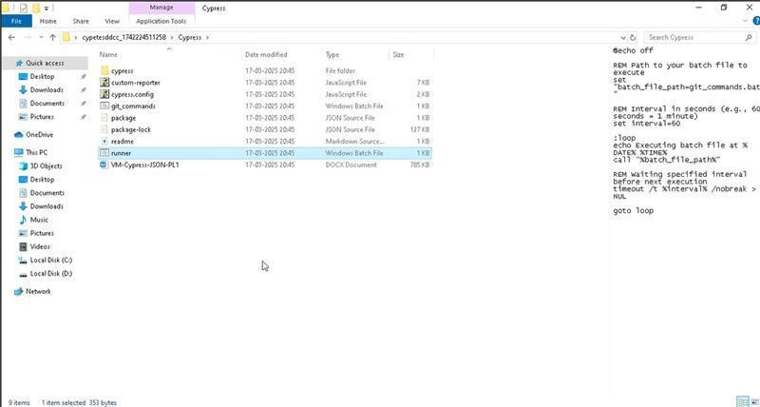

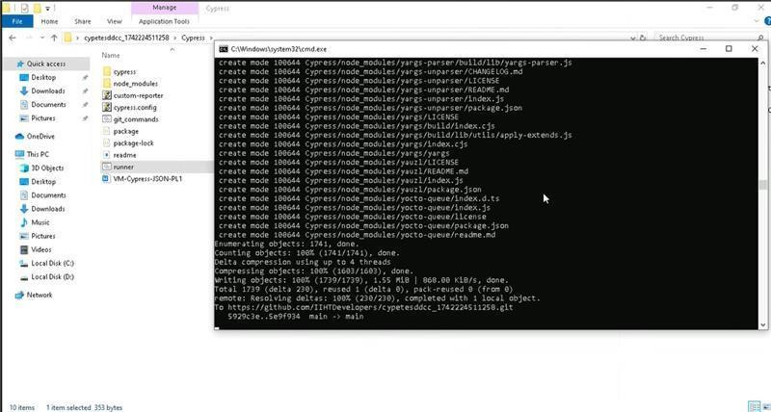

1. **Open command prompt with its location using “cmd” in search bar**

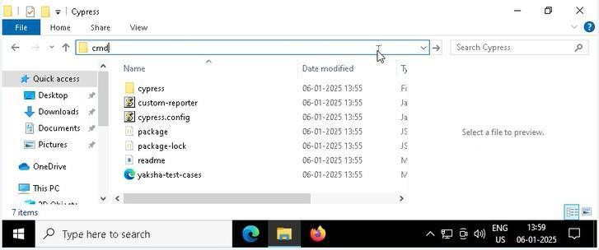

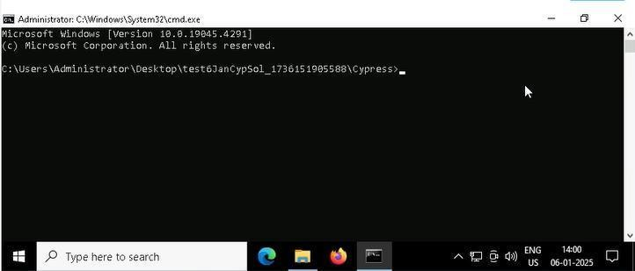

1. **Open VS Code through cmd using below command: code .**

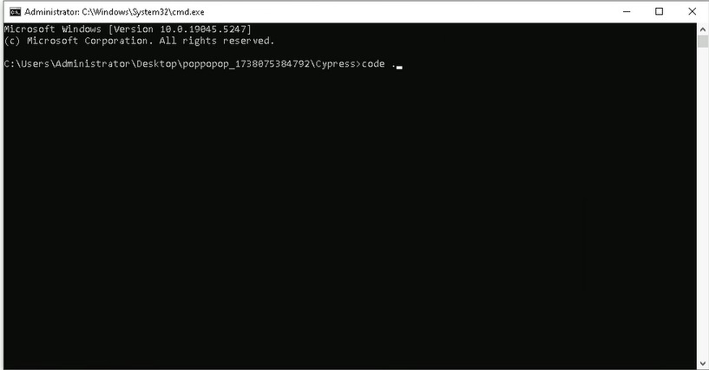

1. **Once VsCode is open. Please open the terminal in Cypress folder:**

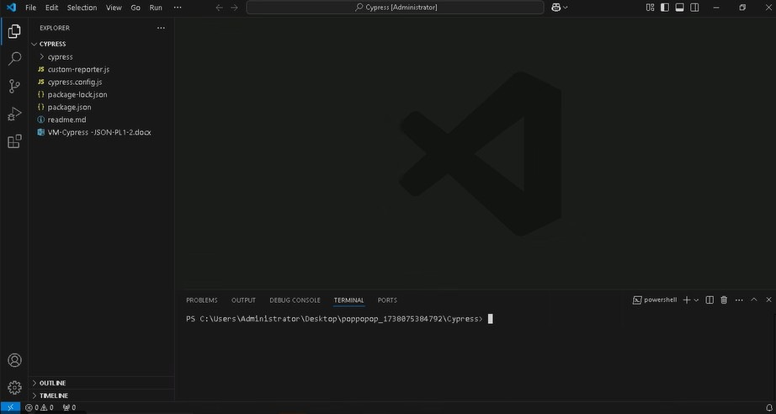

* 1. **Install all dependencies in the Cypress folder path using: npm install**
  2. **Run the following command to open the interactive Cypress Test Runner in the Cypress folder path: npx cypress open**
  3. **Run the following command to run test cases in headless mode in the Cypress folder path: npx cypress run**

If you face any issue in executing above commands i.e npx cypress open and npx cypress run in cmd. Please try to run these in git bash from cypress folder as:

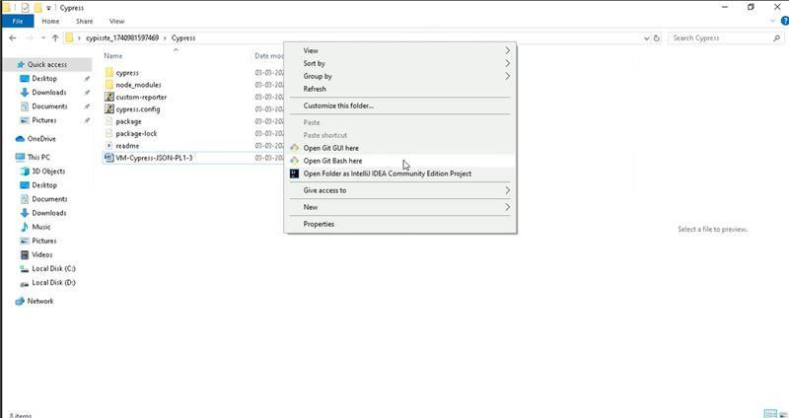

and then execute commands like:

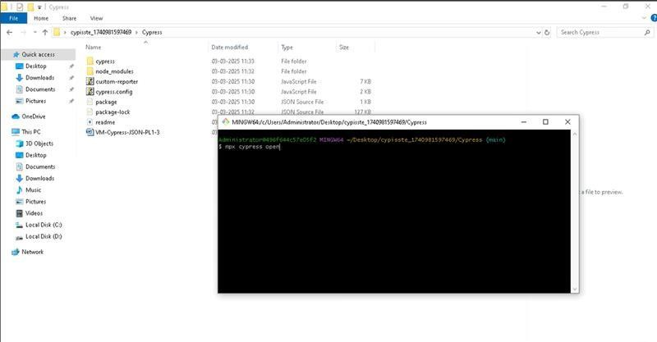

* 1. **Once you have executed the test cases. Now it is necessary to push your code to git. For this, please go inside the folder created on desktop with the email id you have used to login and then:**
     1. **Open gitbash**

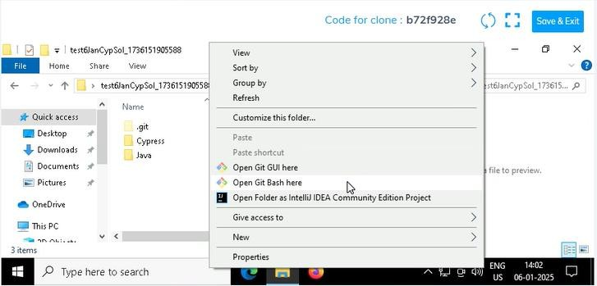

* + 1. **Add all files**

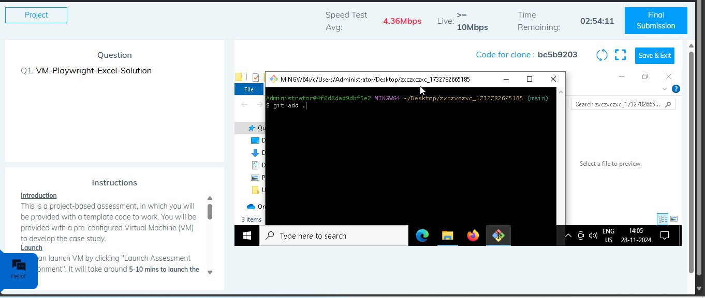

* + 1. **Commit the changes**

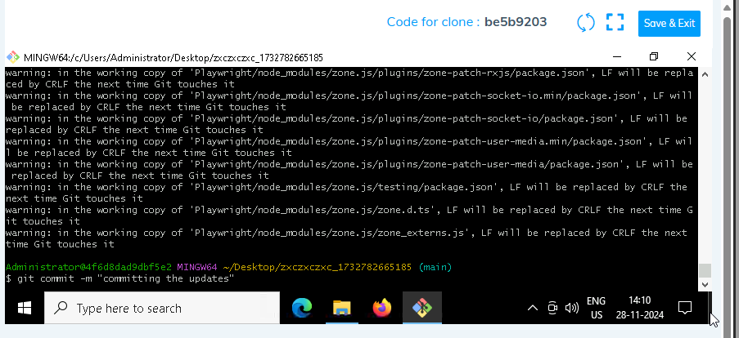

* + 1. **Push the changes**

