Form Automation

Pre-requisite:

As soon as you import project in eclipse, update the project using maven update option as below. This is to resolve issue if any maven dependency not downloaded properly:

1. Right click on project : Go to “Maven” : Select “Update Project”

1. In Update Maven Project Box Select “Force Update of Snapshots/Releases” and click OK

Template Code Structure:

1. Below are the packages and files you will be required to work upon.
2. Other Files and packages you can ignore.
3. In other Files and packages do not do any changes. It would affect your evaluation.
4. You are not required to work in “Test” Folder. Files there are non-editable. Editing those files and trying to save them will throw error and would affect your evaluation.

|  |  |  |
| --- | --- | --- |
| **Package** | **Class/File** | **Description** |
| src/main/java/coreUtilities/utils/ | FileOperations.java | 1. Contains methods to read from json file. 2. Method is in templated form. 3. **You will be required to implement these methods as very first activity, because even URL to navigate to, is read using these methods.** |
| /src/main/java/pages | FormManagement_Pages.java | 1. All core activities (mentioned in list above) to be performed here. 2. The comments associated with each templated method here describe the expectation. 3. You can define locators and xpath here. 4. Declare any variable/object you need to share data/status between different methods. 5. Do not modify the signature of methods declared here. 6. You can create additional supportive common methods in CommonEvents class. |
| /src/main/resources/ | Config.json | URL to navigate to. Already URL is defined here |
|  | expected_data.json | Contains data to fill in form |
| /src/main/java/coreUtilities/utils | CommonEvents.java | 1. Contains all common activities. 2. Certain templated common method declared here. 3. You implement them as per your need. 4. You can add any additional method for common activity here |
|  | Testng.xml | Execution needs to kick started from TestNG xml |

PROBLEM STATEMENT

Need to automate the following activities using Selenium + Java.

Key Activities to implement:

|  |  |
| --- | --- |
| 1 | Navigate to the URL (<https://demo.automationtesting.in/Register.html>) |
| 2 | Validate the Home Page |
| 3 | Click SwitchTo an Alert Link |
| 4 | Validate if control is navigated to new page |
| 5 | Click on button to display the alert box and Validate if alert popup is shown. |
| 6 | Click on Register menu option to navigate to Register page. |
| 7 | Fill the form with data provided in json file. |
| 8 | Click on the country dropdown and Select each country option one by one. |
| 9 | Click on the country dropdown and validate if each country option is selectable from the dropdown. |
| 10 | Check and uncheck each hobby checkbox and validate that the checkboxes are responding correctly to user interaction, allowing selection and deselection. |
| 11 | Select each radio button option for gender and Validate that only one radio button option should be selectable at a time. |
| 12 | Select different dates from the Date Of Birth fields. Validate that dates are selectable |
| 13 | Fill the register form, Fill FirstNameTextbox lastNameTextbox addressInputAreabox emailAddress Textbox And click on submit Button |
| 14 | Click on Interaction Navigation Menu bar, then click on "selectable" option, then click on "Serialize" tab, then click on "Sakinalium - Cross Browser Testing" option |
| 15 | After click on "Sakinalium - Cross Browser Testing" some text value will display . Fetch that text value. |
| 16 | Go to home, then click on "Sign-In" button and validate the title of the "Sign-In" page |
| 17 | Go back to the "Index" page and click on "Skip signIn" button and validate the "Register" page title. |
| 18 | Then fill the register form and click on "Refresh" button |
| 19 | Verify that clicking on refresh button its refreshing all the entered data in all the fields |
| 20 | Go to SwitchTo Tab clickOn Window and then click on "Click" and validate the title of new tab page |
| 21 | Go to SwitchTo Tab clickOn Window and then click on Open new separate window and click and validate the title of new windows page |
| 22 | Go to SwitchTo Tab clickOn Window and then click on Open separate multiple window and click and validate the title of multiple windows page |
| 23 | Go to Interaction clickOn Drag and Drop and click on static validate the title of the Drag and Drop page. |
| 24 | Select the selenium logo and perform Drag and Drop operation. |
| 25 | Go to Widget Tab clickOn Accordio and Select Any Groups And Fetch the Data |
| 26 | Go to Widget Tab clickOn Auto complete and verify the auto complete textbox is present or not then pass the value |

NOTE: "Please do not delete any file in the src folder.  But you are free to add any other file".

Expectations:

1. Learners should write automation script using Java and selenium to automate all the steps in the above question. In other words, automation script should perform all mentioned steps.
2. Learners should not use any tools to create the xpath. They should develop the xpath/cssselector on their own.

IMPLEMENTATION/FUNCTIONAL REQUIREMENT

* 1. **CODE QUALITY/OPTIMIZATIONS**
     1. Associates should have written clean code that is readable.
     2. Associates need to follow SOLID programming principles.

EXECUTION STEPS TO FOLLOW

1. **You are mandatory required to run test cases for applications before final submission. Without which project evaluation will not happen.**
2. **You can launch test cases any time as follows: Right click on testng.xml and run TestNGSuite**

1. **Before final submission, you are also required to push your code to GIT. Following are the steps to follow:**

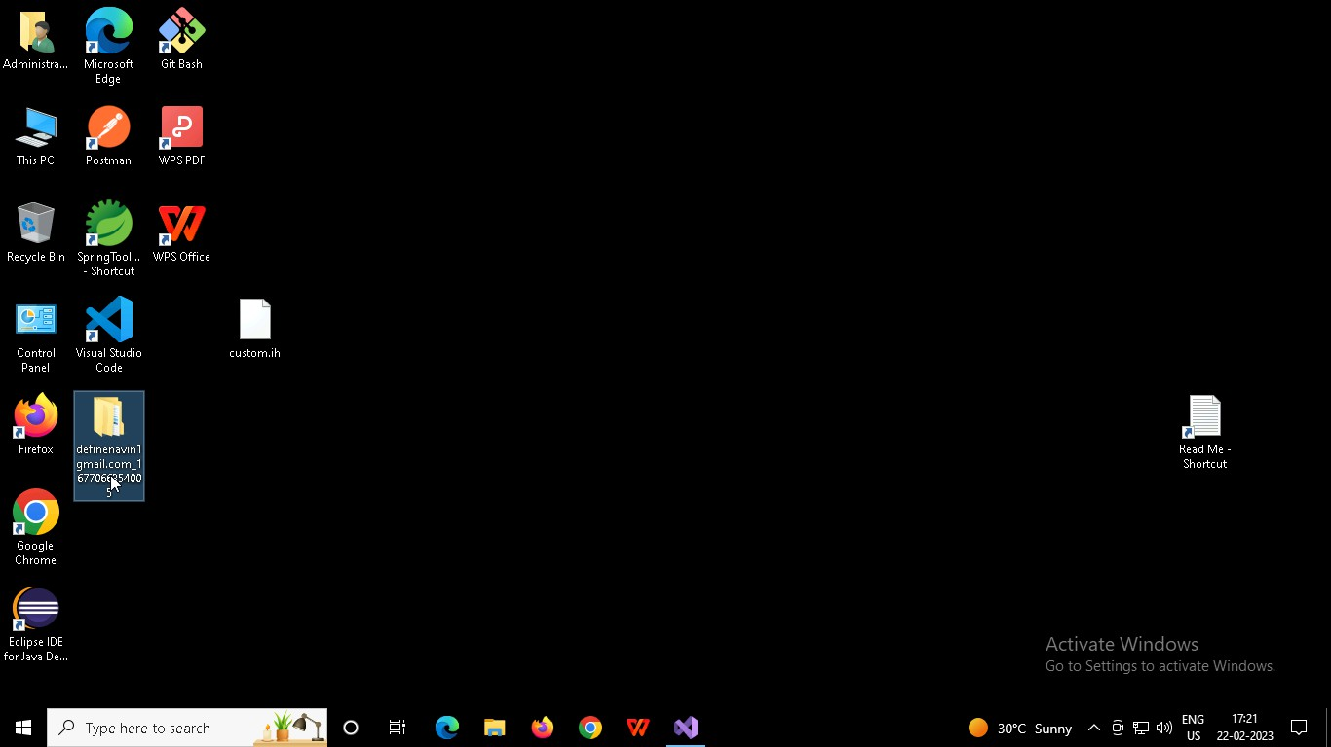

Right click in folder and open Git Bash

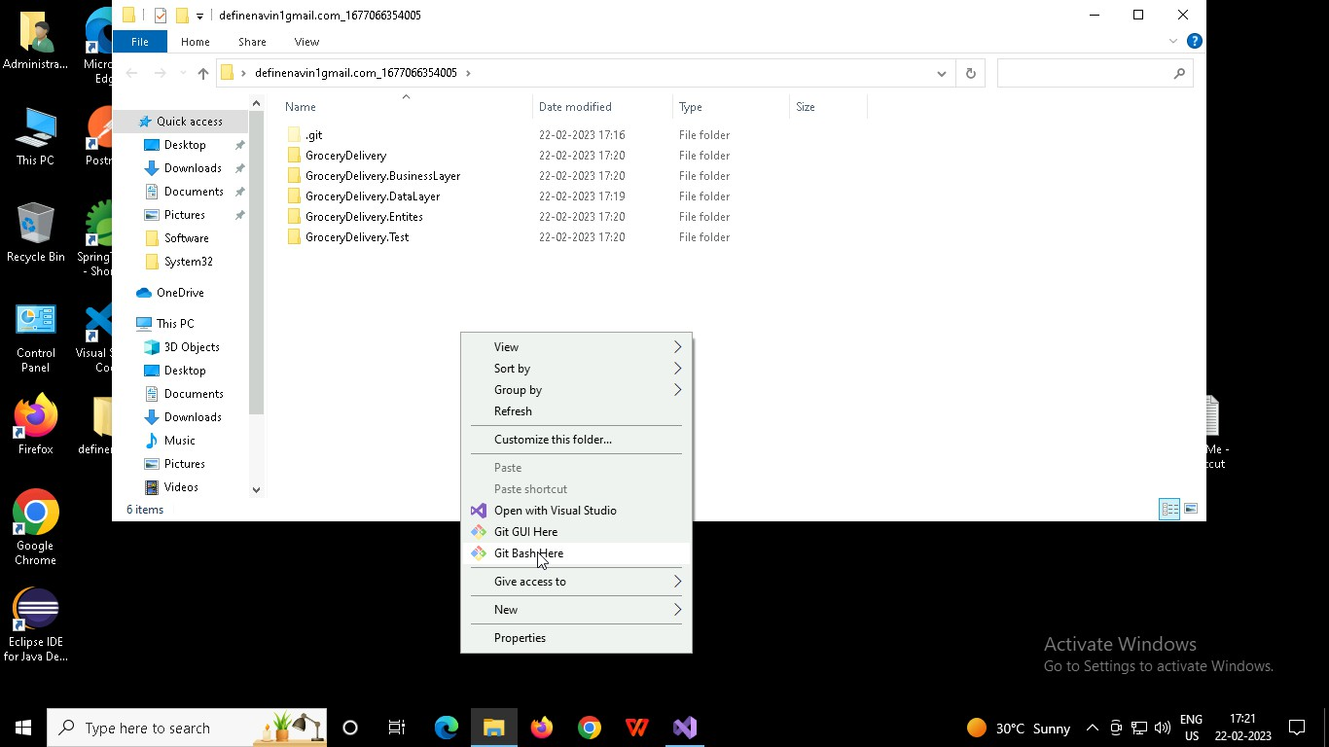

In Git bash terminal, run following commands

* 1. git status
  2. git add .
  3. git commit -m “First commit”

(You can provide any message every time you commit)

* 1. git push

