HealthApp Automation

Pre-requisite:

As soon as you import project in eclipse, update the project using maven update option as below. This is to resolve issue if any maven dependency not downloaded properly:

1. Right click on project : Go to “Maven” : Select “Update Project”

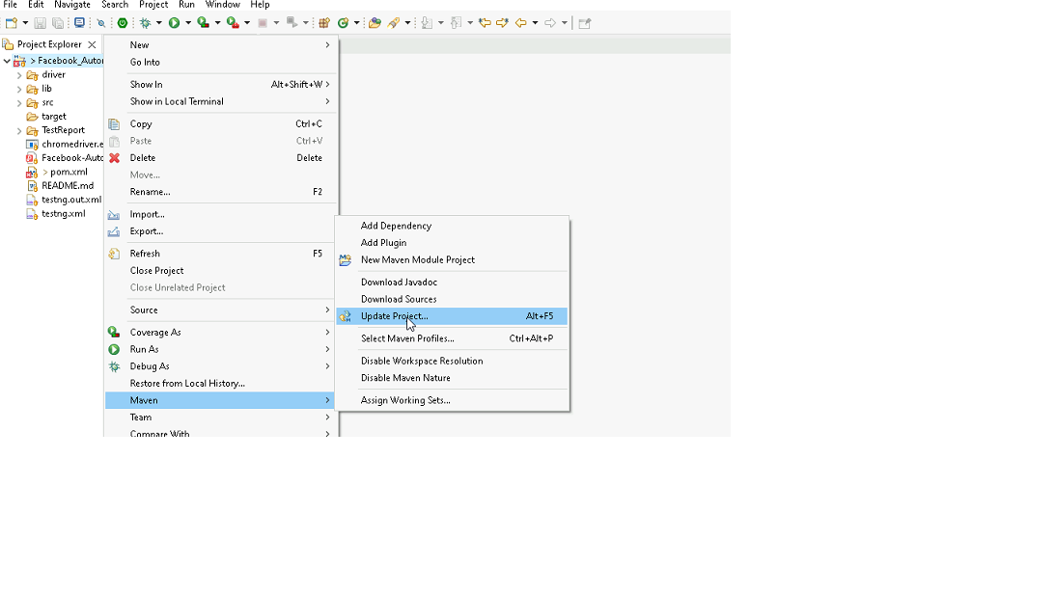

1. In Update Maven Project Box Select “Force Update of Snapshots/Releases” and click OK

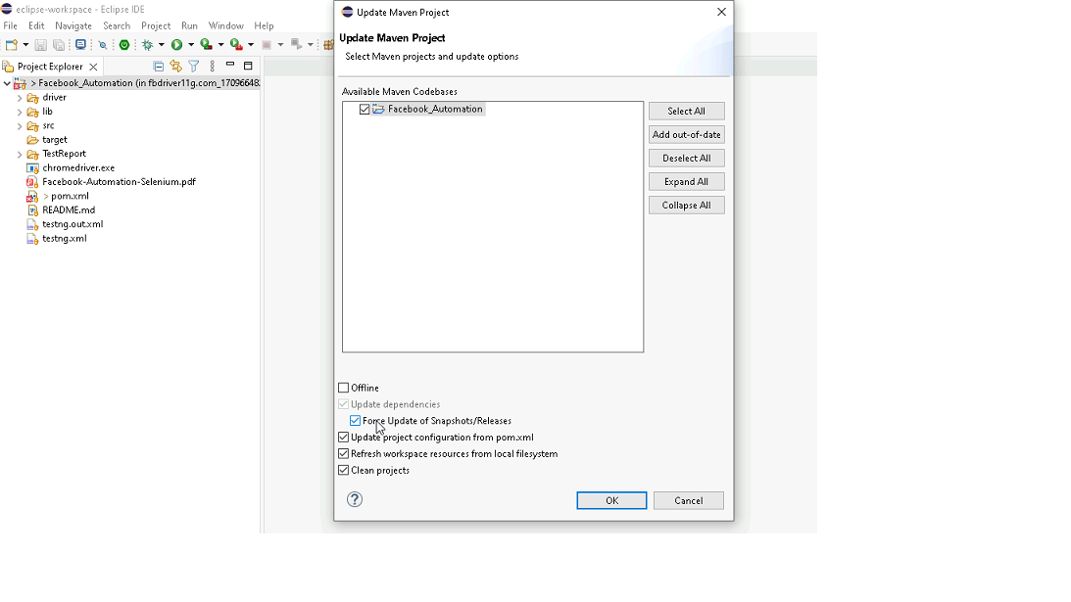

Template Code Structure:

1. Below are the packages and files you will be required to work upon.
2. Other Files and packages you can ignore.
3. In other Files and packages do not do any changes. It would affect your evaluation.
4. You are not required to work in “Test” Folder. Files there are non-editable. Editing those files and trying to save them will throw error and would affect your evaluation.

|  |  |  |
| --- | --- | --- |
| **Package** | **Class/File** | **Description** |
| src/main/java/coreUtilities/utils/ | FileOperations.java | 1. Contains methods to read from json file. 2. Method is in templated form. 3. **You will be required to implement these methods as very first activity, because even URL to navigate to, is read using these methods.** |
| /src/main/java/pages | yakshaHealthAppPages.java | 1. All core activities (mentioned in list above) to be performed here. 2. The comments associated with each templated method here describe the expectation. 3. You can define locators and xpath here. 4. Declare any variable/object you need to share data/status between different methods. 5. Do not modify the signature of methods declared here. 6. You can create additional supportive common methods in CommonEvents class. |
| /src/main/resources/ | Config.json | URL to navigate to. Already URL is defined here |
| /src/main/java/coreUtilities/utils | CommonEvents.java | 1. Contains all common activities. 2. Certain templated common method declared here. 3. You implement them as per your need. 4. You can add any additional method for common activity here |
|  | Testng.xml | Execution needs to kick started from TestNG xml |

PROBLEM STATEMENT

Need to automate the following activities using Selenium + Java.

Key Activities to implement:

|  |  |  |  |
| --- | --- | --- | --- |
| **Sn** | **Summary** | **Action** | **Expected Result** |
| **1** | Verify the title and url of the current page. | 1. go to url : **https://healthapp.yaksha.com/** 2. get the title and url of the current page 3. validate the title and url of the current page | Title should be : DanpheHealth Url should be : https://healthapp.yaksha.com/ |
| **2** | Verify pop up and proceed to the next page in the new 1 counter page. | 1. Click on Billing tab 2.Check Select Counter popup is present 3.Click on New 1 Counter | Search patient page should be present. |
| **3** | Perform the keyboard operation to open the popup and verify that the popup is displayed or not. | 1.Click Alt + N to open the add new patient popup | Add new patient popup should come. |
| **4** | Fill all the textfields which are present inside the Add New Patient popup. | 1.Enter data in the First Name Field. 2.Enter data in the Middle Name Field. 2.Enter data in the Last Name Field. 3.Enter data in the Age Field. 4.Enter data in the Contact Number Field. | All text fields inside the "Add New Patient" popup are successfully filled with appropriate information |
| **5** | Check the data which we are entered are present in all the text fields. | 1.Check data entered in the First Name Field is correctly displayed. 2.Check data entered in the Middle Name Field is correctly displayed 3.Check data entered in the Last Name Field is correctly displayed 4.Check data entered in the Age Field is correctly displayed. 5.Check data entered in the Contact Number Field is correctly displayed | The data entered should correctly displayed in all text fields on the page. |
| **6** | Verify that in **Country** dropdown have all the countries are present or not. | 1.Go to country dropdown. 2.Check all the countries are present or not | Country dropdown have all the countries should present |
| **7** | Simply select India from the **country** dropdown menu and validate India is selected or not. | Select country as India in the country dropdown | User should able to select any country from the country dropdown menu. |
| **8** | Verify the error message, then close the popup. | 1.Click on the Register and Billing button. 2.Verify the error message. 3.Click on Close | Successfully verify the error message. |
| **9** | Verify that the dispensary arrow is expanding and minimizing. | 1.Click on the down arrow of Billing module. 2.Click on the up arrow of Billing module. | Dispensary arrow should expanding and minimizing. |
| **10** | Verify that the left navigation menu scroll bar is scrolling from Dispensary module to settings module. | Scrolling from Dispensary module to settings module. | Scrolling should happen from Dispensary module to settings module. |
| **11** | Search for a patient name and view the details of the selected patient. | 1.Go to Ip Billing tab 2.Search any patient name in search bar 3.Click on View details button | Particular patients details page should open. |
| **12** | First, tick all check boxes then untick them then close that popup. | 1. Click on the Edit items button 2.First Select all check boxes. 3.Unselect all the check boxes. 4.Click on the "X" | User should able to First Select all check boxes and Unselect all the check boxes |
| **13** | Taking screenshot for Doctor page. | 1.Click on the Doctor module. 2.Take a screenshot of the Doctor's home page. | User should take the screenshot. |
| **14** | Deactivate a user or employee by managing the alert popup. | 1.Click on settings 2.Click on security 3.Select any employee 4.Click on Deactivate button present in the specific employee which you want. 5.Click on Ok in the alert popup | User should able to deactivate a user or employee by managing the alert popup. |
| **15** | Verify tooltip of an element which is present inside the Appointment page. | 1.Click on Appointment module. 2.Mouse hover to the Keyboard button. 3.Verify the tooltip message. | Tooltip message should be come. |

NOTE: "Please do not delete any file in the src folder.  But you are free to add any other file".

Expectations:

1. Learners should write automation script using Java and selenium to automate all the steps in the above question. In other words, automation script should perform all mentioned steps.
2. Learners should not use any tools to create the xpath. They should develop the xpath/cssselector on their own.

IMPLEMENTATION/FUNCTIONAL REQUIREMENT

* 1. **CODE QUALITY/OPTIMIZATIONS**
     1. Associates should have written clean code that is readable.
     2. Associates need to follow SOLID programming principles.

EXECUTION STEPS TO FOLLOW

1. **You are mandatory required to run test cases for applications before final submission. Without which project evaluation will not happen.**
2. **You can launch test cases any time as follows: Right click on testng.xml and run TestNGSuite**

1. **Before final submission, you are also required to push your code to GIT. Following are the steps to follow:**

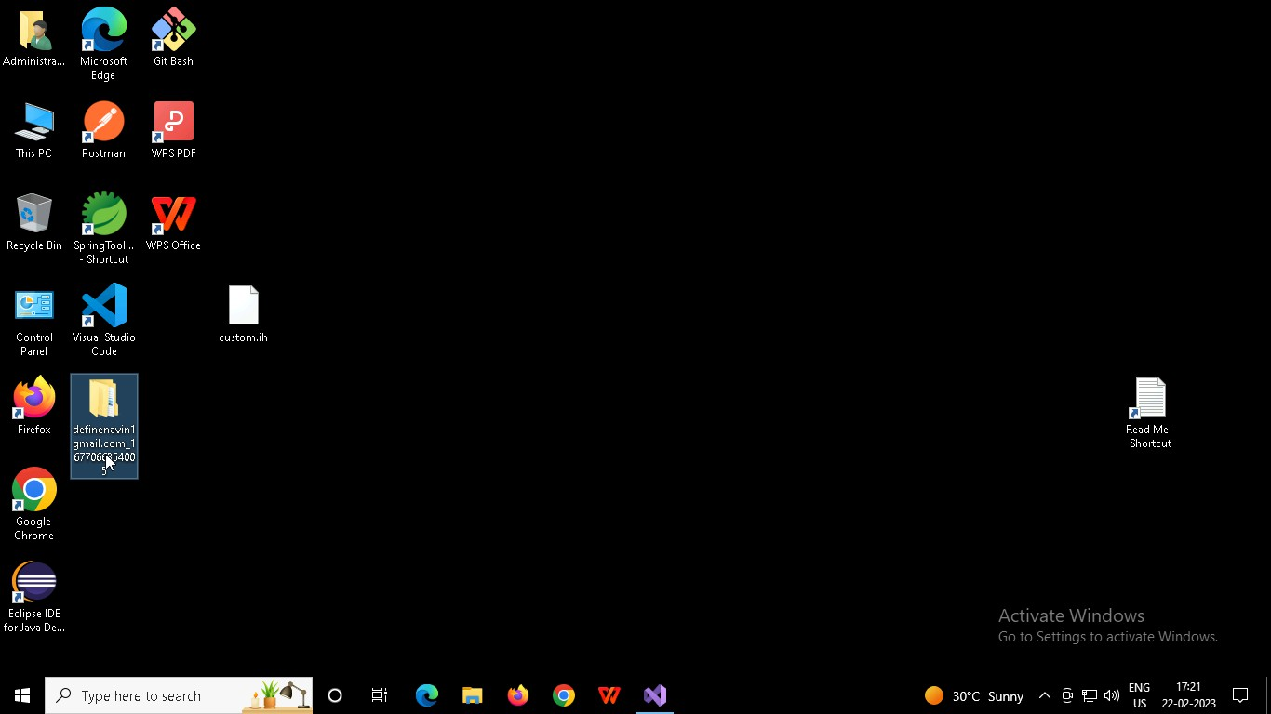

Right click in folder and open Git Bash

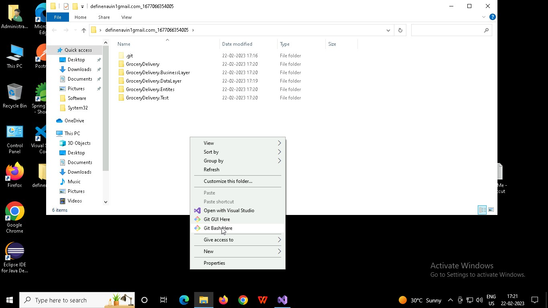

In Git bash terminal, run following commands

* 1. git status
  2. git add .
  3. git commit -m “First commit”

(You can provide any message every time you commit)

* 1. git push

