HealthApp Automation-Dispensary Module

Pre-requisite:

As soon as you import project in eclipse, update the project using maven update option as below. This is to resolve issue if any maven dependency not downloaded properly:

1. Right click on project : Go to “Maven” : Select “Update Project”

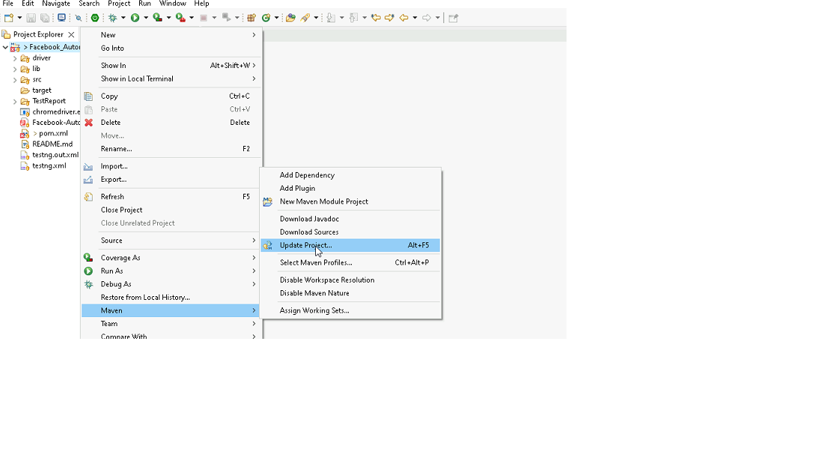

1. In Update Maven Project Box Select “Force Update of Snapshots/Releases” and click OK

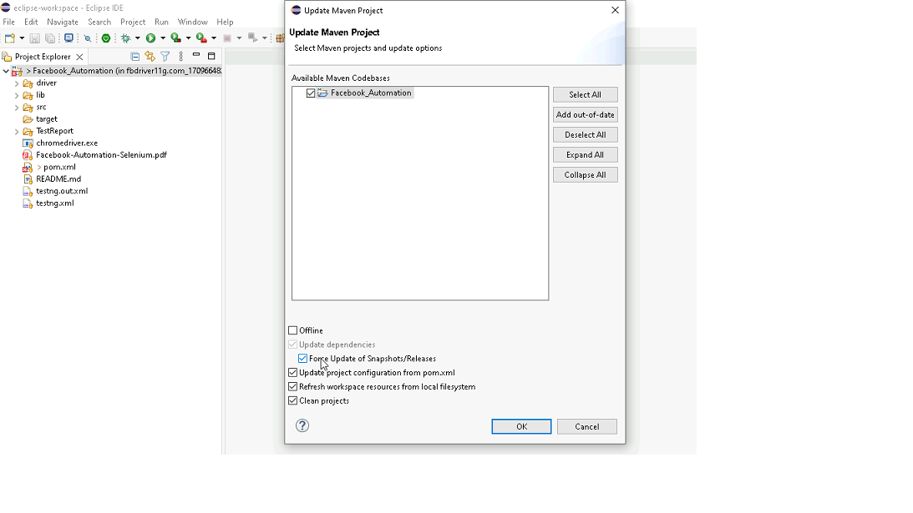

Template Code Structure:

1. Below are the packages and files you will be required to work upon.
2. Other Files and packages you can ignore.
3. In other Files and packages do not do any changes. It would affect your evaluation.
4. You are not required to work in “Test” Folder. Files there are non-editable. Editing those files and trying to save them will throw error and would affect your evaluation.

|  |  |  |
| --- | --- | --- |
| **Package** | **Class/File** | **Description** |
| src/main/java/coreUtilities/utils/ | FileOperations.java | 1. Contains methods to read from json file. 2. Method is in templated form. 3. **You will be required to implement these methods as very first activity, because even URL to navigate to, is read using these methods.** |
| /src/main/java/pages | Dispensary_Pages.java | 1. All core activities (mentioned in list above) to be performed here. 2. The comments associated with each templated method here describe the expectation. 3. You can define locators and xpath here. 4. Declare any variable/object you need to share data/status between different methods. 5. Do not modify the signature of methods declared here. 6. You can create additional supportive common methods in CommonEvents class. |
| /src/main/resources/ | Config.json | URL to navigate to. Already URL is defined here |
|  | expected_data.json | Contains data to fill in form |
| /src/main/java/coreUtilities/utils | CommonEvents.java | 1. Contains all common activities. 2. Certain templated common method declared here. 3. You implement them as per your need. 4. You can add any additional method for common activity here |
|  | Testng.xml | Execution needs to kick started from TestNG xml |

PROBLEM STATEMENT

Need to automate the following activities using Selenium + Java.

Key Activities to implement:

|  |  |  |  |
| --- | --- | --- | --- |
|  | **URL** | <https://healthapp.yaksha.com/> |  |
|  | **username :** | admin |  |
|  | **password :** | pass123 |  |
|  |  |  |  |
|  |  |  |  |
| **Sl No.** | **Summary** | **Action** | **Expected Result** |
| **1** | Verify the title and url of the current page. | 1. go to url : **https://healthapp.yaksha.com/** 2. get the title and url of the current page 3. validate the title and url of the current page | Title should be : **DanpheHealth**  Url should be : **https://healthapp.yaksha.com/Home/Index#/** |
| **2** | verify the Dispensary module is present or not | 1.login healthapp aplication 2. Dispensary module is present in left navigation 3. verify the "DIspensary" module | dispensary Module should be present |
| **3** | verify all sub-modules are displayed correctly after clicking on the "Dispensary" Module. | 1.Click on the Dispensary Module 2.Verify all sub modules are present under the Dispensary module | All sub-modules should be displayed correctly. Expectede Sub modules are : Prescription , Sale , stock, counter, Reports, Patient Consumption |
| **4** | scroll to the bottom of the "Sale" page and verify that "Print Invoice" button , "Discard" button ,"Invoice History" and "Credit Limitis and Balance" text are peresent or not. | 1.Click on Morning Counter 2. scroll to the buttom of the page 3. verify the "Print Invoice" button , "Discard" button, "Invoice History" and "Credit Limitis and Balance" text | user should scroll to the buttom of the page and able to see the "Print Invoice" button , "Discard" button, "Invoice History" and "Credit Limitis and Balance" text |
| **5** | Perform the keyboard operation to open the popup and verify that the popup is displayed or not. | 1.Click Alt + N to open the add new patient popup | Add new patient popup should come. |
| **6** | Validate the error message in firstname textfield after click on "Ok" button | 1. click on "ok" and validate error message in firstname textbox | Error message should be : FirstName is required |
| **7** | Fill all the textfields which are present inside the Add New Patient popup. and verify that value is present after enter the values. | 1.Enter data in the First Name Field. 2.Enter data in the Middle Name Field. 2.Enter data in the Last Name Field. 3.Enter data in the Age Field. 4.Enter data in the Contact Number Field. | All text fields inside the "Add New Patient" popup are successfully filled with appropriate information. The data entered should correctly displayed in all Field on this page. |
| **8** | Navigate to the Last page of the stock details list pagenation and fetch the total stock value | 1.click on "stock" 2.Click on "stock details list" 3. click on last button 4. get the total stock value | User should able to fetch the total stock v alue |
| **9** | check "Main Dispensary" is selected from filter stock dropdown and select main store. | 1. select "Main Dispensary" from filter by store dropdown 2. verify "Main Dispensary" is selected 3.Select main store from dropdown | "Main Dispensary" should be selected |
| **10** | validate "create requisition" button is present or not | 1. click on "Requisitions" Tab 2. validate the "create Requisitions" button is present or not | "create Requisitions" button should be present |
| **11** | verify "Item Name" text field is present in "Add Requisition" page | 1. click on "create requisitions" 2. click on "+" icon , then a "new item" text fielld will come. 3. verify "Item Name" text field is present. | "Item Name" text field should be present. |
| **12** | verify Requisition Details Print page | 1. click on "cancel" button of "Add Requisition" page 2. click on "views" icon of recently created documents. 3. verify "Requisition Details Print" page | Medicine name should be present and validate the "print" and "Requisitions List" button |
| **13** | Get the medicine name from the "Requisition Details Print" page | 1. control should be present on "Requisition Details Print" page 2. get the medicine name from the "Requisition Details Print" table | medicine name should be print on the console |
| **14** | Get the place holder name of address textfiled and verify the place holder name. | 1. Click on social service module 2. click on Register New SSU Patient Registration page 2. get the place holder name of address text field 3.verify the place holder name | placeholder name should be print on console |
| **15** | Close this "New SSU Patient Registration" popup by using javaScript. | 1.Click on the "X" button using javaScript | "New SSU Patient Registration" popup should be closed. |

NOTE: "Please do not delete any file in the src folder.  But you are free to add any other file".

Expectations:

1. Learners should write automation script using Java and selenium to automate all the steps in the above question. In other words, automation script should perform all mentioned steps.
2. Learners should not use any tools to create the xpath. They should develop the xpath/cssselector on their own.

IMPLEMENTATION/FUNCTIONAL REQUIREMENT

* 1. **CODE QUALITY/OPTIMIZATIONS**
     1. Associates should have written clean code that is readable.
     2. Associates need to follow SOLID programming principles.

EXECUTION STEPS TO FOLLOW

1. **You are mandatory required to run test cases for applications before final submission. Without which project evaluation will not happen.**
2. **You can launch test cases any time as follows: Right click on testng.xml and run TestNGSuite**

1. **Before final submission, you are also required to push your code to GIT. Following are the steps to follow:**

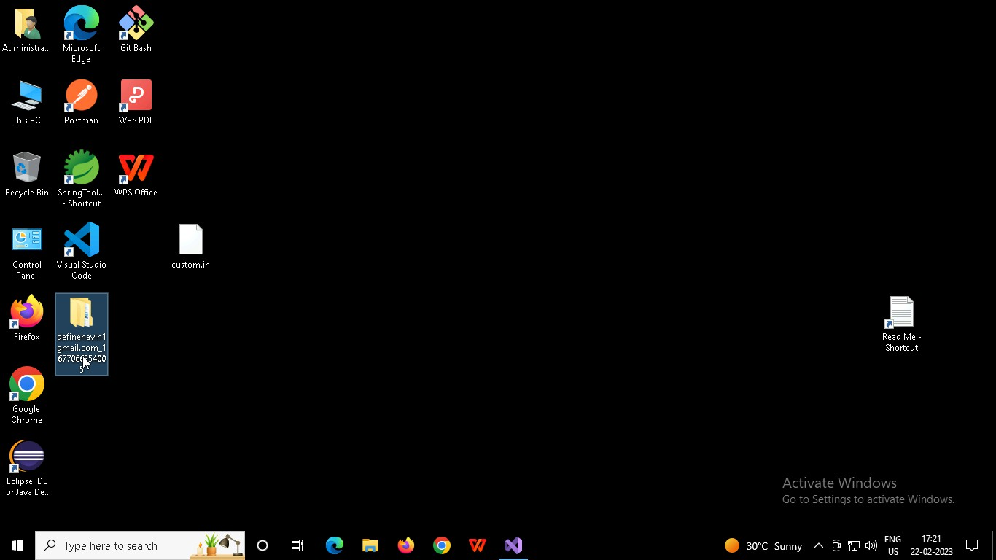

Right click in folder and open Git Bash

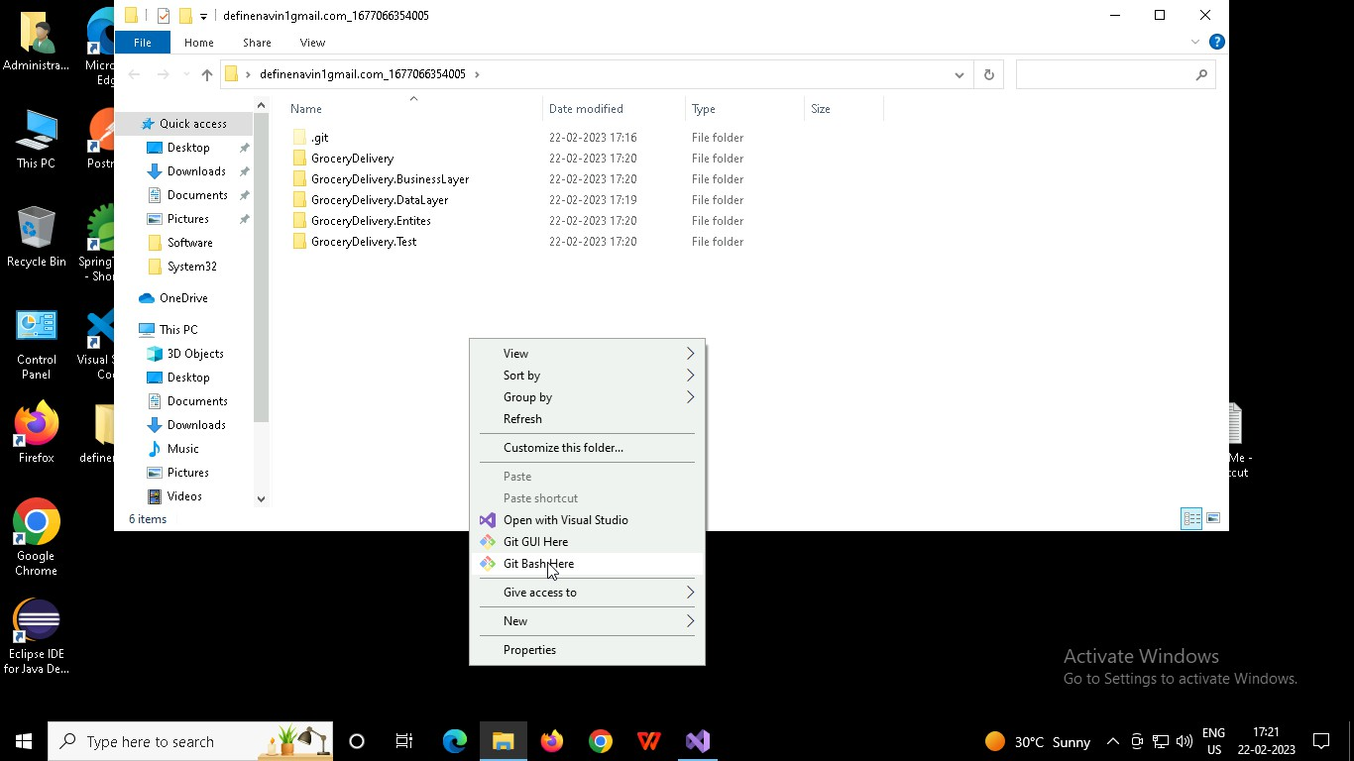

In Git bash terminal, run following commands

* 1. git status
  2. git add .
  3. git commit -m “First commit”

(You can provide any message every time you commit)

* 1. git push

