HealthApp Automation-Dispensary Module

Pre-requisite:

As soon as you import project in eclipse, update the project using maven update option as below. This is to resolve issue if any maven dependency not downloaded properly:

1. Right click on project : Go to “Maven” : Select “Update Project”

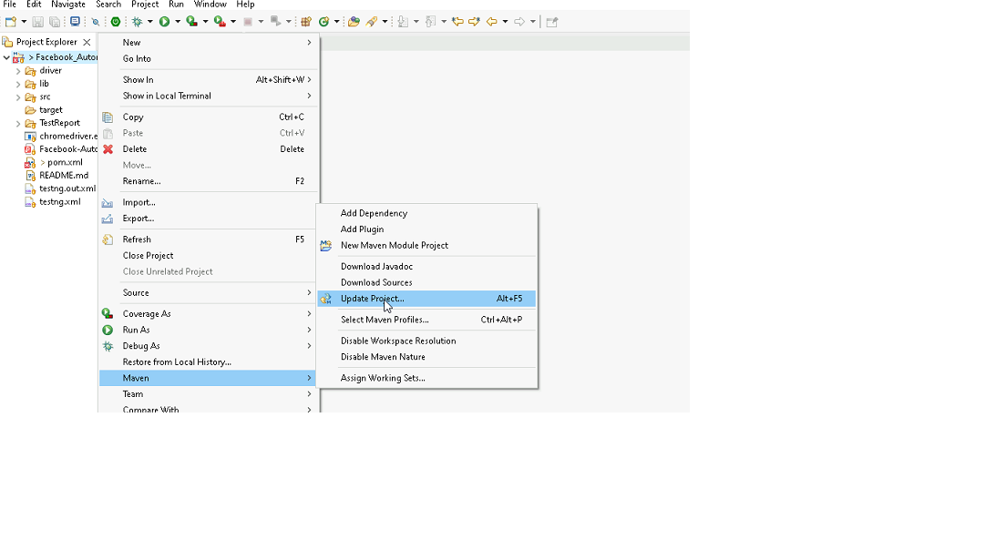

1. In Update Maven Project Box Select “Force Update of Snapshots/Releases” and click OK

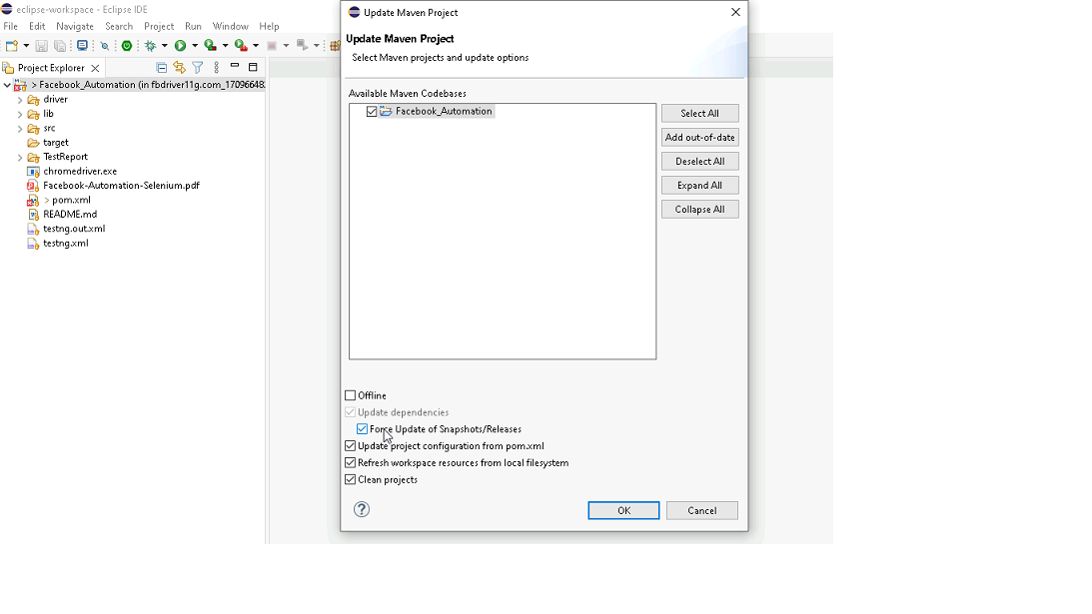

Template Code Structure:

1. Below are the packages and files you will be required to work upon.
2. Other Files and packages you can ignore.
3. In other Files and packages do not do any changes. It would affect your evaluation.
4. You are not required to work in “Test” Folder. Files there are non-editable. Editing those files and trying to save them will throw error and would affect your evaluation.

|  |  |  |
| --- | --- | --- |
| **Package** | **Class/File** | **Description** |
| src/main/java/coreUtilities/utils/ | FileOperations.java | 1. Contains methods to read from json file. 2. Method is in templated form. 3. **You will be required to implement these methods as very first activity, because even URL to navigate to, is read using these methods.** |
| /src/main/java/pages | dispensary_Pages.java | 1. All core activities (mentioned in list above) to be performed here. 2. The comments associated with each templated method here describe the expectation. 3. You can define locators and xpath here. 4. Declare any variable/object you need to share data/status between different methods. 5. Do not modify the signature of methods declared here. 6. You can create additional supportive common methods in CommonEvents class. |
| /src/main/resources/ | Config.json | URL to navigate to. Already URL is defined here |
|  | expected_data.json | Contains data to fill in form |
| /src/main/java/coreUtilities/utils | CommonEvents.java | 1. Contains all common activities. 2. Certain templated common method declared here. 3. You implement them as per your need. 4. You can add any additional method for common activity here |
|  | Testng.xml | Execution needs to kick started from TestNG xml |

PROBLEM STATEMENT

Need to automate the following activities using Selenium + Java.

Key Activities to implement:

|  |  |  |  |  |
| --- | --- | --- | --- | --- |
| **Sl No.** | **Summary** | **Action** | **Expected Result** | **Validation Rules** |
| **1** | Verify the title and url of the current page. | 1. go to url : **https://healthapp.yaksha.com/** 2. login as valid credential **(username : admin , password : pass123)** and click on "**SignIn**" Button 2. get the title and url of the current page 3. validate the title and url of the current page | Title should be : **DanpheHealth**  Url should be : **https://healthapp.yaksha.com/Home/Index#/** | Validate URL & title of the page |
| **2** | verify the Dispensary module is present or not? | 1. after logged in the healthapp aplication 2. Dispensary module is present in left navigation 3. verify the "DIspensary" module is present or not? | dispensary Module should be present | validate Link text is present |
| **3** | verify all sub-modules are displayed correctly after clicking on the expand icon of "Dispensary" Module. | 1.Click on the Expand Icon of **Dispensary** Module 2. then check following sub modules are present : **Prescription Sale stock counter Reports Patient Consumption** 3. Verify all sub modules are present under the Dispensary module or not? | All sub-modules should be displayed correctly. Expectede Sub modules are : **Prescription Sale stock counter Reports Patient Consumption** | validate all fields are present or not |
| **4** | scroll to the bottom of the "**Sale**" page and verify that **"Print Invoice"** button , "**Discard**" button ,"**Invoice History"** and  **"Credit Limitis and Balance"** text are peresent or not? | 1. "**Counter**" sub module of "**Dispensary**" modules should be pre selected. 2. Click on "Morning Counter" link text 3. it should navigate to the "Sale" page 4. scroll to the buttom of the page 5. verify the **"Print Invoice**" button , "**Discard**" button, "**Invoice History**" and **"Credit Limitis and Balance"** details are present or not? | user should scroll to the buttom of the "**Sale**" page and able to see the that **"Print Invoice**" button , "**Discard**" button, "**Invoice History**( **Deposit Balance, Credit , Provisional Amount, Total Due, Balance Amount**  ) and **Credit Limitis and Balance** ( **General Credit Limit, IP Credit Limit, OP Credit Limit, IP Balance, OP Balance**) are present in the "**sales**" sub menu page. | perform scroll to view and validate the given buttons are present or not |
| **5** | Perform the keyboard operation to open the "**Add New Patient**" popup Page and verify that the popup is displayed or not. | 1. "**Sale"** page must be pre selected 2. press **"Alt + N"** from the keyboard, 3. then "**add new patient**" form should popup. 4. verify the "**add new patient**" page Name. | **Add new patient** form should be open. Page name must be **"Add New Patient**" | perform keyboard operation and verify popup page is coming or not. |
| **6** | Validate the error message in "**Add New Patient**" form's **firstname** textfieldafter clicking on "**Ok"** Button without filling any information in the form. | 1. click on "**ok**" button directly without fill any information in "Add New Patient" form's 2. then an error message will display under the **firstname** textfield. 3. then validate error message. | Error message should be : **First Name is required.** | validate error message |
| **7** | Fill all the text fields which are present inside the "Add New Patient" form. Validate entered values. | 1.Enter data in the First Name Field. 2.Enter data in the Middle Name Field. 3.Enter data in the Last Name Field. 4.Enter data in the Age Field. 5.Enter data in the Contact Number Field. | Given text fields value inside the "Add New Patient" form are filled with appropriate information. The entered data should be correctly displayed in First Name, Middle Name, Last Name, Age and Contact Number Field on "**Add New Patient"** form. | verify that the value are present in entered fields |
| **8** | On the "**New Consumption Entry**'s page, validate the confirm! Message that is "**Are you sure you want to Proceed ?**" | 1.Click on the cross "X" of Add New Patient popup. 2. click on the "**Patient Consumption**" sub modules of Dispensarfy module 3. click on "**New Consumption**" button, then "New Consumption Entry" form will popup. 3. directly click on "Save Consumption" button without fill any information 4. then a confirm message will popup (**Message : "Are you sure you want to Proceed ?" )** 5. validate that confirm message. 6. then click on confirm button 7. then close the "New Consumption Entry's page | confirm message should be  **"Are you sure you want to Proceed ?"** | validate the confirm message |
| **9** | on the "Stock" page , select "Main store" from "Filter by store" dropdown and verify that "Main store" is selected and stock value are filtered by the selected store name (store name should be :Main store) | 1. click on "stock" sub modules 2. Select "**Main store**" from "**Filter by store**" dropdown 3. verify "**Main store**" is selected 4. stock list will be filtered by Main store and verify that Store Name is "Main Store" of last record/ element. | "**Main store**" should be selected form "Filter by store" dropdown and Store Name should be "Main Store" | handle the dropdown without using select class and verify selected option is selected or not |
| **10** | on the stock page , please validate clicking "**Create Requisition**" button navigate to "**Add** **Requisitions**" page and validate the page Name. | 1. "Stock" page Pre-Selected. 2. click on "**Requisitions**" Tab of "**Stock"** page 3. validate "**Create Requisition**" button is present or not under "**Requisition**" Tab 4. clicking on **"Create Requisition**" button navigate to the "Add Requisition" page and verify the page name. | "**Create Requisition**" button should be present under "**Requisitions**" Tab and page name should be "Add Requisitions" after click on "**Create** **Requisition**" button | verify button is present and navigate to the "Add Requisitions" page |
| **11** | on the "**Add Requisition**" page, clicking the "**+"** icon button on right hand side of "Remarks" text box add a the New set of elements to add a new records. validate "**New Item**" text field, **Quantity** "Text field and "**Remark**" text box are present or not 2nd rows? | 1. **"Add Requsitions"** page pre-selected. 2. then clicking on **"+"** icon which display in right hand side of the "Remarks" textbox of "Add Requsition" page , it will add a New set of elements to add a new records. 3. verify "**New Item**" text field, "**Quantity** "Text field and "**Remark**" textbox are present or not 2nd rows.? | "New Item" text field, "Quantity "Text field and "Remark" textbox should be present in 2nd rows. | Verify new set of elements textfield is added or not |
| **12** | On the "Requisition" page, verify that view button under "action" navigate to the "**Requisition Details Print**" page and validate the page name is **"Requisition Details Print"** and validate "**print**" and "**Requisitions** **List**" button are present. | 1. click on "cancel" button of "Add Requisition" page 2. click on "view" icon of recently created documents. 3. verify "Requisition Details Print" page | "**Requisition Details Print**" should be present and validate the **"Requisition Details Print"** , "**print**" and "**Requisitions** List" button | verify the page name and button |
| **13** | On the "Requisition Details Print" page, Get the medicine name from the **"Requisition Details Print"** table and validate the medicine name is not blank. | 1. control should be present on "**Requisition Details Print**" page 2. get the medicine name from the "**Requisition Details Print**" table | medicine name should be print on the console | fetch the data from the table |
| **14** | On the ""New SSU Patient Registration" under social service module, get the place holder name of "**Address**" textfiled of "**New SSU Patient Registration**" page and verify the place holder name. | 1. Click on "**social service**" module 2. click on "**Register New SSU Patient**" button 3. then "**New SSU Patient Registration**" page will open. 4. click on "**Address"** Textfield 5. Then get the place holder name of "**Address"** text field 6. verify that place holder name and print on console. | placeholder name should be "**Address**" and then print on console | Validate placeholder name |
| **15** | On the "New SSU Patient Registration" page, Close this "**New SSU Patient Registration**" popup page by using javaScript. | 1.Click on the "**X**" button using javaScript | "**New SSU Patient Registration**" popup page should be closed. | Perform JavaScript Action. |
| **16** | On the Appointment module, under the"New visit" tab, verify tooltips which is present on keyboard icon. | 1. click on "Appointment" module 2. Click on "New 1" link, it will navigate to the "New Visit" page 3. Mouse hover to the keyboard icon 4. Verify the tooltip message. | Tooltip message should be : **ALT + N = New Patient** | handle tooltip |
| **17** | On the Dispensary module's "Sale" page, Open the "New Patient page" and select **India** from the **country** dropdown menu and validate India is properly selected or not. | 1. Dispensary Module should be Pre-expanded 2. click on sales sub modules from Dispensary Module 3. perform "Alt+N" keyboard operation to open the add new patient 4. Select country as India in the country dropdown from "add new patient " page 5. close the "Add New Patient" page. | User should able to select India as country from the country dropdown menu. | handle dropdown by using select class and verify selected option is selected or not |
| **18** | On the Dispensary module's "Sale" page, Taking screenshot of the current page after closing the "Add New Patient" form. | 1.Take a screenshot of the Current page.(Store in the Screenshot folder) | User should take the screenshot. | handle screeshot |
| **19** | On "Procurement" module's , Upload a image in "Add Invoice Header" page. | 1. click on Procurement module 2.Click on settings sub module 3.Click on Invoice headers 4.Click on Add new invoice headers button 5.Upload a file in Choose Logo Image field | Uploaded Image should be displayed. | Handle file upload |
| **20** | On Operation Theatre module, Verify clicking **"New OT Booking"** button popup **"Booking OT Schedule | New Patient"** form. As well as try to book a New OT Booking without patient Name popup the alert message "Patient not Selected! Please Select the patient first!". | 1.Click on Operation Theatre module 2.Click on "New OT booking" button 3.Click on the "Add New OT" Button 4.Verify the alert popup is present and handle alert popup 5.Click on Ok button(Present inside the popup) | Alert popup should be present. | Handle alert popup |

NOTE: "Please do not delete any file in the src folder.  But you are free to add any other file".

Expectations:

1. Learners should write automation script using Java and selenium to automate all the steps in the above question. In other words, automation script should perform all mentioned steps.
2. Learners should not use any tools to create the xpath. They should develop the xpath/cssselector on their own.

IMPLEMENTATION/FUNCTIONAL REQUIREMENT

* 1. **CODE QUALITY/OPTIMIZATIONS**
     1. Associates should have written clean code that is readable.
     2. Associates need to follow SOLID programming principles.

EXECUTION STEPS TO FOLLOW

1. **You are mandatory required to run test cases for applications before final submission. Without which project evaluation will not happen.**
2. **You can launch test cases any time as follows: Right click on testng.xml and run TestNGSuite**

1. **Before final submission, you are also required to push your code to GIT. Following are the steps to follow:**

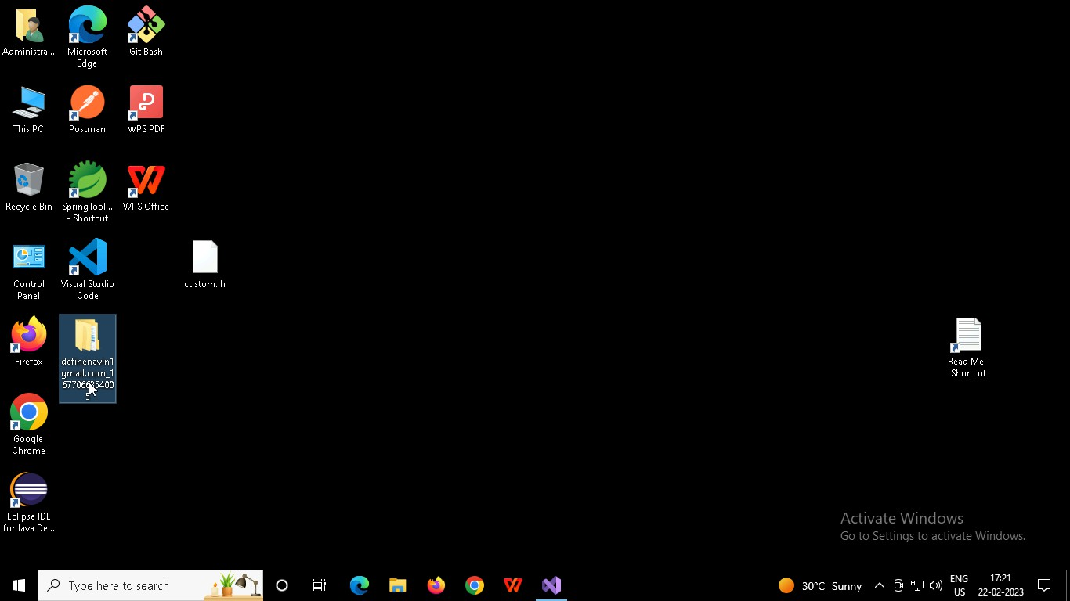

Right click in folder and open Git Bash

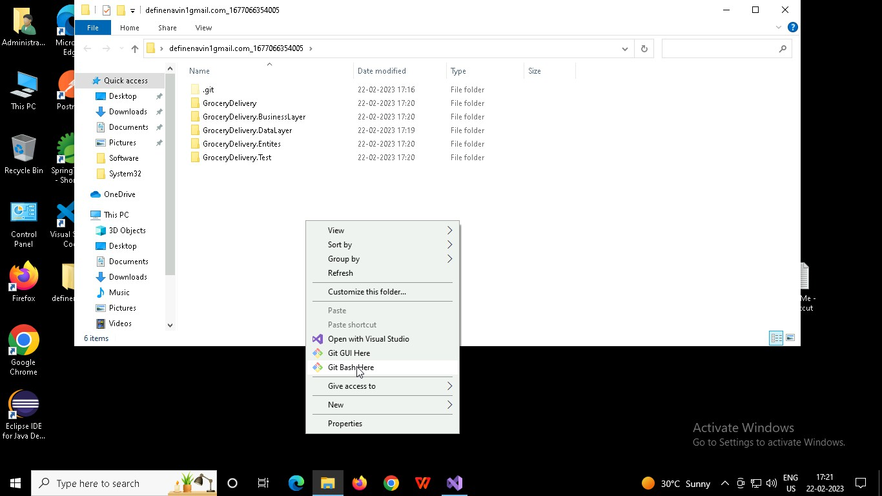

In Git bash terminal, run following commands

* 1. git status
  2. git add .
  3. git commit -m “First commit”

(You can provide any message every time you commit)

* 1. git push

